Deep Learning Based Cyclone Intensity Estimation

Tables:
- Literature Review of papers referred
Authors | Title | Findings
Manil Maskey, Rahul Ramachandran, Muthukumaran Ramasubramanian, Iksha Gurung, Brian Freitag, Aaron Kaulfus, Drew Bollinger, Daniel J. Cecil, Jeffrey Miller | Deepti: Deep-Learning-Based Tropical Cyclone Intensity Estimation System[1] | Demonstrates a complete, real-time, deep learning-based method for estimating the wind speed of tropical cyclones. The system incorporates the creation of a CNN model that can accurately calculate the wind speed of tropical cyclones from only satellite photos. Future research on a variety of topics, such as estimation of wind speed for tropical cyclones with lesser intensities using passive microwave data, could be taken into consideration. Another investigation is a thorough analysis of a specific storm to comprehend model performance with storm structural changes during rapid intensification
Nandhini K., Dr. G. Tamilpavai, Akila Rajini S. | Prediction of Cyclone and Its Classification using Deep Learning Techniques  [4] | Convolutional and recurrent neural networks are two examples of deep learning approaches used in this research. With 1380 input values, Convolutional Neural Network provides the best classification result. Convolutional neural networks have a classification rate of 83.8%, recurrent neural networks using LSTM are at 83.3%, and recurrent neural networks utilizing gated recurrent units (GRU) are at 70%.  Multiple techniques were implemented to get an accurate answer.
Md.Rubyet Kabir, Md. Abdur Rahman Khan, Md. Rashaduzzaman, S.M. Quamrul Hasan | Intensity Analysis of Tropical Cyclone using Dvorak Technique  [6] | For the past 25 to 30 years, the DVKT has served as the main foundation for the worldwide tropical cyclone intensity climatology and has been a crucial operational tool for assessing tropical cyclone strength.  A crucial operational instrument for determining tropical cyclone intensity is the DVKT. The earth's atmosphere can be observed using satellite technology. Digital interpretation techniques of the real-time IR images are currently used to monitor the intensity, track the location, and generate tropical cyclones.
Mensah Kwabena Patrick, Adebayo Felix Adekoya, Ayidzoe Abra Mighty, Baagyire Y. Edward | Capsule Networks- A survey  [5] | DL models such as CNNs have performed well in this field, however they require lots of data and computational power to execute. Capsules were therefore introduced to eliminate the challenges faced by CNNs and have so far performed creditably well.  In capsules, the pooling operation's effect on CNNs' ability to detect object deformation is addressed, enabling them to distinguish between objects from any angle and to classify unseen objects more accurately than CNNs.

- General classification of tropical cyclones
Type of Disturbances | Associated Wind Speed in the Circulation
Low pressure Area | Less than17 knots  (<31 kmph)
Depression | 17 to 27 knots  (31 to 49 kmph)
Deep Depression | 28 to 33 knots  (50 to 61 kmph)
Cyclonic Storm | 34 to 47 knots  (62 to 88 kmph)
Severe Cyclonic Storm | 48 to 63 knots  (89 to 118 kmph)
Very Severe Cyclonic Storm | 64 to 119 knots  (119 to 221 kmph)
Super Cyclonic Storm | 119 knots and above  (221 kmph and above)

Images:
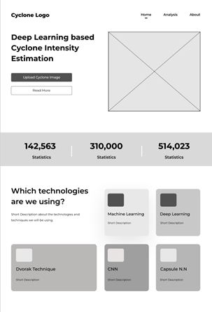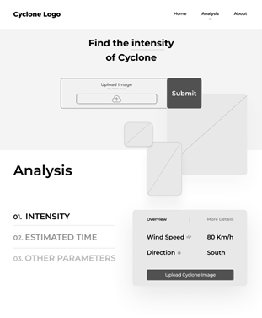
Fig. 4. Figure shows a prototype of the front end design of the proposed work.

