Supplementary Information

article title:
Status of alternative angiogenic pathways in glioblastoma resected under and after bevacizumab treatment

journal name: Journal of Neuro-Oncology

author names: Taketo Ezaki

affiliation and e-mail address of the corresponding author:

Toshihide Tanaka, MD, PhD
Department of Neurosurgery, Jikei University School of Medicine
3-25-8 Nishi-Shinbashi, Minato-ku, Tokyo 105-8461, Japan
TEL: +81-3-3433-1111 (ext. 3461); FAX: +81-3-3459-6412
E-mail: ttanaka@jikei.ac.jp

Supplement Table1

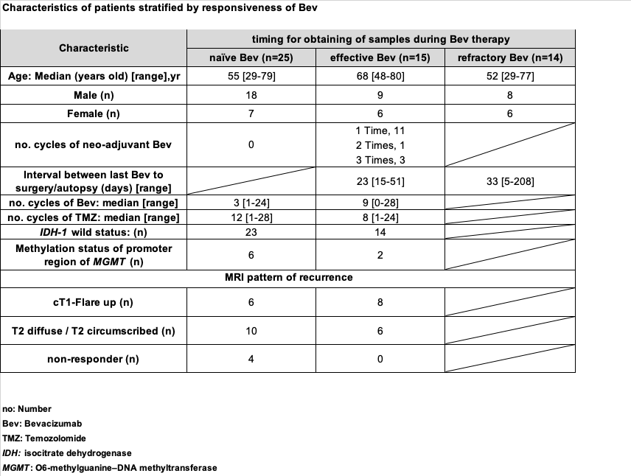

Supplement Table2

