Supporting Information
for

Additive Manufacturing of Carbon Fiber-Reinforced Thermoset Composites via In-Situ Thermal Curing

Carter F. Dojan, Morteza Ziaee, Samuel J. Radosevich, and Mostafa Yourdkhani*

* Corresponding author. Email: yourd@colostate.edu
Fig. S1. Rheological behavior of the composite ink containing 15 vol% of discontinuous carbon fibers at -5 °C, showing the relative stable viscosity of the ink during the printing process.

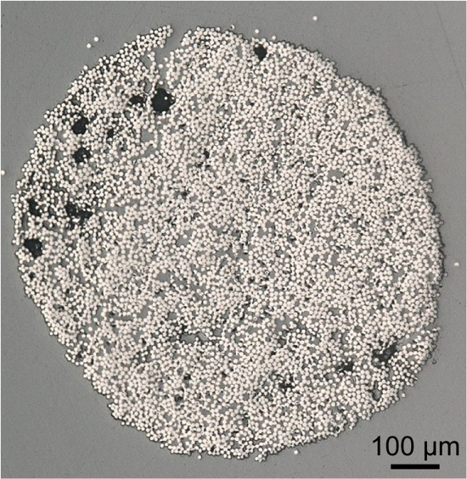
Fig. S2. Optical micrograph from the cross-section of a composite filament with 55.5 vol% of continuous carbon fibers and 1.5 vol% void content.

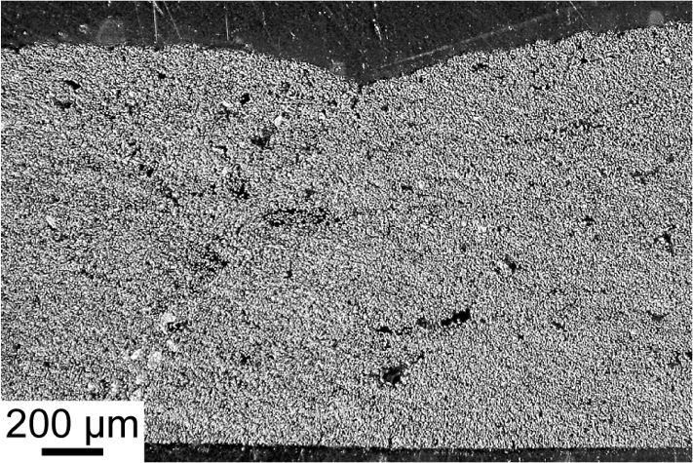
Fig. S3. Optical micrograph from the cross-section of a multilayer composite part, showing the region between two adjacent horizontal print path and a stack of three print layers.

