Investigation of optical, dielectric properties and conduction mechanism of LiCo_{0.7}Mn_{0.3}O₂
KrimiMoufida^{a*}, Saleh M. Altarifi^{b} and Abdallah Ben Rhaiemª

ªLaboratoryLaSCOM, Faculty of Sciences of Sfax, University of Sfax, BP1171,
3000 Sfax, Tunisia
^{b}Department of Physics College of Science, Qassim University, P.O. Box: 6644,
51452 Buraydah, Almolaydah, Saudi Arabia.

*Corresponding author:abdallahrhaiem@yahoo.fr
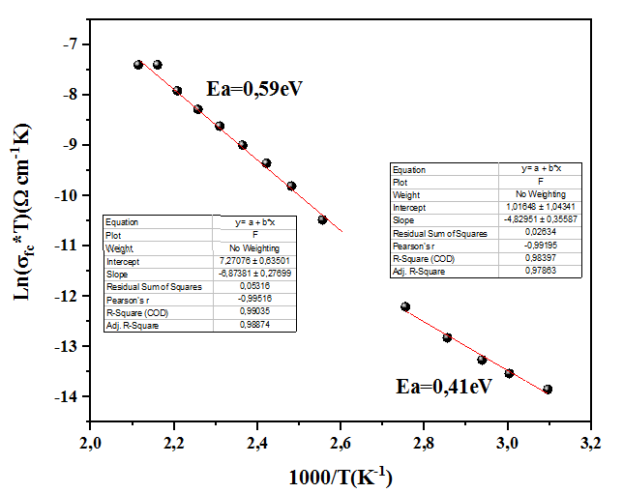
Fig (S1): temperature dependence of Ln (σ_{fc}) of charge carrier.
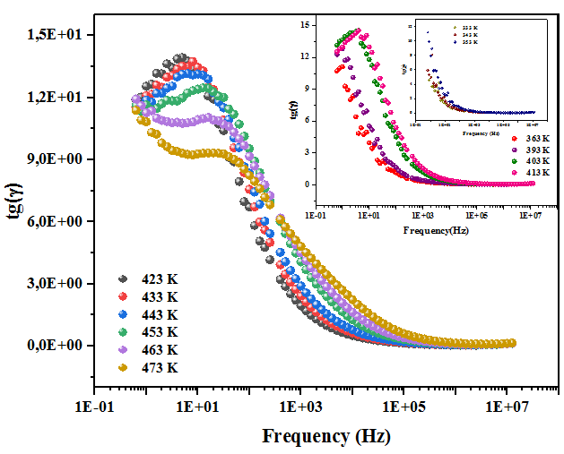
Fig (13): Frequency dependence of the loss tangent (tgγ)
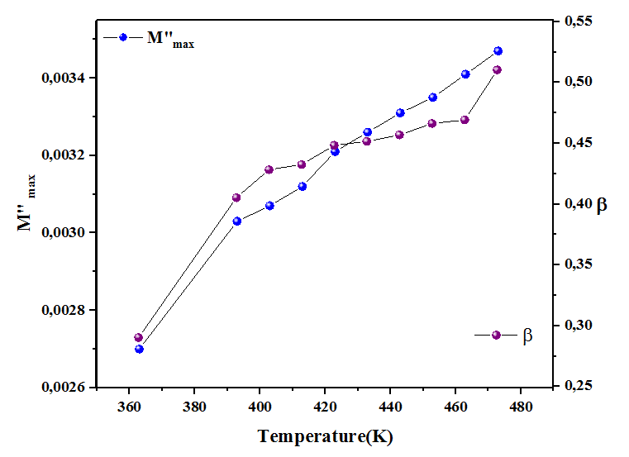
Fig (S3): Variation of (M "_{max}, β) parameters as a function of temperature.
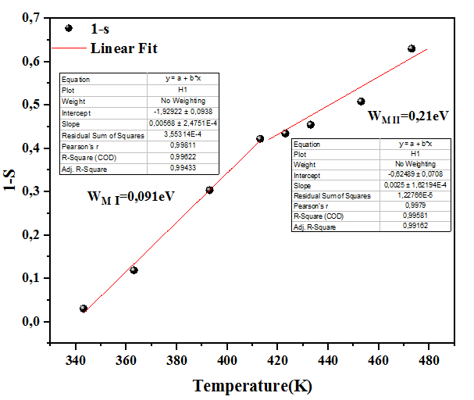
Fig (S4): Variation of (1-s) as a function of temperature
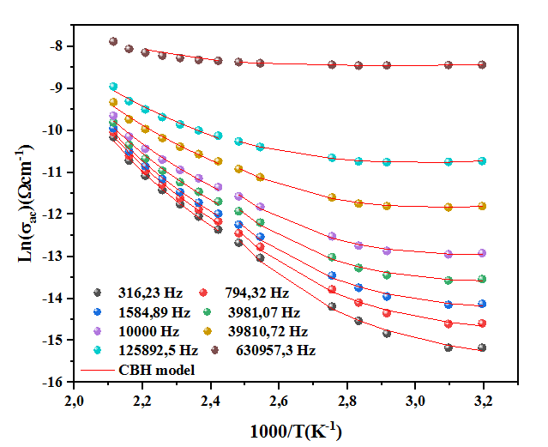
Fig (S5): Ln (σac) as a function of 1000/T for different frequencies values.

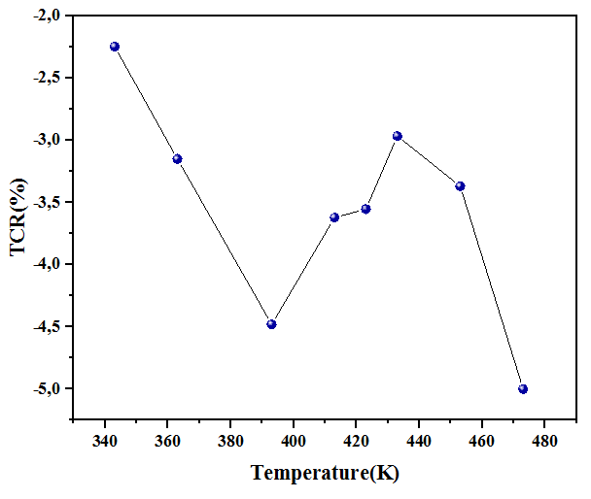
Fig (S6): temperature dependence of TCR (%) for LiCo_{0.7}Mn_{0.3}O₂ compound.

