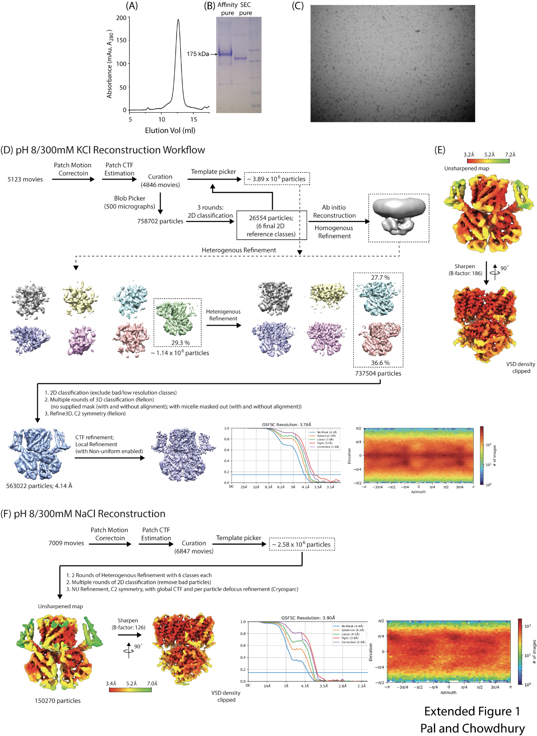Extended Figure 1. Purification of WT sp9C1 and reconstruction at pH 8. A Representative size exclusion chromatography profile of sp9C1 affinity purified using anti-GFP nanobody resin. The SEC Buffer was 300mM NaCl, 25mM HEPES, 1mM TCEP, 0.05% Digitonin, buffered to pH 8. B Representative SDS-PAGE gel of SEC purified sp9C1 obtained from streptactin affinity purification with mEGFP tag still intact (Lane A) and from anti-GFP nanobody affinity purification with a cleaved mEGFP tag (Lane B). (Lane C is the molecular weight marker). C An example micrograph of sp9C1 in pH 8 showing monodisperse single particles. D Single particle reconstruction workflow for sp9C1 in 300mM KCl at pH 8. E Two perpendicular side views of the pH 8/KCl map, before (top) and after (bottom) map sharpening. Maps are colored according to local resolution (FSC = 0.5) as indicated in the color key. F Summary of single particle reconstruction of sp9C1 at pH 8 in presence of 300mM NaCl
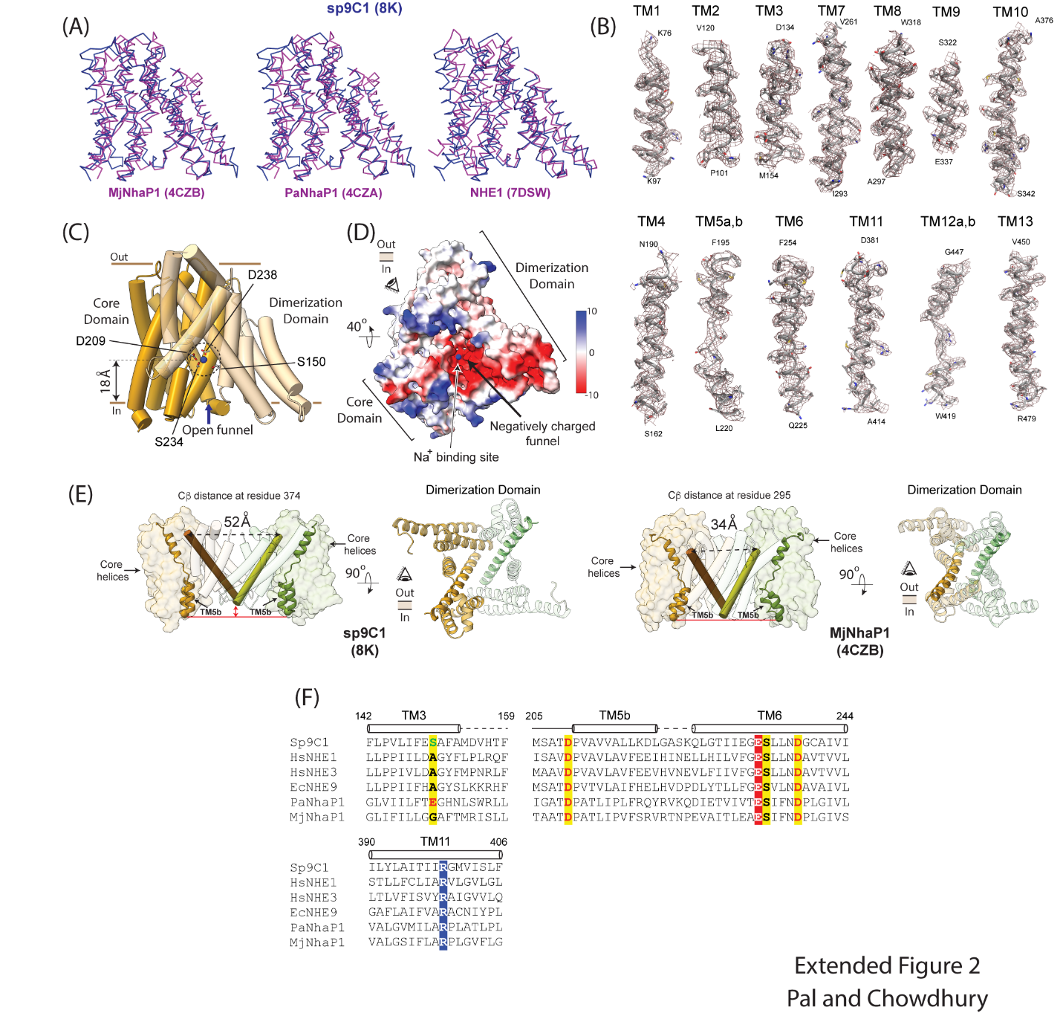Extended Figure 2. The Ion-Exchange Domain of sp9C1. A Structural comparison of a single protomer of the ion exchange domain of sp9C1 (pH 8/KCl), in blue, with those of three representative SLC9s obtained using X-ray crystallography (MjNhaP1 and PaNhaP1) and single-particle cryoEM (NHE1 in the inward-open state), in magenta. B Densities of the 13 transmembrane helices of the ED as observed in the pH 8/KCl sharpened map comparing the model to the map. C Side view of the ED showing the helices of the dimerization domain in transparent yellow and core domain in dark yellow. An open funnel connects the cytoplasm to the ion binding site deep in the transmembrane domain. Residues at the principal ion binding site are shown in sticks. The blue sphere is the mass center of the side chains of the 4 annotated residues and coincides with the putative substrate binding locus. D Bottom-up view of the ED showing the negative electrostatic surface of the cytoplasmic funnel with the putative sodium binding site at its tip. E Comparison of the ED dimer of sp9C1 (side and top-down views on the left) and MjNhaP1 (side and top-down views on the left). TM10s of the two subunits which line the inter-subunit cavity are shown as brown and green cylinders in side-view representations. The exterior ends of TM10 are significantly further apart in sp9C1 than in MjNhaP1 owing to the wider inter-subunit cavity. TM5 (and the intracellular end of TM6) of the 2 subunits are shown in yellow and green cartoon representations. In sp9C1, the intracellular tip of TM5b is ~6Å further below the intracellular ends of the dimerization domain (at the level of TM10) as compared to that in MjNhaP1. The inner surface of sp9C1 ED-dimer is thus significantly more concave. F Sequence alignment of key regions of the ED of different SLC9s, highlighting the ion binding sites in yellow. Two other highly conserved residues, R399 and E233, are also highlighted in blue and red respectively.
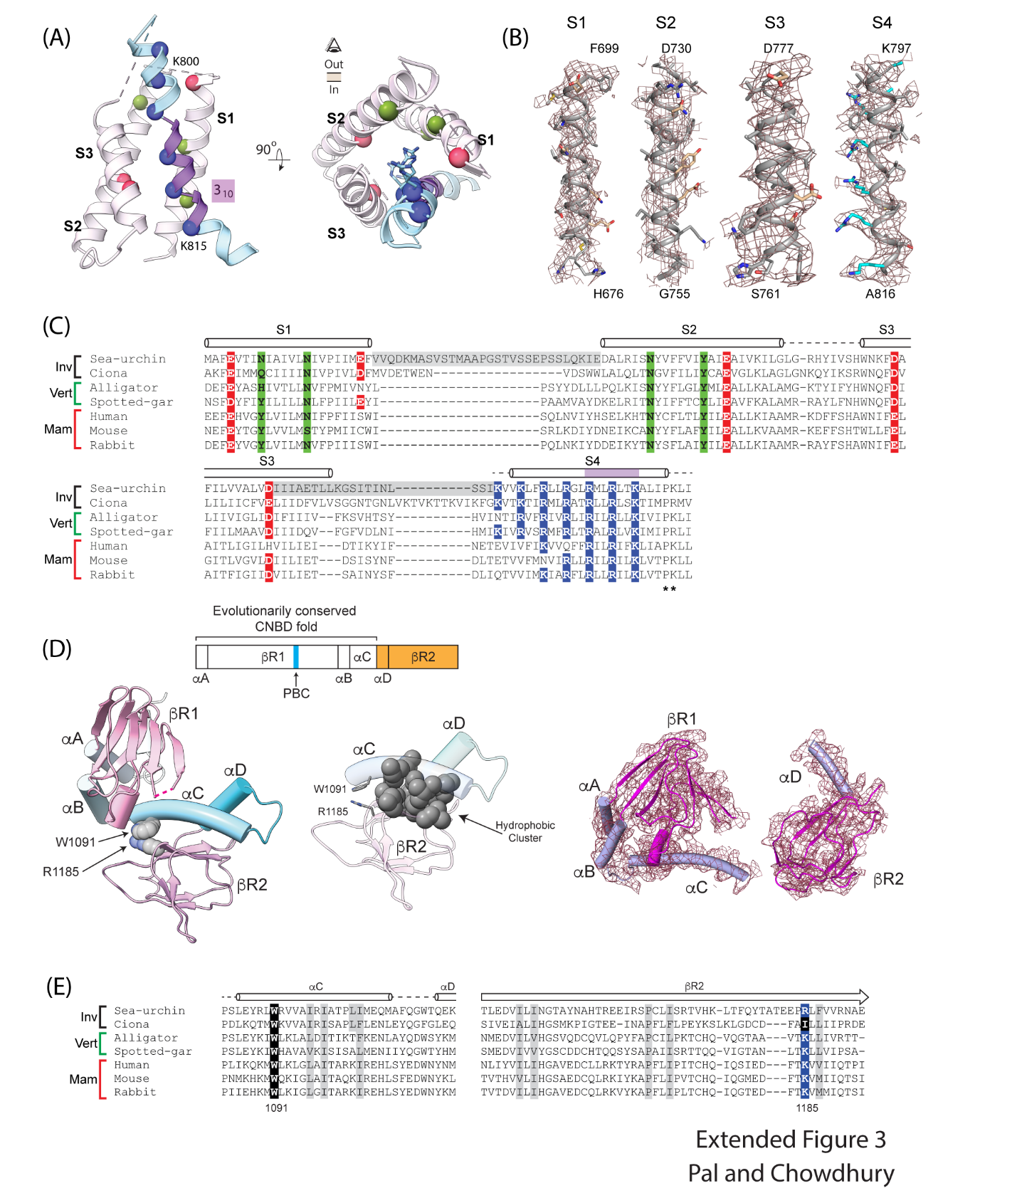Extended Figure 3. Regulatory domains of sp9C1. A Side- and top-down views of voltage-sensing domain. Cα atoms pf positively charged residues on S4 are shown in blue spheres. The 3₁₀ helical segment of S4 is colored in purple while the rest is alpha helical shown in light blue. The positions of polar/negatively charged residues on S1-S3, which putatively stabilize the S4 charges, are shown in green and red spheres. B Density maps of the four helices of the VSD. Side chains of the S4 charges are colored in blue/cyan. C Sequence alignment of the voltage-sensing domain of invertebrate (Inv), vertebrate (Vert) and mammalian (Mam) SLC9C1s. Residues are highlighted as in (A). The extracellular ends of S1 and S2 and S3 and S4, which are missing in density, are highlighted in grey. D Topology, structure and density map of the cytoplasmic domain of sp9C1 showing the CNBD and βR2 domains. PBC (highlighted in blue in the topology) refers to the ‘phosphate binding cassette’, an evolutionarily conserved motif featuring a cluster of positively charged residues that binds the phosphate group of cyclic nucleotides. A conserved pair of residues (W1091 and R1185) and hydrophobic residues at the interface between αC and βR2 are shown in spheres. Red dotted line indicates a short loop in the βR1 domain that is missing in density. E Sequence alignment of αC to βR2 regions of SLC9C1 in various SLC9s showing the interfacial residues (depicted as spheres in (D)), with the W1091 and R1185 sites highlighted in black and blue respectively.
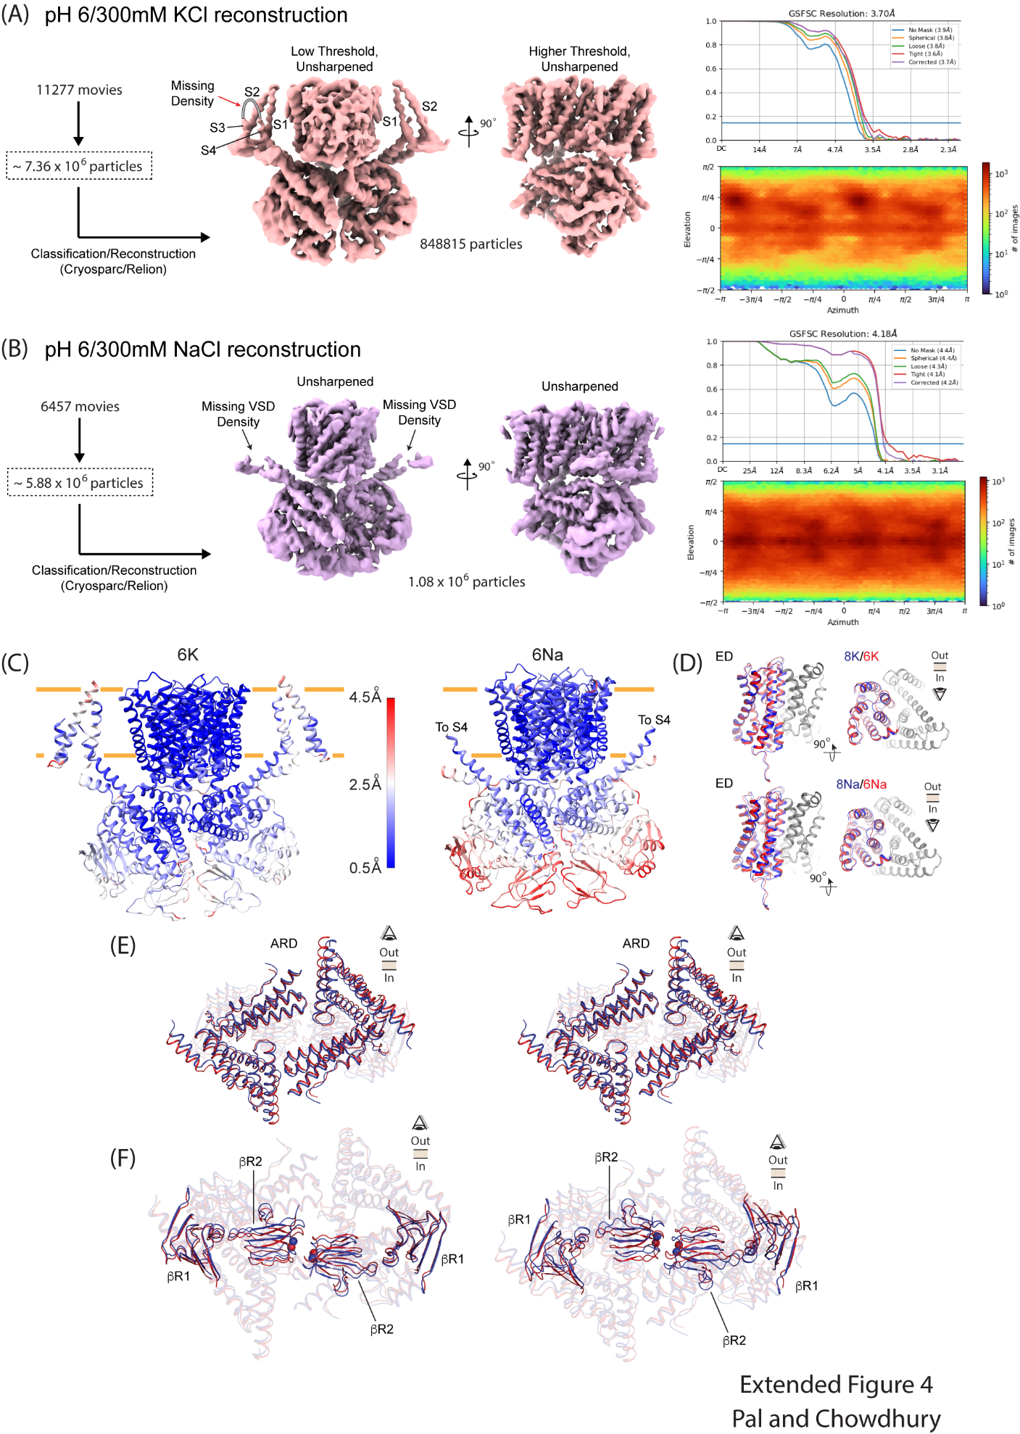Extended Figure 4. Single particle reconstruction of WT sp9C1 in pH 6. A, B Summary of single particle reconstruction of sp9C1 at pH 6, obtained in 300mM KCl (A) or 300mM NaCl (B). The density for the extracellular ends of S3 and S4 helices of the VSD are virtually absent in (A) while in (B), the density for the entire VSD averages out on account of structural heterogeneity. C Structural models of sp9C1 at pH 6, obtained in 300mM KCl (left) or 300mM NaCl, colored according to Cα displacements relative to pH 8/KCl or pH 8/NaCl structures, respectively. D, E, F Structural comparison of the ED (D), ARD (E) and the two β-rolls (F), between pH 8 (blue) and pH 6 (red), in 300mM KCl or NaCl, as indicated. Small pH dependent displacements are observed at the level of βR2 in presence of KCl or NaCl (F). Blue and red spheres indicate the Cα of residue H1172 in pH 8 and pH 6 structures respectively.
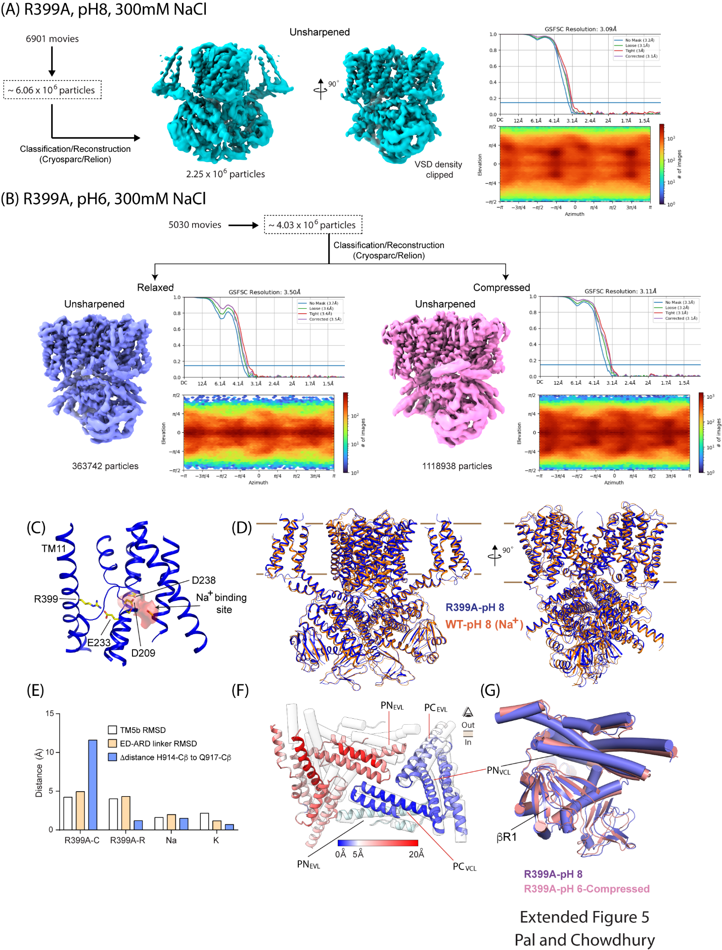
Extended Figure 5. Single particle reconstruction of R399A mutant of sp9C1. A, B Summary of single particle reconstruction of R399A-sp9C1 at pH 8 (A) and pH 6 (B). At pH 6, the number of particles contributing to the Compressed class is ~3-fold higher than those contributing to the Relaxed class. Much like WT, the density for the VSD in both pH 6 classes is virtually absent. C In WT sp9C1, R399 forms a salt-bridge interaction with E233. The salt bridge is close to the ion binding site in the inward-open state of the ED. D Structural comparison of R399A-sp9C1 (blue) and WT-sp9C1 (orange) at pH 8. The two structures superposed well with an overall RMSD of 1.45Å. E Changes in key structural parameters between pH 8 and pH 6 for R399A-Compressed class (R399A-C, group 1), R399A-Relaxed class (R399A-R group 2), WT-sp9C1 in presence of NaCl (Na, group 3) and KCl (K, group 4). The pH 8 structures, used for RMSD and distance calculations, were R399A-pH 8 (for groups 1 and 2), pH8/NaCl (group 3) and pH 8/KCl (group 4). F Structural superposition of ARDs in R399A-pH 6 Compressed Class (colored cartoon) and R399A-pH 8 (transparent tubes). The two ARDs are aligned at using PN_{EVL} of single subunit (marked with black line). Cartoon colors represents the Cα displacements between the two structures. One side of the ARD shows limited displacements with respect to the other. Left, ARD segments belonging to the same subunit are marked with the red line. G Side view ARD-βR1 interface of R399A-pH 6 Compressed Class (pink) and R399A-pH 8 (purple) aligned at the level of the ARD showing that the ARD (PN_{VCL}) and βR1 interface remains preserved.
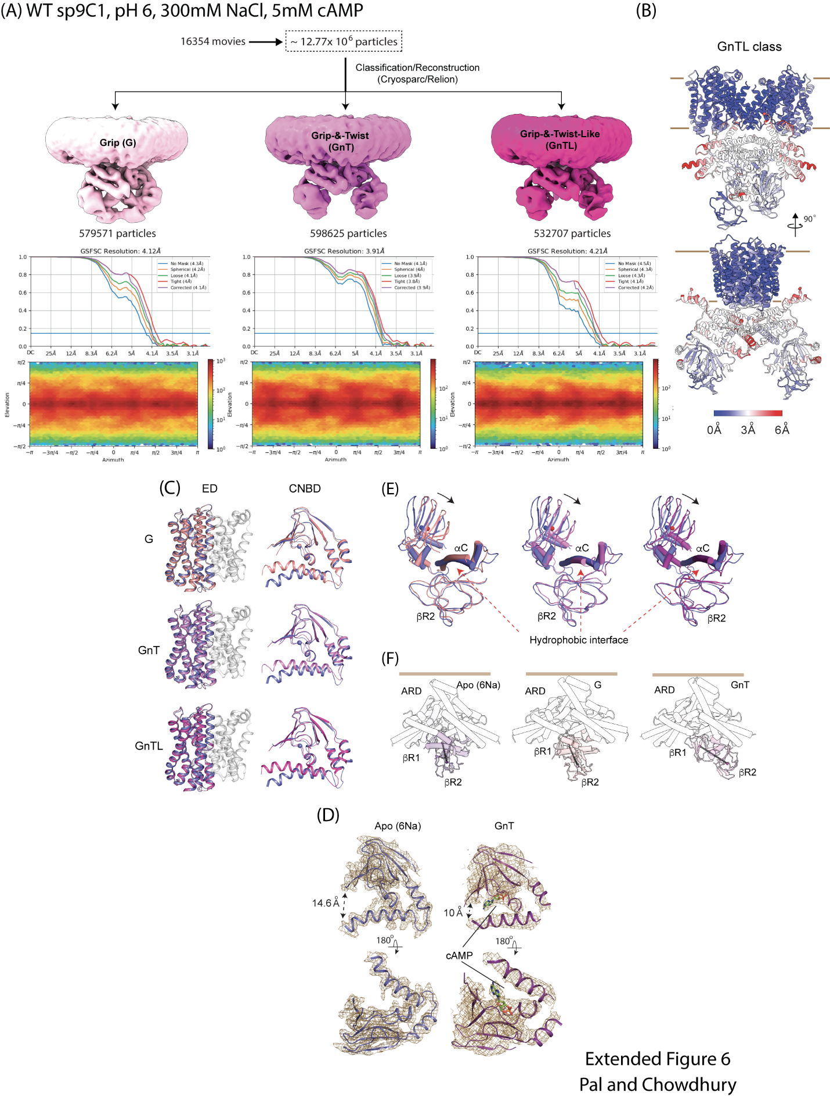
Extended Figure 6. Single particle reconstruction of cAMP bound sp9C1. A Summary of single particle reconstruction of WT sp9C1 in pH 6, with 300mM NaCl and 5mM cAMP showing the 3 structural classes obtained and their final resolutions. Maps are shown at a low contour level to highlight the difference in the cytosolic domains. B Model of the GnTL class in two perpendicular side views, colored according to Cα displacements relative to the GnT class, showing the differences in the ARD and C-terminal domains between the two structures. C Comparison of the ED and CNBD between the Apo (pH 6/NaCl) structure (in blue) and the 3 cAMP conformations, G (light pink), GnT (pink) and GnTL (dark pink). The spheres in the CNBD indicate the Cα atom of R1053 that is involved in cAMP binding. The dimerization domain helices are shown in gray. D Density maps of the CNBD in the Apo (pH 6/NaCl) and cAMP bound (GnT) states, showing the cAMP density. E Structural superposition of the cytoplasmic domains (CNBD and βR2) between Apo and cAMP bounds forms, colored as in (C). Blue and red spheres indicate the center of masses of βR1 in the Apo and cAMP bound states and arrow shows the movement of βR1. F Side view of the full ARD (white tubes) and the cytoplasmic domain of a single subunit in Apo, G and GnT states. In each case the solid black line connects the center of masses of βR1 and βR2. The solid brown lines indicate the inner leaflet of the membrane.

