Extended Data Figures
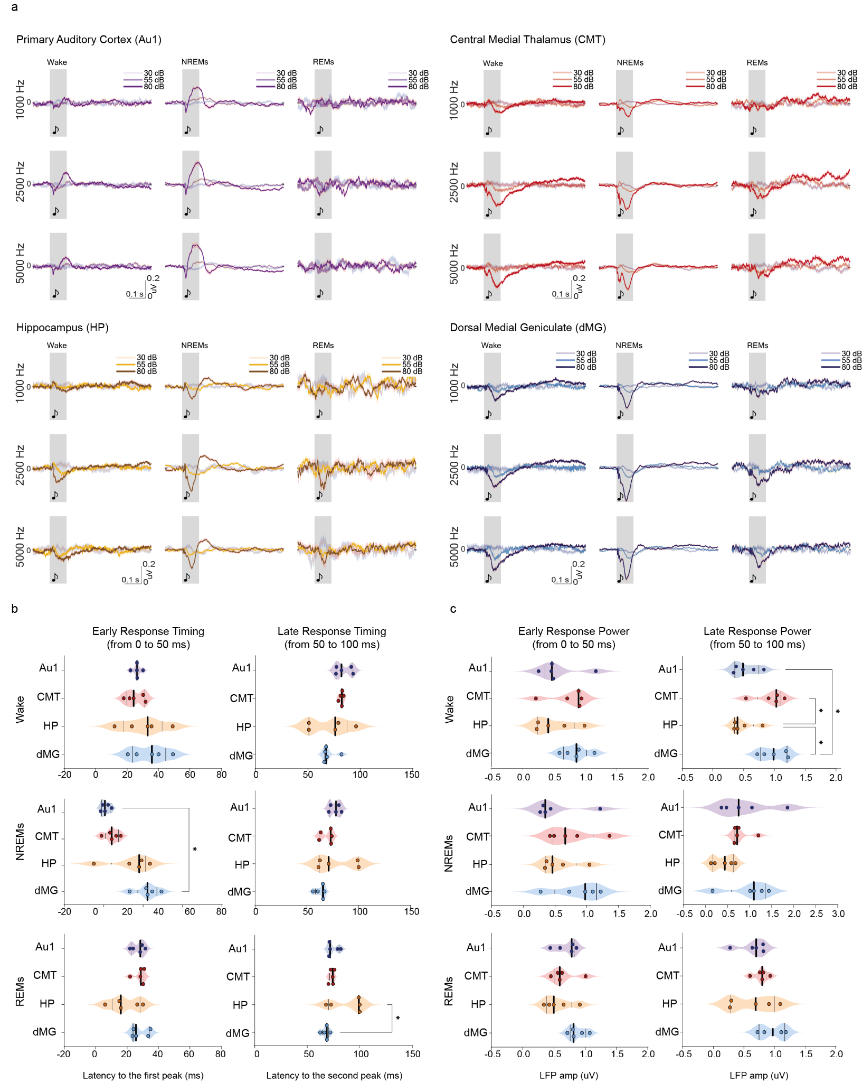

Extended Data Fig. 1: (a) Overview of evoked average auditory-evoked LFP recorded in CMT, HP, Au1, and dMG, across vigilance states. Pure tones at three different frequencies (1 kHz, 2.5 kHz, 5 kHz) of various amplitude (30, 55 and 80 dB SPL) were randomly distributed across wake, NREMs and REMs in freely-moving mice. (b) Time delay of the first (from 0 to 50 ms after the auditory stimuli) and second (from 50 to 100 ms) auditory-evoked potentials (ERPs) of the LFP to 80 dB 5 kHz tones across vigilance states. Data were analyzed using two-way ANOVA with Tukey post hoc test (*p<0.05; **p<0.01; ***p<0.001; ****p<0.0001) and presented as means ± S.E.M..

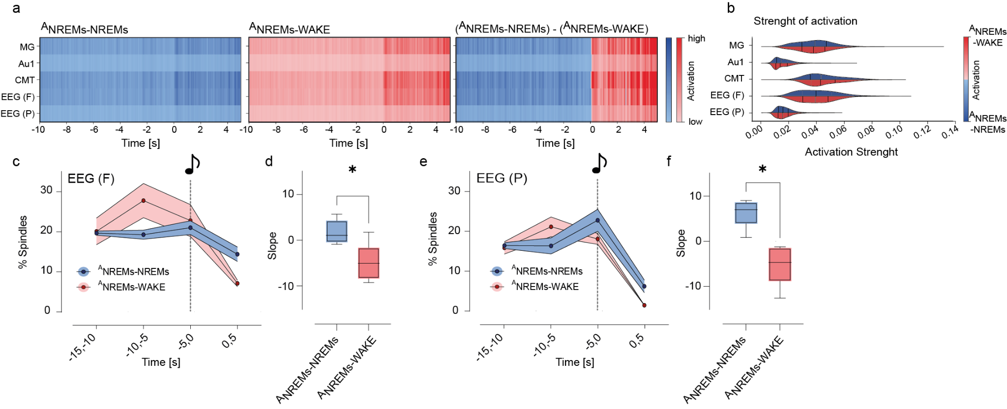

Extended Data Fig. 2: (a) Average activation maps for ^{A}NREMs-NREMs (in blue, left) and ^{A}NREMs-WAKE (in red, middle) transitions for all mice, trials, and trained networks. The training was done with a tenfold cross-validation, on LFP and EEG traces filtered in the SWs range (0.5 to 4 Hz) and extracted from -10 to 5 sec relative to sounds’ onset. Right: the difference between the mean activation maps of the ^{A}NREMs-WAKE and ANREMs-NREMs transitions. (b) The distribution of the average network activation across trials per region. (c) Percentage of spindles rate in ^{A}NREMs-NREMs (in blue) vs ^{A}NREMs-WAKE (in red) transitions recorded from frontal EEG electrodes. (d) Slope of the spindles rates before auditory stimulus onset (events in the animal sleep-throughs rising phase of spindles; events in which the animals wake up declining phase; m= 5 mice). (e) Same as in (c) but for parietal EEG. (f) Same as in (d) but for parietal EEG. Data were analyzed using paired t-test (*p<0.05; **p<0.01; ***p<0.001; ****p<0.0001) and presented as means ± S.E.M..

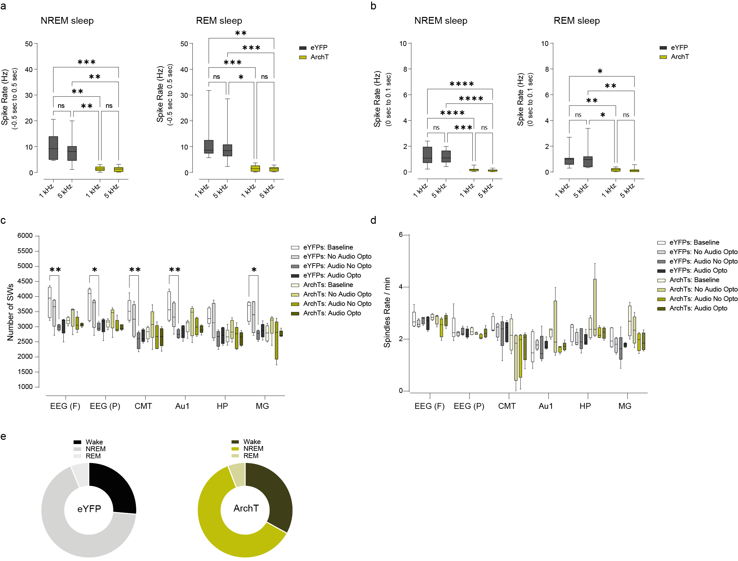

Extended Data Fig. 3: (a) Average spindles rate upon optogenetic silencing of ArchT-expressing CMT neurons and auditory stimuli of 1kHz and 5kHz tones during NREM sleep (left) and REM sleep (right) in ArchT (n = 10 units from 4 mice, 110 trials on average) and eYFP (n = 8 units from 5 mice, 112 trials on average) mice. (b) Same as in (a), but specifically for the auditory evoked responses occurring within a 100-ms time window (after the stimuli). (c) Average number of slow waves detected from EEG, CMT, Au1, HP and dMG electrodes in all experimental conditions upon optogenetic silencing of ArchT-expressing CMT neurons in ArchT (m = 5) and eYFP (m = 5) mice. (d) Average spindles rate detected from EEG, CMT, Au1, HP and dMG electrodes in all the experimental conditions upon optogenetic silencing of ArchT-expressing CMT neurons in ArchT (m = 5) and eYFP (m = 5) mice. (e) Sleep-wake total duration (percentage) in eYFP (left) and in ArchT mice (right) during optogenetic manipulation. Data were analyzed using paired t-test for the spike rate and two-way ANOVA with Tukey post hoc test for the percentage of spindles and slow waves (*p<0.05; **p<0.01; ***p<0.001; ****p<0.0001) and presented as means ± S.E.M..

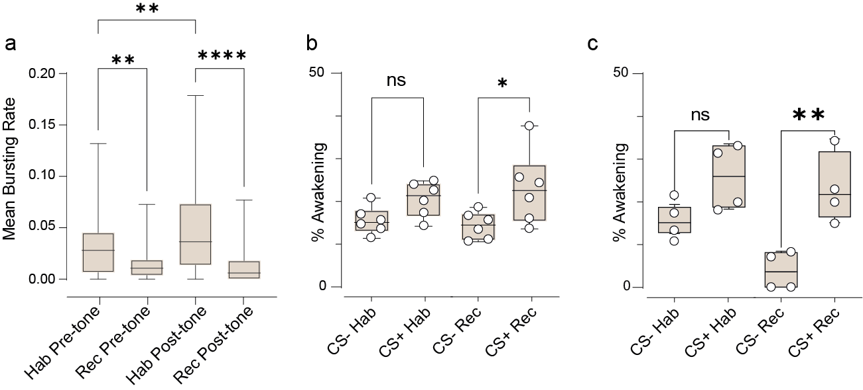

Extended Data Fig. 4: (a) Average burst rate of CMT neurons upon CS- and CS+ exposure during NREMs in Habituation (n = 11 units form m = 6 mice) and Recall (n = 13 units from m= 6 mice) sessions. For each cell, the values of CMT bursting activity observed before the tone (Pre-tone, representing spontaneous bursting activity) during Habituation (Hab) session were compared with those recorded during Recall (Rec) session. Additionally, the bursting activity detected after the tone (Post-tone, indicating stimuli-evoked bursting activity) during Habituation session were compared with that observed in Recall session. (b) Percentage of awakening from NREMs between the CS- and CS+ used to calculate the delta values in Fig. 4c during Habituation (Hab) and Recall (Rec) sessions (m = 6 mice). (c) Percentage of awakening from NREMs used to calculate the delta values in Fig. 5h during Habituation (Hab) and Recall (Rec) sessions (m = 4 mice).

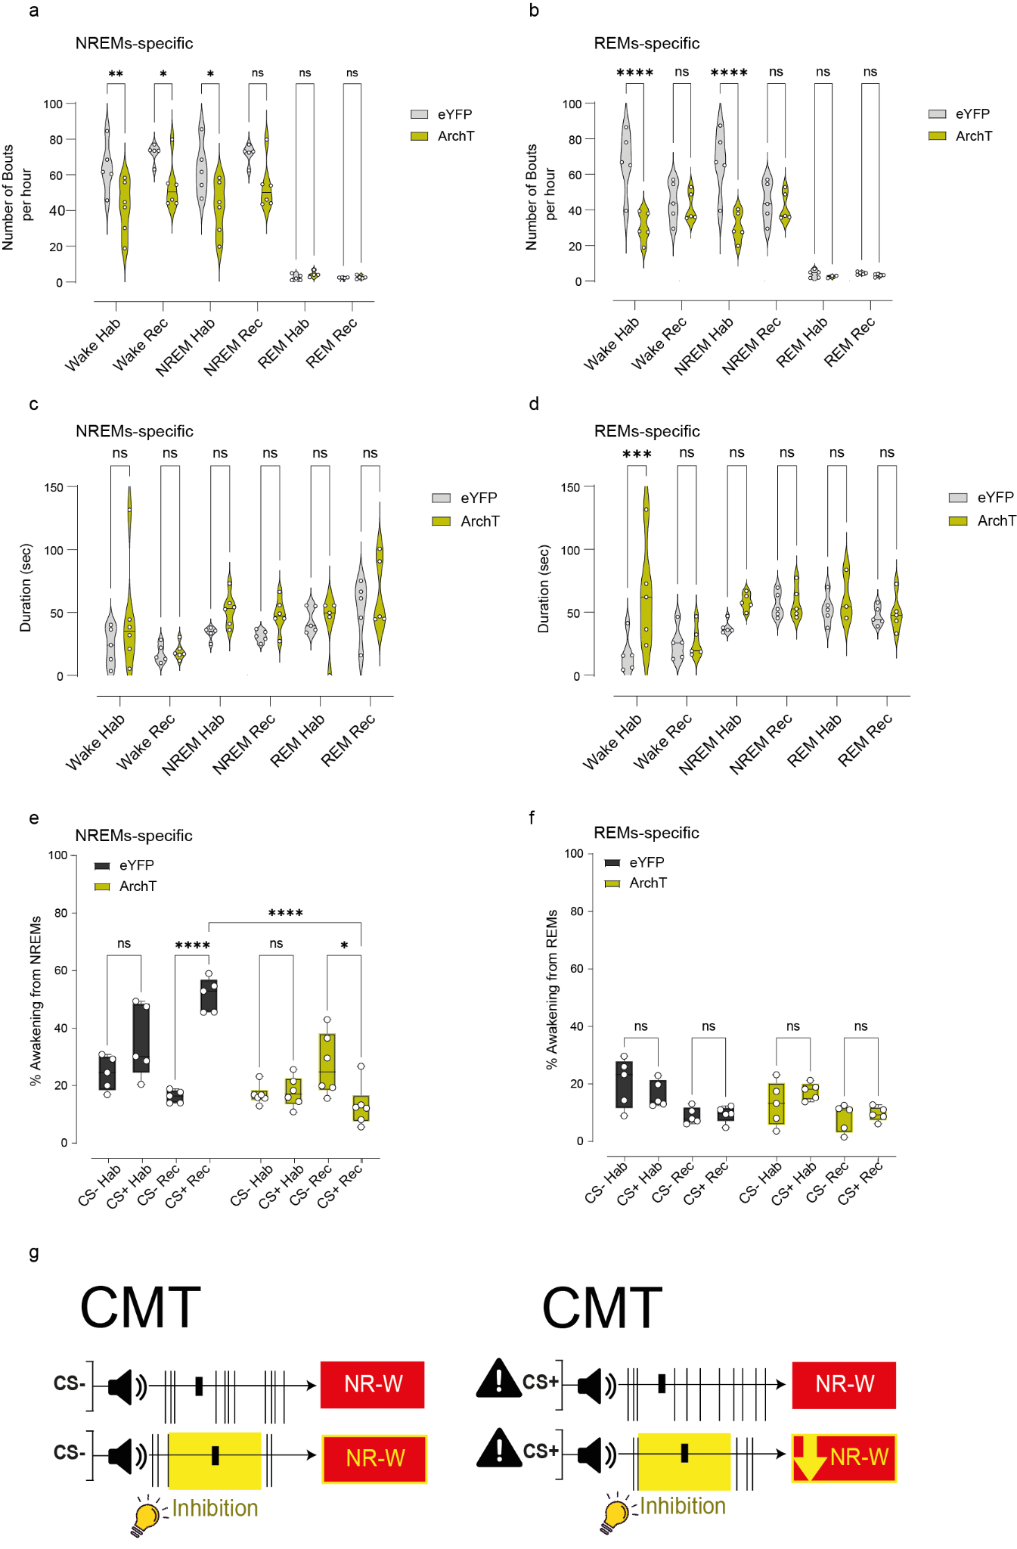
Extended Data Fig. 5: (a) Average number of wake, NREMs and REMs bouts for the group of animals that were exposed to the stimuli (CS- and CS+) specifically during NREMs (NREM-specific) during Habituation and Recall recording in eYFP (m = 5) and ArchT (m = 6) mice. (b) Same as in (a) but for the group of animals that were exposed to the stimuli (CS- and CS+) specifically during REMs (REM-specific) in eYFP (m = 5) and ArchT (m = 5) mice. (c) Average duration of wake, NREMs and REMs bouts for the NREM-specific group of animals during Habituation and Recall recording in eYFP (m = 5) and in ArchT (m = 6) mice. (d) Same as in (c) but for the REMs-specific group in eYFP (m = 5) and in ArchT (m =5) mice. (e) Average percentage of awakening from NREMs for the NREM-specific group upon CS- and CS+ exposure during Habituation and Recall sessions. (f) Same as in (e) but for the REMs-specific group. (g) Schematic illustration of the finding that optogenetic silencing of CMT neurons decreased the ^{A}NREMs-WAKE transitions upon exposure to the CS+ altering the switch of burst-to-tonic discharge mode selective for the CS+. Data were analyzed using two-way ANOVA (*p<0.05; **p<0.01; ***p<0.001; ****p<0.0001) and presented as means ± S.E.M..

