Electronic Supplementary Material (ESM)

Table S1. Mean, range and mean square of traits for parents and RILs
RILs |  |  |  | Parental means |  | Traits
Range | MS_{RILs} | Mean | Roshan |  | SuperHead#2
10.63-123.10 | 1706.465** | 27.72 | 11.923 |  | 123.10 | Proline (μg g⁻¹(f.m.))
10.20-38.22 | 322.786** | 14.973 | 20.262 |  | 31.425 | Protein )mg g⁻¹(f.m.)(
60.38-130.147 | 8345.6** | 91.596 | 108.464 |  | 81.35 | peroxidase (ΔA240 g⁻¹(f.m.) min⁻¹)
1.43-6 | 23.77** | 4.06 | 6 |  | 4.5 | Catalase (ΔA240 g⁻¹(f.m.) min⁻¹)
1.28-30.62 | 818.710** | 3.195 | 11.065 |  | 13.831 | Phenylalanine ammonia-lyase(PAL) (mU/g fresh wt)
*, **, Significant at P<0.05, P<0.01, respectively

Table S2: Pearson’s correlation coefficients (R 2) between analysis parameters includingCatalase, peroxidase, Proline, Protein and Phenylalanine ammonia-lyase(PAL)
Protein | Proline | Phenylalanine ammonia-lyase(PAL) | peroxidase | Catalase
 |  |  |  | 1 | Catalase
 |  |  | 1 | .391** | peroxidase
 |  | 1 | 0.056 | .086* | Phenylalanine ammonia-lyase(PAL)
 | 1 | .254** | .105* | -0.059 | Proline
1 | .223** | .237** | 0.005 | .102* | Protein
* Correlation is significant at P <0.05
** Correlation is significant at P <0.01

Table S3. Total number of unique positional candidate genes
 | trait | QTL name | Linkage group | QTL confidence interval on the genetic map [cM] | QTL confidence interval on the physical map [bp] | Number of positional candidate genes
4 | Catalase | Qtl-9cat | 1B | 54.3-88.4 | 9,253,585-144,395,552 | 1782
5 | Catalase | Qtl-21cat | 2D1 | 67.56-82.317 | 26,451,754-67,901,567 | 1077
6 | Catalase | Qtl-10cat | 2B1 | 41.41-58.08 | 92165728-130492648 | 573
7 | Protein | Qtl-5Protein | 4A | 189.78-192.69 | 669083961-718898622 | 948
8 | Protein | Qtl-9Protein | 1B | 2.01-6.6 | 52,334,139-371,134,366 | 2665
9 | Protein | Qtl-21Protein | 2D1 | 26.8-35.123 | 124,207,584-155,775,476 | 441
10 | Phenylalanine ammonia-lyase(PAL) | Qtl-1pal | A | 53.870-55.330 | 456,472,956-458,275,685 | 22
11 | Phenylalanine ammonia-lyase(PAL) | Qtl-10pal | 2B1 | 14.1-17.86 | 210259946-228699230 | 227
12 | Phenylalanine ammonia-lyase(PAL) | Qtl-17pal | 6B1 | 3.78-4.76 | 457,395,289-520,429,776 | 647
13 | Phenylalanine ammonia-lyase(PAL) | Qtl-18pal | 6B2 | 00-10.41 | 648168211-694347672 | 855
14 | Phenylalanine ammonia-lyase(PAL) | Qtl-21pal | 2D1 | 35.123-48.39 | 534,311,871-558,106,176 | 526
15 | Phenylalanine ammonia-lyase(PAL) | Qtl-21-2pal | 2D1 | 147.956-158.629 | 605,624,176-614,005,904 | 244
16 | Phenylalanine ammonia-lyase(PAL) | Qtl-11pal | 2B2 | 1.58-5.17 | 108,647,353-174,368,605 | 969
Total number of unique positional candidate genes: |  |  |  |  |  | 10976

Table S4: Gene ontology results of Candida genes in of unique positional
 | GO term | Ontology | Description | Number in input list
Qtl-21cat | GO:0046148 | P | pigment biosynthetic process | 5
Qtl-21cat | GO:0042440 | P | pigment metabolic process | 5
 | GO:0004097 | F | catechol oxidase activity | 5
 | GO:0016682 | F | oxidoreductase activity, acting on diphenols and related substances as donors, oxygen as acceptor | 5
 | GO:0016679 | F | oxidoreductase activity, acting on diphenols and related substances as donors | 5
 | GO:0005488 | F | binding | 58
Qtl-9cat | GO:0009056 | P | catabolic process | 22
Qtl-9cat | GO:0044248 | P | cellular catabolic process | 17
 | GO:0042743 | P | hydrogen peroxide metabolic process | 9
 | GO:0042744 | P | hydrogen peroxide catabolic process | 9
 | GO:0072593 | P | reactive oxygen species metabolic process | 9
 | GO:0009698 | P | phenylpropanoid metabolic process | 5
 | GO:0044712 | P | single-organism catabolic process | 10
 | GO:0019748 | P | secondary metabolic process | 5
 | GO:1901575 | P | organic substance catabolic process | 13
 | GO:0032787 | P | monocarboxylic acid metabolic process | 8
 | GO:0006950 | P | response to stress | 17
 | GO:0006979 | P | response to oxidative stress | 9
 | GO:1901565 | P | organonitrogen compound catabolic process | 5
 | GO:0043531 | F | ADP binding | 15
 | GO:0005576 | C | extracellular region | 15
Qtl-9pro | GO:0042743 | P | hydrogen peroxide metabolic process | 10
Qtl-9pro | GO:0042744 | P | hydrogen peroxide catabolic process | 10
 | GO:0009056 | P | catabolic process | 24
 | GO:0072593 | P | reactive oxygen species metabolic process | 10
 | GO:0044248 | P | cellular catabolic process | 19
 | GO:0051169 | P | nuclear transport | 6
 | GO:0006913 | P | nucleocytoplasmic transport | 6
Qtl-5pro | GO:0065007 | P | biological regulation | 64
Qtl-5pro | GO:0050789 | P | regulation of biological process | 57
 | GO:0050794 | P | regulation of cellular process | 54
 | GO:0045454 | P | cell redox homeostasis | 12
 | GO:0019725 | P | cellular homeostasis | 12
 | GO:0065008 | P | regulation of biological quality | 17
 | GO:0060255 | P | regulation of macromolecule metabolic process | 35
 | GO:0019222 | P | regulation of metabolic process | 35
 | GO:0042592 | P | homeostatic process | 13
 | GO:0071704 | P | organic substance metabolic process | 131
 | GO:0044238 | P | primary metabolic process | 122
 | GO:0010468 | P | regulation of gene expression | 33
 | GO:0080090 | P | regulation of primary metabolic process | 33
 | GO:0031323 | P | regulation of cellular metabolic process | 33
 | GO:0009889 | P | regulation of biosynthetic process | 31
 | GO:0008152 | P | metabolic process | 139
 | GO:0010556 | P | regulation of macromolecule biosynthetic process | 31
 | GO:0031326 | P | regulation of cellular biosynthetic process | 31
 | GO:2000112 | P | regulation of cellular macromolecule biosynthetic process | 31
 | GO:0009987 | P | cellular process | 144
 | GO:0051171 | P | regulation of nitrogen compound metabolic process | 31
 | GO:0050790 | P | regulation of catalytic activity | 5
 | GO:2001141 | P | regulation of RNA biosynthetic process | 29
 | GO:0006355 | P | regulation of transcription, DNA-templated | 29
 | GO:1903506 | P | regulation of nucleic acid-templated transcription | 29
 | GO:0051252 | P | regulation of RNA metabolic process | 29
 | GO:0044699 | P | single-organism process | 82
 | GO:0065009 | P | regulation of molecular function | 5
 | GO:0019219 | P | regulation of nucleobase-containing compound metabolic process | 29
 | GO:0044763 | P | single-organism cellular process | 68
 | GO:0010467 | P | gene expression | 60
 | GO:0044237 | P | cellular metabolic process | 114
 | GO:0006629 | P | lipid metabolic process | 18
 | GO:0016864 | F | intramolecular oxidoreductase activity, transposing S-S bonds | 12
 | GO:0003756 | F | protein disulfide isomerase activity | 12
 | GO:0016860 | F | intramolecular oxidoreductase activity | 12
 | GO:0000155 | F | phosphorelay sensor kinase activity | 8
 | GO:0016775 | F | phosphotransferase activity, nitrogenous group as acceptor | 8
 | GO:0004673 | F | protein histidine kinase activity | 8
 | GO:0000988 | F | transcription factor activity, protein binding | 9
 | GO:0060089 | F | molecular transducer activity | 8
 | GO:0000989 | F | transcription factor activity, transcription factor binding | 8
 | GO:0038023 | F | signaling receptor activity | 8
 | GO:0004872 | F | receptor activity | 8
 | GO:0004871 | F | signal transducer activity | 10
 | GO:0016853 | F | isomerase activity | 15
 | GO:0004298 | F | threonine-type endopeptidase activity | 5
 | GO:0070003 | F | threonine-type peptidase activity | 5
 | GO:0005783 | C | endoplasmic reticulum | 21
 | GO:0012505 | C | endomembrane system | 22
 | GO:0005622 | C | intracellular | 120
 | GO:0044464 | C | cell part | 124
 | GO:0043229 | C | intracellular organelle | 94
 | GO:0043227 | C | membrane-bounded organelle | 80
 | GO:0043231 | C | intracellular membrane-bounded organelle | 80
 | GO:0005623 | C | cell | 124
 | GO:0043226 | C | organelle | 94
 | GO:0005737 | C | cytoplasm | 65
 | GO:0044424 | C | intracellular part | 106
 | GO:0005839 | C | proteasome core complex | 5
 | GO:0044444 | C | cytoplasmic part | 53
 | GO:0000502 | C | proteasome complex | 5
 | GO:0005634 | C | nucleus | 45
Qtl-21pal | O:0046148 | P | pigment biosynthetic process | 5
 | GO:0042440 | P | pigment metabolic process | 5
 | GO:0004097 | F | catechol oxidase activity | 5
 | GO:0016682 | F | oxidoreductase activity, acting on diphenols and related substances as donors, oxygen as acceptor | 5
 | GO:0016679 | F | oxidoreductase activity, acting on diphenols and related substances as donors | 5
Qtl-11pal | GO:0005984 | P | disaccharide metabolic process | 5
 | GO:0009311 | P | oligosaccharide metabolic process | 5
Qtl-21-2pal | GO:0016829 | F | lyase activity | 5
 |  | 99

Table s5: Gene Ontological analysis of major candida genes involved in salinity tolerance in experimental wheat genotypes
trait | Gene stable ID | Protein | Gene | GO - Biological processi | GO - Molecular function
cat | TraesCS1B02G035700 | Uncharacterized protein |  | defense response | ADP binding
cat | TraesCS1B02G030900 | NB-ARC domain-containing protein |  |  | ADP binding
cat | TraesCS1B02G025900 | Bowman-Birk trypsin inhibitor-like protein |  |  | serine-type endopeptidase inhibitor activity
cat | TraesCS1B02G034300 | Serine proteinase inhibitor-like allergen |  | response to wounding | serine-type endopeptidase inhibitor activity
cat | TraesCS1B02G043300 | Powdery mildew resistance protein PM3 variant |  |  | ADP binding  ATP binding
cat | TraesCS1B02G034300 | Serine proteinase inhibitor like antigen | spila | response to wounding | serine-type endopeptidase inhibitor activity
cat | TraesCS1B02G027100 | Resistance protein LR10 |  | defense response | ADP binding  ATP binding
cat | TraesCS1B02G104200 | Phosphoglycerate kinase | Pgk-2 | glycolytic process | phosphoglycerate kinase activity  ATP binding
cat | TraesCS1B02G104200 | Phosphoglycerate kinase | Pgk-2 | glycolytic process | phosphoglycerate kinase activity  ATP binding
cat | TraesCS1B02G098000 | Germin-like protein | TRITD_1Av1G028760 |  | manganese ion binding  nutrient reservoir activity
cat | TraesCS1B02G090700 | Endoglucanase |  | cellulose catabolic process  response to freezing | cellulase activity
cat | TraesCS1B02G020900 | Uncharacterized protein |  | defense response | ADP binding  ATP binding
cat | TraesCS1B02G067000 | Knot1 domain-containing protein |  | defense response
cat | TraesCS1B02G022100 | Uncharacterized protein |  | defense response | ADP binding  ATP binding
cat | TraesCS1B02G067300 | Defensin | PDF7 | defense response
cat | TraesCS1B02G095800 | Peroxidase |  | hydrogen peroxide catabolic process  response to oxidative stress | peroxidase activity  metal ion binding  heme binding
cat | TraesCS1B02G043800 | Uncharacterized protein |  | response to wounding | serine-type endopeptidase inhibitor activity
cat | TraesCS1B02G117900 | CULLIN_2 domain-containing protein |  | protein ubiquitination  ubiquitin-dependent protein catabolic process | ubiquitin-protein transferase activity  ubiquitin protein ligase binding
cat | TraesCS1B02G026000 | BOWMAN_BIRK domain-containing protein |  |  | serine-type endopeptidase inhibitor activity
cat | TraesCS1B02G077500 | Patatin |  | lipid catabolic process | phospholipase activity
cat | TraesCS1B02G023000 | Uncharacterized protein |  | defense response | ADPbinding  ATP binding
cat | TraesCS1B02G067100 | Knot1 domain-containing protein |  | defense response
cat | TraesCS1B02G021900 | Uncharacterized protein |  | defense response | ADPbinding  ATP binding
cat | TraesCS1B02G096200 | Peroxidase |  | hydrogen peroxide catabolic process  response to oxidative stress | peroxidaseactivity  metal ionbinding  heme binding
cat | TraesCS1B02G048300 | Phenylalanine ammonia-lyase |  | L-phenylalanine catabolic process  cinnamic acid biosynthetic process | phenylalanine ammonia-lyase activity
cat | TraesCS1B02G027000 | Uncharacterized protein |  | defense response | ADP binding  ATP binding
cat | TraesCS1B02G027300 | Uncharacterized protein |  | defense response | ADP binding  ATP binding
cat | TraesCS1B02G042500 | Uncharacterized protein |  | defense response | ADP binding  ATP binding
cat | TraesCS1B02G096300 | Peroxidase |  | hydrogen peroxide catabolic process  response to oxidative stress | peroxidase activity  metal ion binding  heme binding
cat | TraesCS1B02G075900 | ECA_2 domain-containing protein |  | regulation of transcription by RNA polymerase II  double-strand break repair via homologous recombination | ADP binding  ATP binding  DNA-dependent ATPase activity
cat | TraesCS1B02G096900 | Peroxidase |  | hydrogen peroxide catabolic process  response to oxidative stress | peroxidase activity  metal ion binding  heme binding
cat | TraesCS1B02G096100 | Peroxidase |  | hydrogen peroxide catabolic process  response to oxidative stress | peroxidase activity  metal ion binding  heme binding
cat | TraesCS1B02G033100 | Uncharacterized protein |  | nucleotide-excision repair  nucleotide-excision repair, preincision complex assembly  phosphorylation of RNA polymerase II C-terminal domain  transcription by RNA polymerase II  transcription initiation from RNA polymerase II promoter
cat | TraesCS1B02G104200 | Phosphoglycerate kinase |  | gluconeogenesis  glycolytic process  positive regulation of oxidative phosphorylation | ADP binding  ATP binding  phosphoglycerate kinase activity
cat | TraesCS1B02G070000 | Germin-like protein |  |  | manganese ion binding  nutrient reservoir activity
cat | TraesCS1B02G050400 | Phospholipase D |  | phosphatidylcholine metabolic process  phospholipid catabolic process | calcium ion binding  N-acylphosphatidylethanolamine-specific phospholipase D activity  phospholipase D activity
cat | TraesCS1B02G056900 | Laccase |  | lignin catabolic process | oxidoreductase activity  copper ion binding  hydroquinone:oxygen oxidoreductase activity
cat | TraesCS1B02G096800 | Peroxidase |  | hydrogen peroxide catabolic process  response to oxidative stress | peroxidase activity  metal ion binding  heme binding
cat | TraesCS1B02G020400 | Uncharacterized protein |  | defense response | ADP binding  ATP binding
cat | TraesCS1B02G046200 | Chalcone-flavonone isomerase family protein |  | fatty acid metabolic process | intramolecular lyase activity  fatty acid bindin
cat | TraesCS1B02G115900 | Peroxidase |  | hydrogen peroxide catabolic process  response to oxidative stress | peroxidase activity  metal ion binding  heme binding
cat | TraesCS1B02G048500 | Phenylalanine ammonia-lyase |  | L-phenylalanine catabolic process  cinnamic acid biosynthetic process | phenylalanine ammonia-lyase activity
cat | TraesCS1B02G115800 | Peroxidase |  | hydrogen peroxide catabolic process  response to oxidative stress | peroxidase activity  metal ion binding  heme binding
cat | TraesCS1B02G045900 | Uncharacterized protein |  | defense response | ADP binding  ATP binding
cat | TraesCS1B02G048400 | Phenylalanine ammonia-lyase |  | L-phenylalanine catabolic process  cinnamic acid biosynthetic process | phenylalanine ammonia-lyase activity
cat | TraesCS1B02G020300 | Uncharacterized protein |  | defense response | ADP binding  ATP binding
cat | TraesCS1B02G108500 | 0
cat | TraesCS1B02G098000 | Germin-like protein |  | plasmodesmata-mediated intercellular transport  regulation of root development | manganese ion binding  nutrient reservoir activity
cat | TraesCS2D02G481700 | #REF!
cat | TraesCS2D02G503000 | 0
cat | TraesCS2D02G451200 | Peroxidase | n/a | hydrogen peroxide catabolic process  response to oxidative stress
cat | TraesCS2D02G477300 | Uncharacterized protein
cat | TraesCS2D02G468200 | Polyphenol oxidase | Ppo | pigment biosynthetic process | catechol oxidase activity
cat | TraesCS2D02G468200 | Polyphenol oxidase | Ppo | pigment biosynthetic process | catechol oxidase activity
cat | TraesCS2D02G506500 | UnknownGene_TA3B63E4-1 protein | UnknownGene_TA3B63E4-1 | 0 | DNA-binding transcription factor activity
cat | TraesCS2D02G467100 | FD-like 13 protein |  | positive regulation of transcription, DNA-templated  abscisic acid-activated signaling pathway
cat | TraesCS2D02G493400 | Flavanone 3-hydroxylase | F3H-D1  F3H-A1  n/a  F3H-D1 | positive regulation of transcription, DNA-templated  abscisic acid-activated signaling pathway | oxidoreductase activity  dioxygenase activity
cat | TraesCS2D02G468200 | Polyphenol oxidase | SSPPO-D1 | pigment biosynthetic process | catechol oxidase activity
cat | TraesCS2D02G489700 | WRKY45-like transcription factor | TaWRKY45-D |  | DNA-binding transcription factor activity
cat | TraesCS2D02G468600 | Polyphenol oxidase | PPO-D2 | pigment biosynthetic process | catechol oxidase activity
cat | TraesCS2D02G500900 | Receptor-like protein kinase |  |  | protein kinase activity
cat | TraesCS2D02G493700 | Serine-threonine protein kinase | W55a |  | protein serine/threonine kinase activity
cat | TraesCS2D02G476800 | Non-specific lipid-transfer protein | ltp9.3b | lipid transport | lipid binding
cat | TraesCS2D02G500600 | Glutamine synthetase | GS2 | response to cadmium ion | glutamate-ammonia ligase activity
cat | TraesCS2D02G476900 | Non-specific lipid-transfer protein | ltp9.5 | lipid transport | lipid transport
cat | TraesCS2D02G482000 | Dihydroflavonol 4-reductase 3 |  |  | catalytic activity
cat | TraesCS2D02G468200 | Polyphenol oxidase | PPO | pigment biosynthetic process | catechol oxidase activity
cat | TraesCS2D02G506600 | NADPH-cytochrome P450 reductase |  |  | NADPH-hemoprotein reductase activity
cat | TraesCS2D02G490700 | U1-type domain-containing protein |  | mRNA splicing, via spliceosome | zinc ion binding
cat | TraesCS2D02G456200 | Uncharacterized protein |  |  | GTPase activity and GTP binding
cat | TraesCS2D02G445100 | RBR-type E3 ubiquitin transferase |  | positive regulation of proteasomal ubiquitin-dependent protein catabolic process  protein polyubiquitination  ubiquitin-dependent protein catabolic process | metal ion binding  ubiquitin conjugating enzyme binding
cat | TraesCS2D02G448800 | Uncharacterized protein |  | metal ion transport | metal ion binding
cat | TraesCS2D02G467600 | Exonuclease domain-containing protein |  | DNA catabolic process, exonucleolytic | 3'-5'-exodeoxyribonuclease activity
cat | TraesCS2D02G461000 | Uncharacterized protein |  | RNA modification | RNA binding
cat | TraesCS2D02G467100 | BZIP domain-containing protein |  | abscisic acid-activated signaling pathway | DNA-binding transcription factor activity
cat | TraesCS2D02G460900 | TF-B3 domain-containing protein |  |  | DNA binding
cat | TraesCS2D02G497900 | HMA domain-containing protein |  | metal ion transport | metal ion binding
cat | TraesCS2D02G458500 | Uncharacterized protein |  | nitrogen compound metabolic process | 2-hydroxyglutarate dehydrogenase activity
cat | TraesCS2D02G495800 | 30S ribosomal protein S4, chloroplastic |  |  | rRNA binding
cat | TraesCS2D02G456900 | Uncharacterized protein |  | 0 | 0
cat | TraesCS2D02G492400 | C3H1-type domain-containing protein |  |  | metal ion binding
cat | TraesCS2D02G505900 | Receptor-like serine/threonine-protein kinase |  | recognition of pollen | protein serine/threonine kinase activity
cat | TraesCS2D02G465200 | Uncharacterized protein |  | formation of translation preinitiation complex  eukaryotic translation initiation factor 4F complex assembly  cytoplasmic translation | RNA strand-exchange activityRNA strand annealing activity
cat | TraesCS2D02G471500 | Uncharacterized protein |  | lipid catabolic process  phospholipid metabolic process  pollen development | calcium-dependent phospholipase A2 activity  phospholipase A2 activity
cat | TraesCS2D02G503400 | Protein kinase domain-containing protein |  | protein autophosphorylation | protein serine/threonine kinase activity
cat | TraesCS2D02G446400 | Uncharacterized protein |  | 0 | 0
cat | TraesCS2D02G446800 | Phosphoenolpyruvate carboxykinase (ATP) |  | gluconeogenesis | phosphoenolpyruvate carboxykinase (ATP) activity
cat | TraesCS2D02G492000 | Uncharacterized protein |  | purine nucleotide metabolic process  nucleoside triphosphate biosynthetic process  ion transport | adenylate kinase activity
cat | TraesCS2D02G444000 | Uncharacterized protein |  |  | RNA binding
cat | TraesCS2D02G482100 | Epimerase domain-containing protein |  |  | oxidoreductase activity  oxidoreductase activity, acting on the CH-OH group of donors, NAD or NADP as acceptor
cat | TraesCS2D02G502100 | Glucose-6-phosphate 1-epimerase |  | carbohydrate metabolic process | glucose-6-phosphate 1-epimerase activity
cat | TraesCS2D02G485000 | Receptor-like serine/threonine-protein kinase |  | recognition of pollen | protein serine/threonine kinase activity
cat | TraesCS2D02G500300 | Epimerase domain-containing protein |  |  | catalytic activity
cat | TraesCS2D02G445300 | RBR-type E3 ubiquitin transferase |  | positive regulation of proteasomal ubiquitin-dependent protein catabolic process  protein polyubiquitination  ubiquitin-dependent protein catabolic process | ubiquitin protein ligase activity  ubiquitin conjugating enzyme binding  metal ion binding
cat | TraesCS2D02G501700 | ATPase_AAA_core domain-containing protein |  | chloroplast organization  developmental process | ATP binding
cat | TraesCS2D02G463100 | Uncharacterized protein |  | protein autophosphorylation | protein serine/threonine kinase activity
cat | TraesCS2D02G484700 | Receptor-like serine/threonine-protein kinase |  | recognition of pollen | protein serine/threonine kinase activity
cat | TraesCS2D02G480400 | Uncharacterized protein |  | RNA polymerase III preinitiation complex assembly  regulation of transcription, DNA-templated  DNA-templated transcription, termination | RNA polymerase III type 3 promoter sequence-specific DNA binding
cat | TraesCS2D02G460200 | Germin-like protein |  |  | manganese ion binding  nutrient reservoir activity
cat | TraesCS2D02G456600 | Protein-serine/threonine phosphatase |  |  | protein serine/threonine phosphatase activity
cat | TraesCS2D02G482200 | Epimerase domain-containing protein |  |  | oxidoreductase activity  oxidoreductase activity, acting on the CH-OH group of donors, NAD or NADP as acceptor
cat | TraesCS2D02G491200 | Auxin response factor |  | auxin-activated signaling pathway  egulation of transcription, DNA-templated | DNA binding
cat | TraesCS2D02G502900 | SPL transcription factor | SPL8 |  | DNA binding  metal ion binding
pal | TraesCS2D02G468200 | Polyphenol oxidase | Ppo | catechol oxidase activity  metal ion binding | pigment biosynthetic process
pal | TraesCS2D02G468200 | Genome assembly, chromosome: II | Ppo | catechol oxidase activity  metal ion binding | pigment biosynthetic process
pal | TraesCS2D02G468200 | Polyphenol oxidase | SSPPO-D1 | catechol oxidase activity  metal ion binding | pigment biosynthetic process
pal | TraesCS2D02G468600 | Polyphenol oxidase | PPO-D2 | catechol oxidase activity  metal ion binding | pigment biosynthetic process
pal | TraesCS2D02G468200 | Polyphenol oxidase | Ppo | catechol oxidase activity  metal ion binding | pigment biosynthetic process
pal | TraesCS6B02G286400 | MIKC-type MADS-box transcription factor WM9C | WM9C | DNA-binding transcription factor activity  protein dimerization activity  RNA polymerase II transcription regulatory region sequence-specific DNA binding | positive regulation of transcription by RNA polymerase II
pal | TraesCS6B02G261500 | Putative PDI-like protein | pdil7-2
pal | TraesCS6B02G261500 | Putative PDI-like protein | pdil7-2
pal | TraesCS6B02G261500 | Putative PDI-like protein | pdil7-2
pal | TraesCS6B02G288500 | MYB-related protein |  | DNA binding
pal | TraesCS6B02G259700 | Type A response regulator 5 | RR5 | phosphorelay signal transduction system
pal | TraesCS6B02G268100 | AP2 domain CBF protein | CBFI | DNA-binding transcription factor activity
pal | TraesCS6B02G284300 | HOX1 |  | DNA-binding transcription factor activity, RNA polymerase II-specific  sequence-specific DNA binding | positive regulation of transcription, DNA-templated
pal | TraesCS6B02G261500 | 0
pal | TraesCS6B02G259700 | 0
pal | TraesCS6B02G269200 | Transcription initiation factor IIE subunit beta |  | DNA binding | DNA binding
pal | TraesCS6B02G256700 | GLTP domain-containing protein |  | lipid binding  ceramide 1-phosphate transfer activity | ceramide transport  intermembrane lipid transfer
pal | TraesCS6B02G254600 | Uncharacterized protein |  | protein localization to kinetochore  mitotic sister chromatid segregation  kinetochore assembly  cell division
pal | TraesCS6B02G256900 | Ribosomal_L14e domain-containing protein |  | structural constituent of ribosome  RNA binding | ribosomal large subunit biogenesis  translation
pal | TraesCS6B02G260100 | 0
pal | TraesCS6B02G266100 | 0
pal | TraesCS6B02G286200 | NAC domain-containing protein |  | DNA binding | regulation of transcription, DNA-templated
pal | TraesCS6B02G285100 | Glutaredoxin domain-containing protein |  | electron transfer activity  glutathione-disulfide reductase activity  protein disulfide oxidoreductase activity | cellular response to oxidative stress
pal | TraesCS6B02G268200 | DWNN domain-containing protein | TRITD_6Bv1G150060 | nucleic acid binding  ubiquitin protein ligase activity  zinc ion binding | mRNA processing
pal | TraesCS6B02G286800 | Mitochondrial import inner membrane translocase subunit |  |  | chaperone-mediated protein transport  protein insertion into mitochondrial inner membrane
pal | TraesCS2B02G194200 | 0
pal | TraesCS2B02G194200 | Sucrose synthase |  | sucrose synthase activity | sucrose metabolic process
pal | TraesCS2B02G187000 | Trehalose 6-phosphate phosphatase |  | trehalose-phosphatase activity | trehalose biosynthetic process
pal | TraesCS2B02G145700 | Amylomaltase |  | 4-alpha-glucanotransferase activity  beta-maltose 4-alpha-glucanotransferase activity  starch binding | regulation of defense response  regulation of jasmonic acid mediated signaling pathway  response to wounding
pal | TraesCS2B02G187100 | rehalose 6-phosphate phosphatase |  | trehalose-phosphatase activity | trehalose biosynthetic process
protein | TraesCS4A02G309200 | Uncharacterized protein | TRAES_3BF108300010CFD_c1 | protein kinase activity
protein | TraesCS4A02G220300 |  | 0
protein | TraesCS4A02G200000 | Non-specific serine/threonine protein kinase |  | protein threonine kinase activity  protein serine kinase activity | signal transduction
protein | TraesCS4A02G174400 | RING-type domain-containing protein | 0 |  | protein ubiquitination
protein | TraesCS4A02G291500 | Growth-regulating factor | GRF9-B1 | ATP binding | transcription, DNA-templated  regulation of transcription, DNA-templated
protein | TraesCS4A02G226900 | Chlorophyll a-b binding protein, chloroplastic |  | chlorophyll binding | protein-chromophore linkage  photosynthesis, light harvesting
protein | TraesCS4A02G193600 | WRKY transcription factor | WRKY46 | DNA-binding transcription factor activity  sequence-specific DNA binding
protein | TraesCS4A02G222900 | Alkaline/neutral invertase | AInv | glycopeptide alpha-N-acetylgalactosaminidase activity  sucrose alpha-glucosidase activity | sucrose catabolic process
protein | TraesCS4A02G162500 | WRKY37 transcription factor |  | DNA-binding transcription factor activity  sequence-specific DNA binding
protein | TraesCS4A02G214200 | Protein disulfide-isomerase | pdi | protein disulfide isomerase activity
protein | TraesCS4A02G214200 | Protein disulfide-isomerase | pdi2 | protein disulfide isomerase activity
protein | TraesCS4A02G166500 | Eukaryotic translation initiation factor 3 subunit I | eIF3i | translation initiation factor activity | formation of cytoplasmic translation initiation complex
protein | TraesCS4A02G214200 | Protein disulfide-isomerase | PDI | protein disulfide isomerase activity
protein | TraesCS4A02G262900 | Phytochrome | phya1 | protein homodimerization activity  photoreceptor activity  phosphorelay sensor kinase activity | detection of visible light  protein-chromophore linkage  protein-tetrapyrrole linkage  red, far-red light phototransduction  regulation of transcription, DNA-templated
protein | TraesCS4A02G177600 | Ribulose bisphosphate carboxylase activase B | RcaB | ATPase activity  ATP binding
protein | TraesCS4A02G166900 | UDP-arabinopyranose mutase | rgp | UDP-arabinopyranose mutase activity  transferase activity | plant-type cell wall organization or biogenesis
protein | TraesCS4A02G296600 | Tubulin beta chain | Tubb6 | GTPase activity  GTP binding  structural constituent of cytoskeleton | microtubule-based process
protein | TraesCS4A02G246900 | Uncharacterized protein |  | protein phosphatase inhibitor activity | regulation of phosphoprotein phosphatase activity  regulation of signal transduction
protein | TraesCS4A02G293700 | RING-type domain-containing protein |  | ubiquitin-protein transferase activity | regulation of programmed cell death
protein | TraesCS4A02G318400 | AAA domain-containing protein |  | ATPase activity  ATP binding
protein | TraesCS4A02G267900 | DNA-directed RNA polymerase subunit |  | DNA-directed 5'-3' RNA polymerase activity  nucleic acid binding  zinc ion binding | mRNA cleavage  termination of RNA polymerase I transcription  Biological Process
protein | TraesCS4A02G250800 | Uncharacterized protein |  | oxidoreductase activity, acting on a sulfur group of donors, disulfide as acceptor  protein disulfide isomerase activity  protein disulfide oxidoreductase activity | protein folding in endoplasmic reticulum
protein | TraesCS4A02G201400 | Aminotran_5 domain-containing protein |  | catalytic activity
protein | TraesCS4A02G216500 | O-fucosyltransferase family protein |  | transferase activity | fucose metabolic process
protein | TraesCS4A02G266000 | Protein kinase domain-containing protein |  | protein serine/threonine kinase activity
protein | TraesCS4A02G209500 | Uncharacterized protein |  | autophagosome assembly
protein | TraesCS4A02G223600 | Protein kinase domain-containing protein |  | protein serine/threonine kinase activity  ATP binding
protein | TraesCS4A02G239200 | Dolichol phosphate-mannose biosynthesis regulatory protein |  | dolichol metabolic process | protein glycosylation  mannosylation  GPI anchor biosynthetic process  dolichol metabolic process
protein | TraesCS4A02G234000 | Dof-type domain-containing protein |  | DNA binding | regulation of transcription, DNA-templated  vesicle-mediated transport
protein | TraesCS4A02G225000 | Uncharacterized protein |  | hydrolase activity
protein | TraesCS4A02G317700 | Uncharacterized protein |  | transmembrane transporter activity
protein | TraesCS4A02G218000 | MFS domain-containing protein
protein | TraesCS4A02G247300 | Uncharacterized protein
protein | TraesCS4A02G171400 | Uncharacterized protein |  | ribonuclease MRP activity  ribonuclease P activity | RNA phosphodiester bond hydrolysis, endonucleolytic  tRNA 5'-leader removal  tRNA processing
protein | TraesCS4A02G316500 | Lipase_GDSL domain-containing protein |  | hydrolase activity, acting on ester bonds
protein | TraesCS4A02G306400 | CBFD_NFYB_HMF domain-containing protein |  | chromatin DNA binding  protein heterodimerization activity | cellular response to DNA damage stimulus  heterochromatin assembly  leading strand elongation  nucleosome mobilization
protein | TraesCS4A02G313700 | Fe2OG dioxygenase domain-containing protein |  | Fe cation  L-ascorbate | metal ion binding  oxidoreductase activity
protein | TraesCS4A02G187500 | MFS domain-containing protein |  | transmembrane transporter activity
protein | TraesCS4A02G320100 | Fe2OG dioxygenase domain-containing protein |  | metal ion binding  oxidoreductase activity
protein | TraesCS4A02G240400 | Lipase_3 domain-containing protein |  | lipid metabolic process
protein | TraesCS4A02G334700 | Actin-related protein 2/3 complex subunit 4 |  | actin binding | actin filament polymerization  Arp2/3 complex-mediated actin nucleation
protein | TraesCS4A02G201700 | Peroxidase |  | peroxidase activity  metal ion binding  heme binding | hydrogen peroxide catabolic process  response to oxidative stress
protein | TraesCS4A02G315800 | Mediator of RNA polymerase II transcription subunit 13 |  | transcription coregulator activity | regulation of transcription by RNA polymerase II
protein | TraesCS4A02G223200 | Protein kinase domain-containing protein |  | protein serine/threonine kinase activity  ATP binding | protein autophosphorylation
protein | TraesCS4A02G209800 | GRAS domain-containing protein
protein | TraesCS4A02G227200 | Protein kinase domain-containing protein |  | RNA polymerase II CTD heptapeptide repeat kinase activity  cyclin-dependent protein serine/threonine kinase activity  ATP binding | phosphorylation of RNA polymerase II C-terminal domain  positive regulation of transcription elongation from RNA polymerase II promoter  protein phosphorylation
protein | TraesCS4A02G167300 | Proteasome subunit alpha type |  |  | proteasome-mediated ubiquitin-dependent protein catabolic process
protein | TraesCS4A02G299800 | AA_permease_C domain-containing protein |  | amino acid transmembrane transporter activity | amino acid transport
protein | TraesCS4A02G294300 | Uncharacterized protein |  | zinc ion transmembrane transporter activity | zinc ion transmembrane transport
protein | TraesCS4A02G207000 | AMP-binding domain-containing protein |  | long-chain fatty acid-CoA ligase activity
protein | TraesCS4A02G323400 | Protein kinase domain-containing protein |  | protein serine/threonine kinase activity  ATP binding | protein autophosphorylation
protein | TraesCS4A02G276200 | N-acetyltransferase domain-containing protein |  | peptide alpha-N-acetyltransferase activity | N-terminal peptidyl-methionine acetylation
protein | TraesCS4A02G198500 | Uncharacterized protein |  | serine-type peptidase activity
protein | TraesCS4A02G178200 | RRM domain-containing protein |  | RNA binding
protein | TraesCS4A02G191900 | S-acyltransferase |  | protein-cysteine S-palmitoyltransferase activity | peptidyl-L-cysteine S-palmitoylation  protein targeting to membrane
protein | TraesCS4A02G249400 | Uncharacterized protein |  | sequence-specific DNA binding  zinc ion binding | regulation of transcription, DNA-templated
protein | TraesCS4A02G184000 | Uncharacterized protein |  |  | lipid metabolic process  lipid storage
protein | TraesCS4A02G249200 | Uncharacterized protein |  | ubiquitin protein ligase activity  zinc ion binding | protein ubiquitination  ubiquitin-dependent protein catabolic process
protein | TraesCS4A02G206600 | Uncharacterized protein
protein | TraesCS4A02G166900 | UDP-arabinopyranose mutase |  | UDP-arabinopyranose mutase activity | plant-type cell wall biogenesis  UDP-L-arabinose metabolic process
protein | TraesCS4A02G233500 | ATP-dependent (S)-NAD(P)H-hydrate dehydratase |  | ADP-dependent NAD(P)H-hydrate dehydratase activity  ATP binding  ATP-dependent NAD(P)H-hydrate dehydratase activity | nicotinamide nucleotide metabolic process  metabolite repair
protein | TraesCS4A02G204300 | BZIP domain-containing protein |  | DNA-binding transcription factor activity
protein | TraesCS4A02G205000 | 0
protein | TraesCS4A02G170800 | DUF4149 domain-containing protein
protein | TraesCS4A02G250000 | Uncharacterized protein |  | structural constituent of ribosome | translation
protein | TraesCS4A02G193900 | EGF_CA domain-containing protein |  | calcium ion binding  ubiquitin protein ligase activity | Golgi to vacuole transport  protein targeting to vacuole  ubiquitin-dependent protein catabolic process
protein | TraesCS4A02G167200 | PHD domain-containing protein | TRITD_4Av1G126790 | metal ion binding
protein | TraesCS4A02G199400 | DYW_deaminase domain-containing protein |  | zinc ion binding
protein | TraesCS4A02G294700 | Myb-like domain-containing protein | 0
protein | TraesCS4A02G258100 | DBR1 domain-containing protein |  | RNA lariat debranching enzyme activity | mRNA splicing, via spliceosome
protein | TraesCS4A02G179400 | Uncharacterized protein |  | oxidative phosphorylation uncoupler activity | mitochondrial transmembrane transport
protein | TraesCS4A02G234300 | Uncharacterized protein |  | double-stranded DNA binding | chloroplast organization  developmental process  DNA-templated transcription, termination  regulation of transcription, DNA-templated
protein | TraesCS4A02G269400 | Phytocyanin domain-containing protein |  | electron transfer activity
protein | TraesCS4A02G252800 | Pept_C1 domain-containing protein |  | cysteine-type endopeptidase activity | proteolysis involved in cellular protein catabolic process  regulation of catalytic activity
protein | TraesCS4A02G204400 | RNA_pol_L_2 domain-containing protein |  | protein dimerization activity  DNA-directed 5'-3' RNA polymerase activity  DNA binding | transcription, DNA-templated
protein | TraesCS4A02G281500 | Ribonuclease |  | nuclease activity  RNA binding | gene silencing by RNA  RNA catabolic process
protein | TraesCS4A02G292600 | 0
protein | TraesCS4A02G235600 | SNF1-type serine-threonine protein kinase | SnRK2.10 | protein serine/threonine kinase activity  ATP binding | intracellular signal transduction  protein phosphorylation
protein | TraesCS4A02G274300 | Ethylene receptor 1 | ETR1 | phosphorelay sensor kinase activity
protein | TraesCS1B02G104200 | Phosphoglycerate kinase | Pgk-2 | phosphoglycerate kinase activity | glycolytic process
protein | TraesCS1B02G104200 | Phosphoglycerate kinase | Pgk-2 | phosphoglycerate kinase activity | glycolytic process
protein | TraesCS1B02G198900 | Pectinesterase |  | pectinesterase activity  carboxylic ester hydrolase activity  aspartyl esterase activity | pectin catabolic process  defense response to Gram-negative bacterium  cell wall modification
protein | TraesCS1B02G158500 | Uncharacterized protein |  | GTP binding  GTPase activity
protein | TraesCS1B02G156000 | Uncharacterized protein |  | cullin family protein binding | SCF-dependent proteasomal ubiquitin-dependent protein catabolic process  protein ubiquitination
protein | TraesCS1B02G169600 | Non-lysosomal glucosylceramidase |  | beta-glucosidase activity | glucosylceramide catabolic process
protein | TraesCS1B02G171900 | Uncharacterized protein |  | Ran GTPase binding | intracellular protein transpor
protein | TraesCS1B02G090700 | Endoglucanase |  | cellulase activity | seed oilbody biogenesis  response to freezing  lipid storage  cellulose catabolic process
protein | TraesCS1B02G095800 | Peroxidase |  | peroxidase activity | response to oxidative stress  hydrogen peroxide catabolic process
protein | TraesCS1B02G117900 | CULLIN_2 domain-containing protein |  | ubiquitin-protein transferase activity  ubiquitin protein ligase binding | protein ubiquitination  ubiquitin-dependent protein catabolic process
protein | TraesCS1B02G150900 | Uncharacterized protein |  | GTP binding  GTPase activity
protein | TraesCS1B02G141900 | Proteasome subunit beta |  | threonine-type endopeptidase activity | proteolysis involved in cellular protein catabolic process
protein | TraesCS1B02G077500 | Patatin |  | phospholipase activity | lipid catabolic process
protein | TraesCS1B02G122800 | Phenylalanine ammonia-lyase |  | phenylalanine ammonia-lyase activity  ammonia-lyase activity | cinnamic acid biosynthetic process  L-phenylalanine catabolic process
protein | TraesCS1B02G083800 | Importin N-terminal domain-containing protein |  | Ran GTPase binding  nuclear localization sequence binding  nuclear import signal receptor activity | protein import into nucleu
protein | TraesCS1B02G096300 | Peroxidase |  | peroxidase activity | response to oxidative stress  hydrogen peroxide catabolic process
protein | TraesCS1B02G126500 | Importin subunit alpha |  | nuclear localization sequence binding  nuclear import signal receptor activity | NLS-bearing protein import into nucleus
protein | TraesCS1B02G104200 | Phosphoglycerate kinase |  | phosphoglycerate kinase activity | glycolytic process  gluconeogenesis
protein | TraesCS1B02G096800 | Peroxidase |  | peroxidase activity | response to oxidative stress  hydrogen peroxide catabolic process
protein | TraesCS1B02G115800 | Peroxidase |  | peroxidase activity | response to oxidative stress  hydrogen peroxide catabolic process
protein | TraesCS1B02G152100 | Uncharacterized protein |  | GTP binding  GTPase activity
protein | TraesCS1B02G169600 | 0
protein | TraesCS1B02G129300 | Uncharacterized protein |  | flavin adenine dinucleotide binding  acyl-CoA oxidase activity  acyl-CoA dehydrogenase activity | fatty acid beta-oxidation  embryo development ending in seed dormancy
protein | TraesCS1B02G100000 | 0

Figure S1. The LOD plots (arrows: peak of the curves) of nine traits including protein, proline, Peroxidase, Catalase on chromosome (the last plot is for Spn and was identified with QTLNetwork). Horizontal and vertical axes represent the length of linkage group (cM) and LOD values, respectively.

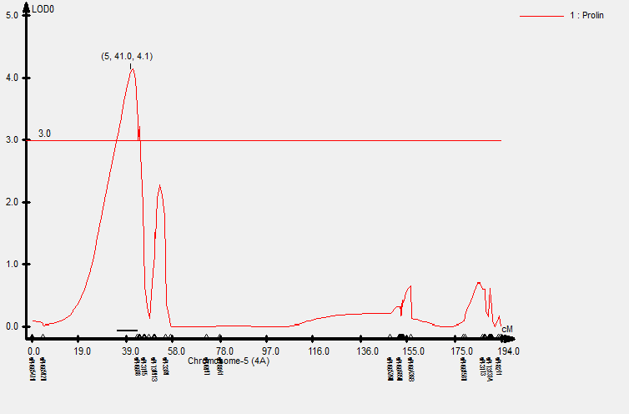
Fig. S1a. Chart obtained by QTL analysis of various attributes by QTL Cartographer. QP-4A
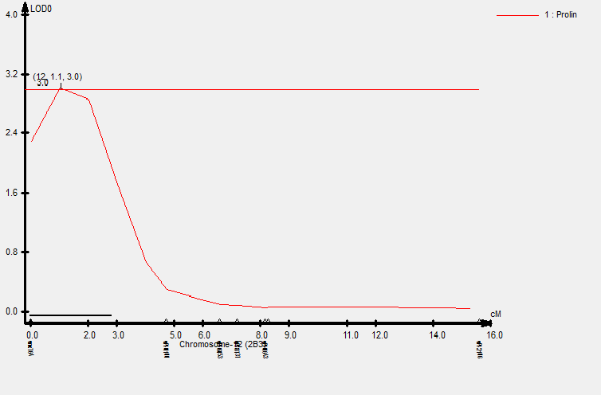
Fig. S1b. Chart obtained by QTL analysis of various attributes by QTL Cartographer. QP-2B3
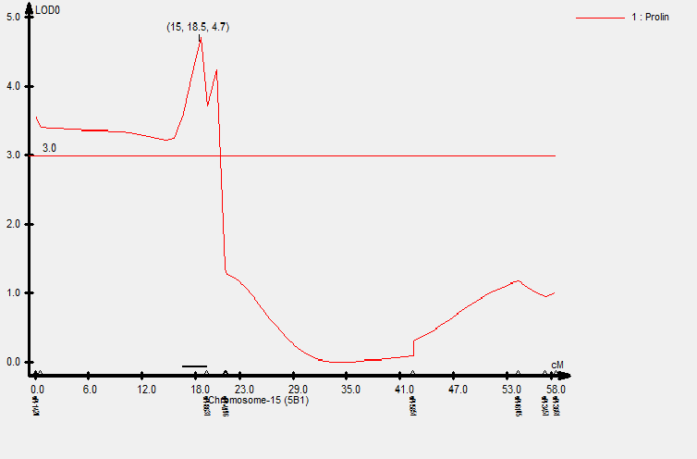
Fig. S1c. Chart obtained by QTL analysis of various attributes by QTL Cartographer. QP-5B1

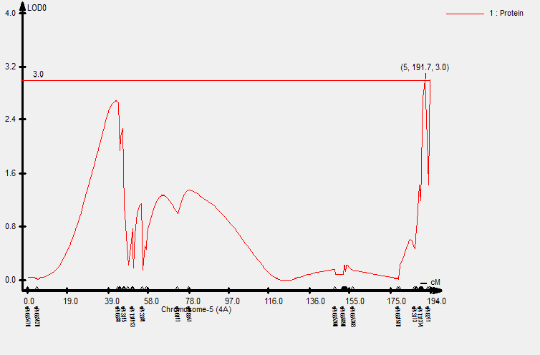

Fig. S1d. Chart obtained by QTL analysis of various attributes by QTL Cartographer. QPro-4A
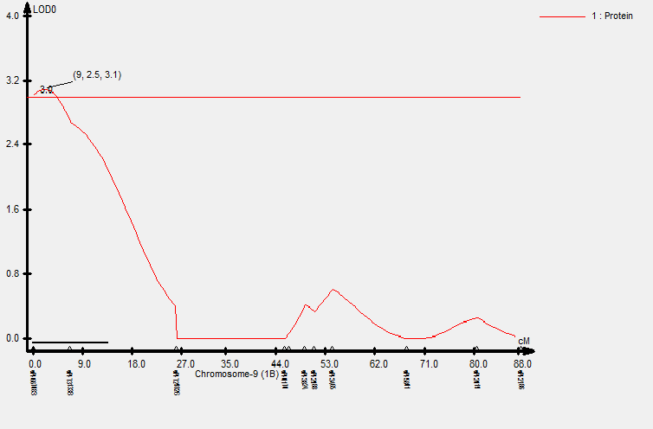
Fig. S1e. Chart obtained by QTL analysis of various attributes by QTL Cartographer. QPro-1B
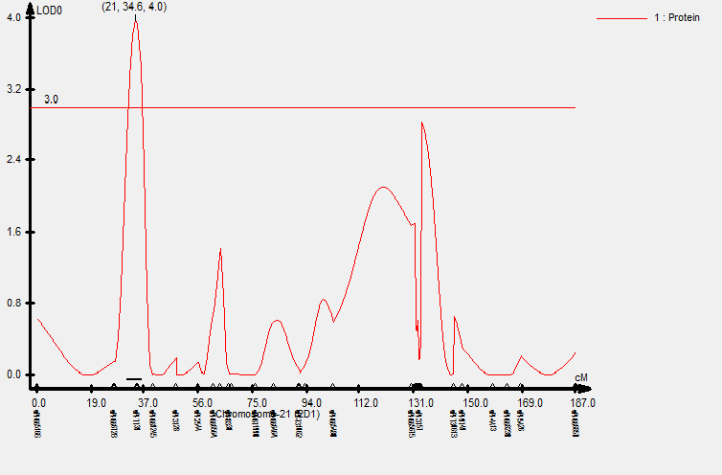
Fig. S1f. Chart obtained by QTL analysis of various attributes by QTL Cartographer. QP-2D

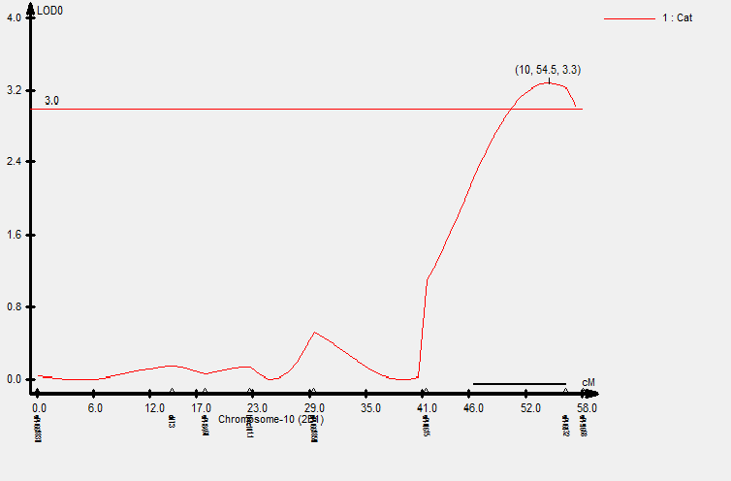
Fig. S1g. Chart obtained by QTL analysis of various attributes by QTL Cartographer. QCat-2B1

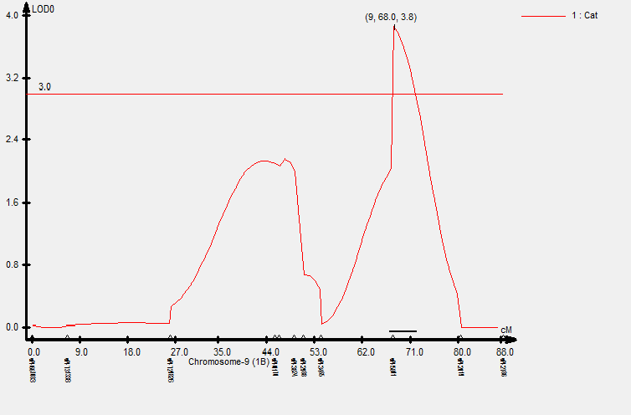
Fig. S1h. Chart obtained by QTL analysis of various attributes by QTL Cartographer. QCat-1B

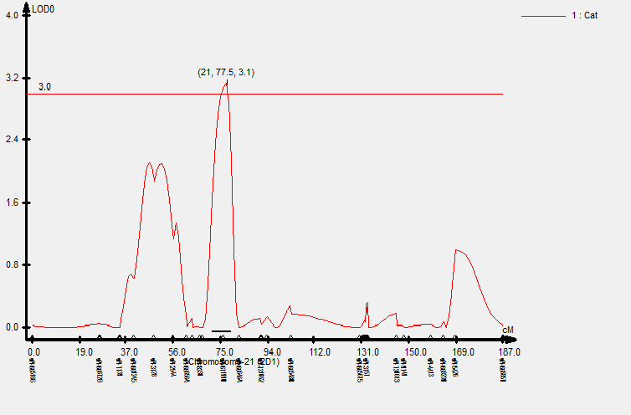
Fig. S1i. Chart obtained by QTL analysis of various attributes by QTL Cartographer. QCat-2D
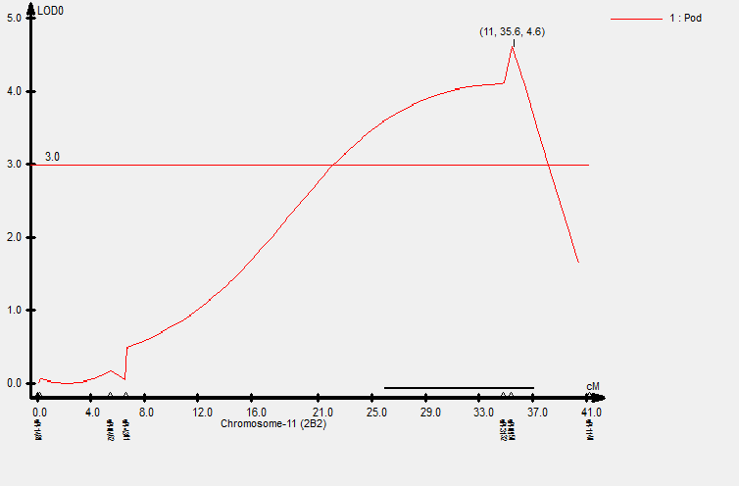
Fig. S1j. Chart obtained by QTL analysis of various attributes by QTL Cartographer. QPod-2B2

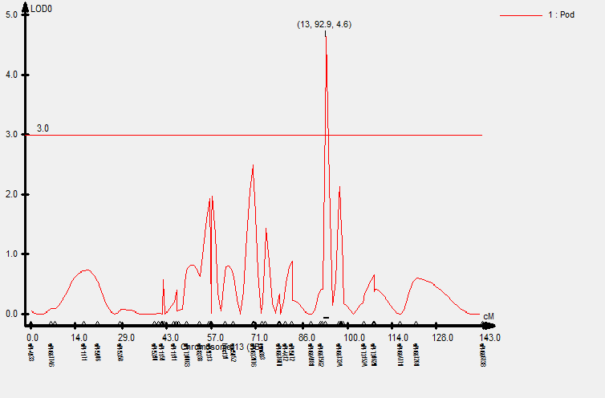
Fig. S1k. Chart obtained by QTL analysis of various attributes by QTL Cartographer. QPod-3B
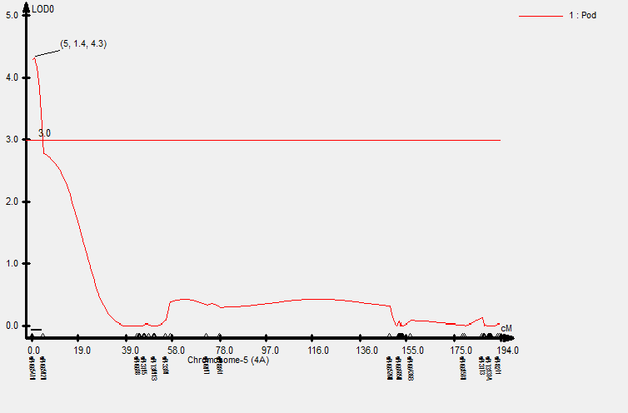
Fig. S1l. Chart obtained by QTL analysis of various attributes by QTL Cartographer. QPod-4A
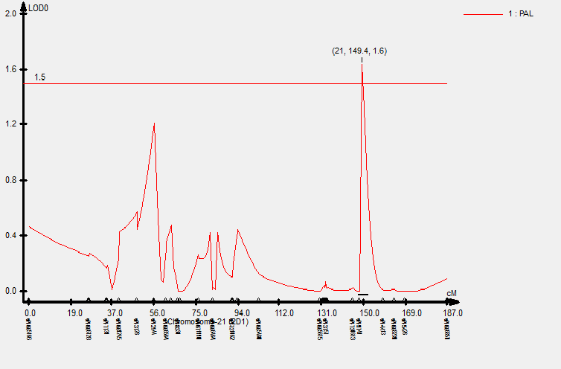
Fig. S1m. Chart obtained by QTL analysis of various attributes by QTL Cartographer. QPal-2D
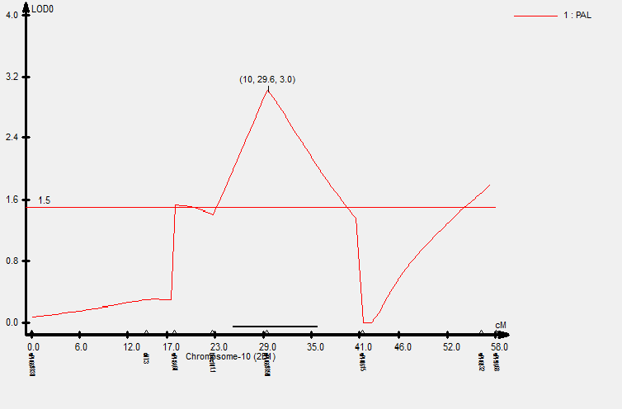
Fig. S1n. Chart obtained by QTL analysis of various attributes by QTL Cartographer. QPal-2B1
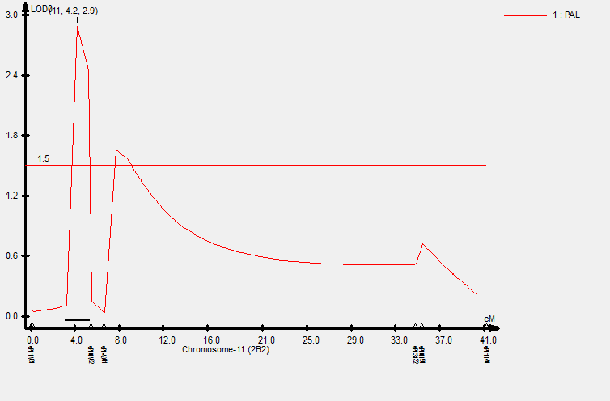
Fig. S1o. Chart obtained by QTL analysis of various attributes by QTL Cartographer. QPal-2B2
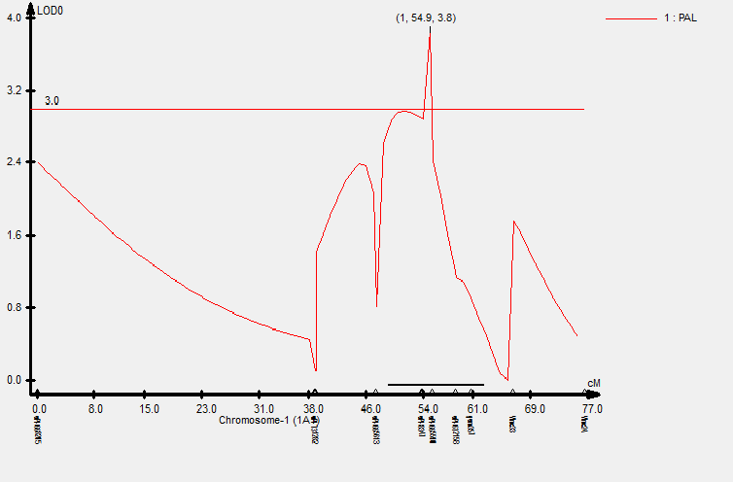

Fig. S1p. Chart obtained by QTL analysis of various attributes by QTL Cartographer. QPal-1A1
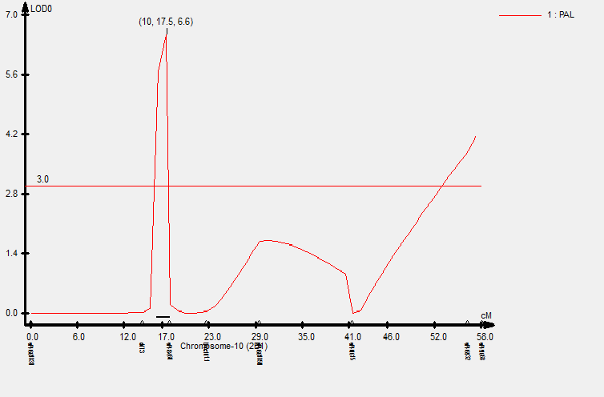
Fig. S1q. Chart obtained by QTL analysis of various attributes by QTL Cartographer. QPal-2B1
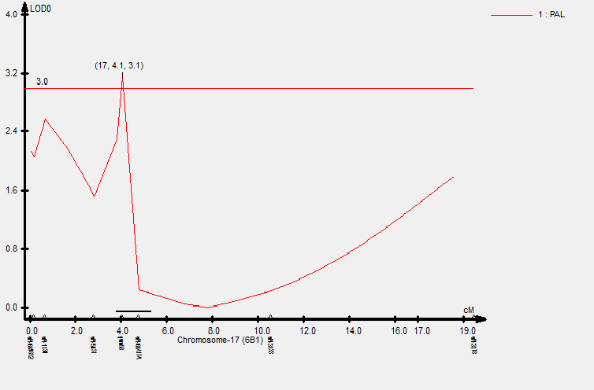
Fig. S1r. Chart obtained by QTL analysis of various attributes by QTL Cartographer. QPal-6B
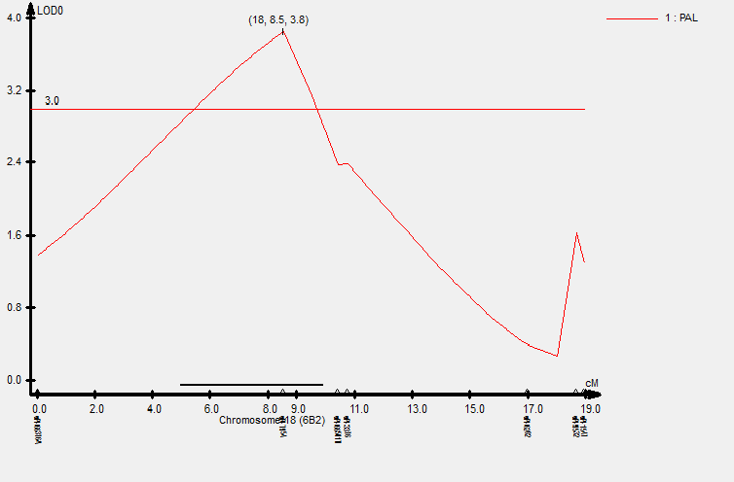
Fig. S1s. Chart obtained by QTL analysis of various attributes by QTL Cartographer. QPal-6B2
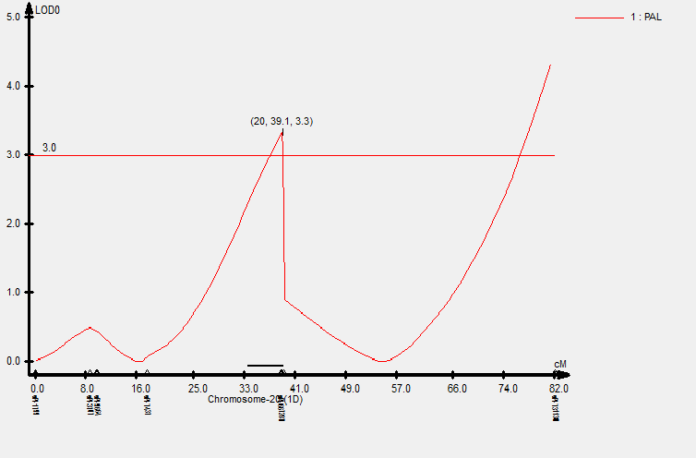
Fig. S1t. Chart obtained by QTL analysis of various attributes by QTL Cartographer. QPal-1D
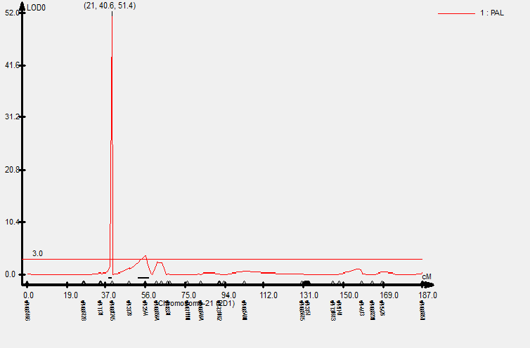
Fig. S1u. Chart obtained by QTL analysis of various attributes by QTL Cartographer. QPal-2D

