Data and Methods

Virus data
Taxonomic data, genome information, structural attributes as well as pathological features were collected the a list of 203 human viral pathogens compiled by Geoghegan et al.¹ The list was filtered by transmission route containing the term “respiratory”, to retain a subset of 39 human respiratory viruses (HuReVs). The filtered list was updated for viruses discovered since, using the ViralZone database.² Four additional viruses were thus included, yielding a full list of 43 HuReVs (combined information in Table 2 and Table 3). Minor discrepancies were identified and corrected by comparison with the NCBI viral genomes database³.
Biophysical data: Experimental data for virus density and volume were compiled from various sources,^{4–9} and used to estimate a mean mass for each HuReV family. Actual mass measurements were also collected from literature sources when available. ^{4–6,9,10} (see Table 1). We were unable to find experimental mass values for the family Arenaviridae, and we found difficult to provide an estimate on the mass due to their well-known pleomorphism.⁵
Capsid data: For encapsidated viruses, their Triangulation number (T-number)¹¹, related to protein copy number, were primarily obtained from the work of Baker, Olson & Fuller¹², and cross-validated with ViralZone². This information was combined to the list of structural proteins, their sequences and masses, obtained from the Uniprot database¹³, which were manually verified. Cleaved proteins were accounted for, and the final protein mass was calculated using the tool Peptide Mass.¹⁴ Lipid content (%) was based on various references, including Bionumbers (ID-106100).^{6,9,15,16} (see Table 2)
Genome information: Oligonucleotides molecular masses as a function of genome length were derived from the BioNumbers (ID-110193; ID-110968) database.¹⁶ Empirical data regarding the genome proportions were obtained from various literature resources, including Bionumbers (ID-106100).^{9,16} To understand the methods that were used to get to these genome content values, we found the work from Green and Piña (1963,1964) to be pioneering this biochemical methodologies.^{17,18} Coronaviridae were the only HuReVs for which we were unable to find empirical genome contribution value in the literature.(see Table 3)

The biophysical perspective
Mass (m) can be defined as the product of density (ρ) to Volume (Vol)
(1)
$$m= ρ*Vol$$
Assuming perfectly spherical geometry for all HuReVs, the relationship between diameter (d), buoyant density (ρ_{b}), and the molecular mass of the total virion ($M_{r}^{TV}$) can be expressed as:
(2)
$$M_{r}^{TV}= ρ_{b}*\frac{π*d^{3}}{6}$$
The exception were the family Poxviridae, considered as ‘brick shaped’. Thus to compute their volume, we used Vol = length * height * width, and replaced the computed Vol value in equation (1), to get the final $M_{r}^{TV}$. Similar approaches in calculating the virion volume have been used in prior works. ^{19,20}

The macromolecular perspective

Diagram - Data collection for the macromolecular perspective
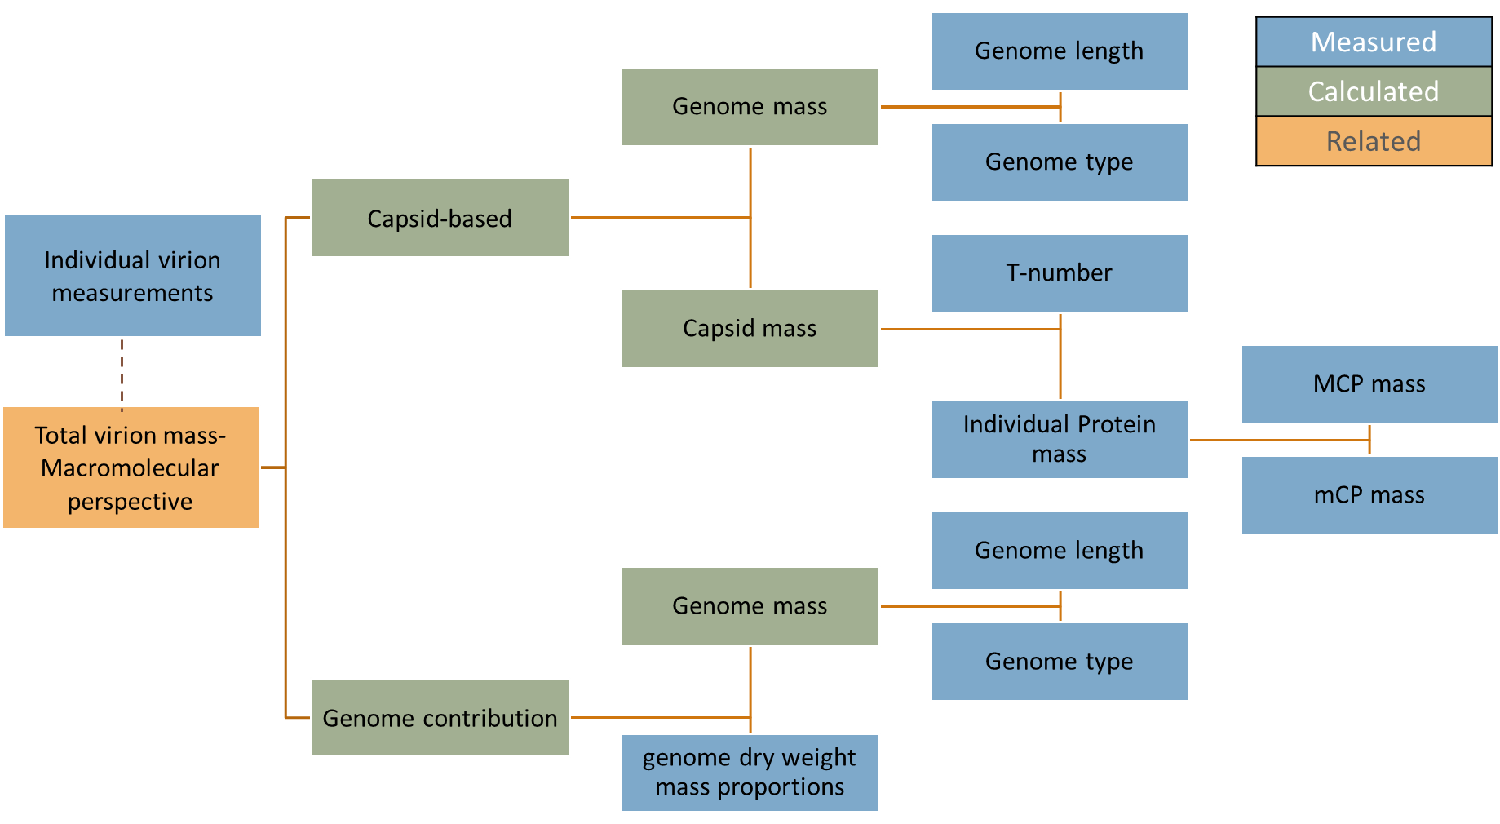
Figure 1. Diagram resuming the ‘capsid-based’ and the ‘genome contribution’ approaches in order to get the total virion mass evaluations. In blue: values reported by measurements based on the literature available; in green: calculated values by our work; in orange: related values in order to compare to the literature reported total virion mass measurements (dotted line).

Genome mass calculation
A genome mass is readily accessible for all viruses knowing their genome type and length in nucleotides (NA: Nucleic Acids). We used the following formula, based on Bionumbers database¹⁶ (ID: 110193), to give an approximate average of the mass:
(3)
$$m_{gen}=\left( m_{NA}×n_{NA}\right)+m_{end}$$
With m_{NA} the average mass of single nucleotides or nucleotide pairs for a given genome type, n_{NA} the genome length in nucleotides or nucleotide pairs, and m_{end} the mass of end groups.
Once the genome mass was computed, we set out to estimate the mass of the ‘genome containers’. Due to important differences in their structures and compositions, we treated encapsidated and non-encapsidated viruses separately.

‘Capsid-derived’ mass calculation approach
For encapsidated viruses, we derived the total virion mass by adding the genome mass to the calculated mass of the capsid. To compute the capsid mass, we relied on their preserved icosahedral geometry, their T-number, and the mass of their structural proteins. The protein copy count is linked to the T-number, which indicates the number of structural units per face of the icosahedron,¹² originally defined by Caspar and Klug.¹¹ These structural units are composed of defined numbers of Major Capsid Proteins (MCP) and minor Capsid Proteins (mCPs) per facet. Since capsids may have one, or more mCPs, we expressed the capsid mass with the following formula:
(4)
$m_{cap}=\sum_{i=1}^{N}{{(m}_{i}·n_{i})}$
Where (m_{i}) = mass of structural protein i; (n_{i}) = copy number of protein i, based on the value of the T-number; [i=1,2,…N]. A similar approach has been demonstrated before in other works.^{21,22}
For viruses featuring an additional lipid component (e.g. Herpesviridae, Togaviridae), the added mass was estimated from the experimentally determined ratio of the lipid content on the virus total mass, denoted as r_{lipids,} i.e. lipid ratio (see Table 2). The total virion mass,$M_{r}^{TV}$, was thus computed using the following formula:
(5)
$$M_{r}^{TV}=\frac{m_{gen} + m_{cap}}{1 - r_{lipids}}$$

‘Genome contribution’ mass calculation approach
Contrary to encapsidated viruses, the actual molecular composition of enveloped viruses cannot be easily derived from the copy numbers of their structural protein, since they are not precisely known. To estimate their total mass, $M_{r}^{TV}$, we relied instead on the computed genome mass (see section 1.3.2) and literature reported values of their genome dry weight contribution to the total virion mass, denoted as r_{genome}, i.e. genome ratio (see Table 3). This approach can be expressed by the following formula:
(6)
$$M_{r}^{TV}=\frac{m_{gen}}{r_{genome}}$$

Statistical methods
All mass data are expressed in Megadaltons (MDa) [= 10⁶ Da], where 1 Da = 1.66054·10⁻²⁷ kg. Due to the order of magnitudes differences in mass between the various species, the mass axis were converted into their logarithmic base-10 values, denoted as Log Mass. Unsupervised hierarchical clustering on non-standardised Log Mass values was performed using the statistical software SAS-JMP (version 17.0.0). More specifically, the agglomerative clustering method, Ward,²³ was used to calculate the minimum variance criterion, thereby minimising the total within-cluster variance, and yielding hierarchical groupings. To facilitate interpretation, the number of clusters represented was arbitrarily selected to correspond to the number of HuReV families considered. Dendograms with geometric spacing were used to represent distance relationships between individual viruses.

Table – ‘Biophysical’ mass calculation method.
Table 1. Table presenting the difference of mass between viral families, presented in alphabetical order, calculated by the biophysical method. Values were calculated as shown before, see section 1.2. N/A = Non-Applicable values. In bold are the range values measured (horizontal: diameter converted to volume; vertical: estimated mass), as plotted in Figure 2, in the article. Highlighted in green, is the mean calculated value by the biophysical method, and highlighted in blue, is the mean experimental mass, as plotted in Figure 2, in the article. Abbreviations are as follows: Dia.: diameter, except for Poxviridae, where it is the volume, presented as (length * width * height); Dens.: Buoyant Density; Range M_{biophy.}: Range biophysical Mass; Mean M_{biophy}: Mean biophysical mass; M_{expm}: Experimentally measured Mass; Mean M_{expm}: Mean Experimental Mass; Ref: literature references.
Virus Family | Capsid (Yes, No) | Dia. [nm] | Dens. [g/cm³] | Range M_{biophy.} [MDa] | Mean M_{biophy.} [MDa] | Range  M_{expm.} [MDa] | Mean M_{expm.} [MDa] | Ref
Adenoviridae | Yes | 70 - 90 | 1,31 - 1,36 | 141,68 - 312,61 | 227,15 | 150 - 180 | 165,00 | ^{5,6}
Arenaviridae | No | 50 - 300 | 1,14 - 1,2 | 44,93 - 10216,08 | 5130,51 | N/A | N/A | ^{16,9,15,5}
Bunyaviridae | No | 80 - 120 | 1,16 - 1,21 | 187,27 - 659,28 | 423,28 | 300 - 400 | 350,00 | ^{16,9,15}
Coronaviridae | No | 120 - 160 | 1,15 - 1,24 | 626,59 - 1601,48 | 1114,04 | 400 | 400,00 | ^{16,9,15,10}
Herpesviridae | Yes | 160 - 300 | 1,22 - 1,28 | 1575,65 - 10897,15 | 6236,40 | 782,9 - 2700 | 1741,45 | ^{5,6}
Orthomyxoviridae | No | 80 - 120 | 1,19 | 192,11 - 648,38 | 420,25 | 250 | 250,00 | ^{16,9,15,6}
Paramyxoviridae | No | 150 | 1,18 - 1,2 | 1255,73 - 1277,01 | 1266,37 | 500 - 660 | 580,00 | ^{16,9,15,6}
Parvoviridae | Yes | 21 - 26 | 1,34 - 1,45 | 3,91 - 8,04 | 5,98 | 5,4 - 6,2 | 5,80 | ^{5,6}
Picornaviridae | Yes | 28 - 30 | 1,33- 1,45 | 9,21 - 12,34 | 10,78 | 8 - 9 | 8,50 | ^{16,9,15,6}
Polyomaviridae | Yes | 40 - 45 | 1,2 - 1,35 | 24,22 - 38,79 | 31,51 | 25 - 26 | 25,50 | ^{5,6}
Poxviridae | No | (270 *270 * 140) – (140-260 * 220 * 450) | 1,16 - 1,3 | 7129,42 - 20150,82 | 13640,12 | 3000 - 5721 | 4360,50 | ^{16,9,15,5,6,8,7}
Reoviridae | Yes | 60 - 98 | 1,36 - 1,39 | 92,63 - 412,51 | 252,57 | 120 - 130 | 125,00 | ^{16,9,15,6}
Togaviridae | Yes | 60 - 70 | 1,18 - 1,22 | 80,37 - 131,95 | 106,16 | 52 | 52 | ^{16,9,15,5,6}

The macromolecular perspective

Table - ‘Capsid-derived’ mass calculation method.
Table 2. The calculation of the mass of individual human respiratory viruses by the ‘capsid based’ mass calculation method. Values were calculated as seen in section 1.3.3, from references seen in section 1.1. The viral families are presented in alphabetical order. Highlighted in blue: the calculations described in the section 1.3.2. Highlighted in green: the calculations of the capsids and nucleo-capsids, based on their T-number. The letters in the T-number refer to d:dextro (i.e. right) and l:laevo (i.e. left).^{12,13} Column colours refer to the Figure 1, and in bold, the log mass value was plotted in Figure 4, in the main article.
Family | Genus | Species | Genome Type | Genome Length (nt) | Genome calc. mass (MDa) | T-number | (Nucleo) Capsid mass (MDa) | Lipid content (%) | Total virion mass (MDa)
Adenoviridae | Mastadenovirus | Human adenovirus C | dsDNA | 35 937 | 21,83 | 25 | 82,39 | 0 | 104,21
Herpesviridae | Roseolovirus | Human herpesvirus 6B | dsDNA | 162 114 | 98,47 | 16 | 144,27 | 22 | 311,21
Herpesviridae | Roseolovirus | Human herpesvirus 6A | dsDNA | 159 322 | 96,77 | 16 | 144,98 | 22 | 309,93
Herpesviridae | Roseolovirus | Human herpesvirus 7 | dsDNA | 153080 | 92,98 | 16 | 146,81 | 22 | 307,43
Herpesviridae | Varicellovirus | Human herpesvirus 3 | dsDNA | 124884 | 75,85 | 16 | 148,78 | 22 | 287,99
Parvoviridae | Erythroparvovirus | Human parvovirus B19 | ssDNA | 5 596 | 1,70 | 1 | 3,73 | 0 | 5,43
Parvoviridae | Bocaparvovirus | Human bocavirus | ssDNA | 5 299 | 1,61 | 1 | 4,01 | 0 | 5,62
Parvoviridae | Dependoparvovirus | Adeno-associated virus | ssDNA | 4 679 | 1,42 | 1 | 3,73 | 0 | 5,16
Picornaviridae | Enterovirus | Poliovirus type 1 | ssRNA | 7440 | 2,38 | 1 | 5,41 | 0 | 7,79
Picornaviridae | Enterovirus | Enterovirus D68 | ssRNA | 7 390 | 2,37 | 1 | 5,70 | 0 | 8,07
Picornaviridae | Enterovirus | Human rhinovirus A | ssRNA | 7 152 | 2,29 | 1 | 5,74 | 0 | 8,03
Picornaviridae | Enterovirus | Human rhinovirus B | ssRNA | 6 900 | 2,21 | 1 | 5,71 | 0 | 7,93
Polyomaviridae | Polyomavirus | WU Polyomavirus | dsDNA | 5 228 | 3,18 | 7d | 19,66 | 0 | 22,83
Polyomaviridae | Polyomavirus | BK polyomavirus | dsDNA | 5153 | 3,13 | 7d | 19,12 | 0 | 22,25
Reoviridae | Orthoreovirus | Mammalian orthoreovirus | dsRNA | 23 500 | 15,06 | 13l | 107,77 | 0 | 122,84
Togaviridae | Rubivirus | Rubella virus | ssRNA | 9 757 | 3,13 | 4 | 27,54 | 30 | 43,81

Table - ‘Genome contribution’ mass calculation method.
Table 3. The calculation of the mass of individual human respiratory viruses was done using the ‘genome contribution’ mass calculation method. Values were calculated as seen in section 1.3.4, from references seen in section 1.1. The viral families are presented in alphabetical order. Species (**): (< 10) reported cases of human-to-human transmission, as reported by Geoghegan et al..¹ Values highlighted in blue are from the calculations described in the section 1.3.2. N/A= Non-Applicable value. Column colours refer to the Figure 1, and in bold, the log mass value was plotted in Figure 4, in the main article.
Family | Genus | Species | Genome Type | Genome Length  (nt) | Genome  mass  (MDa) | Genome contribution (%) | Lipid content (%) | Total virion mass  (MDa)
Arenaviridae | Arenavirus | Lujo virus** | ssRNA | 10352 | 3,32 | 2,00 | 20 | 165,90
Arenaviridae | Arenavirus | Guanarito virus | ssRNA | 10424 | 3,34 | 2,00 | 20 | 167,05
Arenaviridae | Arenavirus | Machupo virus | ssRNA | 10562 | 3,39 | 2,00 | 20 | 169,26
Arenaviridae | Arenavirus | Lassa virus | ssRNA | 10824 | 3,47 | 2,00 | 20 | 173,46
Bunyavirales | Orthohantavirus | Hantaan virus | ssRNA | 11 845 | 3,80 | 1,00-2,0 | 20-30 | 253,10
Bunyaviridae | Hantavirus | Black creek canal virus** | ssRNA | 12000 | 3,85 | 1,00-2,00 | 20-30 | 256,41
Coronaviridae | Alphacoronavirus | Human coronavirus 229E | ssRNA | 27317 | 8,76 | N/A | yes | N/A
Coronaviridae | Betacoronavirus | Human coronavirus NL63 | ssRNA | 27410 | 8,79 | N/A | yes | N/A
Coronaviridae | Betacoronavirus | SARS coronavirus | ssRNA | 29751 | 9,54 | N/A | yes | N/A
Coronaviridae | Betacoronavirus | SARS coronavirus 2 | ssRNA | 29903 | 9,58 | N/A | yes | N/A
Coronaviridae | Betacoronavirus | Human coronavirus HKU1 | ssRNA | 29934 | 9,59 | N/A | yes | N/A
Coronaviridae | Betacoronavirus | Middle East respiratory syndrome | ssRNA | 30063 | 9,64 | N/A | yes | N/A
Coronaviridae | Betacoronavirus | Human coronavirus OC43 | ssRNA | 30578 | 9,80 | N/A | yes | N/A
Orthomyxoviridae | Influenzavirus A | Influenza A H5N1 virus | ssRNA | 13500 | 4,33 | 6,76 | 48,00 | 64,01
Orthomyxoviridae | Influenzavirus A | Influenza A H7N9 virus | ssRNA | 13500 | 4,33 | 6,76 | 48,00 | 64,01
Orthomyxoviridae | Influenzavirus A | Influenza A H3N2 virus | ssRNA | 13588 | 4,36 | 6,76 | 48,00 | 64,42
Orthomyxoviridae | Influenzavirus B | Influenza B virus | ssRNA | 14548 | 4,66 | 6,76 | 48,00 | 68,98
Orthomyxoviridae | Influenzavirus C | Influenza C virus | ssRNA | 14600 | 4,68 | 6,76 | 48,00 | 69,22
Paramyxoviridae | Pneumovirus | Human respiratory syncytial virus | ssRNA | 15128 | 4,85 | 0,50 | 20-25 | 969,74
Paramyxoviridae | Rubulavirus | Human parainfluenza virus 5 | ssRNA | 15246 | 4,89 | 0,50 | 20-25 | 977,30
Paramyxoviridae | Rubulavirus | Mumps virus | ssRNA | 15384 | 4,93 | 0,50 | 20-25 | 986,15
Paramyxoviridae | Respirovirus | Human parainfluenza virus 3 | ssRNA | 15405 | 4,94 | 0,50 | 20-25 | 987,49
Paramyxoviridae | Respirovirus | Human parainfluenza virus 1 | ssRNA | 15504 | 4,97 | 0,50 | 20-25 | 993,84
Paramyxoviridae | Rubulavirus | Human parainfluenza virus 2 | ssRNA | 15654 | 5,02 | 0,50 | 20-25 | 1003,45
Paramyxoviridae | Morbillivirus | Measles virus | ssRNA | 15894 | 5,09 | 0,50 | 20-25 | 1018,84
Paramyxoviridae | Rubulavirus | Human parainfluenza virus 4 | ssRNA | 17091 | 5,48 | 0,50 | 20-25 | 1095,56
Poxviridae | Orthopoxvirus | Variola virus | dsDNA | 185578 | 112,72 | 3 | 4 | 3757,34

Rates of mass separation
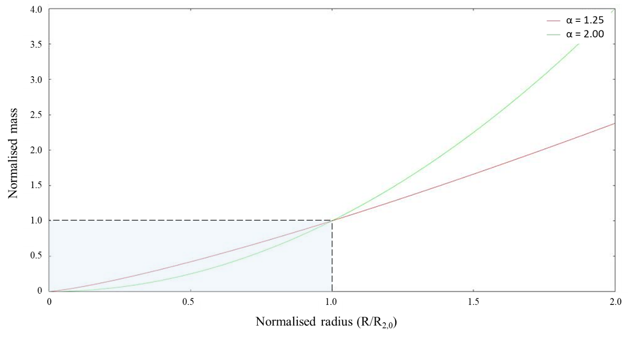
Figure 2. The relationship between the normalised mass and the normalised ratio between the Radius and the Critical Radius (R/R_{2,0}). The respective values of α are given (top right), in green: the quadratic relationship, representing here the ‘capsid mass’ contribution; in red: the value of the allometric exponent, taken from Chaudhari et al.²⁰, representing here the ‘genome mass’ contribution. The region highlighted in light blue shows the section where the ‘genome mass alone’ is more relevant than total virion mass, delimited by the critical radius (dashed black lines).

References
1. Geoghegan, J.L., Senior, A.M., Di Giallonardo, F., and Holmes, E.C. (2016). Virological factors that increase the transmissibility of emerging human viruses. Proc Natl Acad Sci USA 113, 4170–4175. 10.1073/pnas.1521582113.
2. Hulo, C., de Castro, E., Masson, P., Bougueleret, L., Bairoch, A., Xenarios, I., and Le Mercier, P. (2011). ViralZone: a knowledge resource to understand virus diversity. Nucleic Acids Res 39, D576–D582. 10.1093/nar/gkq901.
3. Brister, J.R., Ako-adjei, D., Bao, Y., and Blinkova, O. (2015). NCBI Viral Genomes Resource. Nucleic Acids Research 43, D571–D577. 10.1093/nar/gku1207.
4. Mazzone, H.M. (1998). CRC Handbook of Viruses: Mass-Molecular Weight Values and Related Properties (CRC Press).
5. International Committee on Taxonomy of Viruses, and King, A.M.Q. eds. (2012). Virus taxonomy: classification and nomenclature of viruses: ninth report of the International Committee on Taxonomy of Viruses (Academic Press).
6. Matthews, R.E.F. (1975). A Classification of Virus Groups Based on the Size of the Particle in Relation to Genome Size. Journal of General Virology, 27, 135–149. 10.1099/0022-1317-27-2-135.
7. Gupta, A., Akin, D., and Bashir, R. (2004). Single virus particle mass detection using microresonators with nanoscale thickness. Appl. Phys. Lett. 84, 1976–1978. 10.1063/1.1667011.
8. Bahr, G.F., Foster, W.D., Peters, D., and Zeitler, E.H. (1980). Variability of dry mass as a fundamental biological property demonstrated for the case of Vaccinia virions. Biophysical Journal 29, 305–314. 10.1016/S0006-3495(80)85134-4.
9. Cann, A.J. (2000). RNA viruses. A practical approach. RNA viruses. A practical approach.
10. Robb, J.A., and Bond, C.W. (1979). Coronaviridae. In Comprehensive Virology: Newly Characterized Vertebrate Viruses Comprehensive Virology., H. Fraenkel-Conrat and R. R. Wagner, eds. (Springer US), pp. 193–247. 10.1007/978-1-4684-3563-4_3.
11. Caspar, D.L.D., and Klug, A. (1962). Physical Principles in the Construction of Regular Viruses. Cold Spring Harbor Symposia on Quantitative Biology 27, 1–24. 10.1101/SQB.1962.027.001.005.
12. Baker, T.S., Olson, N.H., and Fuller, S.D. (1999). Adding the Third Dimension to Virus Life Cycles: Three-Dimensional Reconstruction of Icosahedral Viruses from Cryo-Electron Micrographs. MMBR 63, 61.
13. The UniProt Consortium (2015). UniProt: a hub for protein information. Nucleic Acids Research 43, D204–D212. 10.1093/nar/gku989.
14. Wilkins, M.R., Lindskog, I., Gasteiger, E., Bairoch, A., Sanchez, J.-C., Hochstrasser, D.F., and Appel, R.D. (1997). Detailed peptide characterization using PEPTIDEMASS – a World-Wide-Web-accessible tool. ELECTROPHORESIS 18, 403–408. 10.1002/elps.1150180314.
15. Murphy, F.A., Fauquet, C.M., Bishop, D.H.L., Ghabrial, S.A., Jarvis, A.W., Martelli, G.P., Mayo, M.A., and Summers, M.D. (1995). The International Committee on Taxonomy of Viruses. In Virus Taxonomy: Classification and Nomenclature of Viruses Sixth Report of the International Committee on Taxonomy of Viruses Archives of Virology Supplement 10., F. A. Murphy, C. M. Fauquet, D. H. L. Bishop, S. A. Ghabrial, A. W. Jarvis, G. P. Martelli, M. A. Mayo, and M. D. Summers, eds. (Springer), pp. 509–529. 10.1007/978-3-7091-6607-9_3.
16. Milo, R., Jorgensen, P., Moran, U., Weber, G., and Springer, M. (2010). BioNumbers—the database of key numbers in molecular and cell biology. Nucleic Acids Research 38, D750–D753. 10.1093/nar/gkp889.
17. Green, M., and Piña, M. (1963). Biochemical studies on adenovirus multiplication: IV. Isolation, purification, and chemical analysis of adenovirus. Virology 20, 199–207. 10.1016/0042-6822(63)90157-0.
18. Green, M., and Piña, M. (1964). Biochemical studies on adenovirus multiplication, VI. Properties of Highly Purified Tumorigenic Human Adenoviruses and their DNA’s. Proc Natl Acad Sci U S A 51.
19. Cui, J., Schlub, T.E., and Holmes, E.C. (2014). An Allometric Relationship between the Genome Length and Virion Volume of Viruses. J Virol 88, 6403–6410. 10.1128/JVI.00362-14.
20. Chaudhari, H.V., Inamdar, M.M., and Kondabagil, K. (2021). Scaling relation between genome length and particle size of viruses provides insights into viral life history. iScience 24, 102452. 10.1016/j.isci.2021.102452.
21. Dominguez-Medina, S., Fostner, S., Defoort, M., Sansa, M., Stark, A.-K., Halim, M.A., Vernhes, E., Gely, M., Jourdan, G., Alava, T., et al. (2018). Neutral mass spectrometry of virus capsids above 100 megadaltons with nanomechanical resonators. Science 362, 918–922. 10.1126/science.aat6457.
22. Barnes, L.F., Draper, B.E., and Jarrold, M.F. (2022). Analysis of Recombinant Adenovirus Vectors by Ion Trap Charge Detection Mass Spectrometry: Accurate Molecular Weight Measurements beyond 150 MDa. Anal. Chem. 94, 1543–1551. 10.1021/acs.analchem.1c02439.
23. Ward, J.H. (1963). Hierarchical Grouping to Optimize an Objective Function. Journal of the American Statistical Association 58, 236–244. 10.1080/01621459.1963.10500845.

