Supplement information

Table Structural variables of the frailty index
 | Variable definitions | Assignment
1 | Do you have Physical disabilities？ | No=0，Yes=1
2 | Do you have Brain damage/intellectual disability？ | No=0，Yes=1
3 | Do you have Vision problem？ | No=0，Yes=1
4 | Do you have Hearing problem？ | No=0，Yes=1
5 | Do you have Speech impediment？ | No=0，Yes=1
6 | Have you been diagnosed with Hypertension by a doctor? | No=0，Yes=1
7 | Have you been diagnosed with Dyslipidemia (elevation of low density lipoprotein, triglycerides (TGs), and total cholesterol, or a low high density lipoprotein level) by a doctor? | No=0，Yes=1
8 | Have you been diagnosed with Diabetes or high blood sugar by a doctor? | No=0，Yes=1
9 | Have you been diagnosed with Cancer or malignant tumor (excluding minor skin cancers) by a doctor? | No=0，Yes=1
10 | Have you been diagnosed with Chronic lung diseases, such as chronic bronchitis ,emphysema ( excluding tumors, or cancer) by a doctor? | No=0，Yes=1
11 | Have you been diagnosed with Liver disease (except fatty liver, tumors, and cancer) by a doctor? | No=0，Yes=1
12 | Have you been diagnosed with Heart attack, coronary heart disease, angina, congestive heart failure, or other heart problems by a doctor？ | No=0，Yes=1
13 | Have you been diagnosed with Stroke by a doctor? | No=0，Yes=1
14 | Have you been diagnosed with Kidney disease (except for tumor or cancer) by a doctor? | No=0，Yes=1
15 | Have you been diagnosed with Stomach or other digestive diseases (except for tumor or cancer) by a doctor？ | No=0，Yes=1
16 | Have you been diagnosed with Emotional, nervous, or psychiatric problems by a doctor? | No=0，Yes=1
17 | Have you been diagnosed with Memory-related disease (such as dementia, brain atrophy, and Parkinson’s disease) by a doctor? | No=0，Yes=1
18 | Have you been diagnosed with Arthritis or rheumatism by a doctor? | No=0，Yes=1
19 | Have you been diagnosed with Arthritis or rheumatism by a doctor? | No=0，Yes=1
20 | Would you say your health is very good, good, fair, poor or very poor? | Very good=0,Good=0.25,Fair=0.5, Poor=0.75,Very poor=1
21 | Do you have any difficulty with running or jogging about 1 Km? | No, I don’t have any difficulty=0,I have difficulty but can still do it=0.33,Yes,I have difficulty and need help=0.66,I can not do it=1
22 | Do you have difficulty with walking 1 km? | No, I don’t have any difficulty=0,I have difficulty but can still do it=0.33,Yes,I have difficulty and need help=0.66,I can not do it=1
23 | Do you have difficulty with walking 100 metres? | No, I don’t have any difficulty=0,I have difficulty but can still do it=0.33,Yes,I have difficulty and need help=0.66,I can not do it=1
24 | Do you have difficulty with getting up from a chair after sitting for a long period? | No, I don’t have any difficulty=0,I have difficulty but can still do it=0.33,Yes,I have difficulty and need help=0.66,I can not do it=1
25 | Do you have difficulty with climbing several flights of stairs without resting? | No, I don’t have any difficulty=0,I have difficulty but can still do it=0.33,Yes,I have difficulty and need help=0.66,I can not do it=1
26 | Do you have difficulty with stooping, kneeling, or crouching? | No, I don’t have any difficulty=0,I have difficulty but can still do it=0.33,Yes,I have difficulty and need help=0.66,I can not do it=1
27 | Do you have difficulty with reaching or extending your arms above shoulder level? | No, I don’t have any difficulty=0,I have difficulty but can still do it=0.33,Yes,I have difficulty and need help=0.66,I can not do it=1
28 | Do you have difficulty with lifting or carrying weights over 10 jin, like a heavy bag of groceries? | No, I don’t have any difficulty=0,I have difficulty but can still do it=0.33,Yes,I have difficulty and need help=0.66,I can not do it=1
29 | Do you have difficulty with picking up a small coin from a table? | No, I don’t have any difficulty=0,I have difficulty but can still do it=0.33,Yes,I have difficulty and need help=0.66,I can not do it=1
30 | Because of health and memory problems, do you have any difficulty with dressing? | No, I don’t have any difficulty=0,I have difficulty but can still do it=0.33,Yes,I have difficulty and need help=0.66,I can not do it=1
31 | Because of health and memory problems, do you have any difficulty with bathing or showering? | No, I don’t have any difficulty=0,I have difficulty but can still do it=0.33,Yes,I have difficulty and need help=0.66,I can not do it=1
32 | Because of health and memory problems, do you have any difficulty with eating, such as cutting up your food? | No, I don’t have any difficulty=0,I have difficulty but can still do it=0.33,Yes,I have difficulty and need help=0.66,I can not do it=1
33 | Do you have any difficulty with getting into or out of bed? | No, I don’t have any difficulty=0,I have difficulty but can still do it=0.33,Yes,I have difficulty and need help=0.66,I can not do it=1
34 | Does anyone ever help you use the toilet? | No, I don’t have any difficulty=0,I have difficulty but can still do it=0.33,Yes,I have difficulty and need help=0.66,I can not do it=1
35 | Because of health and memory problems, do you have any difficulties with doing household chores? | No, I don’t have any difficulty=0,I have difficulty but can still do it=0.33,Yes,I have difficulty and need help=0.66,I can not do it=1
36 | Because of health and memory problems, do you have any difficulties with preparing hot meals? | No, I don’t have any difficulty=0,I have difficulty but can still do it=0.33,Yes,I have difficulty and need help=0.66,I can not do it=1
37 | Because of health and memory problems, do you have any difficulties with shopping for groceries? | No, I don’t have any difficulty=0,I have difficulty but can still do it=0.33,Yes,I have difficulty and need help=0.66,I can not do it=1
38 | Because of health and memory problems, do you have any difficulties with taking medications? | No, I don’t have any difficulty=0,I have difficulty but can still do it=0.33,Yes,I have difficulty and need help=0.66,I can not do it=1
39 | Because of health and memory problems, do you have any difficulties with managing your money? | No, I don’t have any difficulty=0,I have difficulty but can still do it=0.33,Yes,I have difficulty and need help=0.66,I can not do it=1

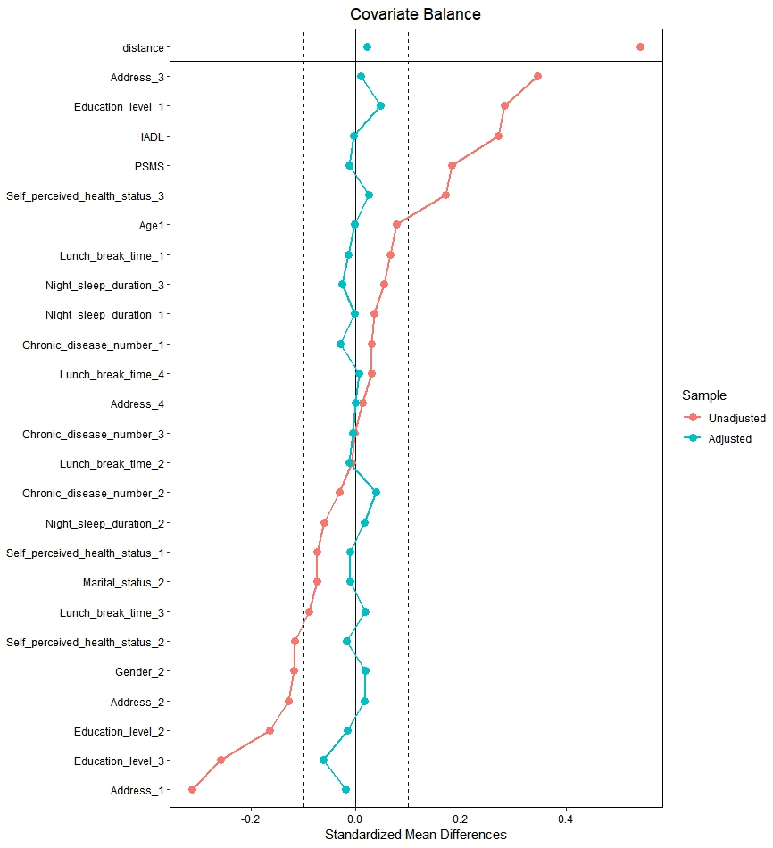

Fig Standardized mean differences before and after propensity score matching.

Abbreviations: PSMS: Physical Self-Maintenance Scale; IADL: Instrumental Activities of Daily Living

Note:
Age:1=<75 years old
Gender:1=Male
Martial status:1= Married,2=Unmarried
Address:1=The center of a city or town;2=Urban and rural areas or towns;3=Village;
4=Special area
Education level:1=Primary or below;2=Junior high school/technical secondary school;3=High school or above
Chronic diseases number:1=0;2=1~2;3=≥2
Self-perceived health status :1=Good;2=Fair;3=Poor
Night sleep duration(h):1=<6;2=6~9;3=>9
Lunch break time(min):1=0;2=<30;3=30~90;4=≥90

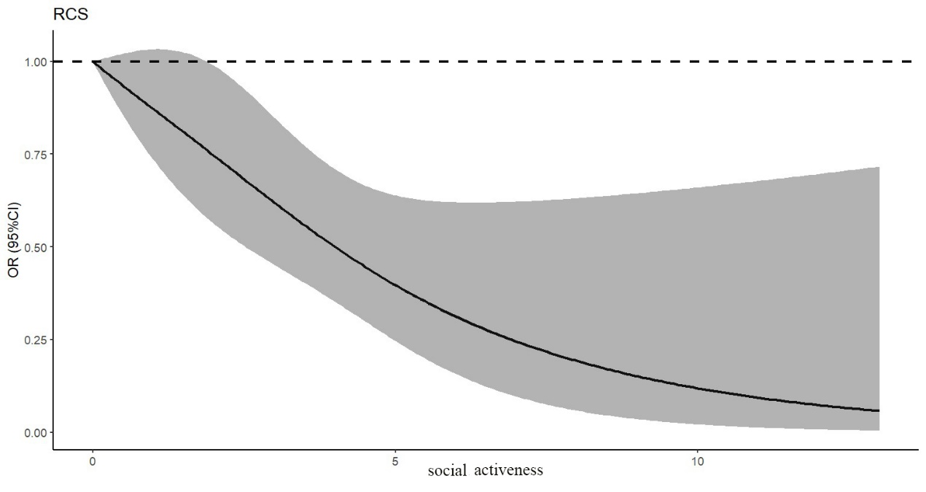
Fig Dose-response analysis of social activity and frailty symptoms

