Modeling Longitudinal And Survival Data: The Framingham Heart Study

List of Figures

S1: Type I Error Confidence Intervals for Link (Exponential and Weibull Distribution, N = 100) | 2
S2: Estimates and Confidence Intervals for Link (Weibull Distribution, N = 100) | 3
S3: Estimates and Confidence Intervals for Age (Weibull Distribution, N = 100) | 4
S4: Estimates and Confidence Intervals for Sex (Weibull Distribution, N = 100) | 5

S1: TYPE I ERROR CONFIDENCE INTERVALS FOR LINK
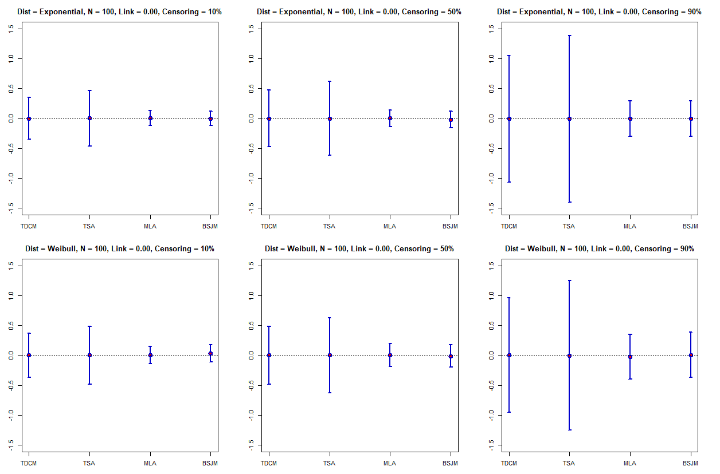
S2: ESTIMATES AND CONFIDENCE INTERVALS FOR LINK
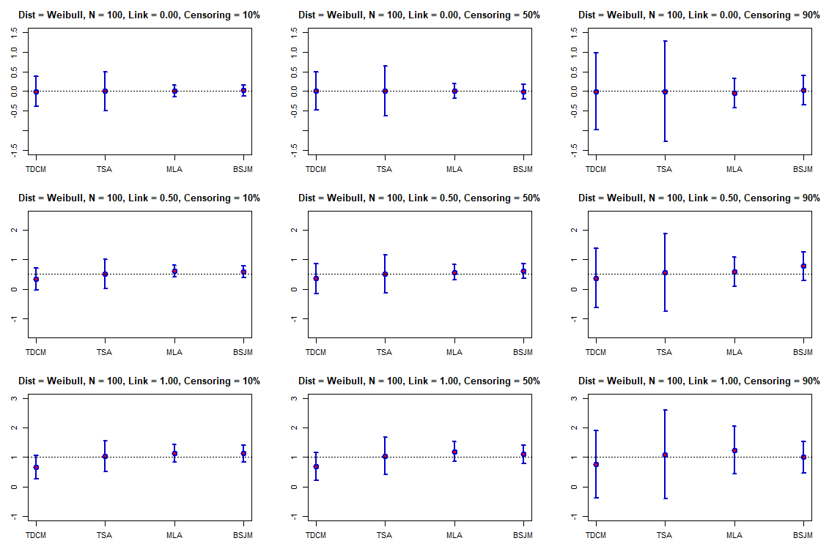

S3: ESTIMATES AND CONFIDENCE INTERVALS FOR AGE
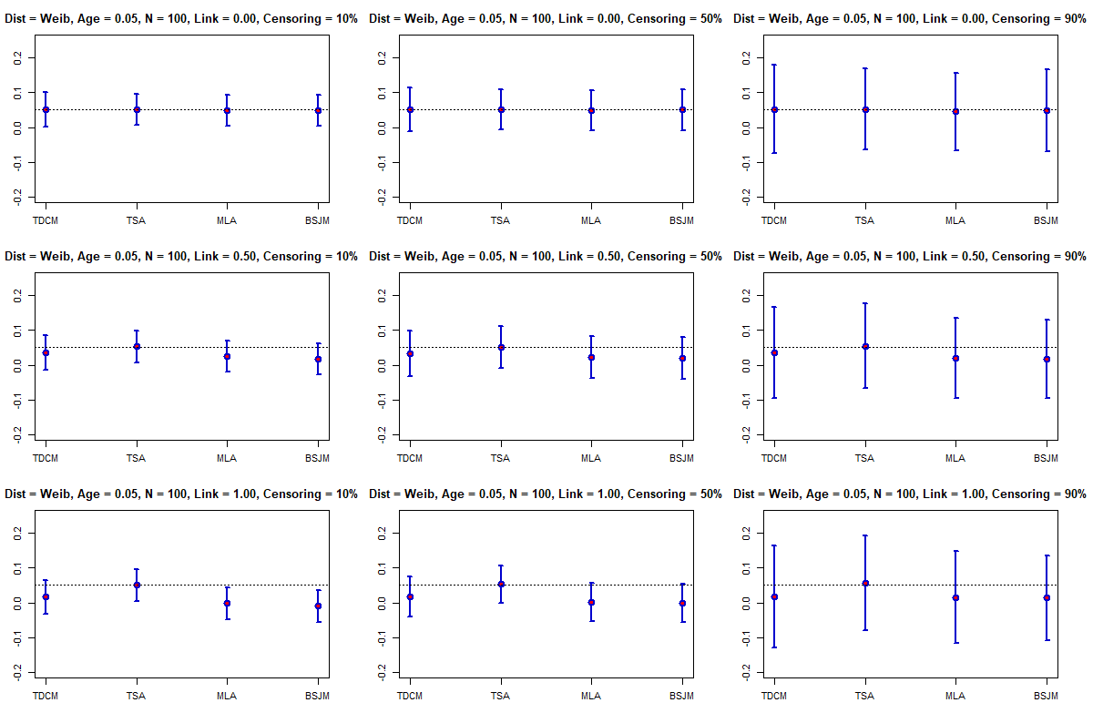

S4: ESTIMATES AND CONFIDENCE INTERVALS FOR SEX
