Supplement to:

Categorization of continuous covariates and complex regression models – friends or foes in intersectionality research
Adrian Richter¹, Sabina Ulbricht¹, and Sarah Brockhaus ²
¹ Department of Prevention Research and Social Medicine, Institute for Community Medicine, University Medicine Greifswald, Greifswald, Germany
² Faculty of Computer Science and Mathematics, University of Applied Sciences Munich, Munich, Germany
ORCID
Adrian Richter, ORCID-ID: 0000-0002-3372-2021
Sabina Ulbricht, ORCID-ID: 0000-0001-7617-0266
Sarah Brockhaus, ORCID-ID: 0000-0001-9484-7488
Content
MSE for response 2 with R² = 0.33 2
MSE for response 4 with R² = 0.8 3
Average coefficient size of approach 1 4
Piecewise constant predictions of approach 1 5
Significance of strata 7
BE-BIC and resampling 8
Sensitivity analyses 9
Results of setting 1 10
Setting 2 12
BE-BIC and resampling 14
REFERENCE LIST 15

MSE for response 2 with R² = 0.33
Figure SF1 and SF 2 are in analogy to Figure 2 from the main paper; the difference is the lower (SF 2) and higher (SF 3) R².
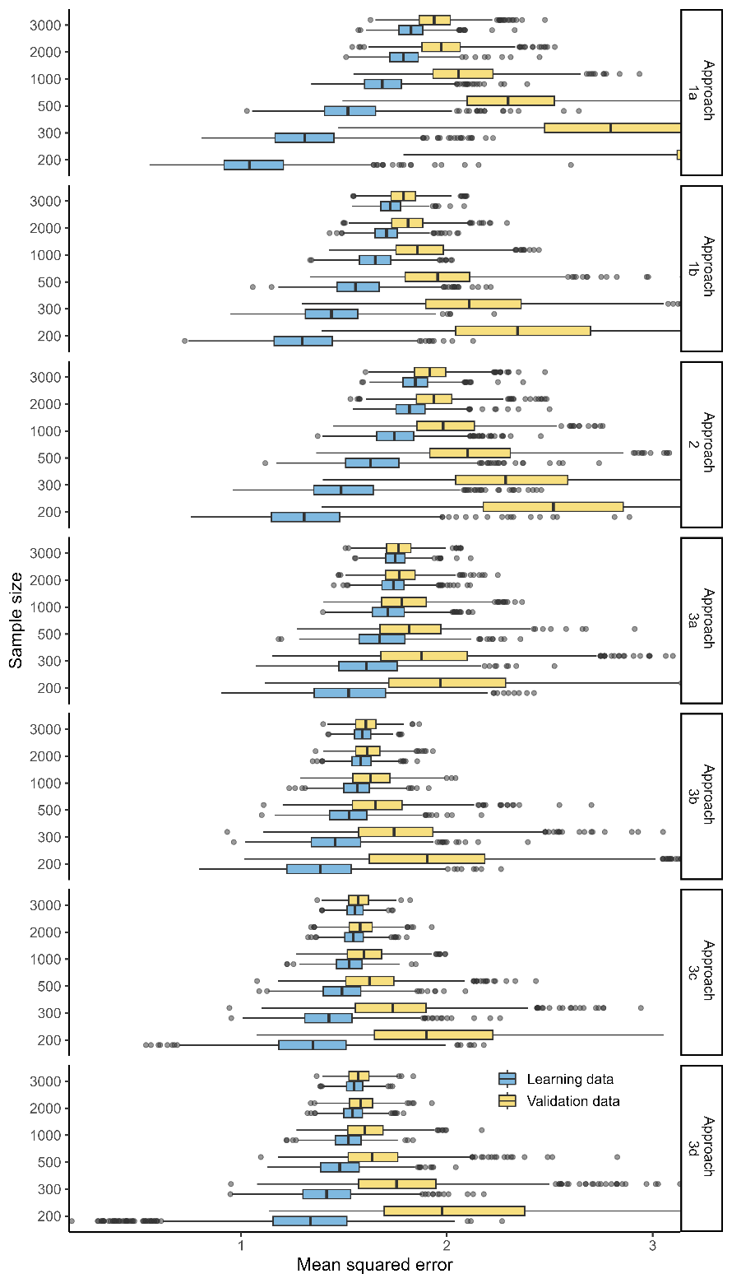
Supplementary Figure SF 1: Mean squared error over 1000 simulations of setting 2 with SNR of 0.5 (a weak association between age, sex, age:sex and the response). The gray vertical dashed lines correspond to median MSE in internal validation data using BE-BIC with covariates entering linear only.

MSE for response 4 with R² = 0.8
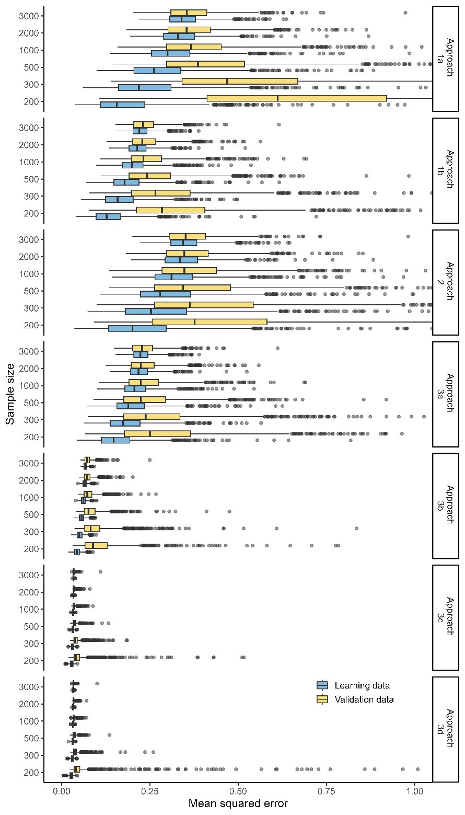
Supplementary Figure SF 2: Mean squared error over 1000 simulations of setting 2 with SNR of 4 (strong association between age, sex, age:sex and the response). The gray vertical dashed lines correspond to median MSE in internal validation data using BE-BIC with covariates entering linear only.

Average coefficient size of approach 1

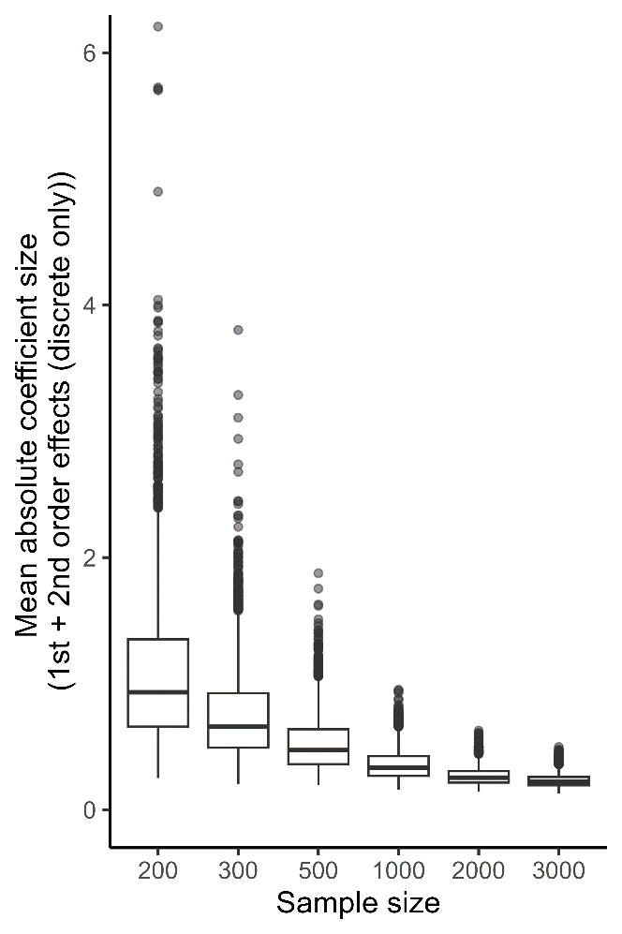

Supplementary Figure SF 3: Average coefficient size from Approach 1 (1st + 2nd order effects (discrete)) over 1000 simulations in setting 1. The true underlying coefficients are all zero.

Piecewise constant predictions of approach 1
The categorization of the continuous variable age leads to piecewise constant predictions that can be seen in Figure SF 4 (top and bottom panel). In practice, such jumps in the predictions are usually unrealistic. Using, e.g., restricted cubic splines (RCS) the predictions of the model are very close to the true effects over the entire range of age (middle panel).
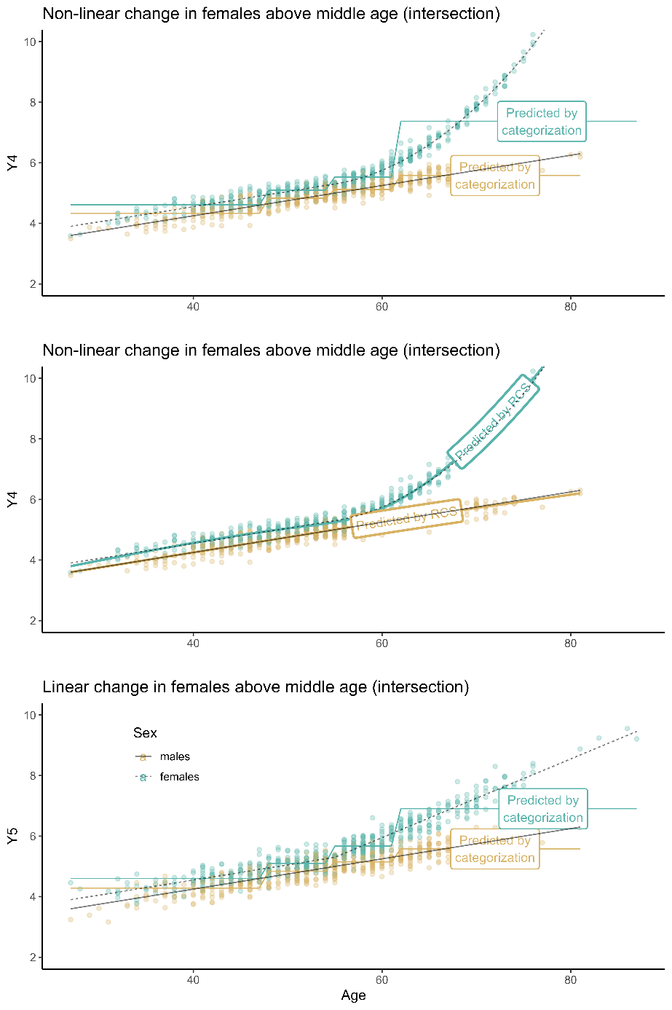

Supplementary Figure SF 4: top panel, approach 1a using arbitrary categorization of age predicts piecewise constant values of the response. Middle panel, approach 3c using restricted cubic splines, model-based predictions overlap the true effect. Bottom panel, approach 1a in a setting of a linear increase for females above middle age. (colored lines = predictions; black solid line = true effect for males, black dotted line = true effect for females).

Significance of strata
Figure SF 5 shows that the probability for a stratum to be significant depends on how close it lies to the reference stratum. For smaller and mediums sized dataset the problem is more pronounced.
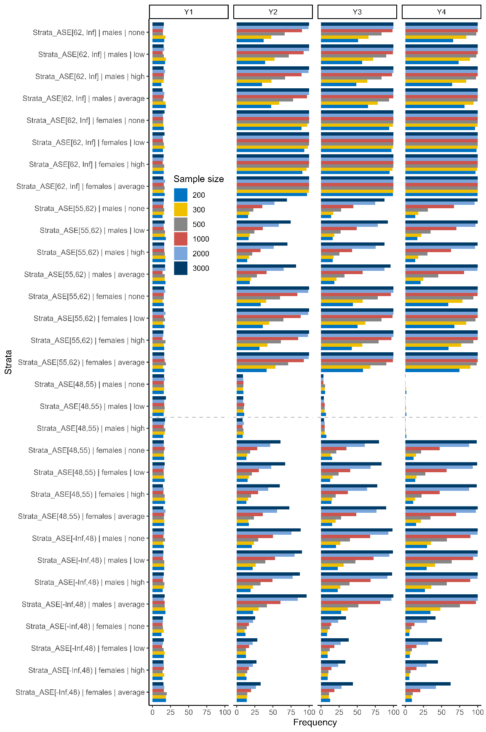

Supplementary Figure SF 5: : Frequencies of p-values <0.05 across all simulations. Gray dashed line represents location of reference category, i.e. from the center of the data.

BE-BIC and resampling
This study has in fact implemented an adapted version of a two-stage approach suggested for variable selection and finding the optimal functional form of a continuous covariate [1, 2]. The approach is as follows:
- Define different models modeling continuous covariates either linear or using a functional form
- Resample the data using bootstrap with replacement or repeated k-fold cross-validation [3]
  - Use BE-BIC to select variables (and interaction terms)
  - Predict outcome in internal validation data (out-of-bag) using the resulting model from BE-BIC
  - Use some model calibration measure such as MSE or strictly proper scoring rules corresponding to the modelled response [4, 5]
- Over all bootstrap iterations, count model selection frequencies and average the calibration criteria
In practice this approach, as all others, cannot guarantee to result in the true model and also other issues are involved [6]. However, as results of this study have shown, the probability of creating false-positive and spurious results is considerably lower compared with other proposals for examining intersectionality. In our example (setting 2 with SNR of 1; sample size = 1000), BE-BIC always selected the true model most frequently and had lowest MSE. We would decide for a model using the terms age + sex + age:sex and age modelled with RCS with three degrees of freedom (Supplementary Table ST1).
Supplementary Table ST 1: Summary of selection frequencies from BE-BIC (setting 2 with SNR of 1; sample size = 1000) and corresponding mean squared error in internal validation data.
Included terms | Selection frequency | Aproach | MSE
Age | Sex | Age:Sex | 45.20% | BE-BIC (linear) | 0.926
Age | Sex | Diabetes | Age:Sex | Age:Diabetes | 7.30% | BE-BIC (linear) | 0.924
Age | BMI | Sex | Age:BMI | Age:Sex | 6.50% | BE-BIC (linear) | 0.934
Age | Sex | Age:Sex | 68.00% | BE-BIC (rcs, df=2) | 0.772
Age | Sex | Diabetes | Age:Sex | Sex:Diabetes | 5.80% | BE-BIC (rcs, df=2) | 0.800
Age | Sex | Diabetes | Age:Sex | 4.70% | BE-BIC (rcs, df=2) | 0.775
Age | Sex | Age:Sex | 77.20% | BE-BIC (rcs, df=3) | 0.736
Age | Sex | Diabetes | Age:Sex | 6.00% | BE-BIC (rcs, df=3) | 0.745
Age | Sex | Diabetes | Age:Sex | Sex:Diabetes | 6.00% | BE-BIC (rcs, df=3) | 0.758
Age | Sex | Age:Sex | 79.80% | BE-BIC (rcs, df=4) | 0.739
Age | Sex | Diabetes | Age:Sex | Sex:Diabetes | 6.30% | BE-BIC (rcs, df=4) | 0.758
Age | Sex | Diabetes | Age:Sex | 6.10% | BE-BIC (rcs, df=4) | 0.746

Sensitivity analyses
In this analysis we assumed a more realistic setting and simulated a covariance structure being representative for the general population. We used a scientific use file of the German Ageing Survey [7, 8] from 2014; a nationwide study being representative for the adult German population > 40 years. Form this study we selected covariates age, sex, BMI, education (ISCED levels), and presence of diabetes.
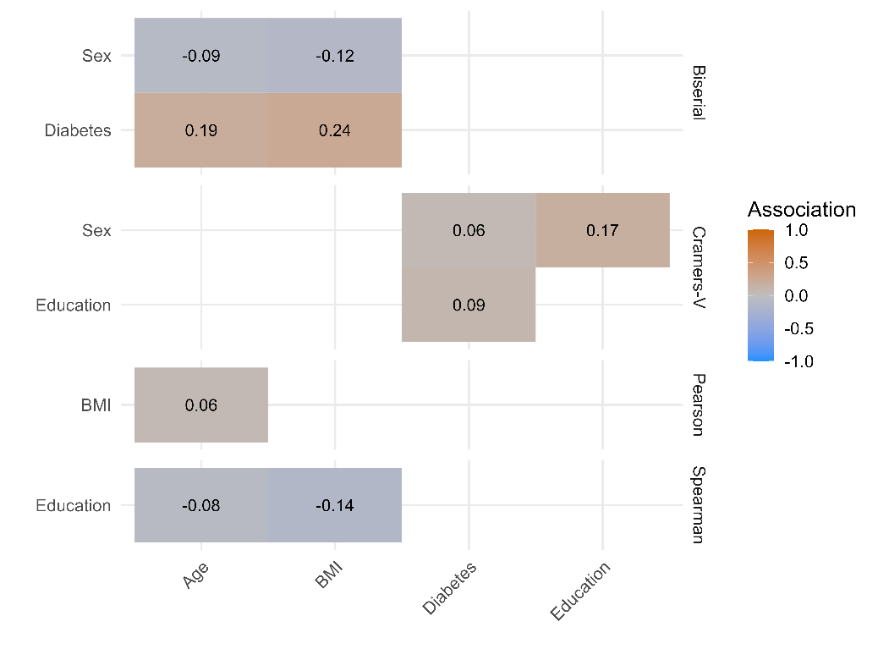

Supplementary Figure SF 6: All bivariate associations between age, sex, BMI, education, and diabetes in data of the German Ageing Survey 2014.

For simulations we used the following covariance matrix ($Σ$) which relates to the respective matrix of correlation ($M_{ρ}$):
$$Σ=\left[\begin{matrix}100 & 3 & -0.9 & -0.8 & 1.9 & 0 \\ 3 & 25 & -0.6 & -0.7 & 1.2 & 0 \\ -0.9 & -0.6 & 1 & 0.17 & 0.06 & 0 \\ -0.8 & -0.7 & 0.17 & 1 & 0.09 & 0 \\ 1.9 & 1.2 & 0.06 & 0.09 & 1 & 0 \\ 0 & 0 & 0 & 0 & 0 & 2\end{matrix}\right];M_{ρ}=\left[\begin{matrix}1.00 & 0.06 & -0.09 & -0.08 & 0.19 & 0 \\ 0.06 & 1.00 & -0.12 & -0.14 & 0.24 & 0 \\ -0.09 & -0.12 & 1.00 & 0.17 & 0.06 & 0 \\ -0.08 & -0.14 & 0.17 & 1.00 & 0.09 & 0 \\ 0.19 & 0.24 & 0.06 & 0.09 & 1.00 & 0 \\ 0.00 & 0.00 & 0.00 & 0.00 & 0.00 & 1\end{matrix}\right].$$

Setting 1 remained the same, i.e. none of the covariates was associated with the response. In setting 2 however, we included an interaction of BMI and diabetes in a form that a frailty score increases if high BMI and diabetes are present:
$y_{i}=β_{0}+β_{1}\left(A_{i}\right)+β_{2}\left(S_{i}\right)+β_{3}\left(I\left(A_{i}>mean\left(A\right)\right)A_{i}^{2}:S_{i}\right)+β_{4}\left(I\left(B_{i}>mean\left(B\right)\right)B_{i}^{2}:D\right)+ϵ_{i}$.
With: A = age, B = BMI, D = diabetes, and S = sex.

Results of setting 1

Supplementary Table ST 2: Simulation results for setting 1 on correctly identifying intercept only model (numbers in parentheses relate 25th, 50th 75th percentile of erroneously chosen terms).
Sample size | 1st + 2nd order (discrete) | 1st + 2nd order (mixed) | 3 group  strata | BE-BIC  (linear) | BE-BIC  (rcs, df=2) | BE-BIC  (rcs, df=3) | BE-BIC  (rcs, df=4)
200 | 1.80% (4; 7; 11) | 7.90% (2; 4; 6) | 5.40% (2; 4; 7) | 35.60% (0; 3; 6) | 47.10% (0; 1; 7) | 56.10% (0; 0; 7) | 56.10% (0; 0; 7)
300 | 1.50% (4; 7; 10) | 7.30% (2; 4; 6) | 5.80% (2; 4; 7) | 39.20% (0; 3; 5) | 51.70% (0; 0; 5) | 60.20% (0; 0; 3) | 64.70% (0; 0; 3)
500 | 1.20% (4; 7; 10) | 6.00% (2; 4; 6) | 4.20% (2; 4; 6) | 47.40% (0; 1; 3) | 61.40% (0; 0; 3) | 67.90% (0; 0; 3) | 72.00% (0; 0; 1)
1000 | 1.10% (5; 7; 10) | 4.60% (2; 4; 6) | 3.20% (2; 4; 7) | 56.90% (0; 0; 3) | 70.90% (0; 0; 1) | 77.40% (0; 0; 0) | 81.00% (0; 0; 0)
2000 | 0.70% (5; 7; 10) | 4.20% (2; 4; 6) | 2.30% (2; 4; 6) | 65.70% (0; 0; 3) | 79.90% (0; 0; 0) | 85.10% (0; 0; 0) | 87.50% (0; 0; 0)
3000 | 0.70% (4.75; 7; 10) | 4.50% (2; 4; 6) | 3.90% (2; 4; 6) | 69.00% (0; 0; 3) | 84.50% (0; 0; 0) | 88.30% (0; 0; 0) | 90.00% (0; 0; 0)

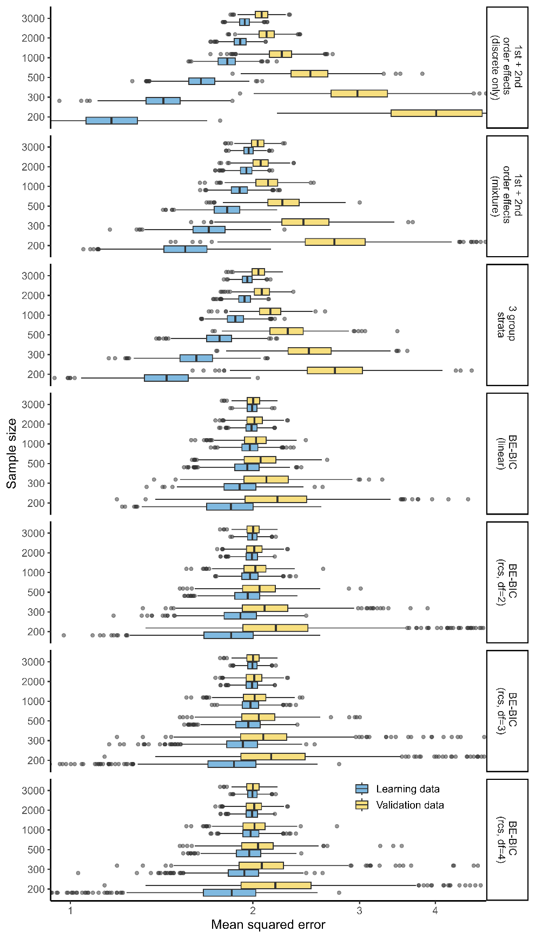
Supplementary Figure SF 7: Mean squared error over 1000 simulations of setting 1 (no association between covariates and the response) but with considerable more association between covariates in this sensitivity analysis. The gray vertical dashed lines correspond to median MSE in internal validation data using BE-BIC with covariates entering linear only.

Setting 2

Supplementary Table ST 3: Simulation results for setting 2 on correctly identifying age + sex + BMI + diabetes + age:sex + bmi:diabetes (numbers in parentheses relate 25th, 50th 75th percentile of erroneously chosen terms).
Sample size | Response | 1st + 2nd order (discrete) | 1st + 2nd order (mixed) | BE-BIC  (linear) | BE-BIC  (rcs, df=2) | BE-BIC  (rcs, df=3) | BE-BIC  (rcs, df=4)
200 | Y3 | 1.6% (2; 5; 9) | 37.9% (3; 5; 7) | 25.0% (0; 2; 4) | 37.0% (0; 2; 3) | 47.1% (0; 1; 2) | 47.1% (0; 1; 3)
300 | Y3 | 2.5% (3; 5; 8) | 52.3% (3; 5; 7) | 25.7% (0; 2; 4) | 45.0% (0; 1; 2) | 60.0% (0; 0; 2) | 63.2% (0; 0; 1)
500 | Y3 | 3.7% (3; 5; 8) | 69.3% (3; 5; 7) | 34.0% (0; 2; 3) | 55.1% (0; 0; 2) | 70.1% (0; 0; 1) | 72.1% (0; 0; 1)
1000 | Y3 | 12.0% (3; 5; 7.25) | 86.9% (4; 5; 7) | 34.1% (0; 2; 3) | 57.4% (0; 0; 2) | 77.1% (0; 0; 0) | 80.0% (0; 0; 0)
2000 | Y3 | 36.2% (3; 5; 8) | 97.3% (4; 6; 8) | 40.2% (0; 2; 2) | 64.1% (0; 0; 2) | 83.5% (0; 0; 0) | 85.6% (0; 0; 0)
3000 | Y3 | 55.9% (3.75; 5; 8) | 99.2% (4; 6; 8) | 44.5% (0; 2; 2) | 63.8% (0; 0; 2) | 87.0% (0; 0; 0) | 88.3% (0; 0; 0)
* Note, approach 2 (stratification) was not included as identification of the true underlying effects is not possible using this approach.

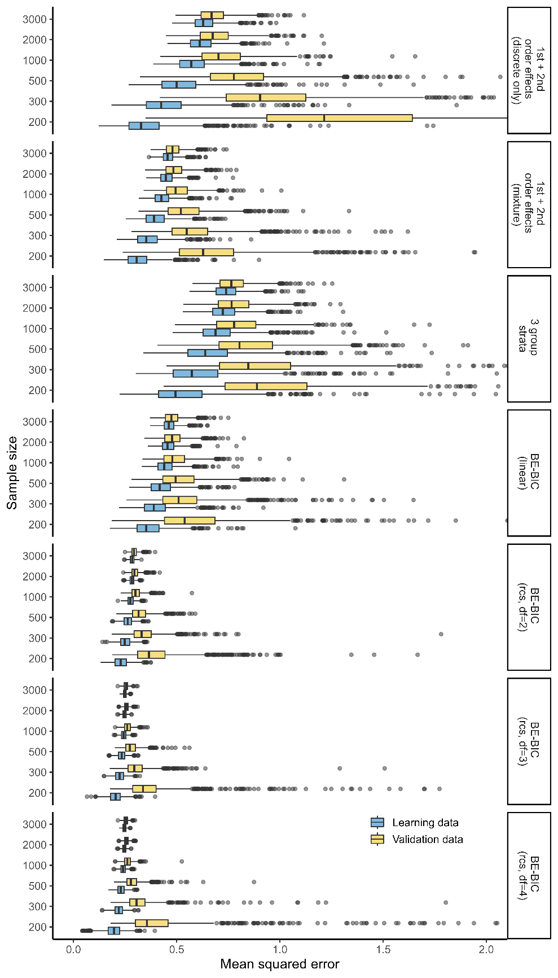
Supplementary Figure SF 8: Mean squared error over 1000 simulations of setting 2 with SNR of 1 (moderate association between age, sex, BMI, diabetes, age:sex, BMI:diabetes, and the response). The gray vertical dashed lines correspond to median MSE in internal validation data using BE-BIC with covariates entering linear only.

BE-BIC and resampling
In our example (setting 2 with SNR of 1; sample size = 1000), BE-BIC always selected the true model most frequently and had lowest MSE. We would decide for a model using the terms age + sex + BMI + Diabetes + age:sex + BMI:diabetes; age and BMI would be modelled using RCS with three degrees of freedom (Supplementary Table ST1).

Supplementary Table ST 4: Summary of selection frequencies from BI-BIC and corresponding mean squared error in internal validation data.
Included terms | Selection frequency | Aproach | MSE
Age | BMI | Sex | Diabetes | Age:Sex | BMI:Diabetes | 23.70% | BE-BIC (linear) | 0.4755
Age | BMI | Sex | Diabetes | Age:Sex | Age:Diabetes | BMI:Diabetes | 18.20% | BE-BIC (linear) | 0.4808
Age | BMI | Sex | Diabetes | Age:BMI | Age:Sex | BMI:Diabetes | 8.80% | BE-BIC (linear) | 0.4945
Age | BMI | Sex | Diabetes | Age:Sex | BMI:Diabetes | 59.00% | BE-BIC (rcs, df=2) | 0.3000
Age | BMI | Sex | Diabetes | Age:Sex | Age:Diabetes | BMI:Diabetes | 12.20% | BE-BIC (rcs, df=2) | 0.3029
Age | BMI | Sex | Diabetes | Age:BMI | Age:Sex | BMI:Diabetes | 7.50% | BE-BIC (rcs, df=2) | 0.3104
Age | BMI | Sex | Diabetes | Age:Sex | BMI:Diabetes | 85.60% | BE-BIC (rcs, df=3) | 0.2599
Age | BMI | Sex | Diabetes | Age:Sex | BMI:Diabetes | Sex:Diabetes | 4.70% | BE-BIC (rcs, df=3) | 0.2642
Age | BMI | Sex | Diabetes | Age:Sex | Age:Diabetes | BMI:Diabetes | 1.80% | BE-BIC (rcs, df=3) | 0.2762
Age | BMI | Sex | Diabetes | Age:Sex | BMI:Diabetes | 86.00% | BE-BIC (rcs, df=4) | 0.2612
Age | BMI | Sex | Diabetes | Age:Sex | BMI:Diabetes | Sex:Diabetes | 5.70% | BE-BIC (rcs, df=4) | 0.2650
Age | BMI | Sex | Education | Diabetes | Age:Sex | BMI:Diabetes | 1.80% | BE-BIC (rcs, df=4) | 0.2605

REFERENCE LIST

[1] Sauerbrei W, Royston P, Binder H. Selection of important variables and determination of functional form for continuous predictors in multivariable model building. Statistics in Medicine. 2007;26:5512-28. https://doi.org/10.1002/sim.3148.
[2] Buchholz A, Holländer N, Sauerbrei W. On properties of predictors derived with a two-step bootstrap model averaging approach—A simulation study in the linear regression model. Computational Statistics & Data Analysis. 2008;52:2778-93. https://doi.org/10.1016/j.csda.2007.10.007.
[3] Filzmoser P, Liebmann B, Varmuza K. Repeated double cross validation. Journal of Chemometrics. 2009;23:160-71. https://doi.org/10.1002/cem.1225<.
[4] Gneiting T, Raftery AE. Strictly proper scoring rules, prediction, and estimation. Journal of the American Statistical Association. 2007;102:359-78. https://doi.org/10.1198/016214506000001437.
[5] Czado C, Gneiting T, Held L. Predictive model assessment for count data. Biometrics. 2009;65:1254-61. https://doi.org/10.1111/j.1541-0420.2009.01191.x.
[6] Sauerbrei W, Perperoglou A, Schmid M, Abrahamowicz M, Becher H, Binder H, et al. State of the art in selection of variables and functional forms in multivariable analysis—outstanding issues. Diagnostic and Prognostic Research. 2020;4:3. https://doi.org/10.1186/s41512-020-00074-3.
[7] Deutsches Zentrum für Altersfragen - FDZ (2022). SUF Deutscher Alterssurvey (DEAS) 1996-2021-doi: 10.5156/DEAS.1996-2021.M.002. 2022.
[8] Klaus D, Engstler H, Mahne K, Wolff JK, Simonson J, Wurm S, et al. Cohort Profile: The German Ageing Survey (DEAS). International Journal of Epidemiology. 2017;46:1105-g. https://doi.org/10.1093/ije/dyw326.

