Supporting Information

Charge Transfer Mechanism for Realization of Double Negative Differential Transconductance

Kyu Hyun Han,¹ Seung-Hwan Kim,² Seung-Geun Kim,³ Jong-Hyun Kim,³ Sungjoo Song,³ and Hyun-Yong Yu^{1,*}

K.-H. Han, Prof. H.-Y. Yu
¹School of Electrical Engineering, Korea University, Seoul 02841, Korea

*corresponding author : yuhykr@korea.ac.kr

Dr. S.-H. Kim
²Center for Spintronics, Korea Institute of Science and Technology (KIST), Seoul 02792, Republic of Korea

Dr. S.-G. Kim, J.-H. Kim, S.-j. Song
³Department of Semiconductor Systems Engineering, Korea University, Seoul 02841, Korea

KEYWORDS: anti-ambipolar transistor, negative differential transconductance, peak voltage modulation, quaternary inverter, multi-valued logic

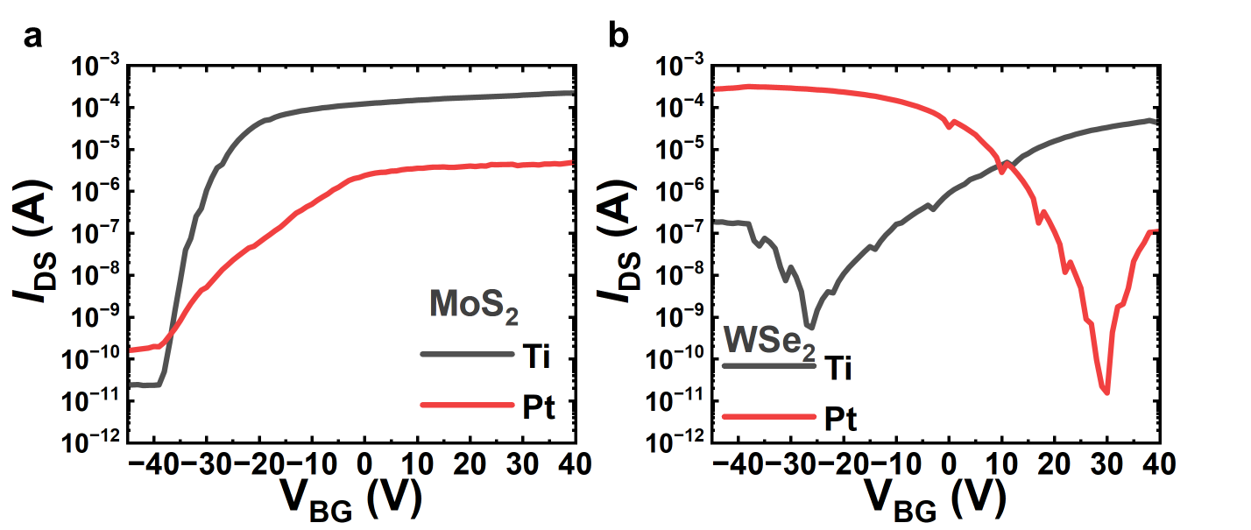
Fig. S1. The electrical characteristics of MoS₂, WSe₂ FET with Ti and Pt contact metals, respectively.

Fig. S1 shows the electrical characteristics of MoS₂ and WSe₂ FET with Ti, Pt contact metals, respectively. As shown in Fig. S1a, although the MoS₂ FET maintains n-type characteristics regardless of contacted metals, it exhibits a higher I_{on} when Ti is used as the contact metal than Pt. Additionally, as shown in Fig. S1b, the WSe₂ FET demonstrates ambipolar behavior due to mid-gap Fermi level pinning, however, by using Ti and Pt as contacts, it was achieved to n-type and p-type characteristics, respectively. From this results, regardless of strong Fermi level pinning effect of 2D materials, the threshold voltage (V_{TH}) and on-current (I_{on}) of FET can vary depending on the work function of contact metals. Therefore, based on this experimental evidence, to form the widest overlapping area, Ti and Pt are the most suitable contact metals for MoS₂ and WSe₂, respectively.

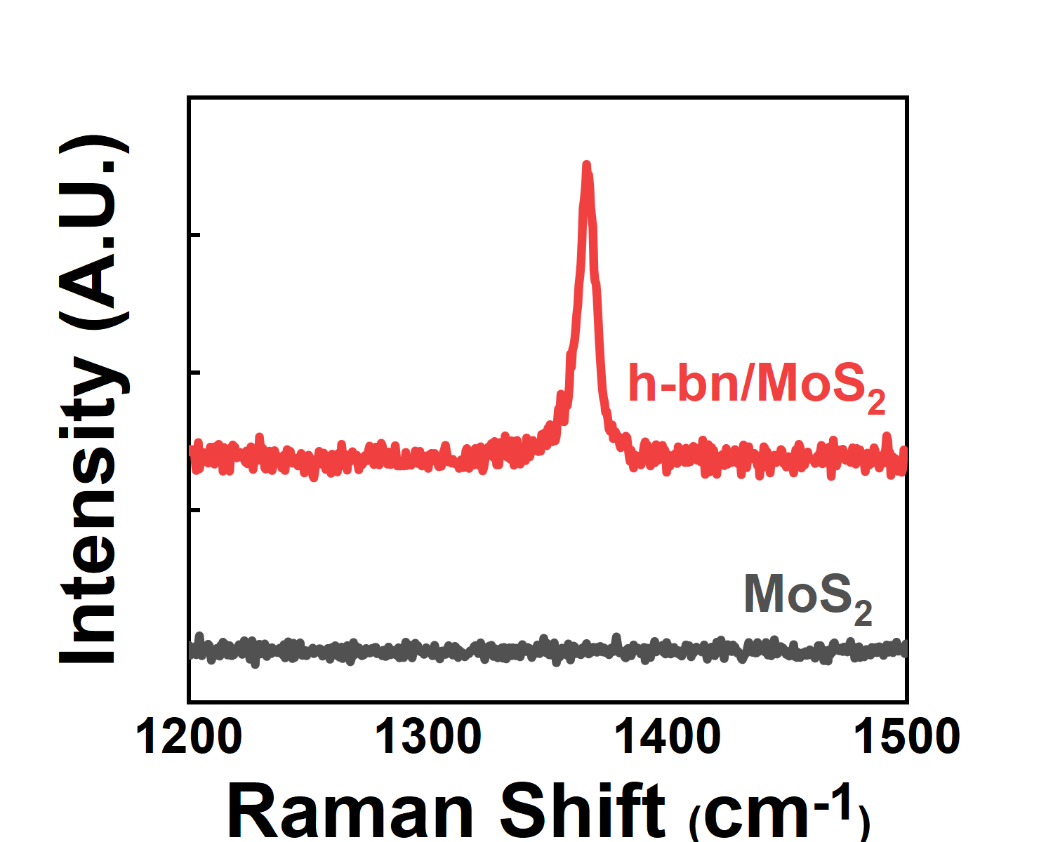
Fig. S2. The Raman spectra of MoS₂ and h-bn/MoS₂.

In the anti-ambipolar transistor (AAT) w/ AuCl₃ manufacturing process, after covering h-bn on the MoS₂ channel, the Raman spectra measurement was performed to confirm the adhesion of h-bn/MoS₂. Compared to the pristine MoS₂ channel, the Raman peak was appeared at h-bn/MoS₂ area. This Raman peak corresponding to the E_{2g} vibration peak of h-bn, and this result means that the h-bn covering process on MoS₂ had stably proceeded.

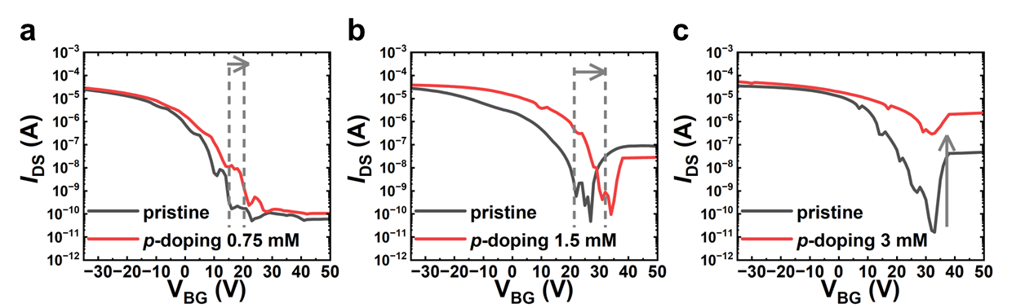
Fig. S3. The electrical characteristics of WSe₂ FET before and after p-doping process, including the AuCl₃ concentration of a 0.75 mM, b 1.5 mM, c 3 mM.

Fig. S3 shows the electrical characteristics of the WSe₂ FET before and after p-doping with the AuCl₃ concentration of 0.75mM, 1.5mM, 3mM, respectively. As shown in Fig. S3a, when the AuCl₃ concentration is 0.75mM, the shifted V_{TH} value can be significantly low, making it impractical to achieve the NDT peak. In contrast, as shown in Fig. S3c, at AuCl₃ concentrations of 3mM, the off current of WSe₂'s electrical curve increases, potentially leading to the formation of an incomplete NDT peak, regardless of the shifted value. Therefore, as shown in Fig. S3b, the AuCl₃ concentration of 1.5mM represents the optimal p-doping condition for WSe₂, as it maintains a low off current while achieving the highest shifted value of the WSe₂ electrical curve.

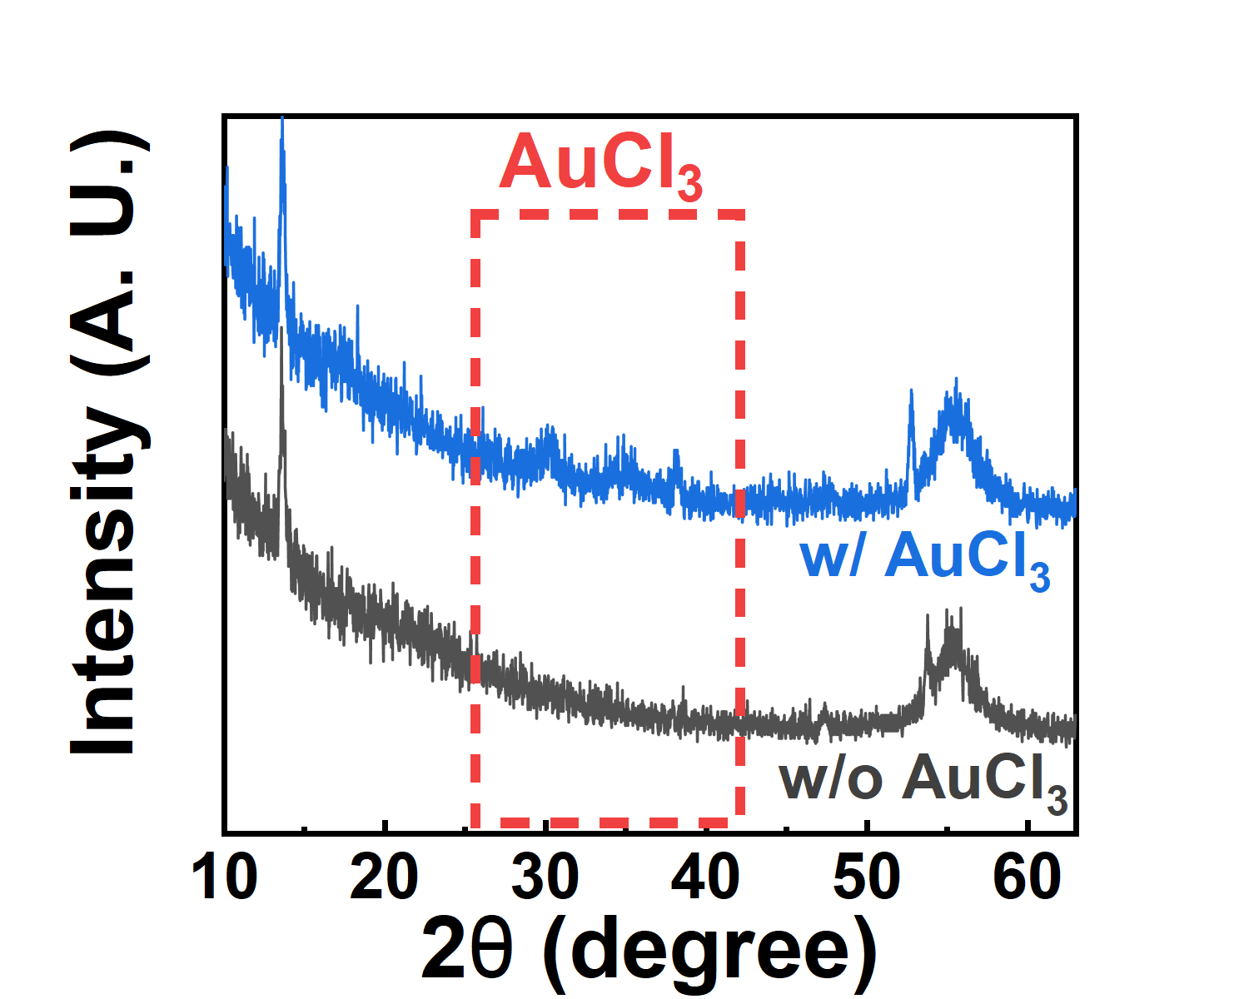
Fig. S4. The XRD spectra of the WSe₂ w/ and w/o AuCl₃.

To investigate the final device structure, AuCl₃ was coated on the WSe₂ channel in the AAT heterostructure. For the existence confirmation of the AuCl₃ on WSe₂ channel, the X-ray diffraction (XRD) measurement was performed on WSe₂ w/o and w/ AuCl₃, respectively. After coating the AuCl₃ on WSe₂ channel, the XRD peak of AuCl₃ was observed near 35 degree, indicating that AuCl₃ was stably deposited on WSe₂ channel.

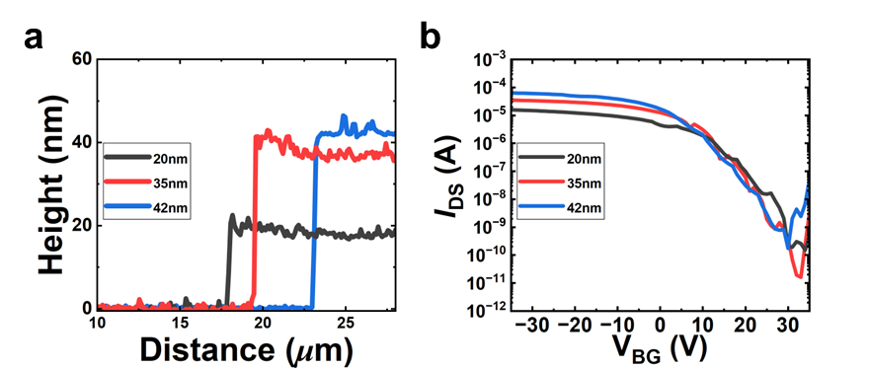
Fig. S5. a The heigh profiles of WSe₂ with various thickness. b The electrical characteristics of WSe₂ FET with various thickness.

Fig. S5 shows the AFM height profiles and electrical curves of various thicknesses WSe₂ FETs. As shown in Fig. S5a, the electrical measured WSe₂ flakes were 20nm, 35nm, 42nm, respectively. As depicted in Fig. S5b, regardless of thickness, the on/off current ratio appears relatively consistent. In contrast, I_{on} can be increased by up to thickness due to the higher charge quantity. Therefore, to implement the NDT peak with high PVCR, utilizing thicker thickness proves advantageous.

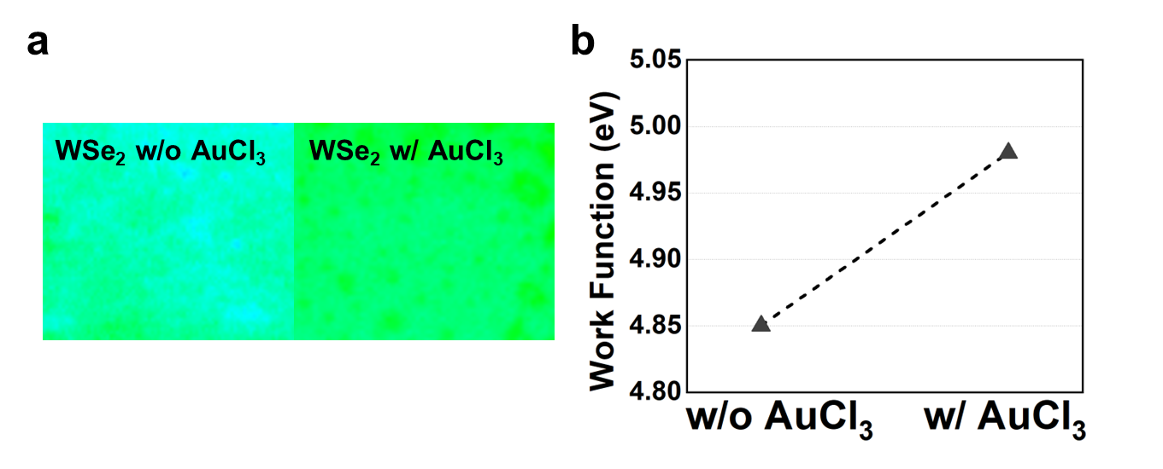
Fig. S6. a The KPFM colored mapping images, and b the quantitative value of the WSe₂ w/o and w/ AuCl₃, respectively.

Fig. S6 presents the kelvin probe force microscopy (KPFM) experimental results of the WSe₂ channel w/o and w/ AuCl₃, respectively. Before measuring the absolute work function of WSe₂ channel, the highly oriented pyrolytic graphite (HOPG) as reference materials must be measured to calibrate the KPFM tip. Fig. S6a presents the KPFM colored mapping images of the WSe₂ w/o and w/ AuCl₃, respectively. As shown in Fig. S6a, after p-doping of WSe₂, the KPFM mapping color of WSe₂ w/o AuCl₃ was changed by increasing the work function, due to p-doping effect. Fig. S6b shows the average work function quantitative values of the WSe₂ w/o and w/ AuCl₃ from result of Fig. 2b.

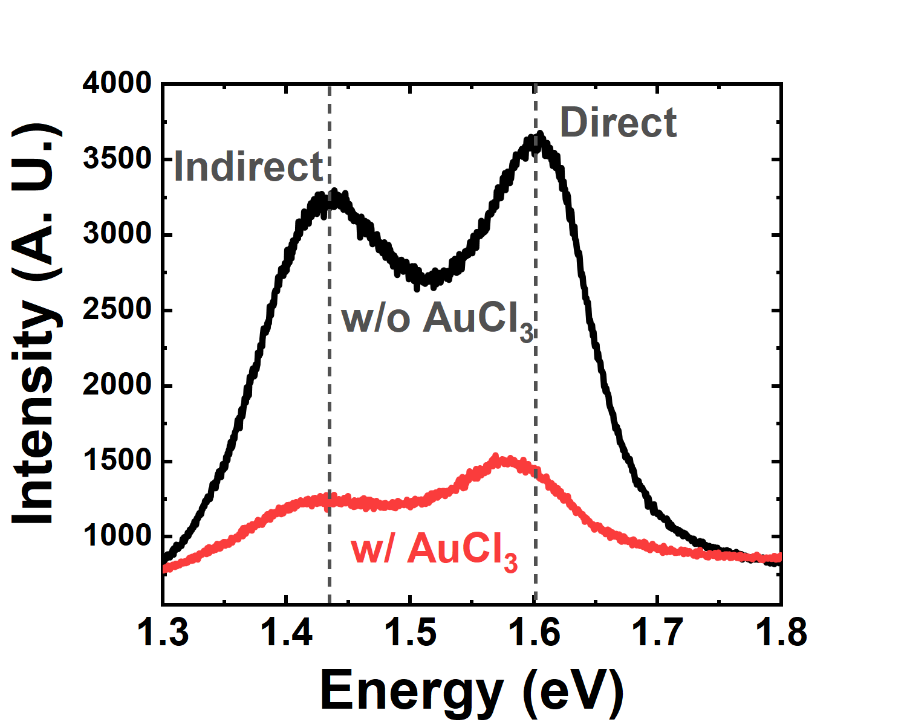
Fig. S7. The photoluminescence (PL) of the WSe₂ w/o and w/ AuCl₃, respectively.

The photoluminescence (PL) of WSe₂ w/o and w/ AuCl₃ were measured to analyze the p-doping effect of AuCl₃ dopant. First, as shown in WSe₂ w/o AuCl₃ (black solid line) of Fig. S7, the two peaks of WSe₂ were appeared as indirect (1.43 eV) and direct (1.6 eV) peak. Specially, the direct peak was composed of exciton peak (1.59 eV) and trion peak (1.64eV). Second, as shown in WSe₂ w/ AuCl₃ (red solid line) of Fig. S7, the indirect peak is the same as the WSe₂ at 1.43 eV. Additionally, it was confirmed that the direct peak of WSe₂ w/ AuCl₃ was shifted from 1.6 eV to 1.58 eV compared to WSe₂ w/o AuCl₃. Then, this direct peak intensity of WSe₂ w/ AuCl₃ was quenched compared to WSe₂ w/o AuCl₃. Because the exciton peak of this direct peak is reduced by the p-doping effect of AuCl₃, the direct peak is red-shifted for the dominant trion peak. Then, the direct peak intensity of WSe₂ was reduced, owing to the decrease of exciton peak intensity by p-doping effect. Therefore, we confirmed the p-doping effect of WSe₂ through PL analysis.

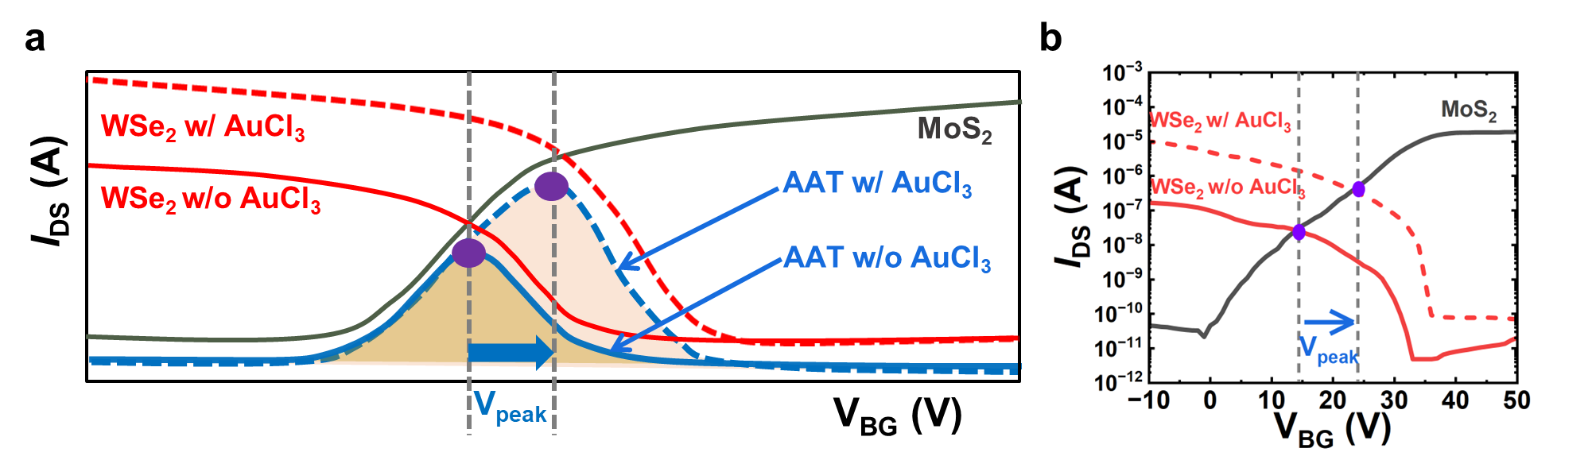
Fig. S8. a Electrical schematic illustration of the V_{peak} modulation mechanism. b Electrical curves of MoS₂ channel, and WSe₂ channel w/o and w/ AuCl₃.

Fig. S8a shows the schematic electrical curve to explain the V_{peak} modulation mechanism of the AAT through the doping technique. The NDT peak forms in the overlap area between the electrical curves of MoS₂ and WSe₂ (blue solid line, AAT w/o AuCl₃). Then, as shown by the purple point, V_{peak} can be defined as the overlapping point between the electrical curves of MoS₂ and WSe₂. After p-doping of the WSe₂ channel in the AAT w/ AuCl₃, the electrical curve of WSe₂ is right-shifted (red dotted line, WSe₂ w/ AuCl₃). The V_{peak} value can be changed by the threshold voltage (V_{TH}) positive shift of WSe₂ through the p-doping effect (blue dotted line, AAT w/ AuCl₃). Furthermore, after p-doping of the WSe₂ channel, the PVCR can be increased because of the transition of I_{peak}/I_{valley} by increasing the on-current (I_{on}). Fig. S8b shows the experimental electrical curve of MoS₂, and WSe₂ w/o and w/ AuCl₃, respectively. As shown in Fig. S8b, after p-doping (w/ AuCl₃), the overlapping point between MoS₂ and WSe₂ is changed by the transition of electrical curve of WSe₂.

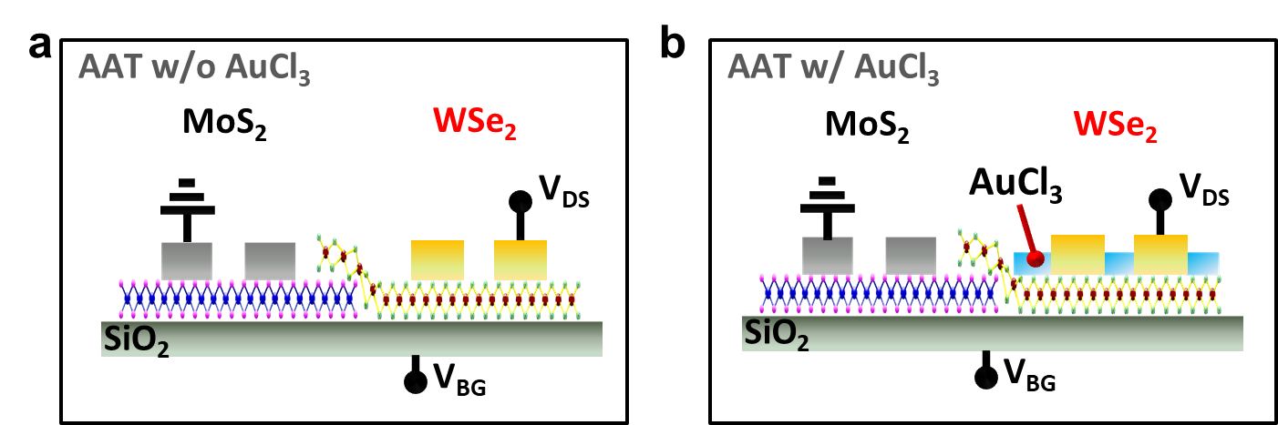
Fig. S9. The 2D cross-sectional structure of AAT a w/o and b w/ AuCl₃.

Fig. S9 presents the 2D cross-sectional structure of AAT w/o and w/ AuCl₃. Fig. S9a shows the AAT w/o AuCl₃ before covering the AuCl₃ on WSe₂ channel. Fig. S9a is the device structure from which the electrical results of Fig. 3a were derived. Fig. S9b presents the AAT w/ AuCl₃, by covering the AuCl₃ layer on WSe₂ channel in AAT w/o AuCl₃. The electrical curve in Fig. 3b is derived from the device structure of Fig. S9b.

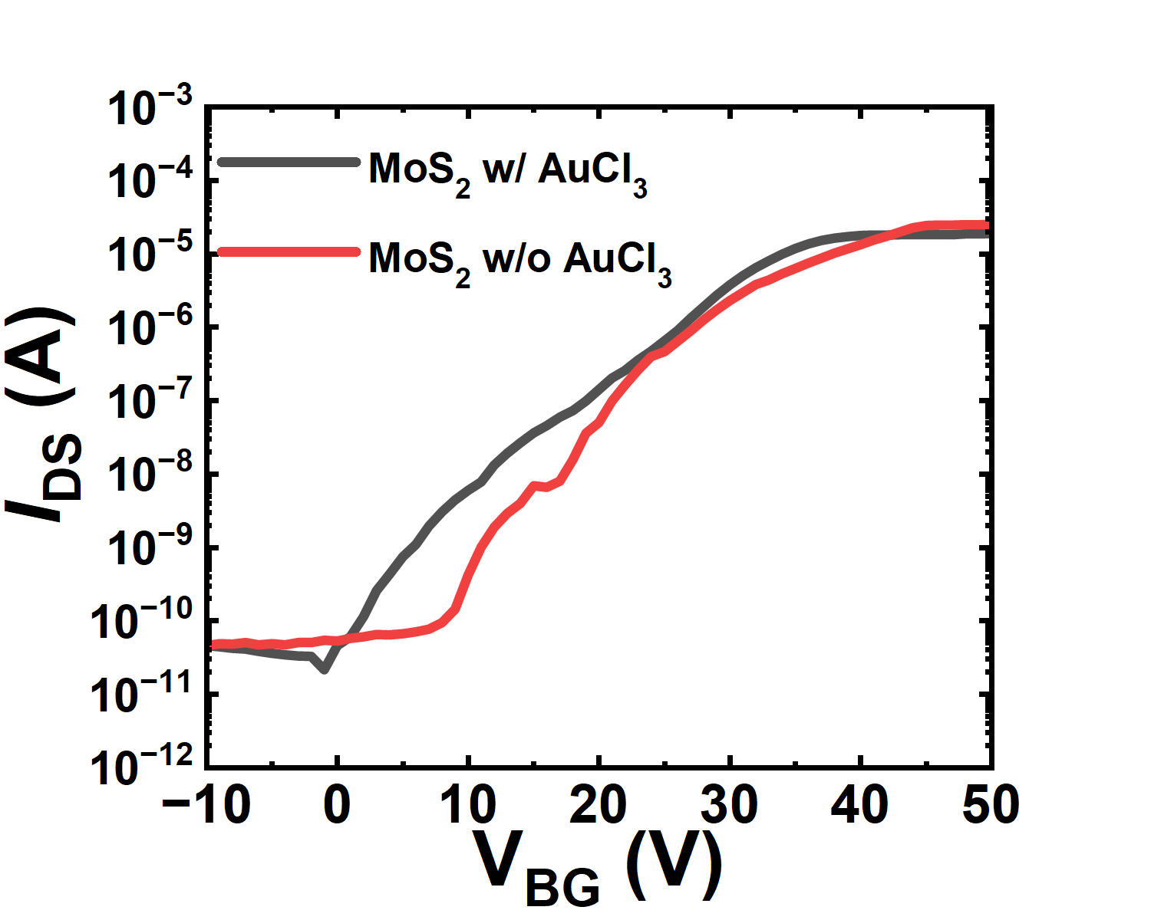
Fig. S10. The electrical characteristics of h-bn/MoS₂ channel before (w/o) and after (w/) AuCl₃ coating in AAT.

In the anti-ambipolar transistor (AAT) w/ AuCl₃ manufacturing process, before AuCl₃ coating on WSe₂ channel, to supress the p-dopig effect of MoS₂, there is a process of protecting the MoS₂ channel with h-bn. Fig. S10 shows the electrical characteristics of h-bn/MoS₂ channel w/o and w/ AuCl₃. As shown in Fig. S10, after p-doping of WSe₂, the electrical curve of the MoS₂ channel was hardly changed compared to MoS₂ channel before p-doping. In particular, because there is almost no change in I_{on} of the MoS₂ channel before and after doping, the slight change near the V_{TH} of the electrical curve is influenced by other process factors.

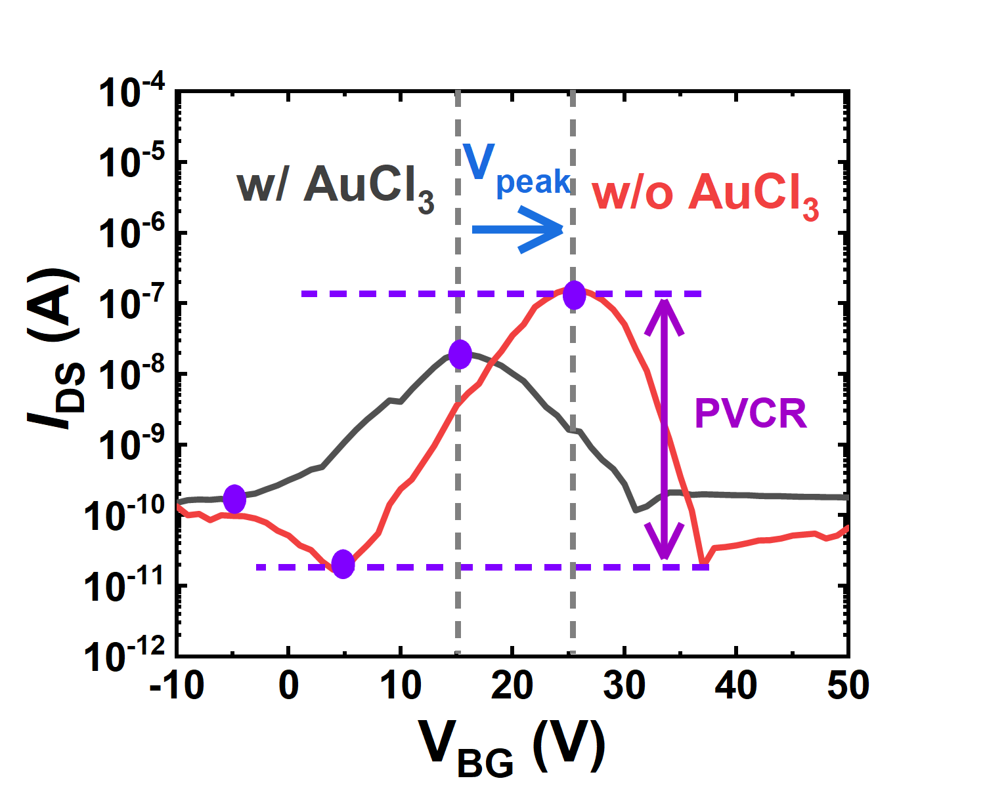
Fig. S11. The XRD spectra of the Control and p-doped WSe₂.

Fig. S11 shows the NDT electrical characteristics of the AATs w/o and w/ AuCl₃, at log scale from Fig. 3c. From this result, after p-doping, it is confirmed that the V_{peak} and PVCR of NDT peak have modulated.

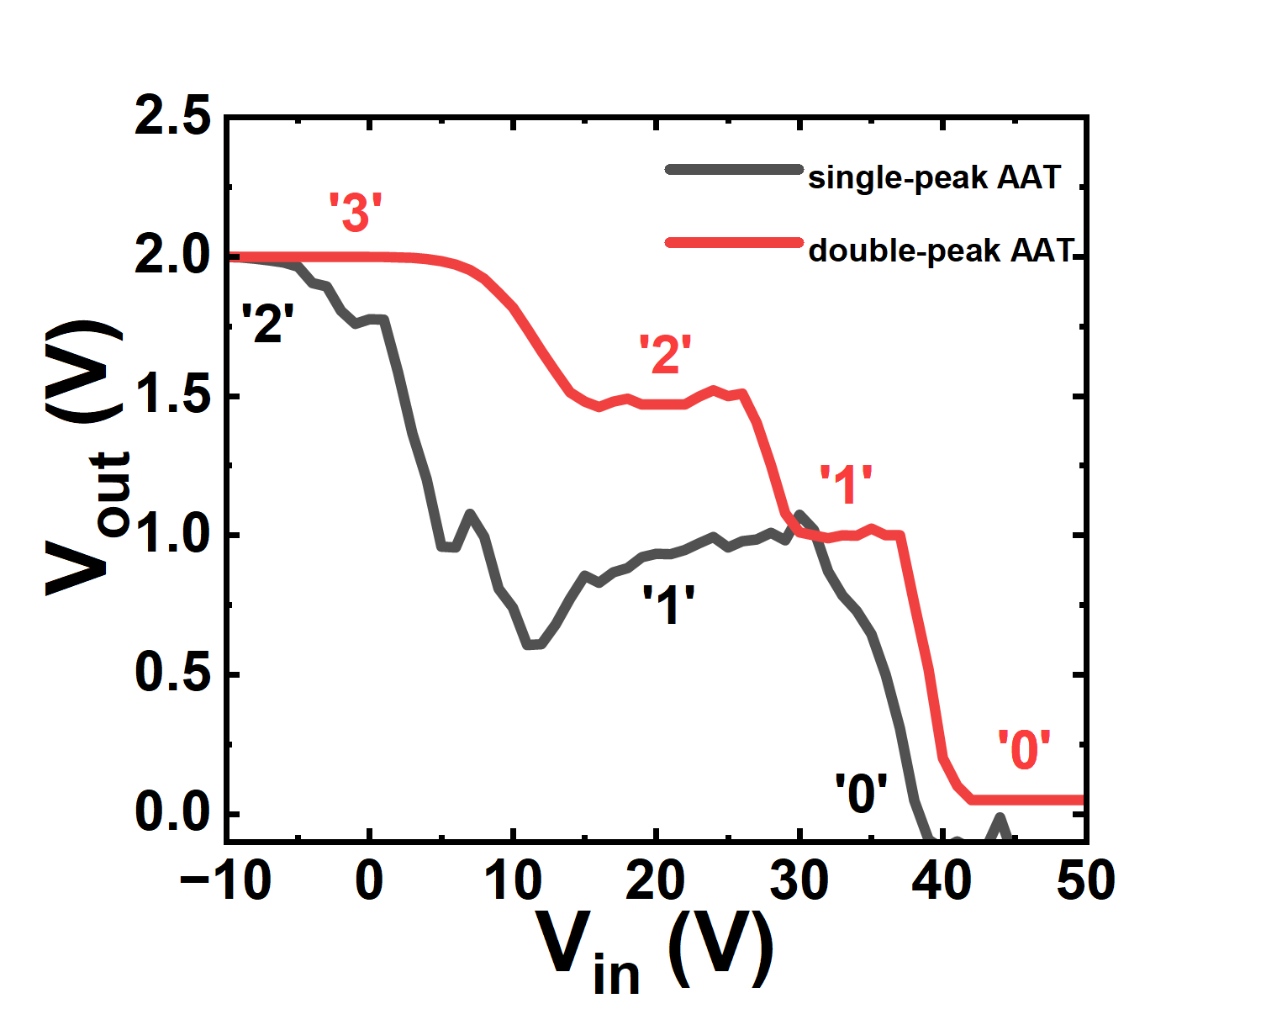
Fig. S12. Voltage transfer characteristics (VTC) of quaternary inverter at V_{DD} = 2 V, based on single-peak AAT and double-peak AAT.

Fig. S12 presents the VTCs of ternary and quaternary inverter, by single- and double-peak AAT, respectively. In single-peak AAT, the ternary inverter was implemented by forming the middle logic state. Furthermore, in double-peak AAT, the quaternary inverter was implemented by forming two additional logic state. As shown in Fig. S12, it confirmed that the number of NDT peak can induce the intermediate logic state. Therefore, as a results, our double-peak AAT have the high reliability for stable implementation of quaternary inverter.

