Uncropped western blotting figures
Figure5-uncropped:
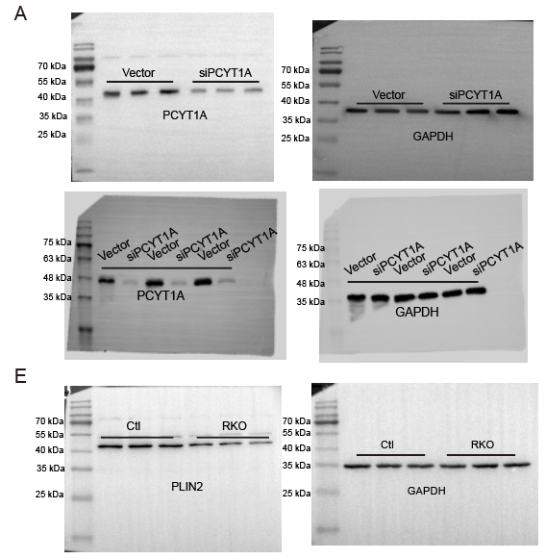

Figure8-uncropped:
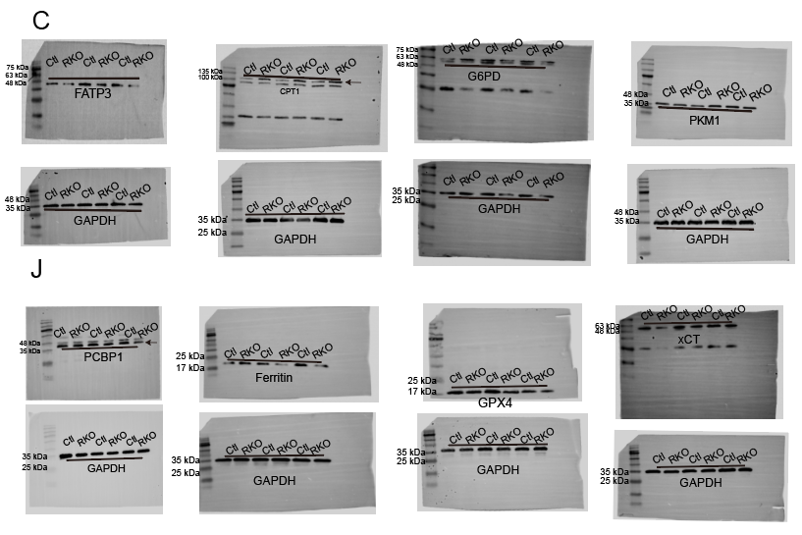

FigureS2-uncropped:
55 kDa
40 kDa
35 kDa
70 kDa
55 kDa
40 kDa
35 kDa

GAPDH
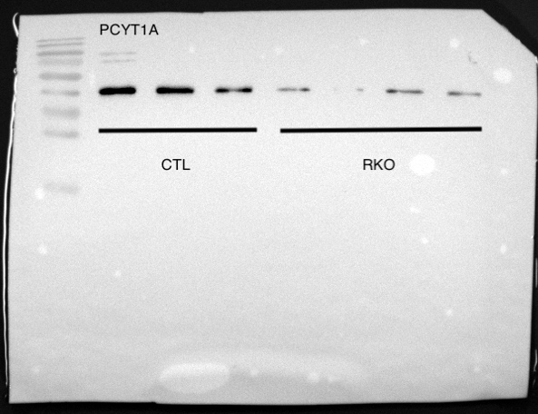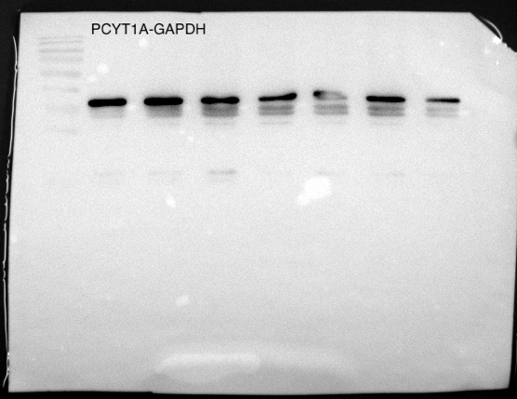
GAPDH
40 kDa
35 kDa
40 kDa
35 kDa
55 kDa

