PCYT1A deficiency disturbs fatty acid metabolism and induces ferroptosis in mice retina
Kaifang Wang^{1#}, Huijuan Xu^{1,2#}, Rong Zou¹, Guangqun Zeng³, YeYuan⁴, Xianjun Zhu^{1,2,5}, Xiaohui Zhao³*, Jie Li^{1,6} *, Lin Zhang^{1,2,5}*
¹The Sichuan Provincial Key Laboratory for Human Disease Gene Study and Department of Laboratory Medicine, Center for Medical Genetics, Sichuan Provincial People’s Hospital, School of Medicine, University of Electronic Science and Technology of China, Chengdu, Sichuan, 610072, China;
²Key Laboratory of Tibetan Medicine Research, Chinese Academy of Sciences and Qinghai Provincial Key Laboratory of Tibetan Medicine Research, Northwest Institute of Plateau Biology, Xining, Qinghai 810008, China;
³The people’s hospital of Pengzhou, Chengdu, Sichuan, 611930, China;
⁴ Medical Center Hospital of QiongLai City, Chengdu, Sichuan, 611530, China
⁵ Research Unit for Blindness Prevention of Chinese Academy of Medical Sciences (2019RU026), Sichuan Academy of Medical Sciences and Sichuan Provincial People’s Hospital, Chengdu, Sichuan, 610072 China.
⁶ Department of Ophthalmology, Sichuan Provincial People's Hospital, School of Medicine, University of Electronic Science and Technology of China, Chengdu, Sichuan, 610072, China

#Authors contribute equally to this work
*Correspondence: Prof. Lin Zhang, zhanglin202@uestc.edu.cn or Dr. Jie Li, doctorjacklee@163.com or Prof. Xiaohui Zhao, xhzhao@nwipb.cas.cn

Figure S1. Single-cell sequencing map of mouse retina shows that Pcyt1a is mainly expressed in Müller glia cells. (A) The expression profile of Pcyt1a in single-cell sequencing maps of mouse retina at 3 months of age. The results show that Pcyt1a is mainly expressed in Müller glia cells cluster. The red dashed box indicates the Müller glia cells cluster, and the blue dashed box indicates the rod cells cluster. Each dot represents a cell, and the darker the color, the higher the expression level. (B) The expression profiles of Müller glia cell-specific makers Slc1a3 and Rlbp1 in single-cell sequencing maps of mouse retina respectively, proving that the cell population within the red dashed box is the Müller glia cells cluster.

Figure S2. Construction strategy and validation of retina-specific knockout of Pcyt1a mouse model. (A) Scheme showing the construction strategy for Pcyt1a-RKO mice. (B) Genotyping of RKO mice by PCR. (C) Immunoblotting experiments showed that the PCYT1A protein was reduced in RKO mice. Sample size, n=6.
Figure S3. Fundus images and OCT scanning photos on Ctl and RKO mice at 2-months of age.
Figure S4. H&E staining of retinas from 10-month-old mice. H&E staining on the retina from 10-month-old mice (left), and thickness quantification of the PRS, ONL and INL (right). Sample size n=3. Scale bar 20μm. PRS, photoreceptor segment; ONL, outer nuclear layer; INL, inner nuclear layer.

Figure S5. Immunofluorescence staining of retina in 2-month-old mice.
(A-F) Immunofluorescence staining of retinal rod cells in 2-month-old mice. RHO in green, NaK in red, DAPI in blue. Scale bar, 20μm. OS, outer segment; IS, inner segment; ONL, outer nuclear layer. (G-L) Immunofluorescent staining of retinal cone cells from 2-month-old mice, M-opsin in green, PNA in red and DAPI in blue. Scale bar, 20μm. (M-O) Figures indicate the results of statistical analysis of the length of OS, IS and PNA (indicate the photoreceptor segment of cone cell). Sample size n=3; *** P < 0.001.

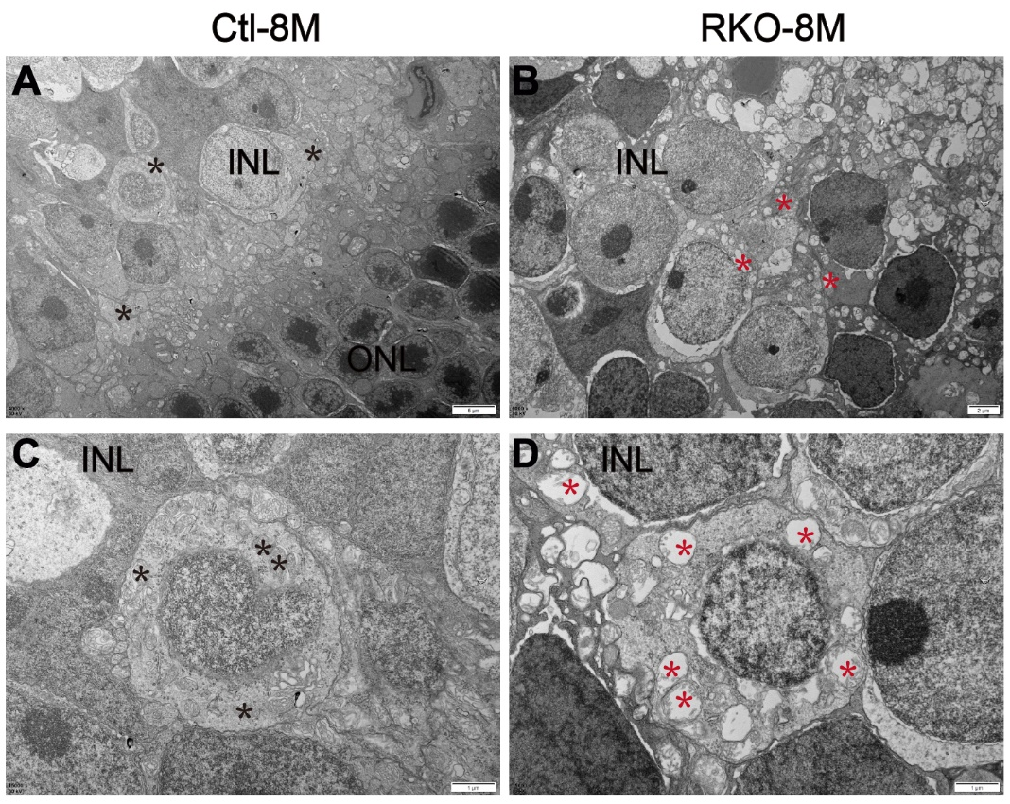
Figure S6. Transmission electron microscopy of retinas from RKO and Ctl mice at 8-month of age. ONL outer nucleus player; INL, inner nucleus player; Asterisk in black indicate the mitochondria from INL of RKO retina; Asterisk in red indicate the mitochondria from INL of RKO retina; Scale bar, 2μm for A-B, and 1μm for C-D.

Figure S7. Detection of ferroptosis indicators in ARPE-19 cells without OA induction. (A) There was no significant change in the levels of free fatty acids in siPCYT1A group compared with Vector group. (B) ROS was increased in siPCYT1A group compared with Vector group. Flow cytometry peaks are shown on the left, blue curve represents the Vector group and red curve represents the siPCYT1A group. Relative quantitative statistics are plotted on the right. (C) The siPCYT1A cells exhibited higher FAO levels. (D) Mitochondrial Fe²⁺ did not changed in siPCYT1A group compared with Vector group. Flow cytometry peaks are shown on the left, blue curve represents the Vector group and red curve represents the siPCYT1A group. (E) GSSG/GSH levels did not changed in siPCYT1A cells. (F) Peroxidized lipids did not changed in siPCYT1A group compared with Vector group. Flow cytometry peaks are shown on the left, blue curve represents the Vector group and red curve represents the siPCYT1A group. Sample size n=4, ***P<0.0001. ns, not significant.

