Interactions between the protein barnase and co-solutes studied by NMR
Clare R. Trevitt, Yashwanth Kumar D. R., Nicholas J. Fowler and Mike P. Williamson

Supplementary Material
Supplementary Material contains a table of fitted data for all co-solutes as a separate text file (Table S1), a figure showing the hydrogen bonding network around L42 and R83, a figure showing chemical shift changes for N, H and C’ on titration with a 1:1 mixture of thiocyanate and sulfate, and a figure showing chemical shift changes for methyl H and C on titration with TMAO.
Table S1
This file has a separate line for each nucleus (amide proton, amide nitrogen, and amide carbonyl) and each co-solute. Each line contains two sets of data. Columns 4-10 contain values fitted to the full equation (3), namely m_{L}, Δδ_{max}, and K_{d}, together with their associated errors, and the χ² value for the fitting. Columns 14-18 contain values fitted to the simple linear equation Δδ_{max}, = m_{L}[L] + c, again with the errors and χ² values. The choice as to which of these values to use was usually dictated by the criteria set out in the Methods section of the main text. Namely, the full fit was used, unless K_{d} was outside the range of 5 – 900 mM, or the fitted absolute value of Δδ_{max} was less than 0.03 ppm for ¹H, or 0.06 ppm for ¹⁵N or ¹³C, in which case the simple linear equation was used.
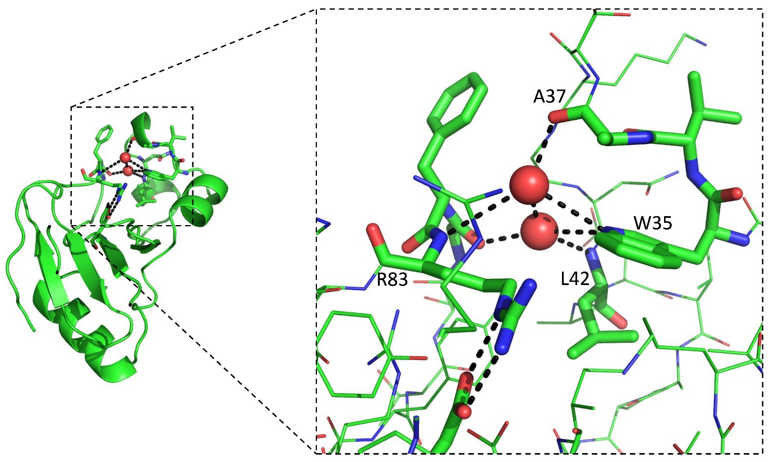
Fig. S1. Hydrogen bonding network in the barnase crystal structure (pdb ID 1a2p) involving two deeply buried water molecules, which form hydrogen bonds to the NH of R83, L42 and the W35 sidechain. The sidechain of R83 makes hydrogen bonds to the scissile phosphate of the substrate and is a key active site residue.

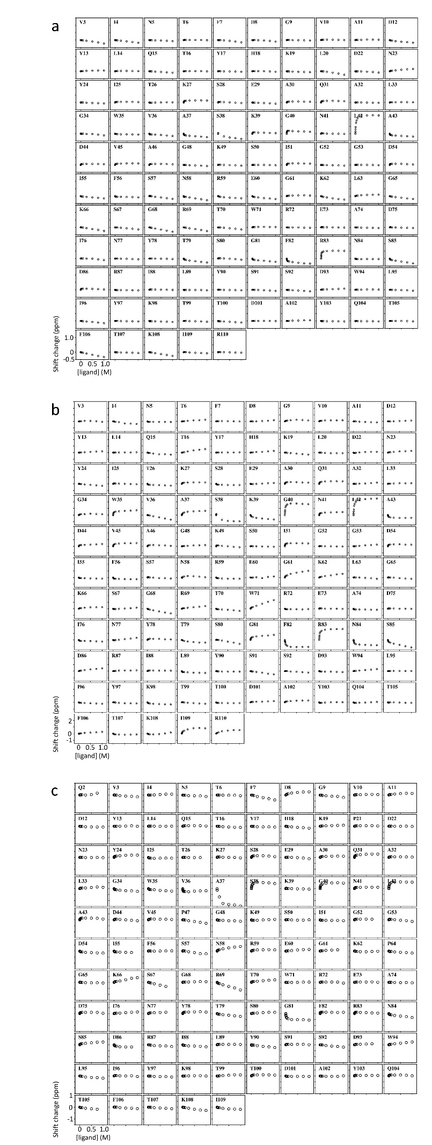
Fig. S2. Chemical shift changes for (a) ¹H, (b) ¹⁵N and (c) ¹³C nuclei from backbone amides in barnase on addition of a 1:1 mixture of thiocyanate and sulfate. Chemical shift scale are given at the bottom left of each panel.
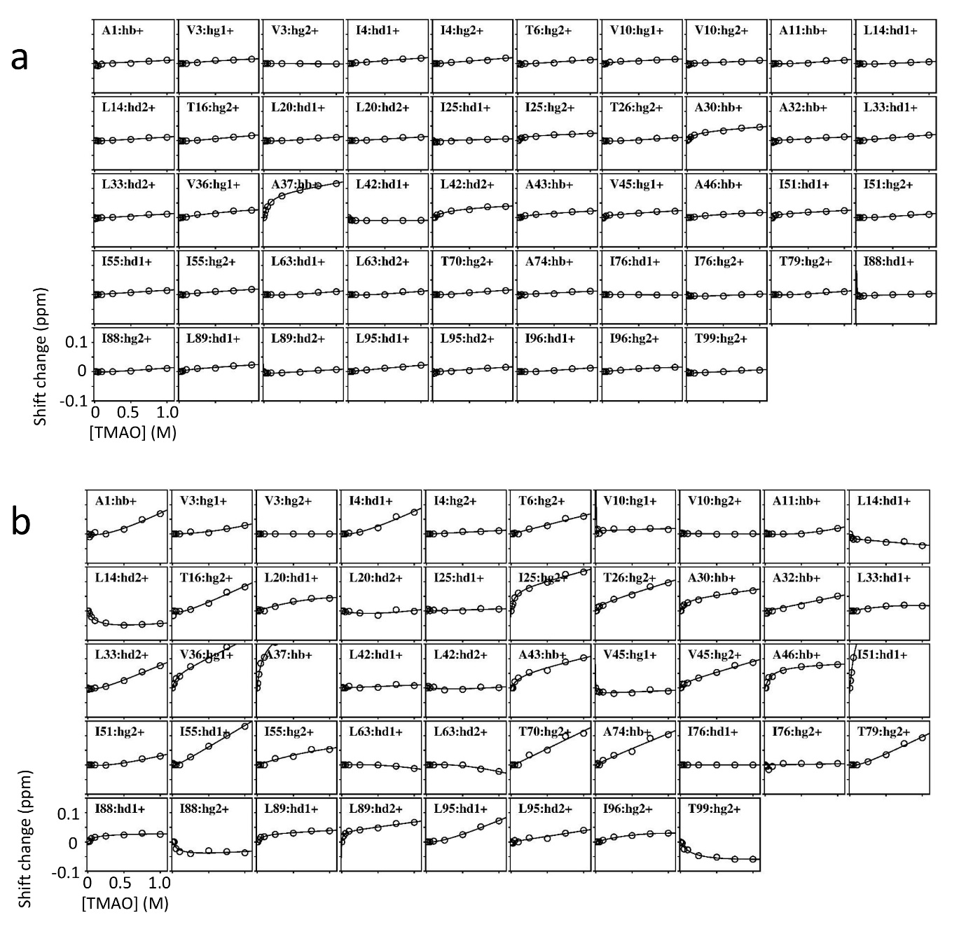
Fig. S3. Chemical shift changes for (a) ¹H and (b) ¹³C nuclei from methyl groups in barnase on addition of TMAO. ¹H shifts show no indication of binding (ie no curvature), except for A30, A37 and L42. L42 is one of the two residues with unusual behaviour (Fig 2), and A37 carbonyl is part of the same hydrogen bonding network. The ¹³C shifts show much more curvature, but predominantly for alanines.

