Supplementary Information for
Electrochemically controlled blinking of fluorophores to enable quantitative stochastic optical reconstruction microscopy (STORM) imaging
Ying Yang^{1†}, Yuanqing Ma^{1,2†}, Richard Tilley¹, Katharina Gaus², J. Justin Gooding^{1*}
¹School of Chemistry and Australian Centre for NanoMedicine, University of New South Wales, Sydney 2052, Australia
²EMBL Australia Node in Single Molecule Science, The University of New South Wales, 2052 Sydney, Australia
†These authors contributed equally to this work: Ying Yang, Yuanqing Ma
*Corresponding author. Email: justin.gooding@unsw.edu.au (J. G.)

Supplementary Figures
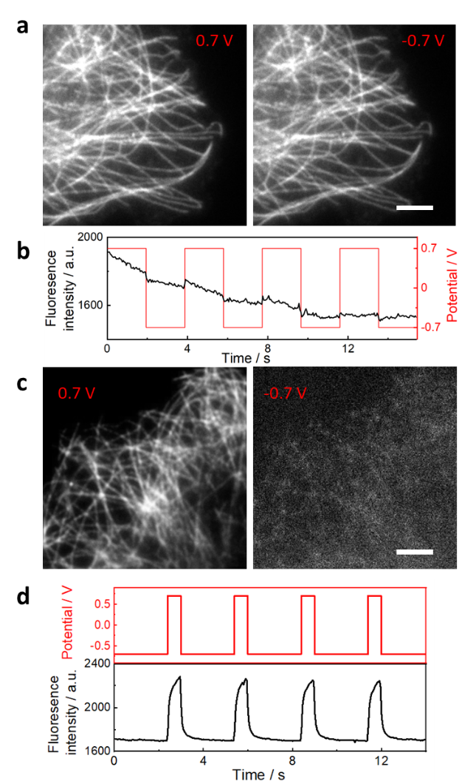
Supplementary Figure 1. a, TIRF images of Alexa 647 labelled microtubules (α-tubulin) of COS-7 cell in oxygen scavenger tris buffer with 2 mM Trolox at +0.7 V (left) and -0.7 V (right). All the Alexa 647 stays in the bright state while the overall fluorescence intensity is slightly higher at 0.7 V than the values at -0.7 V. The decay in fluorescence intensity was attributed to photobleaching during the images acquisition, b, the corresponding electrochemical potential modulated fluorescence intensity change curves for a. c, TIRF images of Alexa 647 labelled microtubules (α-tubulin) of COS-7 cell in oxygen scavenger tris buffer with 1 mM potassium ferricyanide at +0.7 V (left) and -0.7 V (right). All of the Alexa 647 are in bright state at positive potential (0.7 V) and are switched to a dim state at negative potential (-0.7 V), d, the corresponding electrochemical potential modulated fluorescence intensity change curves for c. A 642 nm laser with intensity of 0.1 kW cm⁻² was used as the excitation laser for the imaging. The scale bar is 5 μm.
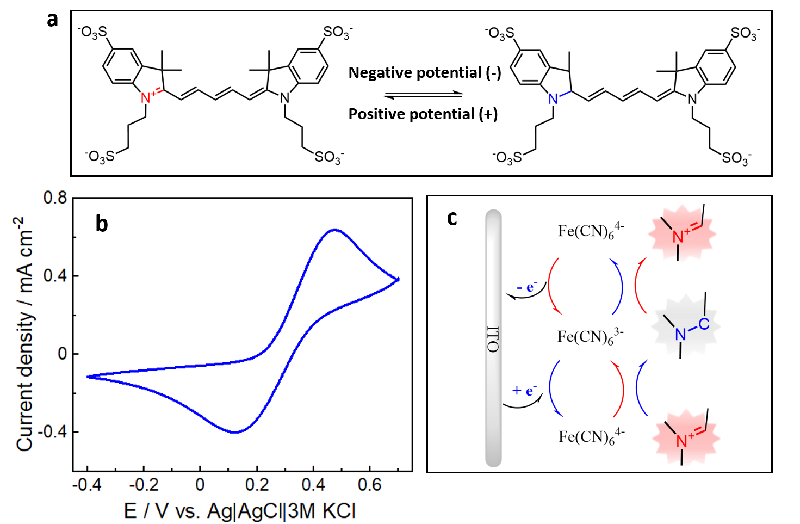
Supplementary Figure 2. a, Electrochemical redox reaction of Alexa 647 mediated by Trolox or ferricyanide, the redox reaction happens between the quaternary ammonium cation and a tertiary amine. b, Cyclic voltammetry for Alexa 647/ITO in oxygen scavenger tris imaging buffer (see Method) with 1 mM ferricyanide, scan rate is 50 mV / s. c Scheme representation of the sequence of the ferricyanide mediated Alexa 647 redox reactions during cyclic voltammetry.

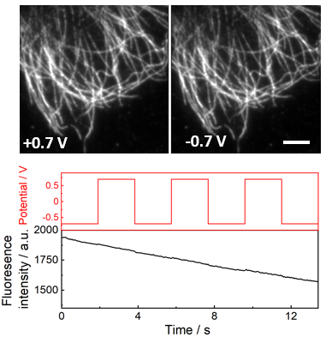
Supplementary Figure 3. Alexa 647 shows no obvious fluorescence intensity change by switching the applied potential at ITO surface. The imaging buffer is oxygen scavenger tris buffer without adding Trolox, ferricyanide, or cysteamine. A 642 nm laser with intensity of 0.1 kW cm⁻² was on during the imaging. All the Alexa 647 stays in the bright state when the electrochemical potential was cycled between 0.7 V and -0.7 V. The decay in fluorescence intensity was due to photobleaching during the images acquisition. The scale bar is 5 μm.

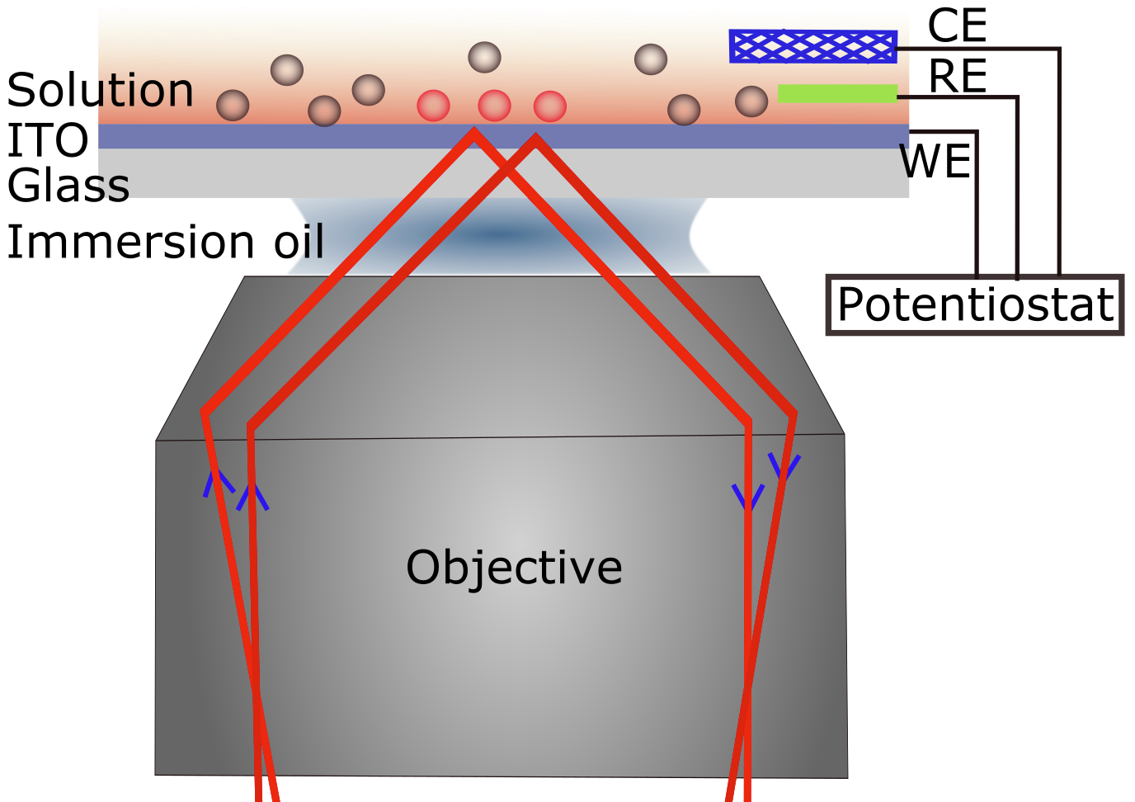
Supplementary Figure 4. Schematic illustration of the total internal reflectance (TIRF) microscope integrated with the electrochemistry set-up. A typical three-electrode system is utilized, which includes a transparent ITO covered glass slide as the working electrode (WE), a silver/silver chloride wire in 3 M KCl as the reference electrode (RE), and a platinum mesh counter electrode. Each electrode is connected to a potentiostat, which applies a defined potential difference between the WE and RE and monitor the current flow between the WE and CE. In TIRF microscopy the laser is totally internally reflected at the ITO/ water interface, and an evanescent field is created such that only fluorophores in the thin layer close to ITO surface will be excited. The red colored circles indicate excited fluorophores, and the grey circles imply unexcited fluorophores.
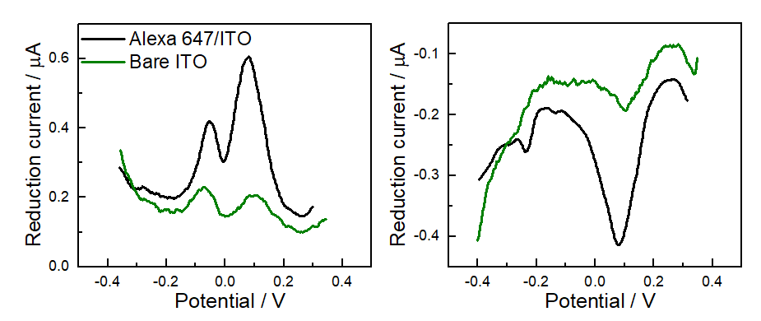
Supplementary Figure 5. Differential pulsed voltammetry curves for ITO (green line) and Alexa 647 accumulated ITO (COS-7 cells were attached and ITO and the microtubules were labelled with Alexa 647, marked as Alexa 647/ITO, black line) in STORM buffer.
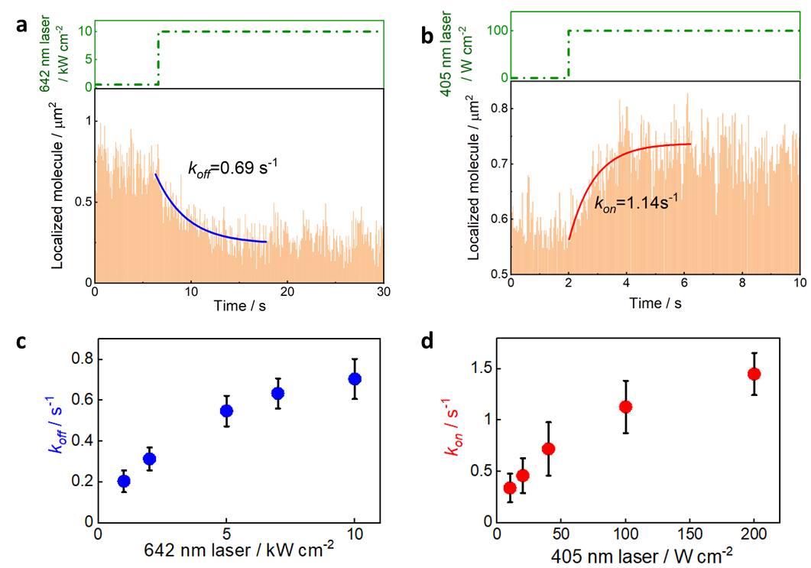
Supplementary Figure 6. a, For comparison, the rate constant for k_{on} and k_{off} using photochemical switching was measured by (b) irradiated the sample with strong 642 nm laser (10 kW cm⁻²) to switch Alexa 647 off (to obtain k_{off}) first, and then reduce the 642 nm laser to 3 kW cm⁻²,(c) followed by turning UV light on the OFF state fluorophores are switched back to ON state (to determine k_{on}). The rate constants k_{on} and k_{off} as a function of the photochemical switching conditions are summarized in d-e. Error bars in d and e denote mean ± standard deviation (n = 6 replicates of distinct samples).
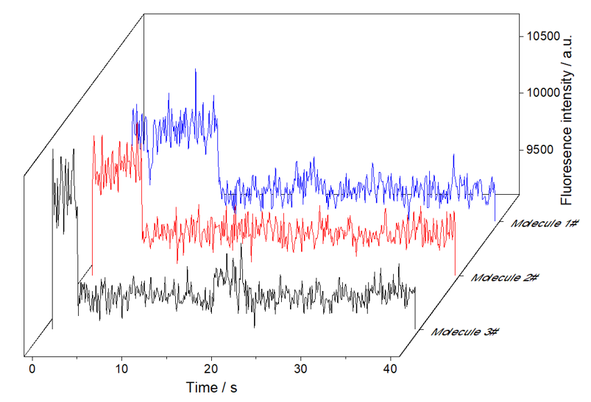
Supplementary Figure 7. Examples of photobleaching curves of single Alexa 647 molecules covered ITO in PBS buffer. A total of 400 frames TIRF images were taken, with exposure time of 100 ms, the 642 nm laser intensity was 1 kW cm⁻². By analyzing the fluorescence trajectories of 411 molecules in the field of view, 100% of the molecules have only one single bleaching step. The fluorescence statistics data showed the average fluorescence background is 9491 ± 106 a.u., and the average fluorescence intensity of single Alexa 647 molecules is 10112 ± 303 a.u.
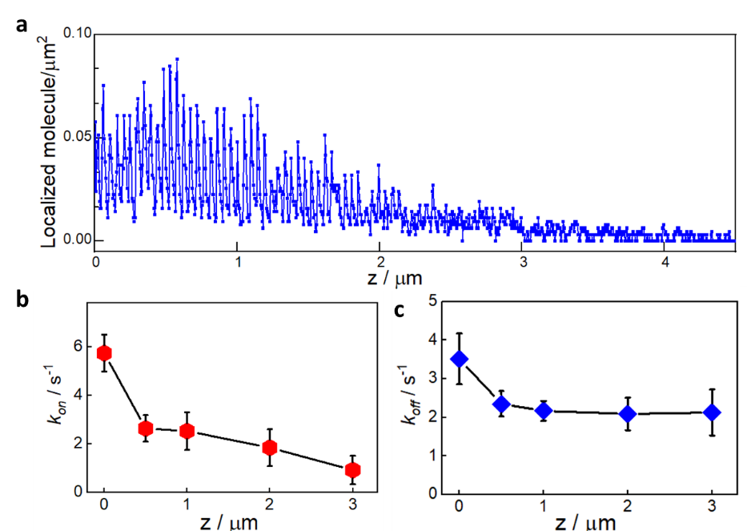
Supplementary Figure 8. The change for Alexa 647 switching capability using EC-STORM with the distance increase from the ITO surface. a-c, When an Alexa 647 labelled polystyrene beads (with diameter of 100 μm) are placed on ITO electrode in STORM buffer, the Alexa 647 on the beads shows the switching response to the electrochemical potential, and this response becomes slower with the distance increase between Alexa 647 and ITO surface. The electrochemical potential was switched between 0.1 V for 0.2 s and -0.8 V for 0.5 s for multiple cycles. The movie was recorded under high inclined and laminated optical sheet (HILO) illumination mode, with frame rate of 50 ms.
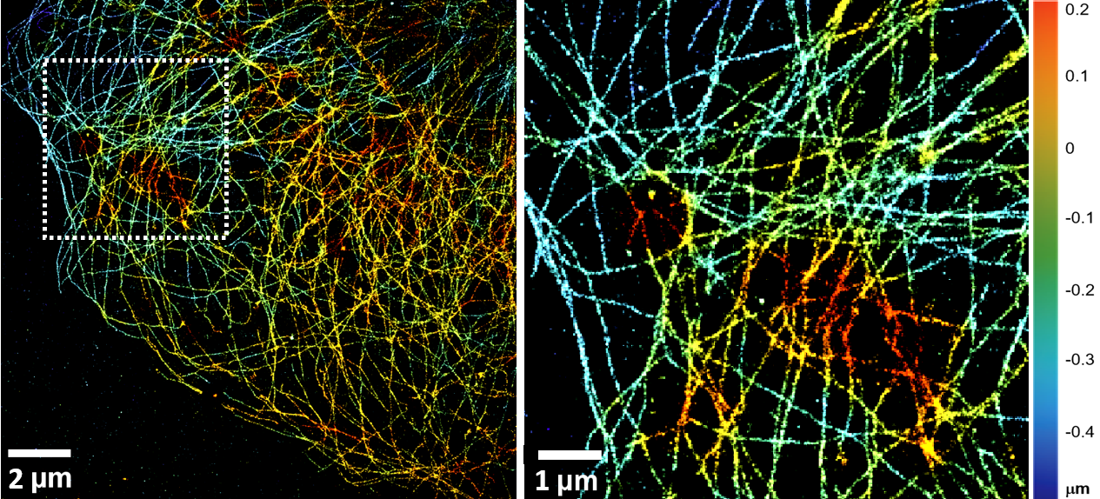
Supplementary Figure 9. 3D EC-STORM image of cellular microtubule network on COS-7 cells. The axial position is represented as a z-colour coded map. Image was reconstructed from 30000 frames of 33 ms exposure time to reach a localization precision ∼25 nm along the radial direction and ∼50 nm along the axial one.
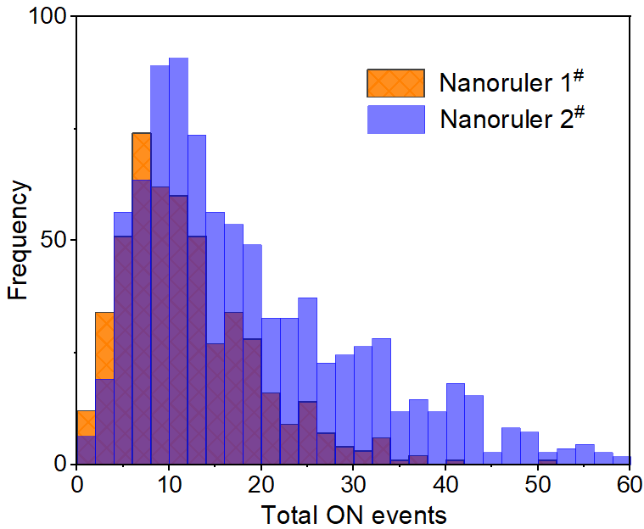
Supplementary Figure 10. Histogram of the total ON events of Alexa 647 on two groups of nanorulers (Nanoruler 1# with 6 × 2 and Nanoruler 2# 12 × 2 binding sites for Alexa 647) by UV light activation. A total 15000 frames (33 ms exposure time) of images were collected to reconstruct the STORM image, and the total ON events were counted on resolved nanorulers, 1 kW cm⁻² of 642 nm laser and 10 W cm⁻² of UV laser were on during imaging.
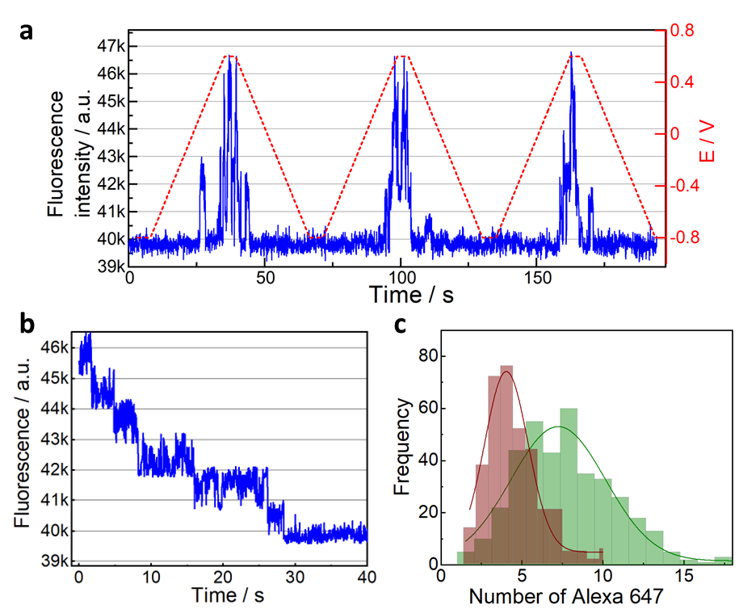
Supplementary Figure 11. a, How the Alexa 647 molecules can be reversibly turned on and off at one nanoruler (blue line for stepwise fluorescence intensity change) by linearly increasing or decreasing the electrochemical potential (red dashed line) with a scan rate of 50 mV s⁻¹. The applied potential was held for 2 s at -0.8 V and 0.6 V before scanning potential progressively to more positive or negative values each time. b, By regrouping the segmented fluorescence traces (from panel e) with similar intensity and ranking the grouped segmented traces in descending order, a stepwise fluorescence trajectory curve was obtained. c, Histogram for the number of Alexa 647 counted at each DNA DNA nanoruler by taking the ratio of the maximum intensity obtained in e to the single molecule brightness of Alexa647 obtained by step fitting in b.

Supplementary Movie 1. The electrochemical potential modulated fluorescence switching of Alexa 647 in oxygen scavenger tris buffer with 1 mM ferricyanide. The imaging sample is COS-7 cells labeled for microtubules with Alexa 647.
Supplementary Movie 2. The electrochemical potential modulated fluorescence switching of Alexa 647 in oxygen scavenger tris buffer with 50 mM cysteamine, while at constant potential, Alexa 647 shows stochastic blinking property. The imaging sample is COS-7 cells labeled for actin with Alexa 647.
Supplementary Movie 3. The ON state Alexa 647 molecule density change during cyclic voltammetry scan. During the imaging session, the electrochemical potential was ramped from -0.4 V to 0.3 V and then back to -0.4 V, with scan rate of 20 mV s⁻¹. The imaging sample is COS-7 cells labeled for microtubules with Alexa 647, and imaging buffer is oxygen scavenger tris buffer with 50 mM cysteamine.
Supplementary Movie 4. The ON state Alexa 647 molecule density when the electrochemical potentials are switched between several relative positive values (-0.4, -0.2, -0.1, 0, and 0.1 V) and -0.7 V for 10 s at each still potential. The imaging sample is COS-7 cells labeled for microtubules with Alexa 647, and imaging buffer is oxygen scavenger tris buffer with 50 mM cysteamine.
Supplementary Movie 5. The ON state Alexa 647 molecule density at different positive potentials as indicated. The imaging sample is COS-7 cells labeled for microtubules with Alexa 647, and imaging buffer is oxygen scavenger tris buffer with 50 mM cysteamine.
Supplementary Movie 6. When an Alexa 647 labelled polystyrene beads (with diameter of 100 μm) are placed on ITO electrode in STORM buffer, the Alexa 647 on the beads shows the switching response to the electrochemical potential. The electrochemical potential was switched between 0.1 V for 0.2 s and -0.8 V for 0.5 s for multiple cycles. The movie was recorded under high inclined and laminated optical sheet (HILO) illumination mode, with frame rate of 50 ms.
Supplementary Movie 7. The ON and OFF switching of Alexa 647 at DNA nanoruler sample (two ends of the DNA nanoruler has 6 binding sites for Alexa 647 and that were separated by 94 nm) under EC-STORM where the potential was pulsed. 1 kW cm⁻² of 642 nm laser was on, the electrochemical potential was pulsed between -0.6 V for 900 ms and 0.1 V for 100 ms for multiple cycles.

