Table. 1. MA performance of similar materials reported in the literatures
Absorbers | Dª (mm) | RL_{min}^{b} (dB) | EAB^{c} (GH_{Z}) | Ref.
SiOC/CFs | 5.10 | -47.50 | 1.20 | [1]
CF-SiCw | 3.00 | -44.52 | 5.20 | [2]
NiCo@NPC@CF | 3.50 | -46.50 | 10.0 | [3]
MnO₂@HNCFs | 2.80 | -32.17 | 7.80 | [4]
ATP/IF | 1.80 | -35.00 | 8.80 | [5]
CF@NiO/Ni | 1.80 | -43.92 | 5.64 | [6]
CSA | 1.80 | -46.20 | 5.20 | [7]
SiO₂/SCCF | 5.50 | -29.30 | 12.30 | [8]
SCF/CoFe | 2.00 | -40.40 | 3.50 | [9]
Co₃O₄/CF | 4.75 | -61.55 | 4.72 | This work
a-the matching thickness of MA materials.
b-the minimum reflection loss (RL_{min}) of MA materials.
c-the effective absorption bandwidth (EAB) of MA materials.

To study the dissolution of urea content in solution, we denoted samples with different urea contents (12.5 mM, 25.0 mM, 50.0 mM, 100.0 mM) were noted as S1, S2, S3, and S4, respectively, and the solutes were dissolved in the mixed solutions as shown in Figure 1. From the figure 1, it can be seen that the solutions of S1-S3 were well mixed, but there were obvious small white particles in S4 (marked by white circles).

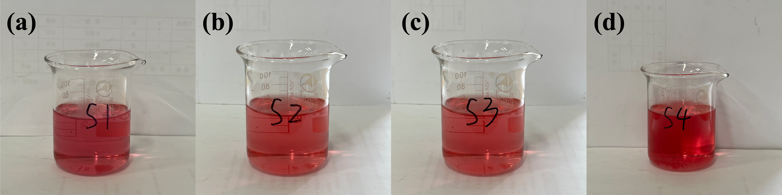
1
Fig. S1 Diagram of the dissolution process of the solution: S1-S4.

Reference
[1] Zeng S, Feng W, Peng S, et al. Dual-functional SiOC ceramics coating modified carbon fibers with enhanced microwave absorption performance[J]. RSC Advances, 2019, 9(53): 30685-30692.
[2] Wang Y, Wen Z, Long L, et al. Dielectric response and microwave absorption properties of SiC whisker-coated carbon fibers[J]. Journal of Materials Science: Materials in Electronics, 2019, 30(16): 15075-15083.
[3] Jin H, Wen H M, Hong Q, et al. NiCo@NPC@CF nanocomposites derived from NiCo-MOF/cotton for high-performance electromagnetic wave absorption[J]. Journal of Materials Chemistry C, 2022, 10(21): 8310-8320.
[4] Cui Y, Yang K, Lyu Y, et al. Hollow nitrogen-doped carbon nanofibers filled with MnO2 nanoparticles/nanosheets as high-performance microwave absorbing materials[J]. Carbon, 2022, 196: 49-58.
[5] Min D, Jiang J, Qing Y, et al. Attapulgite coated polycrystalline iron fibers composites with light weight feature and enhanced microwave absorption properties[J]. Journal of Alloys and Compounds, 2023, 948: 169817.
[6] Wang S, Liu Z, Liu Q, et al. Promoting the microwave absorption performance of hierarchical CF@NiO/Ni composites via phase and morphology evolution[J]. International Journal of Minerals, Metallurgy and Materials, 2023, 30(3): 494-503.
[7] Teng S, Xie W, Zhang D, et al. Ultra-broadband electromagnetic wave absorbent: In-situ generated silica modified conductive carbon fiber aerogels[J]. Ceramics International, 2023, 49(15): 24744-24751.
[8] Sun J, Huang X, Liu Y, et al. Enhanced microwave absorption performance originated from interface and unrivaled impedance matching of SiO2/carbon fiber[J]. Applied Surface Science, 2023, 623: 157029.
[9] Feng J, Yang L, Dong H, et al. Construction of hollow and porous carbon Fiber/CoFe composites derived from strawberry petiole for enhanced microwave absorption[J]. Materials Letters, 2023, 348: 134679.

