Supplementary information
A pilot study of pancreaticoduodenal artery aneurysms concomitant with coeliac artery stenosis: Using computational haemodynamics to better understand a rare disease.

Authors
Dirk Blom^{1,2,4}, Rama Chidambaram³, Harrison Caddy^{1,5}, Julian Soares³, Nikhilesh Bappoo^{1,5}, Lachlan Kelsey^{1,5}, Shirley Jansen^{2,3,4,6}, Barry Doyle^{1,5}.

- Vascular Engineering Laboratory, Harry Perkins Institute of Medical Research, QEII Medical Centre, Nedlands and the UWA Centre for Medical Research, The University of Western Australia, Perth 6009, Australia
- Curtin Medical School, Curtin University, Perth, Australia.
- Department of Vascular and Endovascular Surgery, Sir Charles Gairdner Hospital, Perth, Australia.
- Heart and Vascular Research Institute, Harry Perkins Institute of Medical Research, QEII Medical Centre, Nedlands.
- School of Engineering, The University of Western Australia, Perth, Australia.
- Medical School, The university of Western Australia, Perth, Australia.
Address for Correspondence:
Name: Dirk Blom
Address: Harry Perkins Institute of Medical Research, 6 Verdun Street, Nedlands, Western Australia, 6009, Australia.
Tel: +61 8 6151 0700 Fax: +61 8 6151 0700
Email: dirk.blom@perkins.org.au

Inlet Boundary Calculations
4D-MRI data for patients with similar pathologies, Y. Mano et al. report and average body surface area of 1.67 m² and average supra-coeliac flow rate of 0.038 kg/s for density of 1060 kg/m³. The cardiac output (CO) of the Y. Mano et al. cohort was estimated using Equation 2 for reported mean height and weight of 160.6 cm and 62.8 kg respectively.(Mano et al. 2013) The CO of our cohort was also estimated using Equation 2 (Jegier et al. 1963) to calculate a scaling factor to apply to the supra-coeliac flow measured by Y. Mano et al. as per Equation 3. The scaled supra coeliac flow was applied as the inlet condition (Equation 4). This assumes that the ratio of CO to supra-coeliac flow is constant across patients.
$$BSA[m^{2}]=\sqrt{\frac{height[cm]*weight[kg]}{3600}}$$ | (1)
$$CO\left[\frac{L}{min}\right]=3.06*BSA+0.37$$ | (2)
$${SF}_{CO}=\frac{CO}{5.492}$$ | (3)
$$inletflowrate,{\overset{˙}{m}}_{in}\left[\frac{kg}{s}\right]={SF}_{CO}*{SC}_{4D}$$ | (4)

Where BSA = Body surface area (estimated); CO = Cardiac output; SC_{4D} = Supra-coeliac flow rate measured using 4D-MRI by Mano et al.; SF = scaling factor. BSA is estimated using the method proposed by R.D. Mosteller (1987).

Where data were missing, a corresponding average height and/or weight for the Australian population (ABS 2012) was assigned based on gender and scaled based on the difference of the metric available to the population average using an estimated cubic relationship between height and weight. Values were converted using a density of 1060 kg/m³. Note, a transient solver was utilised when sufficient convergence could not be achieved using steady state methods.

Mesh Sensitivity Analysis
Reconstructions were discretised using polyhedral cells with prismatic layers on the walls and mesh cell size that automatically varied based on vessel diameter.
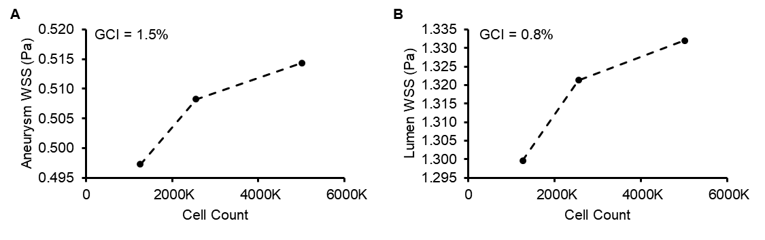
Supplementary Figure 1. Analysis of numerical error in the simulation of a case, estimated using the grid convergence index (GCI) showing estimated error in (A) average aneurysm wall shear stress (WSS) and (B) average lumen WSS calculations.

Mesh settings used are summarised in Table I and mesh extrusions of ten times the diameter were applied at the inlets and outlets.
Supplementary Table I. Summary of parameters used for creating the computational mesh throughout the fluid domain.
Region / diameter - mm | Aneurysm | 0-5 | 5-10 | 10-100
Prism layers - n | 16 | 16 | 12 | 8
Prism layer thickness - mm | 0.20 | 0.15 | 0.40 | 0.80
Prism layer stretching | 1.30 | 1.30 | 1.30 | 1.25
Absolute cell size - mm | 0.1 | 0.2 | 0.4 | 0.8

Murray’s Law Exponent Selection
Using Equation 5, Murray’s law (ML) exponents of 2.00, 2.33, 2.42 and 3.00 (previously reported for other vasculatures) were compared (Chnafa et al. 2017; Revellin et al. 2009).
$$GML split flow rate, {\dot{m}}_{out, i}= {\dot{m}}_{in}*\frac{d_{i}^{2.33}}{\sum_{j=1}^{N}{d_{j}^{2.33}}}$$ | (5)

Where ${\dot{m}}_{in}=mass flow rate (\frac{kg}{s})$ and $d=vessel diameter (m)$.
The results detailed in Table II demonstrate the importance of outlet boundary condition selection, with the difference between ruptured and intact groups decreasing as the exponent increased. A ML exponent of 2.42 produced average aneurysm shear stress within 34% of those measured by 4D-MRI in the cohort studied by Mano et al.,(Mano et al. 2013) indicating it may be the most suitable outlet condition in lieu of more accurate in-vivo data. Note, the flow regime was assumed laminar as the Reynold’s number was approximated at 250 in a PDA region where it was expected to be highest.
Supplementary Table II. Comparison of aneurysm wall shear tress (WSS) between rupture and intact groups for different Murray’s law exponents set as the outlet condition.
ML Exponent | 2 | 2.33 | 2.42 | 3
Cohort | 1.27 (1.44) | 0.57 (0.67) | 0.46 (0.12) | 0.12 (0.13)
Rupture | 0.57 (0.36) | 0.27 (0.16) | 0.46 (0.12) | 0.07 (0.04)
Intact | 1.53 (1.62) | 0.69 (0.76) | 0.55 (0.61) | 0.14 (0.15)
Rupture vs Intact difference - % | 63 | 62 | 17 | 46
Cohort vs 4DMRI difference - % | 76 | 47 | 33 | 159
Results are reported as mean (std. deviation) unless otherwise stated. ML = Murray’s law; 4DMRI = four-dimensional magnetic resonance imaging obtained by Mano et al.¹

Image Reconstruction
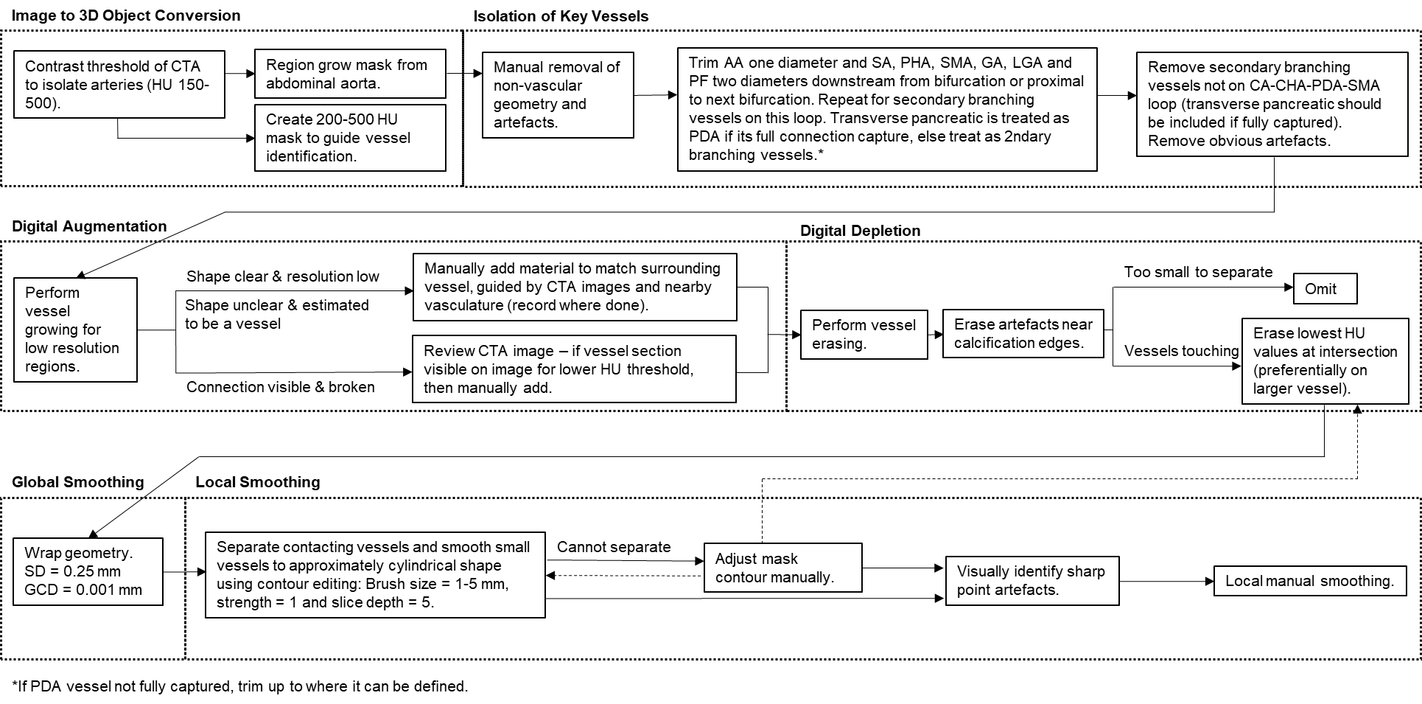
Supplementary Figure 2. Workflow used during the three-dimensional reconstruction of visceral arteries from computed tomography angiography images.
* If PDA vessel not fully captured, trim up to where it can be defined and place outlets at trimmed surface.

References
ABS. (2012). 4.338.0 - Profiles of Health, Australia, 2011-2013: Height and Weight. Retrieved 29/08/2022 from https://www.abs.gov.au/ausstats/abs@.nsf/lookup/4338.0main+features212011-13
Chnafa, C., Bouillot, P., Brina, O., Delattre, B. M. A., Vargas, M. I., Lovblad, K. O., Pereira, V. M., & Steinman, D. A. (2017). Vessel calibre and flow splitting relationships at the internal carotid artery terminal bifurcation. Physiol Meas, 38(11), 2044-2057. https://doi.org/10.1088/1361-6579/aa92bf
Jegier, W., Sekelj, P., Auld, P. A., Simpson, R., & McGregor, M. (1963). THE RELATION BETWEEN CARDIAC OUTPUT AND BODY SIZE. Br Heart J, 25(4), 425-430. https://doi.org/10.1136/hrt.25.4.425
Mano, Y., Takehara, Y., Sakaguchi, T., Alley, M. T., Isoda, H., Shimizu, T., Wakayama, T., Sugiyama, M., Sakahara, H., Konno, H., & Unno, N. (2013). Hemodynamic Assessment of Celiaco-mesenteric Anastomosis in Patients with Pancreaticoduodenal Artery Aneurysm Concomitant with Celiac Artery Occlusion using Flow-sensitive Four-dimensional Magnetic Resonance Imaging. European Journal of Vascular and Endovascular Surgery, 46(3), 321-328. https://doi.org/10.1016/j.ejvs.2013.06.011
Mosteller, R. (1987). Simplified Calculation of Body-Surface Area. New England Journal of Medicine, 317(17), 1098-1098. https://doi.org/10.1056/nejm198710223171717
Revellin, R., Rousset, F., Baud, D., & Bonjour, J. (2009). Extension of Murray's law using a non-Newtonian model of blood flow. Theoretical Biology and Medical Modelling, 6(1), 7. https://doi.org/10.1186/1742-4682-6-7

