Additional File 2. Word Cloud comparison for responses on IPC guideline implementation steps in each facility.

Once IPC guidelines have been developed, what steps should be taken to ensure their implementation at the facility?
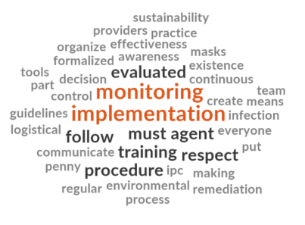 | 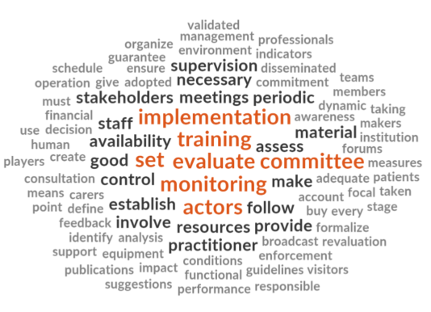
Facility A Baseline | Facility B Baseline
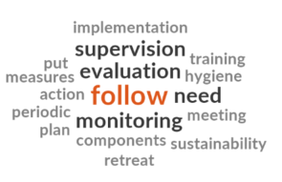 | 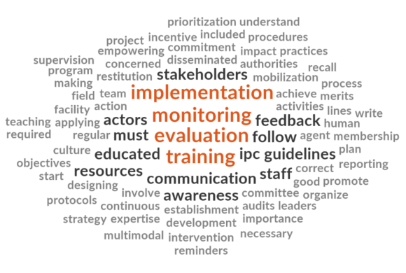
Facility A Follow-up | Facility B Follow-up

