SUPPLEMENTARY INFORMATION

S.1 Ammonia demand

We consider global demand for ammonia in two scenarios: (i) current, derived¹ from yearly average between 1997 and 2003 and (ii) future, based on the 100% achievement of the local attainable yields¹. We computed the fertilizer nitrogen demand based on the sixteen major crops listed in Table S1, which account for ~90% of global caloric production from croplands² and derived the corresponding amount of ammonia assuming stoichiometric 1.21 kg of ammonia per kg of nitrogen. In both scenarios, ammonia demand is classified based on the local presence of water scarcity from previous work².

Table S1. Major crops data in current scenario and future scenario globally. The values reported refer to the aggregated value from the 16 major crops in the table.

 | current scenario | future scenario
global ammonia demand | 102.6 Mt/y | 169.9 Mt/y
harvested area | 828.5 Mha | 828.5 Mha
major crops | barley, cassava, groundnut, maize, millet, oil palm,  potato, rapeseed, rice, rye, sorghum,  soybean, sugarbeet, sugarcane, sunflower, wheat

Figure S1 presents the global demand of ammonia, aggregated at country scale. The main three countries for ammonia demand for fertilizer use are China, India and the United States. These countries together, represent 49% and 46% of the global ammonia demand for fertilizer use in the current and future scenarios.
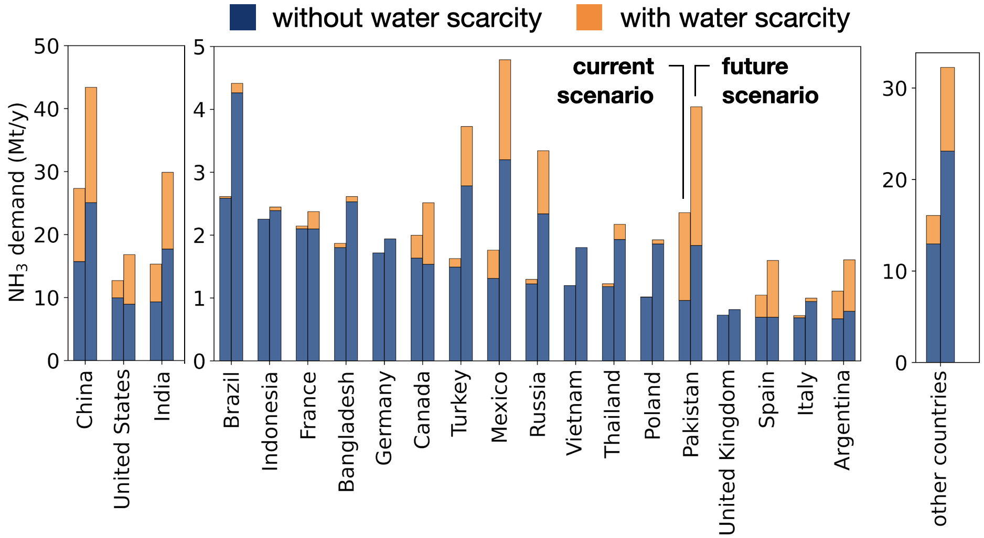
Figure S1. Impact of water scarcity on ammonia demand. Ammonia demand is split between pixels with water scarcity and without water scarcity. The order of the countries reflects the ammonia demand in the current scenario.

S.2 Energy density
We consider electric Haber-Bosch and electrocatalysis as candidate technologies which could be deployed for distributed ammonia production. Table S2 summarizes the values of energy demand required to supply the demand of ammonia from the two technologies. Low-carbon production of ammonia requires any of these technologies to be fed with renewable electricity, here assumed to be provided by small-scale solar panels. We compute the energy demand for ammonia production for all cells, N, for all technologies, T as:

D_{t,i} = c_{t} F_{i} $∀$ i $∈$ N, $∀$ t $∈$ T (1)

with:
- D_{t,i} (TWh/y) yearly demand of energy for ammonia production with technology t in grid cell i,
- c_{t} (TWh/Mt_{NH3}) energy requirement for technology t (Table S2),
- F_{i} (Mt_{NH3}/y) yearly average demand of ammonia used as fertilizer in cell i (Methods – Section 4.1).

Table S2. Energy density of technologies for distributed ammonia production considered in this study. For electrocatalysis, the energy density and the energy efficiency correspond to (e^{DER}/EE^{DER}) and EE^{DER}, respectively, in Equation 6 of Methods – Section 4.6. For electric Haber-Bosch, the energy density and the energy efficiency correspond to ($e^{electr}$/${EE}^{HB}$+$e^{HB}$) and ${EE}^{HB}$, respectively, in Equation 5 of Methods – Section 4.6.

technology | energy density (TWh/Mt_{NH3}) | energy efficiency (-)
electrocatalysis | 2020: 20.2 (14.9, 28.2)  2030: 16.8 (12.7, 22.5)  2050: 11.2 (9.4, 13.3) | 2020: 0.27 (0.19, 0.36)  2030: 0.32 (0.24, 0.42)  2050: 0.48 (0.40, 0.57)
electric Haber-Bosch | 2020: 12.6 (11.8, 14.3)  2030: 12.0 (11.3, 14.5)  2050: 11.2 (11.1, 11.3) | 2020: 0.62 (0.54, 0.67)  2030: 0.66 (0.53, 0.70)  2050: 0.71 (0.70, 0.72)

S.3 Land availability
We quantify the amount of land required for the production of ammonia from agrivoltaic systems to assess whether the installation of PV panels only on croplands allows a sufficient production of electricity to satisfy the local demand of ammonia as fertilizer. The total area required to be covered by solar panels is computed from the technology-specific energy requirements to satisfy the local demand of ammonia:

A_{i,t} = D_{t,i} / S_{i} ^{solar} $∀$ i $∈$ N, $∀$ t $∈$ T (2)

The coverage area, A^{coverage}, used for installation of agrivoltaic systems in cell i is defined as:

A^{coverage}_{i} = γ A^{cropland}_{i} $∀$ i $∈$ N (3)

with:
- γ (-) ground cover ratio, representing the ratio of the surface occupied by the photovoltaic cells to the total area occupied by the agrivoltaic system³,
- A^{cropland}_{i} (km²) sum of harvested area for 16 major crops (Table S1 in Suppl. Inf. – Section S.1) in cell i.
Land availability (LA) is assessed based on the ratio of land demand, A_{i,t}, representing the land requirements to meet ammonia demand (Equation 2) and land coverage, representing the land used for the contemporary production of electricity from solar panels and crops harvesting (Equation 3):

LA_{i,t} = A_{i,t} / A_{i}^{coverage} $∀$ i $∈$ N, $∀$ t $∈$ T (4)

Based on the energy density considered in this study (Suppl. Inf. – Section S.2), LA is always greater than one, indicating that all the electricity required to satisfy the local demand for ammonia can be generated by agrivoltaic systems on croplands.

S.4 Sensitivity analysis
We carry out a sensitivity analysis to quantify the impact of uncertainty on some of the main parameters involved in the calculation of the cost of ammonia (Methods – Section 4.6) based on the total and the Sobol indices. The sources of uncertainty are both the global geographical coverage of the analysis and the temporal coverage of the scenarios considered (from 2020 to 2050). While in this study we used a simplified model of the capital and operating costs, local conditions and uncertainties (like variable energy supply, temperature management) should be taken into consideration for more accurate analyses of decentralized production^{4,5}. Table S3 reports the reference values and the range of variation of the parameters involved in the calculation. Figure S2 (a,b) indicate that, both in case of ammonia production from electric Haber-Bosch and electrocatalysis, the main parameters affecting the median of the global distribution of ammonia is the local cost of electricity, dependent on the capital expenditures and the discount rate of solar photovoltaics. For electrocatalysis, the median of the cost of ammonia is also affected by the energy efficiency of electrocatalysis Figure S2 (b). According to Equation 7 in Methods – Section 4.6, the energy efficiency depends on the Faradaic efficiency and the overpotential of the catalyst, whose range of variation is still large, due to the low maturity of the technology (TRL 1-3)⁶.

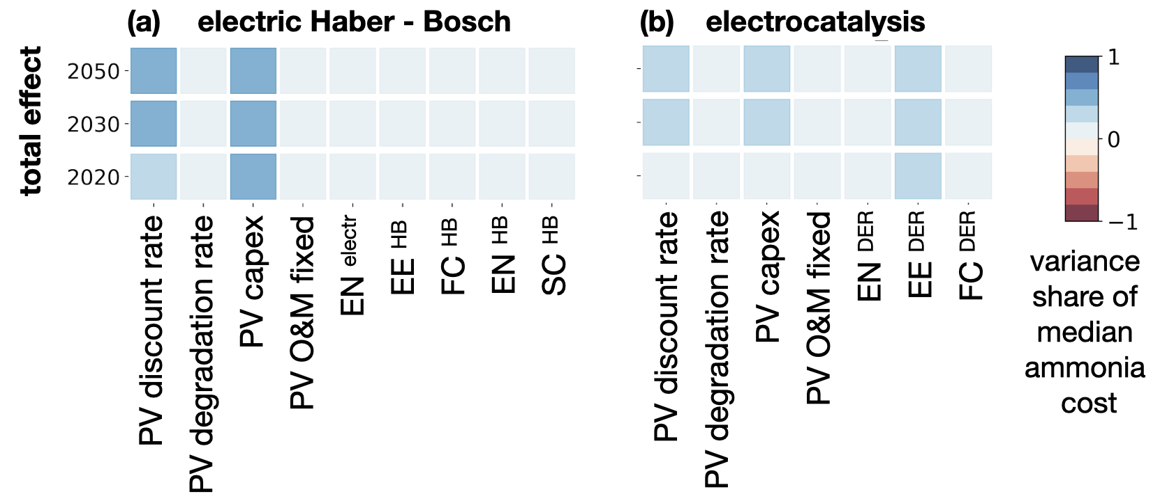
Figure S2. Impact of uncertainty on median of the global distribution of the cost of ammonia. The main parameters affecting the median of the cost of ammonia are the capital expenditures of photovoltaic panels and the discount rate over the lifetime of the panels which determine the local levelized cost of electricity. Additionally, the median of the cost of ammonia in case of electrocatalysis is mainly affected by the energy efficiency of the technology (EE^{DER} in Equation 7 in Methods – Section 4.6).

S.5 Assumptions in cost and performance of the technologies
Table S3 collects the values of the coefficients used in the cost-analysis (Methods – Section 4.5, 4.6) relative to the evolution of the performance of the technology, its capital and its operating expenditures.

Table S3. Coefficients used in the calculation of energy potential. Costs are presented in EUR based on the conversion rate⁹ of 1 USD = 0.95 EUR.

symbol | description | value | reference
$C$  (EUR/kW) | capital expenditure for distributed commercial solar panels including cost of balance of plant | 2020: 1674.3 (1172.0, 2176.6)  2030: 866.4 (606.5, 1126.3)  2050: 665.0 (465.5, 864.5) | central value [10];  relative variation compared to  central value [11]
O  (EUR/kW/y) | fixed operation and maintenance expenses for commercial photovoltaic panels | 2020: 18.1  2030: 11.40  2050: 10.5 | [10]
$$r$$  (-) | nominal discount rate | 0.089 | [10]
$I$  (MWh/y) | yearly-average spatially-explicit solar potential | - | [12]
$$T$$  (y) | solar panels lifetime | 2020: 30  2030: 35  2050: 35 | [13]
CF  (-) | spatially-explicit capacity factor | - | [14]
$d$  (-) | degradation rate | 0.005 | [14]
$e^{electr}$  (MWh/t_{NH3}) | electrolyser chemical energy demand | 7.0 | [15]
$${EE}^{HB}$$  (-) | energy efficiency of the electrolyser | 2020: 0.62 (0.54, 0.67)  2030: 0.66 (0.53, 0.70)  2050: 0.71 (0.70, 0.72) | [16]
${FC}^{HB}$  (EUR/t_{NH3}) | fixed costs of Haber-Bosch coupled with electrolyser and air separation based on capex and fixed O&M  (2% of capex) | 2020: 74 (64, 85)  2030: 57 (48, 72)  2050: 45 (37, 49) | [13, 16, 17]
$η$  (-) | PV panels conversion efficiency from solar radiation to electricity | 0.14 | [3]
$γ$  (-) | ratio of total panel surface  to soil surface | 0.36 | [3]
$e^{HB}$  (MWh/t_{NH3}) | Haber-Bosch chemical energy demand | 1.33 | [15]
${SC}^{HB}$  (EUR/t_{NH3}) | cost of hydrogen buffer as fraction of fixed costs | 0.31 (0.19, 0.43) | [17]
$e^{DER}$  (MWh/t_{NH3}) | direct electrochemical reduction chemical energy demand | 5.37 | [15]
${EE}^{DER}$  (-) | energy efficiency of direct electrochemical reduction  (derived from Equation 7 in main text) | 2020: 0.27 (0.19, 0.36)  2030: 0.32 (0.24, 0.42)  2050: 0.48 (0.40, 0.57) | [15]
$${FC}^{DER}$$  (EUR/t_{NH3}) | fixed cost of direct electrochemical reduction including capex, O&M (2% of capex) and air separation unit | 2020: 84.8 (56.7, 122.6)  2030: 50.1 (28.2, 92.2)  2050: 25.6 (8.4, 38.1) | [13,15, 16]
FE  (V) | Faradaic efficiency | 2020: 0.5 (0.4, 0.6)  2030: 0.7 (0.6, 0.8)  2050: 0.9 (0.85, 0.95) | [18]
TE  (V) | thermodynamic voltage | 1.137 | [15]
OP  (V) | overpotential  electrocatalysis | 2020: 1.0 (0.75, 1.25)  2030: 1.0 (0.75, 1.25)  2050: 1.0 (0.75, 1.25) | [18]

S.6 Ammonia market price
To assess the cost-competitiveness of the technologies considered in our analysis, we compare the technology-specific cost of ammonia with the variation of the historical ammonia market price from the World Bank commodity price database⁷. Specifically, we consider the yearly-average real 2010 urea market price (USD/t_{urea}) between 2000 - 2023 converted into ammonia market price (USD/t_{ammonia}) based on the mass balance of urea production (0.57 t_{ammonia}/t_{urea}):

2 NH₃ (17 g/mol) + CO₂ (44 g/mol) → CH₄N₂O (60 g/mol) + H₂O (18 g/mol)

Additionally, we convert USD prices into EUR based on historical exchange reference rates⁸. From the historical distribution, we derive the price statistics used in Figure 2 of the main text, here summarized in Figure S2 and Table S4.

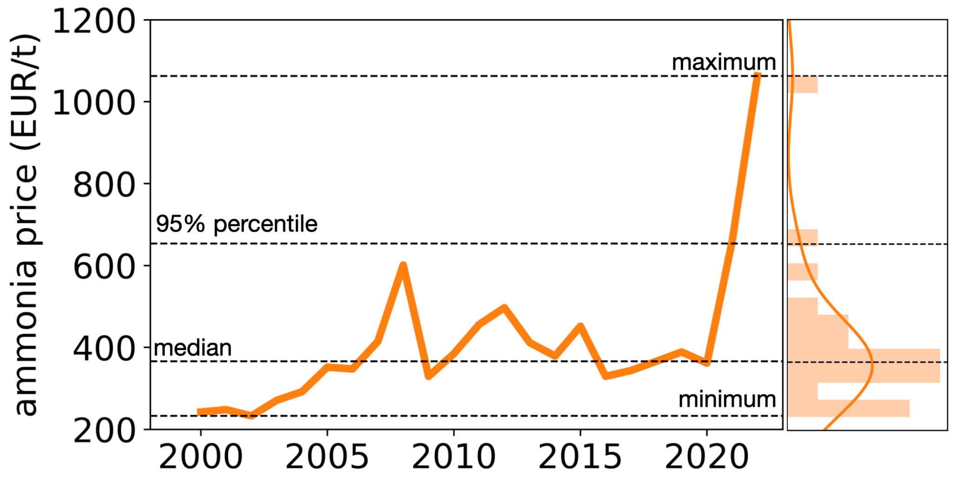
Figure S2. Historical ammonia market price between 2000 and 2023 (EUR/t_{ammonia}). Data elaborated from the urea real 2010 market price of the World Bank commodity price database⁷.

Table S4. Statistics from ammonia price distribution (EUR/t).

minimum | median | 95% percentile | maximum
232.8 | 365.8 | 653.2 | 1062.6

SUPPLEMENTARY REFERENCES
- Mueller, N.D., Gerber, J.S., Johnston, M., Ray, D.K., Ramankutty, N. & Foley, J.A. Closing yield gaps through nutrient and water management. Nature 490(7419), 254-257 (2012).
- Rosa, L., Rulli, M.C., Davis, K.F., Chiarelli, D.D., Passera, C. & D’Odorico, P. Closing the yield gap while ensuring water sustainability. Environmental Research Letters 13(10), 104002 (2018).
- Amaducci, S., Yin, X. & Colauzzi, M. Agrivoltaic systems to optimise land use for electric energy production. Applied energy 220, 545-561 (2018).
- Verleysen, K., Coppitters, D., Parente, A., De Paepe, W. & Contino, F. How can power-to-ammonia be robust? Optimization of an ammonia synthesis plant powered by a wind turbine considering operational uncertainties. Fuel 266(117049), (2020).
- Verleysen, K., Parente, A. & Contino, F. How sensitive is a dynamic ammonia synthesis process? global sensitivity analysis of a dynamic Haber-Bosch process (for flexible seasonal energy storage). Energy 232(121016), (2021).
- Smith, C., Hill, A.K. & Torrente-Murciano, L. Current and future role of Haber–Bosch ammonia in a carbon-free energy landscape. Energy & Environmental Science 13(2), 331-344 (2020).
- Ha, Jongrim, M. Ayhan Kose, & Franziska Ohnsorge. One-Stop Source: A Global Database of Inflation.Policy. World Bank, Research Working Paper 9737 (2021).
- Eurostat, Euro foreign exchange reference rate, https://www.ecb.europa.eu/stats/policy_and_exchange_rates/euro_reference_exchange_rates/html/eurofxref-graph-usd.en.html
- European Central Bank, Eurosystem, Euro foreign exchange reference rates, https://www.ecb.europa.eu/stats/policy_and_exchange_rates/euro_reference_exchange_rates/html/eurofxref-graph-usd.en.html (2022)
- National Renewable Energy Laboratory. Annual Technology Baseline. National Renewable Energy Laboratory https://atb.nrel.gov/ (2021).
- International Energy Agency, Net Zero by 2050. https://www.iea.org/reports/net-zero-by-2050 (2021).
- ESMAP. Global Solar Atlas 2.0. Technical Report, World Bank. https://globalsolaratlas.info/map (2019).
- Terlouw, T., Bauer, C., McKenna, R. & Mazzotti, M. Large-scale hydrogen production via water electrolysis: a techno-economic and environmental assessment. Energy & Environmental Science 15(9), 3583-3602 (2022).
- Dupont, E., Koppelaar, R. & Jeanmart, H. Global available solar energy under physical and energy return on investment constraints. Applied Energy 257, 113968 (2020).
- Hochman, G., Goldman, A.S., Felder, F.A., Mayer, J.M., Miller, A.J., Holland, P.L., Goldman, L.A., Manocha, P., Song, Z. & Aleti, S. Potential economic feasibility of direct electrochemical nitrogen reduction as a route to ammonia. ACS Sustainable Chemistry & Engineering 8(24), 8938-8948 (2020).
- Everall, J., & Ueckerdt, F. Electrolyser CAPEX and efficiency data for: Potential and risks of hydrogen-based e-fuels in climate change mitigation. https://doi.org/10.5281/zenodo.4619892 (2021).
- Nayak-Luke, R.M. & Bañares-Alcántara, R. Techno-economic viability of islanded green ammonia as a carbon-free energy vector and as a substitute for conventional production. Energy & Environmental Science 13(9), 2957-2966 (2020).
- Martín, A.J., Shinagawa, T. & Pérez-Ramírez, J. Electrocatalytic reduction of nitrogen: from Haber-Bosch to ammonia artificial leaf. Chem 5(2), 263-283 (2019).

