Supplementary Figure 1
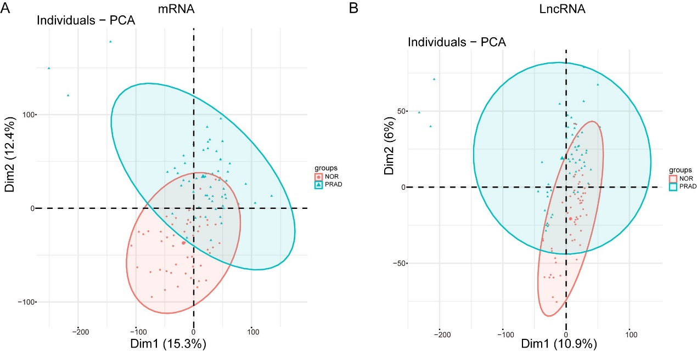

Supplementary Figure 2
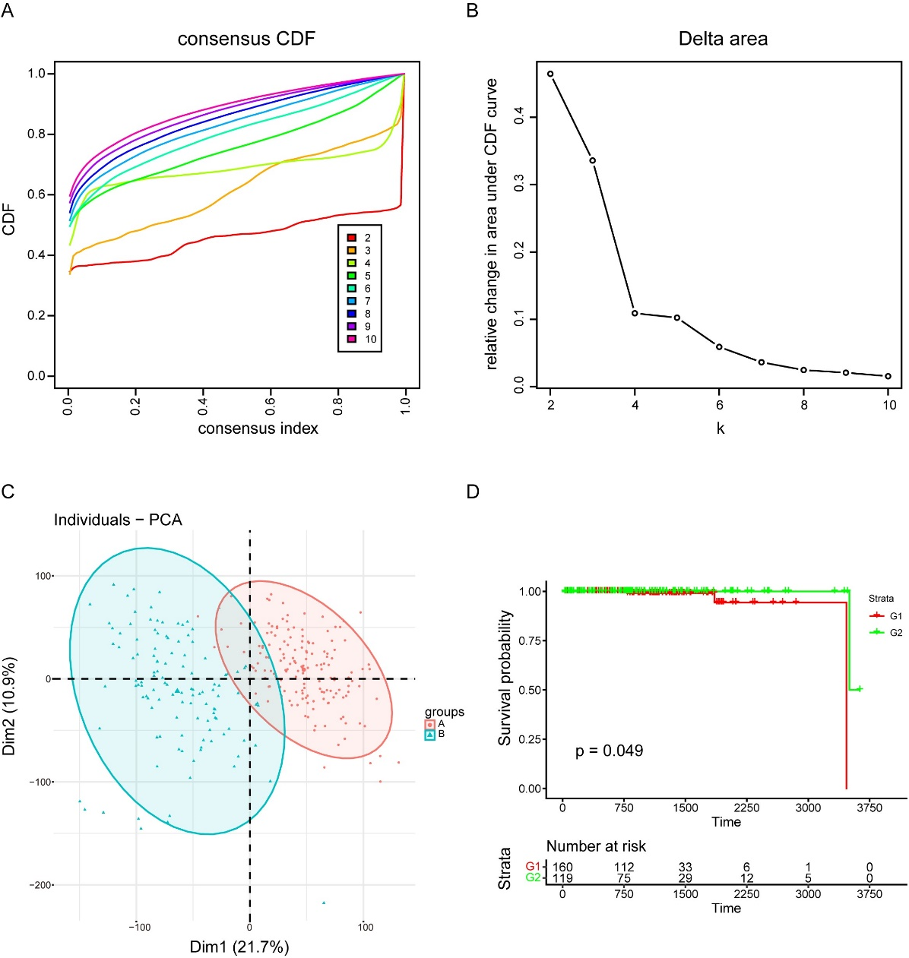
Supplementary Figure 3
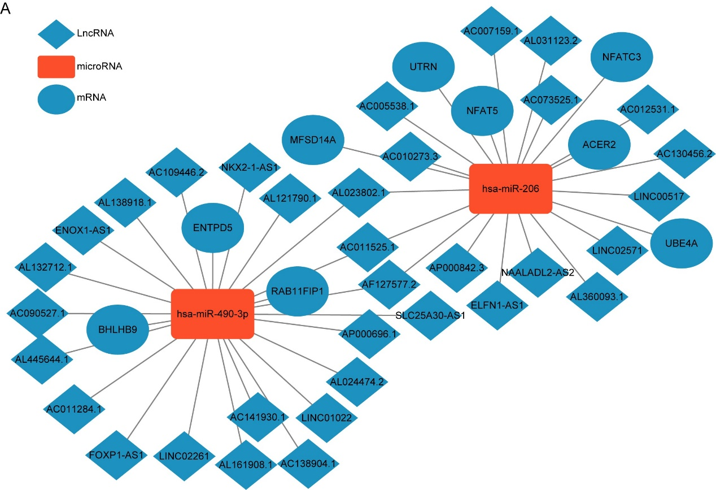
Supplementary Figure 4
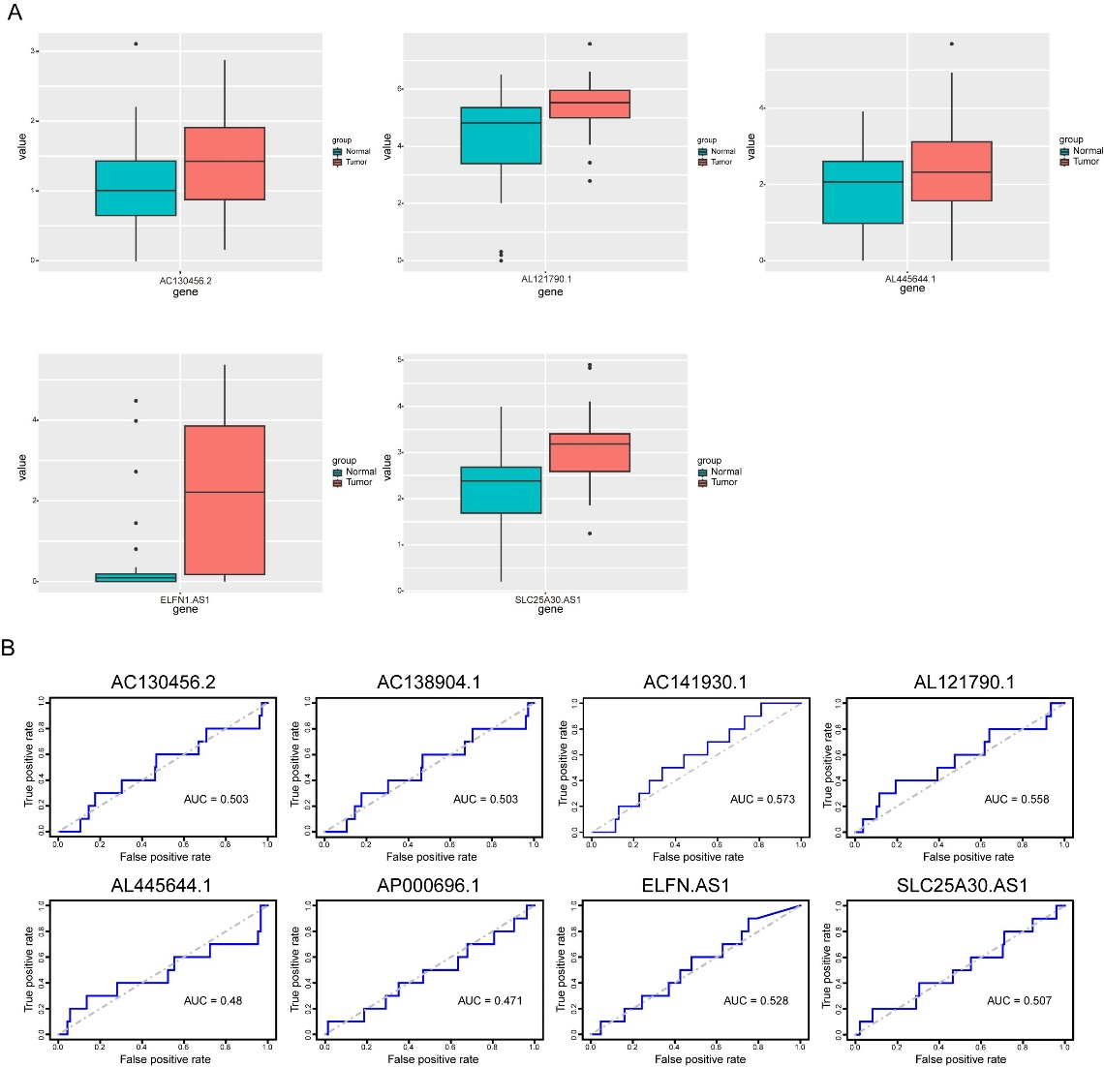
Supplementary Figure 5
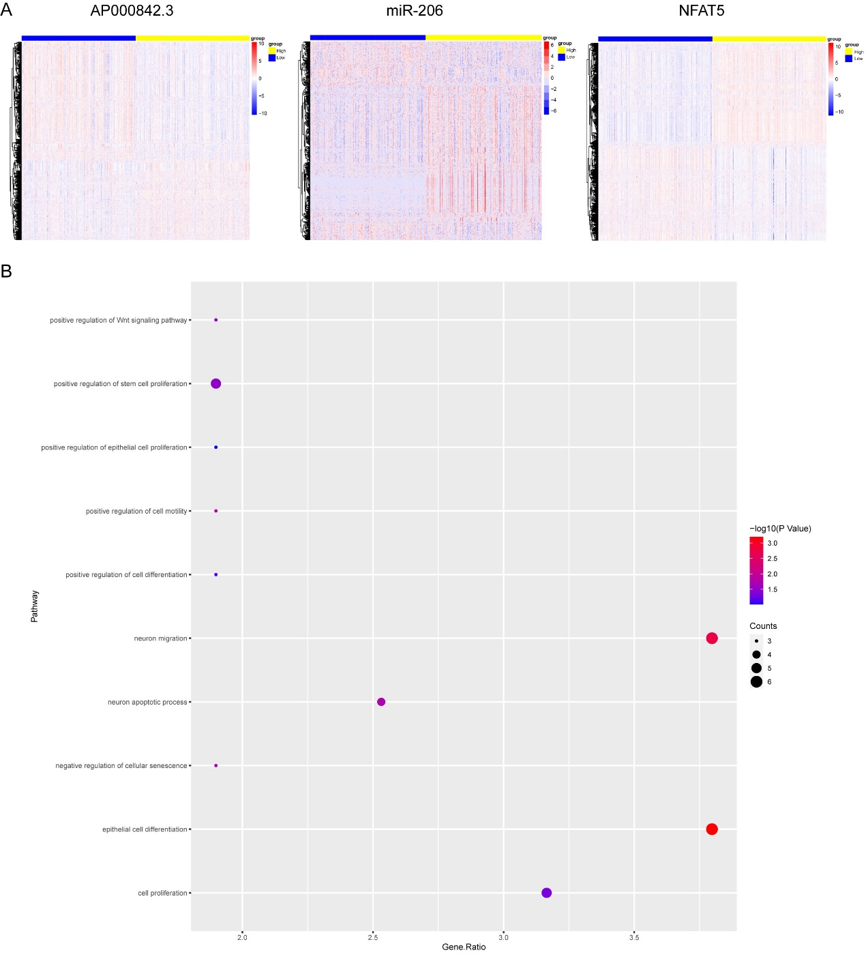

Supplements Figure1
(A) The results of differential expression analysis of mRNAs. PCA diagrams of mRNAs.
(B) The results of differential expression analysis of lncRNAs. PCA diagrams of lncRNAs.
Supplements Figure2
(A) Cumulative distribution function (CDF).
(B) Delta area plot.
(C) PCA depicted the distribution for clusters.
(D) Survival curves for the two groups.
Supplements Figure3
(A) The ceRNA network.
Supplements Figure4
(A) Expression of another five potential lncRNAs in tumor and normal tissues of prostate cancer patients. Normal tissue is shown in red and tumor tissue is shown in green.
(B) Analysis of AUC curve of 8 lncRNAs.
Supplements Figure5
(A) The volcano map showed the differential genes in the high expression group and low expression group.
(B) Bubble plots showed GSEA enrichment of differential genes.

