Supporting Information
Unraveling the Distinct Effects of CuO_{x} and PtCu alloy Sites in Pt−Cu Bimetallic Catalysts for CO Oxidation at Different Temperature
Yunan Li^{a,c} ‡ , Lingling Guo^{b} ‡, Meng Du^{a,b}, Chen Tian^{a,c}, Gui Zhao^{d}, Zhengwu Liu^{a,c}, Zhenye Liang^{a,c}, Kunming Hou ^{b}, Junxiang Chen ^{e}, Xi Liu^{d}, Luozhen Jiang^{a,b}*, Bing Nan^{a,b}*, Lina Li^{a,b}*
ª Shanghai Institute of Applied Physics, Chinese Academy of Sciences, Shanghai 201204, China
^{b} Shanghai Advanced Research Institute, Chinese Academy of Sciences, Shanghai 201210, China
^{c} University of Chinese Academy of Sciences, Beijing 100049, China
^{d} School of Chemistry and Chemical, In-situ Centre for Physical Sciences, Shanghai Jiao Tong University, Shanghai 200240, China
^{e} Division of China, TILON Group Technology Limited, Shanghai 200090, China
*Corresponding author. E-mail: nanb@sari.ac.cn (B. Nan); jianglz@sari.ac.cn (L. Jiang); lilina@sinap.ac.cn (L. Li).
‡ These authors contributed equally to this work.
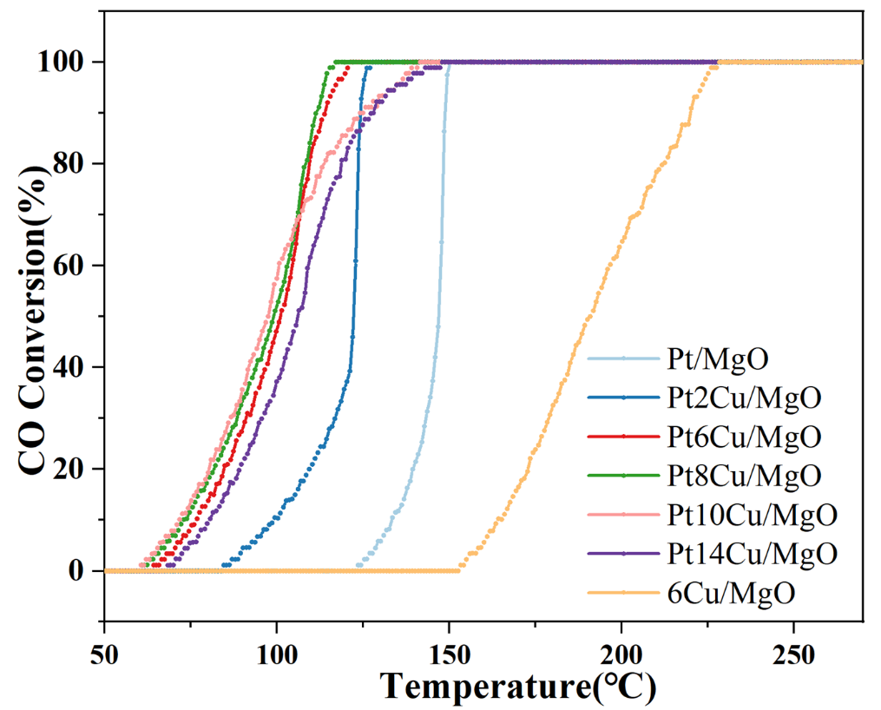
Fig. S1. “Light off” profiles for CO Oxidation reaction (1%CO/20%O₂/79%He, 120,000ml·h⁻¹·g_{cat}⁻¹).

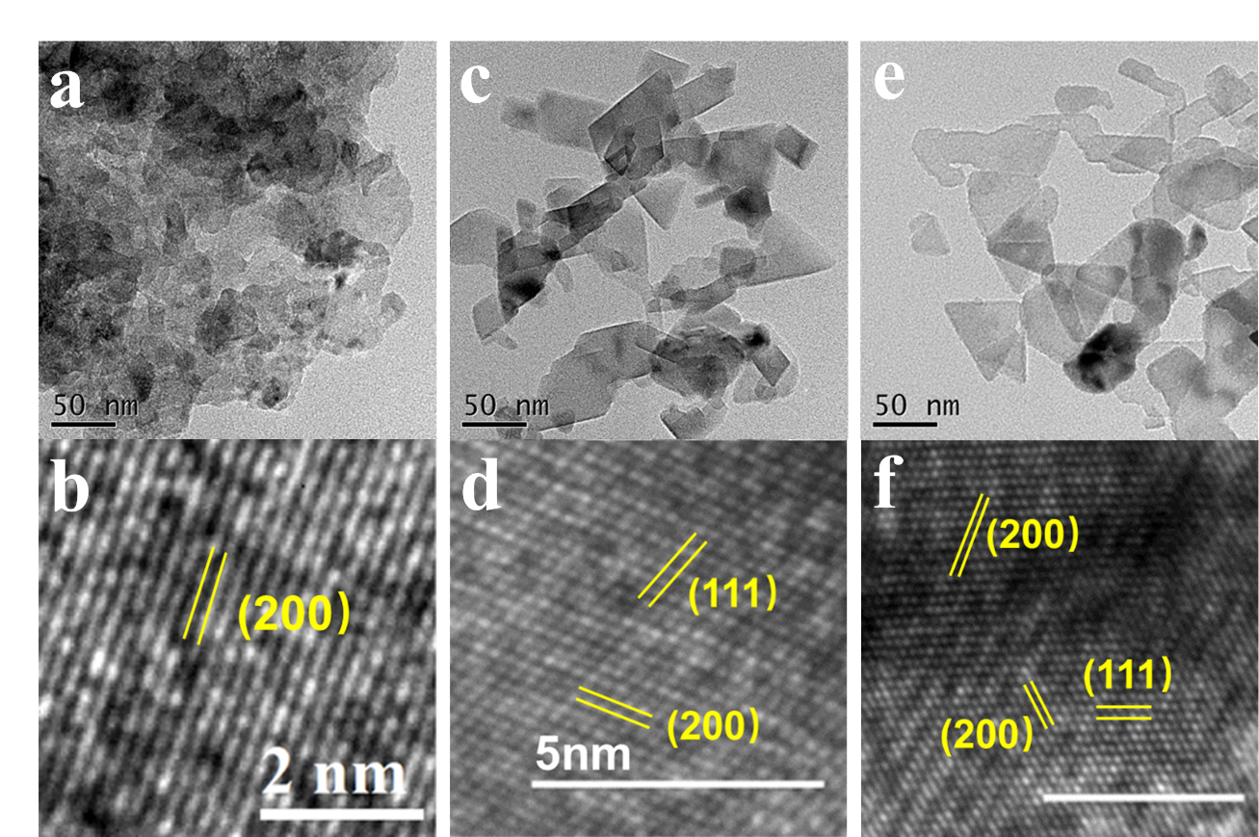
Fig. S2. TEM and HRTTM images of PtCu/MgO catalysts.

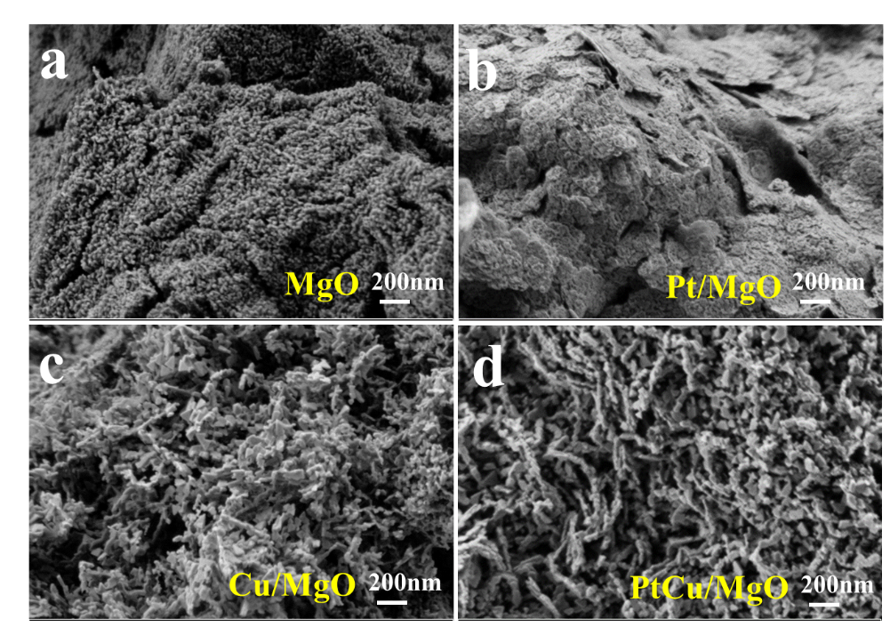
Fig. S3. SEM image of PtCu/MgO catalysts.

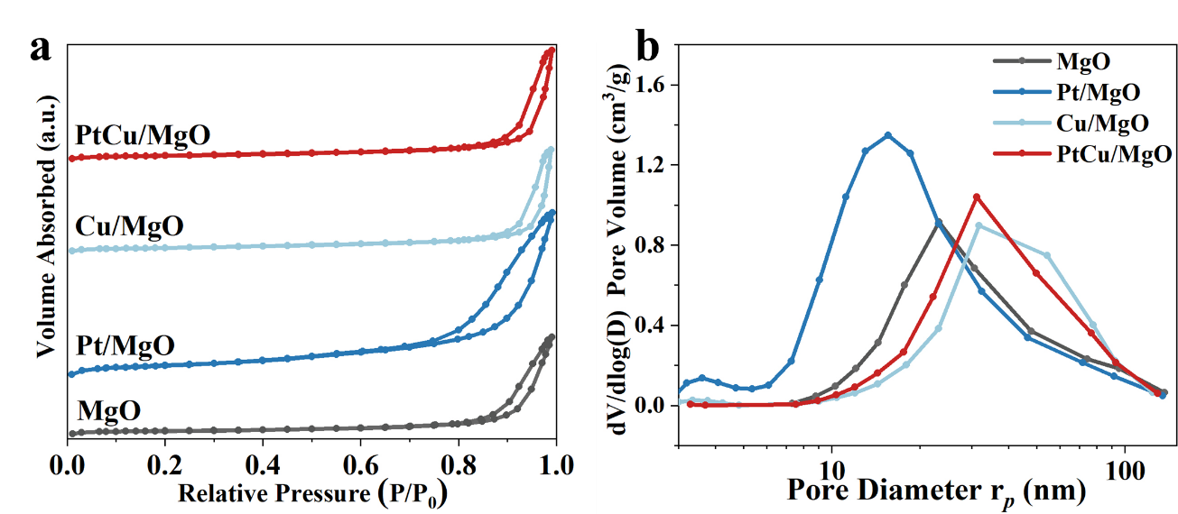
Fig. S4. (a) N₂ adsorption experimental results of adsorption-desorption isotherm, (b) BJH pore-size distribution.
The specific surface area and total pore volume of all the catalysts are calculated and listed in Table S1. It can be clearly seen that the specific surface areas (S_{BET}) and BJH pore volume of Pt/MgO (165 m²g⁻¹, 0.83 cm³g⁻¹) is significantly larger than that of MgO, Cu/MgO, and PtCu/MgO (56-68 m²g⁻¹, 0.49-0.54 cm³g⁻¹).
Fig. S4 shows the nitrogen adsorption-desorption isotherms of all the catalysts. The corresponding pore size distribution shows that Cu/MgO and Pt6Cu/MgO have much larger macroporous structures than MgO, whereas Pt/MgO has much smaller mesoporous pores than MgO, which is consistent with the observation from SEM (Fig. S2). The difference in pore structure may be caused by the difference in NO₃⁻ amount of Pt and Cu precursors during impregnation. Giuliana have reported the effect of the NO₃⁻ amount on pore structure during the synthesis of TiO₂ by sol-gel method. They found that as the amount of NO₃⁻ increased, the pore size gradually increased.

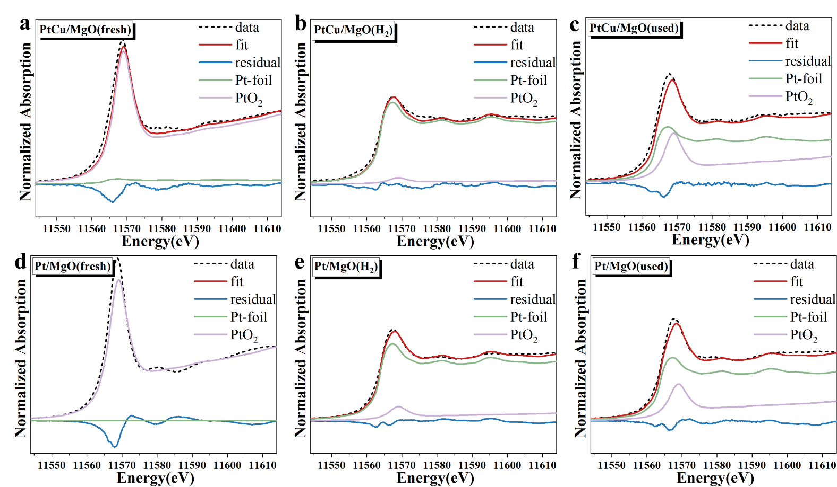
Fig. S5. XANES Pt-L₃ edge spectra and liner combination fitting results for PtCu/MgO catalysts.

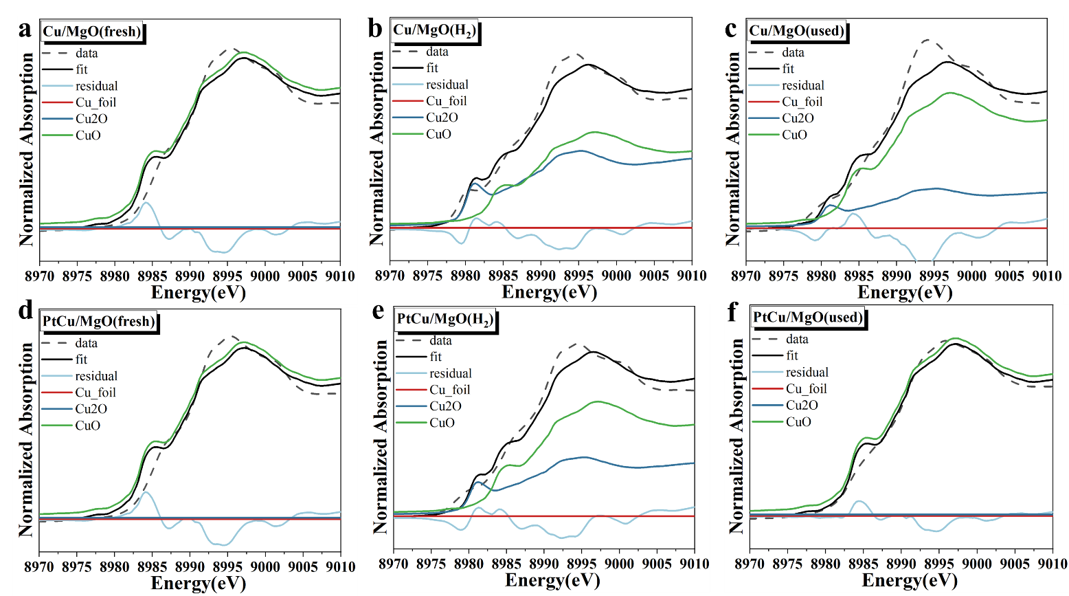
Fig. S6. XANES Cu-K edge spectra and liner combination fitting results for PtCu/MgO catalysts.

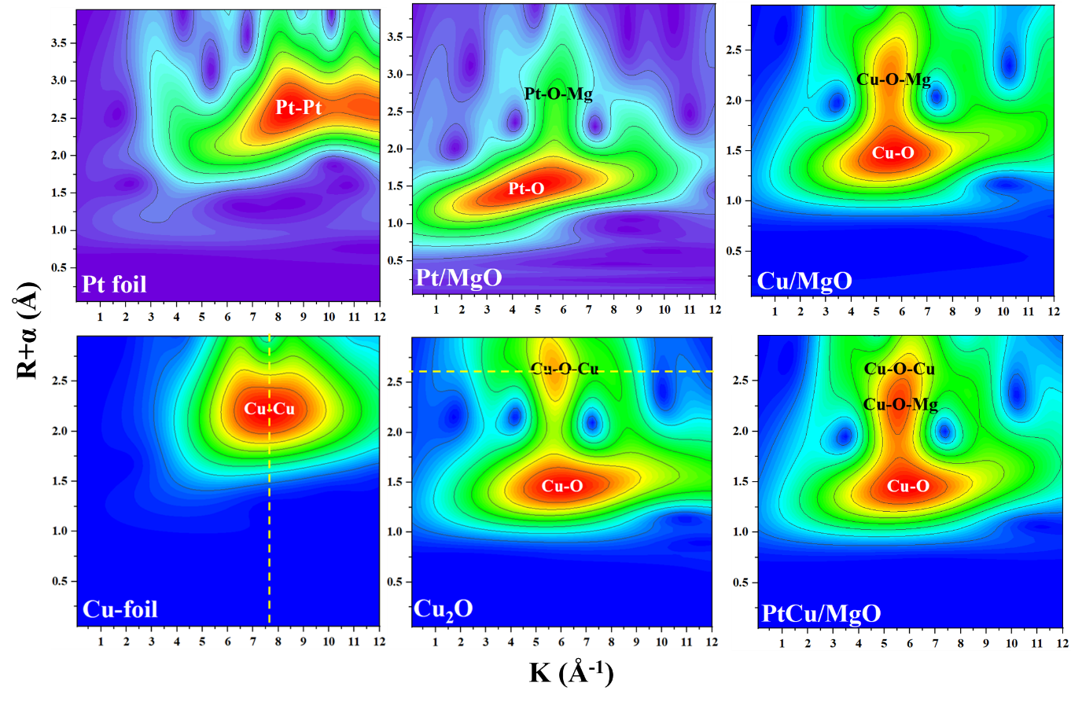
Fig. S7. WT-EXAFS contour plot of Pt L3-edge and Cu K-edge signals for Pt/MgO and Cu/MgO.

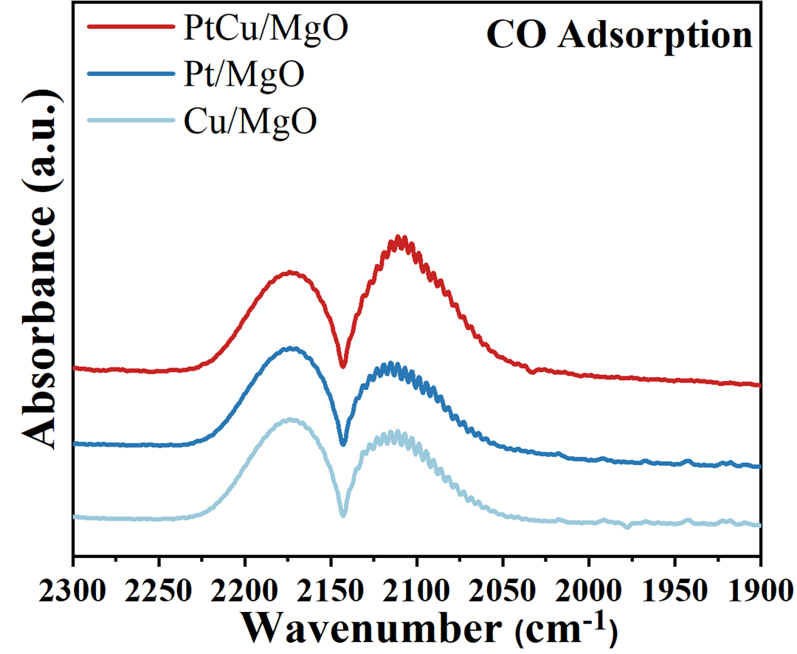
Fig. S8. In-situ DRIFTS spectra for PtCu/MgO catalysts tested at 100°C after oxygen pretreatment: The catalysts were pretreated in situ at 300 °C under O₂ flow in the DRIFTS reaction cell before data collection.

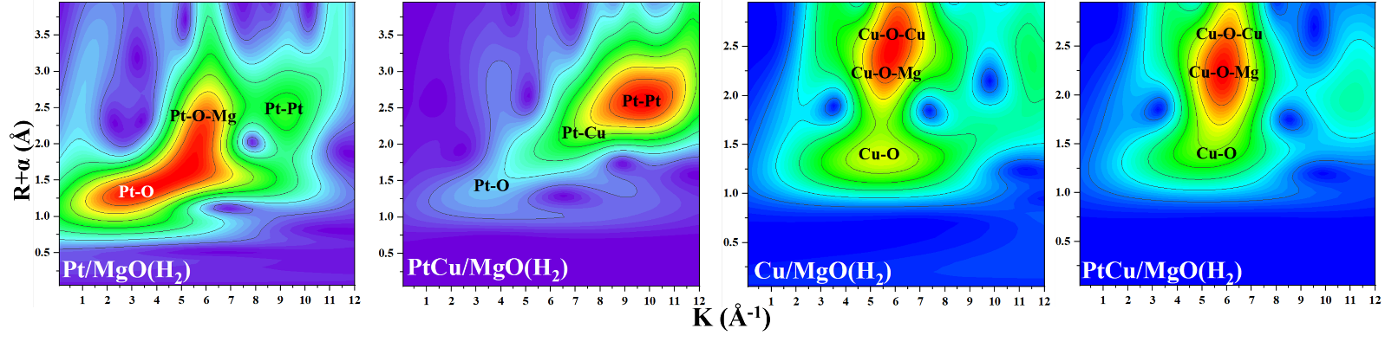
Fig. S9. WT-EXAFS contour plot of Cu K-edge and Pt L₃-edge signals for the PtCu/MgO catalysts after H₂ pretreatment.

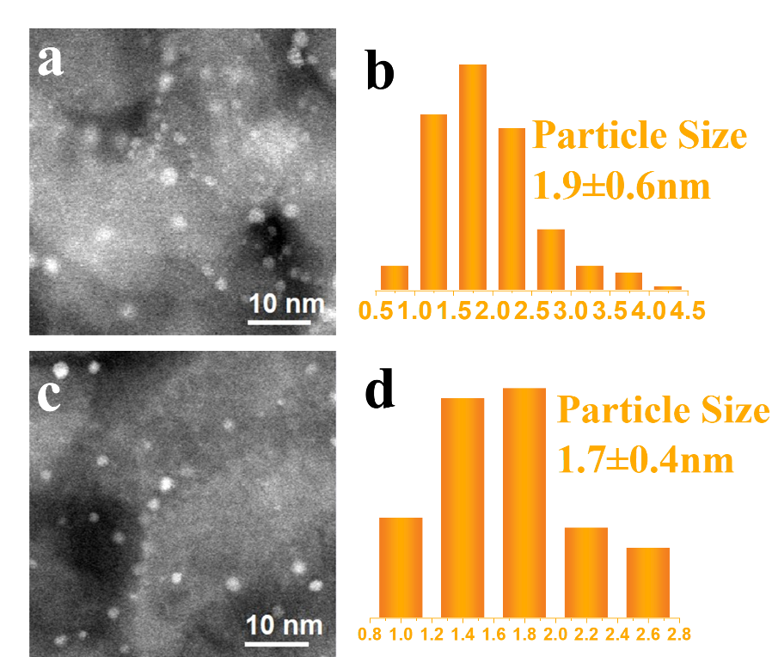
Fig. S10. Representative aberration-corrected HAADF-STEM images and statistical results of particle size distribution of Pt/MgO (a, b) and PtCu/MgO (c, d).

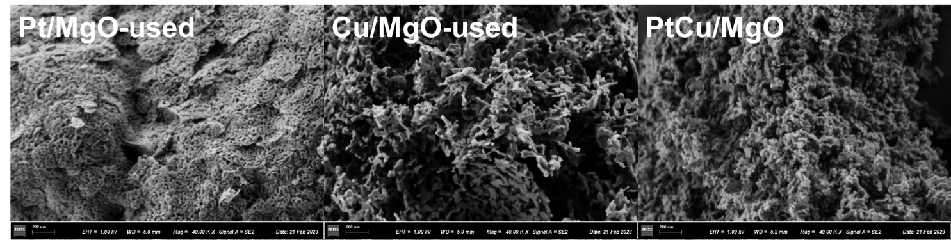
Fig. S11. SEM images of used PtCu/MgO catalysts.

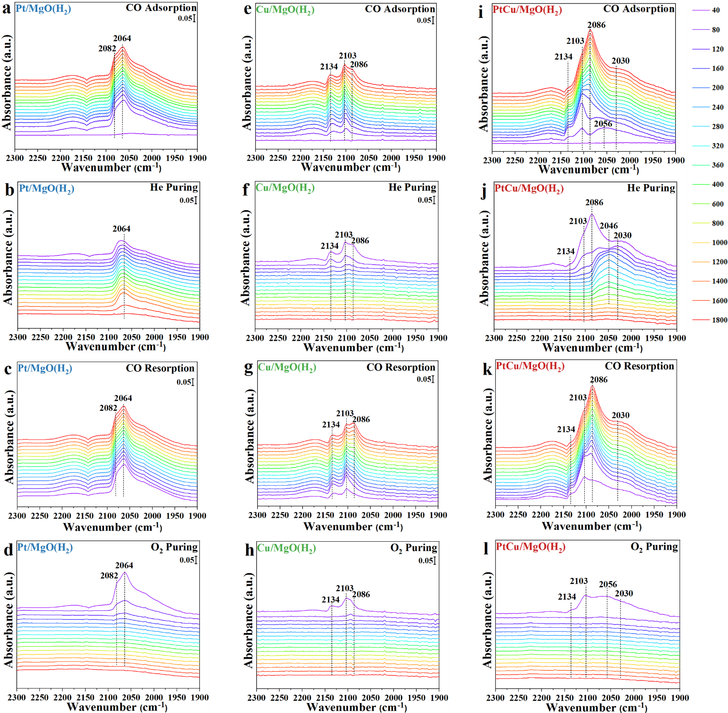
Fig. S12. (a-l) In-situ DRIFTS spectra for PtCu/MgO catalysts tested at 100°C after hydrogen pretreatment: (a-b) Pt/MgO (H₂), (e-h) Cu/MgO (H₂), (i-l) PtCu/MgO (H₂). The catalysts were pretreated in situ at 500 °C under H₂ flow in the DRIFTS reaction cell before data collection.

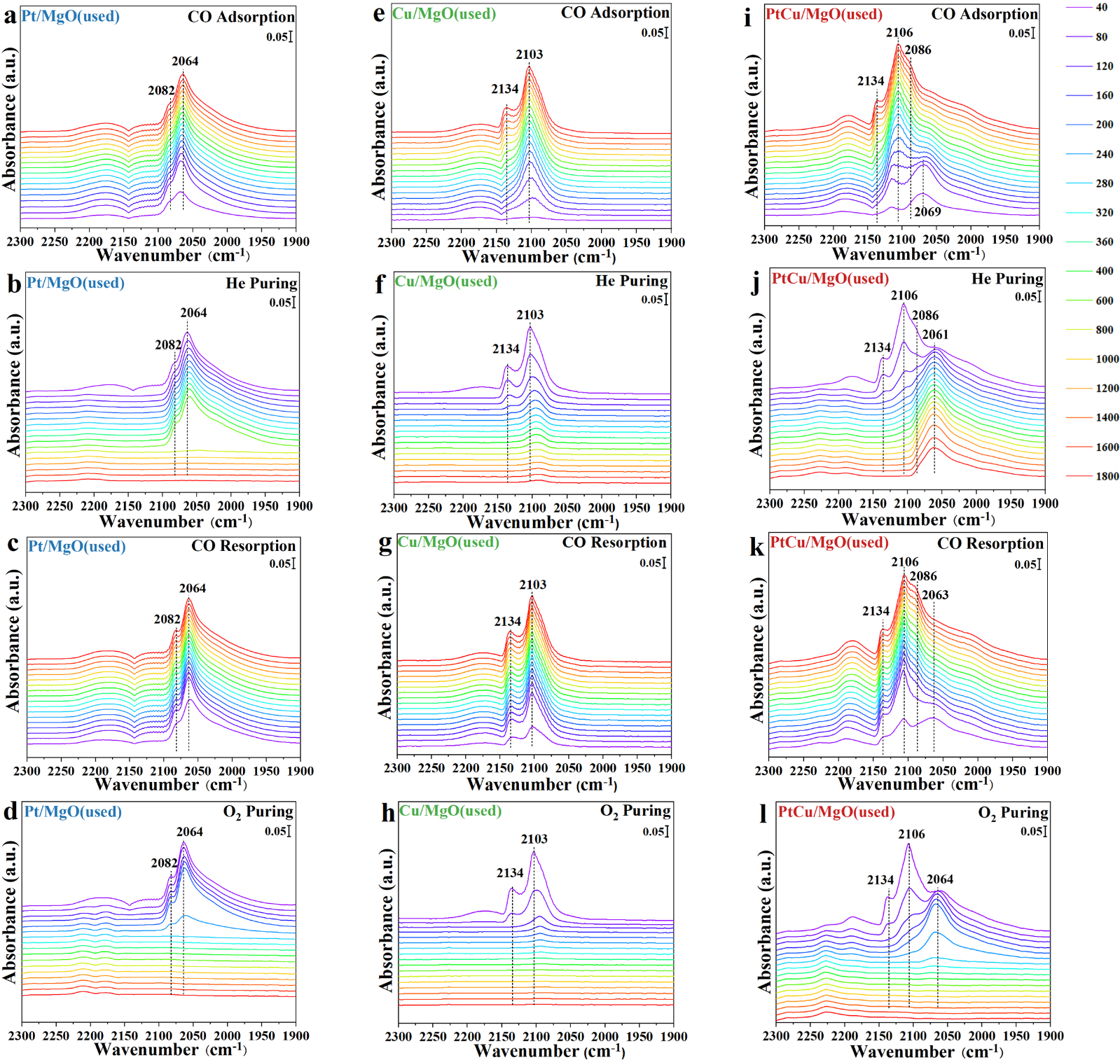
Fig. S13. (a-l) In-situ DRIFTS spectra for used PtCu/MgO catalysts tested at 100 °C: (a-b) Pt/MgO (used), (e-h) Cu/MgO (used), (i-l) PtCu/MgO (used). The catalysts were pretreated in situ at 500 °C under H₂ flow and underwent CO oxidation reaction from 30 to 300 ℃ in the DRIFTS reaction cell before data collection.
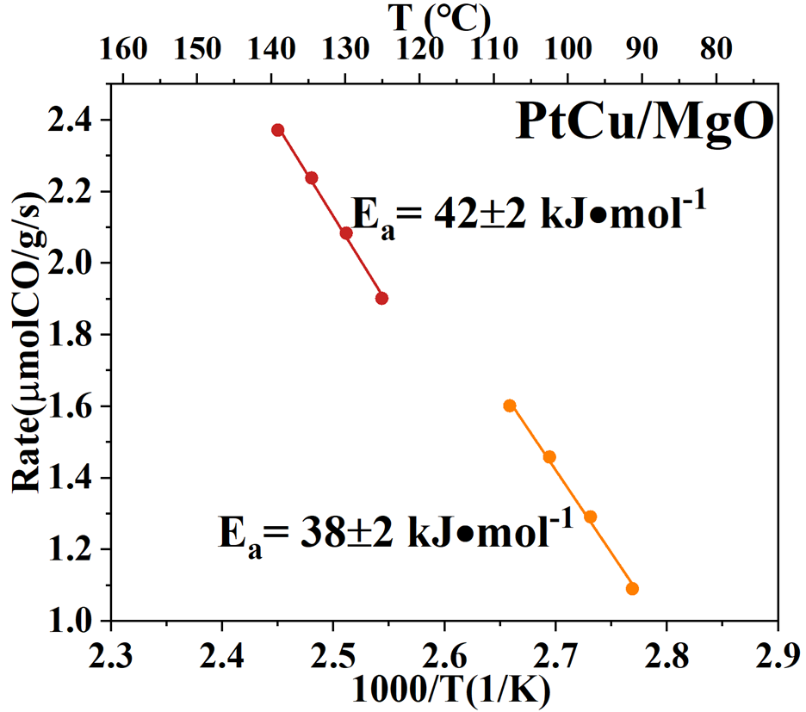
Fig. S14. Arrhenius plots for the CO Oxidation over PtCu/MgO at different temperature ranges.

Table S1 Pt and Cu bulk concentration, BET Specific surface areas (S_{BET}), BJH pore volume (V_{p}), lattice constants (a) and average particle sizes calculated from XRD (D_{XRD}) for PtCu/MgO catalysts
Sample | Pt(at.%)ª | Cu(at.%)ª | S_{BET} | V_{P} | a | D_{XRD}
Sample | Pt(at.%)ª | Cu(at.%)ª | (m²g⁻¹)^{b} | (cm³g⁻¹)^{b} | (Å)^{c} | (nm)^{c}
MgO | — | — | 56 | 0.49 | 4.1986(4) | 19
0.5Pt/MgO | 0.48 | — | 165 | 0.83 | 4.2159(4) | 11
 |  |  |  |  | 4.2185(4) ^{d} | 11^{d}
Pt/MgO | 1.19 | — | 172 | 0.80 | 4.2166(7) | 10
 |  |  |  |  | 4.2025(7) ^{d} | 11 ^{d}
6Cu/MgO | — | 6.0 | 63 | 0.51 | 4.2139(4) | 18
 |  |  |  |  | 4.1998 (4) ^{d} | 18^{d}
0.5Pt6Cu/MgO | 0.54 | 5.3 | 68 | 0.54 | 4.2143(4) | 17
 |  |  |  |  | 4.2015(4) ^{d} | 19 ^{d}
ª Determined by ICP-AES; ^{b} Calculated from nitrogen adsorption-desorption results; ^{c} Calculated from XRD patterns; ^{d} Used after CO oxidation reaction.

Table S2 Averaged oxidation state of platinum (δ) and the corresponding EXAFS fitting results for Pt L₃ edges (R: distance; CN: coordination number; σ²: Debye-Waller factor; ∆E₀: inner potential correction) of PtCu/MgO catalysts.
Smple | δª | Scatter | R(Å) | CN | σ² | ΔE₀(eV)
Pt/MgO | 4 | O | 2.02±0.01 | 5.9±0.3 | 0.003 | 12.2±0.5
Pt/MgO | 4 | Mg | 3.02±0.01 | 5.7±0.7 | 0.005 | 12.2±0.5
Pt/MgO | 4 | Pt | 3.36±0.03 | 5.7±1.5 | 0.006 | 12.2±0.5
PtCu/MgO | 3.8 | O | 1.99±0.02 | 3.8±0.3 | 0.003 | 9.4±0.6
 |  | Pt | 2.79±0.02 | 2.8±0.6 | 0.004
 |  | Mg | 2.95±0.06 | 1.3±0.7 | 0.005
 |  | Cu | 3.28±0.03 | 1.7±0.7 | 0.005
 |  | O | 3.65±0.03 | 7.0±2.3 | 0.007
Pt/MgO(H₂) | 0.4 | O | 2.01±0.01 | 2.6±0.2 | 0.003 | 9.5±1.0
 |  | Pt | 2.74±0.02 | 2.3±0.5 | 0.004
 |  | Mg | 3.02±0.03 | 3.6±0.6 | 0.005
PtCu/MgO(H₂) | 0.2 | O | 2.01±0.04 | 1.0±0.6 | 0.003 | 4.4±1.2
 |  | Cu | 2.59±0.04 | 0.8±0.3 | 0.004
 |  | Pt | 2.67±0.01 | 8.0±0.6 | 0.004
 |  | Cu1 | 3.64±0.01 | 1.0±0.6 | 0.011
Pt/MgO(used) | 1.0 | O | 2.02±0.03 | 1.7±0.4 | 0.002 | 11.7±3.7
Pt/MgO(used) | 1.0 | Pt | 2.77±0.03 | 6.0±0.9 | 0.005 | 11.7±3.7
Pt/MgO(used) | 1.0 | Pt | 3.29±0.07 | 2.6±1.3 | 0.007 | 11.7±3.7
PtCu/MgO(used) | 1.4 | O | 1.94±0.02 | 1.8±0.3 | 0.002 | 3.0±2.6
PtCu/MgO(used) | 1.4 | Cu | 2.58±0.05 | 0.9±0.3 | 0.004 | 3.0±2.6
PtCu/MgO(used) | 1.4 | Pt | 2.75±0.02 | 6.1±1.1 | 0.005 | 3.0±2.6
ªDetermined by linear combination analysis on the XANES profiles with references of Pt foil (δ = 0)/PtO₂ (δ = 4) for Pt L₃ edges. S₀² was fixed at 0.87. The σ² values were constrained in order to decrease the number of fit parameters and the correlations between them. The distances for Pt-Pt, Pt-O, Pt-Cu, and Pt-O-Cu are from the crystal structure of Pt foil, PtO₂, PtCu and Mg₂PtO₄.

Table S3 Averaged oxidation state of platinum (δ) and the corresponding EXAFS fitting results for Cu k edges (R: distance; CN: coordination number; σ²: Debye-Waller factor; ∆E₀: inner potential correction) of PtCu/MgO catalysts.
Smple | δª | Scatter | R(Å) | CN | σ² | ΔE₀(eV)
Cu/MgO | 2 | O | 1.97±0.01 | 2.0±0.2 | 0.003 | -3.8±1.0
 |  | Cu1 | 2.84±0.02 | 0.5±0.3 | 0.006
 |  | Mg | 2.95±0.03 | 4.7±0.7 | 0.008
PtCu/MgO | 2 | O | 1.96±0.01 | 2.0±0.2 | 0.003 | -6.1±1.0
 |  | Cu1 | 2.81±0.01 | 0.6±0.3 | 0.006
 |  | Mg | 2.93±0.02 | 5.4±0.8 | 0.008
Cu/MgO(H₂) | 1.5 | O | 1.93±0.01 | 1.2±0.2 | 0.003 | -3.6±1.1
 |  | Cu | 2.55±0.02 | 2.2±0.4 | 0.005
 |  | Cu1 | 2.73±0.01 | 5.6±0.8 | 0.007
 |  | Mg | 2.82±0.04 | 5.5±0.9 | 0.008
PtCu/MgO(H₂) | 1.6 | O | 1.99±0.01 | 1.4±0.2 | 0.003 | -1.6±1.2
 |  | Cu | 2.58±0.01 | 2.0±0.3 | 0.005
 |  | Cu1 | 2.77±0.01 | 3.0±0.5 | 0.007
 |  | Mg | 2.91±0.01 | 4.6±0.6 | 0.008
Cu/MgO(used) | 1.8 | O | 1.91±0.01 | 2.1±0.2 | 0.003 | -7.9±1.3
 |  | Cu | 2.55±0.02 | 0.7±0.2 | 0.005
 |  | Cu1 | 3.09±0.01 | 1.5±0.3 | 0.007
PtCu/MgO(used) | 2 | O | 1.93±0.01 | 2.7±0.1 | 0.003 | -7.6±0.9
 |  | Cu | 2.53±0.02 | 0.4±0.1 | 0.005
 |  | Cu1 | 3.08±0.02 | 1.0±0.2 | 0.007
ªDetermined by linear combination analysis on the XANES profiles with references of Cu foil (δ = 0) /Cu₂O (δ = 1) /CuO (δ = 2) for Pt L₃ edges. S₀² was fixed at 0.93. The σ² values were constrained in order to decrease the number of fit parameters and the correlations between them. The distances for Cu-Cu, Cu-O and Cu-O-Mg are from the crystal structure of Cu foil, CuO and Mg₃CuO_{4.}

Table S4 Comparison of the apparent activation energy over the representative Pt-based and Cu-based catalysts for CO oxidation.
Sample | Apparent activation energy (kJ⋅mol⁻¹)
1wt%Pt/CeO₂ | 45
4wt%Pt/Al₂O₃ | 70
0.7wt%Pt/SiO₂ | 60
20wt%Cu/TiO₂ | 64-76
10wt%Cu/CeO₂ | 60-72

