S 1: Average seasonal population of rugose spiraling whitefly at three different locations of leaves (base, middle and top leaflets) of oil palm accessions
Palm  No | Rugose spiralling whitefly
Palm  No | Base |  |  |  | Middle |  |  |  | Top |  |  |  | Avg popl/LL
Palm  No | S | N | A | N+A | S | N | A | N+A | S | N | A | N+A | Avg popl/LL
2 | 1.59 | 1.88 | 0.03 | 1.91 | 2.31 | 1.63 | 0.25 | 1.88 | 2.75 | 2.50 | 0.50 | 3.00 | 2.26
4 | 1.69 | 4.34 | 0.41 | 4.75 | 2.47 | 5.41 | 0.75 | 6.16 | 3.16 | 4.41 | 1.88 | 6.28 | 5.73
6 | 1.88 | 4.03 | 0.28 | 4.31 | 2.59 | 3.25 | 0.66 | 3.91 | 3.19 | 3.41 | 0.31 | 3.72 | 3.98
18 | 1.03 | 2.44 | 0.66 | 3.09 | 1.16 | 4.75 | 1.63 | 6.38 | 0.63 | 2.84 | 0.34 | 3.19 | 4.22
15 | 0.88 | 0.13 | 0.09 | 0.22 | 1.00 | 0.03 | 0.06 | 0.09 | 0.28 | 0.06 | 0.00 | 0.06 | 0.13
13 | 0.97 | 0.13 | 0.09 | 0.22 | 1.31 | 0.34 | 0.13 | 0.47 | 0.97 | 0.34 | 0.22 | 0.56 | 0.42
22 | 0.34 | 0.00 | 0.06 | 0.06 | 0.22 | 0.00 | 0.00 | 0.00 | 0.28 | 0.09 | 0.31 | 0.41 | 0.16
24 | 0.47 | 0.13 | 0.09 | 0.22 | 0.47 | 0.09 | 0.03 | 0.13 | 0.78 | 0.00 | 0.03 | 0.03 | 0.13
29 | 0.84 | 0.25 | 0.03 | 0.28 | 2.19 | 0.44 | 0.06 | 0.50 | 2.13 | 2.06 | 0.03 | 2.09 | 0.96
40 | 0.44 | 0.03 | 0.00 | 0.03 | 0.69 | 0.41 | 0.22 | 0.63 | 1.22 | 3.13 | 1.47 | 4.59 | 1.75
39 | 0.44 | 0.00 | 0.06 | 0.06 | 0.91 | 1.22 | 0.25 | 1.47 | 1.09 | 3.28 | 1.94 | 5.22 | 2.25
35 | 0.94 | 0.53 | 0.22 | 0.75 | 2.28 | 0.81 | 1.13 | 1.94 | 1.50 | 2.03 | 1.69 | 3.72 | 2.14
42 | 0.53 | 0.13 | 0.22 | 0.34 | 1.41 | 0.34 | 0.06 | 0.41 | 1.97 | 0.94 | 0.03 | 0.97 | 0.57
47 | 1.16 | 1.13 | 0.34 | 1.47 | 1.72 | 3.19 | 0.03 | 3.22 | 1.88 | 3.69 | 0.47 | 4.16 | 2.95
50 | 1.56 | 0.41 | 0.00 | 0.41 | 2.16 | 2.22 | 1.06 | 3.28 | 2.44 | 3.66 | 0.66 | 4.31 | 2.67
52 | 2.25 | 3.38 | 0.44 | 3.81 | 3.88 | 9.31 | 5.88 | 15.19 | 2.75 | 6.75 | 1.50 | 8.25 | 9.08
53 | 1.66 | 0.00 | 0.09 | 0.09 | 1.44 | 2.03 | 3.59 | 5.63 | 1.34 | 0.41 | 2.81 | 3.22 | 2.98
57 | 0.44 | 0.41 | 0.03 | 0.44 | 0.69 | 1.53 | 0.16 | 1.69 | 1.72 | 0.72 | 0.56 | 1.28 | 1.14
66 | 0.91 | 0.06 | 0.09 | 0.16 | 0.81 | 0.47 | 0.63 | 1.09 | 0.59 | 0.03 | 0.09 | 0.13 | 0.46
69 | 1.66 | 0.22 | 0.06 | 0.28 | 1.72 | 0.44 | 0.00 | 0.44 | 1.03 | 0.22 | 0.09 | 0.31 | 0.34
70 | 1.03 | 0.38 | 0.19 | 0.56 | 1.22 | 0.81 | 0.56 | 1.38 | 0.38 | 0.16 | 0.00 | 0.16 | 0.70
71 | 0.94 | 0.25 | 0.09 | 0.34 | 2.09 | 0.31 | 0.03 | 0.34 | 2.00 | 0.19 | 0.03 | 0.22 | 0.30
73 | 1.63 | 0.75 | 0.06 | 0.81 | 1.00 | 0.41 | 0.19 | 0.59 | 1.00 | 0.50 | 0.19 | 0.69 | 0.70
76 | 1.25 | 1.44 | 0.63 | 2.06 | 1.50 | 1.81 | 0.00 | 1.81 | 1.41 | 2.63 | 0.22 | 2.84 | 2.24
83 | 0.75 | 0.91 | 0.03 | 0.94 | 2.22 | 2.81 | 0.19 | 3.00 | 1.69 | 3.75 | 0.47 | 4.22 | 2.72
84 | 1.41 | 0.03 | 0.16 | 0.19 | 2.69 | 3.88 | 0.47 | 4.34 | 2.66 | 2.94 | 0.88 | 3.81 | 2.78
85 | 0.78 | 0.28 | 0.03 | 0.31 | 2.25 | 0.69 | 0.09 | 0.78 | 2.78 | 1.41 | 0.06 | 1.47 | 0.85
99 | 0.31 | 0.44 | 0.06 | 0.50 | 2.13 | 1.09 | 0.38 | 1.47 | 2.50 | 3.28 | 0.97 | 4.25 | 2.07
98 | 0.47 | 0.00 | 0.00 | 0.00 | 1.16 | 0.75 | 0.06 | 0.81 | 1.13 | 1.34 | 0.09 | 1.44 | 0.75
96 | 1.13 | 0.56 | 0.03 | 0.59 | 3.16 | 3.88 | 0.66 | 4.53 | 2.00 | 3.00 | 2.00 | 5.00 | 3.38
104 | 1.09 | 0.25 | 0.00 | 0.25 | 0.97 | 0.88 | 0.59 | 1.47 | 0.56 | 0.84 | 0.75 | 1.59 | 1.10
106 | 0.63 | 0.22 | 0.00 | 0.22 | 2.34 | 0.75 | 0.41 | 1.16 | 1.88 | 3.03 | 0.44 | 3.47 | 1.61
109 | 0.69 | 0.00 | 0.19 | 0.19 | 1.63 | 0.84 | 0.25 | 1.09 | 1.09 | 1.97 | 1.25 | 3.22 | 1.50
114 | 0.72 | 0.13 | 0.00 | 0.13 | 1.41 | 1.25 | 0.00 | 1.25 | 1.28 | 0.53 | 0.09 | 0.63 | 0.67
117 | 1.16 | 2.78 | 0.13 | 2.91 | 0.91 | 0.63 | 0.31 | 0.94 | 0.34 | 0.31 | 0.16 | 0.47 | 1.44
112 | 0.34 | 0.28 | 0.00 | 0.28 | 0.75 | 0.28 | 0.00 | 0.28 | 0.13 | 0.00 | 0.00 | 0.00 | 0.19
Mean | 1.00 | 0.79 | 0.14 | 0.92 | 1.64 | 1.64 | 0.58 | 2.22 | 1.51 | 1.85 | 0.63 | 2.47 | 1.87
SD | 0.50 | 1.17 | 0.17 | 1.28 | 0.81 | 1.91 | 1.12 | 2.83 | 0.88 | 1.64 | 0.72 | 2.07 | 1.82
C; Colonies, N: Nymphs, A: Adults, LL: leaflet; The numbers are the average of eight leaflets, two each from four directions

S 2: Average seasonal population of bondar nesting whitefly at three different locations of leaves (base, middle and top leaflets) of oil palm accessions
Palm Number | Bondar nesting whitefly
Palm Number | Base |  | Middle |  | Top |  | Avg pest population (N+A) per leaflet
Palm Number | C | N+A | C | N+A | C | N+A | Avg pest population (N+A) per leaflet
2 | 3.31 | 2.81 | 3.94 | 3.38 | 5.38 | 3.34 | 3.18
4 | 1.06 | 1.00 | 3.41 | 2.94 | 4.09 | 3.22 | 2.39
6 | 1.81 | 1.59 | 3.34 | 2.91 | 5.47 | 3.78 | 2.76
18 | 3.00 | 3.03 | 9.69 | 9.28 | 12.28 | 11.09 | 7.80
15 | 0.66 | 0.34 | 4.31 | 1.78 | 5.19 | 1.88 | 1.33
13 | 0.94 | 0.88 | 6.31 | 3.81 | 7.09 | 4.69 | 3.13
22 | 2.06 | 1.38 | 6.78 | 6.56 | 5.34 | 4.47 | 4.14
24 | 1.34 | 0.97 | 7.50 | 5.53 | 8.50 | 5.94 | 4.15
29 | 0.59 | 0.41 | 1.72 | 1.34 | 2.44 | 2.06 | 1.27
40 | 0.19 | 0.06 | 2.56 | 2.16 | 6.91 | 6.06 | 2.76
39 | 0.88 | 0.84 | 2.97 | 2.69 | 6.56 | 6.25 | 3.26
35 | 0.78 | 0.69 | 2.22 | 1.84 | 4.38 | 4.88 | 2.47
42 | 0.16 | 0.03 | 0.72 | 0.50 | 2.06 | 1.72 | 0.75
47 | 1.59 | 1.41 | 10.00 | 7.13 | 8.88 | 6.84 | 5.13
50 | 1.25 | 0.94 | 3.16 | 2.19 | 1.69 | 1.44 | 1.52
52 | 0.50 | 0.50 | 4.88 | 4.38 | 4.13 | 3.63 | 2.83
53 | 0.56 | 0.44 | 4.69 | 4.25 | 6.28 | 5.50 | 3.40
57 | 0.28 | 0.31 | 6.34 | 5.13 | 10.28 | 6.94 | 4.13
66 | 1.22 | 0.72 | 4.69 | 3.31 | 7.63 | 4.53 | 2.85
69 | 0.47 | 0.47 | 3.66 | 2.53 | 4.59 | 3.16 | 2.05
70 | 2.13 | 1.13 | 6.81 | 5.34 | 7.84 | 5.94 | 4.14
71 | 0.56 | 0.53 | 0.75 | 0.78 | 1.00 | 1.00 | 0.77
73 | 0.72 | 0.50 | 2.63 | 1.66 | 5.22 | 2.50 | 1.55
76 | 3.25 | 2.66 | 7.34 | 5.69 | 8.75 | 6.56 | 4.97
83 | 1.44 | 1.09 | 6.63 | 5.22 | 6.28 | 5.16 | 3.82
84 | 2.44 | 0.63 | 3.72 | 2.81 | 4.63 | 3.69 | 2.38
85 | 0.94 | 0.94 | 2.78 | 1.91 | 3.56 | 2.03 | 1.63
99 | 0.19 | 0.16 | 5.91 | 4.13 | 4.28 | 3.28 | 2.52
98 | 0.56 | 0.50 | 1.88 | 1.19 | 3.09 | 2.59 | 1.43
96 | 0.31 | 0.13 | 2.38 | 1.66 | 2.94 | 2.56 | 1.45
104 | 0.66 | 0.69 | 7.31 | 5.06 | 5.59 | 4.66 | 3.47
106 | 0.31 | 0.25 | 2.47 | 2.03 | 3.13 | 2.38 | 1.55
109 | 0.09 | 0.13 | 3.59 | 2.91 | 3.66 | 3.03 | 2.02
114 | 0.31 | 0.28 | 3.22 | 2.78 | 5.63 | 3.53 | 2.20
117 | 1.81 | 1.50 | 7.53 | 3.97 | 6.63 | 4.19 | 3.22
112 | 0.72 | 0.41 | 4.94 | 4.72 | 9.41 | 6.50 | 3.88
Mean | 1.09 | 0.84 | 4.52 | 3.49 | 5.58 | 4.20 | 2.84
SD | 0.88 | 0.74 | 2.35 | 1.93 | 2.52 | 2.05 | 1.42
C; Colonies, N: Nymphs, A: Adults; *Average of eight leaflets, two each from four directions

S 3. Surface maps of spatial distribution of BNW colonies at base, middle and tip leaflets based on the inverse distance weighting (IDW) interpolation method
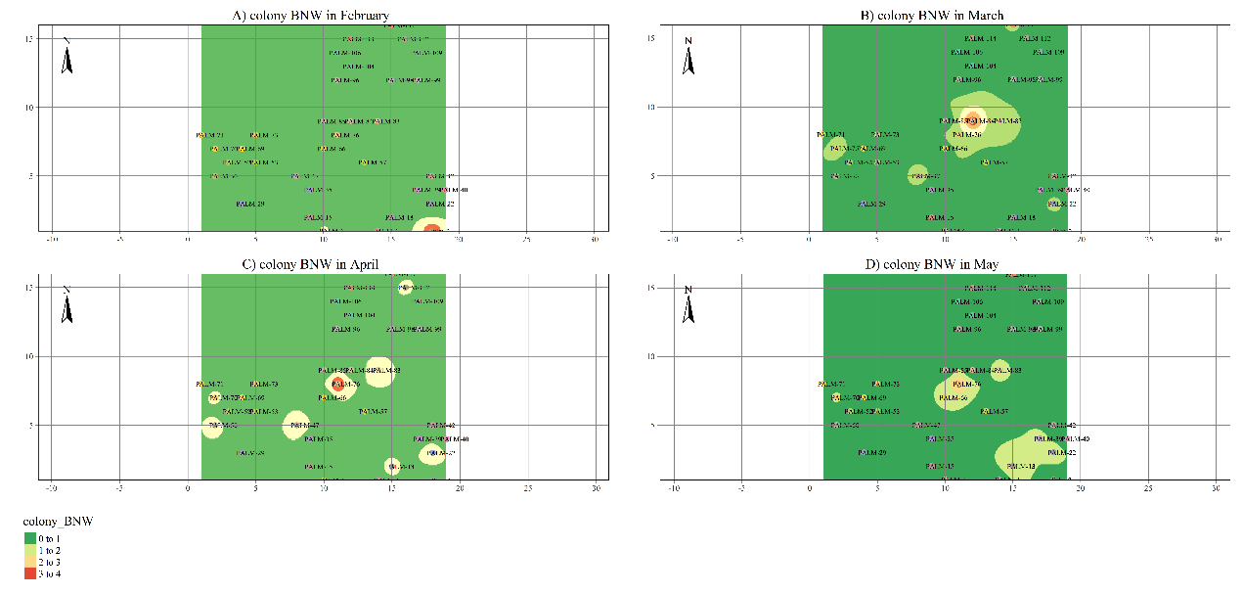
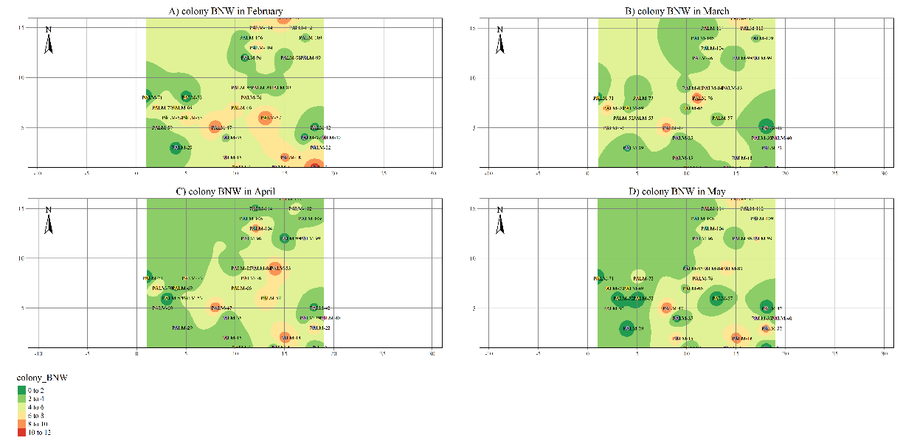
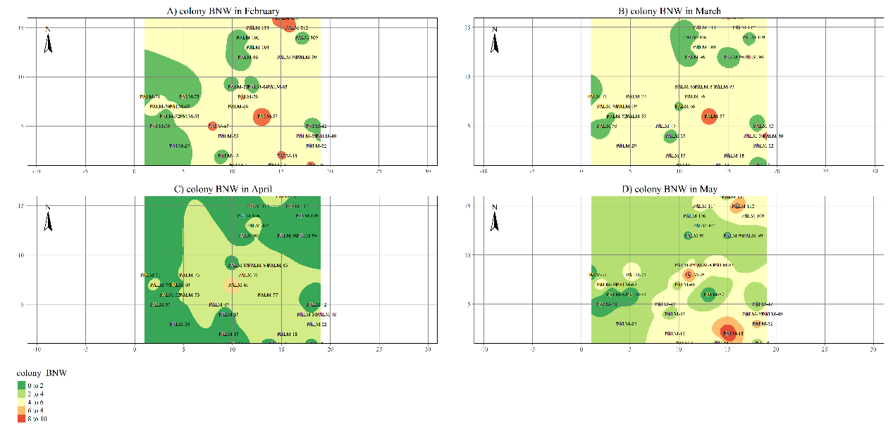
S 4. Surface maps of spatial distribution of BNW nymphs+adults at the base, middle and tip leaflets based on the inverse distance weighting (IDW) interpolation method
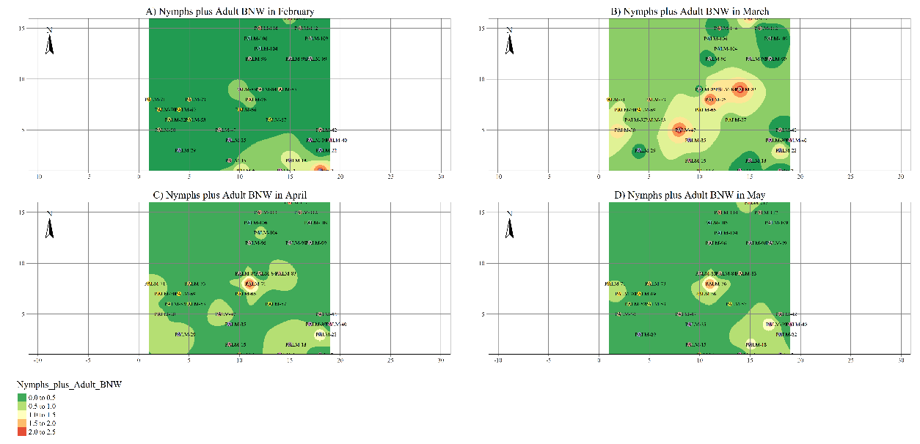
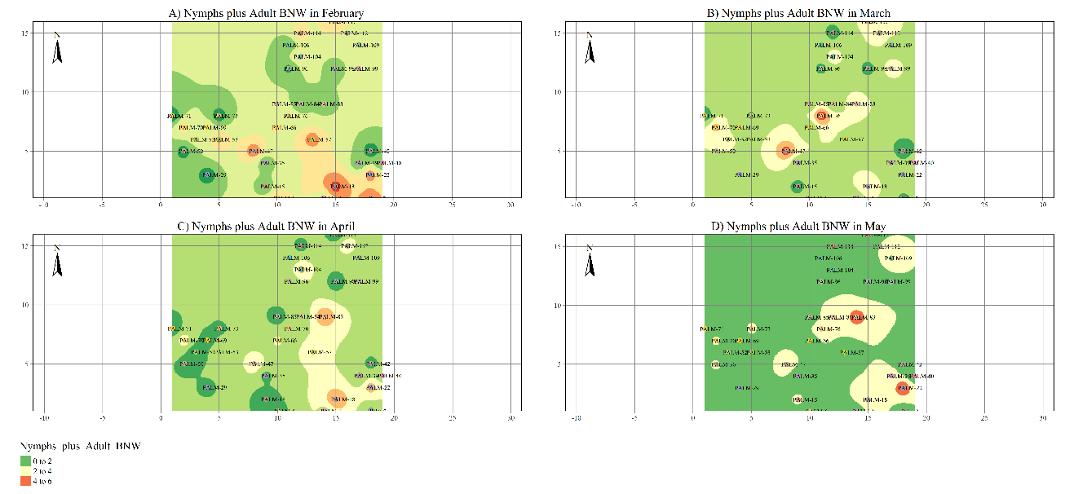
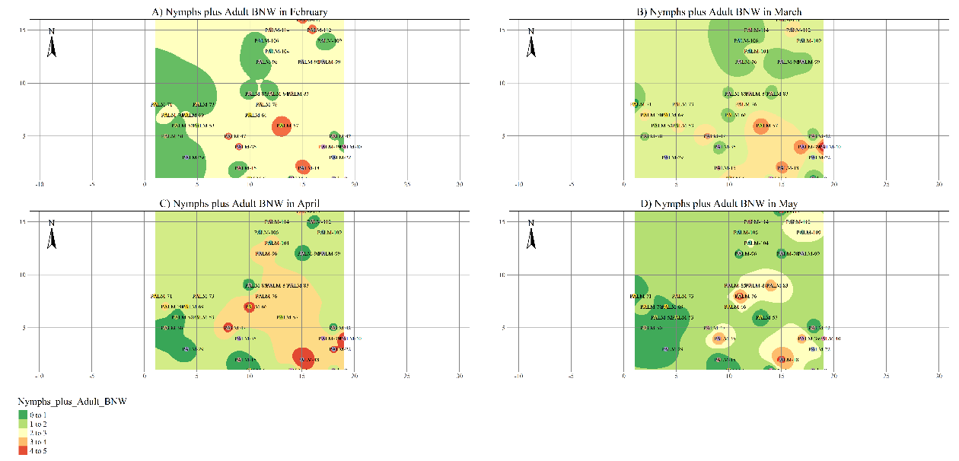

S 5. Surface maps of spatial distribution of RSW colonies at the base, middle and tip leaflets based on the inverse distance weighting (IDW) interpolation method

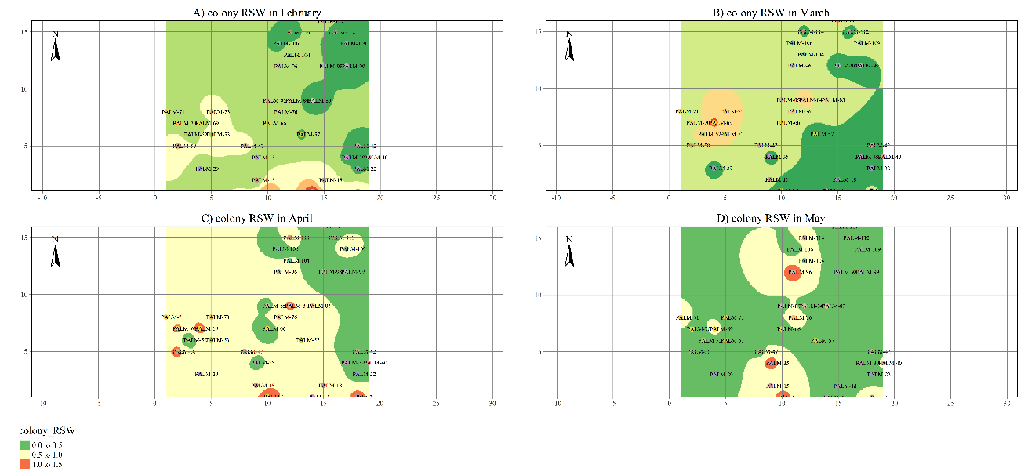
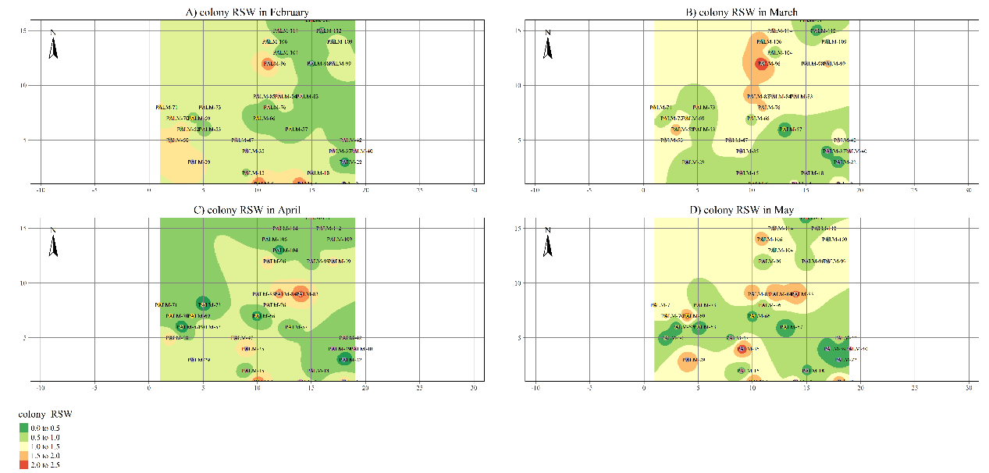
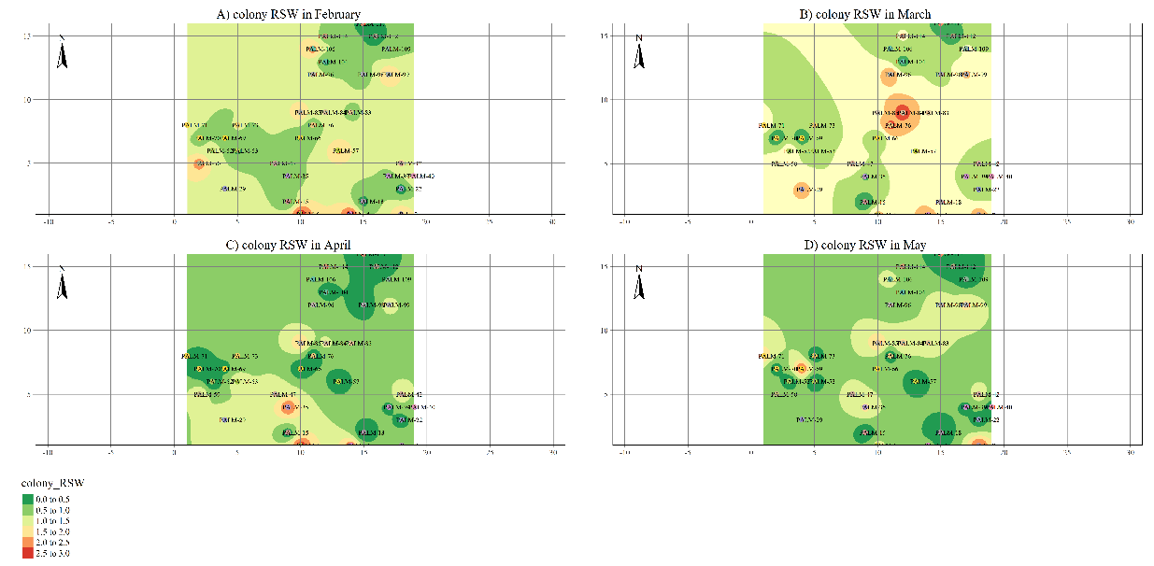
S 6. Surface maps of spatial distribution of RSW Nymphs+Adults at the base, middle and top leaflets based on the inverse distance weighting (IDW) interpolation method
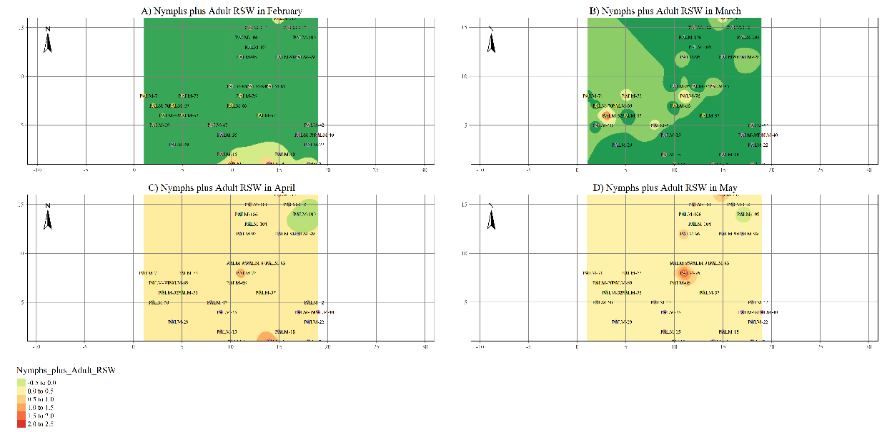
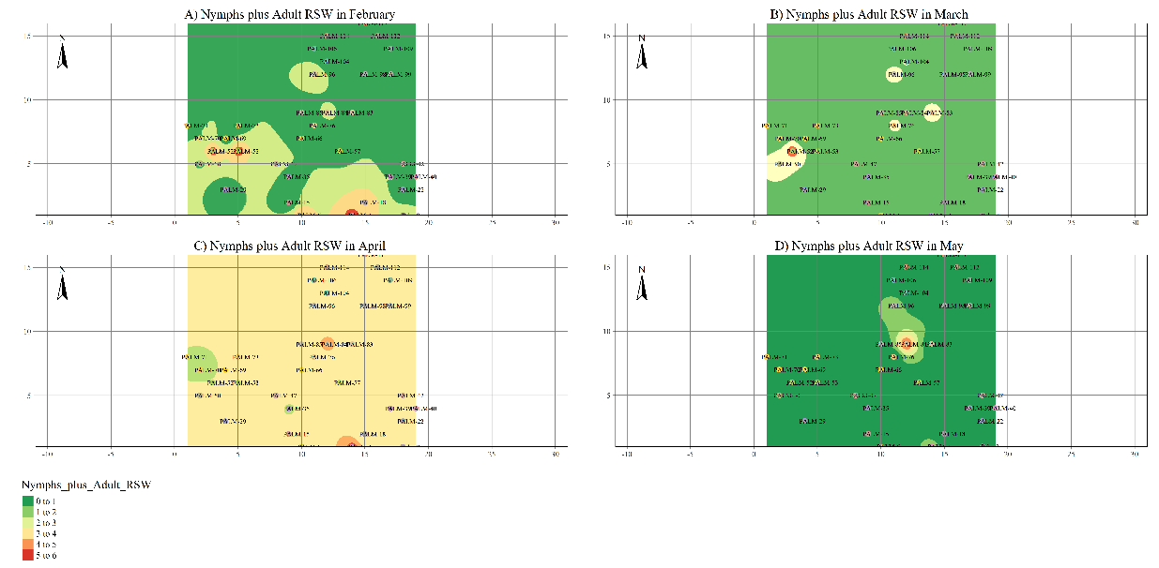
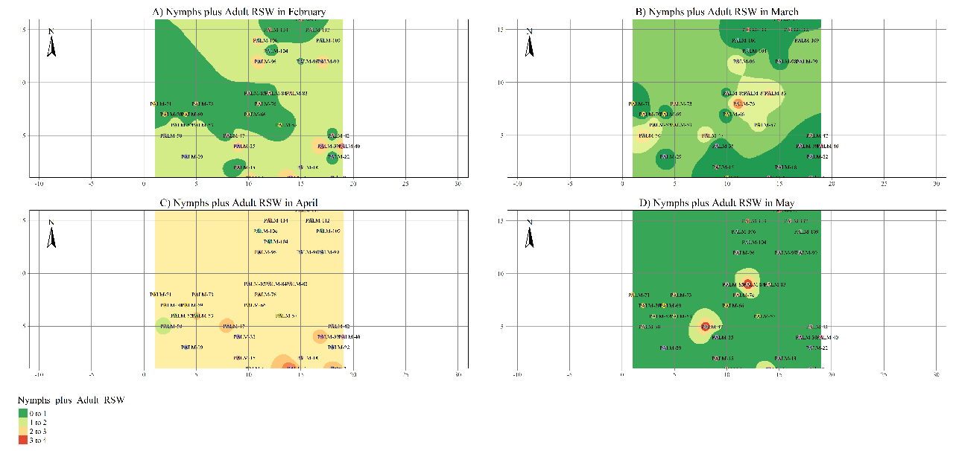

S 7: Kruskal wallis chi-square statistics between leaf position and month wise population of invasive whiteflies
Month | Parameter Readings | chi-squared statistic | degrees of freedom | p -value
February | colony_RSW | 10.315 | 2 | 0.0058
March | colony_RSW | 9.6397 | 2 | 0.0081
April | colony_RSW | 17.2735 | 2 | 2.00E-04
May | colony_RSW | 18.3149 | 2 | 1.00E-04
February | Nymphs_plus_Adult_RSW | 29.7386 | 2 | 0
March | Nymphs_plus_Adult_RSW | 16.3341 | 2 | 3.00E-04
April | Nymphs_plus_Adult_RSW | 3.7825 | 2 | 0.151
May | Nymphs_plus_Adult_RSW | 0.7366 | 2 | 0.692
February | colony_BNW | 77.7994 | 2 | 0
March | colony_BNW | 116.0505 | 2 | 0
April | colony_BNW | 128.8615 | 2 | 0
May | colony_BNW | 97.963 | 2 | 0
February | Nymphs_plus_Adult_BNW | 70.7901 | 2 | 0
March | Nymphs_plus_Adult_BNW | 110.768 | 2 | 0
April | Nymphs_plus_Adult_BNW | 95.1137 | 2 | 0
May | Nymphs_plus_Adult_BNW | 51.2729 | 2 | 0
Bold values are statically significant at 1% level
S 8: Kruskal wallis chi-square statistics between leaf position and over all month population of invasive whiteflies
Leaf Position | Parameter Readings | chi-squared statistic | degrees of freedom | p -value
Base | colony_RSW | 9.2384 | 3 | 0.0263
Middle | colony_RSW | 10.114 | 3 | 0.0176
Tip | colony_RSW | 7.2165 | 3 | 0.0653
Base | Nymphs_plus_Adult_RSW | 5.3472 | 3 | 0.148
Middle | Nymphs_plus_Adult_RSW | 2.7902 | 3 | 0.425
Tip | Nymphs_plus_Adult_RSW | 1.9913 | 3 | 0.574
Base | colony_BNW | 1.7353 | 3 | 0.629
Middle | colony_BNW | 11.114 | 3 | 0.0111
Tip | colony_BNW | 23.4969 | 3 | 0
Base | Nymphs_plus_Adult_BNW | 3.3661 | 3 | 0.339
Middle | Nymphs_plus_Adult_BNW | 15.1617 | 3 | 0.0017
Tip | Nymphs_plus_Adult_BNW | 24.4852 | 3 | 0
Bold values are statically significant at 1% level

