List of Tables
Table 1 Specifications of the Mowon Reservoir
Table 2 Comparison of a stair and trees reproduced from different photography angles
Table 3 Results of the preliminary test for the selection of the optimal aerial photography condition
Table 4 The relative coordinate accuracy of the point cloud model of the target site
Table 5 Status of the weather stations in the Mowon Reservoir watershed
Table 6 Hydrograph data of each watershed for the target area
Table 7 Setup of the two-dimensional hydraulic modelling for the bridge
Table 8 The computer resources used for flood wave analysis in this study
Table 9 Comparison of the peak runoff arrival times for each bridge
Table 10 Comparison of the water depth, peak runoff, and flow velocity at Bridge 1
Table 11 Comparison of the estimated flood wave propagation area
Table 1 Specifications of the Mowon Reservoir
Basin | Embankment |  |  |  | Spillway
Watershed area  (ha) | Length  (m) | Height (m) | Upstream slope  (V:H) | Downstream slope  (V:H) | Length  (m) | Height  (m)
79 | 127.0 | 5.6 | 1.0:3.5 | 1.0:1.7 | 14.0 | 2.0

Table 2 Comparison of a stair and trees reproduced from different photography angles
Case | Photography angles
Case | 45° | 55° | 65° | 75°
Staircase | 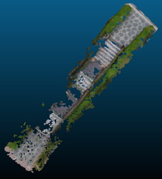 | 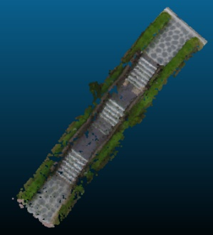 | 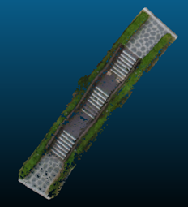 | 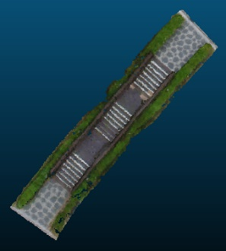
Tree B | 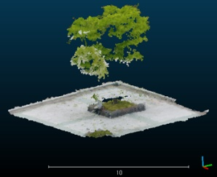 | 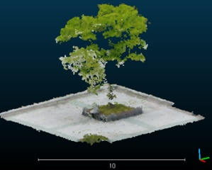 | 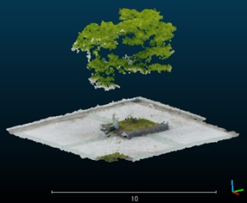 | 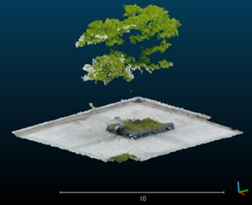
Tree C | 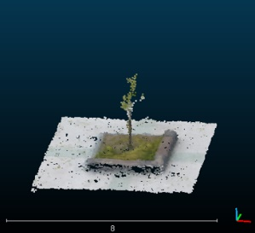 | 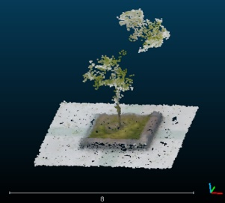 | 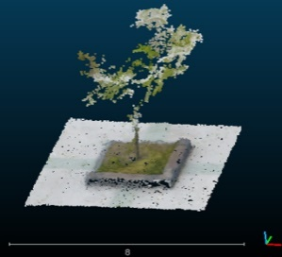 | 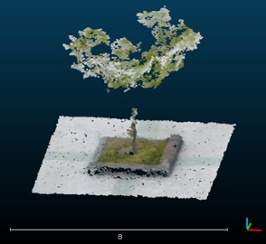
Tree D | 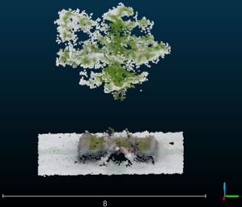 | 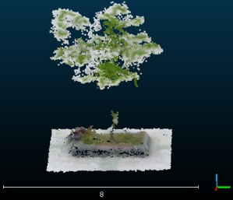 | 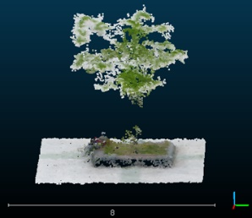 | 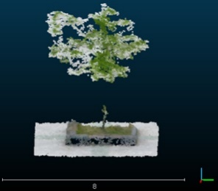

Table 3 Results of the preliminary test for the selection of the optimal aerial photography condition
Case | Condition | Images | Battery | Reproducibility*
Overlap  (%, based on 45˚ photography angle) | front 70%, side 63% | 11 | 8% | staircase ×, trunks ×
Overlap  (%, based on 45˚ photography angle) | front 80%, side 72% | 18 | 11% | staircase ▽, trunks △
Overlap  (%, based on 45˚ photography angle) | front 90%, side 81% | 41 | 18% | staircase ○, trunks ○
Photography angle  (˚, based on front 80%, side 72% overlap) | 45 | 22 | 12% | staircase ▽, trunks △
Photography angle  (˚, based on front 80%, side 72% overlap) | 55 | 22 | 12% | staircase ○, trunks ○
Photography angle  (˚, based on front 80%, side 72% overlap) | 65 | 22 | 12% | staircase ○, trunks ▽
Photography angle  (˚, based on front 80%, side 72% overlap) | 75 | 22 | 11% | staircase ○, trunks ▽
* Reproducibility rate: ○ = upper 90%, △ = 70 ~ 90%, ▽ = 50 ~ 70%, × = under 50%

Table 4 The relative coordinate accuracy of the point cloud model of the target site
Scale (m) | X (%) | Y (%) | Z (%)
1.0 | 98.42 | 99.59 | 99.81
2.0 | 100.00 | 100.00 | 100.00
3.0 | 100.00 | 100.00 | 100.00

Table 5 Status of the weather stations in the Mowon Reservoir watershed
Name | Observatory code | Latitude |  | Longitude | Elevation  (EL.m) |  | Observer type
Jangdong | 40074082 | 34°46’43” | 127°00’34” |  |  | 200 | Telemeter
Jangheung | 51011260 | 34°41’19” | 126°55’10” |  |  | 44 | Telemeter

Table 6 Hydrograph data of each watershed for the target area
Data | Watershed A | Watershed B | Watershed C | Watershed D
Watershed area (m²) | 790,000 | 924,000 | 188,000 | 115,000
Flow path (km) | 1.570 | 2.158 | 1.110 | 0.861
Curve number (CNⅢ) | 86 | 86 | 88 | 92
Time of concentration ($T_{C}$, h) | 0.138 | 0.183 | 0.108 | 0.105
Storage coefficient (K, h) | 0.162 | 0.213 | 0.125 | 0.147
Peak runoff (m³/s) | 12.0 | 13.9 | 2.9 | 1.8

Table 7 Setup of the two-dimensional hydraulic modelling for the bridge
Modelling for the bridge flow | Beams upper flow |  |  | Piers
Modelling for the bridge flow | 2D numerical analysis (DWE or SWE) |  |  | Culvert option
Modelling for the bridge flow | Shape |  |  | Material
Modelling for the bridge flow | Rectangular |  |  | Concrete
Modelling for the bridge flow | Entrance loss coefficient | Exit loss coefficient | Manning’s n
Modelling for the bridge flow | 0.5 | 1.0 | 0.011
The flow under the bridge calculation method (Brunner, 2016) | Inlet control headwater | Unsubmerged | $$\frac{E_{i}}{h_{i}}=\frac{H_{c}}{h_{i}}+K{\left[\frac{Q_{b}}{a_{b}h_{i}^{0.5}}\right]}^{M}-0.5s_{b}$$
The flow under the bridge calculation method (Brunner, 2016) | Inlet control headwater | Submerged | $$\frac{E_{i}}{h_{i}}=c{\left[\frac{Q_{b}}{a_{b}h_{i}^{0.5}}\right]}^{2}+Y-0.5s_{b}$$
The flow under the bridge calculation method (Brunner, 2016) | Outlet control headwater | $$Z_{3}+Y_{3}+\frac{a_{3}V_{3}^{2}}{2g}=Z_{2}+Y_{2}+\frac{a_{2}V_{2}^{2}}{2g}+H_{L}$$
where $E_{i}$ is headwater energy depth above the invert of the bridge inlet (m); $h_{i}$ is interior height of the bridge barrel (m); $Q_{b}$ is the discharge through the bridge (cm); $H_{c}$ is the specific head at critical depth (m); $a_{b}$ is the full cross-sectional area of the bridge barrel (m²); $s_{b}$ is the bridge barrel slope (m/m); $K, M, c, Y$ are the equation constants, which vary depending on the bridge shape and entrance conditions; $Z_{3}$ is the upstream invert elevation of the bridge; $Y_{3}$ is depth of water above the upstream bridge inlet; $V_{3}$ is the average velocity upstream of the bridge; $a_{3}$ is the velocity weighting coefficient upstream of the bridge; $Z_{2}$ is the downstream invert elevation of the bridge; $Y_{2}$ is the depth of water above the downstream bridge inlet; $V_{2}$ is the average velocity downstream of the bridge; $a_{2}$ is the velocity weighting coefficient downstream of the bridge; and $H_{L}$ is the total energy loss through the bridge.

Table 8 The computer resources used for flood wave analysis in this study
Resources | Name
CPU | Intel® Core™ i7-8700 @ 3.20 GHz
RAM | SAMSUNG DDR4 PC-19200 32GB
Graphic | NVIDIA GeForce GTX 1060 3GB
Storage | Western Digital WD Black 3D M.2 2280
Operating system | Windows 10 pro x64

Table 9 Comparison of the peak runoff arrival times for each bridge
Case | Bridge 1 (s) | Bridge 2 (s) | Bridge 3 (s)
DWE | 49 | 138 | 168
SWE | 52 | 181 | 227

Table 10 Comparison of the water depth, peak runoff, and flow velocity at Bridge 1
Case | Water depth  (m) | Peak flow (beams upper flow)  (m³/s) | Velocity  (m/s)
DWE | 2.70 | 42.34 (0.00) | 2.36
SWE | 2.96 | 35.90 (1.34) | 4.29

Table 11 Comparison of the estimated flood wave propagation area
Case | Actual flood wave propagation area  (A, m²) | Simulation results  (B, m²) | Difference of  A and B  (B–A, m²) | Overlapping area  (A$∩$B, m²) | Estimation accuracy  ((A$∩$B/A)$×$100, %) | Total analysis time  (hour:min)
DWE | 19,422.006 | 18,135.371 | –1,286.634 | 9,487.657 | 48.9 | 52:06
SWE | 19,422.006 | 25,501.029 | 6,079.024 | 13,074.712 | 67.3 | 63:21
3D method | 19,422.006 | 28,387.809 | 8,965.804 | 16,383.704 | 84.4 | 174:32

