Supplementary Figures for

Age-dependent loss of Crls1 causes myopathy and skeletal muscle regeneration failure

Young-Kyo Seo et al.
*Corresponding author. Email: ykseo@kribb.re.kr

This PDF file includes:

Table S1 to S2
Figs. S1 to S2

Table S1. Antibodies used for immunoblot, immunofluorescence and immunohistochemistry.
Product | Cat. num. | Company
Alpha-Tubulin antibody | sc23948 | Santa Cruz
CRLS1 Polyclonal Antibody | PA5-100137 | Invitrogen
CRLS1 antibody (Internal Region) | ABIN6261040 | antibodies-online
Total OXPHOS Rodent WB Antibody Cocktail | ab110413 | abcam
Laminin Antibodies | L9393 | Sigma
Laminin Monoclonal Antibody (A5) | MA1-06100 | Invitrogen
Recombinant anti-Myhc/MHC | AB37484 | Abcam
GFP Polyclonal Antibody, Alexa Fluor™ 488 | A21311 | Invitrogen
Goat anti-Rabbit IgG (H+L) Secondary Antibody, HRP | 31460 | Invitrogen
Goat anti-mouse IgG (H+L) Secondary Antibody, HRP | 31430 | Invitrogen
Goat anti-Rat IgG (H+L) Highly Cross-Adsorbed Secondary Antibody, Alexa Fluor™ Plus 594 | A48264 | Invitrogen
Goat anti-Rabbit IgG (H+L) Highly Cross-Adsorbed Secondary Antibody, Alexa Fluor™ Plus 594 | A32740 | Invitrogen
Goat anti-Mouse IgG (H+L) Highly Cross-Adsorbed Secondary Antibody, Alexa Fluor™ Plus 594 | A32742 | Invitrogen
Goat anti-Mouse IgG (H+L) Highly Cross-Adsorbed Secondary Antibody, Alexa Fluor™ Plus 488 | A32723 | Invitrogen
Goat anti-Rabbit IgG (H+L) Highly Cross-Adsorbed Secondary Antibody, Alexa Fluor™ Plus 488 | A32731 | Invitrogen

Table S2. Primer sets used for quantitative PCR analyses

Application | Target | Sequence (5'-3')
SYBR qPCR | 36b4-F | AGATTCGGGATATGCTGTTGG
SYBR qPCR | 36b4-R | AAAGCCTGGAAGAAGGAGGTC
SYBR qPCR | Myhc1-F | GAGCAGCAGGTGGATGATCT
SYBR qPCR | Myhc1-R | GCTTGGCTCGCTCTAGGTC
SYBR qPCR | Myhc2a-F | AAGCGAAGAGTAAGGCTGTC
SYBR qPCR | Myhc2a-R | GTGATTGCTTGCAAAGGAAC
SYBR qPCR | Myhc2b-F | GTCACCAAAGGCCAGACG
SYBR qPCR | Myhc2b-R | ACATCTTCTCATACATGGACTTGG
SYBR qPCR | Ptpmt1-F | GCAACACCTCGAAGGAATGG
SYBR qPCR | Ptpmt1-R | GAGATTGGCCAAGGTTGGGA
SYBR qPCR | Myhc2x-F | TCGCTGGCTTTGAGATCTTT
SYBR qPCR | Myhc2x-R | CGAACATGTGGTGGTTGAAG
SYBR qPCR | Crls1-F | GCCGCCAGCTCGTATGAAAA
SYBR qPCR | Crls1-R | AATCAGGTAGCCCAACACGG
SYBR qPCR | Pnpla8-F | TTTGCCCCGGATCGATTTGT
SYBR qPCR | Pnpla8-R | TGTAGCCTGCAGTCCTTTGG
SYBR qPCR | Lclat1-F | CTGTCTCGCCCCAGTGTC
SYBR qPCR | Lclat1-R | TCCATGACACCATGATTCTGAC
SYBR qPCR | Tafazzin-F | GGGTGCACATCTTCCCAGAA
SYBR qPCR | Tafazzin-R | GCCGTCCAATTCCTACCCAT
SYBR qPCR | Cox8b-F | CTTCCGCCGTGGAGCAG
SYBR qPCR | Cox8b-R | GTGGGCTAAGACCCATCCTG
SYBR qPCR | Cox7a1-F | ATCCGGAGTCTTAGAACAGGTC
SYBR qPCR | Cox7a1-R | GGTCATTGTCGGCCTGGAAG
SYBR qPCR | Cox7a2-F | CGAAGGCATTTTGAAAACAAGGTTC
SYBR qPCR | Cox7a2-R | ACCAAGCGTCAGAGCCATTGTG
SYBR qPCR | Cox7b-F | GGTGAATTTGCACCAAGGCA
SYBR qPCR | Cox7b-R | TTGCTGAATGCTTCGAACTTGG
SYBR qPCR | Cox6c-F | CGCTGCCTATAAGTTTGGCG
SYBR qPCR | Cox6c-R | CCAGCCTTCCTCATCTCTTCG

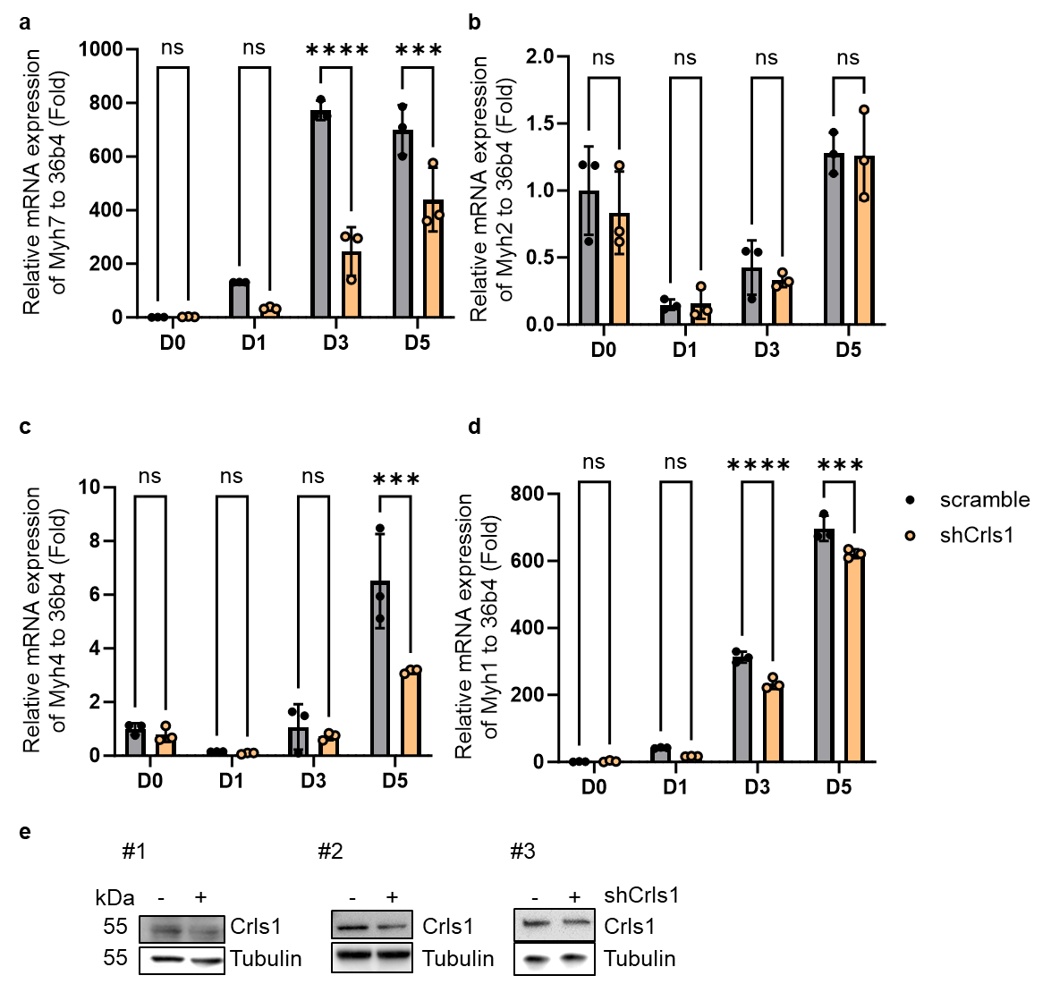

Fig. S1. AAV9-mCrls1-mediated Crls1 upregulation improved muscle mass and mitochondria complex protein levels in aging mice. (a)-(d) qPCR analysis of MyHC isoform expression in Myoblast and Myotube differentiated for 1, 3, 5 days. (e) Immunoblot of whole cell lysate from scramble and shCrls1 C2C12 cell line.

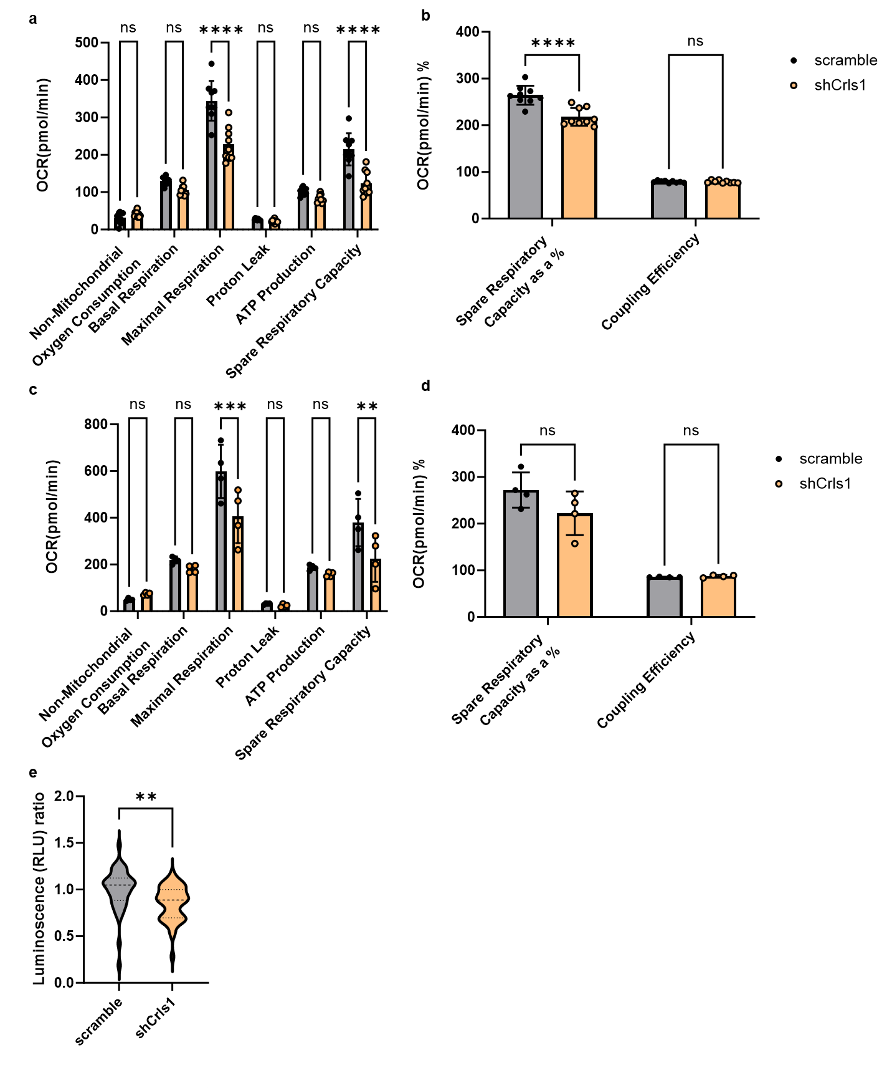

Fig. S2. Analysis Oxygen consumption rate (OCR). (a and b) Analysis Oxygen consumption rate (OCR) in myoblast. (n=10) (c and d) Analysis Oxygen consumption rate (OCR) in differentiated myoblast for 24horus. (n=4)
(e)Measure of ATP production using ATPLite Luminescence Assay system in Myoblast (n =44 per group).

