Supplementary information
Intimately coupling photocatalytic optical fibers and biofilm for rapid and sustainable degradation of 4-chlorophenol
Jilin Yuan,^{a,§} Linyang Li,^{a,§} Chuanbao Xiao,^{a,§} Nianbing Zhong,^{*a,b} Dengjie Zhong,^{c} Haixing Chang,^{*c} Yuanyuan He,ª and Tiancong Li^{b}
ªIntelligent Fiber Sensing Technology of Chongqing Municipal Engineering Research Center of Institutions of Higher Education, Chongqing Key Laboratory of Modern Photoelectric Detection Technology and Instrument, Chongqing Key Laboratory of Fiber Optic Sensor and Photodetector, Chongqing University of Technology, Chongqing 400054, China.
^{b}Liangjiang International College, Chongqing University of Technology, Chongqing 401135, China.
^{c}School of Chemistry and Chemical Engineering, Chongqing University of Technology, Chongqing 400054, China.

§These authors contributed equally.
*Nainbing Zhong, Email: zhongnianbing@163.com
*Haixing Chang, Changhx@cqut. edu. cn

Supplementary Figures

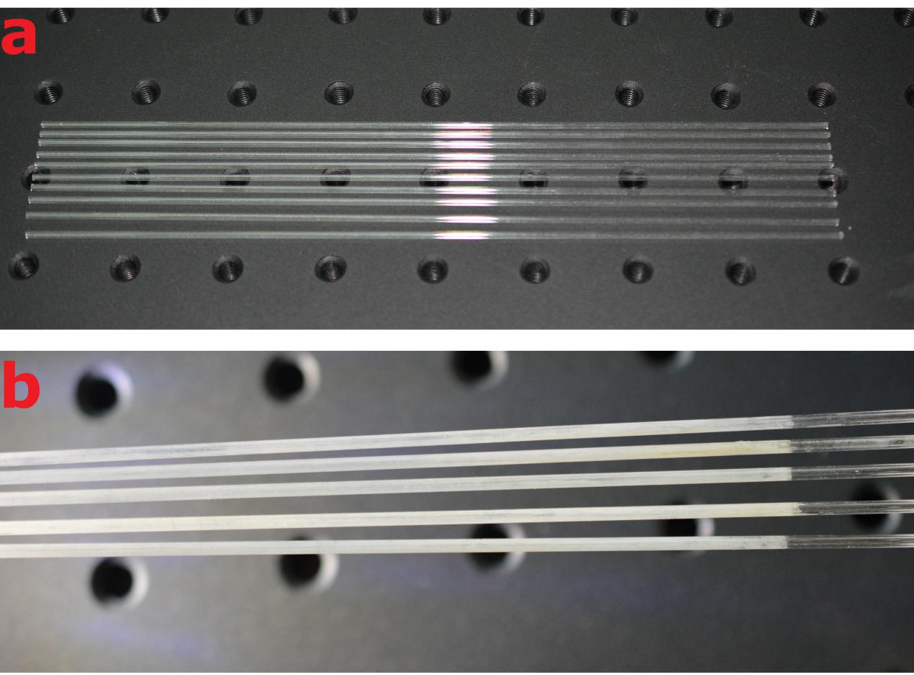
Fig. S1 Optical fibers images. (a) Hollow quartz optical fibers (HQOFs). (b) N-doped TiO₂ (NT-)-coated photocatalytic hollow quartz optical fibers (PcHQOFs).

Fig. S2 Illustration of the ICPB system. Acronyms are: NpM, nucleopore membrane; MSI, microbial solution inlet; MSO, microbial solution outlet; PMMA, Poly(methyl methacrylate; RUP, reactor upper plate; RLP, reactor lower plate; LED, light emitting diode; WwI, wastewater inlet; WwO, wastewater outlet; PcHQOF, photocatalytic hollow quartz optical fiber; and HQOF, hollow quartz optical fiber.
The photoreactor was separated to up region (biodegradation region) and down region (photocatalytic region) by using nuclear pore membrane (NpM). The working volume of the up and down regions was ~27 and 57 mL, respectively. The NpM was used to immobilize the S. obliquus cells and transmit the visible light emitted by the photocatalytic optical fibers surface, produced O₂ by the S. obliquus photosynthesis, and 4-CP and its photocatalytic products from the photocatalytic region. The up region was composed of microalgae biofilm and gas phase space, which was used to degrade the photocatalytic products and part of 4-CP and produce O₂. The down region was composed of two rows of 36 photocatalytic optical fibers, filled with 4-CP wastewater, and used to rapidly degrade 4-CP and dechlorinate. The excitation light of the photocatalytic optical fibers was from UV-vis LED light sources.

Fig. S3 Scanning transmission electron microscopy (STEM)-Energy dispersive spectrometer (EDS) plane-scan and X-ray diffractometry (XRD) pattern analysises of the NT. (a) STEM-EDS plane-scan analysis of the NT; Elements are Ti, O, and N in the NT. (b) XRD pattern of the NT. The nine primary peaks at 2θ = 25.26°, 38.01°, 48.09°, 53.91°, 55.07°, 62.7°, 68.8°, 70.23°, and 75.09° correspond to the (101), (004), (200), (105), (211), (204), (116), (220), and (215) reflection planes, respectively, of tetragonal crystals of anatase TiO₂.

Fig. S4 Characterizations of the photo-absorption and luminescence properties of the hollow optical fiber (HQOF) and 20-µm NT-coated PcHQOF. (a) UV-vis absorption spectra of the NT particles. (b) Surface luminous spectrum of the HOF and NT-coated PcHQOF at an axial distance of 6 cm. The excitation spectra of NT and NT-coated PcHQOFs is in the range of 200-950 nm.

Fig. S5 Photocatalytic degradation of 4-CP and pH and DO concentration changes. (a) Photocatalytic degradation of 4-CP within 4 hours under different initial pH (T=30 ℃). (b) Photocatalytic degradation of 4-CP within 4 hours under different initial temperature (PH=7.0). (c) 4-CP degradation, DOC removal and dichlorination (PH=7.0, T=35 ℃). (d) DO and pH changes in the solution (PH=7.0, T=35 ℃).

Fig. S6 Biodegradation of the 4-CP. (a) The effect of initial pH on the biodegradation of 4-CP in 4 h (T=30 ℃, initial DO=225.94 µM). (b) The effect of temperature on the biodegradation of 4-CP in 4 h (pH=7.0, initial DO=250.31 µM).

Fig. S7 Continuous degradation of the 4-CP and changes in DO concentration of the liquid phase by using the ICPB system. (a) Removal of the 4-CP; Initial DO was 269.69 mM, pH was 7.0, temperature was 30 °C, volume of reaction solution was 100 ml, and liquid flow rate was 3 ml/min. (b) Change in DO concentration (temperature at 30 °C and pH at 7.0); The DO concentration from the initial concentration of 269.69 µM increased to 311.88 µM at 172 h due to the O₂ production by the biofilm.

Fig. S8. Bio-TEM images of microalgae samples and bacterial consortium in the biofilms. (a) Bio-TEM image of the initial biofilm that was just inoculated on the surface of NpMs. (b) Bio-TEM image of the biofilm grown with the 4-CP for 8 d. (c) The relative abundance of top 19 associated bacterial genera in S. obliquus biofilms based on sequences of 16S rDNA. Total 16S rDNA reads were 479623, and average counts per sample were 78736. 1, 2, and 3 represent the triplicated samples from initial biofilms and three ICPB systems having the same culture conditions. The heatmap represents the average relative abundance fold changes of the biofilms after 8 d of growth exposed to 4-CP, compared to initial biofilm sample. Cell wall (CW), nucleus (N), Vacuole (V), starch grain (S), and pyrenoid (P), cytoplasm (C).

Supplementary Sections

Supplementary Section S1: Experimental materials and reagents
Isopropyl titanate (≥ 95.0%), acetone (≥ 99.5%), absolute ethanol (GC grade, ≥ 99.8%), sodium hydroxide (AR grade, 96%), ammonia (AR grade, 25-28%), acetylacetone (GR grade, ≥ 99.5%), Triton X-100 (biochemical reagent grade), ammonium chloride (GR grade, 99.8%), polyethylene glycol 2000, Nitric acid (AR grade, 65-68%), 4-chlorophenol (AR grade, 99.0%), and nitric acid (AR grade, 65-68%) were purchased from Aladdin, China. 4-aminoantipyrine (AR grade, 98%), potassium ferricyanide (AR grade, ≥ 99.5%) and sodium hydroxide (AR grade, 96%) were purchased from Chinese traditional medicine, China. Hollow quartz optical fiber (inner diameter 0.8mm, outer diameter 1.5mm, length 200mm) was purchased from Tianjin Tianke, China.

Supplementary Section S2: Cultivation of microalgae biofilm
The species of biofilm microalgae was S. obliquus (FACHB-13) and purchased from Freshwater Algae Species Bank of Wuhan Institute of Hydrobiology, Chinese Academy of Sciences. The S. obliquus was cultured with BG11 medium (Du et al. 2012), air-CO₂ mixed gas (CO₂ at a volume concentration of 5%), 25 ℃ temperature, and 160 μmol m⁻² s⁻¹ fluorescent lamp light intensity to logarithmic growth phase before inoculation. Thereafter, 50-mL of S. obliquus solution was taken and diluted using BG11 medium. The diluted S. obliquus with OD800 nm = 0.8 was injected into the upper region of the ICPB photoreactor using a peristaltic pump (L100-1S-2, LONGER, China). To form the initial biofilm on the nuclear pore membrane (NpM), 100 mL of the diluted S. obliquus solution with OD800_{nm} = 0.8 was introduced into the biofilm region of the ICPB photoreactor through a peristaltic pump (BT100-1L, DG-6, Longer, China) with a flow rate of 3 mL/min (continuous operation for 24 h) and the microbial solution inlet and outlet, as shown in Fig. S2.

Supplementary Section S3: Characterization of photocatalysts and biofilms
Field emission scanning electron microscopy (FESEM) images and energy-dispersive X-ray spectroscopy (EDS) analyses of NT and its coated optical fibers were performed on an Ultra 55 FESEM (Carl Zeiss, Germany). Scanning transmission electron microscopy (STEM) of the NT was performed on a Tecnai G2 F20 S-TWIN microscope (FEI, USA) operating at 200 keV. The N-doped TiO₂ particle size was statistically analyzed using the STEM images and software SigmaScan Pro software (USA). The NT was scanned at 2θ angles of 20–80° using a X-ray diffractometry (XRD, Rigaku D/max 2500PC, Rigaku Co., Japan) with a LynxEye detector and Cu Kα₁ radiation (λ = 1.5406 Å). X-ray photoelectron spectroscopy (XPS) analyse of the NT was performed on a photoelectron spectrometer (Thermo Scientific ESCALAB250Xi, Thermo, USA) using an Al Kα X-ray beam (1486.6 eV) with C 1s (284.8 eV) as the reference. The coating thickness of the NT was analyzed using FESEM. The UV-vis-NIR absorbance spectra (200–1100 nm) of the NT-coated PcHQOFs and HQOFs were measured with a spectrometer (QE65 Pro, Ocean Optics, USA). The light emitted from the surface of the optical fibers was collected using a UV-vis fiber-optic probe (Wang et al. 2019). The light intensity was detected using a optical power meter (36R, Newport Corporation, USA) with the working wavelength range of 200–1100 nm and power range of 100 pW–0.2 W, respectively.
The surface morphology of the microalgae biofilms was characterized using the FESEM, and the internal structure of cells was observed in the ultrathin sections by transmission electron microscopy (FEI Tecnai G2 20 S-TWIN) using a method adapted from the reported by Liu and Xiong (Liu et al. 2009).

Supplementary Section S4: Liquid-phase analysis
The above reaction process uses a dissolved oxygen electrode (DO-958-BF, INESA, China) and a chloride ion measuring electrode (PCL-1-01, INESA, China) to display the changes of dissolved oxygen and chloride ions in the liquid phase in real time. Furthermore, to investigate the degradation efficiency of the 4-CP, the 4-CP (C_{t}/C₀) and dissolved organic carbon (DOC) removal (C_{t}/C₀), where the C_{t} and C₀ are indicating the remaining concentration at time t and initial concentration, were investigated. DOC was determined using a TOC analyzer (Vario TOC, Thermo Fisher, USA) with a 0.22 µm mixed fiber membrane filter. The concentration of 4-CP was determined using the 4-aminoantipyrine spectrophotometric method (National Standard HJ 503-2009) at 506.833 nm with the QE65 Pro spectrometer.

Supplementary Section S5: Bioinformatics analysis
Biomass and lipid content. The dried microalgal biomass at 105 ºC is measured by using an ultra-microbalance (XPR6U; Mettler-Toledo, Greifensee, Switzerland). The total lipid content of microalgae is determined by the Bligh-Dyer method (Bligh et al. 1959), and the percentage of the lipid in the biofilms is calculated by the following formula,
ρ = W₁/W₀ × 100%
where W₀ is the dry weight of algae powder (g), and W₁ is the weight of lipid (g).
Molecular 16S rRDA taxonomic analyses. The initial biofilm and biofilms grown with 4-CP after 8 d were collected. The 6 samples were frozen in liquid nitrogen before 16S rRDA gene sequencing. Total genomic DNA was isolated and extracted using the Machery-Nagel NucleoSpin®-96 Tissue kit (Macherey–Nagel Duren, Germany), following the manufacturer's protocols. DNA quantification was performed by BioSpec-nano (Shimadzu Corporation, Japan). A total of 50 ng ±20% DNA was used for PCR-amplification, using Q5® High-Fidelity DNA Polymerase (NEB), targeting the V3-V4 region of bacterial 16S rRNA gene, followed with purification with OMEGA DNA extraction kit (Omega, United States). Furthermore, the PCR product was gel-purified using 1.8% agarose gel, and the concentration was quantified using Qubit-3 Qubit 3 Fluorometer (Invitrogen™; Thermo Fisher Scientific Inc; Waltham, MA, USA). Thereafter, the PCR product was sequenced on an Illumina HiSeq 2500 platform (Biomarker Technologies Corporation, Beijing, China).
In microbial diversity analysis, the original data is spliced (FLASH, version 1.2.11), the spliced sequence is subjected to quality filtering (Trimmomatic, version 0.33), and the chimera (UCHIME, version 8.1) is removed to obtain a high-quality Tags sequence. Clean tags were clustered into OTU by USEARCH (version 10.0 at 97% similarity levels, and the OTU was filtered when reabudance less than 0.005%. The database, including bacteria 16S: Silva (Release132, http://www.arb-silva.de), Eukaryota 18S: Silva (Release132, http://www.arb-silva.de), AMF 18S: MaarjAM (http://www.maarjam.botany.ut.ee), and fungene (http://fungene.cme.msu.edu/), was adopted.

Supplementary Reference

Bligh EG, Dyer WJ (1959) A rapid method of total lipid extraction and purification Can. J. Biochem. (8): 911–917.
Du Z, Hu B, Shi A, Ma X, Cheng Y, Chen P, Liu Y, Lin X, Ruan R (2012) Cultivation of a microalga Chlorella vulgaris using recycled aqueous phase nutrients from hydrothermal carbonization process. Bioresource Technol. 126: 354–357. https://doi.org/10.1016/j.biortech.2012.09.062
Liu H, Xiong M (2009) Comparative toxicity of racemic metolachlor and S-metolachlor to Chlorella pyrenoidosa. Aquat. Toxicol. 93(2-3):100–106. https://doi.org/10.1016/j.aquatox.2009.04.006
Wang Z, Zhong N, Chen M, Chang H, Zhong D, Wu Y, Liu H, Zhao M, Tang B, Song T, Shi S (2019) Photochemical reflective optical fiber sensor for selective detection of phenol in aqueous solutions. Appl. Optics 58(8): 2091–2099. https://doi.org/10.1364/AO.58.002091

