Supplementary Information

A height-renderable morphable tactile display enabled by programmable modulation of local stiffness in photothermally-active polymer
Inwook Hwang¹, Seongcheol Mun¹, Jung-Hwan Youn¹, Hyeong Jun Kim², Seung Koo Park¹, Meejeong Choi¹, Tae June Kang², Qibing Pei³, Sungryul Yun¹,*

¹Tangible Interface Creative Research Section, Electronics and Telecommunications Research Institute, Daejeon, South Korea
²Department of Mechanical Engineering, Inha University, Incheon, South Korea
³Department of Materials Science and Engineering, Henry Samueli School of Engineering and Applied Science, University of California, Los Angeles, USA
Corresponding Author. E-mail: sungryul@etri.re.kr

Supplementary Note 1. Surface energy estimation via contact angle tests
Contact angle test for both PtBA and GNPE films was carried out using a KRÜSS DSA 25S drop shape analyzer. For the test, two probe liquids, a polar liquid (Deionized water) and a non-polar liquid (Diiodomethane), were individually dropped on each polymer surface. Contact angle of the liquid droplet formed onto the film surface is measured by a vision system of the equipment. Finally, we calculated surface energy of each film by exploiting Owens, Wendt, Rabel and Kaelble (OWRK) method (see equation (1-3)) [Ref. 39 in the main text]
$\frac{σ_{L}(1+cosθ)}{2}= {{(σ}_{s}^{D}∙σ_{L}^{D})}^{1/2}+{{(σ}_{s}^{P}∙σ_{L}^{P})}^{1/2}$ (1),
$σ_{S}^{D}=\frac{{σ_{L}^{D}(1+\cos{θ})}^{2}}{4}$, $σ_{S}^{P}=\frac{{σ_{L}^{P}(1+\cos{θ})}^{2}}{4}$ (2),
$σ_{S}= σ_{S}^{D}+σ_{S}^{P}$ (3)
Where $σ_{S}$ is surface energy of solid (S), $θ$ is contact angle with each liquid drop, and $σ_{s}^{D}$, $σ_{s}^{P}$, $σ_{L}^{D}$ and $σ_{L}^{P}$ are dispersive and polar components of surface energy for solid and liquid, respectively.

Supplementary Note 2. Load-bearing test of the morphed shape
In our tactile display, each localized area is morphed into curved shape. Due to the geometrical feature, only for a single tactile cell, it is difficult to stably put a weight on the morphed area for the load-bearing test. Therefore, we first made out-of-plane deformation (deformation height: around 1250 µm) at four different areas by locally irradiating the NIR-LED light (light power: 1.1 W) under a pneumatic pressure of 18 kPa. The deformed areas, which were 12 mm distant from each other, formed protrusive vertices of a square. After generating the deformation, their deformed shape was latched by cooling down to ambient temperature under the pneumatic pressure and then reducing the pressure to atmospheric level. Finally, as shown in Supplementary Fig. 10, we carried out the load-bearing test by placing a glass substrate onto the deformed areas, putting the weight onto the substrate, and then measuring change in deformation height depending on the weight through a PSV-500 Laser scanning vibrometer.

Supplementary Note 3. Thermo-mechanical simulation of the photothermal-pneumatic actuation
- Simulation conditions and the material properties
We carried out a numerical analysis using the finite element method to estimate the displacement profile and maximum displacement of PtBA-GNPE bilayer actuators as a function of temperature while maintaining a constant air pressure. The simulation software used was ANSYS Workbench 2021 R1 and the analysis included both steady-state thermal and static structural analyses. As the material properties of the bimorph layers exhibit a strong temperature dependence, we accounted for this non-linearity by enabling the Large Deflection option in the static structural analysis. The aim of this choice was to obtain more accurate results, taking into account the significant deformations experienced by the actuators.
To improve the convergence of the simulations, we used appropriate sub-stepping techniques. Specifically, in the Step Control panel, we initialized the number of sub-steps to 20, set the minimum sub-step to 10 and allowed a maximum of 100 sub-steps. This strategy ensured better convergence and stability during the iterative solving process. In addition, a multi-zone meshing technique was used to facilitate convergence in the numerical analysis. The mesh comprised a total of 363,432 nodes and 65,618 hexahedral elements, which optimized the representation of the physical system and allowed the accurate capture of complex deformations.
By implementing these approaches, we achieved a comprehensive analysis of the behavior of the PtBA-GNPE bilayer actuators under varying temperatures and constant pneumatic pressure, providing valuable insights into their mechanical response and performance. The content of GNP in the GNPE was controlled at 0.5, 1, 2 and 5 wt%. The material properties of each sample, including Young's modulus, coefficient of thermal expansion and thermal conductivity, were determined experimentally and used for the simulations. The properties of PtBA and GNPEs as a function of temperature used in the simulation have been summarized and presented in Supplementary Table 1 as follows:

Supplementary Table 1. Material properties used in the simulation
Material property |  | Material
 |  | PtBA | GNPE0.5 | GNPE1.0 | GNPE2.0 | GNPE5.0
Density (g cm⁻³) |  | 1.022 | 1.05 | 1.053 | 1.054 | 1.096
 | Temperature (℃)
Specific heat capacity (J g⁻¹K⁻¹) | 25 | 1.418 | 1.486 | 1.424 | 1.415 | 1.293
Specific heat capacity (J g⁻¹K⁻¹) | 50 | 1.235 | 1.515 | 1.46 | 1.448 | 1.333
Specific heat capacity (J g⁻¹K⁻¹) | 100 | 1.95 | 1.563 | 1.531 | 1.514 | 1.411
Specific heat capacity (J g⁻¹K⁻¹) | 150 | 2.06 | 1.632 | 1.614 | 1.571 | 1.481
Coefficient of thermal expansion (10⁻⁶ K⁻¹) | 22-40 | 129.6 | 286 | 272 | 246 | 210
Coefficient of thermal expansion (10⁻⁶ K⁻¹) | 40-50 | 147.5
Coefficient of thermal expansion (10⁻⁶ K⁻¹) | 50-70 | 328.9
Coefficient of thermal expansion (10⁻⁶ K⁻¹) | 70-120
Coefficient of thermal expansion (10⁻⁶ K⁻¹) | 100-150
Thermal Conductivity (mW m⁻¹K⁻¹) | 25 | 146.627 | 163.398 | 185.26 | 195.31 | 236.04
Thermal Conductivity (mW m⁻¹K⁻¹) | 50 | 139.7058 | 184.64 | 194.56 | 209.375 | 234.02
Thermal Conductivity (mW m⁻¹K⁻¹) | 100 | 261.52 | 213.14 | 211.91 | 224.735 | 254.41
Thermal Conductivity (mW m⁻¹K⁻¹) | 150 | 273.809 | 241.38 | 253.72 | 267.54 | 289.09
Young’s modulus (MPa) | 25 | 684.53 | 0.842 | 0.665 | 0.4522 | 0.333
Young’s modulus (MPa) | 55 | 3.315 | 0.903 | 0.732 | 0.442 | 0.361
Young’s modulus (MPa) | 65 | 0.925 | 0.908 | 0.714 | 0.47 | 0.378
Young’s modulus (MPa) | 70 | 0.599 | 0.924 | 0.802 | 0.48 | 0.377
Young’s modulus (MPa) | 75 | 0.4844 | 0.931 | 0.779 | 0.51 | 0.385
Young’s modulus (MPa) | 85 | 0.3659 | 0.922 | 0.787 | 0.485 | 0.378
Young’s modulus (MPa) | 95 | 0.2914 | 1.022 | 0.863 | 0.497 | 0.377
Young’s modulus (MPa) | 110 | 0.212 | 1.033 | 0.854 | 0.526 | 0.491
Young’s modulus (MPa) | 125 | 0.196 | 1.107 | 0.921 | 0.571 | 0.52

For the geometry, a bilayer of PtBA and GNPE, each 100-micron thick, was modelled as a disc with a diameter of 20 mm. The surface heat flux was then applied to the surface of a 4 mm circular region on the central surface of the GNPE. A fixed boundary condition was set on the bottom surface of the GNPE except for the area where the surface heat flux was applied. The initial temperature was set at 22 ºC. Convective heat transfer was applied to the outer surface area with a convective heat transfer coefficient of 10.0 W m⁻²K⁻¹. A pressure of 3 kPa was applied to the underside of the GNPE. The Ansys Parametric Design Language (APDL) code used to apply the Gaussian heat flux distribution and the material properties used for the simulation are given below:

[APDL code for the application of gaussian heat flux distribution]
c=arg1
a=1
b=1
d=4.714

*DIM,HEAT_FLX1,TABLE,6,19,1,,,,0
!
! Begin of equation: c*exp(-1*(({X}/a)^2+({Y}/b)^2)/d^2)
*SET,HEAT_FLX1(0,0,1), 0.0, -999
*SET,HEAT_FLX1(2,0,1), 0.0
*SET,HEAT_FLX1(3,0,1), c
*SET,HEAT_FLX1(4,0,1), a
*SET,HEAT_FLX1(5,0,1), b
*SET,HEAT_FLX1(6,0,1), d
*SET,HEAT_FLX1(0,1,1), 1.0, -1, 0, 0, 0, 0, 0
*SET,HEAT_FLX1(0,2,1), 0.0, -2, 0, 1, 0, 0, -1
*SET,HEAT_FLX1(0,3,1), 0, -3, 0, 1, -1, 2, -2
*SET,HEAT_FLX1(0,4,1), 0.0, -1, 0, 1, 0, 0, -3
*SET,HEAT_FLX1(0,5,1), 0.0, -2, 0, 1, -3, 3, -1
*SET,HEAT_FLX1(0,6,1), 0.0, -1, 0, 1, 2, 4, 18
*SET,HEAT_FLX1(0,7,1), 0.0, -3, 0, 2, 0, 0, -1
*SET,HEAT_FLX1(0,8,1), 0.0, -4, 0, 1, -1, 17, -3
*SET,HEAT_FLX1(0,9,1), 0.0, -1, 0, 1, 3, 4, 19
*SET,HEAT_FLX1(0,10,1), 0.0, -3, 0, 2, 0, 0, -1
*SET,HEAT_FLX1(0,11,1), 0.0, -5, 0, 1, -1, 17, -3
*SET,HEAT_FLX1(0,12,1), 0.0, -1, 0, 1, -4, 1, -5
*SET,HEAT_FLX1(0,13,1), 0.0, -3, 0, 1, -2, 3, -1
*SET,HEAT_FLX1(0,14,1), 0.0, -1, 0, 2, 0, 0, 20
*SET,HEAT_FLX1(0,15,1), 0.0, -2, 0, 1, 20, 17, -1
*SET,HEAT_FLX1(0,16,1), 0.0, -1, 0, 1, -3, 4, -2
*SET,HEAT_FLX1(0,17,1), 0.0, -1, 7, 1, -1, 0, 0
*SET,HEAT_FLX1(0,18,1), 0.0, -2, 0, 1, 17, 3, -1
*SET,HEAT_FLX1(0,19,1), 0.0, 99, 0, 1, -2, 0, 0
! End of equation: c*exp(-1*(({X}/a)^2+({Y}/b)^2)/d^2)
!-->
sf,s1,hflux,%HEAT_FLX1%

- Simulation results
Supplementary Fig.11a shows the deformation height of the PtBA-GNPE bilayer with different GNP contents in response to changes in temperature. As the temperature increases, the deformation rapidly increases and then gradually converges, as shown by the simulation results. It is also evident that the displacement with respect to temperature increases as the GNP content in the bilayer increases, which is mainly due to the decrease in Young's modulus of GNPE with increasing GNP content (as shown in Fig. 2h and 2i in the main text).
Supplementary Fig.11b-d show the simulation results of the deformation height of the PtBA-GNPE bilayer with 2 wt% GNP content as a function of temperature. These simulations aimed to identify the influencing factors among the PtBA properties, namely coefficient of thermal expansion (CTE), thermal conductivity coefficient and Young's modulus, on the deformation of the bilayer. In Supplementary Fig. 11b and c, we compare the simulation results with fixed values of CTE (147.5×10⁻⁶ K⁻¹) and thermal conductivity (146.627 mW m⁻¹K⁻¹) for PtBA. As shown in the figures, variations in the CTE and thermal conductivity of PtBA have negligible effects on the deformation height of the bilayer. Supplementary Fig. 11d shows a comparison between simulation results with a fixed value of elastic modulus for GNPE in PtBA (684.53 MPa) and simulation results taking into account the variation of elastic modulus with temperature. It is clear that the change in Young's modulus has a significant effect on the deformation of the bilayer.
These simulations provide valuable insights into the photothermal deformation behavior of PtBA-GNPE bilayers and lay the foundation for optimizing their operational performance. Furthermore, experimental evidence supports the feasibility of maximizing the height deformation of PtBA-GNPE bilayers by tailoring the properties of GNPE, in particular its elastic modulus. By systematically evaluating the effects of PtBA and GNPE properties, these results improve our understanding of bilayer behavior and aid in the design of high performance photothermal actuators.

Supplementary Fig. 1. An illustrated fabrication process of the thin PtBA film

Supplementary Fig. 2. Photographs of the AgNWs and Tosylated PEDOT embedded PtBA films. a and b, Photothermal heating performance of tosylated PEDOT and AgNWs during irradiation of NIR light. c and d, Microscopic observation of their surface after out-of-plane deformation under a pneumatic pressure of 6 kPa.

Supplementary Fig. 3. An illustrated fabrication process of the GNPE film

Supplementary Fig. 4. a, Photograph comparing transparency of the GNPEs with different GNP wt%. b and c, Photographs of elongation-recovery test of the GNPE membranes with different GNP wt%: b, GNPE 0.5 (GNP: 0.5 wt%) and c, GNPE 5.0 (GNP: 5.0 wt%).
Supplementary Fig. 5. Storage modulus of the pristine PDMS and GNPEs at ambient conditions under a dynamic strain of 5%.

Supplementary Fig. 6. Photographs of elongation test of GNPE 10.0 film constructed on a glass plate after chemical crosslinking at 60 ºC for 5 days in heating oven.
Supplementary Fig. 7. Reaction time dependent FT-IR spectra of the GNPE 5.0.

Supplementary Fig. 8. Temperature dependent thermal strain profile of the specimens under cyclic heating-cooling process. a, PtBA, b-e, GNPE 0.5, GNPE 1.0, GNPE 2.0, and GNPE 5.0, respectively.

Fig. 9. Liquid contact angle measurement of the PtBA and the GNPE with different GNP contents. a-d, Contact angle of deionized water droplet (polar liquid) formed onto PtBA, GNPE 1.0, GNPE 2.0, and GNPE 5.0, respectively. e-h, Contact angle of diiodomethane droplet (non-polar liquid) formed onto PtBA, GNPE 1.0, GNPE 2.0, and GNPE 5.0, respectively.

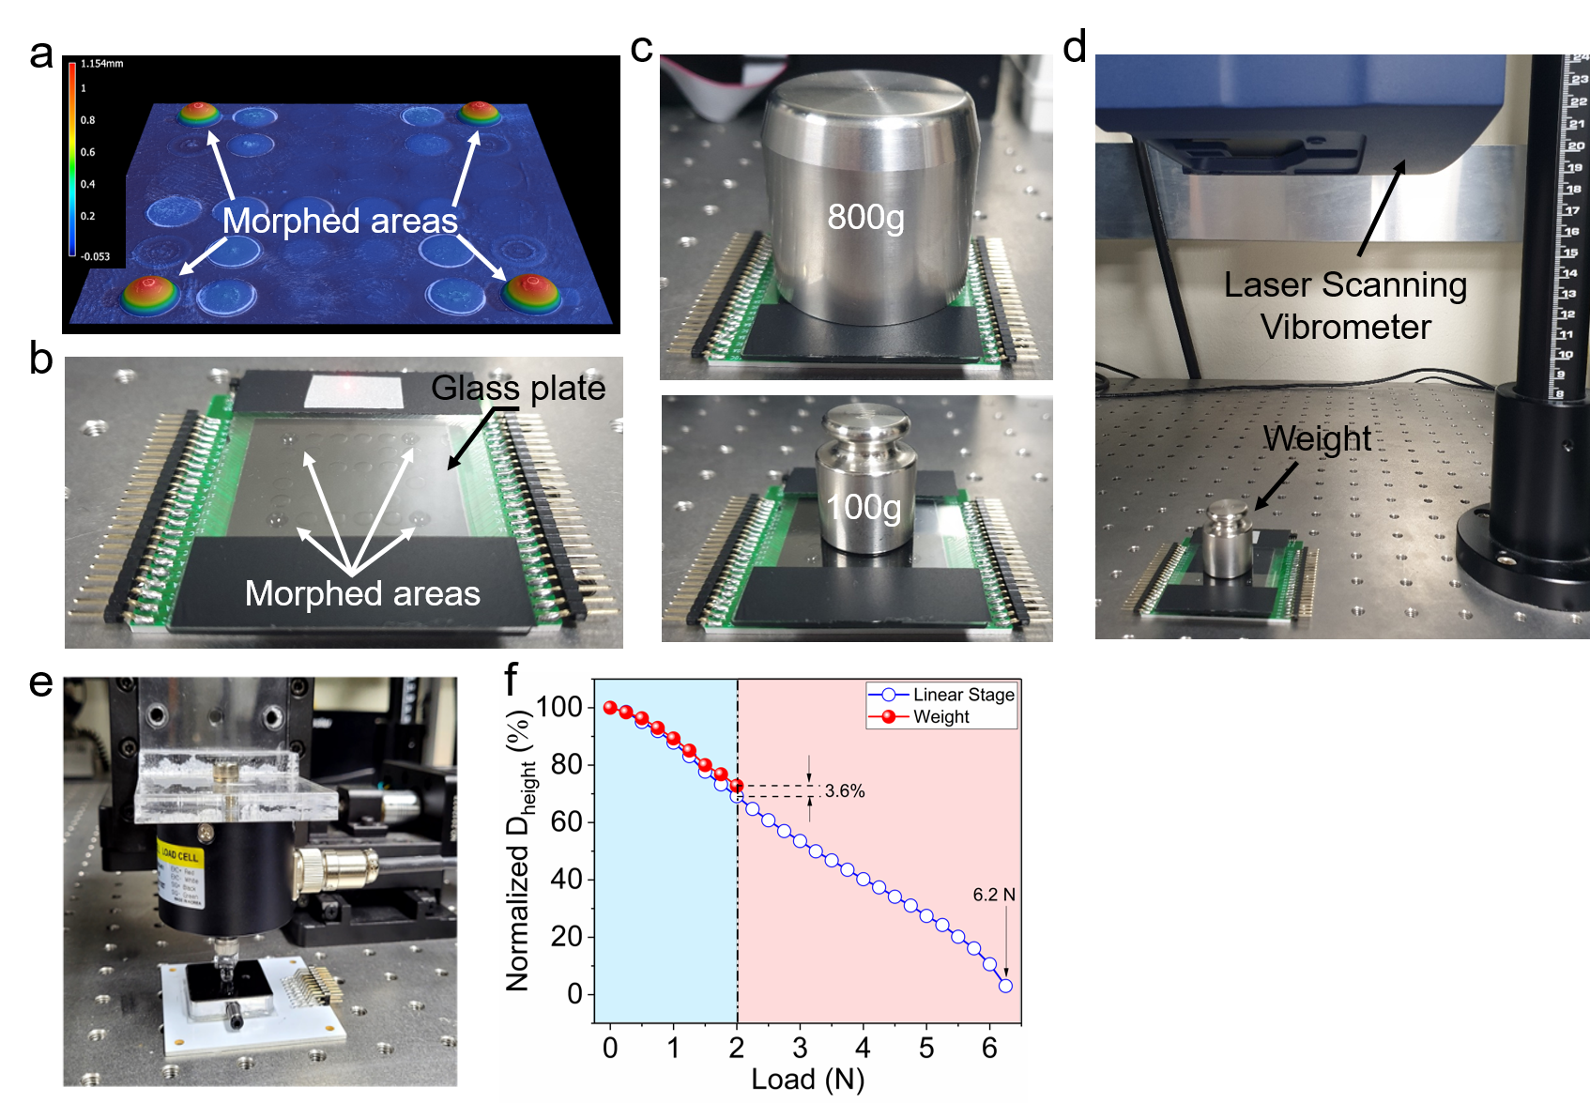
Supplementary Fig.10. Load-bearing test of the morphed areas after being latched. a, A 3D profiler image of tactile display with four morphed areas, equally spaced. b and c, Test set-up for applying load up to 2 N to each morphed area. d, Test environment using a laser scanning vibrometer for measuring change in deformation height with weight. e, Test environment using a load cell integrated into a linear stage. f, Comparison of load-D_{height} plots achieved from different methodology.

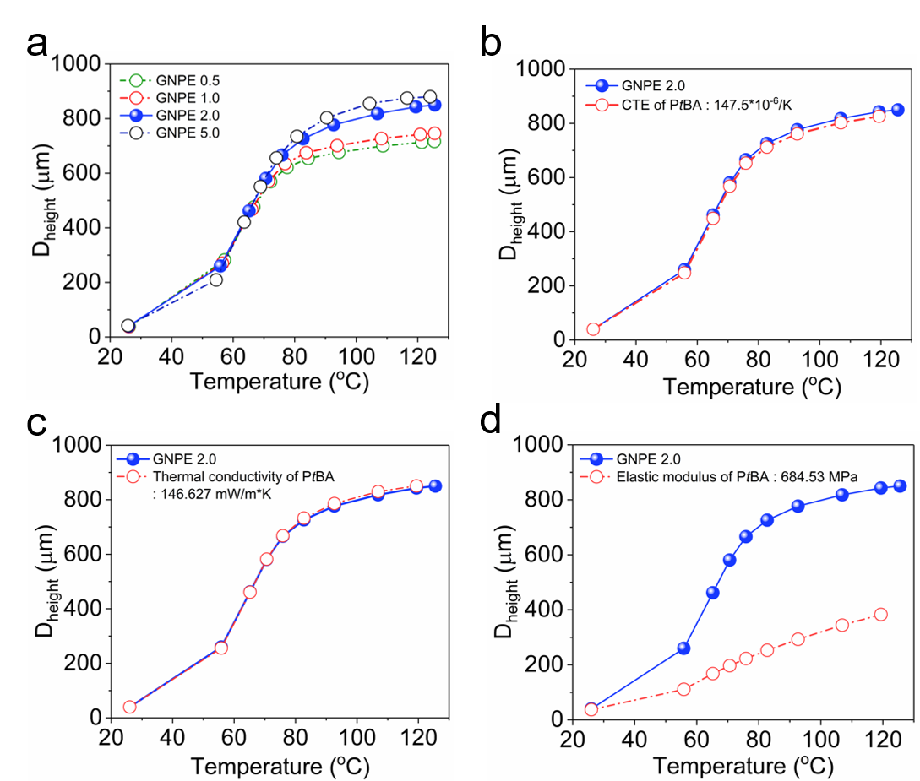
Supplementary Fig. 11. Thermo-mechanical simulation. a, The temperature dependent change in deformation height of PtBA-GNPE bilayer, adopting the GNPE layer with different GNP contents. b-d, Comparison of achievable deformation height between experimental data for PtBA-GNPE bilayer with GNPE 2.0 (colored in blue) and estimated results (red) adopting CTE of the PtBA as 147.5∙10⁻⁶ K⁻¹, thermal conductivity of PtBA as 146.627 mW m⁻¹∙K⁻¹, and the elastic modulus of PtBA as 684.53 MPa, respectively.

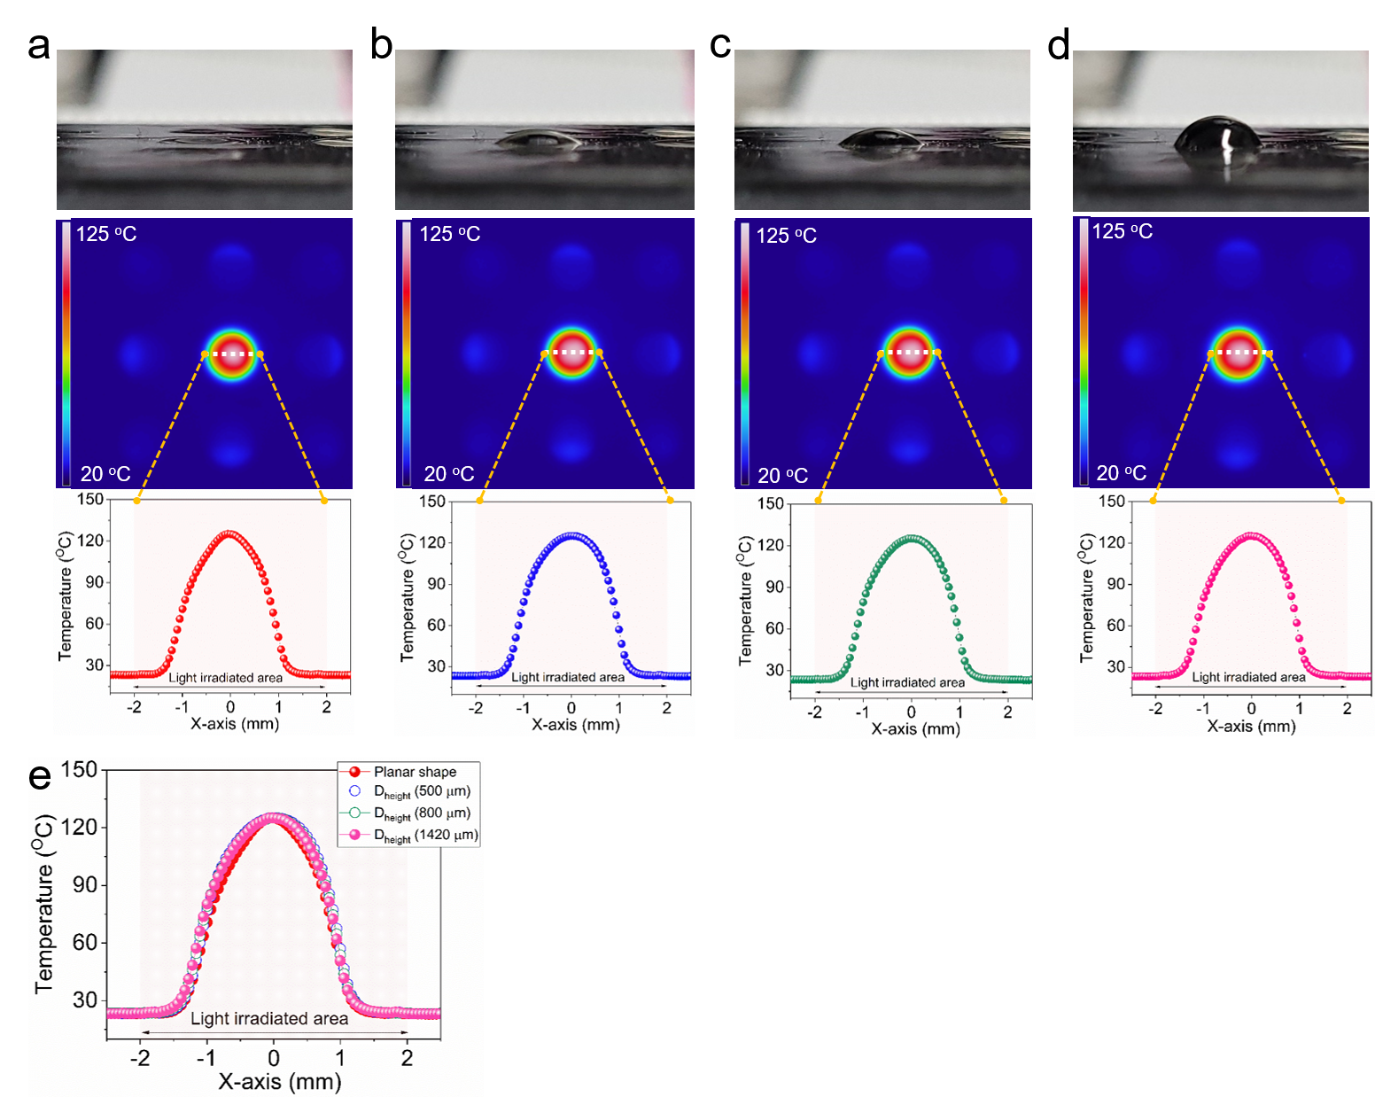
Supplementary Fig. 12. Comparison of temperature distribution on latched structure with different deformation heights during second photothermal heating through illumination of the LED light for three seconds with the same light power (1.4 W) to recover from the deformed state to the initial state. a, Planar shape, b-d, Deformed shape with deformation height of 0 µm, 500 µm, 800 µm, and 1420 µm, respectively. e, Comparison of temperature profiles achieved at target area.

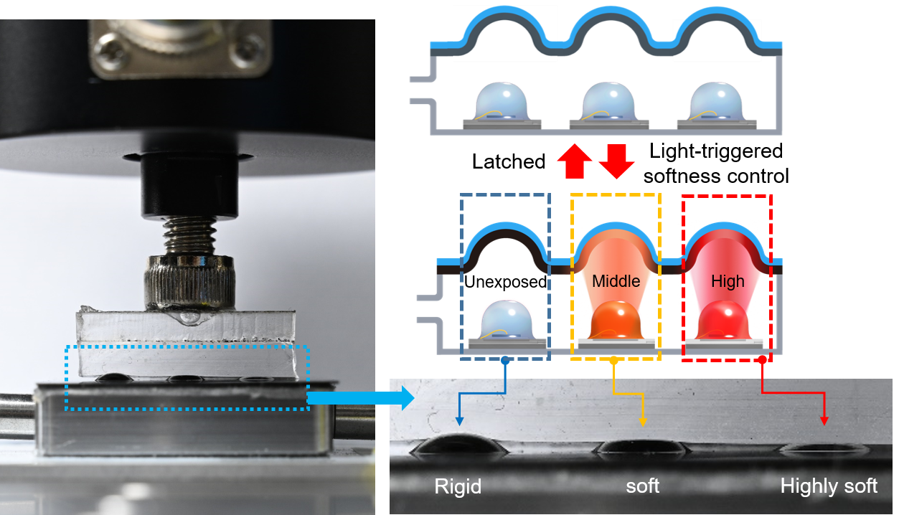
Supplementary Fig. 13. Softness control of individual morphed area. A photograph applying pressure to the morphed areas, which was latched, during localized irradiation of the light with different power. Since the morphed area is getting softer as temperature of the area increases, light power control of the individual LED for photo-thermal heating can change softness of the morphed areas to different levels. Therefore, as shown in the photograph, the deformation height of three morphed areas is reduced differently under a constant load.

