Supplementary Information for
Global patterns of soil organic carbon dynamics in the 20–100 cm soil profile for different ecosystems: A global meta-analysis
Haiyan Wang^{a,b}, Yulong Yinª, Tingyao Caiª, Xingshuai Tianª, Zhong Chenª, Kai Heª, Zihan Wangª, Haiqing Gongª, Qi Miaoª, Yingcheng Wangª, Yiyan Chuª, Qingsong Zhang^{a,b,*}, Minghao Zhuangª, Zhenling Cui^{a,} *
ªCollege of Resources and Environmental Sciences, China Agricultural University, 100193 Beijing, China
^{b} Sanya Institute of China Agricultural University, 572025 Sanya, China
*Corresponding author: Zhenling Cui. Email: cuizl@cau.edu.cn
Qingsong Zhang. Email: zhangqs@cau.edu.cn
Supplementary Information submitted to: Environmental Chemistry Letters.

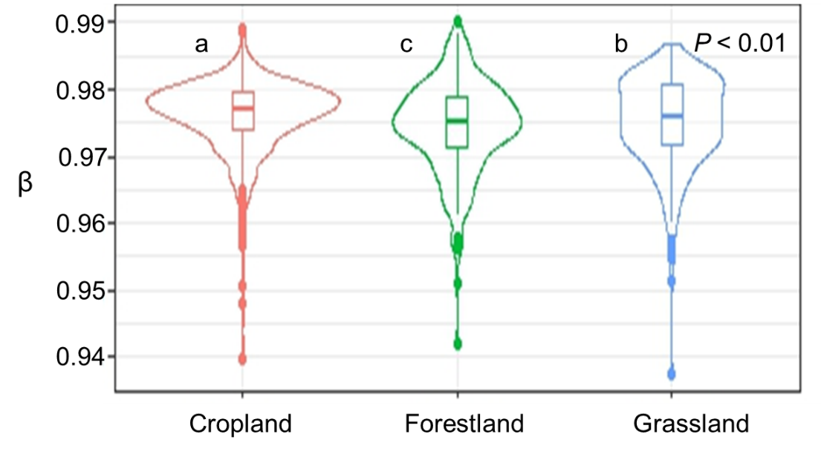
Figure S1. Soil β values of the study sites showing significant differences in different ecosystems with ANOVAR analysis and Duncan's new multiple range test.
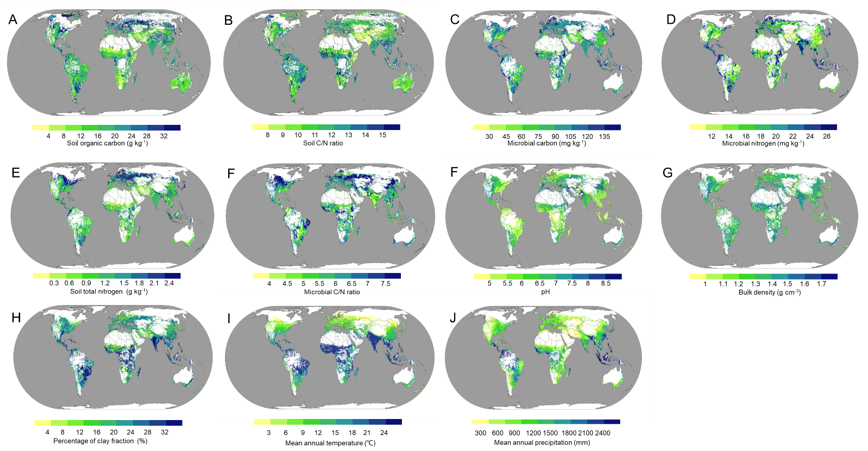
Fig. S2 Cropland: Global grid-level soil organic carbon (A), soil C/N ratio (B), microbial carbon (C), microbial nitrogen (D), soil total nitrogen (E), microbial C/N ratio (F), pH (G), bulk density (H), percentage of clay fraction (I), mean annual temperature (J), mean annual precipitation (K).

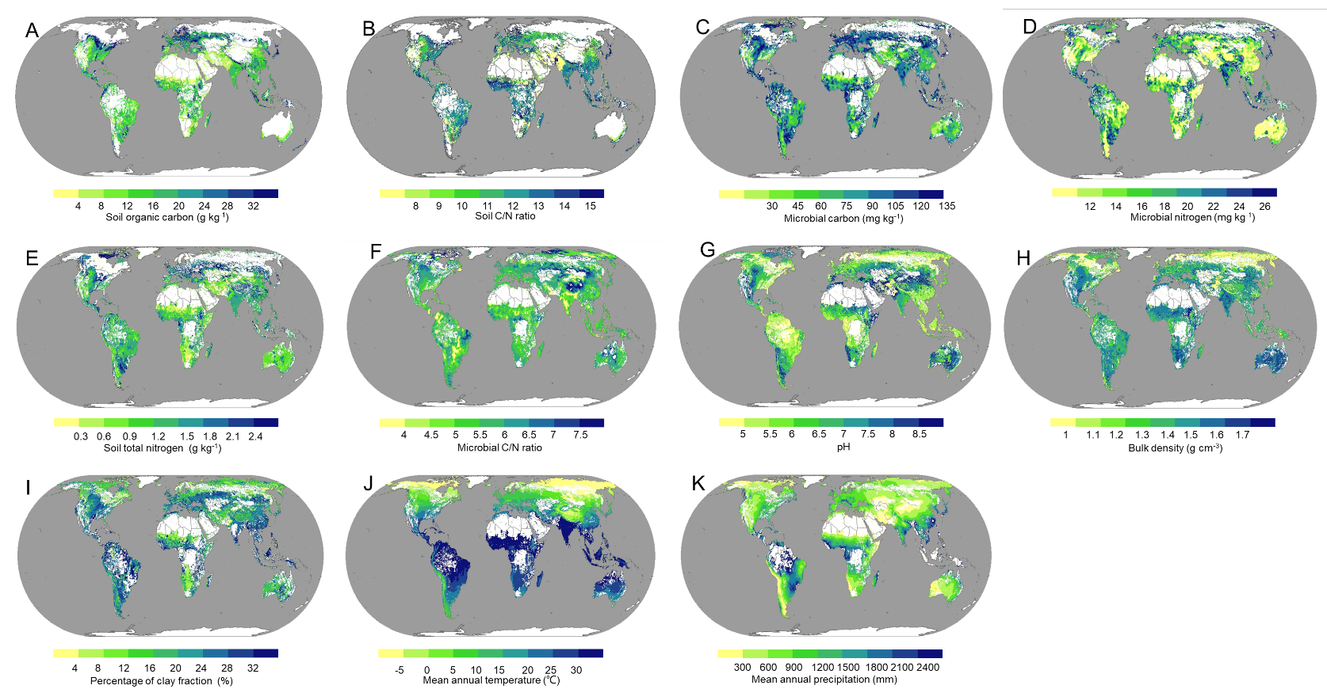
Fig. S3 Grassland: Global grid-level soil organic carbon (A), soil C/N ratio (B), microbial carbon (C), microbial nitrogen (D), soil total nitrogen (E), microbial C/N ratio (F), pH (G), bulk density (H), percentage of clay fraction (I), mean annual temperature (J), mean annual precipitation (K).

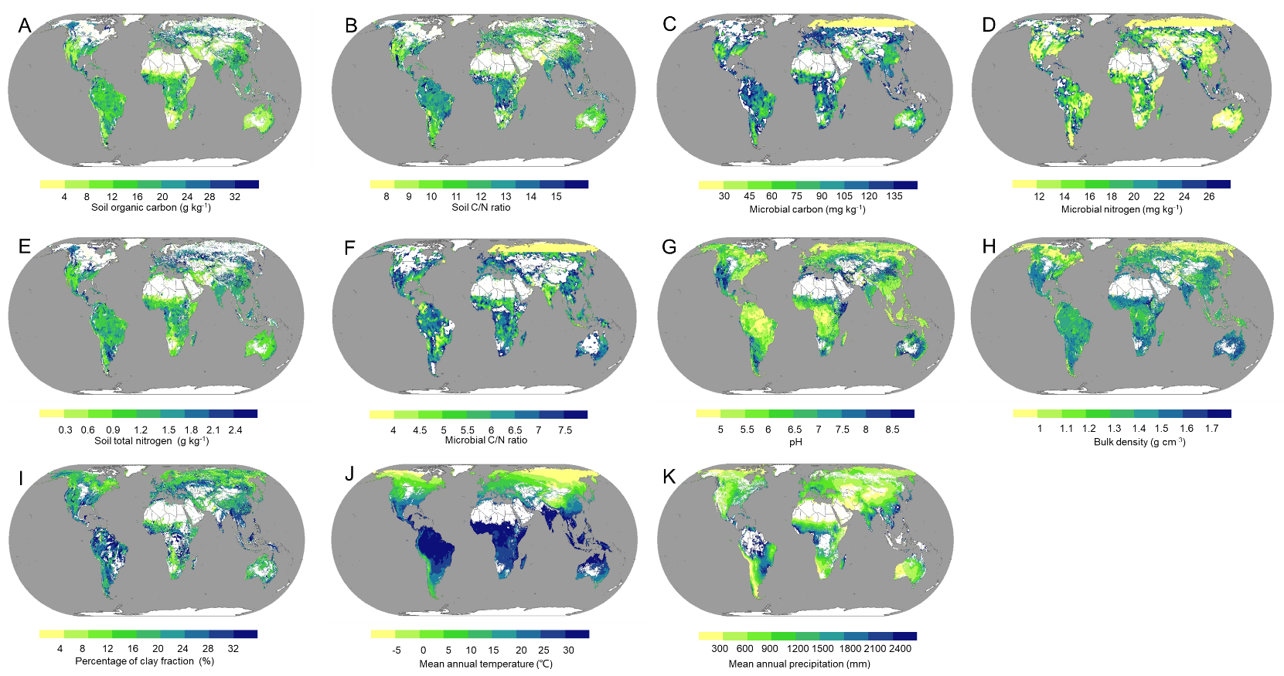
Fig. S4 Forestland: Global grid-level soil organic carbon (A), soil C/N ratio (B), microbial carbon (C), microbial nitrogen (D), soil total nitrogen (E), microbial C/N ratio (F), pH (G), bulk density (H), percentage of clay fraction (I), mean annual temperature (J), mean annual precipitation (K).
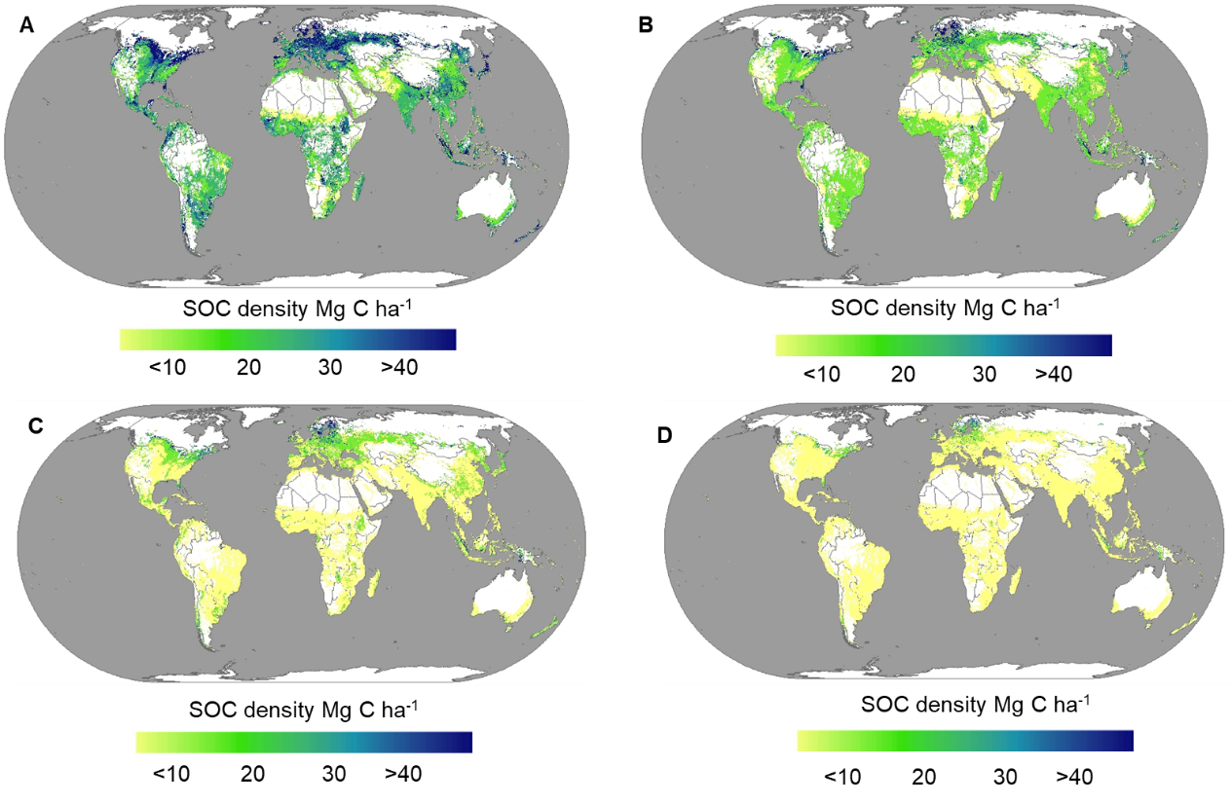
Figure S5. Grid-level maps showing the predicted global soil profiles SOC density of the cropland. A, B, C and D represents the 20–40 cm, 40–60 cm,60–80cm,80–100cm layer, respectively.
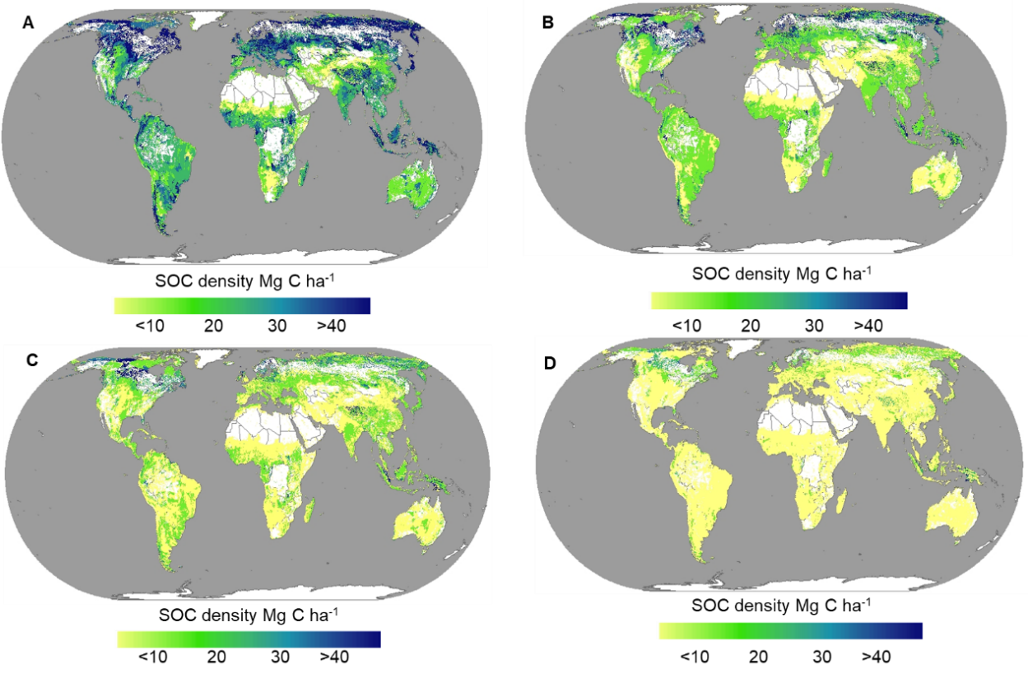
Figure S6. Grid-level maps showing the predicted global soil profiles SOC density of the grassland. A, B, C and D represents the 20–40 cm, 40–60 cm,60–80cm,80–100cm layer, respectively.

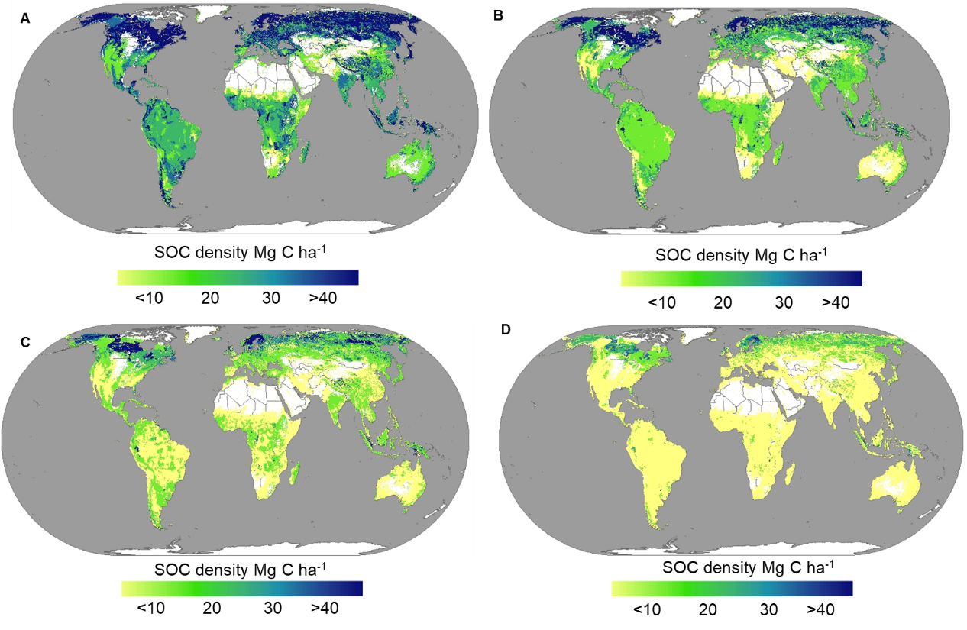
Figure S7. Grid-level maps showing the predicted global soil profiles SOC density of the forestland. A, B, C and D represents the 20–40 cm, 40–60 cm,60–80cm,80–100cm layer, respectively.
Table S1. Comparisons of estimated SOC density with other studies
 | Topsoil (Mg ha⁻¹) | Subsoil (Mg ha⁻¹) | Total (Mg ha⁻¹) | References
 | 0-30 (0-20) | 30-100 (20-100) | 0-100
 | (cm) | (cm) | (cm)
Cropland | 41 | 48 | 89 | Liu et al., 2021
Tropical cropland | 85 | 184 | 269 | Reichenbach et al., 2023
Paddy | 51 | 57 | 108 | Liu et al., 2021
Cropland | 54.6 | 63.8 | 118.4 | This study
Forestland | 87 | 102 | 189 | Dixon et al., 1994
Tropical forestland | 91 | 189 | 280 | Reichenbach et al., 2023
Mangrove | 130 | 153 | 283 | Atwood et al., 2017
Forestland | 80.2 | 100.4 | 180.6 | This study
Grassland | 38 | 44 | 82 | Conant et al., 2017
Grassland | 70.4 | 83.3 | 153.7 | This study
All land | 45 | 53 | 98 | Hiederer et al., 2011
All land | 68.4 | 82.5 | 150.9 | This study

