Supplementary Material

- Table 1: Methods on Identifying Significant NPIs

Model/Methods | Goals | Data Needed | End Product
Linear Regression  Leffler et al., 2020 (11) | Identifying significant predictors of COVID-19 related deaths (log-scale) | Daily number of deaths (observed); Disease duration; Duration of each NPI’s implementation in each region; Region-specific demographics and geographic info | P-values reported by the multiple linear regression indicating the significance
Logistic Regression  Dreher et al., 2021 (5) | Identifying significant predictors of dichotomized Rt (above 1 coded as 1, less than 1 coded as 0) | Each region’s Rt estimate on the day of interest; Duration of each NPI’s implementation in each region; | P-values reported by the logistic linear regression indicating the significance
Cox PH Model  Dreher et al., 2021 (5) | Identifying significant NPIs affecting time to 1000th case | Each regions’ time to 1000th case; Duration of each NPI’s implementation in each region; | P-values reported by the Cox PH regression indicating the significance
Linear Mixed Model  Pozo-Martin et al., 2021 (15) | Identifying significant NPIs affecting the weekly average growth rate | Each region’s cumulative number of confirmed cases (observed); Each NPI’s stringency index in each region; Total number of tests performed per thousand population in each region during the study period; region-specific geographical, social, and economical features | P-values reported by the linear mixed model indicating the significance
Panel Regression  Li et al., 2021 (12) | Identifying significant NPIs affecting mobility and COVID-19 growth rates | Each region’s daily number of confirmed cases and deaths (observed); Google mobility data for each region; Daily counts of positive and total tests in each region; Total population in each region; Each NPI’s start date/duration in each region | P-values reported by the panel regression model indicating the significance

- Table 2: Methods on Estimating Joint Effectiveness of NPI Portfolios

Model/Methods | Goals | Data Needed | End Product
SEIR-type Model  Ivorra et al., 2020 (9) | Estimating the joint effectiveness of NPI portfolios through reproduction number | Epidemiological parameters (disease contact rates, transition rates, infection reported rate, etc.); Each region’s daily number of infections and recoveries (observed); | Time-varying daily effective reproduction number Rt
Maximum Likelihood Approach  Azimi et al., 2020 (1) | Estimating the joint effectiveness of NPI portfolios through reproduction number | Each region’s daily number of infections (observed) | Time-varying daily effective reproduction number Rt

- Table 3: Methods on Estimating the Effectiveness of Individual NPIs

Model/Methods | Goals | Data Needed | End Product
Prototypical Model  Flaxman et al., 2020 (8) | Estimating the effectiveness of individual NPI | Daily number of deaths (observed); Start date of each NPI in each state | Each NPI’s relative percentage reduction on the reproduction number Rt
Counterfactual Model  Mishra et al., 2021 (13) | Estimating the pandemic situation having a region/group adopting other region/group’s NPI policy portfolios | Daily number of deaths (observed) | Percentage change on the reproduction number Rt, number of infections, and number of deaths
Advanced Model  Banholzer et al., 2021 (2) | Estimating the effectiveness of individual NPI | Daily number of infections (observed); Start date of each NPI in each state | Each NPI’s relative percentage reduction on the number of infections

- Table 4: Summary on Previous Studies

Author | Model Used & Data Source | Setting & Study Period | NPIs Studied
Chernozhukov et al. (4) | SEM & SEIR,  New York Times | USA, all states,  Mar 7 – Jun 3, 2020 | (1) Stay at-home / (2) Closed nonessential businesses / (3) Closed K-12 schools / (4) Face mask mandates for employees in public facing businesses
Courtemanche et al. (5) | Event Study Model, John Hopkins University | USA, 3138 counties,  Mar 1 – Apr 27, 2020 | (1) Shelter-in-place orders / (2) Public school closing / (3) Bans on large social gatherings / (4) Closures of entertainment-related businesses
Dreher et al. (6) | Linear & Logistic Regression,  John Hopkins University for cases and deaths, effective reproduction number were collected from Rt.live | USA, all states,  Up to Apr 30, 2020 | (1) Stay-at-home orders / (2) Educational facilities closure / (3) Non-essential business closure / (4) Limitations on mass gatherings
Ebrahim et al. (7) | T-test, Chi-square test,  Data collected by 104 trained volunteers | USA, 1320 counties, March to July 2020 | (1) Closure of nonessential workplaces / (2) Shelter-in-place/stay-at-home orders / (3) Enforcement of shelter-in-place or stay-at-home / (4) Size restrictions on public gatherings / (5) School closing / (6) Public transport closures / (7) Publicly available testing
Jalali et al. (14) | Kruskal-Wallis tests and Correlation Tests,  John Hopkins University | USA, 30 most populous counties and 10 most populous counties of CA, FL, NY and TX,  Mar 1 – May 31, 2020 | 3 broad categories: (1) Restrictions on mass gatherings / (2) Stay-at-home orders / (3) Face mask requirements
Li et al. (17) | Regression,  Google community mobility data | USA, all states,  Mar 1 – Jul 13, 2020 | (1) School closing / (2) Workplace closures / (3) Public event cancellations / (4) Public information campaigns / (5) Public transport closures / (6) Stay-at-home orders / (7) International/national travel controls
Olney et al. (19) | Bayesian Hierarchical Model, New York Times or cases and deaths, manually collected NPI start dates | USA, all states,  Feb 29 - Apr 25, 2020 | (1) Social distancing encouraged / (2) Schools or universities closing / (3) Public events (ban for more than 100 people)/ (4) Lockdown / (5) Self-isolating ill / (6) Sports (public event ban of more than 1000 people)
Banholzer et al. (1) | Bayesian Framework | 20 countries: 15 EU countries, USA, Canada, Australia, Norway and Switzerland | (1) School closing / (2) Border closures / (3) Public event bans / (4) Gathering bans / (5) Venue closing / (6) Lockdowns prohibiting public movements without valid reason / (7) Work bans on non-essential business activities
Bo et al. (2) | Generalized Linear Mixed Model | Worldwide, 190 countries | (1) Mandatory face mask in public / (2) Isolation or quarantine (3) Social distancing / (4) Traffic restrictions
Brauner et al. (3) | Bayesian Hierarchical Model | Worldwide, 41 countries: 34 European and 7 non-European | (1–3) Gatherings limited to 1000/100/10 people or less / (4–5) Some/ All but essential shops closed / (6–7) Schools or universities closed / (8) Stay-at-home orders with exemptions
Esra et al. (8) | Bayesian Framework | Worldwide, 26 countries and 34 US states | (1) Quarantine and isolation policies / (2) Limits on gatherings / (3) School closing (primary, secondary and tertiary educational institutions) / (4) Mask policies / (5) Household confinements (stay-at-home-orders, shelter-in-place orders and lockdowns)
Flaxman et al. (9) | Bayesian Hierarchical Model | Europe, 11 countries | (1) Lockdown / (2) Cancel public events / (3) School closing / (4) Self-isolation / (5) Social distancing encouraged
Fountoulakis et al. (10) | Correlation Test & Linear Regression | Europe, 40 countries | (1) School closing / (2) Workplace closing / (3) Public events ban / (4) Gathering ban / (5) Public transport closure / (6) Lockdown implementation / (7) Domestic travel ban / (8) International travel ban
Haug et al. (11) | LASSO, RF, TF | Worldwide, 79 territories, 56 countries | Different categories of NPIs in their hierarchical levels (42,151 measures) : School closing and gathering ban
Hunter et al. (12) | Bayesian Model | Europe, 30 countries | (1) Mass gathering restrictions / (2) Initial business closure / (3) Educational facilities closed / (4) Non-essential services closed / (5) Stay-at-home order / (6) Travel severely limited - none European country
Islam et al. (13) | Regression Model | Worldwide, 149 countries | (1) Closures of schools / (2) Workplace / (3) Public transport / (4) Restrictions on mass gatherings and public events / (5) Restrictions on movement (stay-at-home regulations and restrictions on movements within a country)
Koh et al. (15) | Regression | Worldwide, 142 countries | (1) International travel controls (including screening, quarantine and bans on international movement) / (2) Restrictions on mass gatherings (including public event bans and size restrictions on gatherings) / (3) Lockdown-type measures (including workplace closure, internal movement restrictions)
Li et al. (16) | Regression | Worldwide, 131 countries | (1) Closure of schools / (2) Closure of workplaces / (3) Public events bans / (4) Restrictions on the size of gatherings / (5) Closure of public transport / (6) Stay-at-home orders / (7) Restrictions on internal movement / (8) Restrictions on international travel
Liu et al. (18) | Regression | Worldwide, 130 countries | (1) Internal containment and closure (School and workplace closure, public event cancelation, limits on gathering sizes, public transport closure, stay-at-home requirement, internal movement restriction) / (2) International travel restrictions / (3) Economic policies / (4) Health systems policies (Public information campaign, testing policy, contact tracing)
Papadopoulos et al. (20) | Linear Regression | Worldwide, 137 countries | (1) School closing / (2) Workplace closing / (3) Cancelling of public events / (4) Restriction on gatherings / (5) Closure of public transport / (6) Stay-at-home restrictions / (7) Domestic travel restrictions / (8) International travel restrictions / (9) Public information / (10) Testing framework / (11) Contact tracing
Piovani et al. (21) | Multivariable Negative Binomial Regression for Panel Data | OECD countries | (1) Mass gathering ban (more than 1000 people) / (2) School closures
Pozo-Martin et al. (22) | Generalized Linear Mixed Model | OECD countries | (1) School closing requirements / (2) Workplace closing requirements / (3) Public events cancelling requirements / (4) Restrictions on gatherings / (5) Public transport restrictions / (6) Stay-at-home requirements / (7) Restrictions on internal travel / (8) International travel controls / (9) Public health information campaigns / (10) Mask wearing requirements / (11) Testing policy / (12) Contact tracing policy
Stokes et al. (23) | Linear Regression | Worldwide, 130 countries | (1) School closing / (2) Workplace closing / (3) Public event cancelling / (4) Gathering restrictions / (5) Public transport closure / (6) Stay-at-home requirements / (7) Restrictions on internal movement / (8) International travel controls / (9) Public information campaigns
Wibbens et al. (24) | Bayesian Framework | 40 territories: 17 countries and 23 US states | (1) Closing of schools / (2) Closing of workplaces / (3) Public event cancelling / (4) Gathering bans / (5) Public transport closure / (6) Shelter-in-place orders and home confinement / (7) Restrictions on internal movement / (8) Restrictions on international travel / (9) Public information campaigns / (10) Testing access / (11) Contact tracing

- Table 5: Summary of Previous Studies on Estimating NPI Effectiveness in the United States

Author | Study Period | Model Used | Setting | NPIs Studied
Olney et al., 2021 (14) | 2/29/20 – 4/25/20 | Bayesian Hierarchical Model | USA, all states | (1) Social distancing encouraged / (2) Schools or universities closing / (3) Public events (ban for more than 100 people)/ (4) Lockdown / (5) Self-isolating ill / (6) Sports (public event ban of more than 1000 people)
Dreher et al., 2021 (5) | Early Outbreak in 2020 | Regression | USA, all states | (1) Stay-at-home orders / (2) Educational facilities closure / (3) Non-essential business closure / (4) Limitations on mass gatherings
Li et al., 2021 (12) | March – April 2020 | Regression | USA, all states | (1) School closing / (2) Workplace closures / (3) Public event cancellations / (4) Public information campaigns / (5) Public transport closures / (6) Stay-at-home orders / (7) International/national travel controls
Courtemanche et al., 2021 (4) | 3/1/20 - 4/27/20 | Regression | USA, 3138 counties | (1) Shelter-in-place orders / (2) Public school closing / (3) Bans on large social gatherings / (4) Closures of entertainment-related businesses
Ebrahim et al., 2020 (6) | March – July 2020 | T-test, Chi-square test | USA, 1320 counties | (1) Closure of nonessential workplaces / (2) Shelter-in-place/stay-at-home orders / (3) Enforcement of shelter-in-place or stay-at-home / (4) Size restrictions on public gatherings / (5) School closing / (6) Public transport closures / (7) Publicly available testing
Jalali et al., 2020 (10) | 3/1/20 - 5/31/20 | Kruskal-Wallis tests and Correlation Tests | USA, 30 most populous counties and 10 most populous counties of CA, FL, NY and TX | 3 broad categories: (1) Restrictions on mass gatherings / (2) Stay-at-home orders / (3) Face mask requirements
Zhang et al., 2021 (18) | February - August 2020 | Regression | US, all states | (1) Implementation of shutdowns / (2) Mask mandates

- Table 6: State demographics and the basic reproduction number R₀ before implementation of any NPIs.

Stateª | Cumulative  cases | Cumulative  deaths | Population | Case perc (%) | Death perc (%) | R₀
Alaska | 676 | 12 | 738432 | 0.0915 | 0.0016
Alabama | 26485 | 774 | 4858979 | 0.5451 | 0.0159 | 3.22
Arkansas | 12917 | 182 | 2978204 | 0.4337 | 0.0061 | 2.54
Arizona | 36844 | 1203 | 6828065 | 0.5396 | 0.0176 | 3.46
California | 157620 | 5114 | 39144818 | 0.4027 | 0.0131 | 3.52
Colorado | 29299 | 1605 | 5456574 | 0.5369 | 0.0294 | 3.14
Connecticut | 45235 | 4204 | 3590886 | 1.2597 | 0.1171 | 3.78
District of Columbia | 9799 | 515 | 672228 | 1.4577 | 0.0766 | 3.47
Delaware | 10340 | 543 | 945934 | 1.0931 | 0.0574 | 3.53
Florida | 77326 | 2938 | 20271272 | 0.3815 | 0.0145 | 3.30
Georgia | 58414 | 2494 | 10214860 | 0.5719 | 0.0244 | 2.83
Hawaii | 736 | 17 | 1431603 | 0.0514 | 0.0012
Iowa | 24082 | 658 | 3123899 | 0.7709 | 0.0211 | 2.76
Idaho | 3399 | 87 | 1654930 | 0.2054 | 0.0053
Illinois | 133016 | 6326 | 12859995 | 1.0343 | 0.0492 | 3.85
Indiana | 40430 | 2386 | 6619680 | 0.6108 | 0.0360 | 3.53
Kansas | 11319 | 246 | 2911641 | 0.3887 | 0.0084 | 3.15
Kentucky | 12647 | 505 | 4425092 | 0.2858 | 0.0114 | 3.35
Louisiana | 47172 | 3018 | 4670724 | 1.0100 | 0.0646 | 3.50
Massachusetts | 105690 | 7647 | 6794422 | 1.5555 | 0.1125 | 3.91
Maryland | 62032 | 2947 | 6006401 | 1.0328 | 0.0491 | 3.66
Maine | 2810 | 101 | 1329328 | 0.2114 | 0.0076 | 2.87
Michigan | 66085 | 6018 | 9922576 | 0.6660 | 0.0606 | 3.71
Minnesota | 30693 | 1335 | 5489594 | 0.5591 | 0.0243 | 3.62
Missouri | 16607 | 896 | 6083672 | 0.2730 | 0.0147 | 3.11
Mississippi | 19799 | 895 | 2992333 | 0.6617 | 0.0299 | 3.31
Montana | 609 | 19 | 1032949 | 0.0590 | 0.0018
North Carolina | 45114 | 1140 | 10042802 | 0.4492 | 0.0114 | 3.52
North Dakota | 3101 | 74 | 756927 | 0.4097 | 0.0098
Nebraska | 16851 | 220 | 1896190 | 0.8887 | 0.0116 | 2.40
New Hampshire | 5345 | 320 | 1330608 | 0.4017 | 0.0240 | 3.61
New Jersey | 167669 | 12708 | 8958013 | 1.8717 | 0.1419 | 4.12
New Mexico | 9845 | 440 | 2085109 | 0.4722 | 0.0211 | 3.60
New York | 383944 | 30856 | 19795791 | 1.9395 | 0.1559 | 4.19
Nevada | 11315 | 465 | 2890845 | 0.3914 | 0.0161 | 3.13
Ohio | 41576 | 2404 | 11614373 | 0.3580 | 0.0207 | 3.60
Oklahoma | 8417 | 360 | 3911338 | 0.2152 | 0.0092 | 2.40
Oregon | 5820 | 180 | 4028977 | 0.1445 | 0.0045 | 3.14
Pennsylvania | 83589 | 6243 | 12802503 | 0.6529 | 0.0488 | 3.65
Rhode Island | 16093 | 914 | 1056298 | 1.5235 | 0.0865 | 3.60
South Carolina | 19378 | 602 | 4896146 | 0.3958 | 0.0123 | 3.16
South Dakota | 5928 | 75 | 858469 | 0.6905 | 0.0087
Tennessee | 31004 | 482 | 6600299 | 0.4697 | 0.0073 | 3.24
Texas | 90488 | 2097 | 27469114 | 0.3294 | 0.0076 | 3.15
Utah | 14608 | 143 | 2995919 | 0.4876 | 0.0048 | 3.53
Virginia | 54886 | 1552 | 8382993 | 0.6547 | 0.0185 | 3.46
Vermont | 1128 | 55 | 626042 | 0.1802 | 0.0088
Washington | 26530 | 1211 | 7170351 | 0.3700 | 0.0169 | 1.97
Wisconsin | 22932 | 694 | 5771337 | 0.3973 | 0.0120 | 3.29
West Virginia | 2322 | 88 | 1844128 | 0.1259 | 0.0048
Wyoming | 1079 | 18 | 586107 | 0.1841 | 0.0031
ªStates in green issued mask mandate policy during the study period (from 02/01/2020 to 06/15/2020) and states in pink did not. States in grey were excluded from the analysis due to low death count.

- Table 7: Summary of Previous Studies on Estimating NPI Effectiveness of Mask Mandate
Author | Study Period | Model Used | Setting | NPIs Studied
Bo et al, 2021 (3) | 1/23/20 – 4/13/20 | Linear Mixed Model | Worldwide | (1) Mandatory face mask in public / (2) Isolation or quarantine (3) Social distancing / (4) Traffic restrictions
Pozo-Martin et al., 2021 (15) | October – December 2020 | Regression | Worldwide | (1) School closing requirements / (2) Workplace closing requirements / (3) Public events cancelling requirements / (4) Restrictions on gatherings / (5) Public transport restrictions / (6) Stay-at-home requirements / (7) Restrictions on internal travel / (8) International travel controls / (9) Public health information campaigns / (10) Mask wearing requirements / (11) Testing policy / (12) Contact tracing policy
Esra et al., 2020 (7) | Start of the pandemic -5/2/20 | Linear Mixed Model | Worldwide | (1) Quarantine and isolation policies / (2) Limits on gatherings / (3) School closing (primary, secondary and tertiary educational institutions) / (4) Mask policies / (5) Household confinements
Jalali et al., 2020 (10) | 3/1/20 - 5/31/20 | Kruskal-Wallis tests and Correlation Tests | USA, 30 most populous counties and 10 most populous counties of CA, FL, NY and TX | 3 broad categories: (1) Restrictions on mass gatherings / (2) Stay-at-home orders / (3) Face mask requirements
Leffler et al., 2020 (11) | Early Outbreak in 2020 | Regression | Worldwide | (1) School closing / (2) Workplace closing / (3) Cancel public events / (4) Restrictions on gatherings / (5) Close public transport / (6) Stay-at-home requirements / (7) Internal movement restrictions / (8) International travel restrictions / (9) Income support / (10) Public information campaigns / (11) Testing policy / (12) Contact tracing policy / (13) Public wearing of masks
Zhang et al., 2021 (18) | February - August 2020 | Regression | US, all states | (1) Implementation of shutdowns / (2) Mask mandates

- Table 8: Bayesian hierarchical model comparisons

Bayesian Hierarchical Framework | Prototypical Model  by Flexman et al., 2020 (8) | Counterfactual Model  by Mishra et al., 2021 (13) | Advanced Model  by Banholzer et al., 2021 (2)
Pros | Effective in restoring the reproduction number (Rt) in each state over time  Using indicator variables to reflect the NPI implementation status in each state | Comparing the result that actually happened with the result which would happen under different situation but didn’t happen.  Switching the NPI portfolios in different regions and provide counterfactual results | Introducing a time-delayed response function, allowing a few days to let the NPIs become fully effective  Using daily observed case data to allow “outlier states” to be included into the analysis.
Cons | States with low death counts were excluded since the model use observed death data  Assuming fully effective once NPI was being implemented, which is unlikely to be true in reality. | Assuming the population of each group would respond in the same way to the same intervention | Assuming definition of a confirmed case and the reporting practice are the same among states  When NPIs in a state were implemented concurrently, it’s hard to distinguish between the effects of single NPI.

- Table 9: Summary of previous studies using Bayesian hierarchical models

Author | Model Used | Region Studied | Time Frame
Flaxman et al., 2020 (8) | Prototypical Model | 11 European Countries | Feb 2020 until May 4th, 2020
Olney et al., 2021 (14) | Prototypical Model | United States, all states | Feb 29th to Apr 25th, 2020
Sharma et al., 2021 (16) | Prototypical Model | 7 European Countries | Between Aug 2020 and Jan 2021
Mishra et al., 2021 (13) | Counterfactual Model | United Kingdom, Sweden, and Denmark | Mar 13th to Jul 1st, 2020
Banholzer et al., 2021 (2) | Advanced Model | 15 European Countries, Norway, Switzerland, Australia, United States, and Canada | Between Feb and May 2020

Figure List 1: Prototypical Bayesian Hierarchical Model Rt estimation over the Study Period

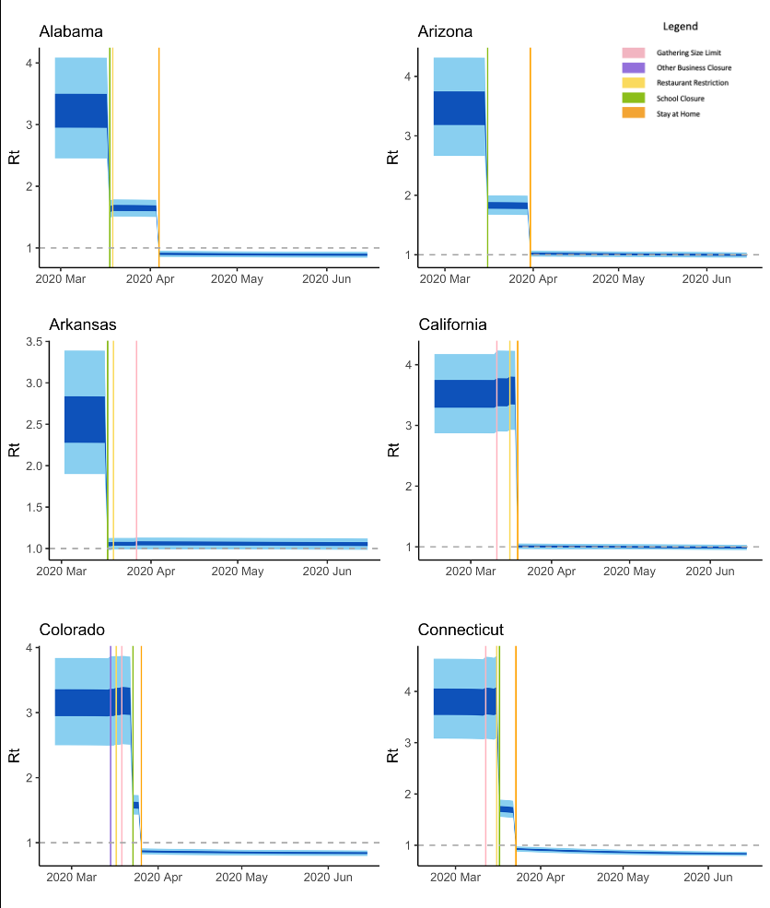

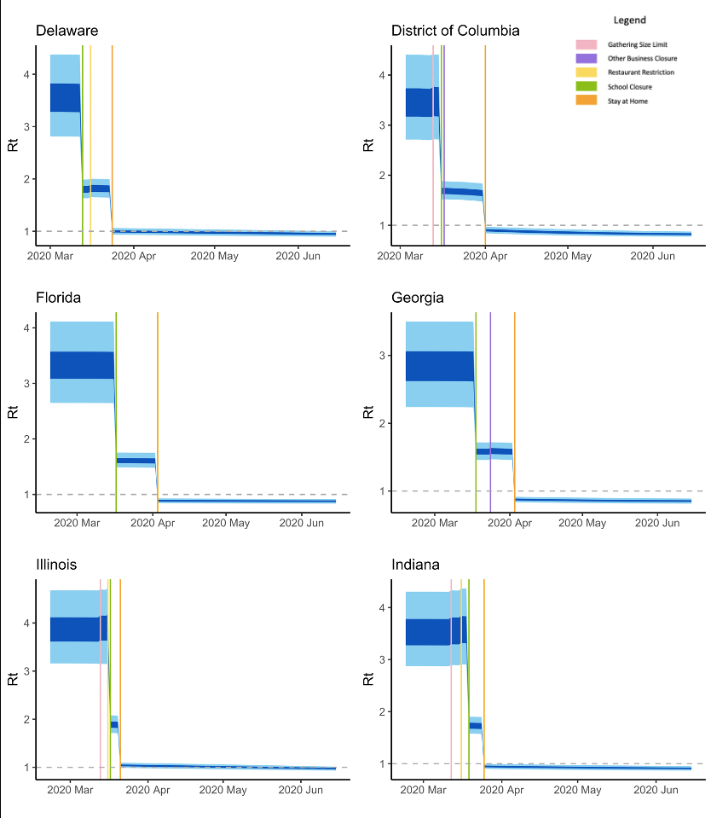
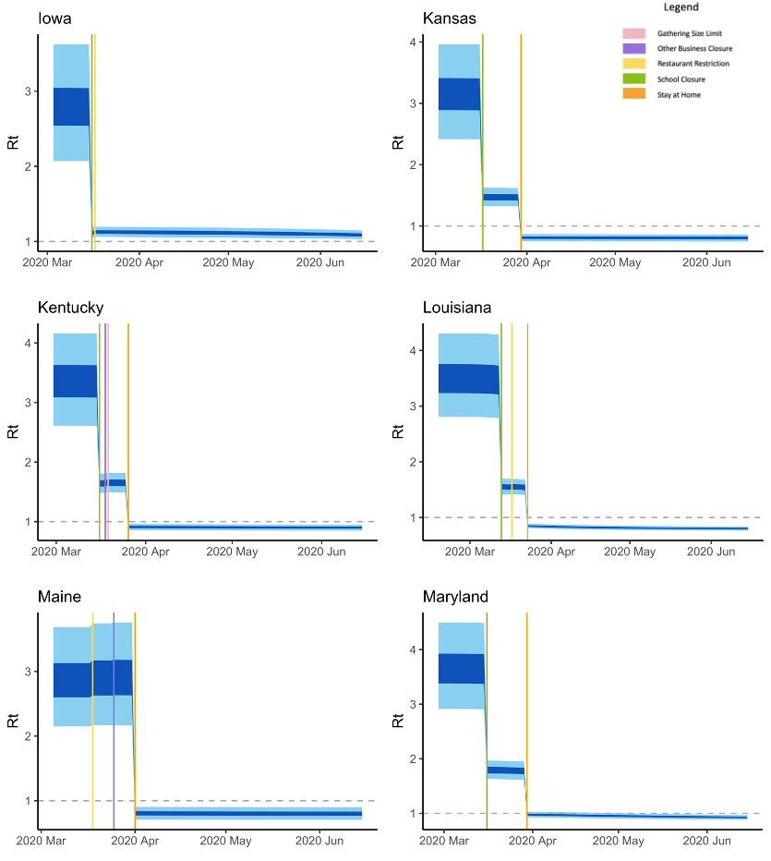
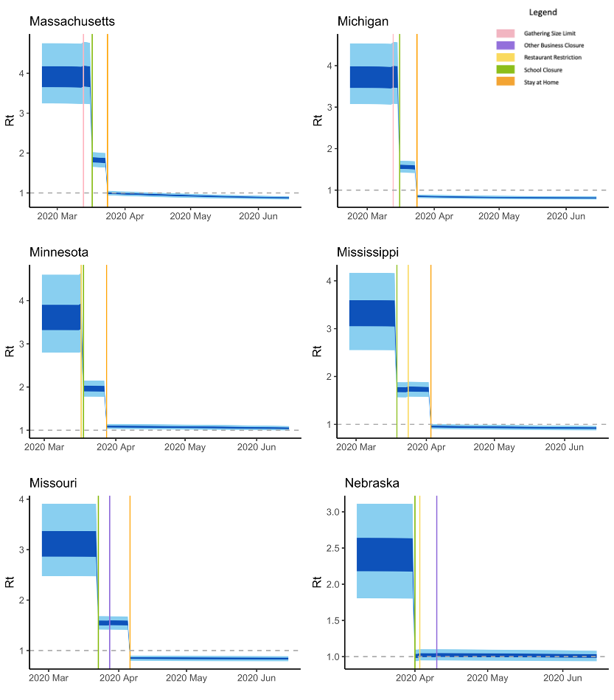
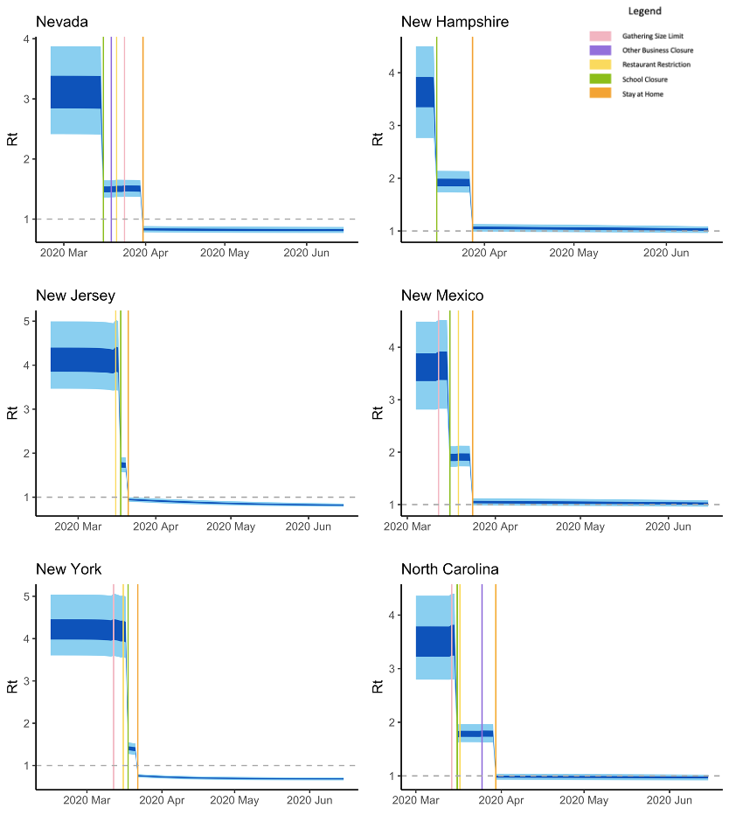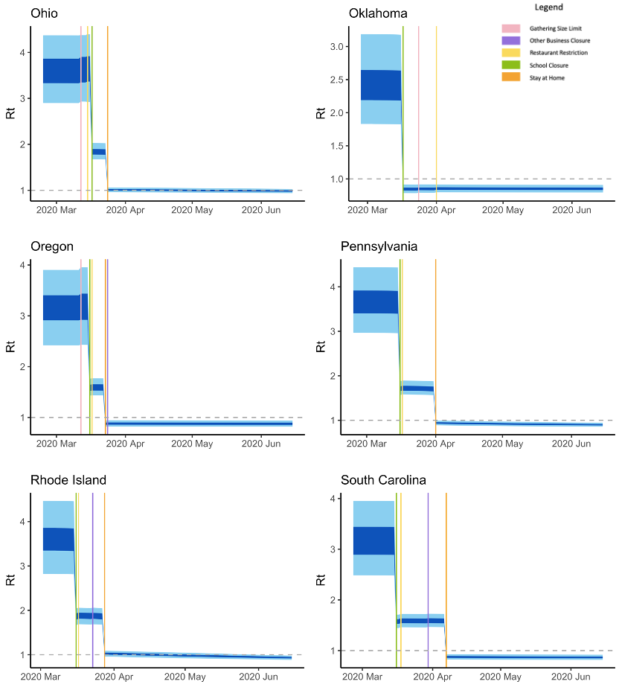

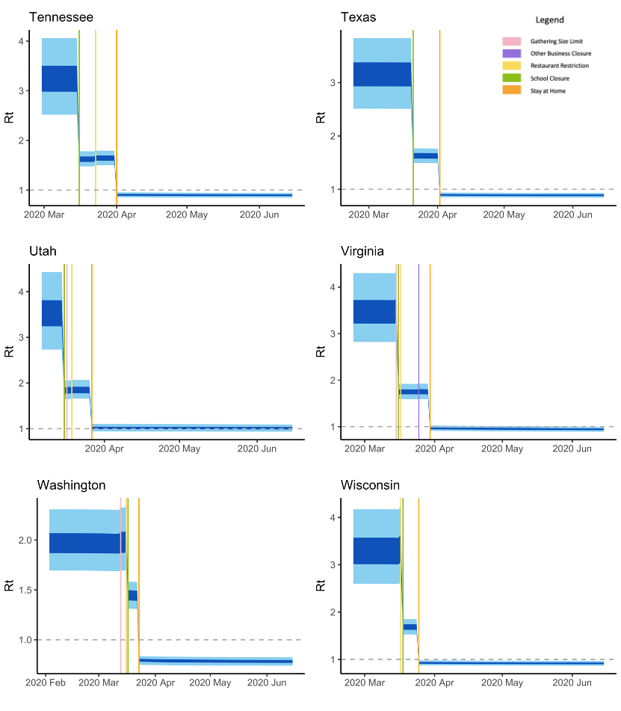

- Figure List 2: Advanced Prototypical Bayesian Hierarchical Model Expected Daily Number of Reported Infection Estimation Over the Study Period.

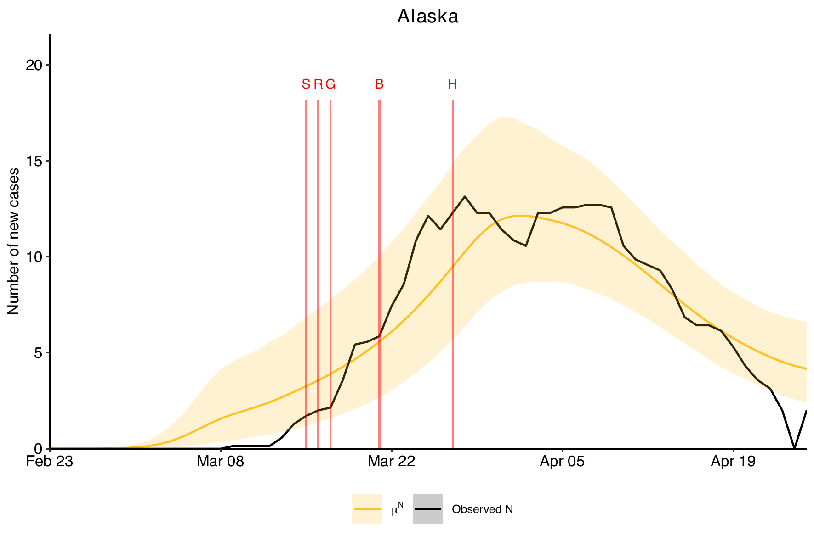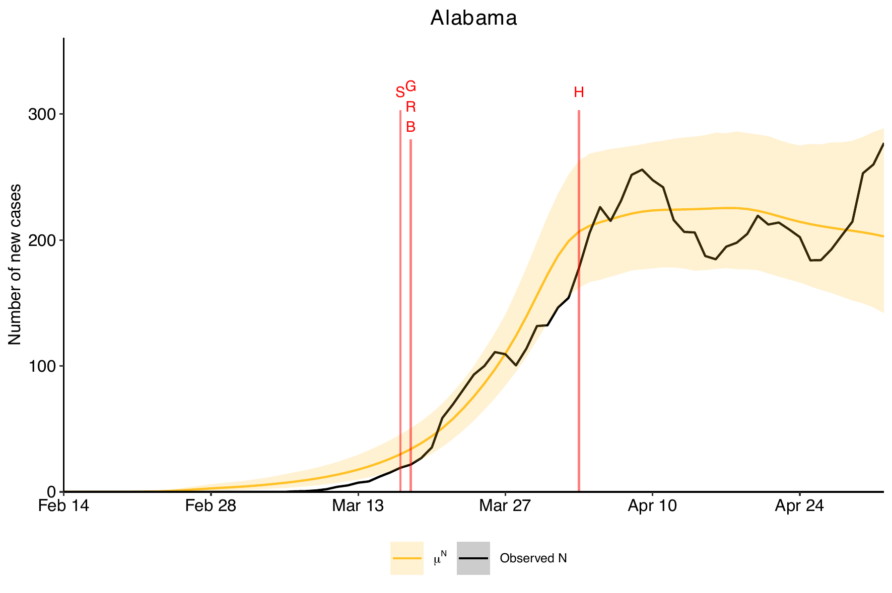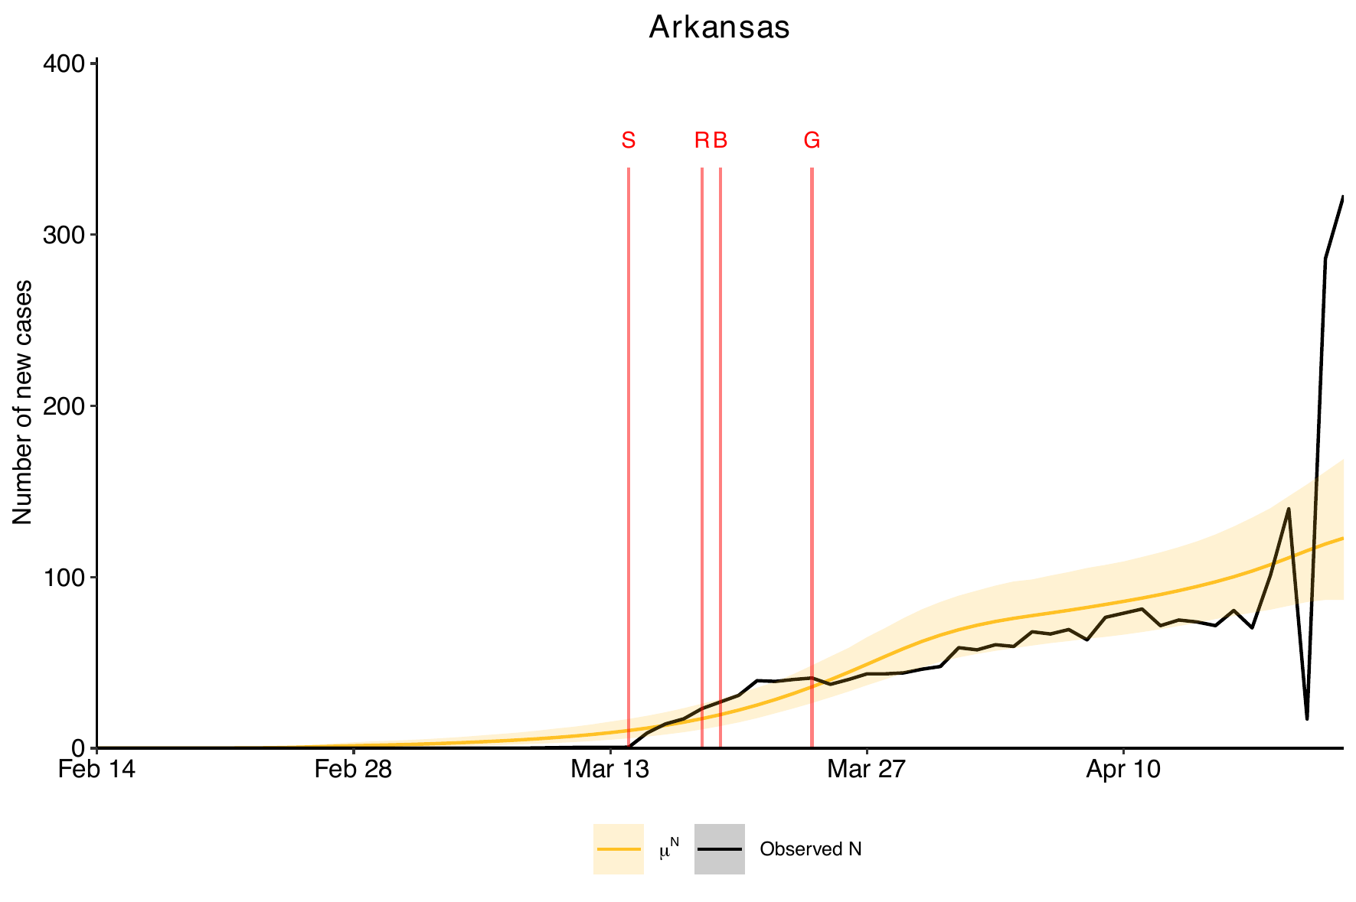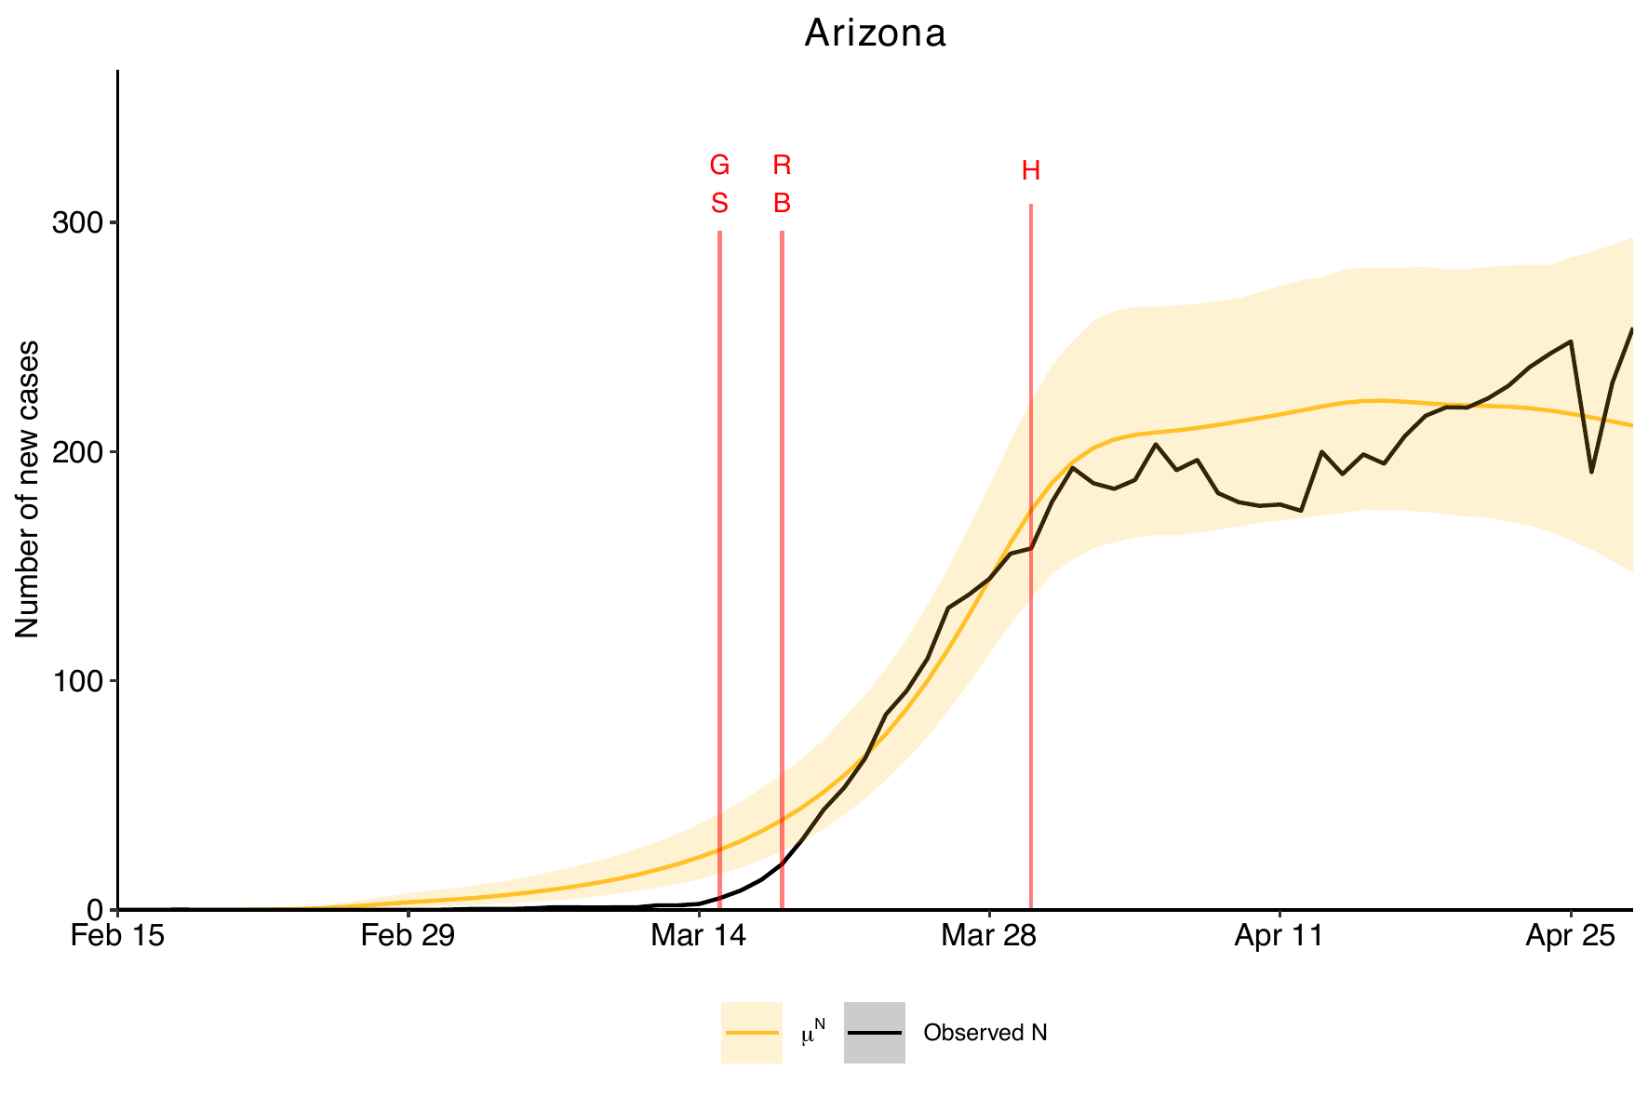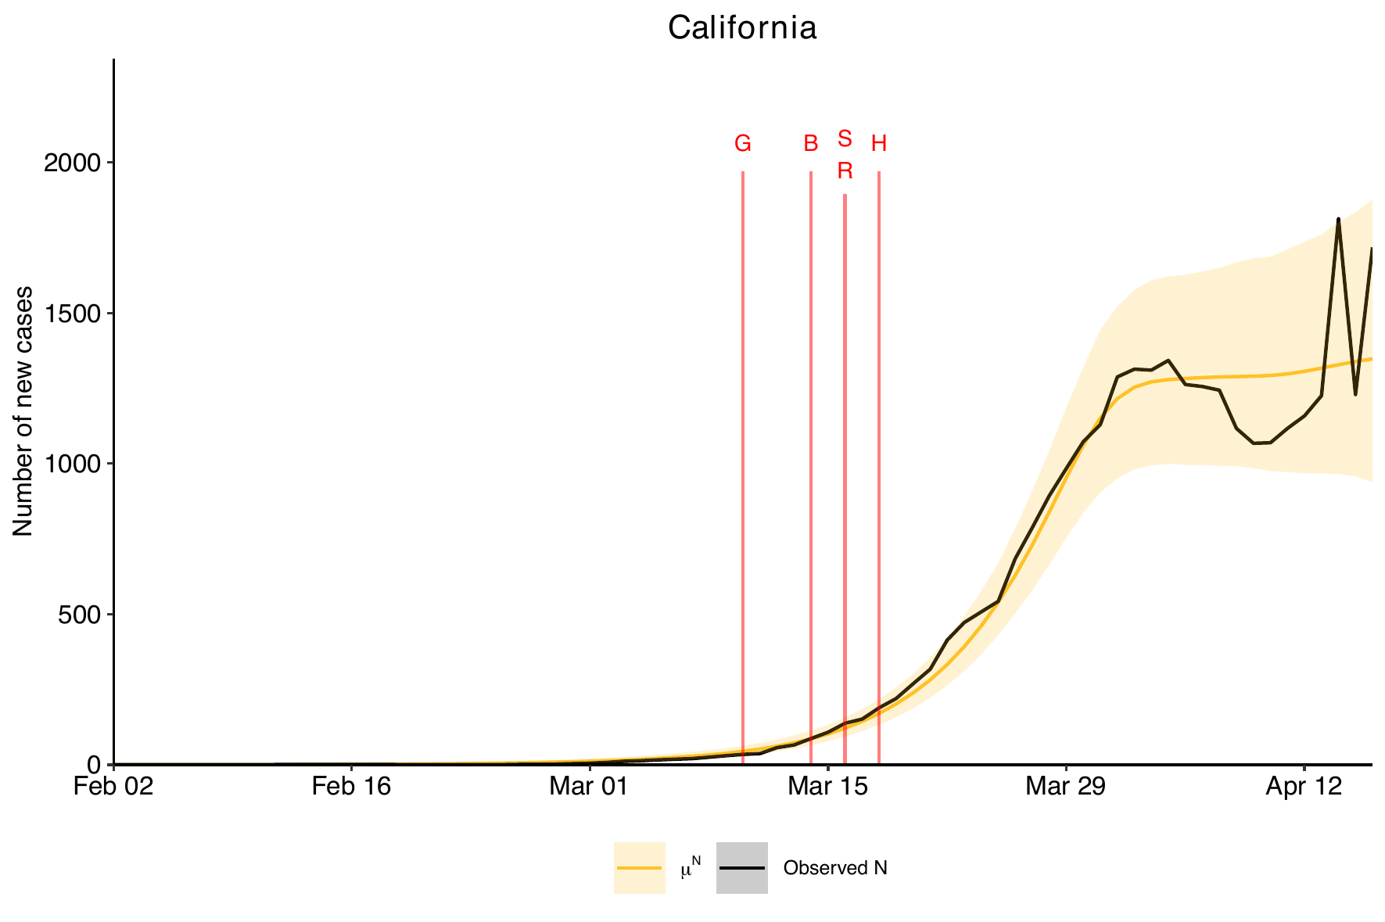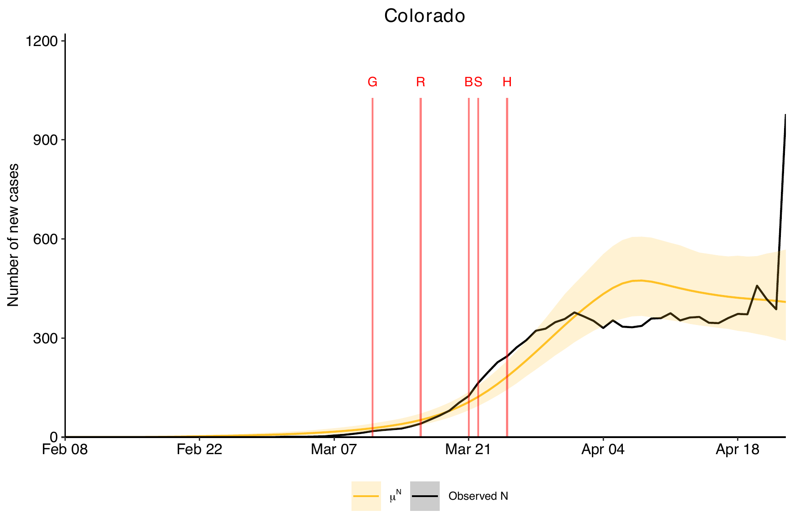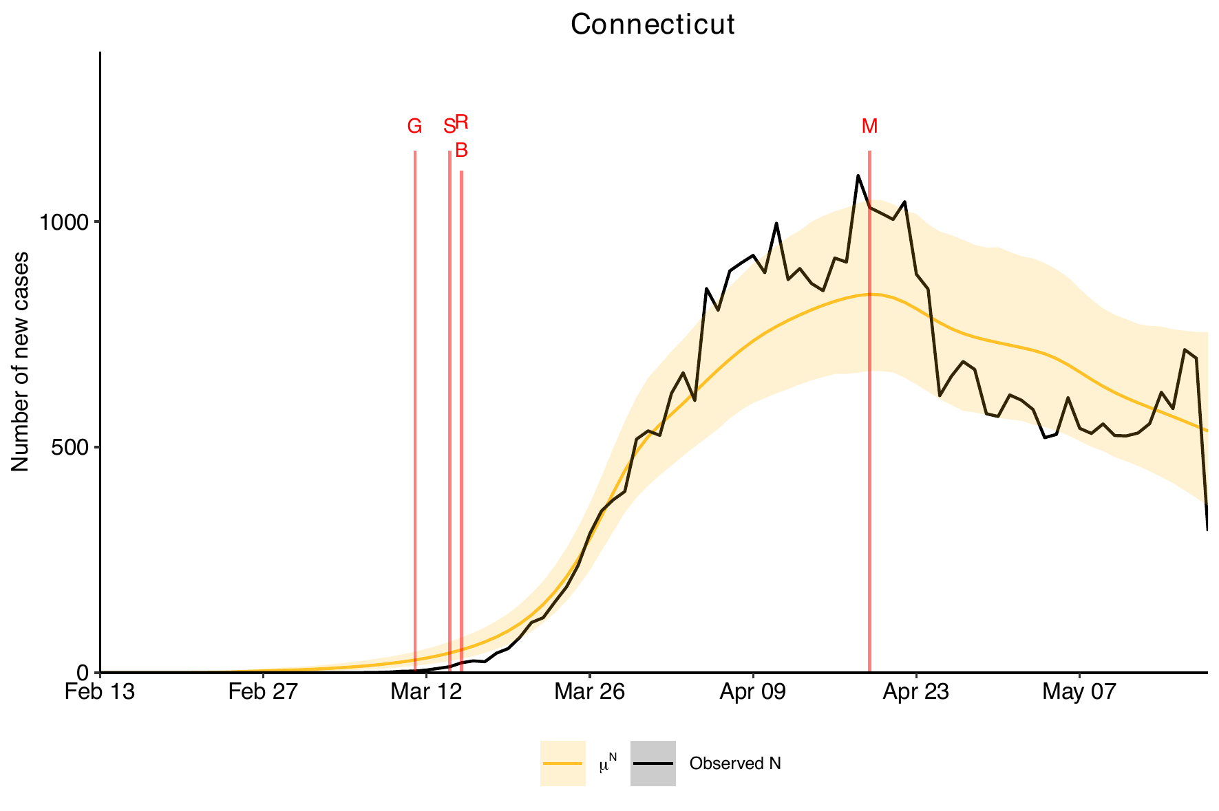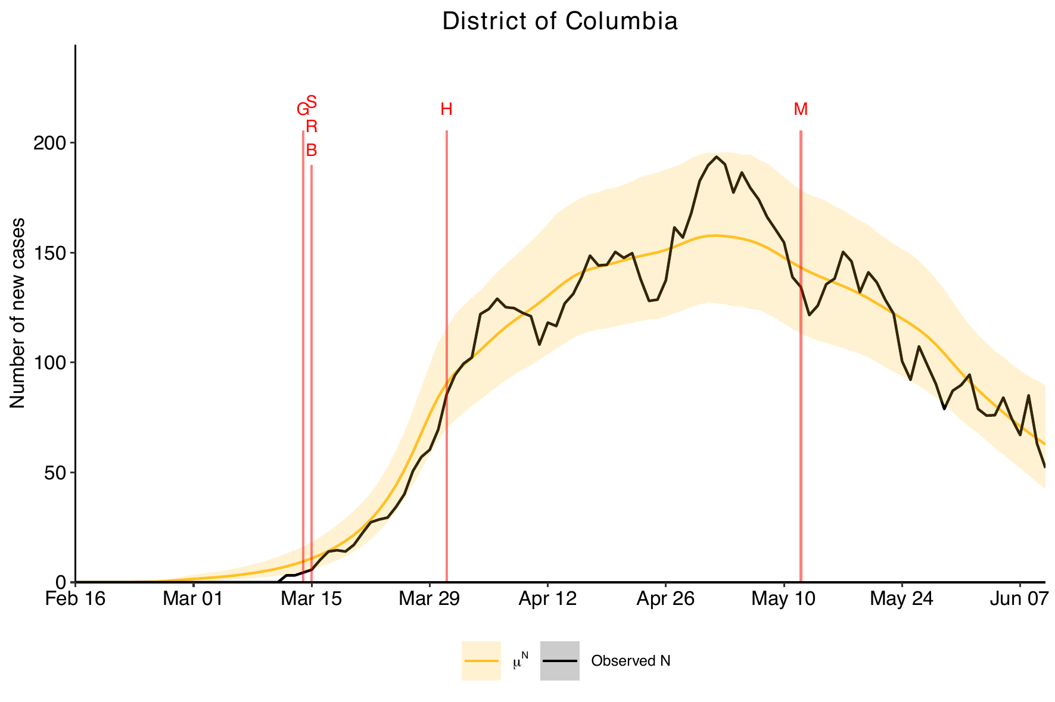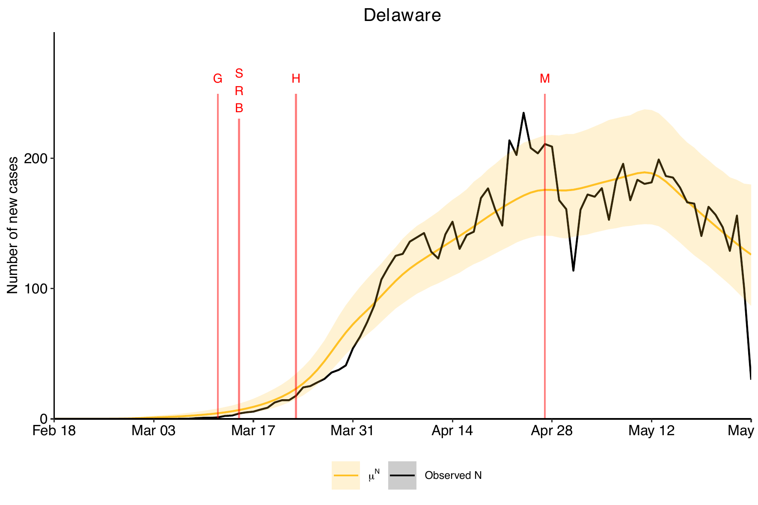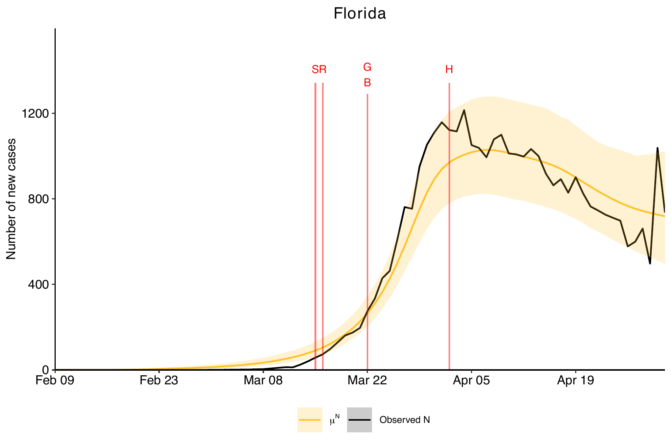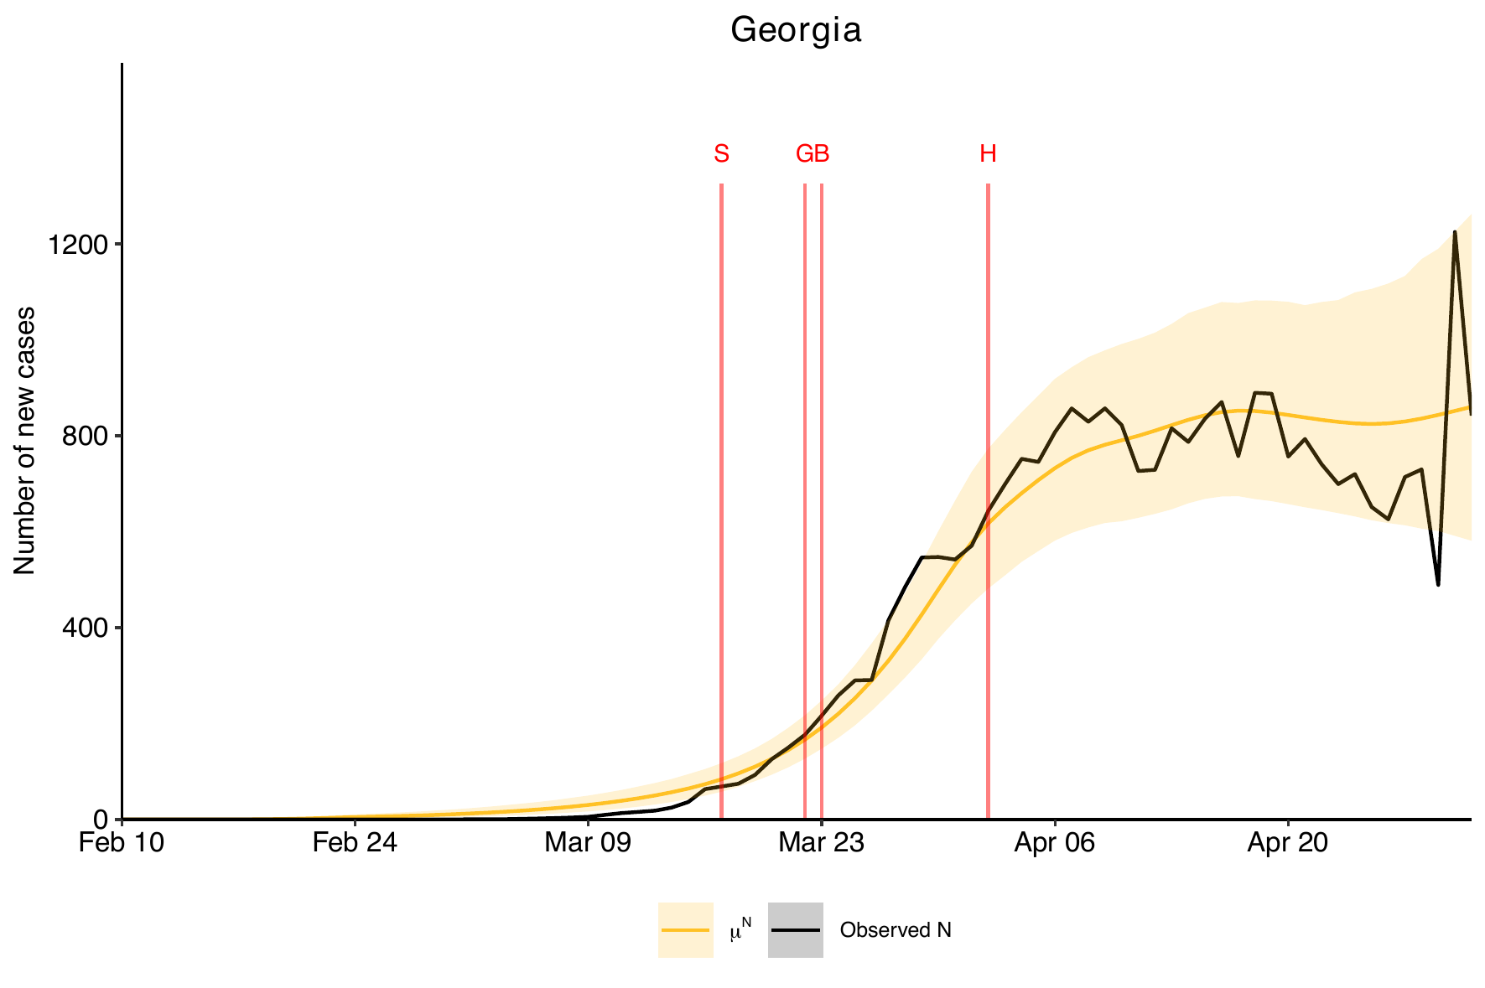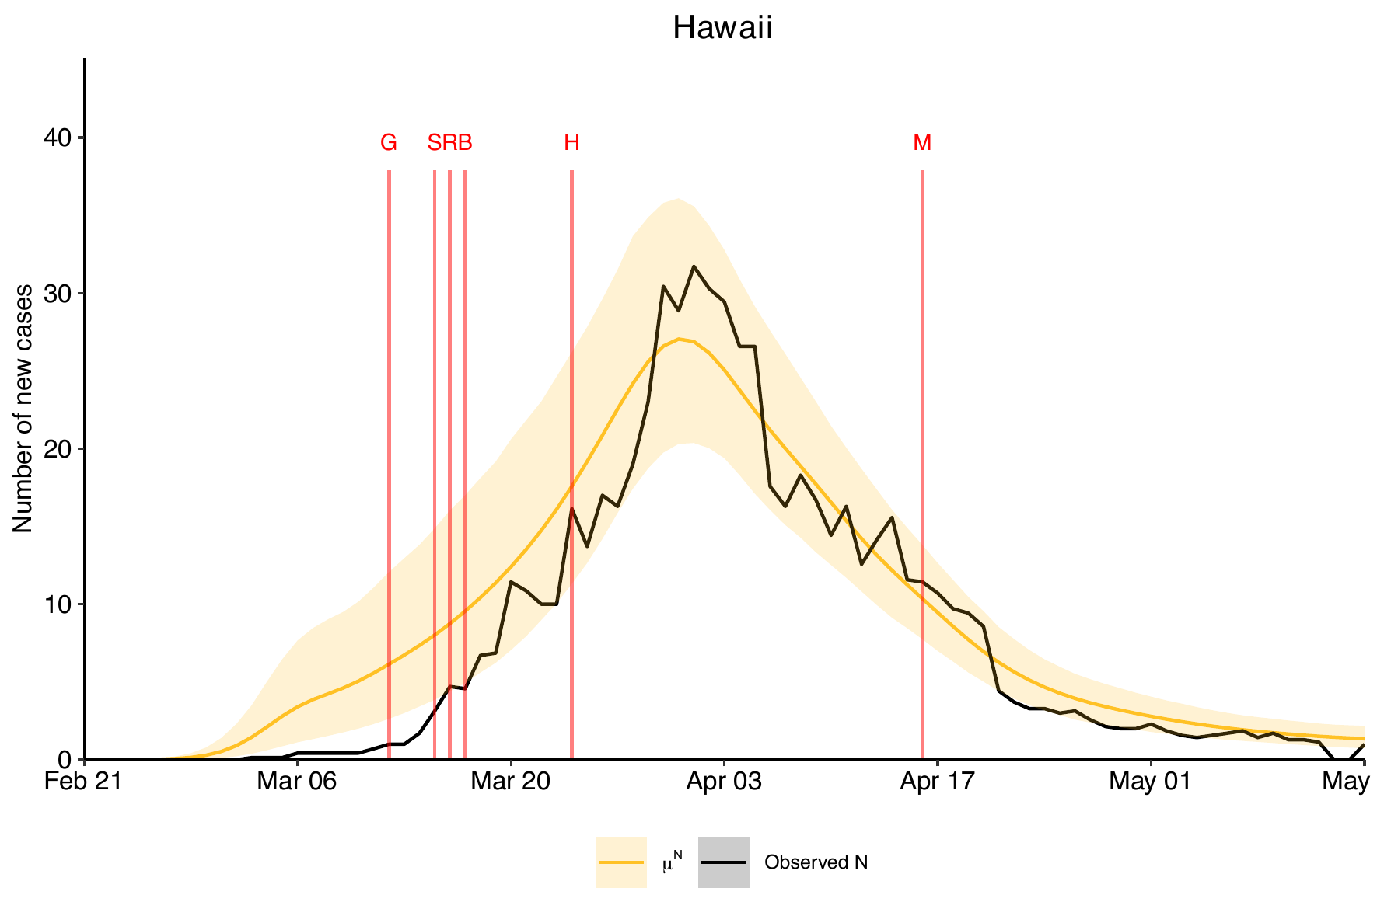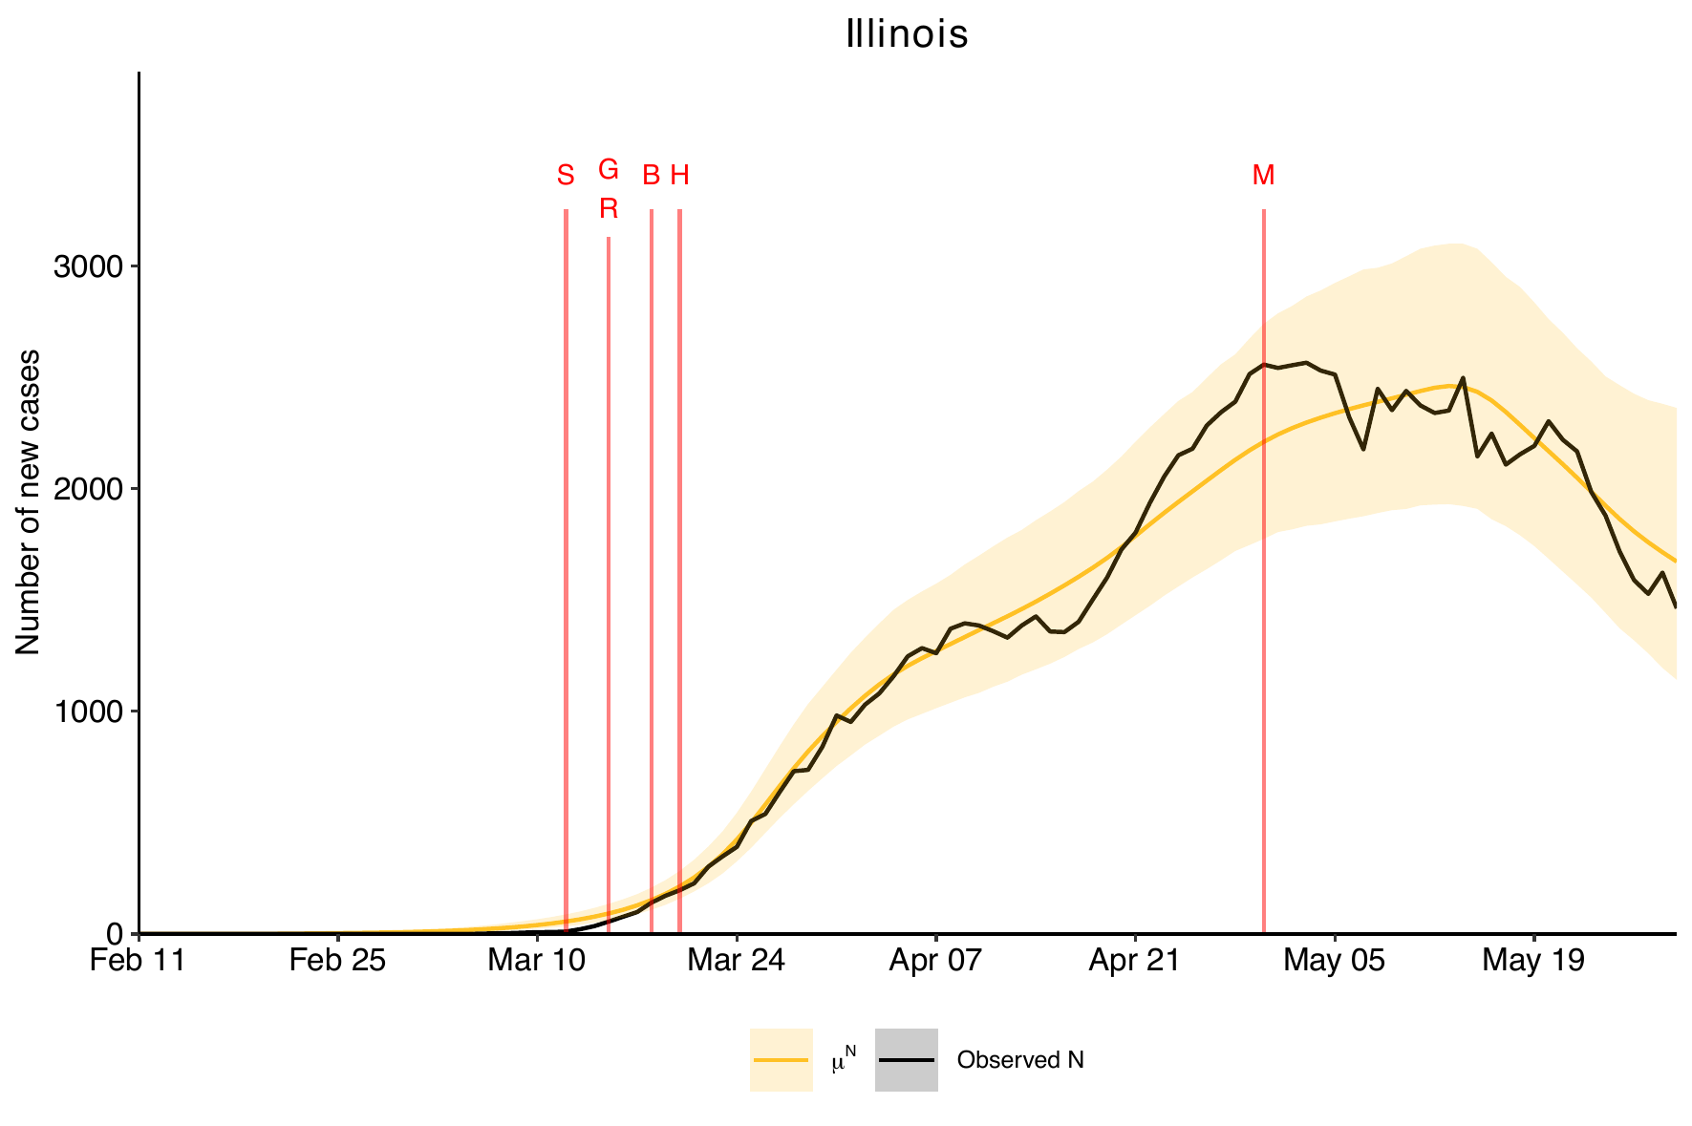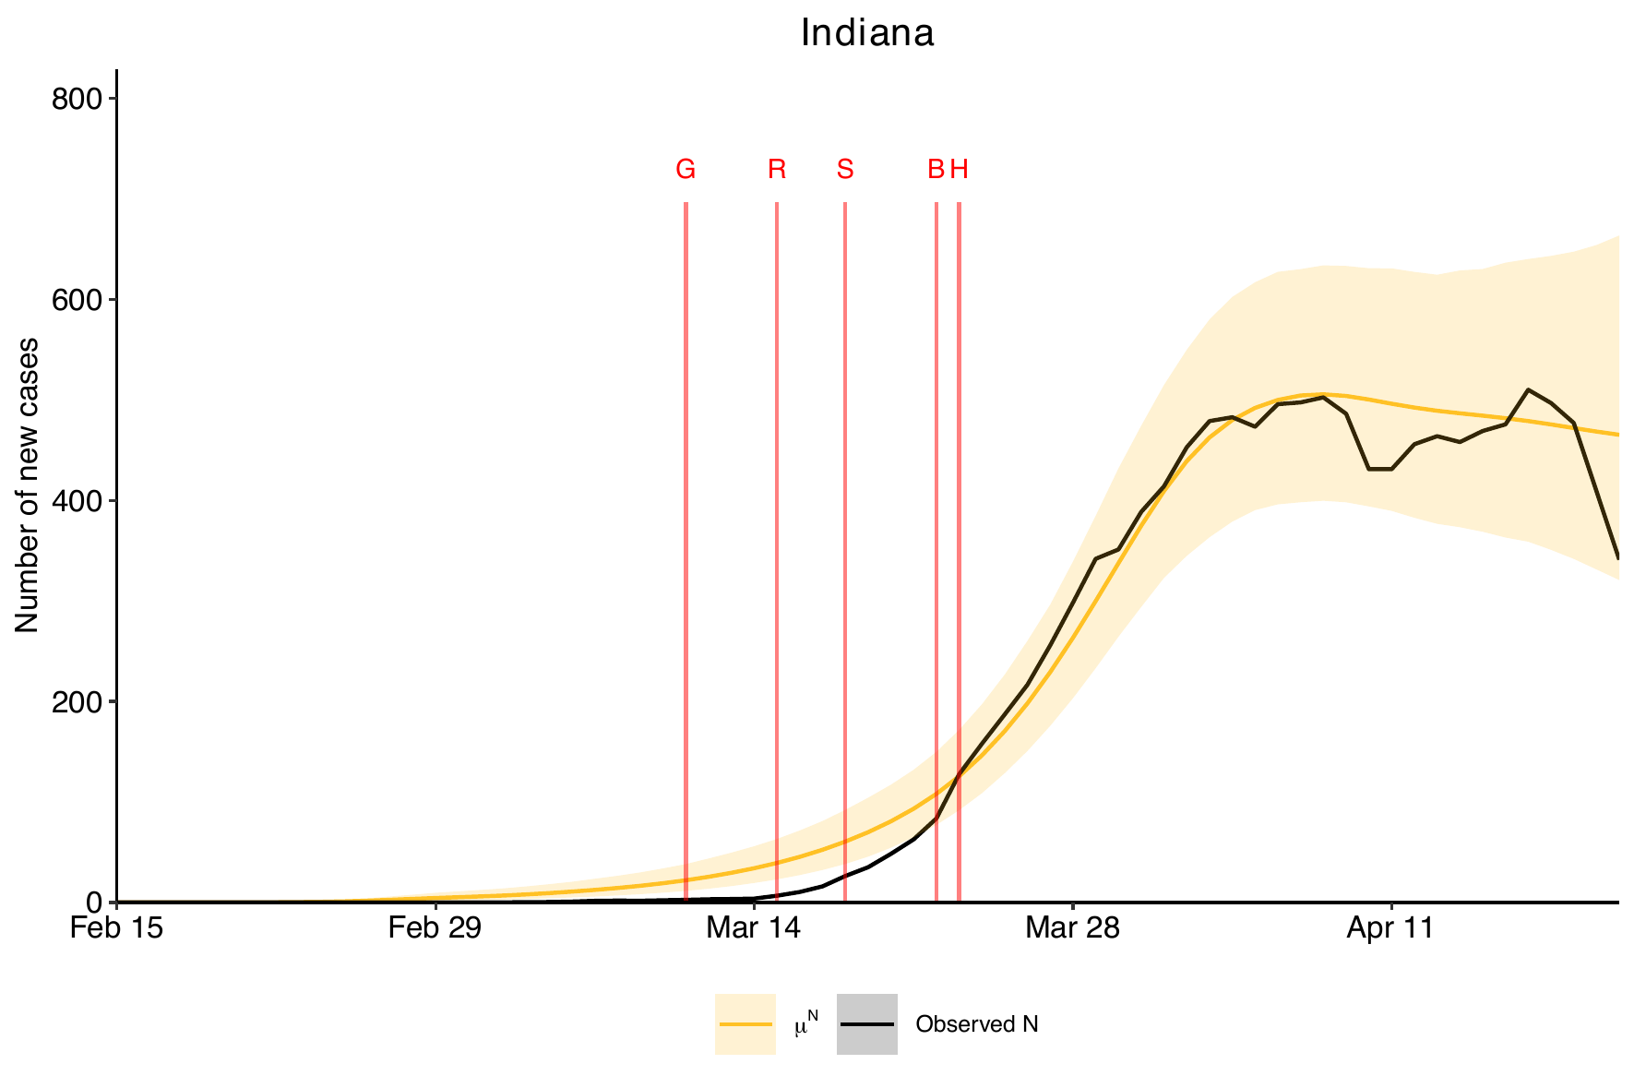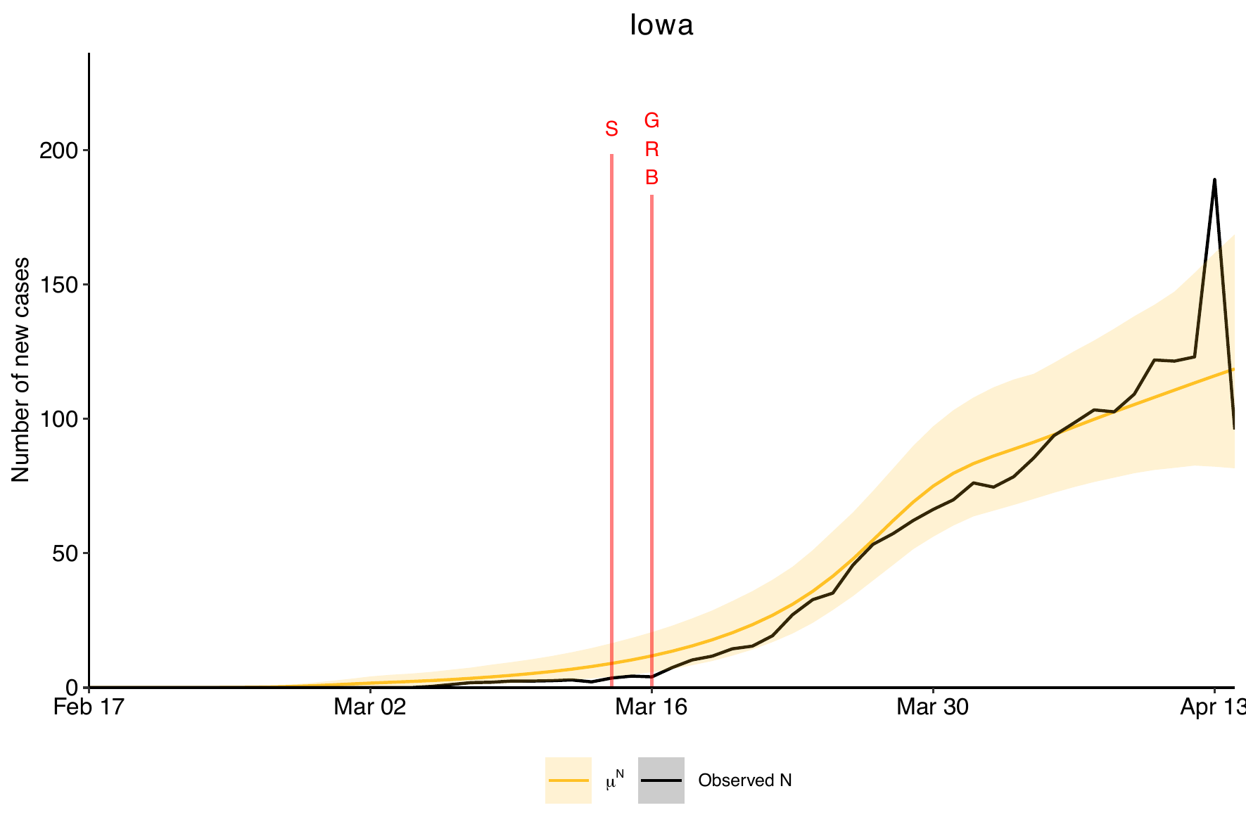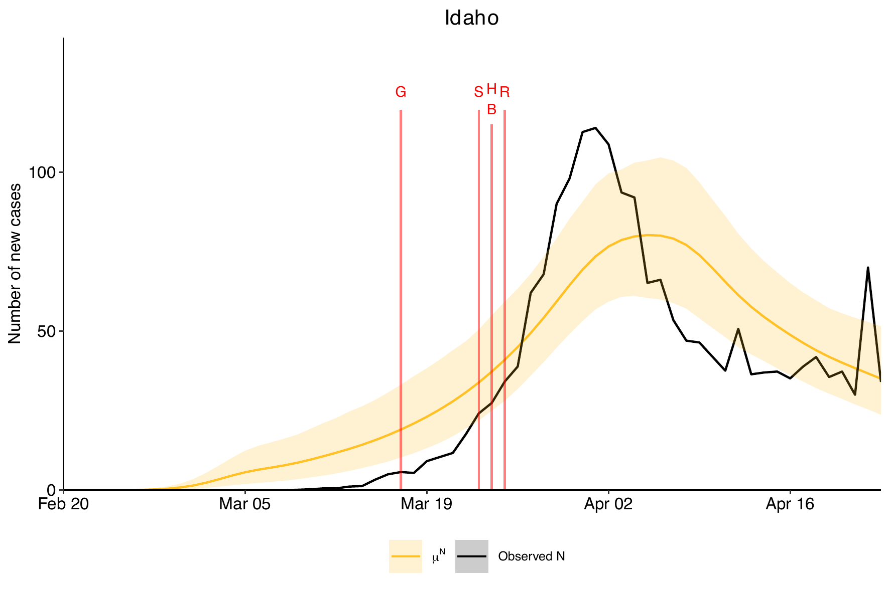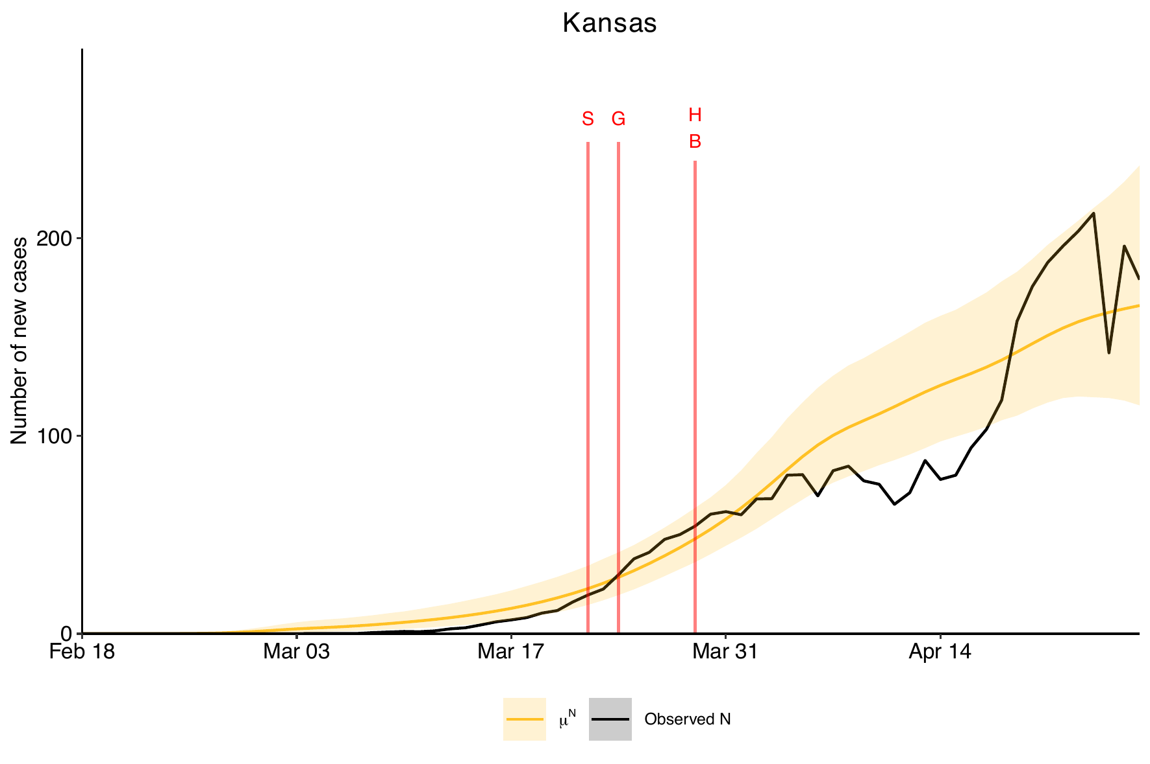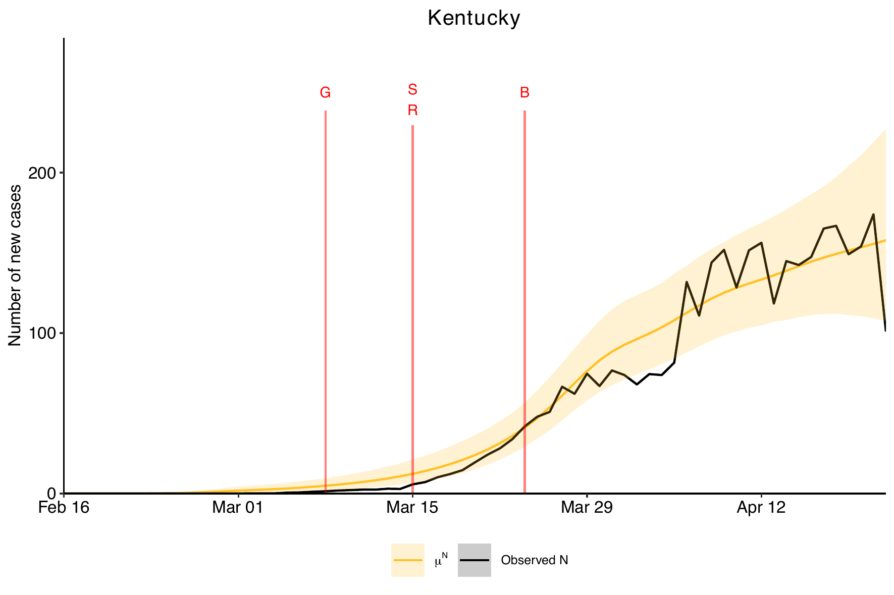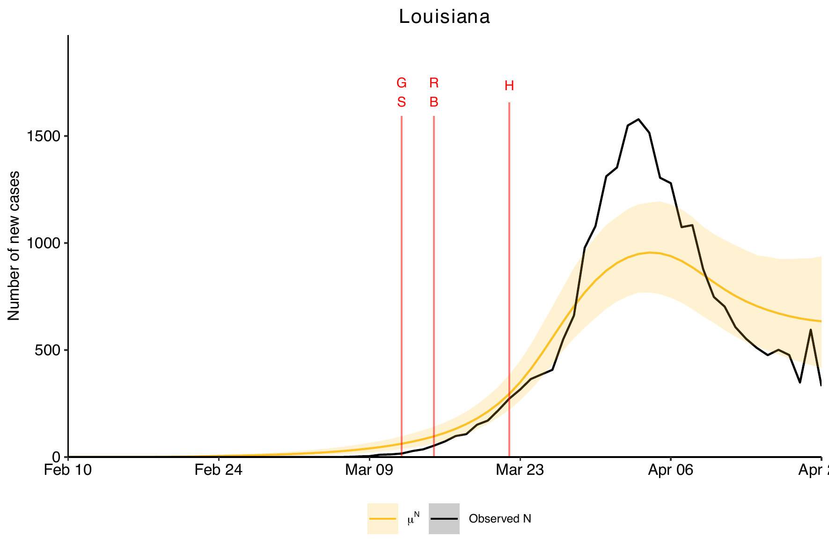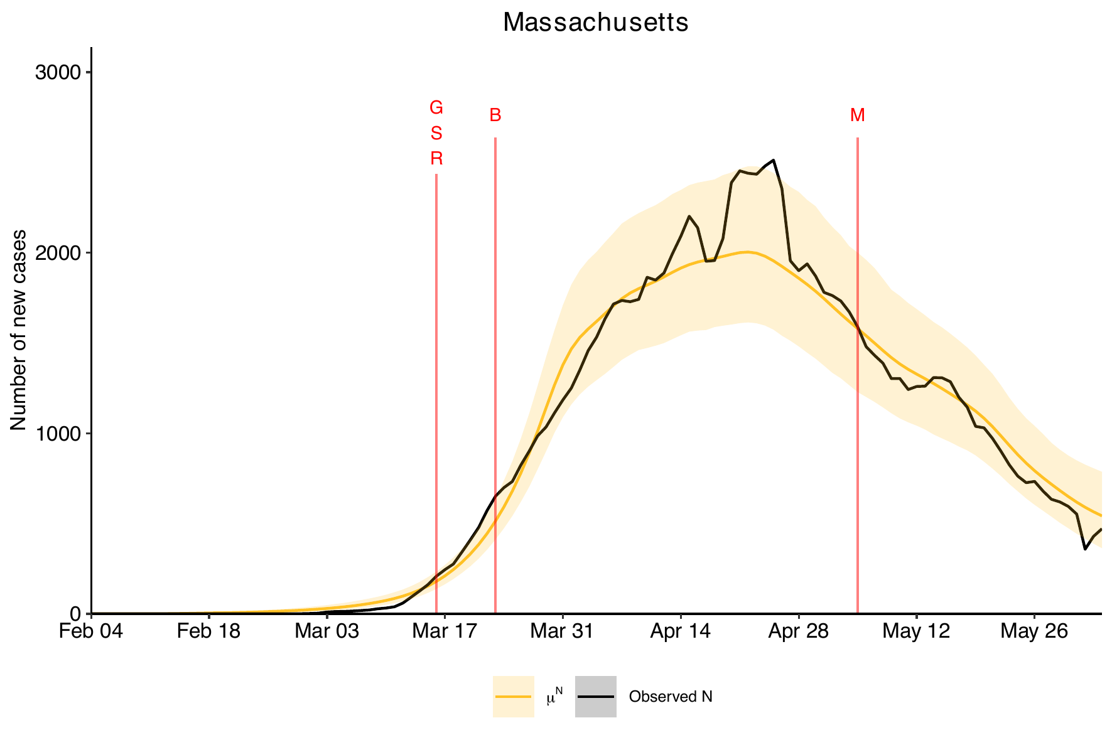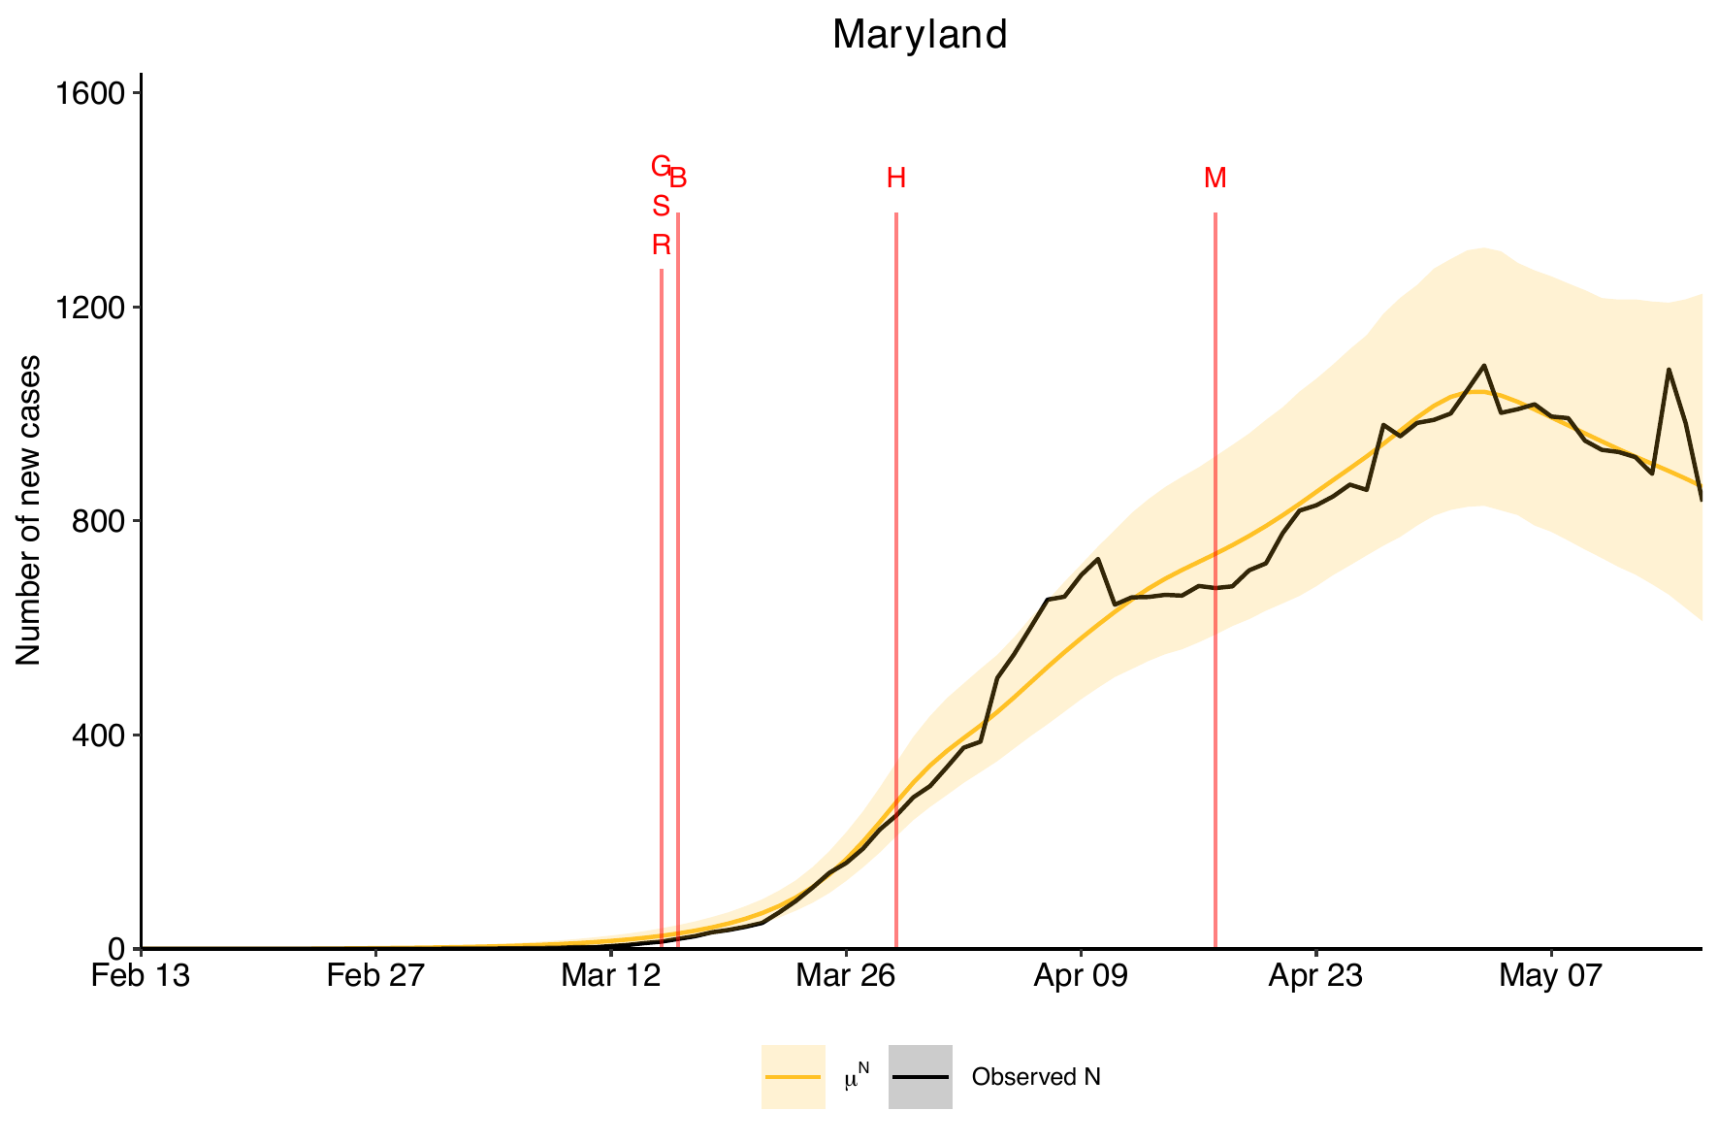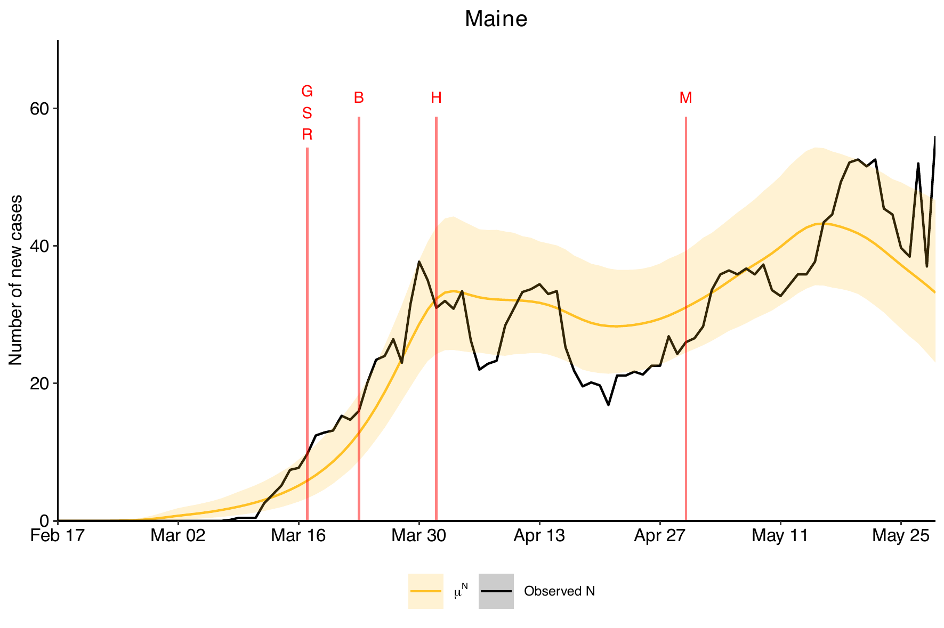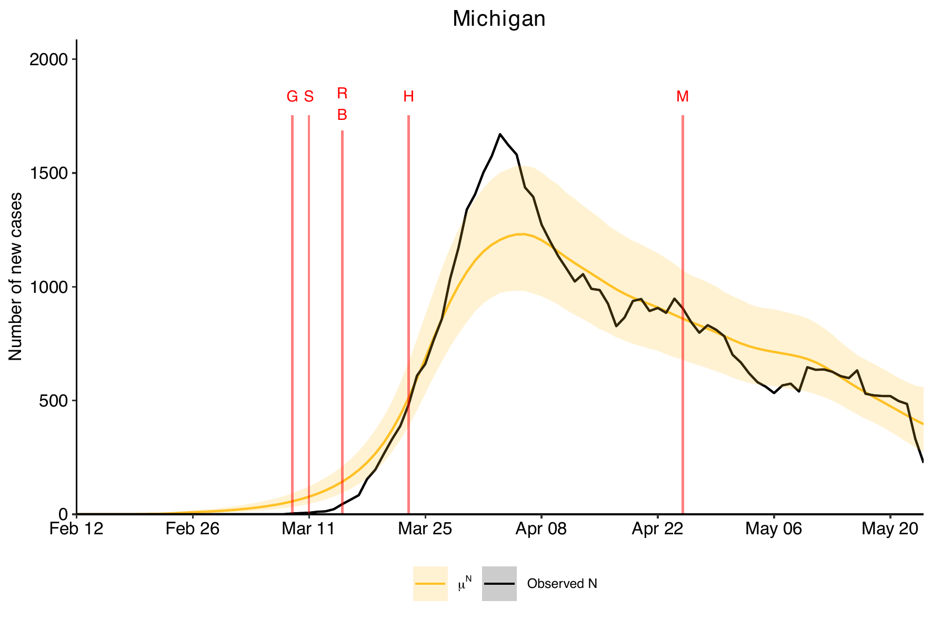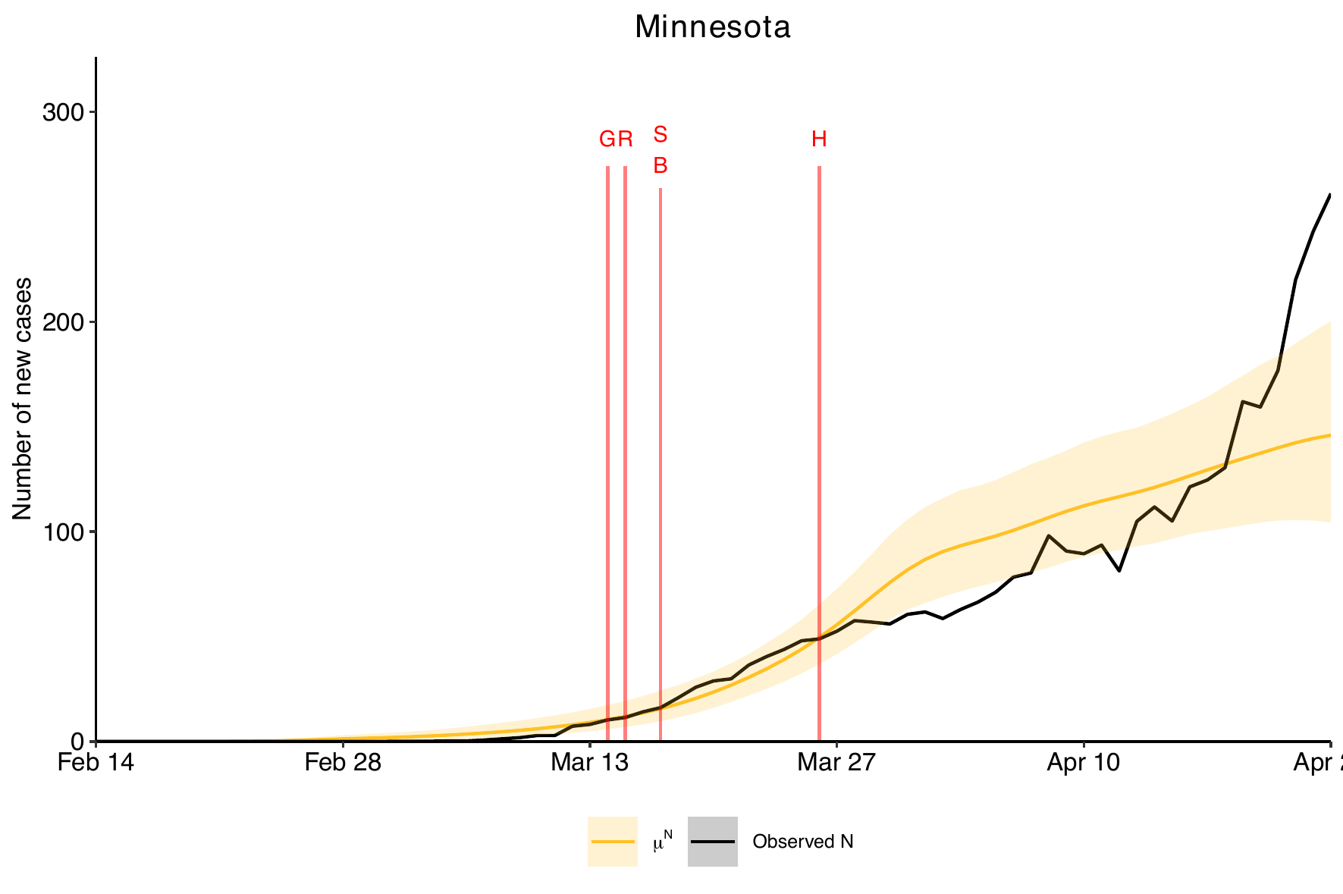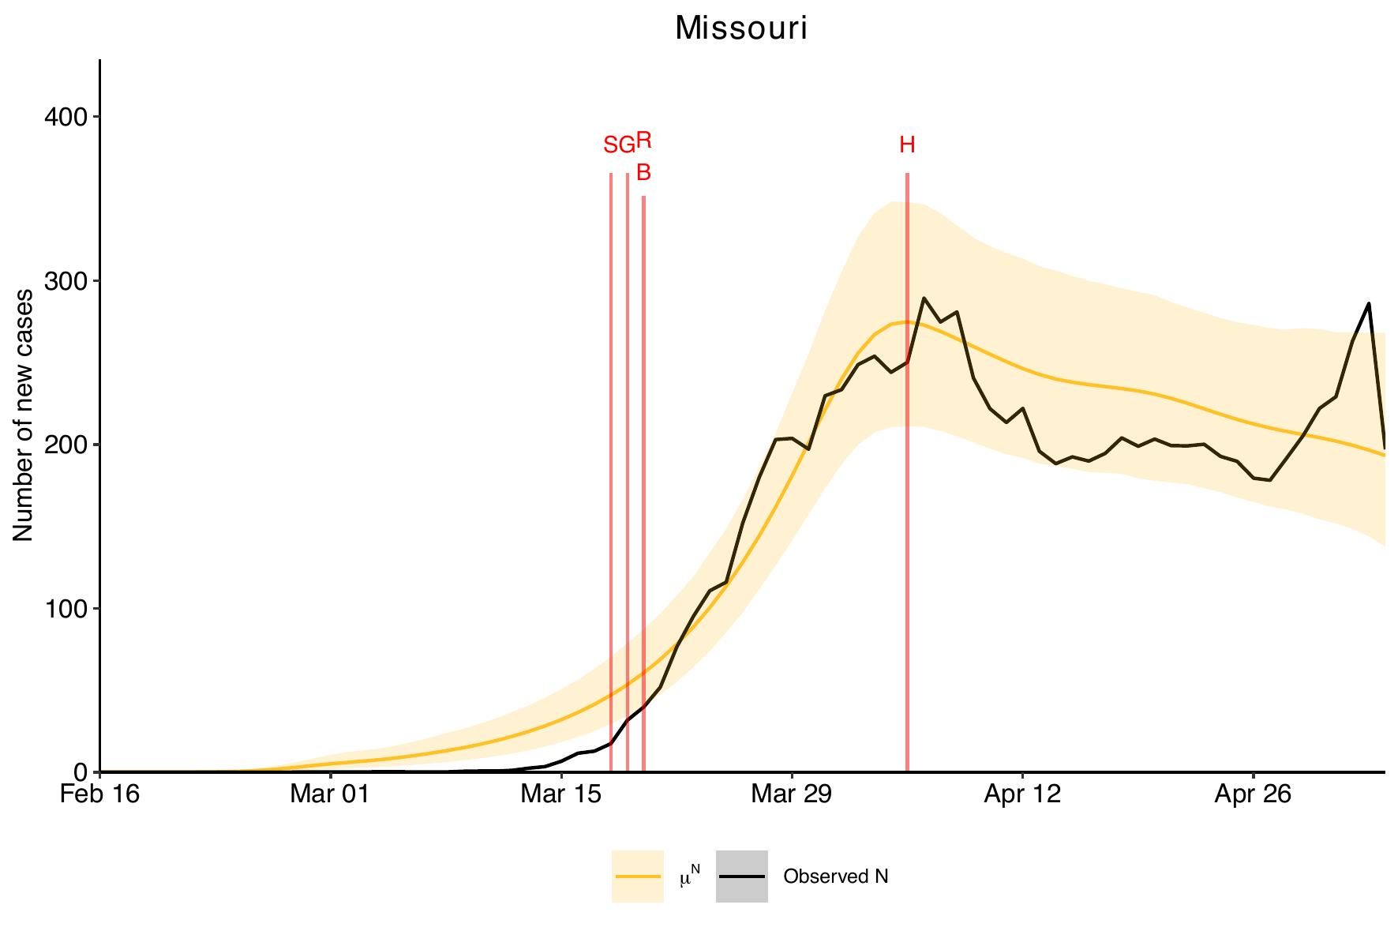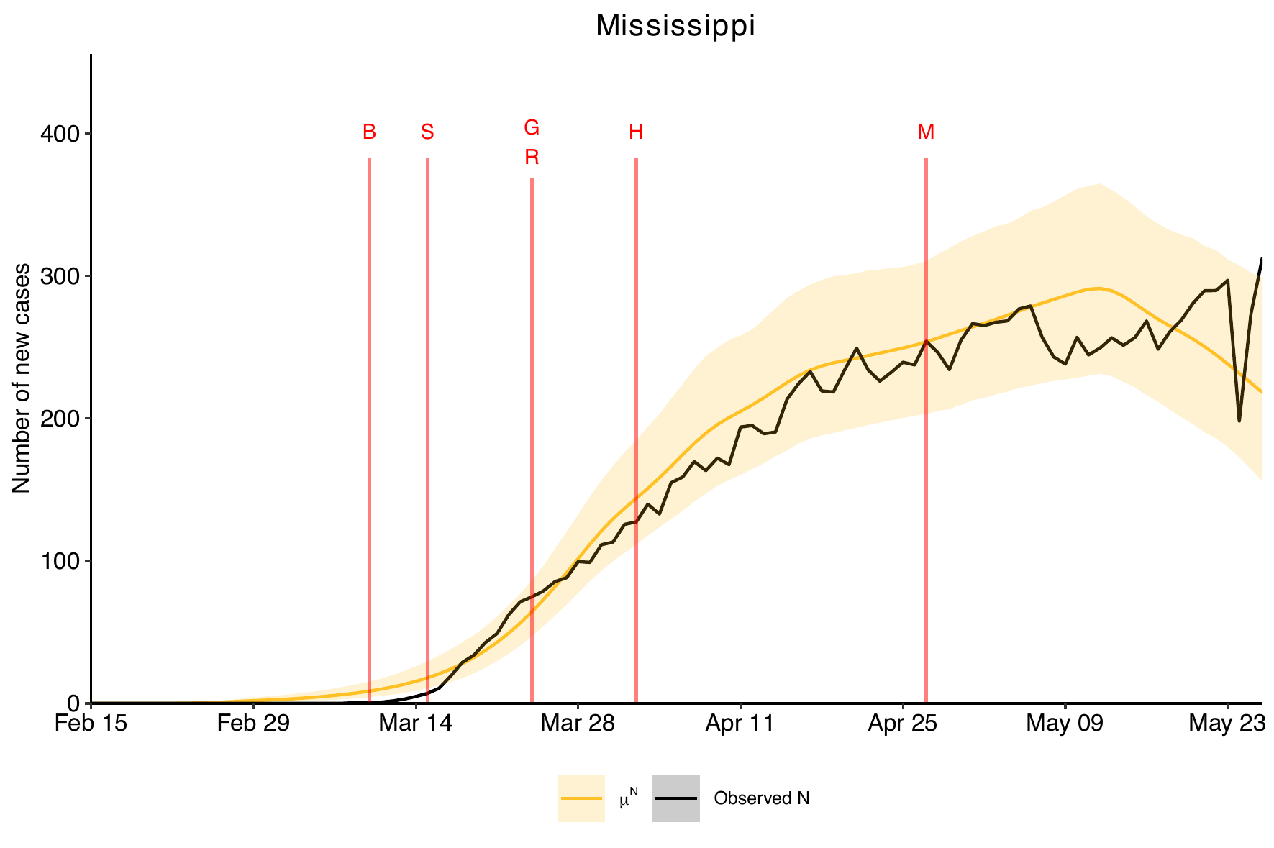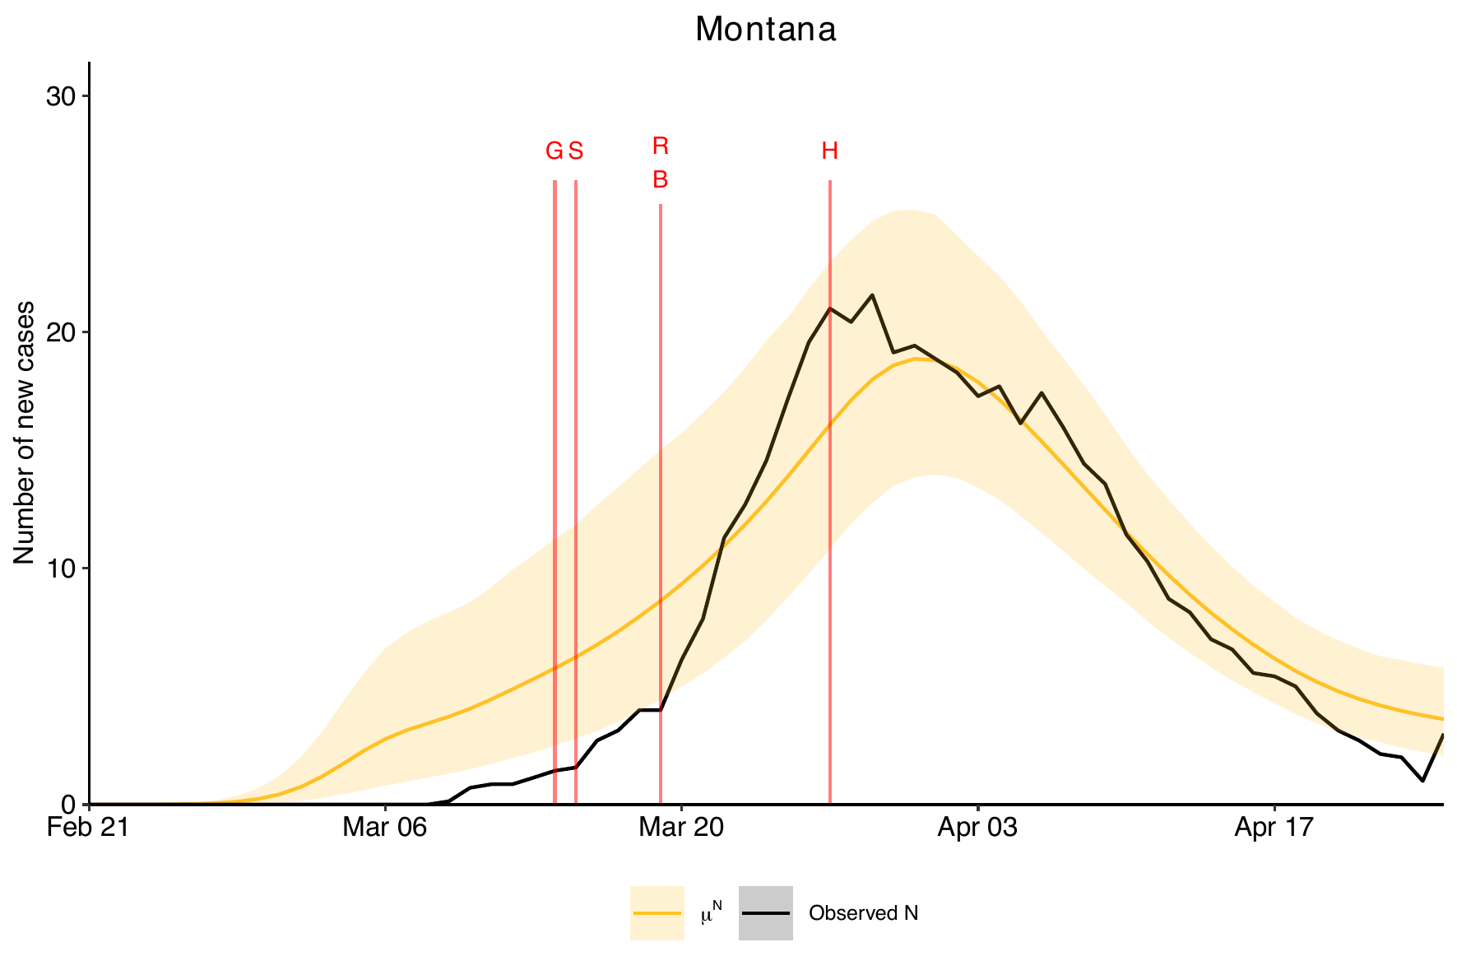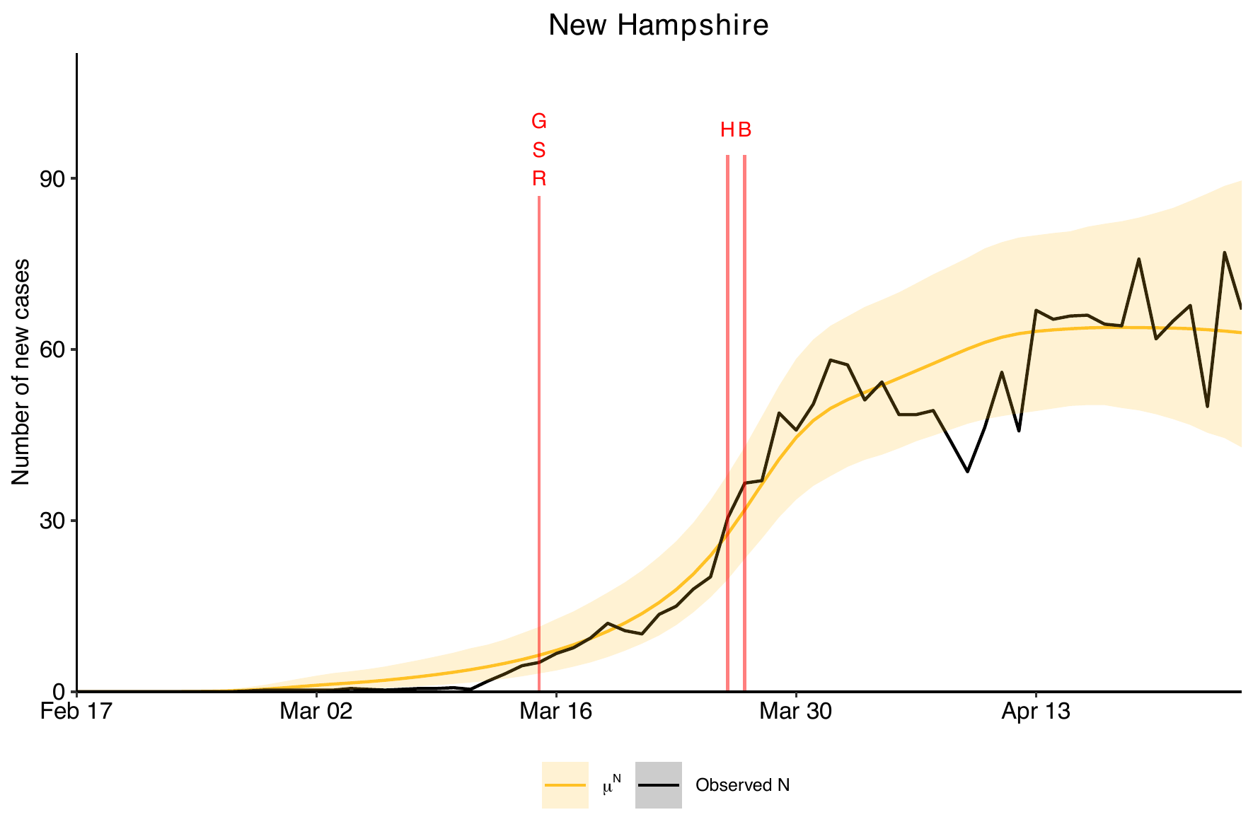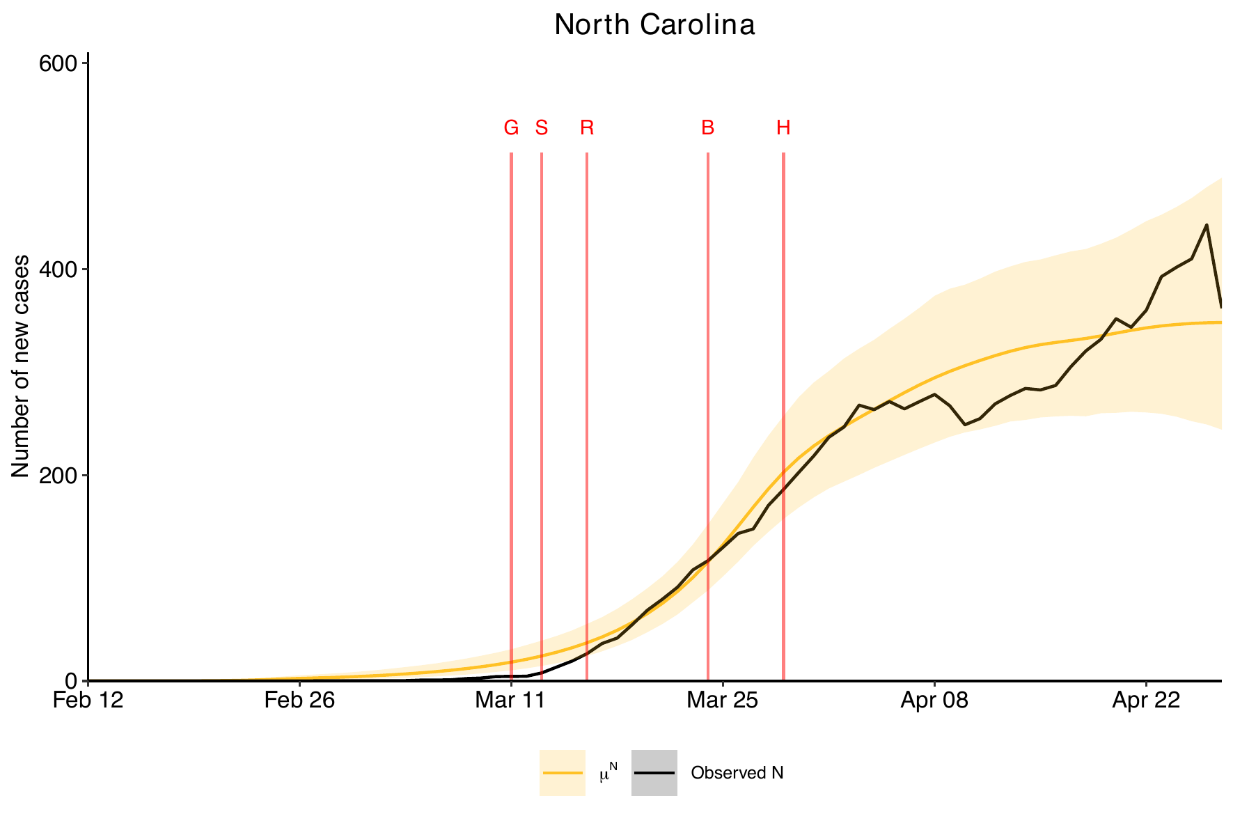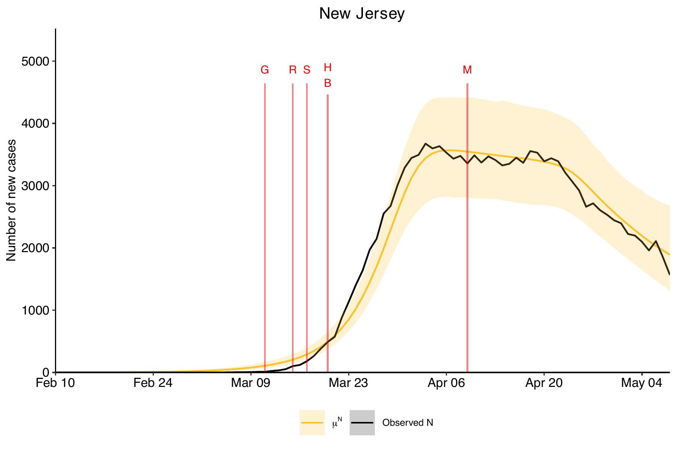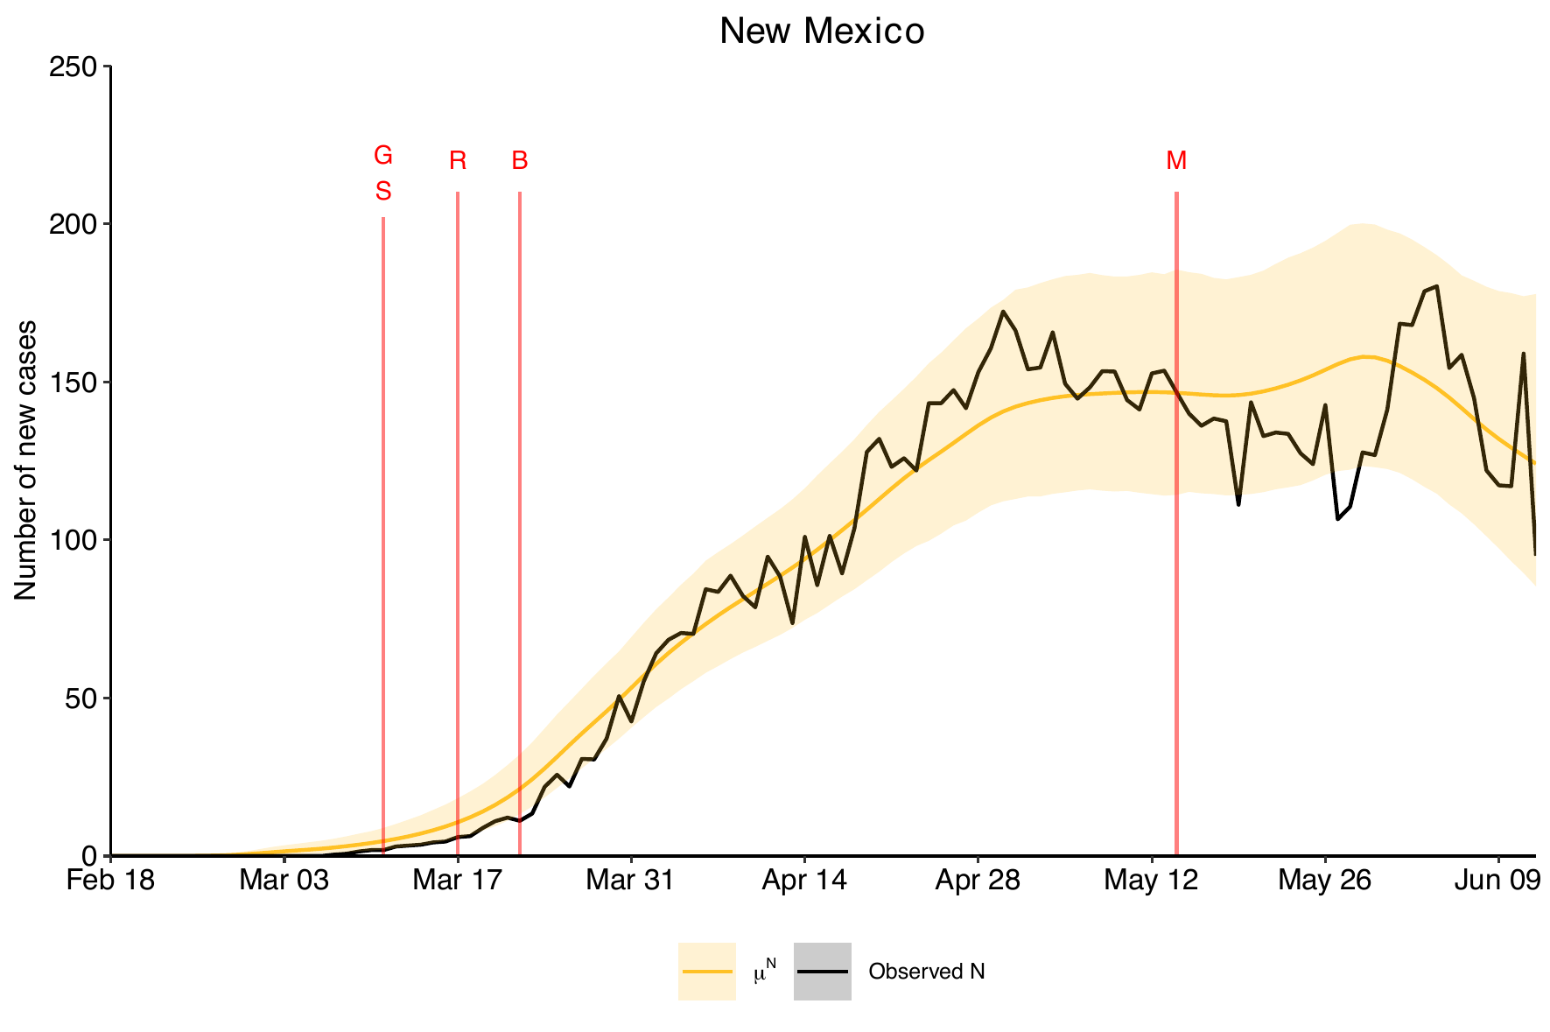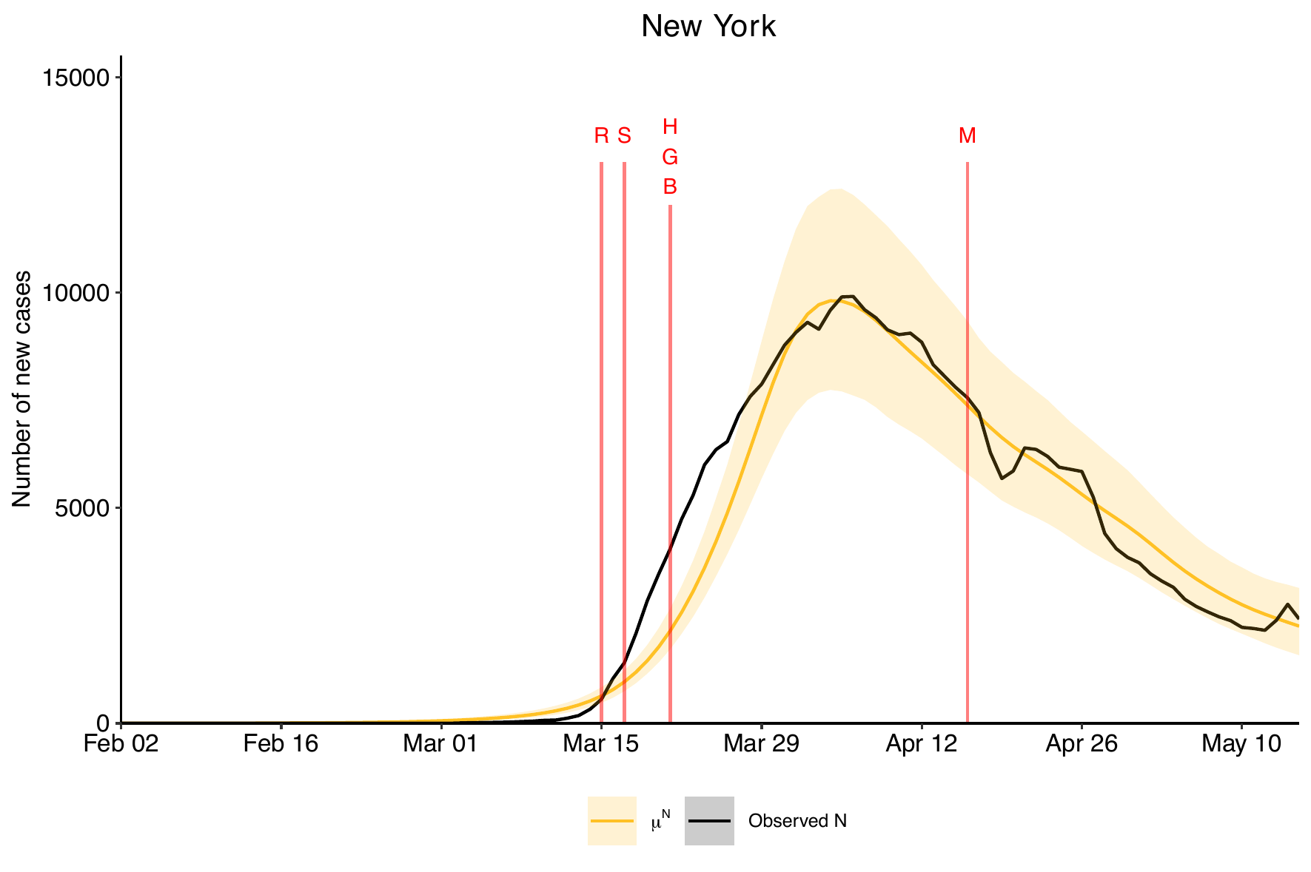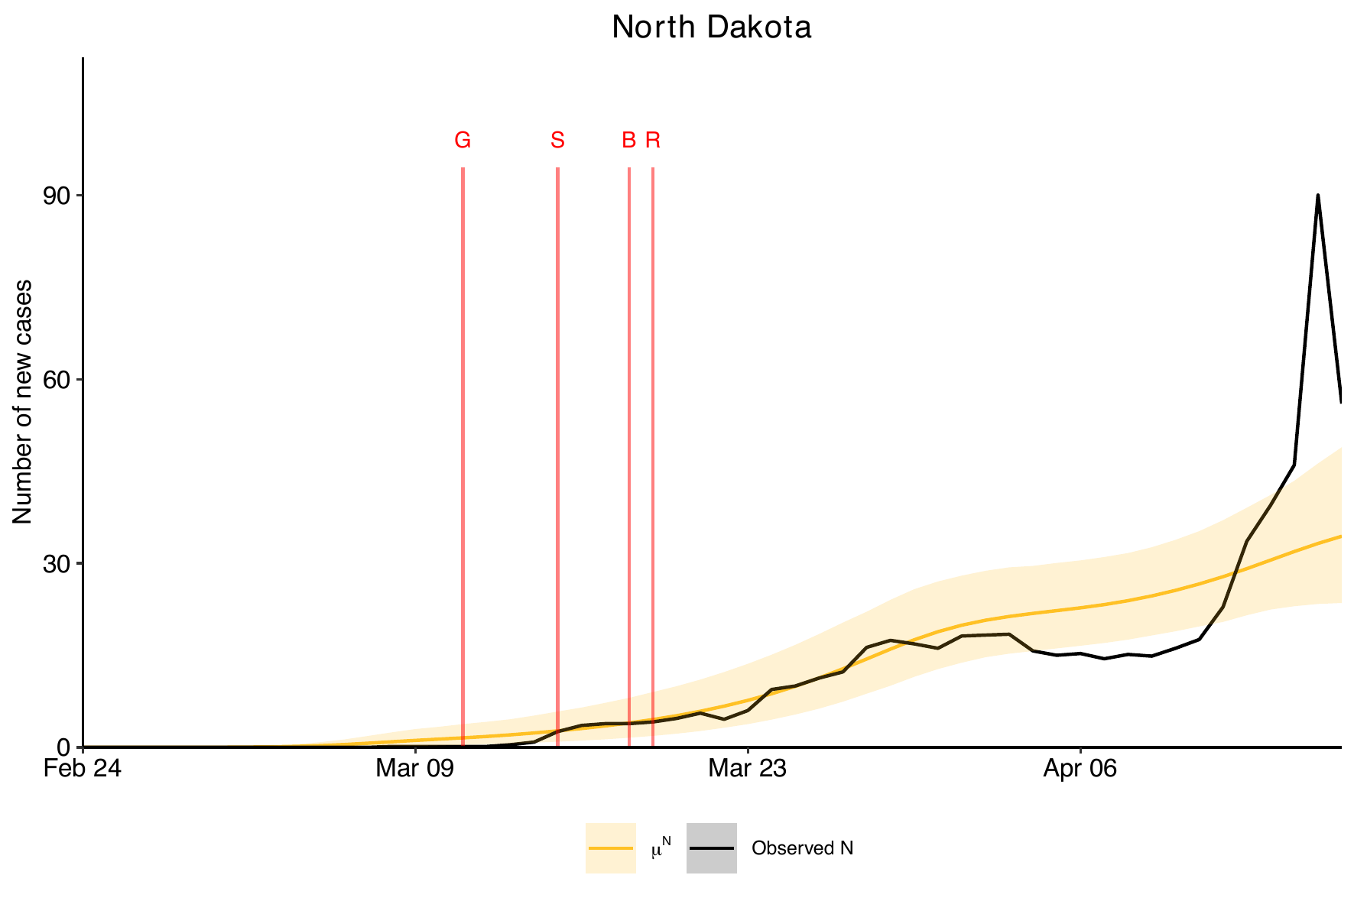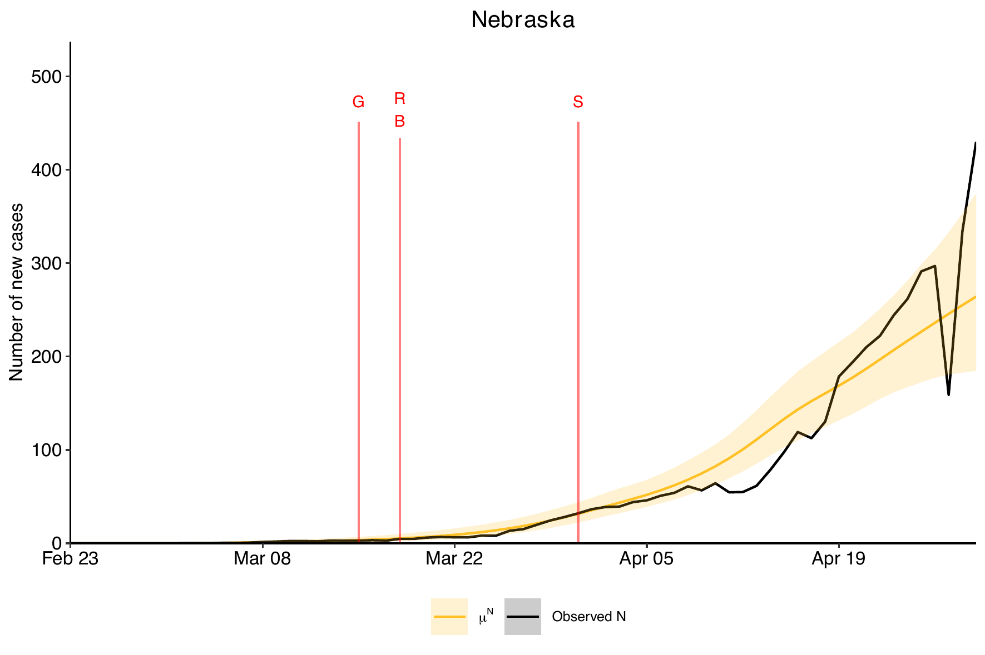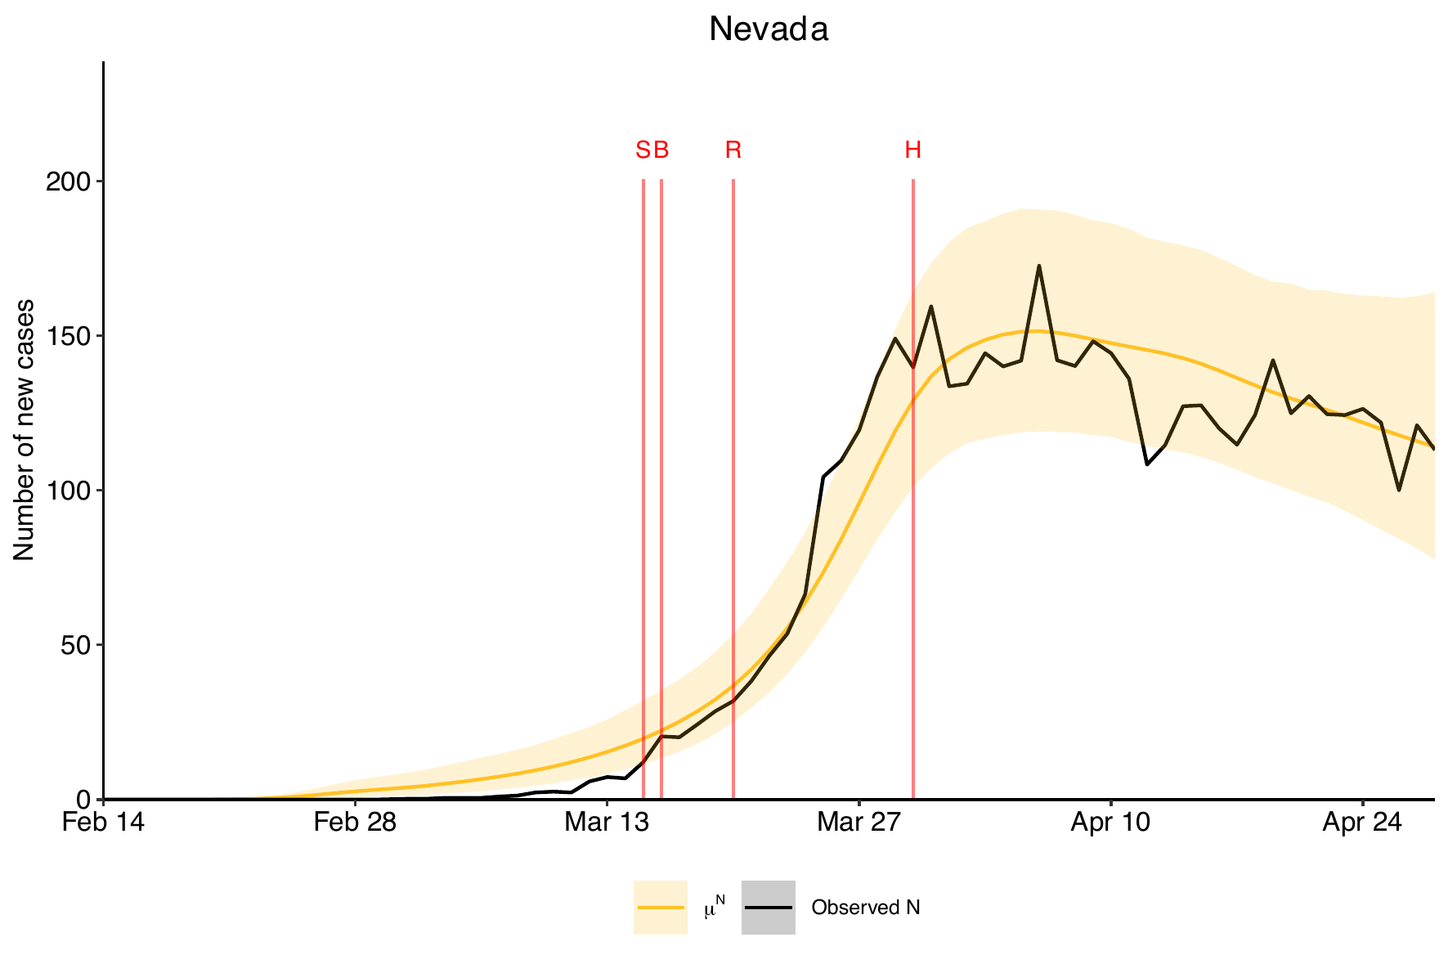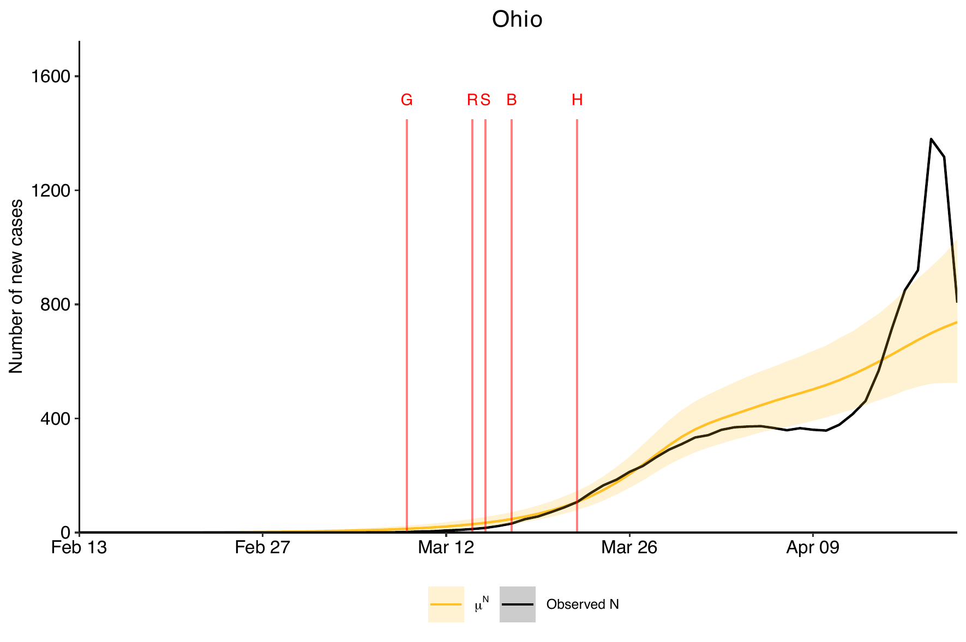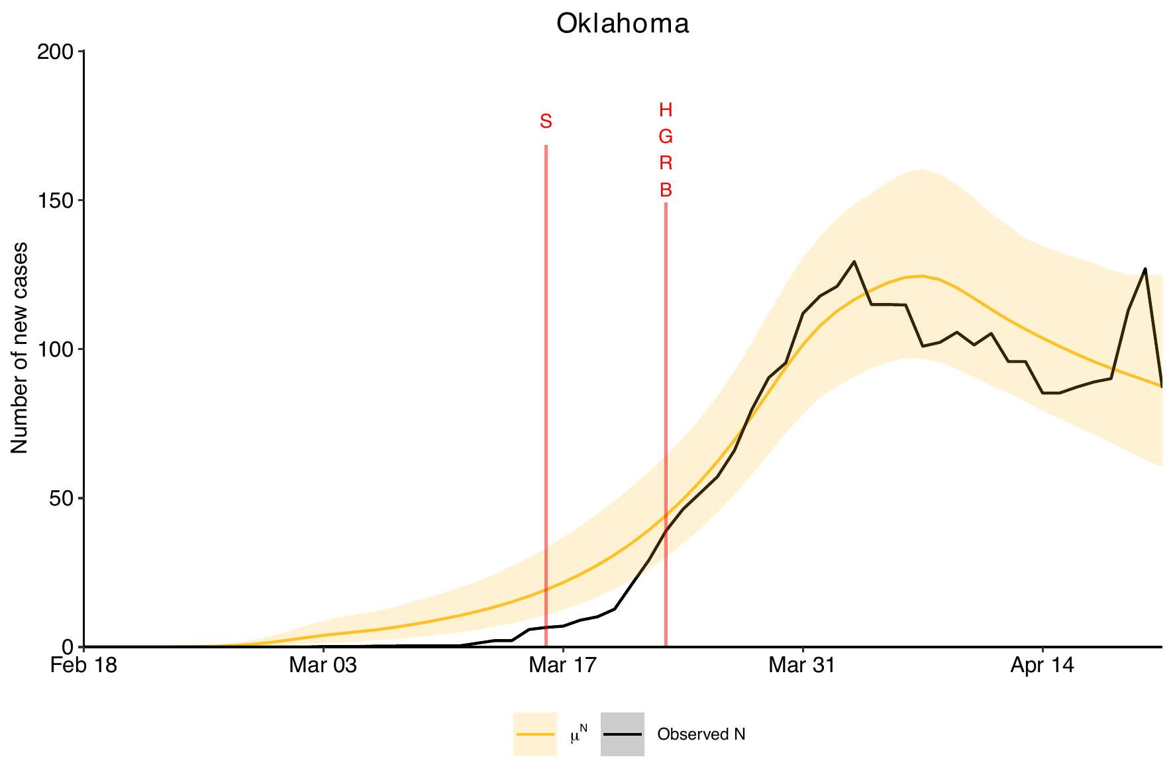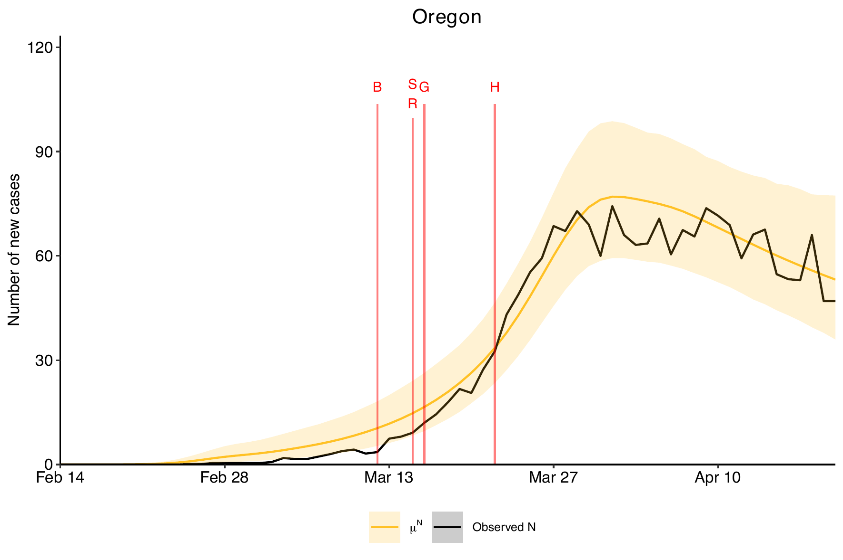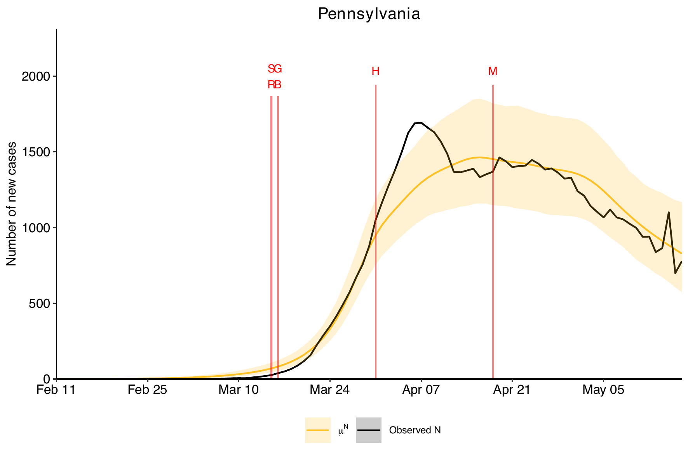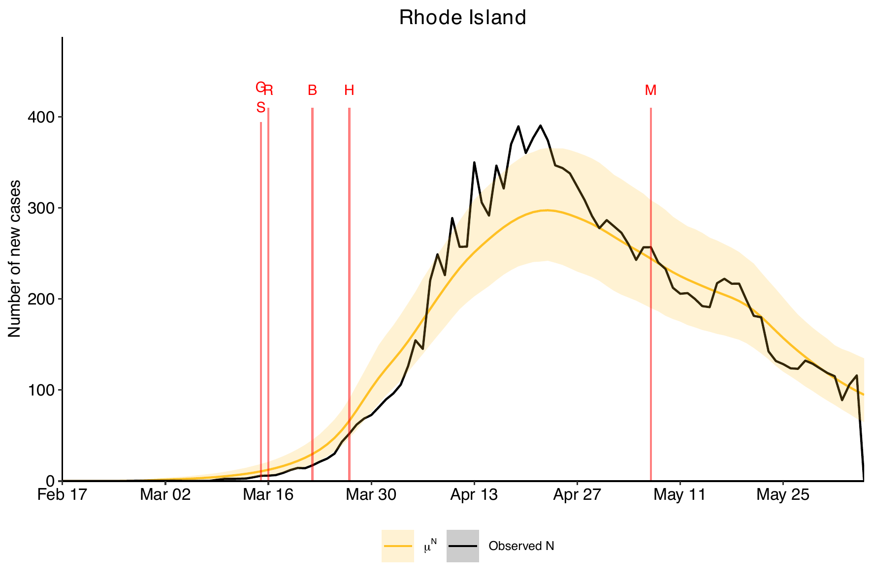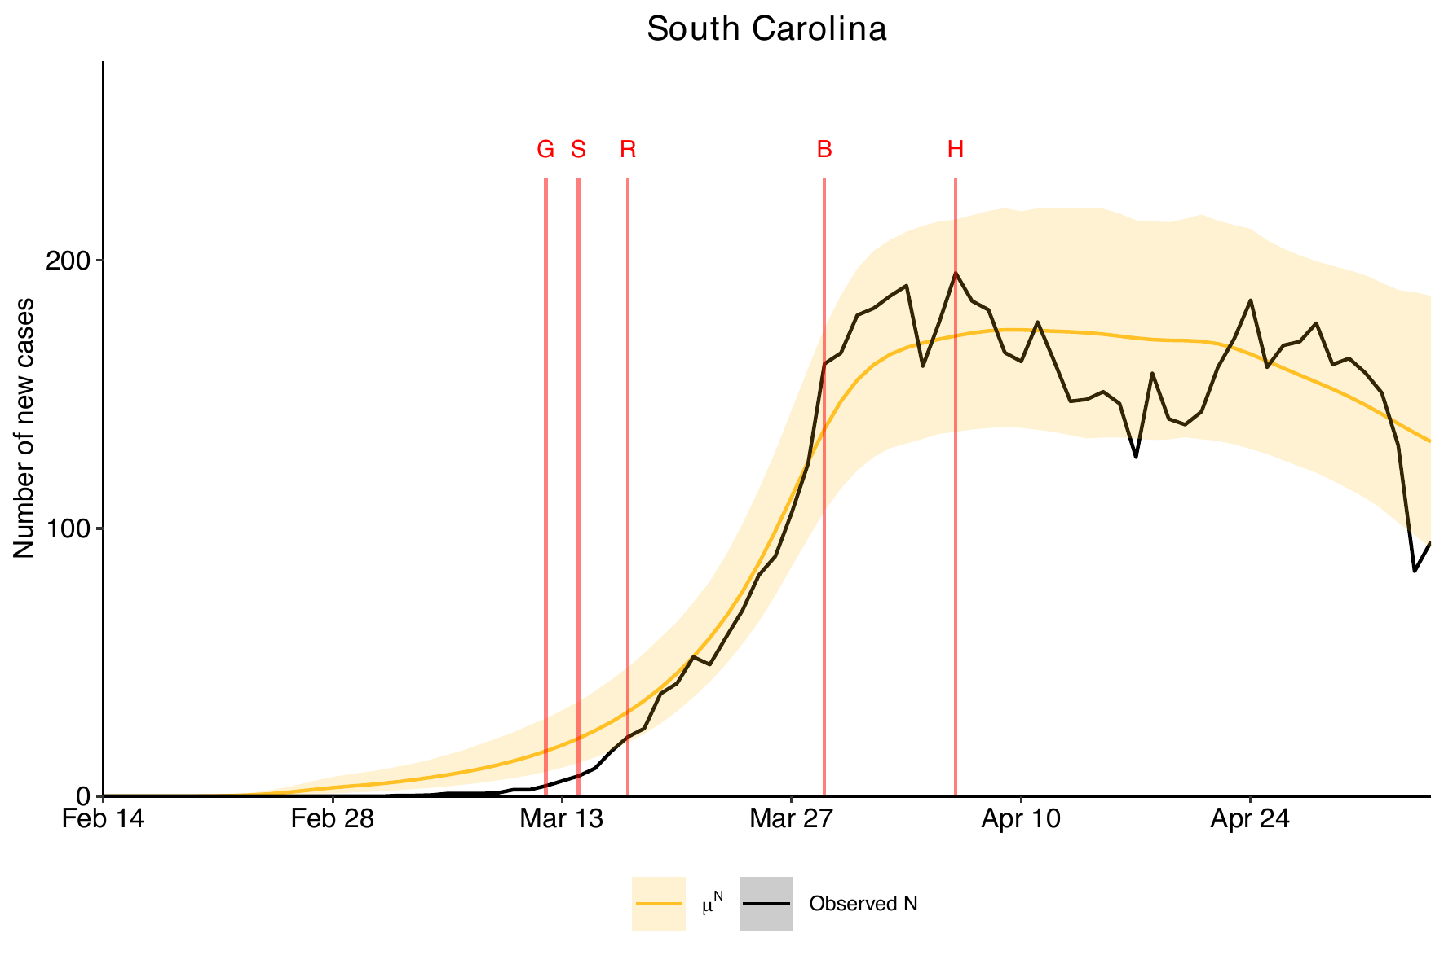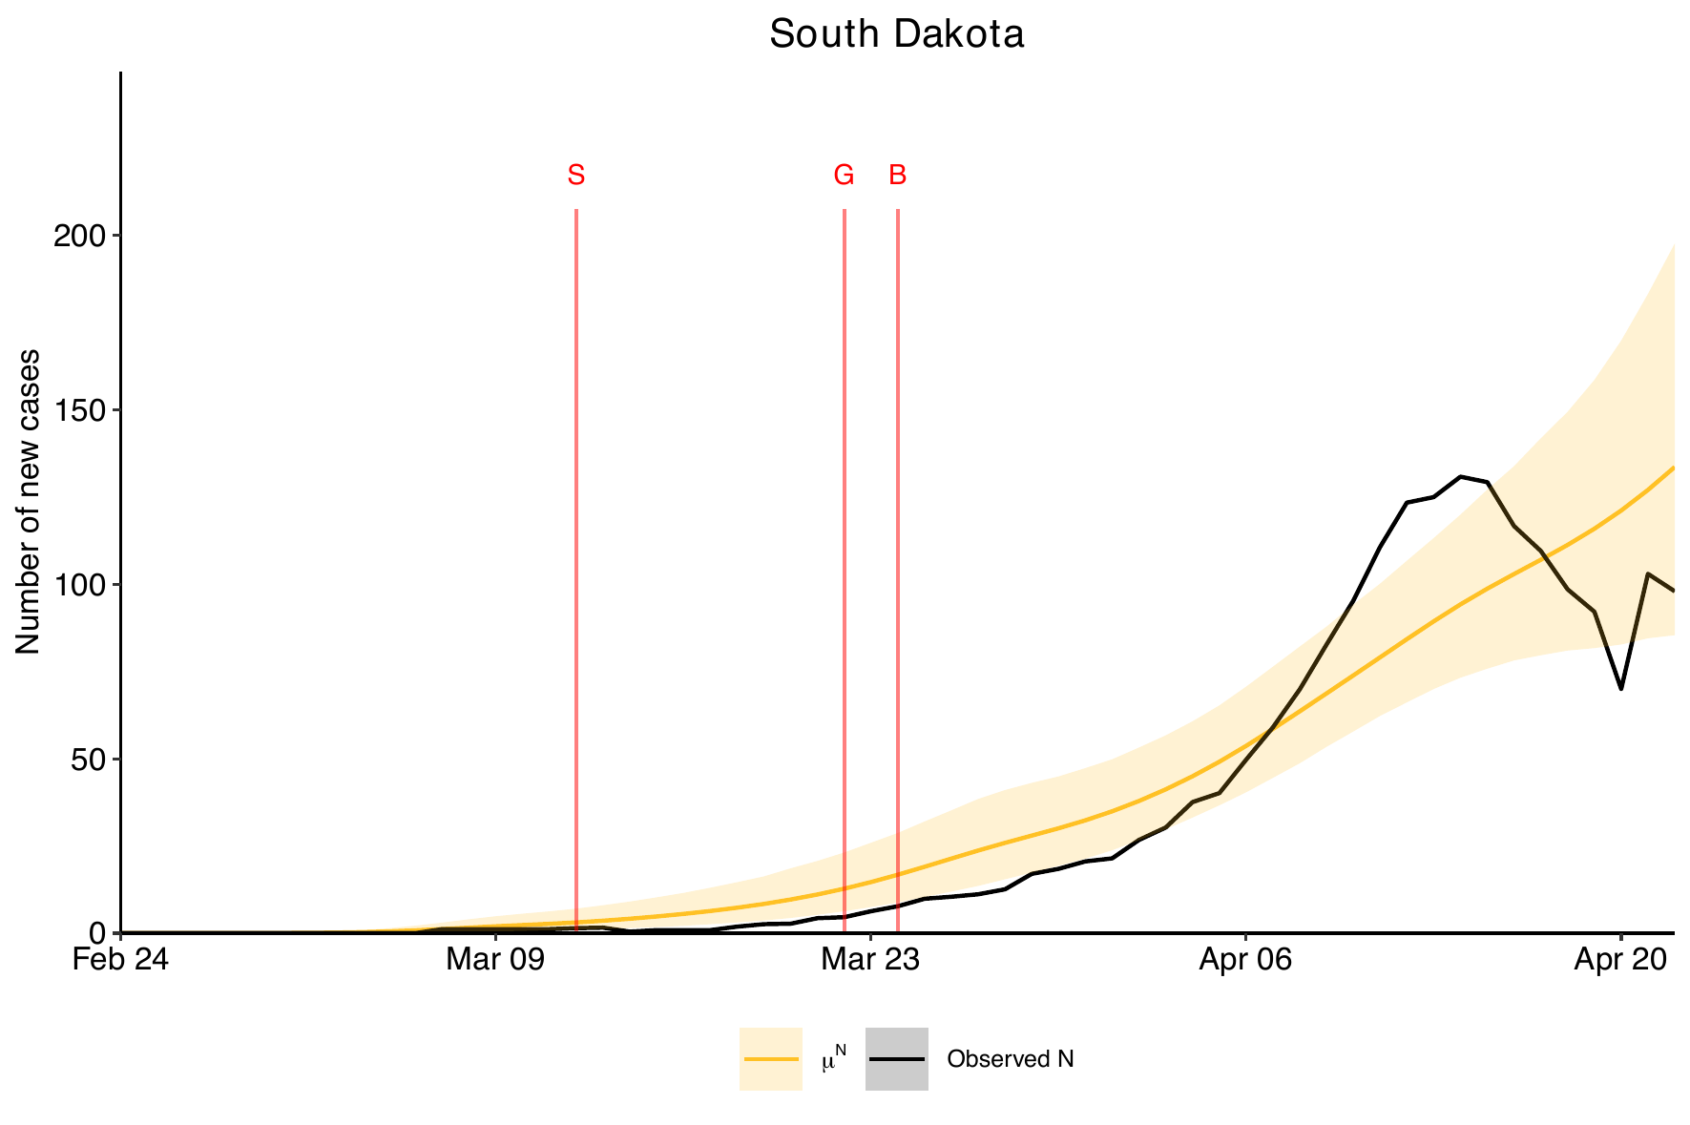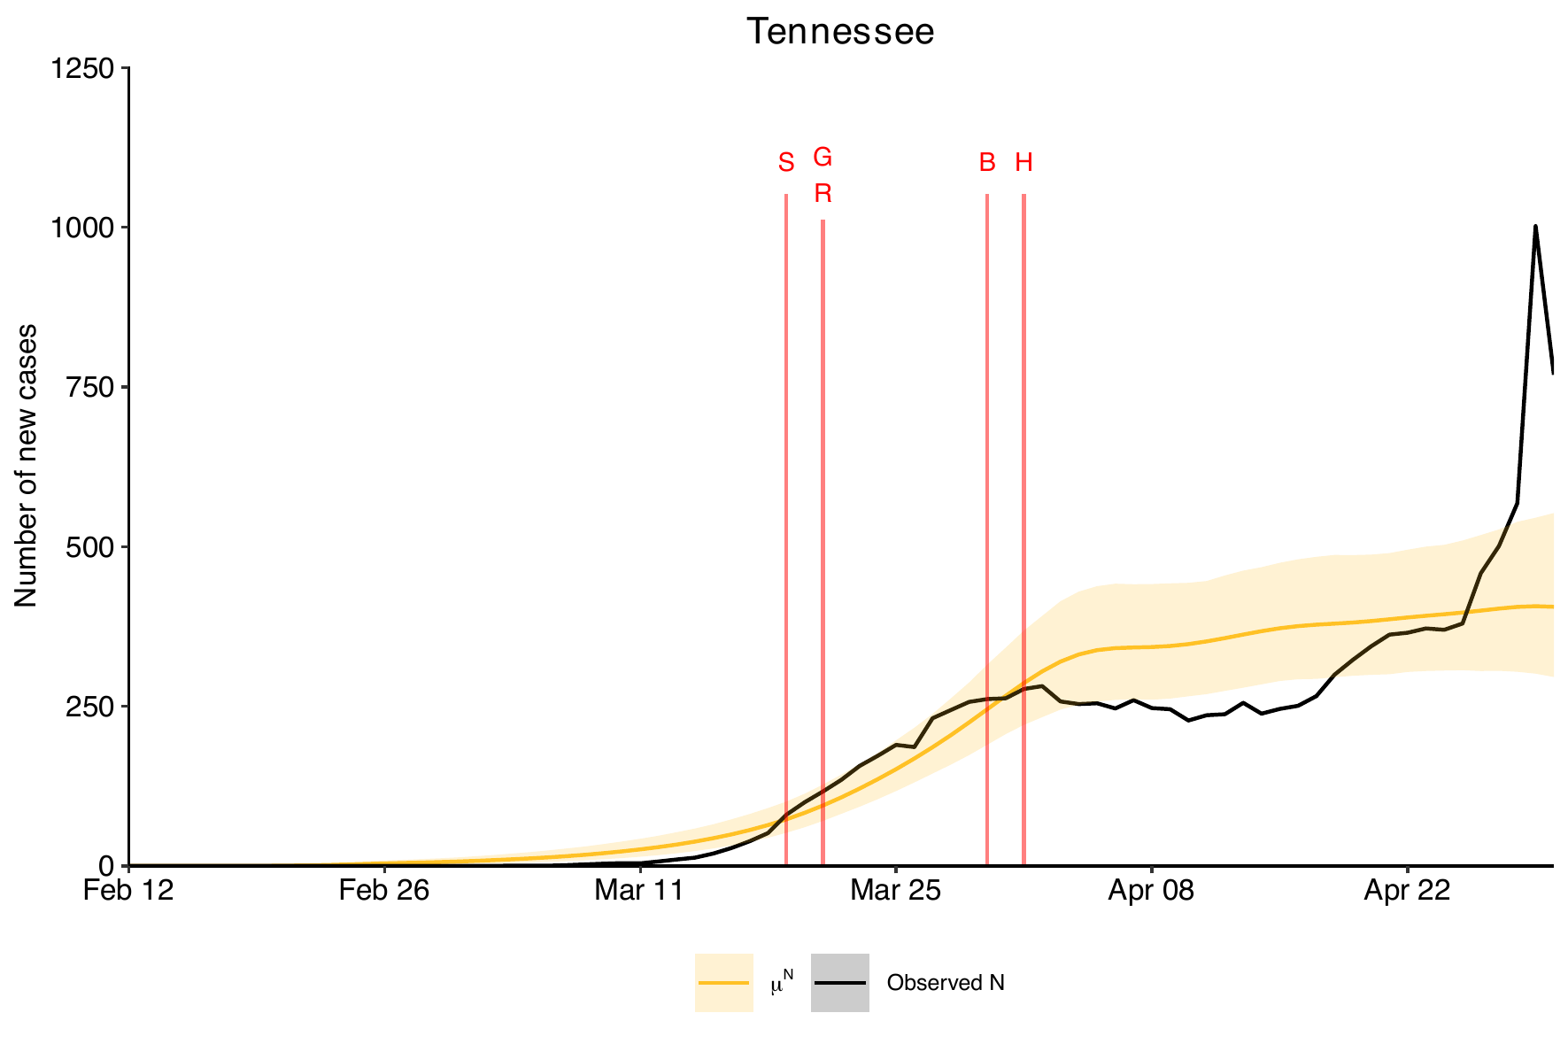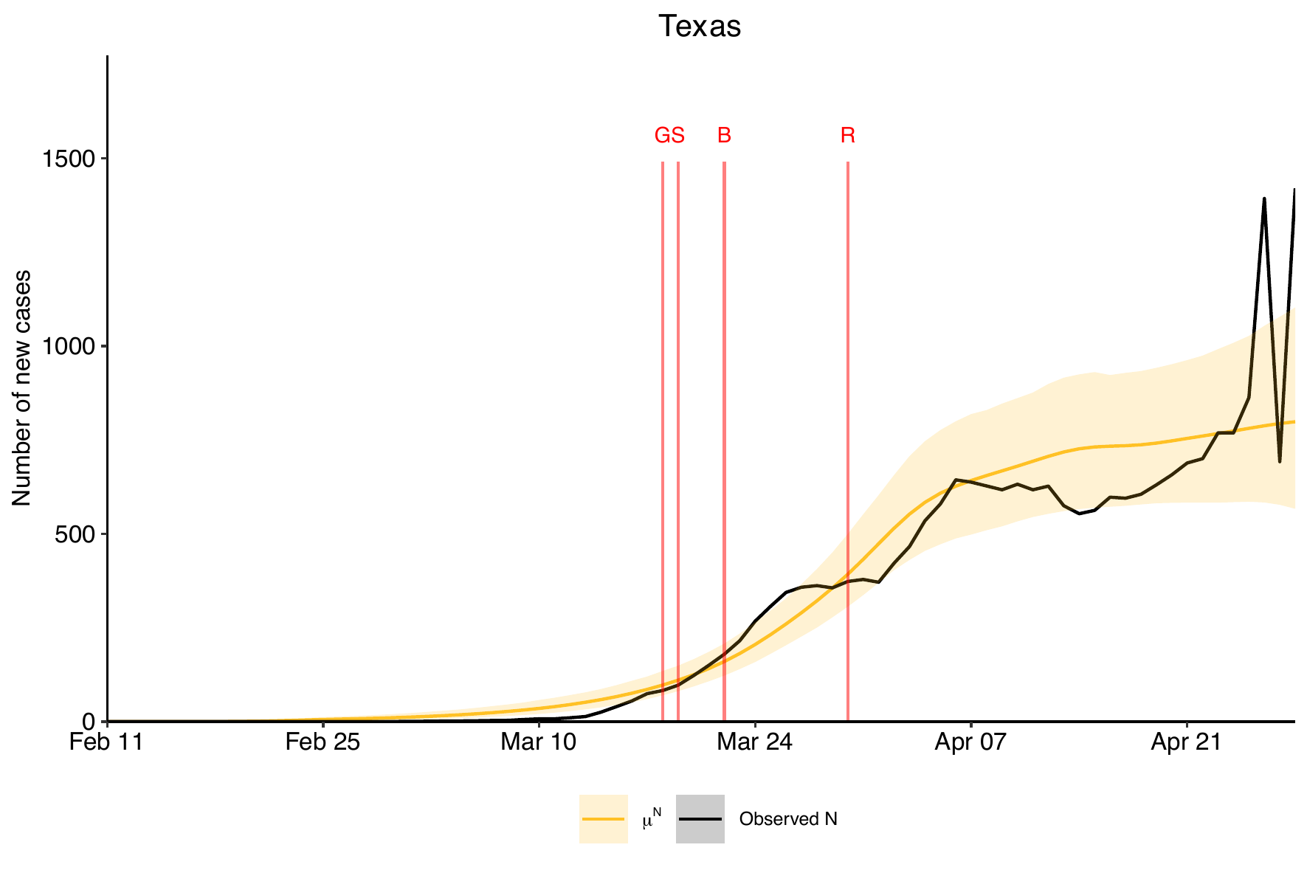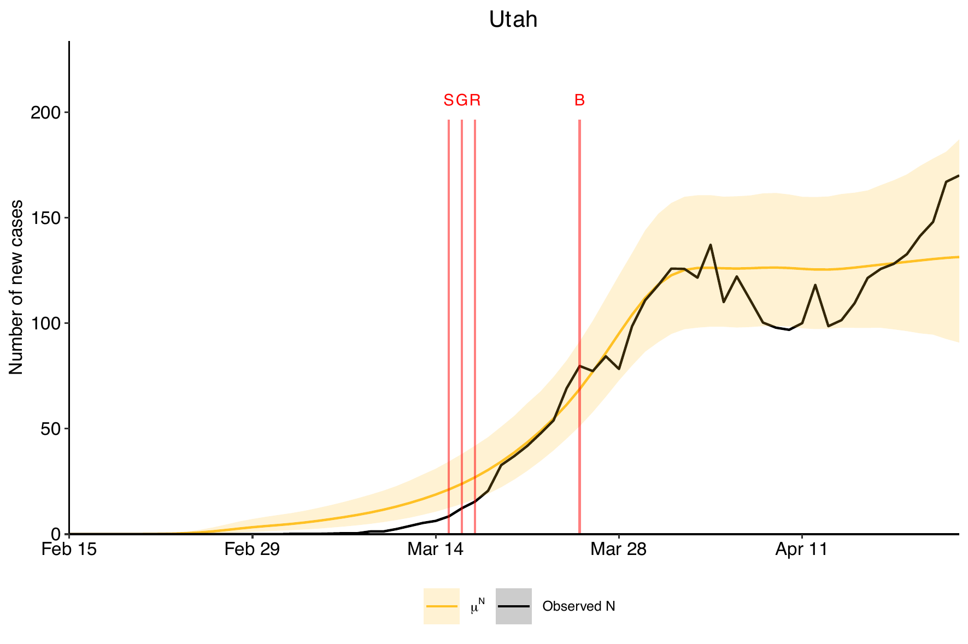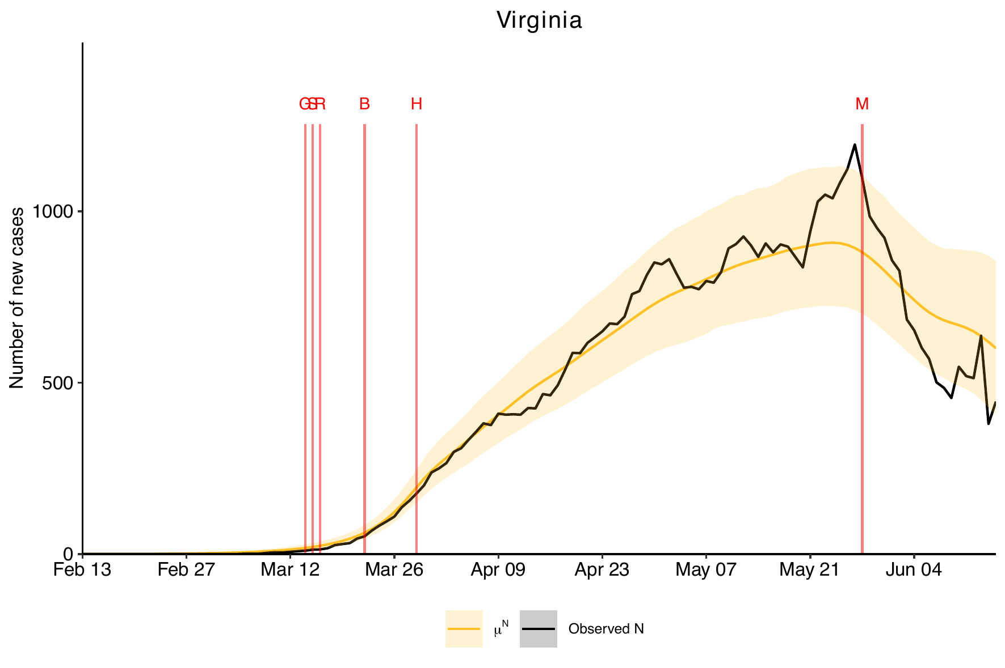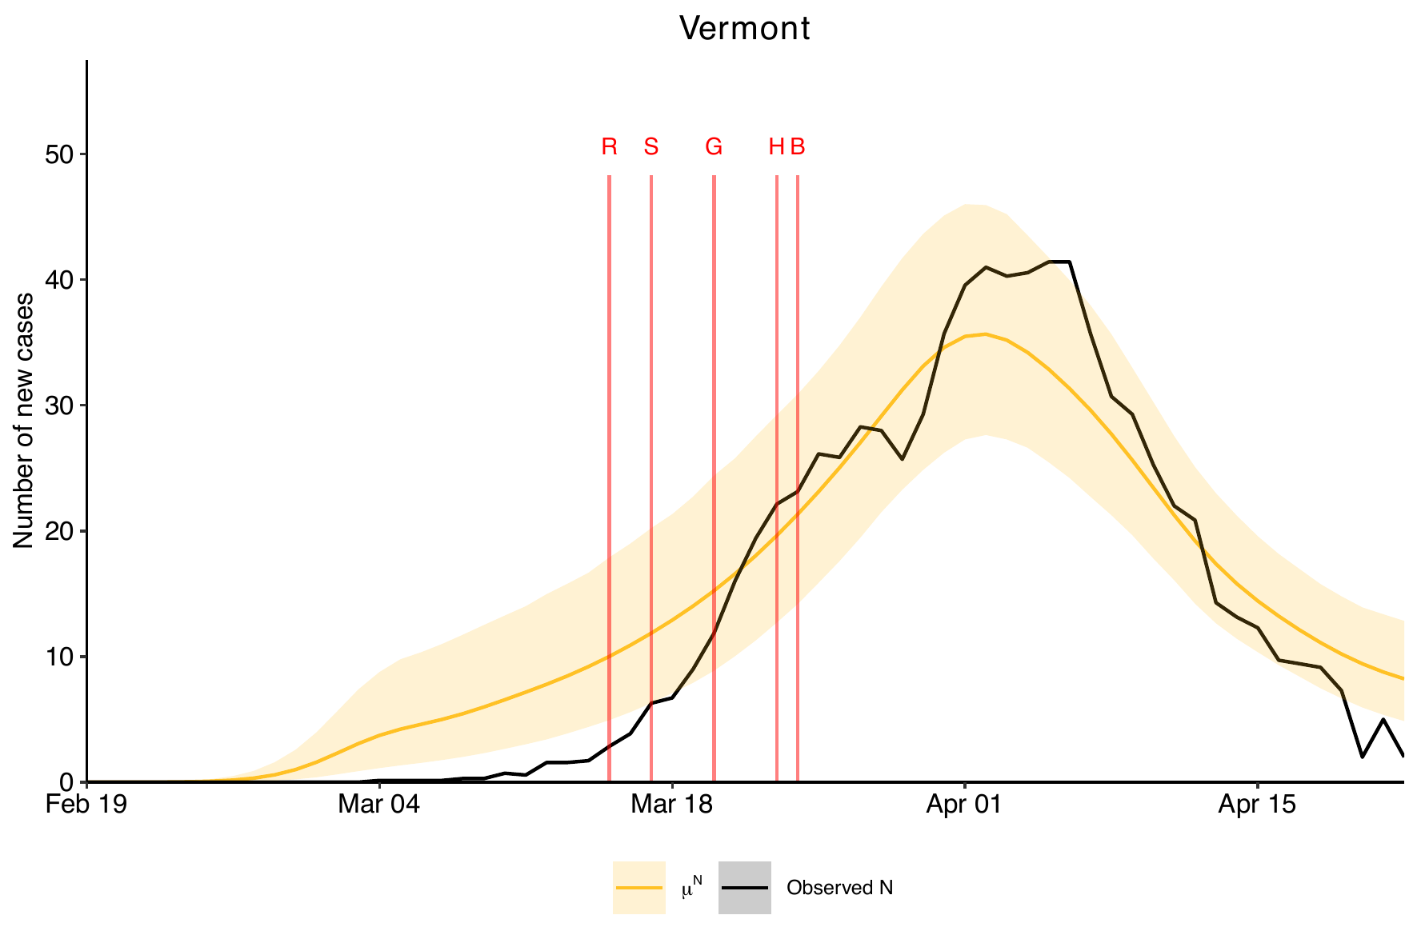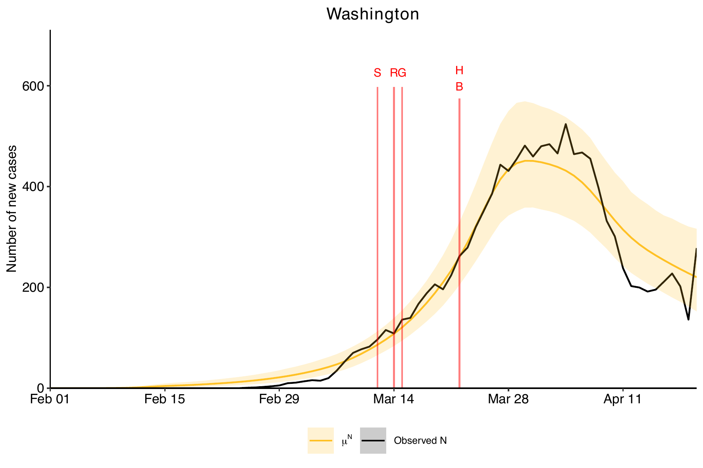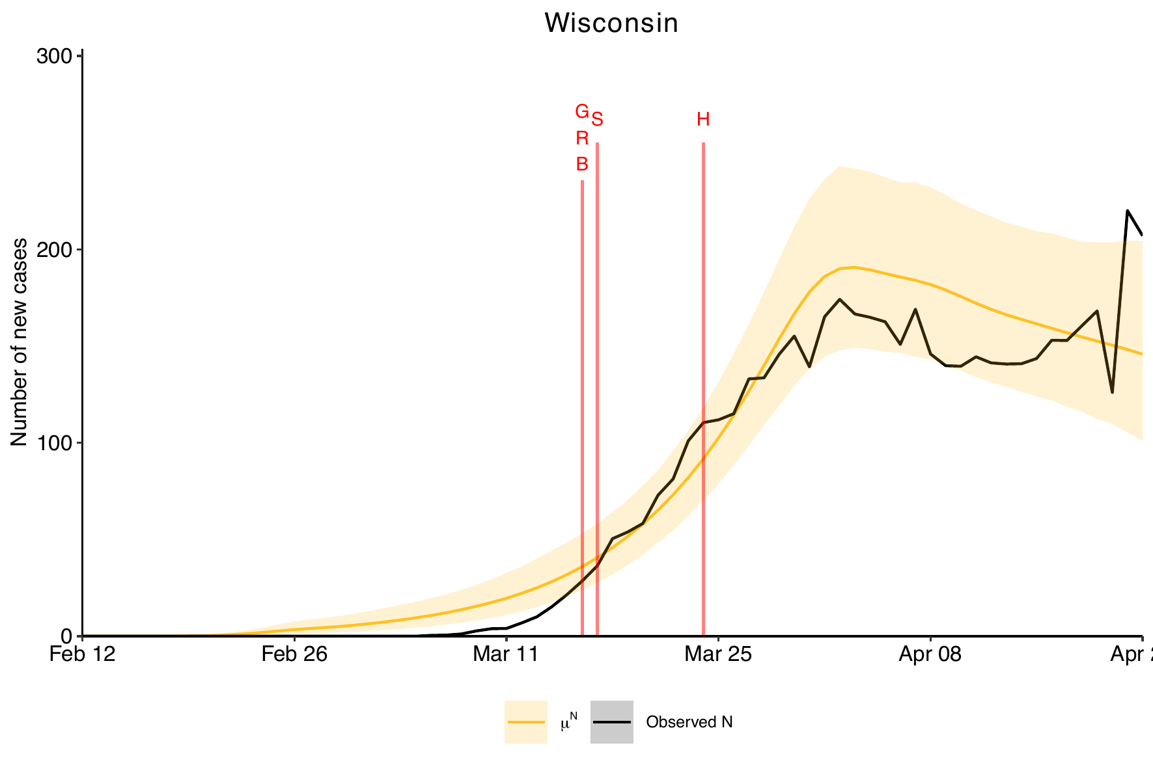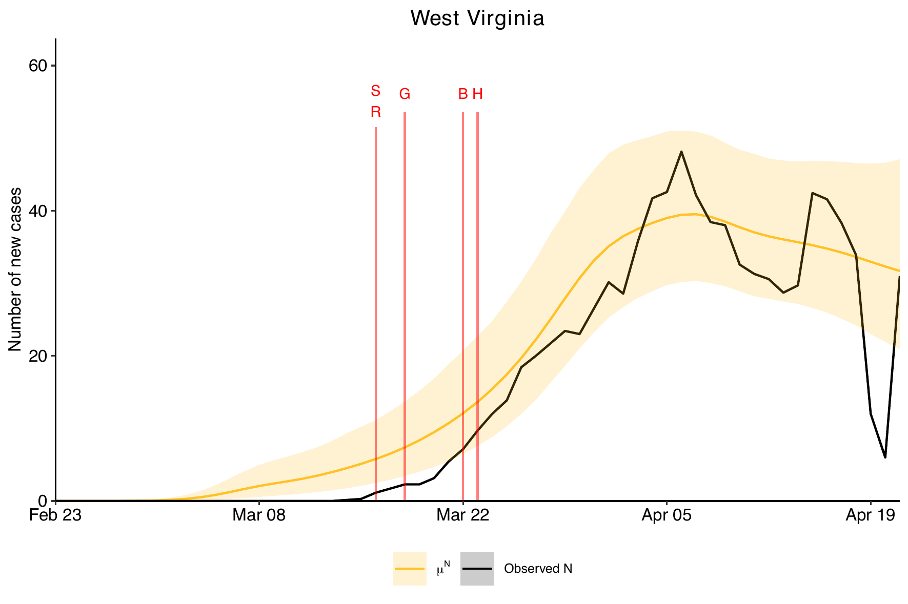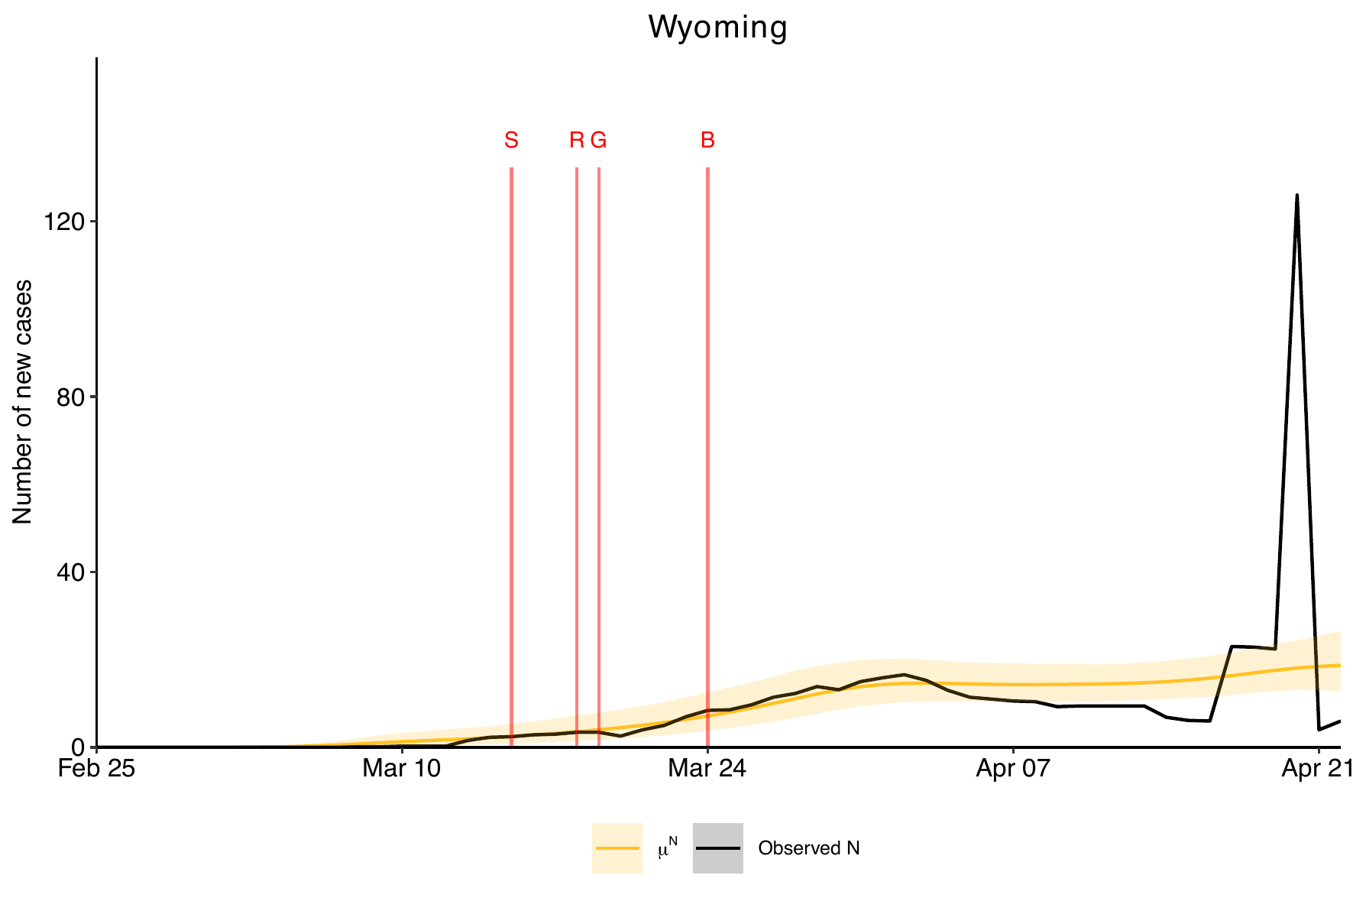

- Figure List 3: Advanced Prototypical Bayesian Hierarchical Model Expected Daily Number of True Infection Estimation Over the Study Period.

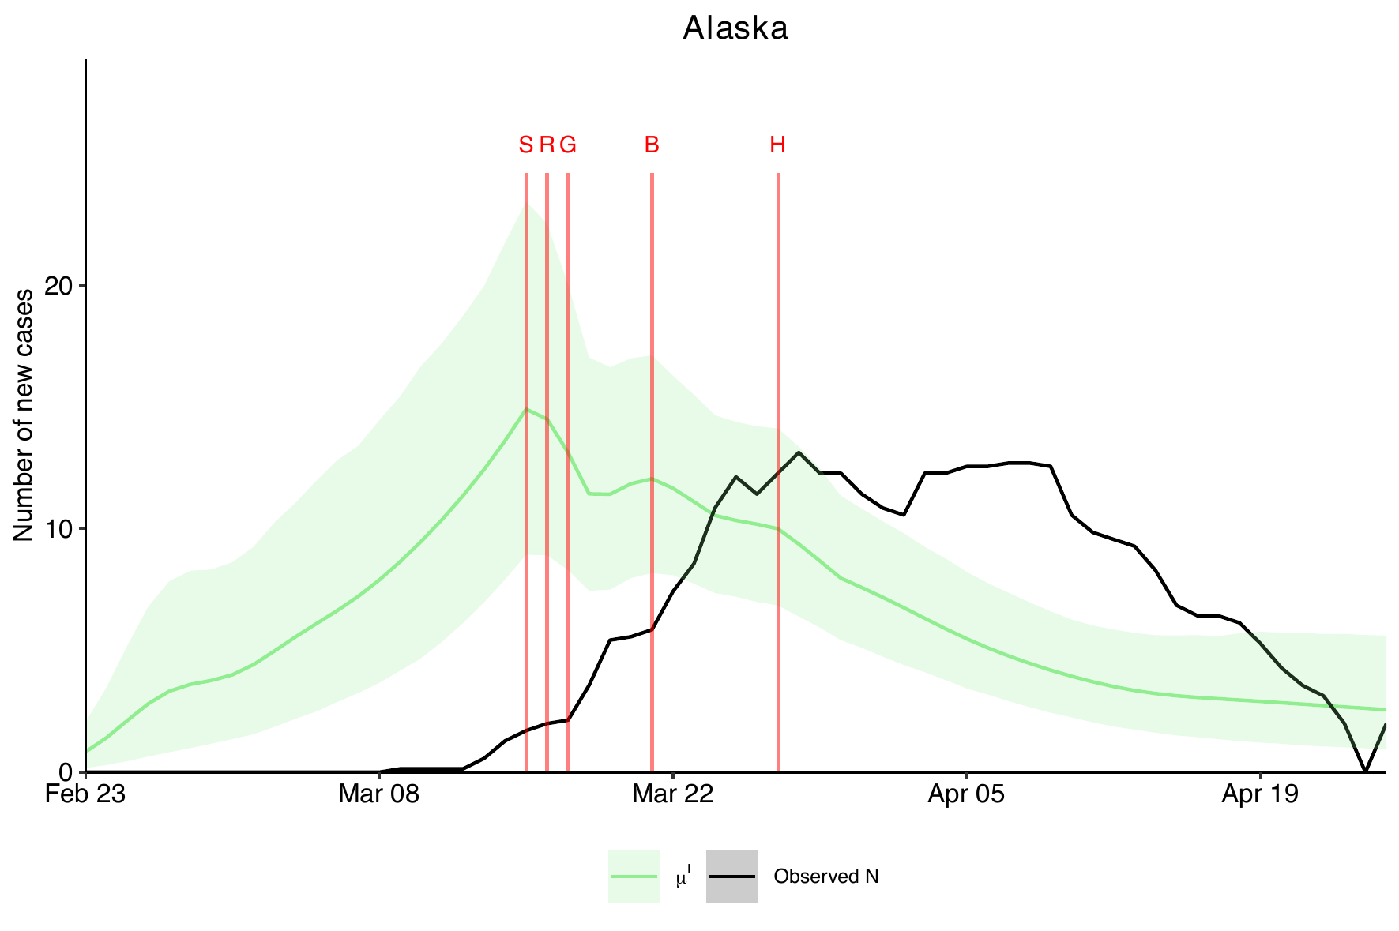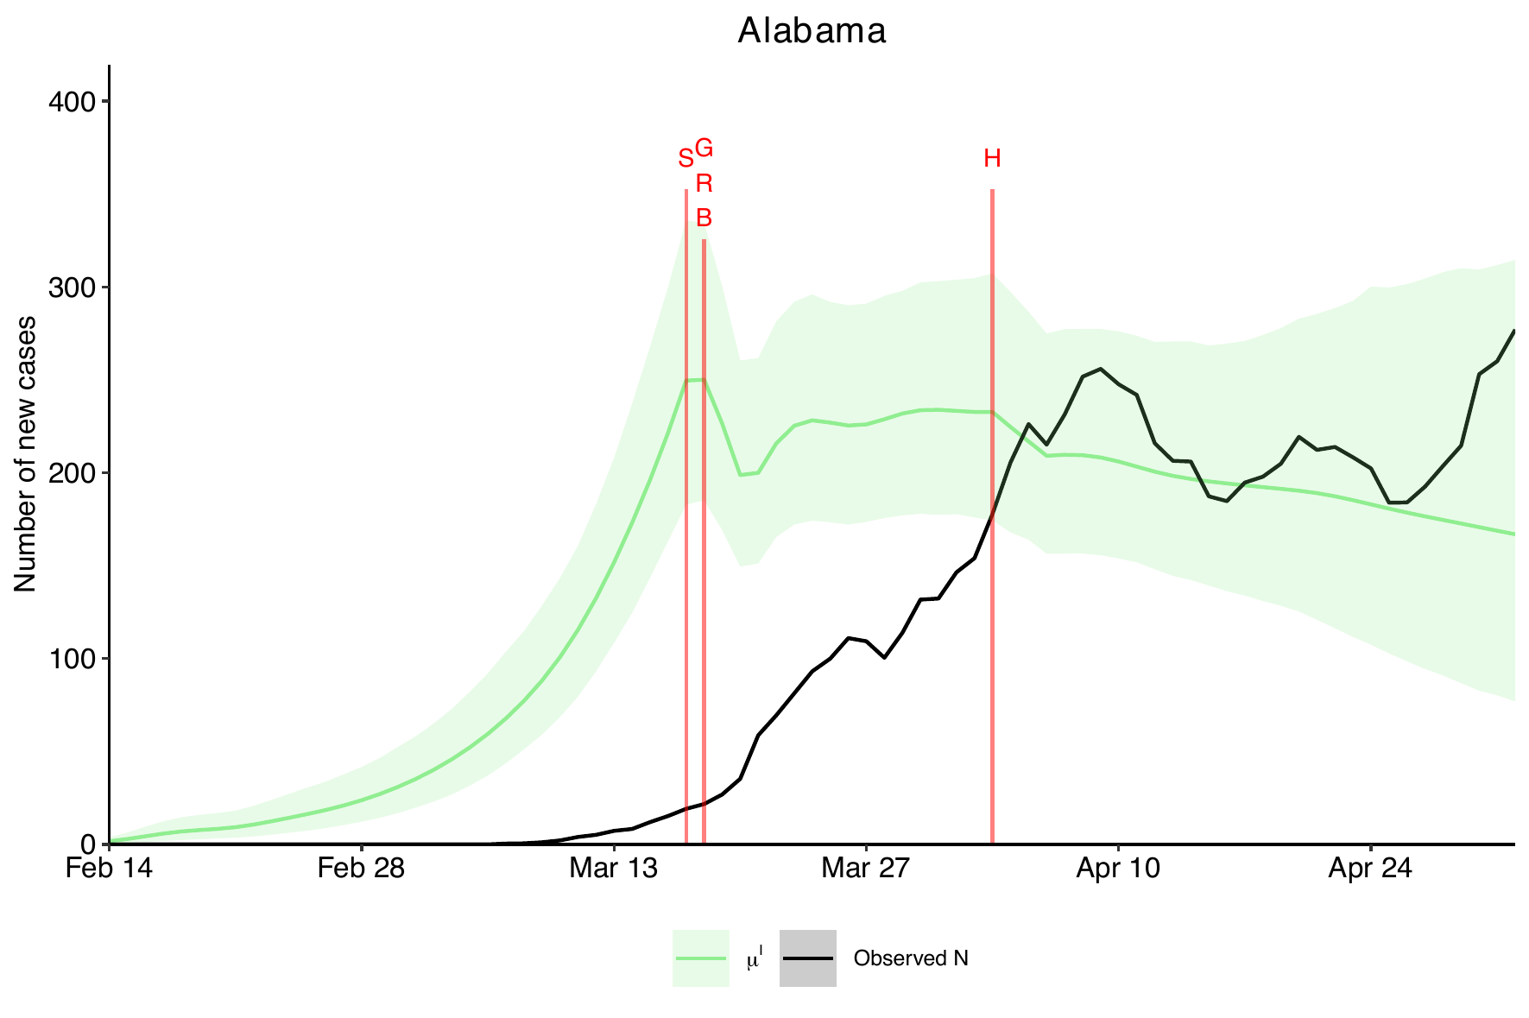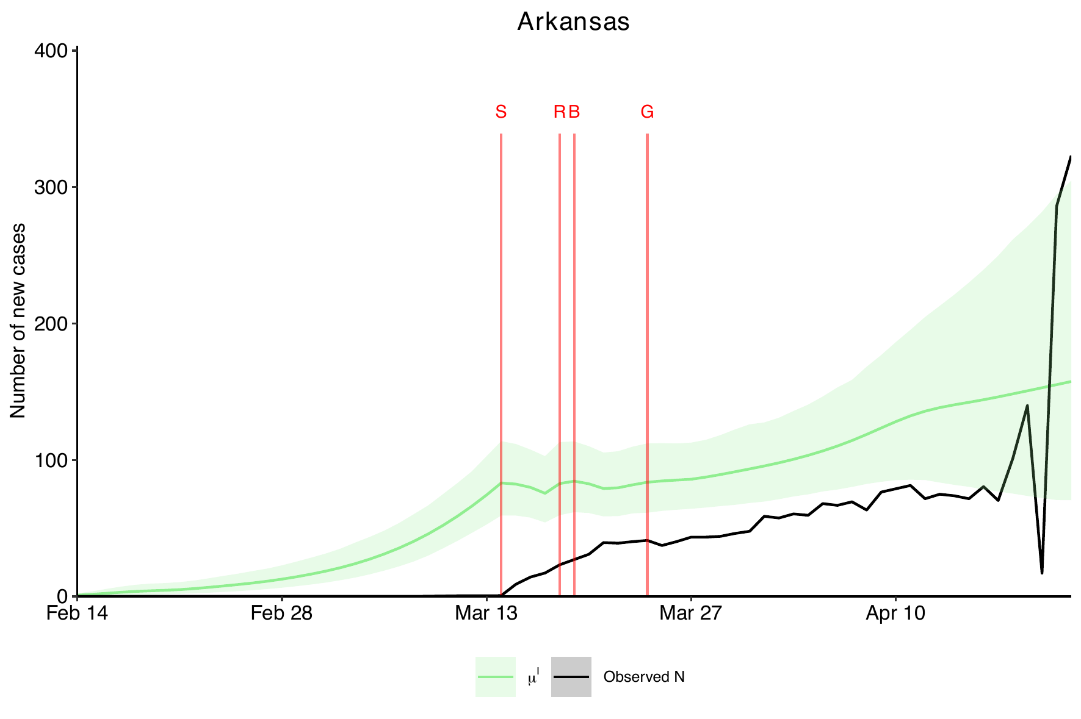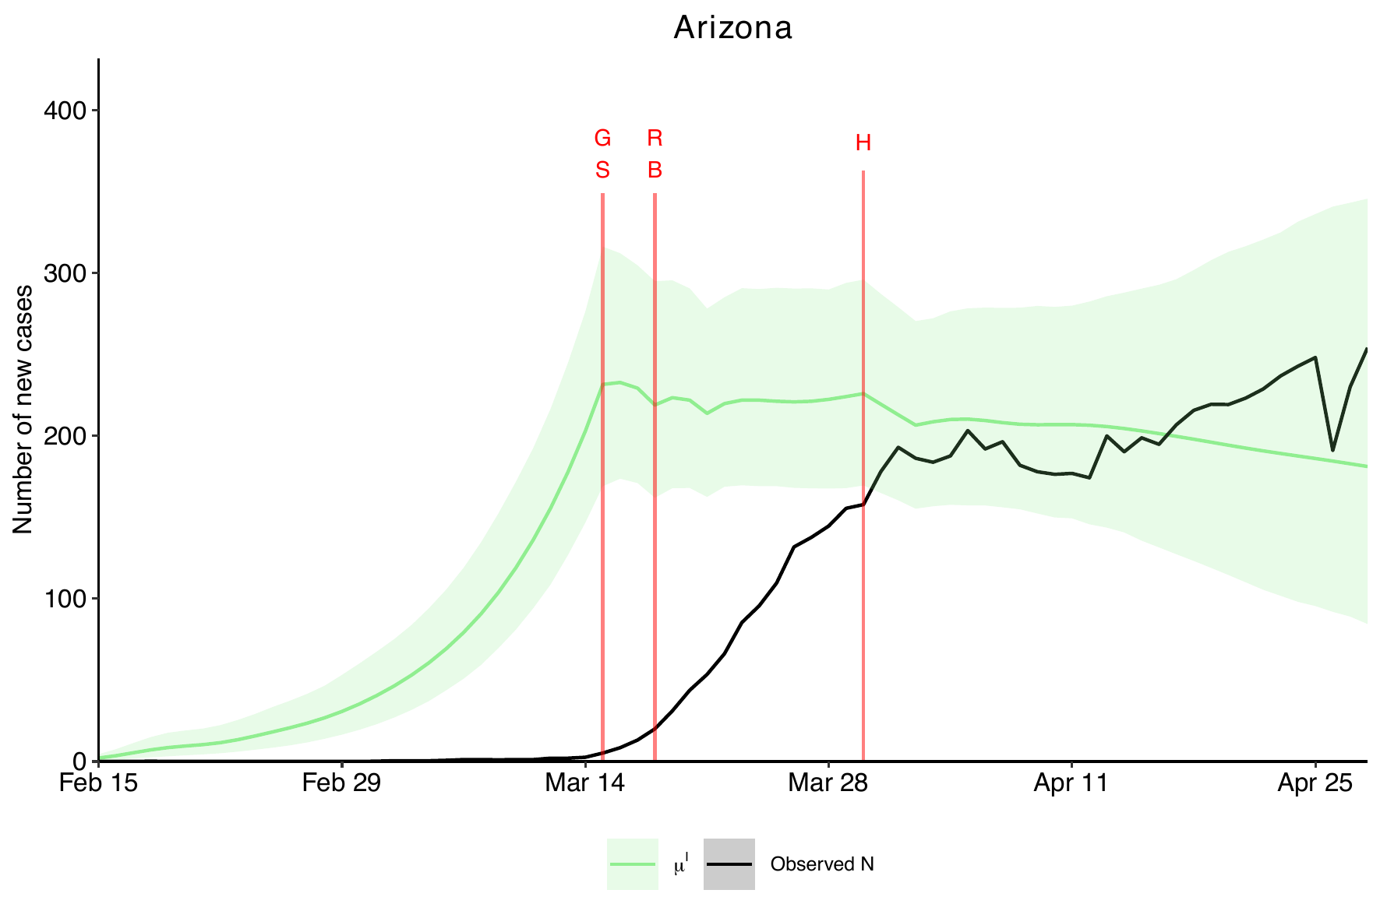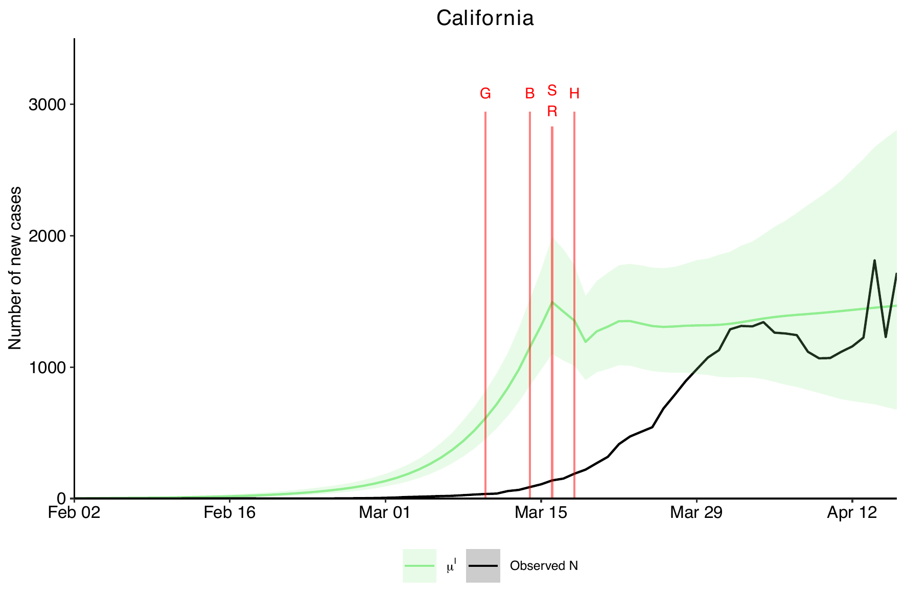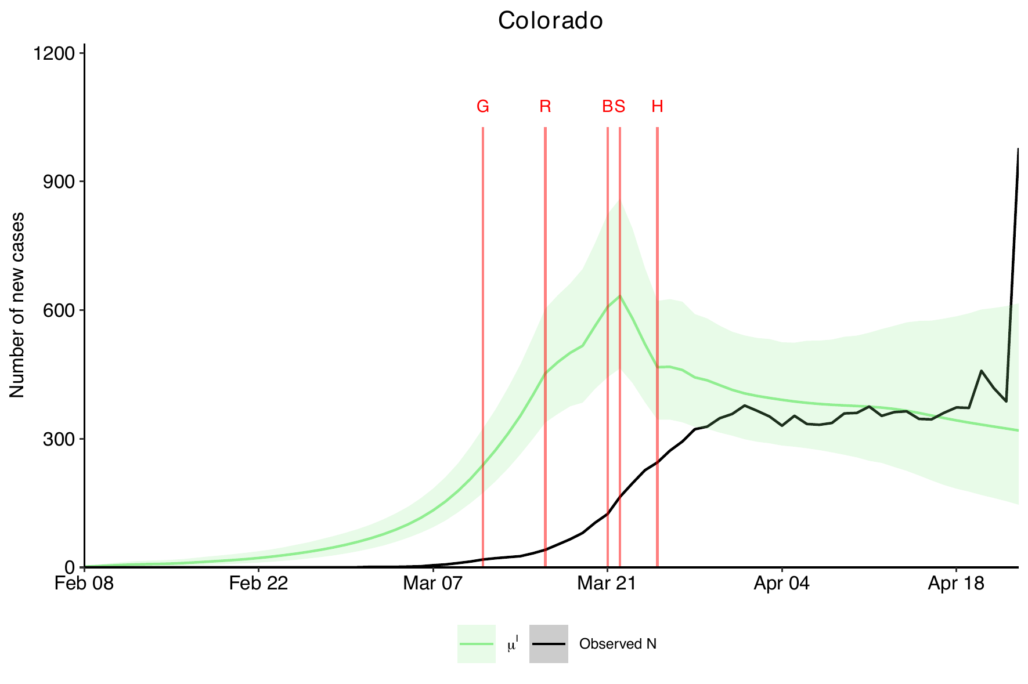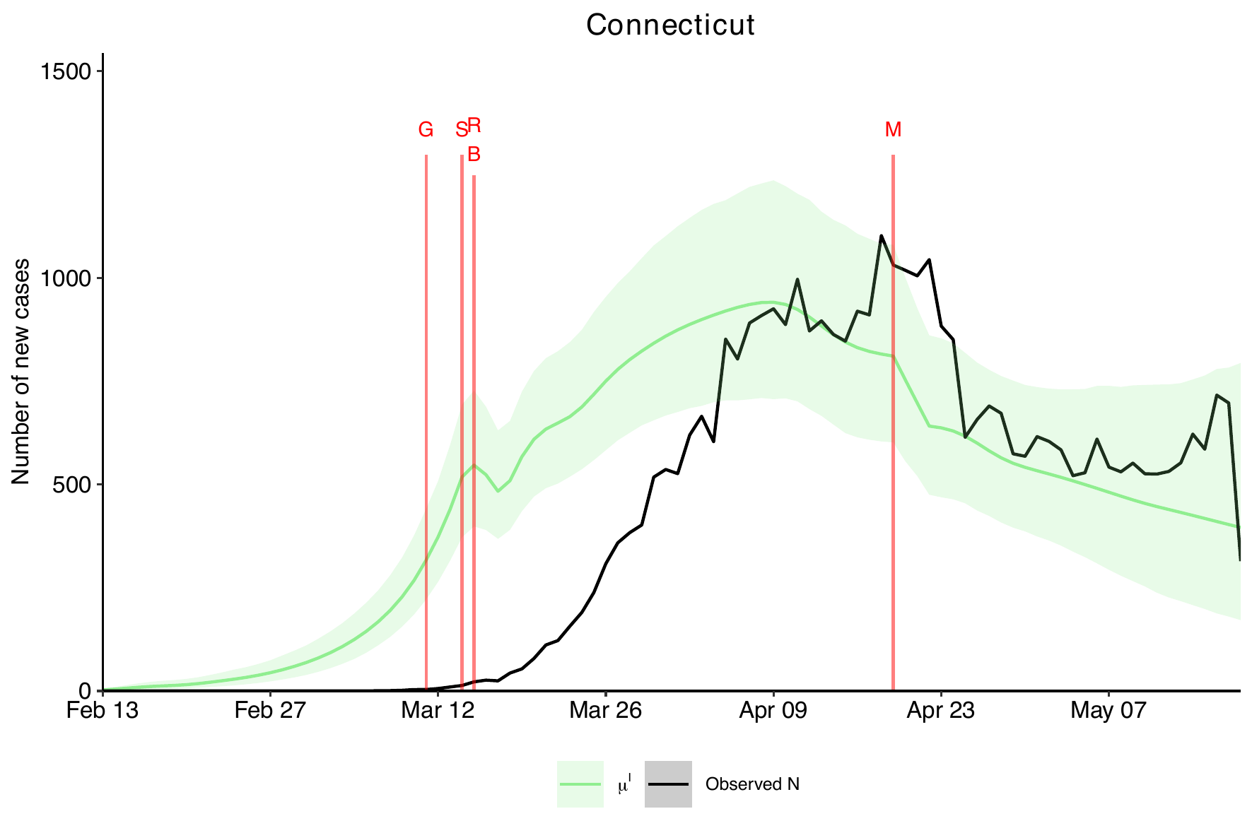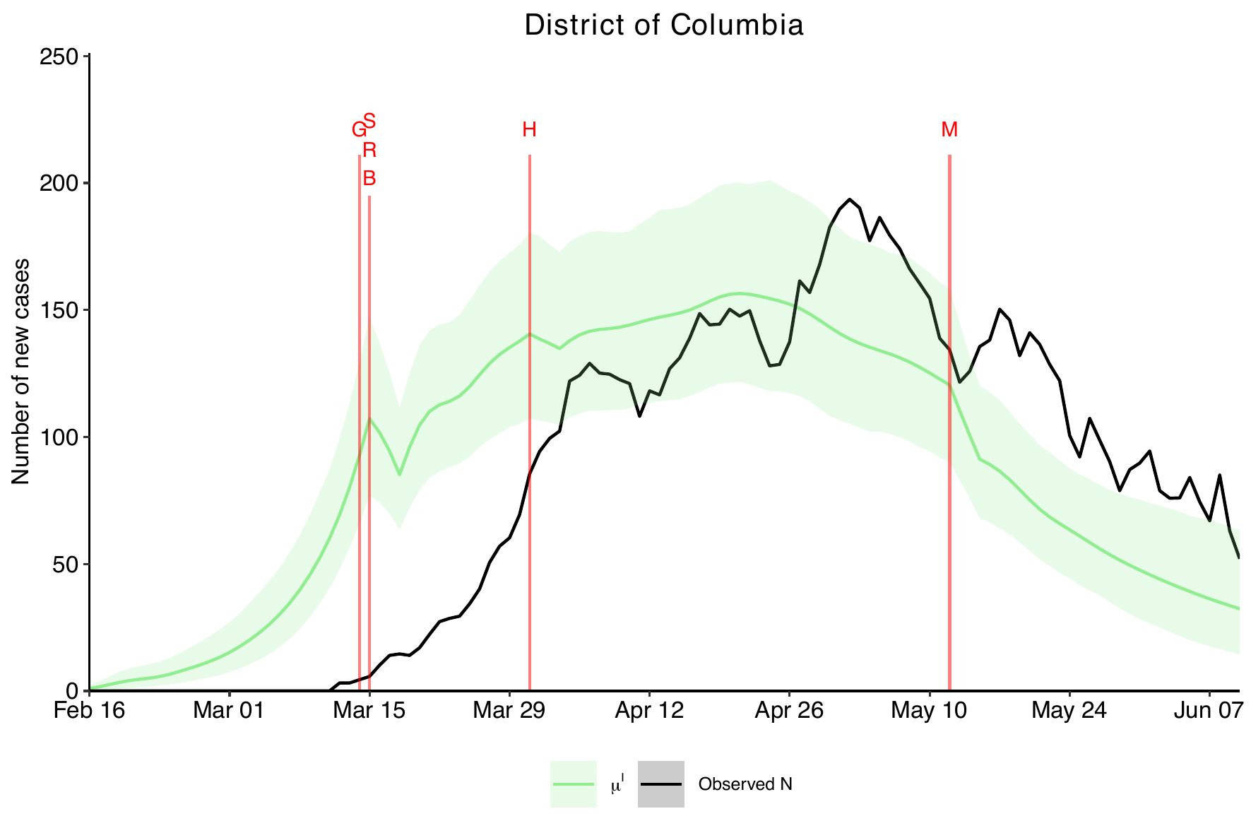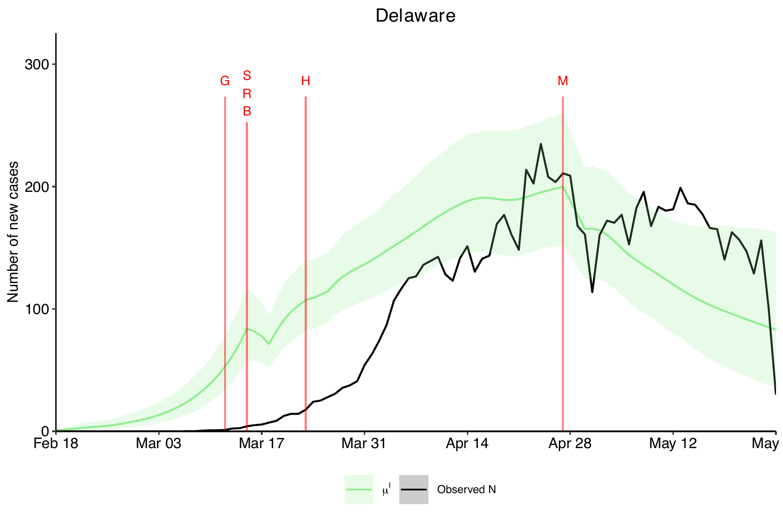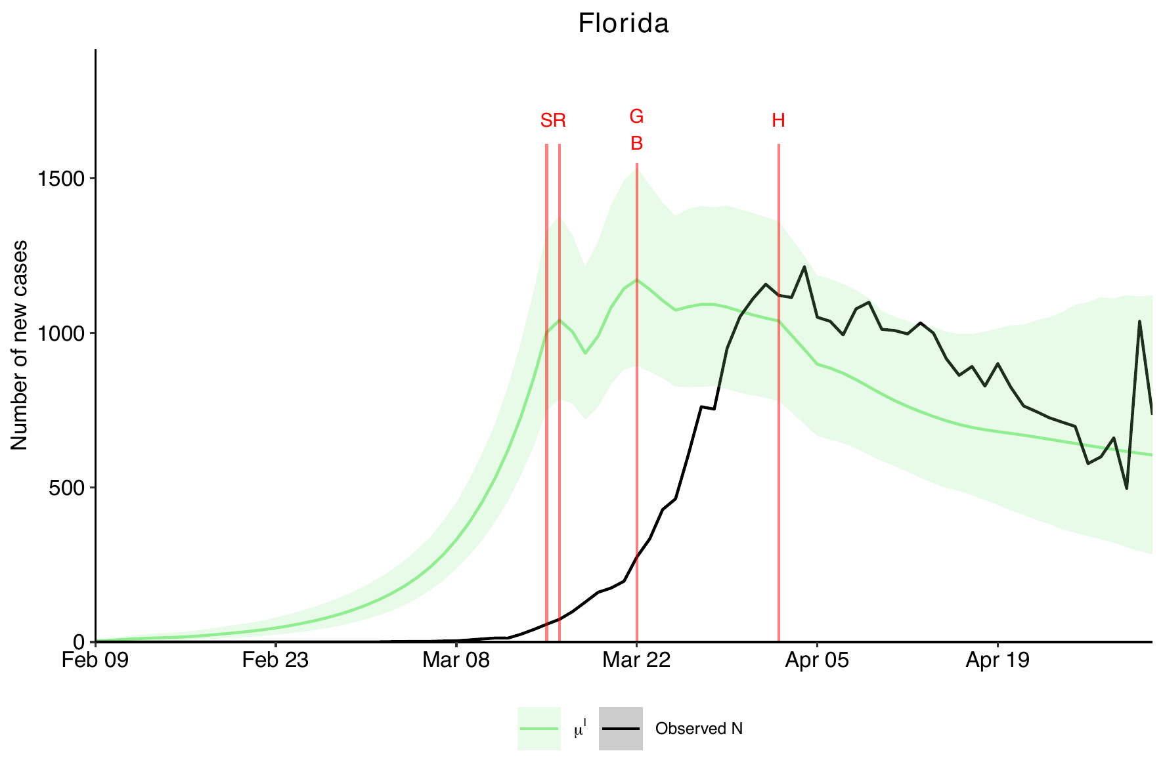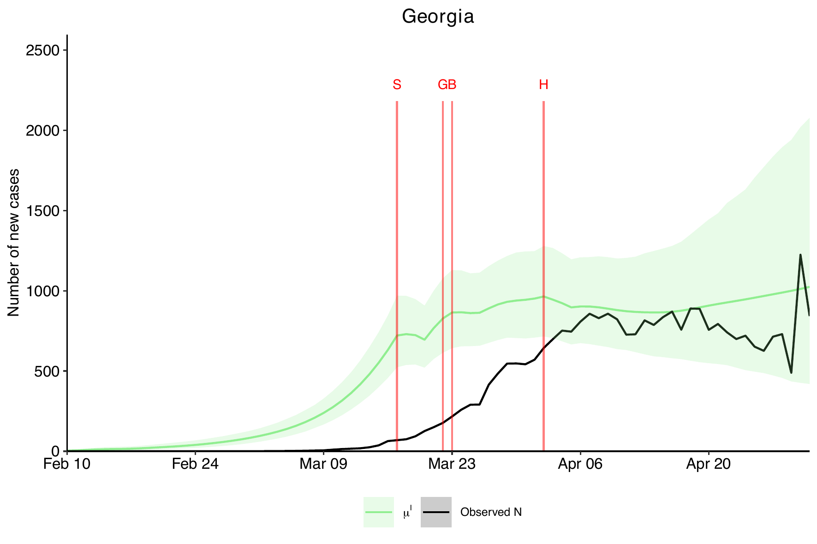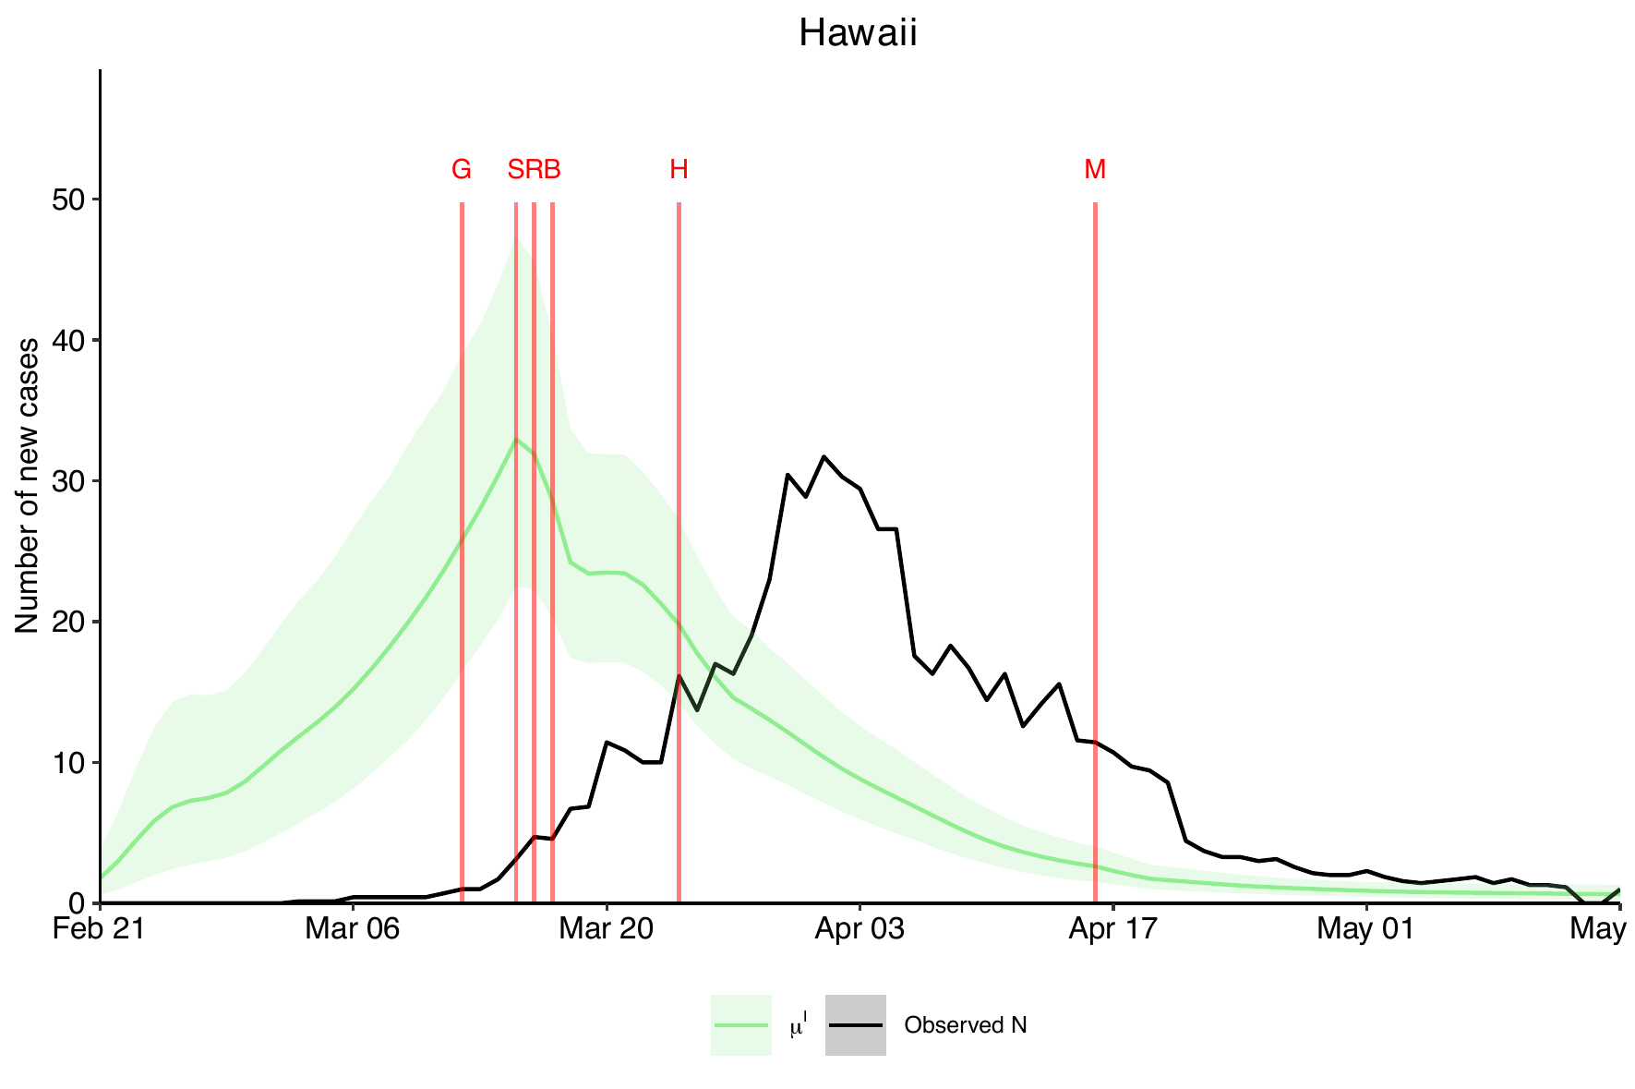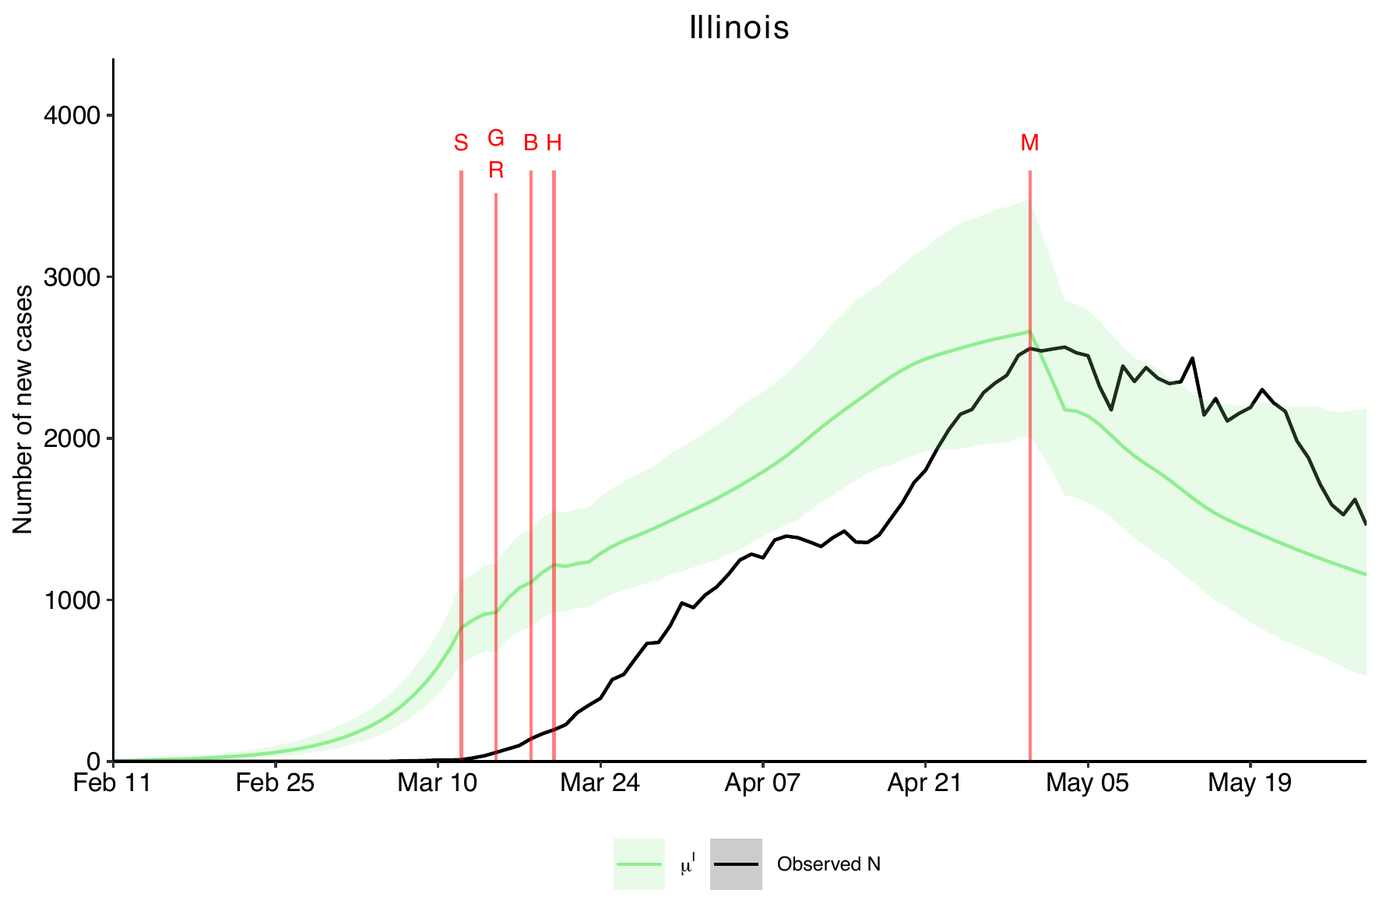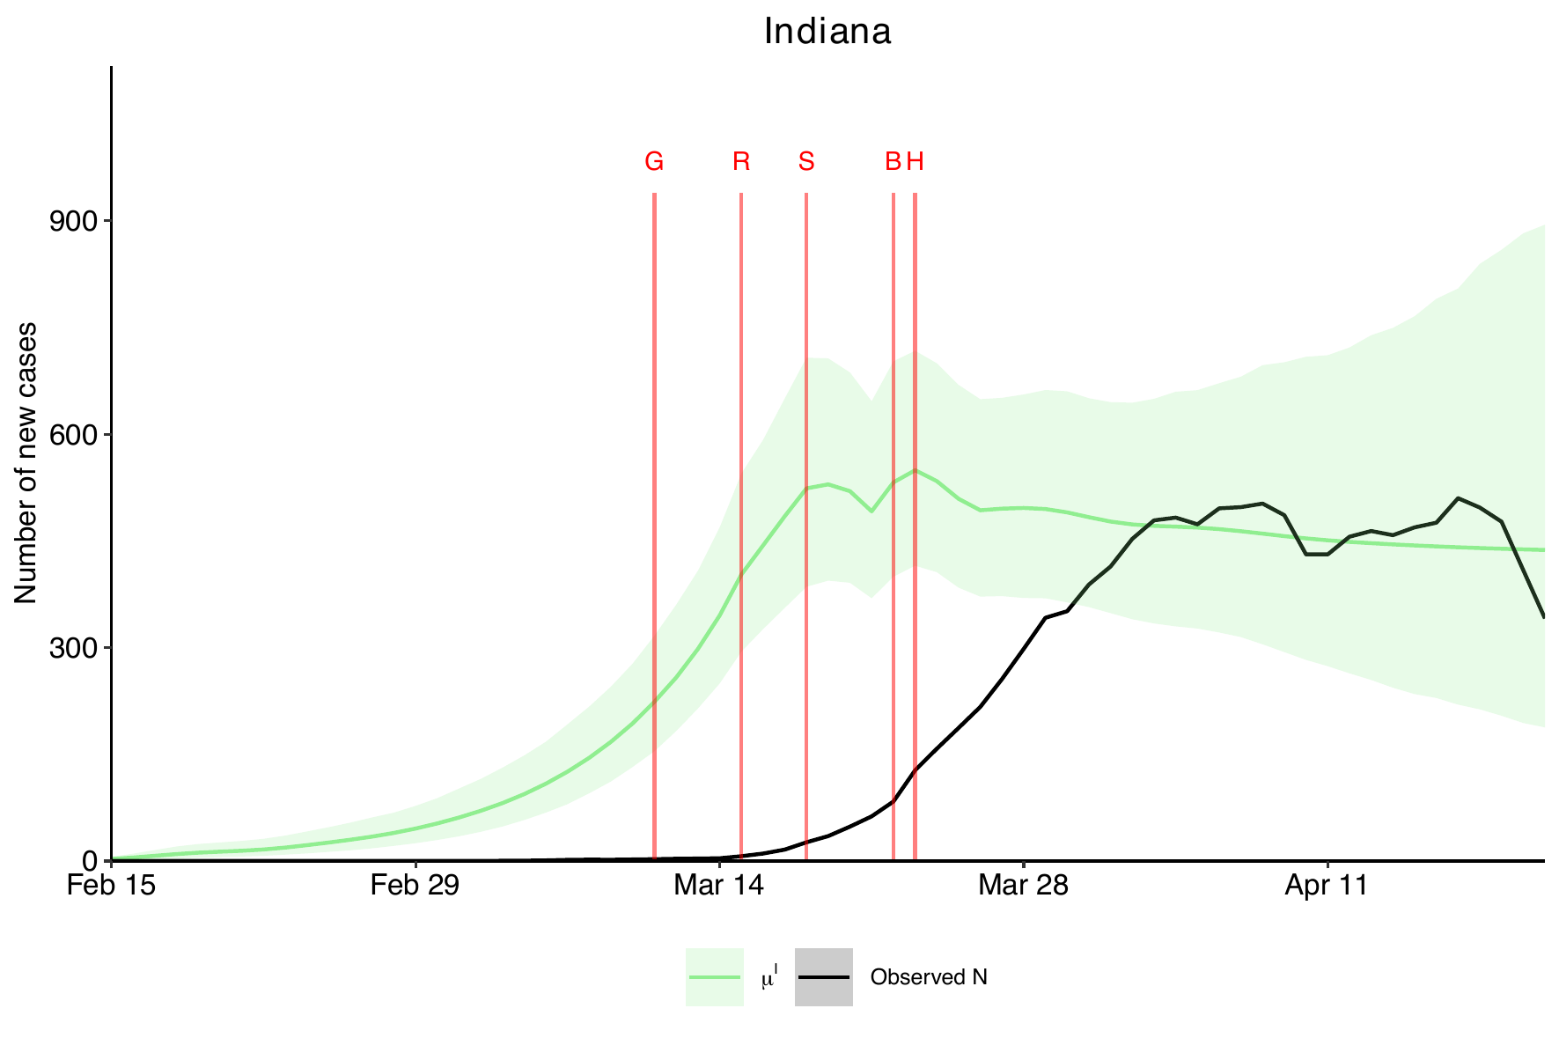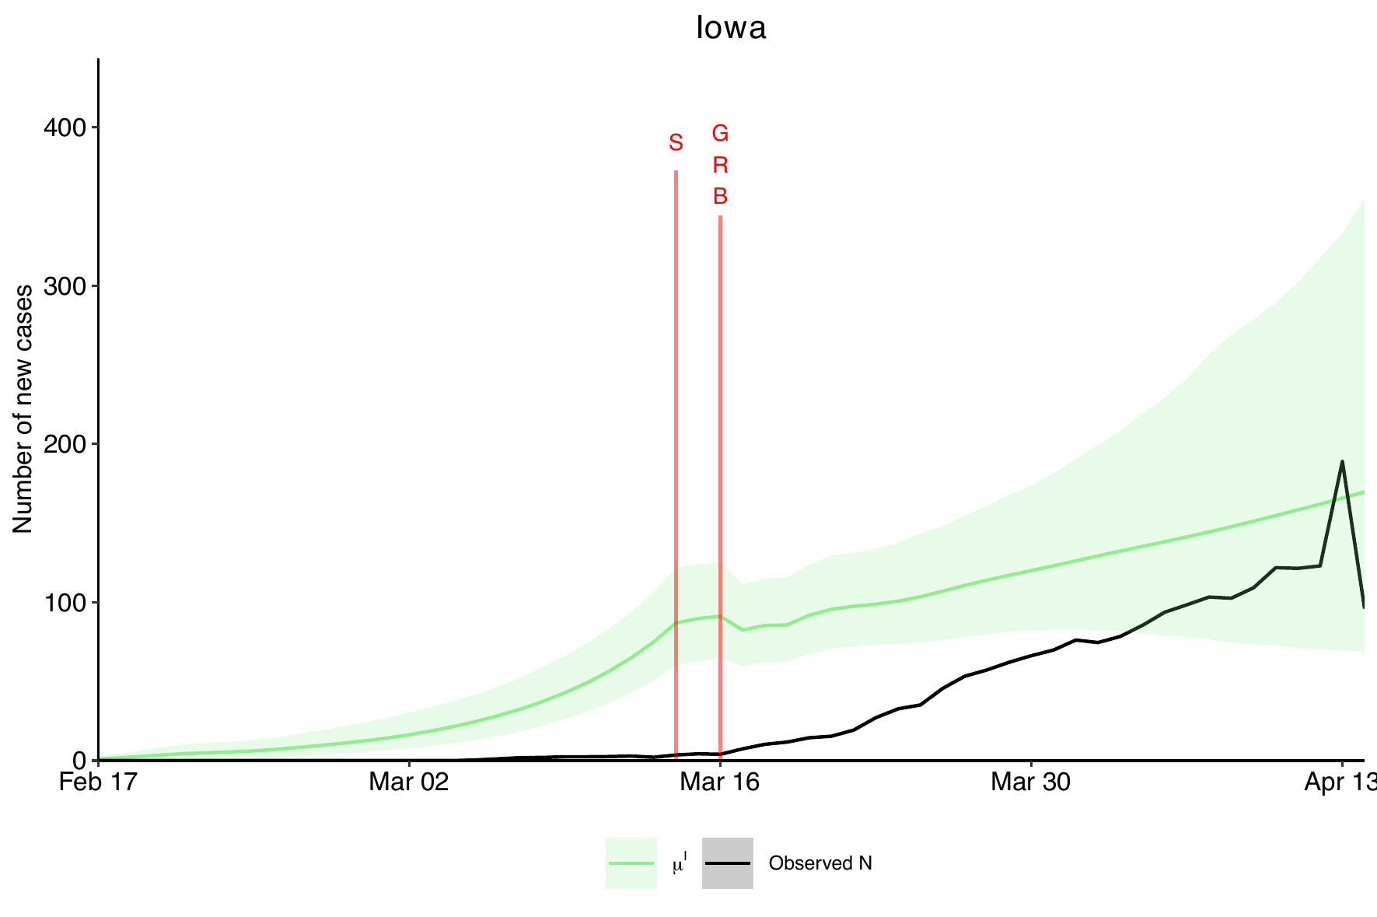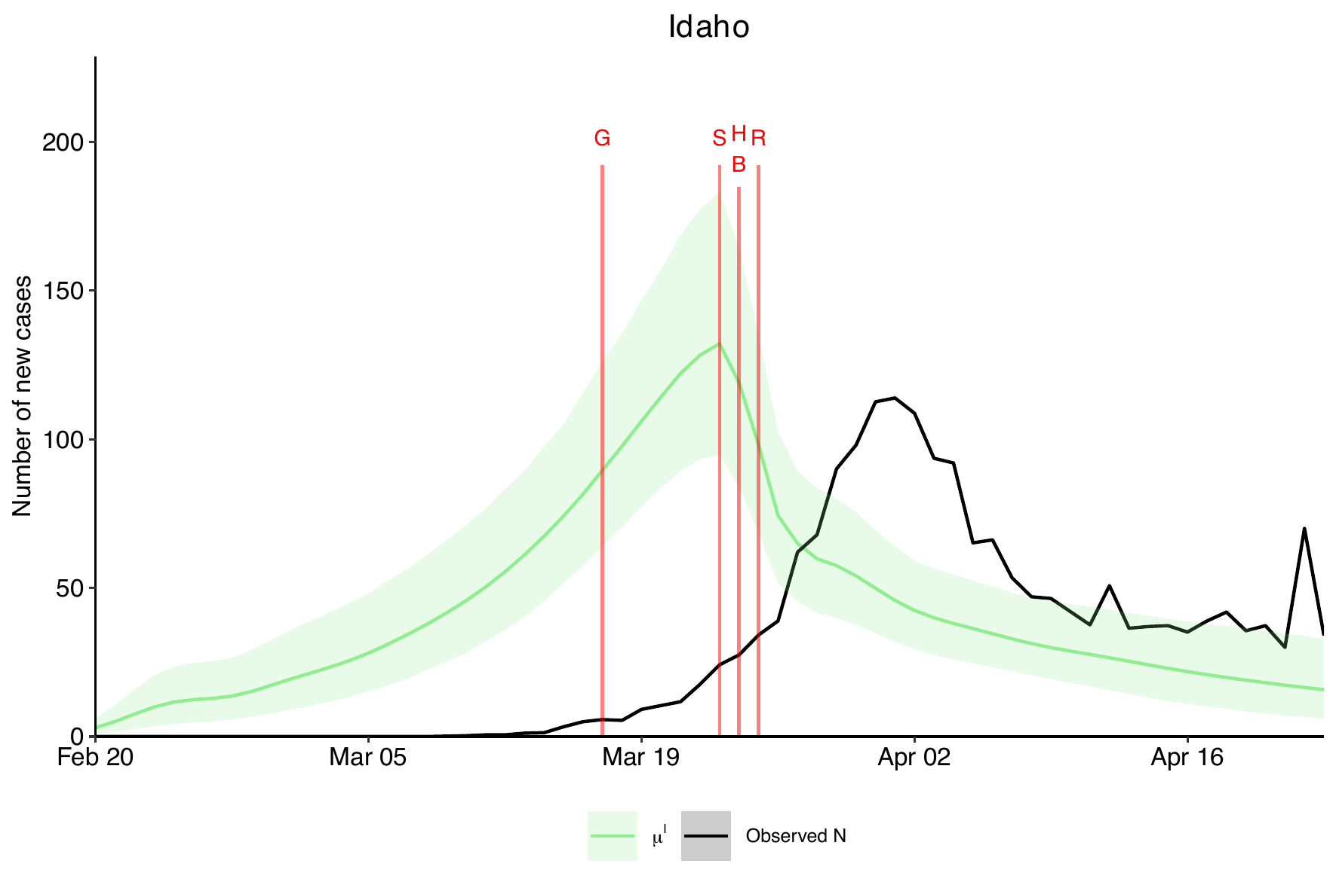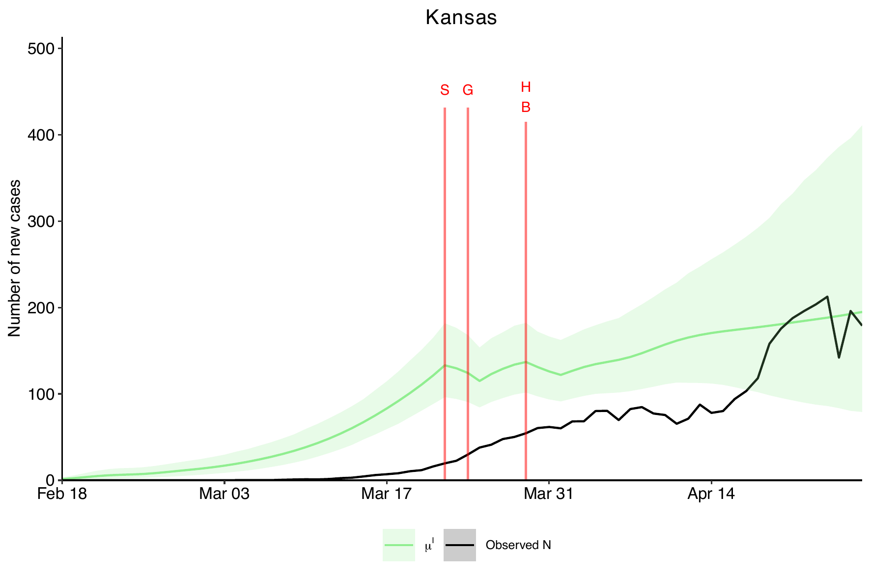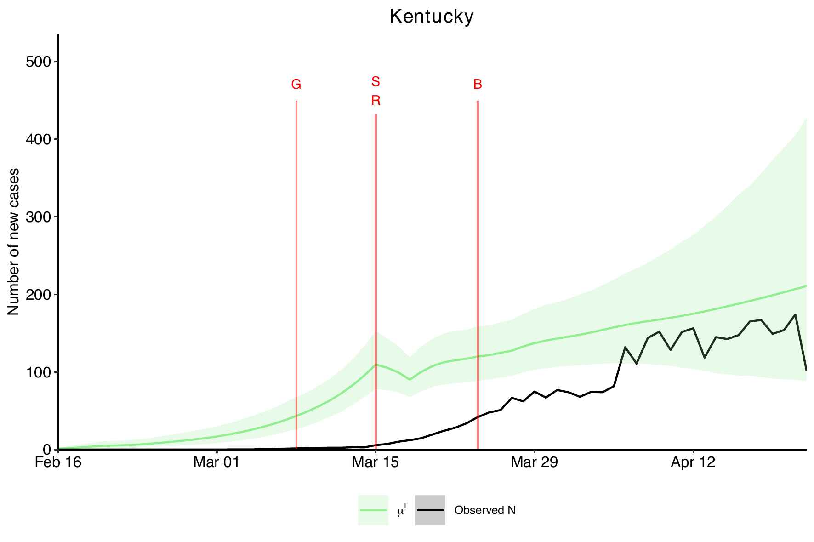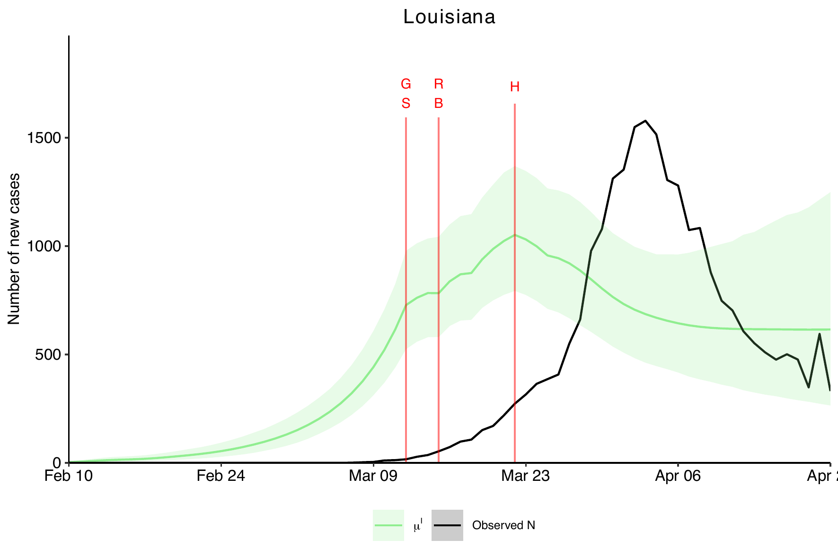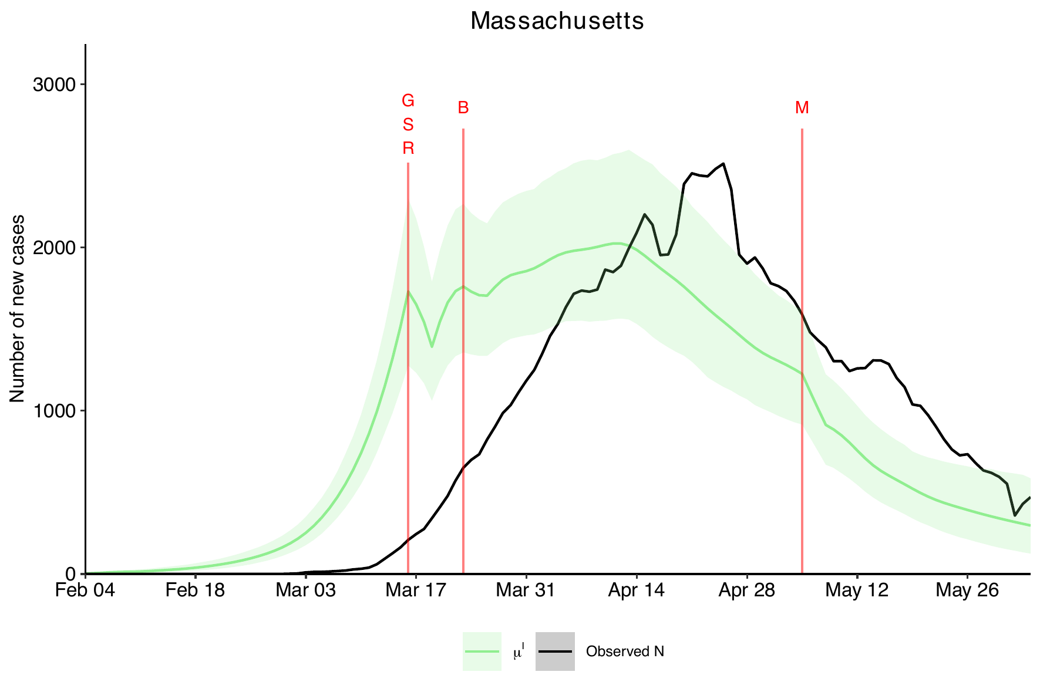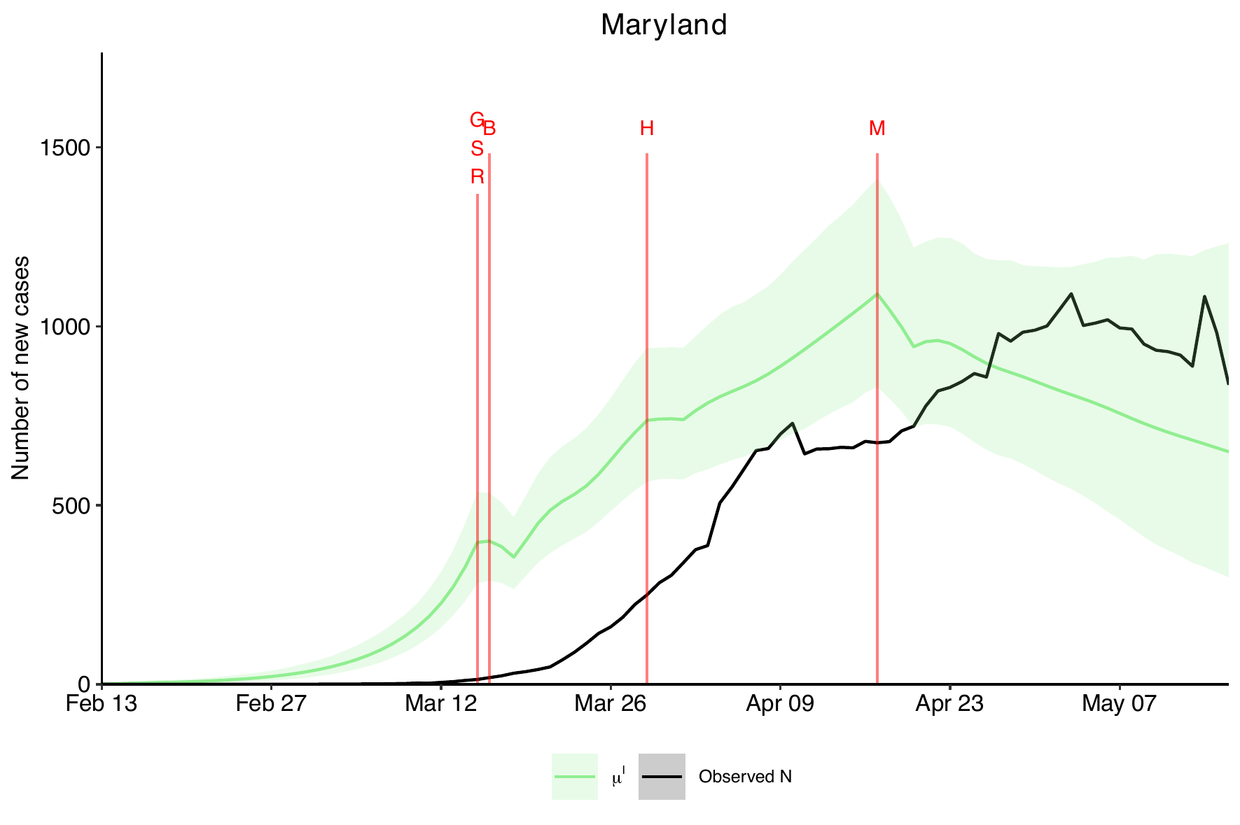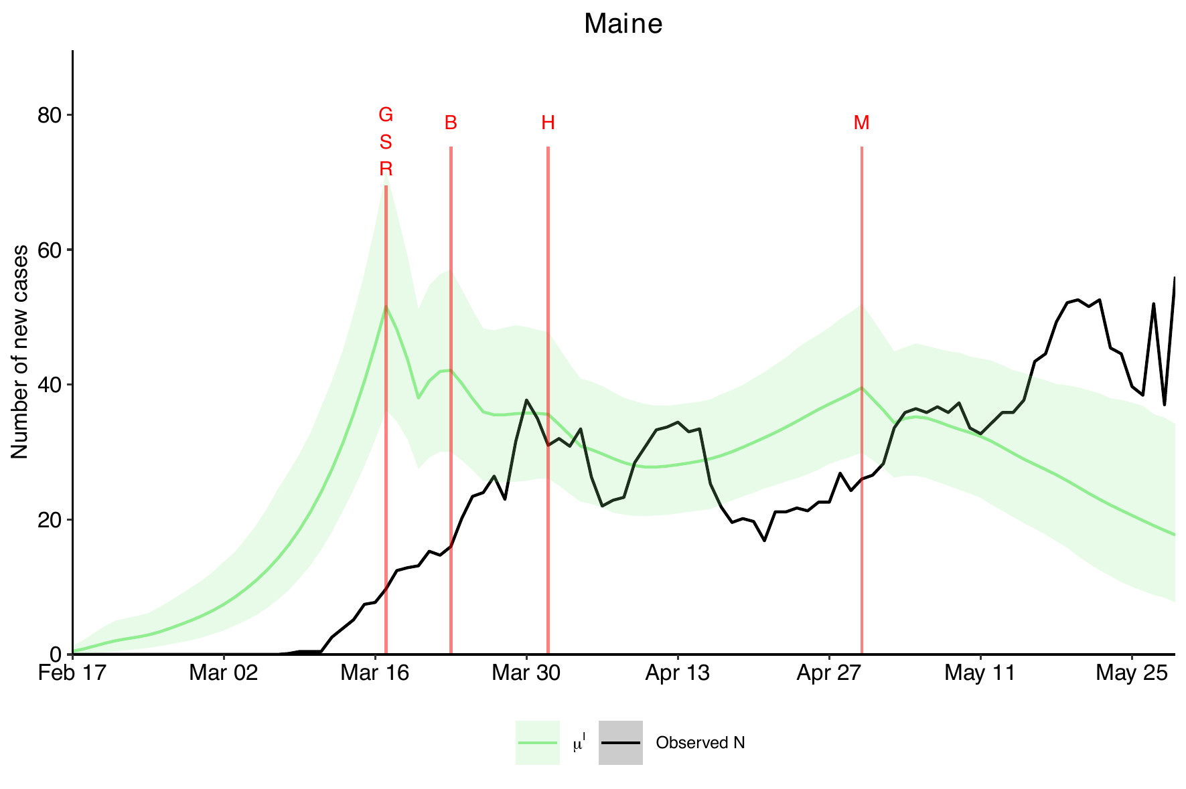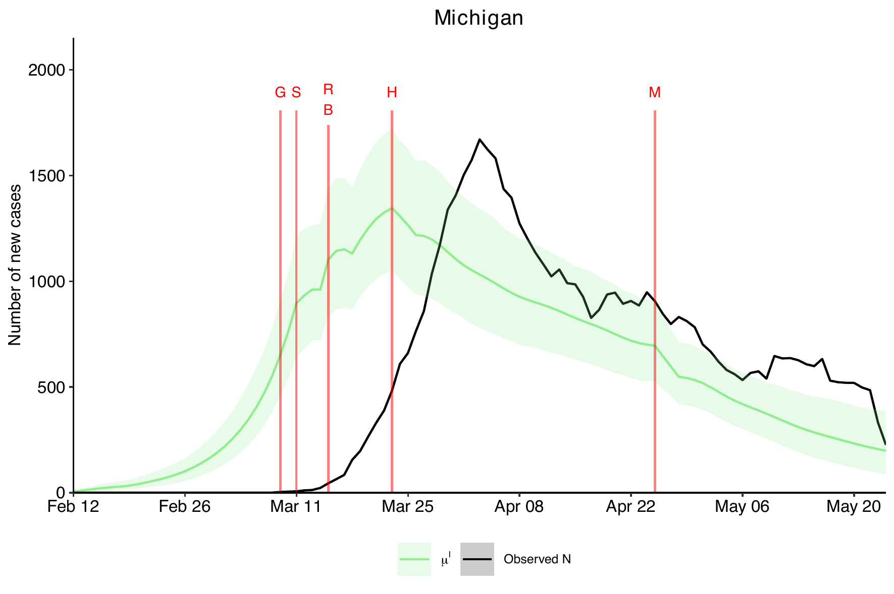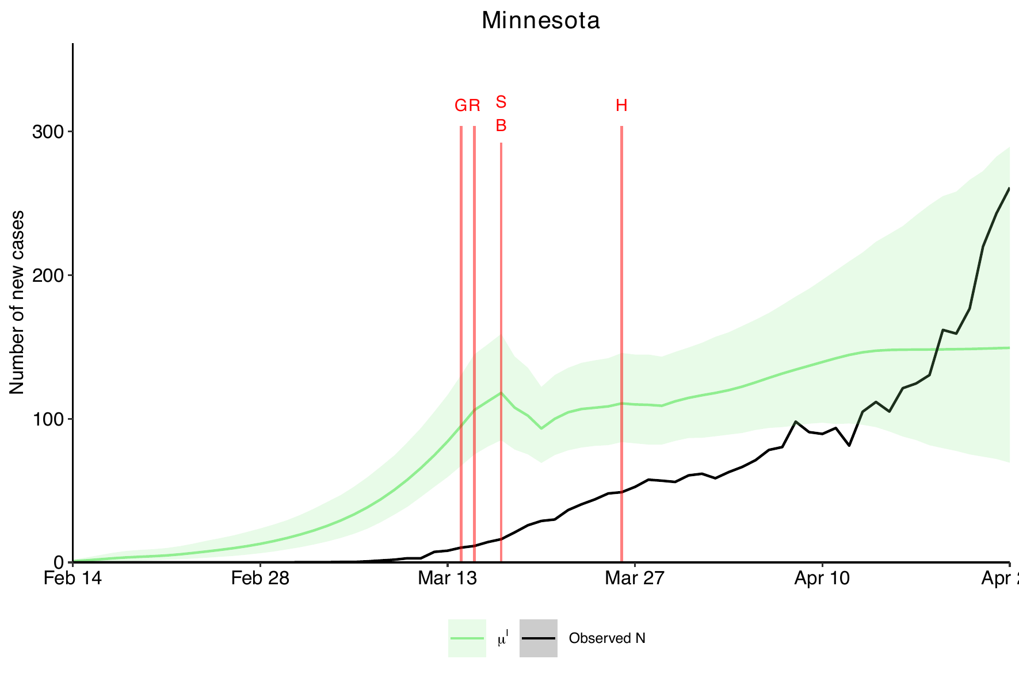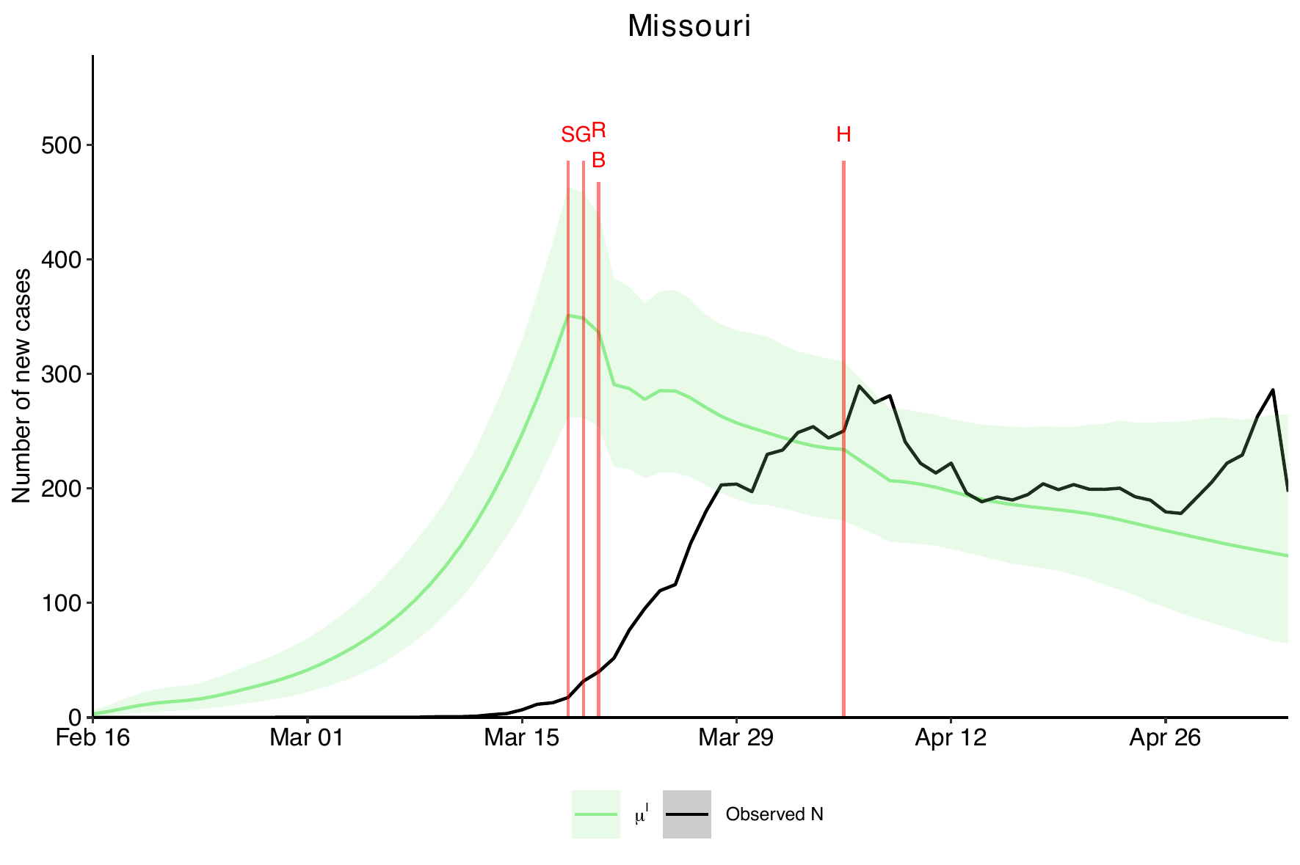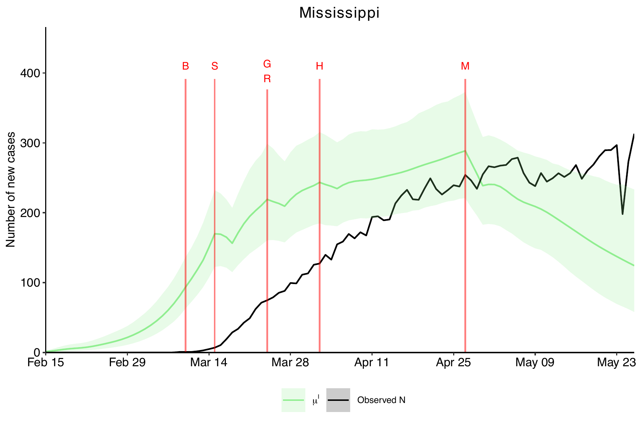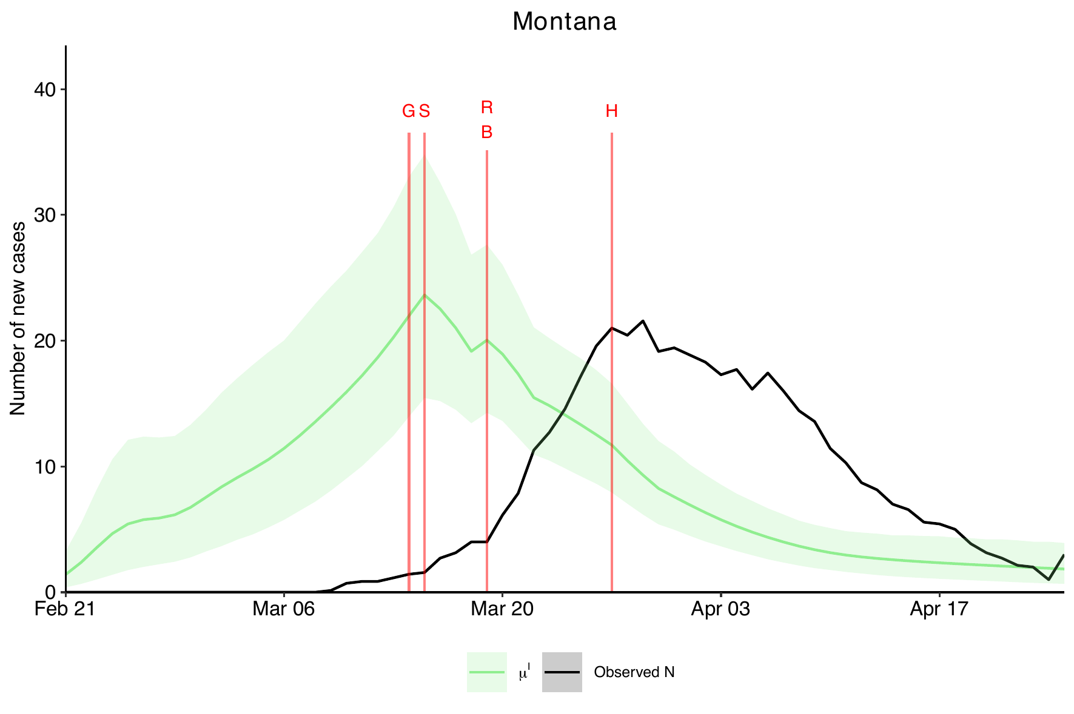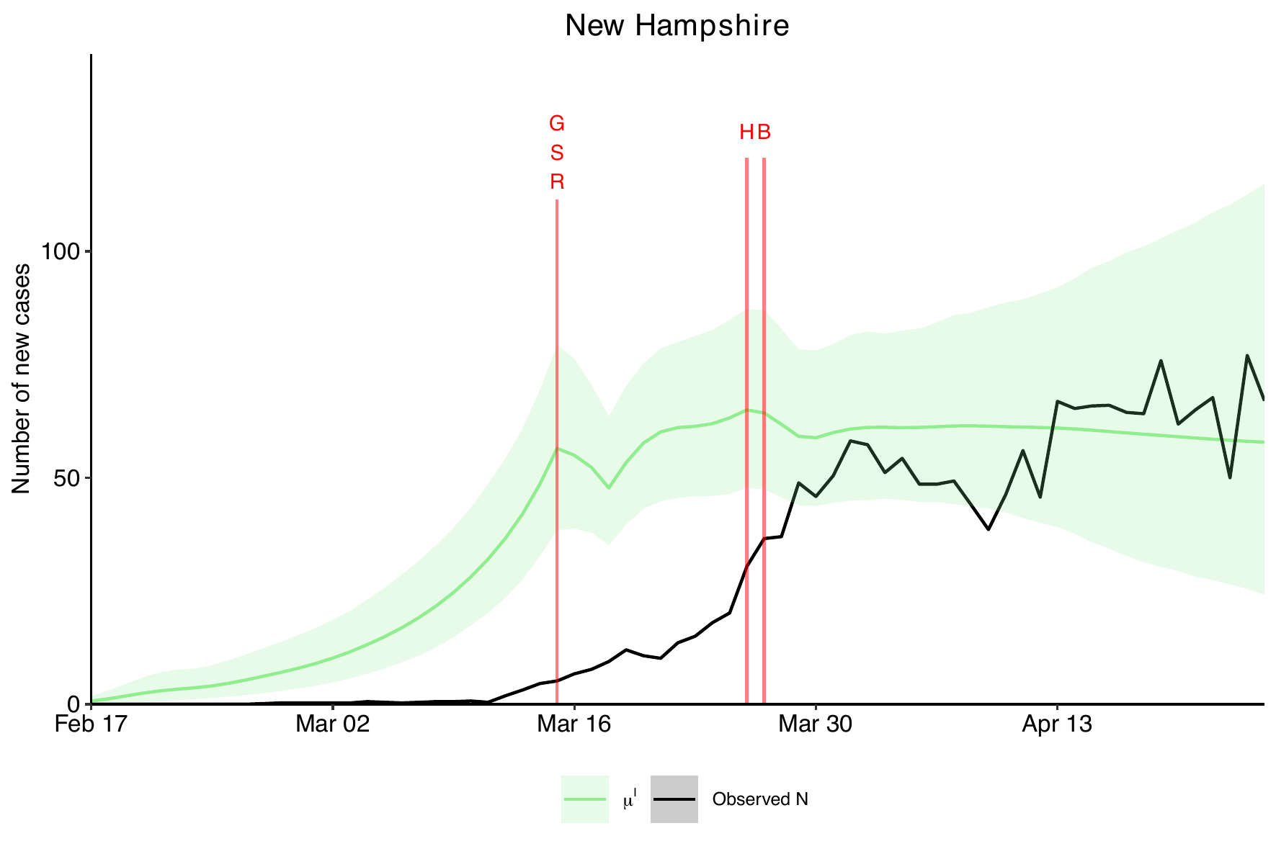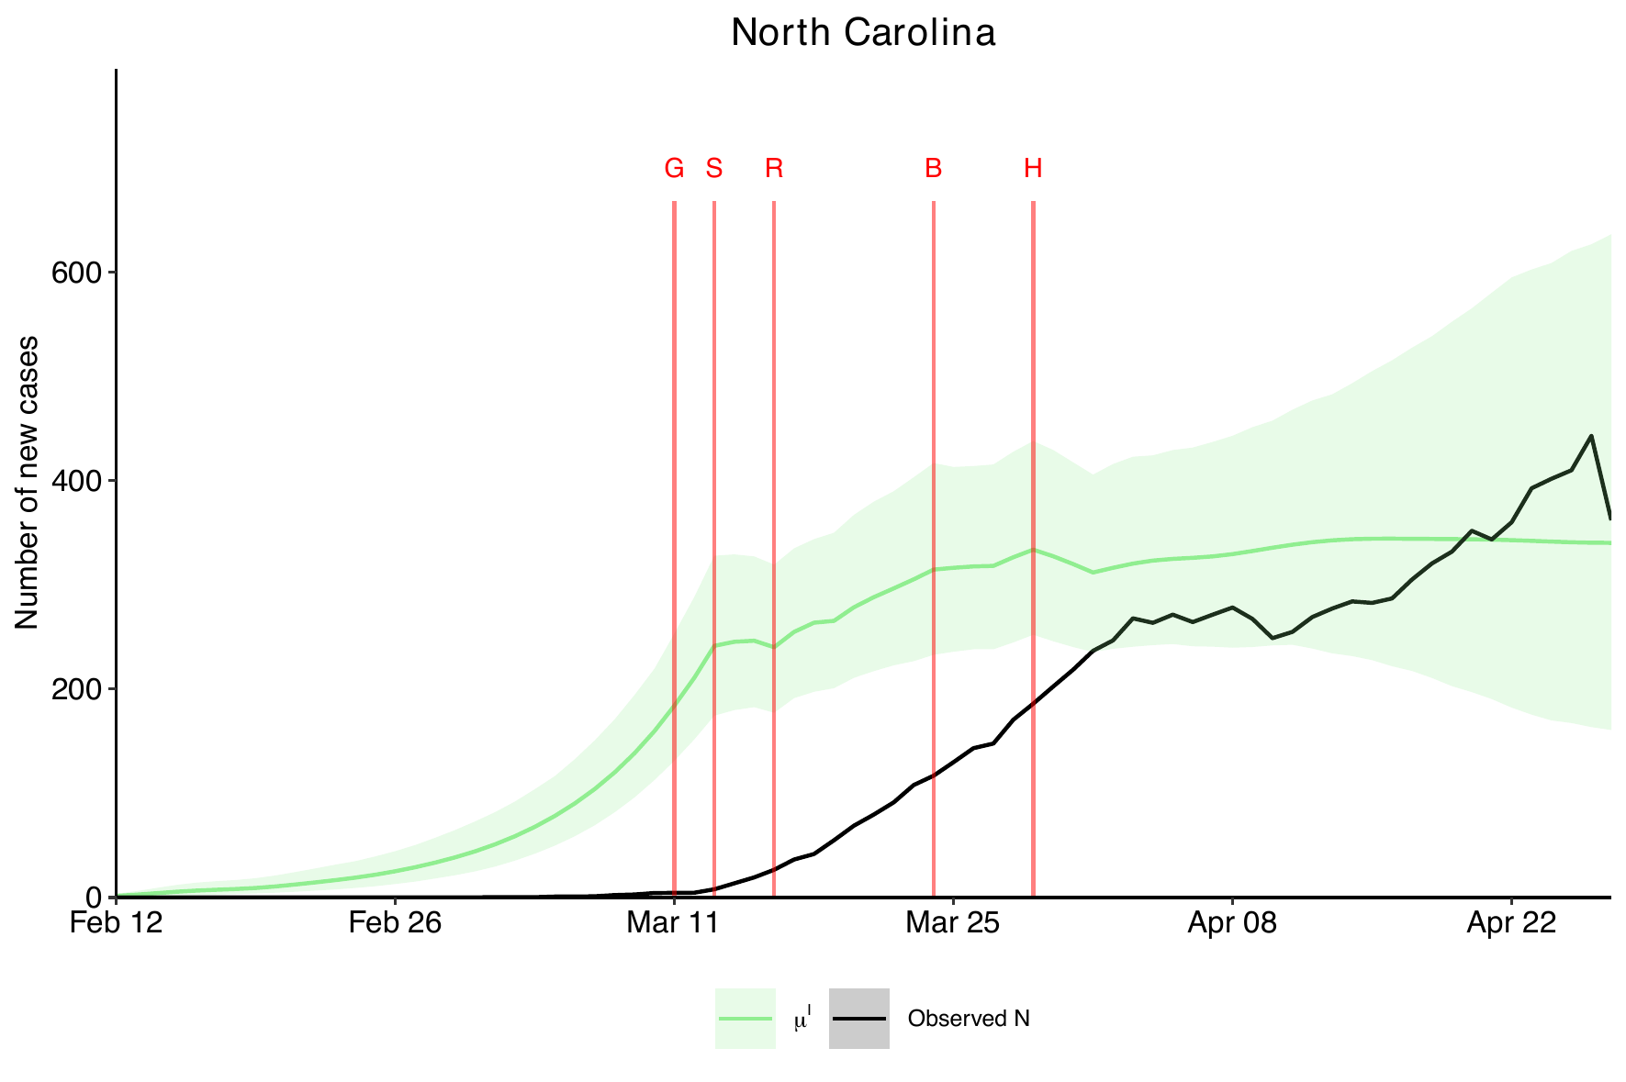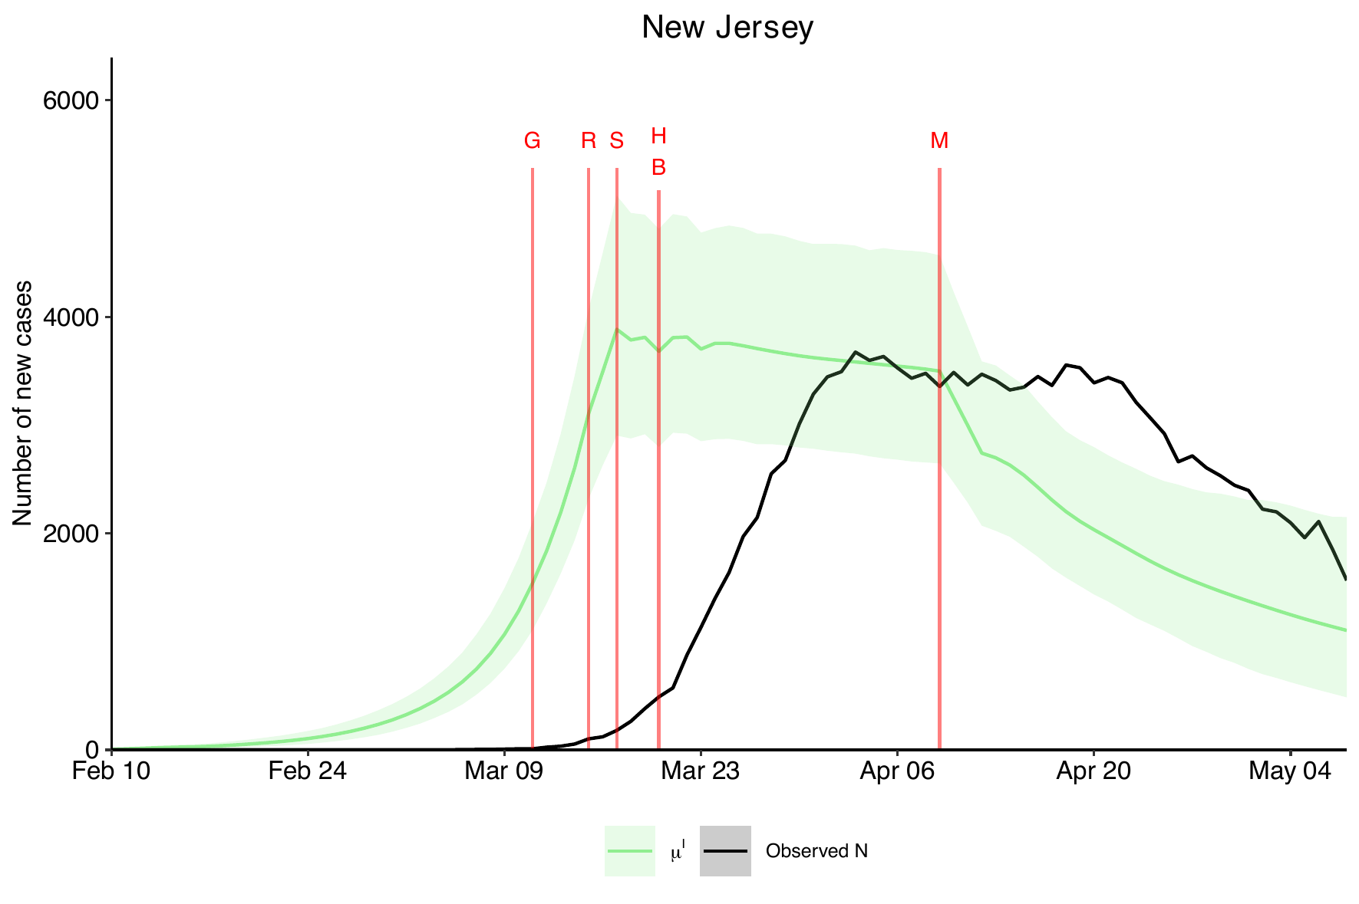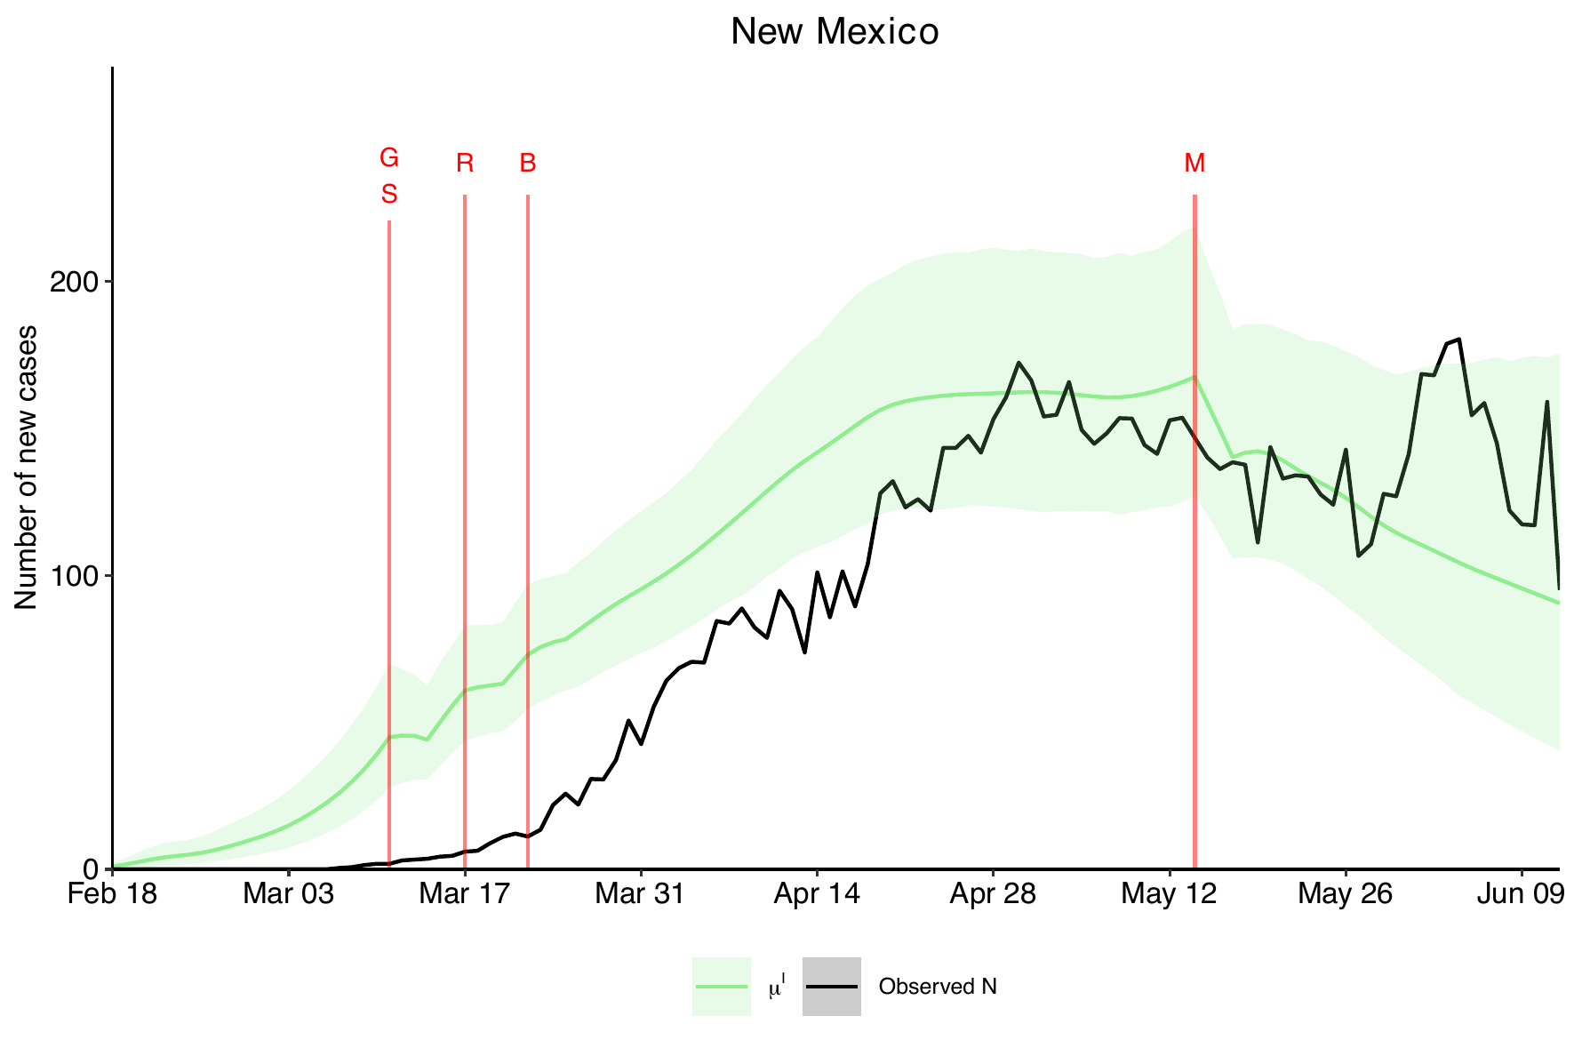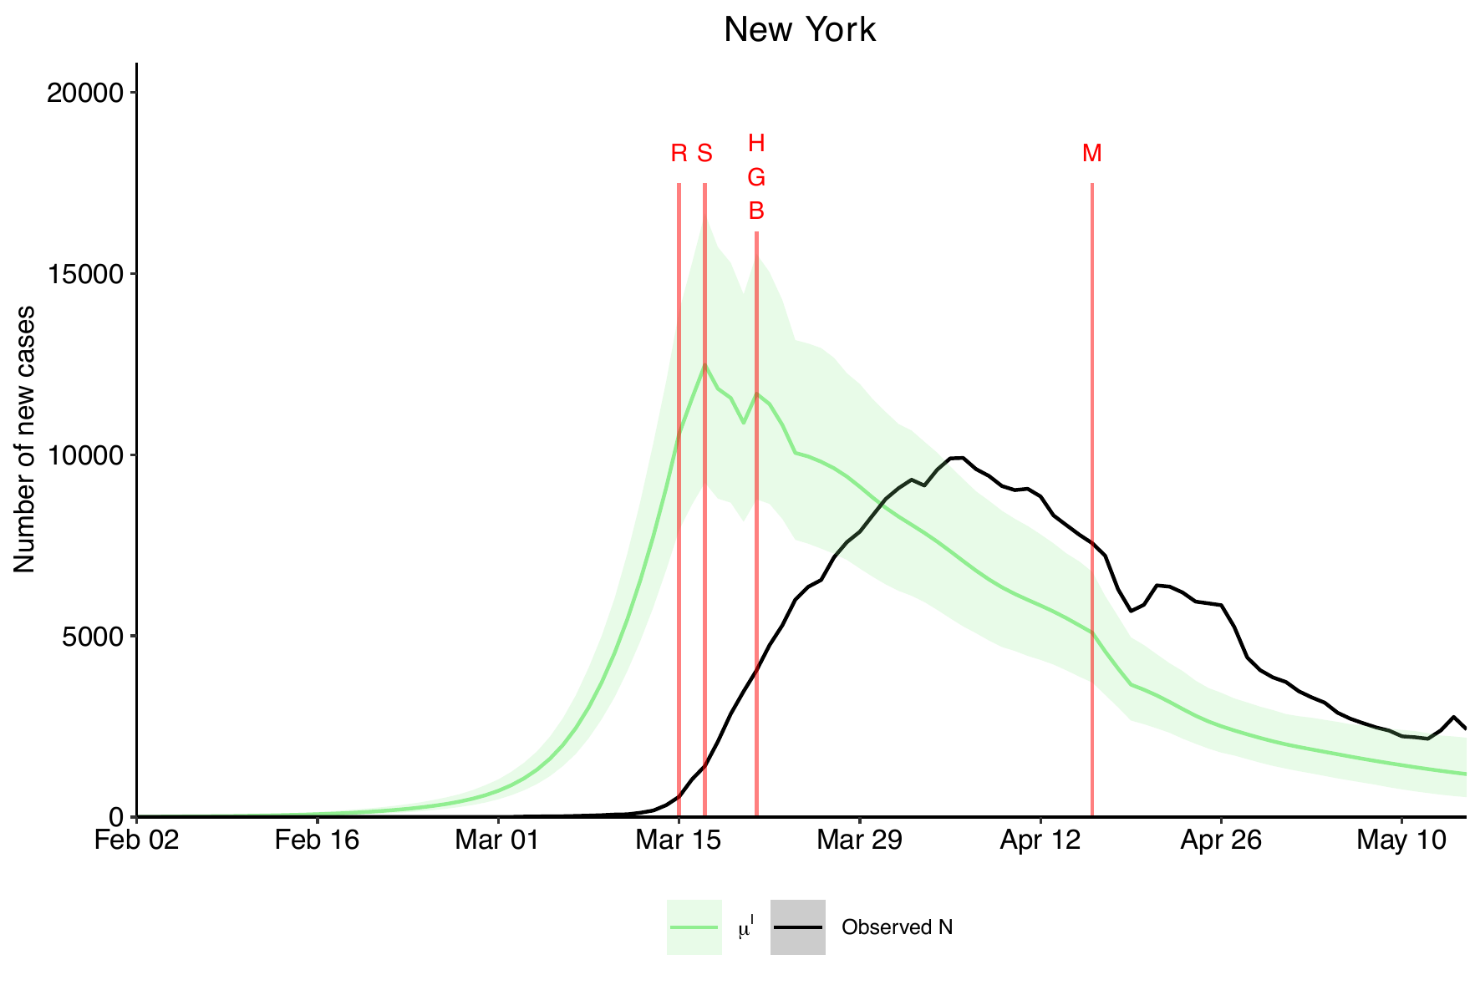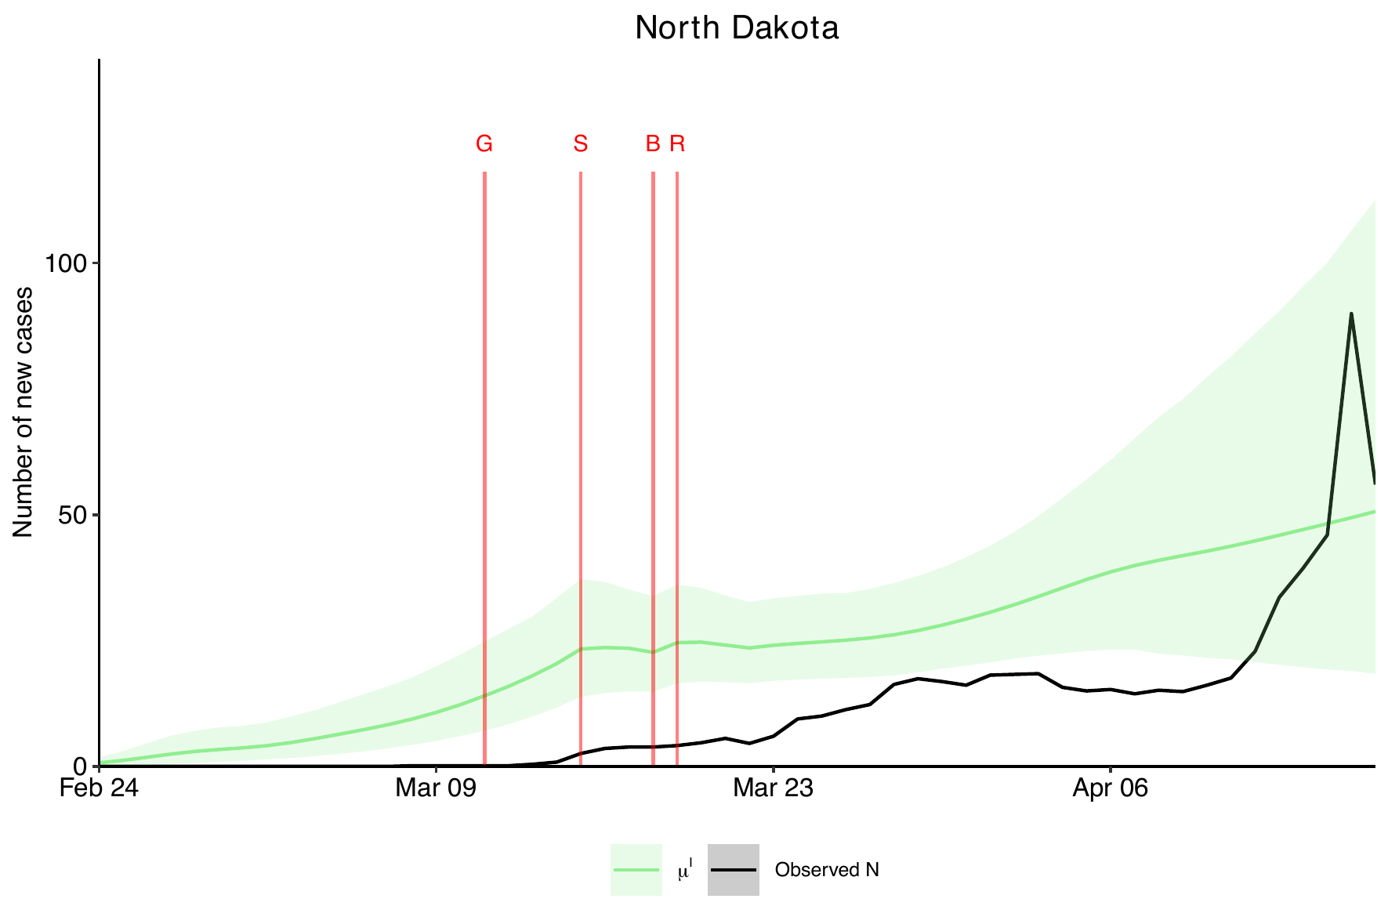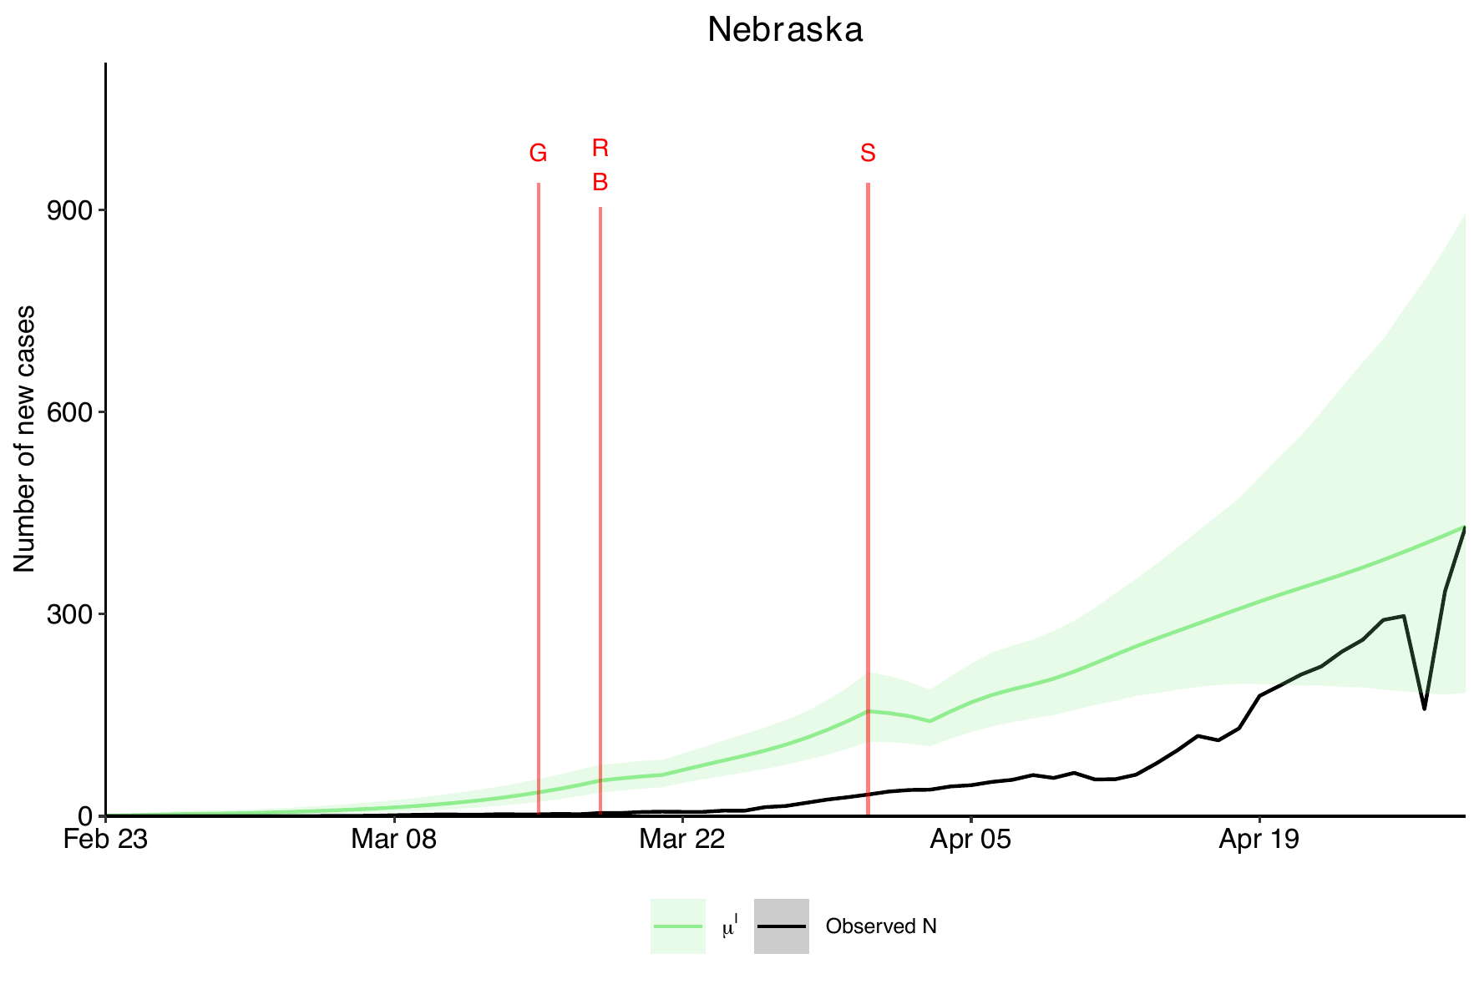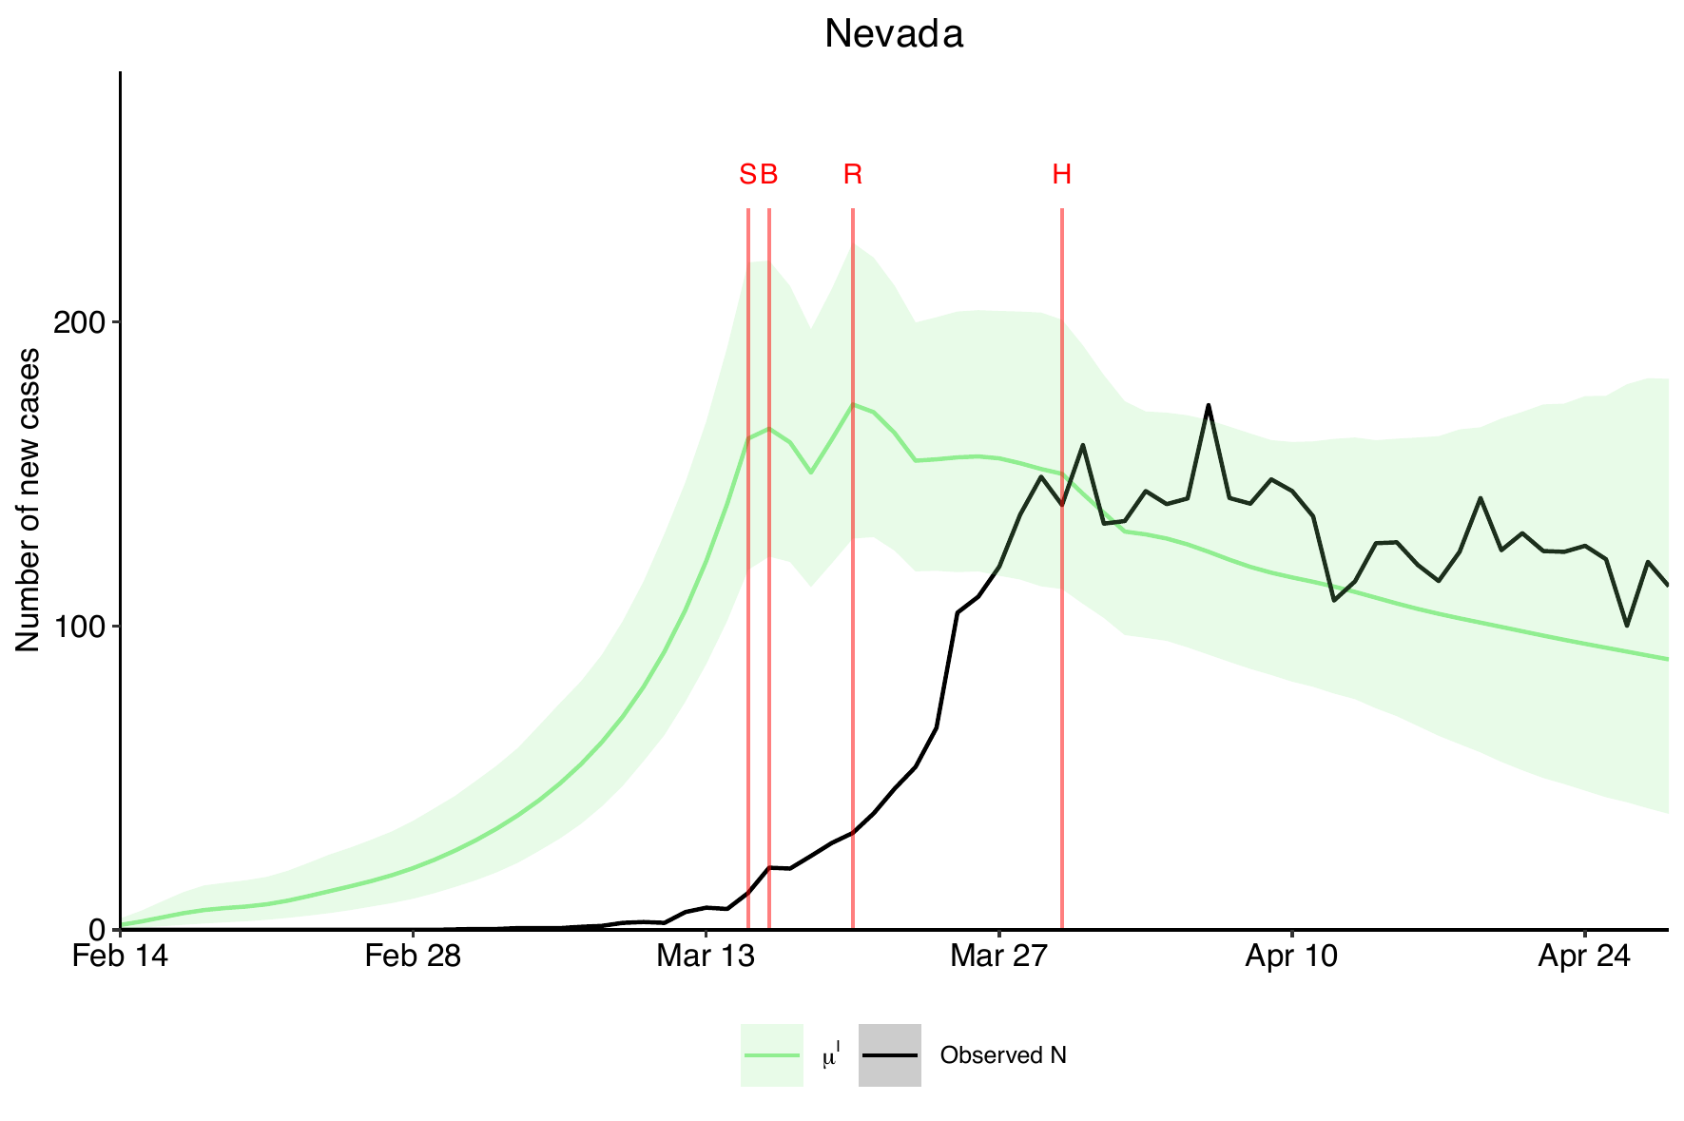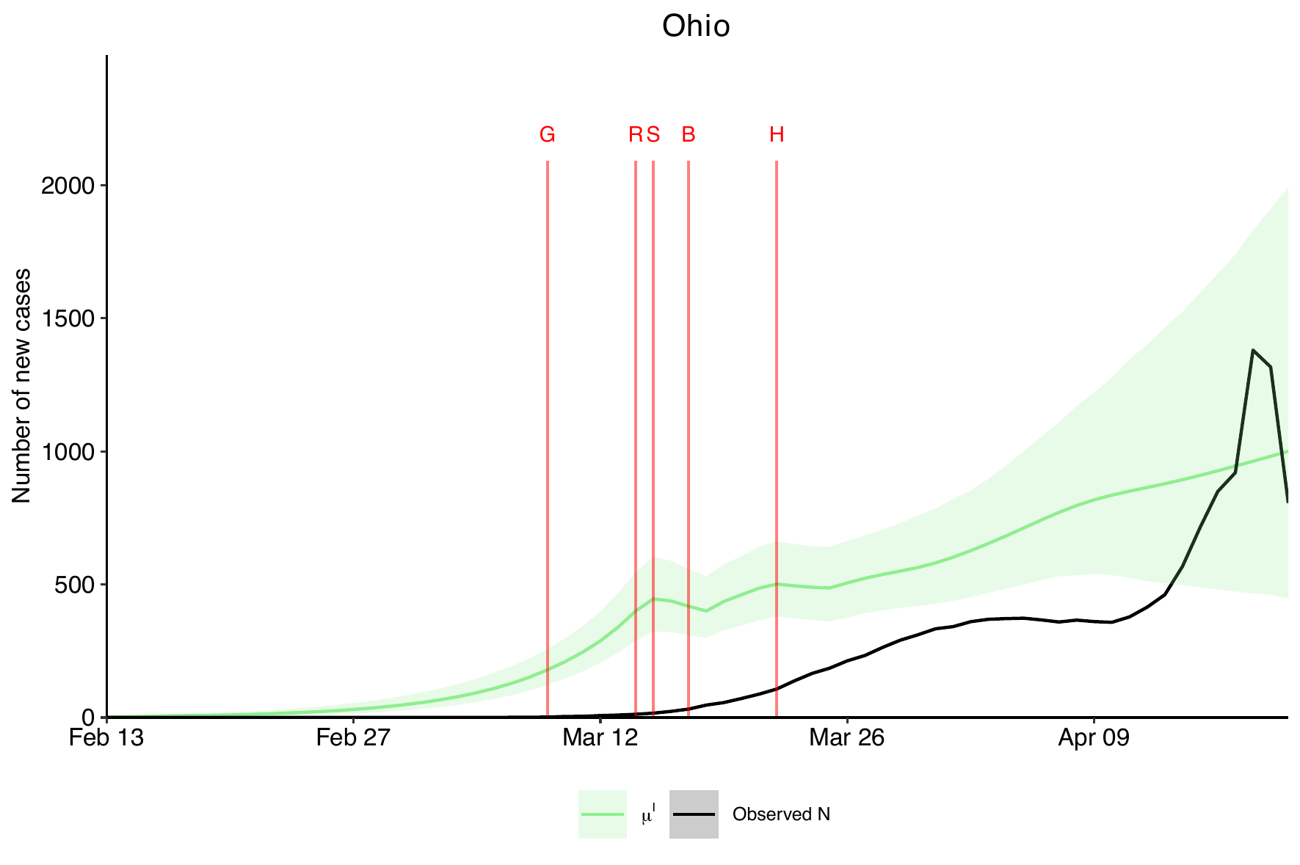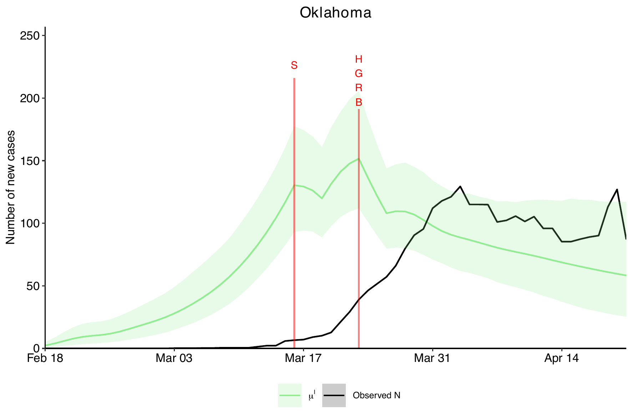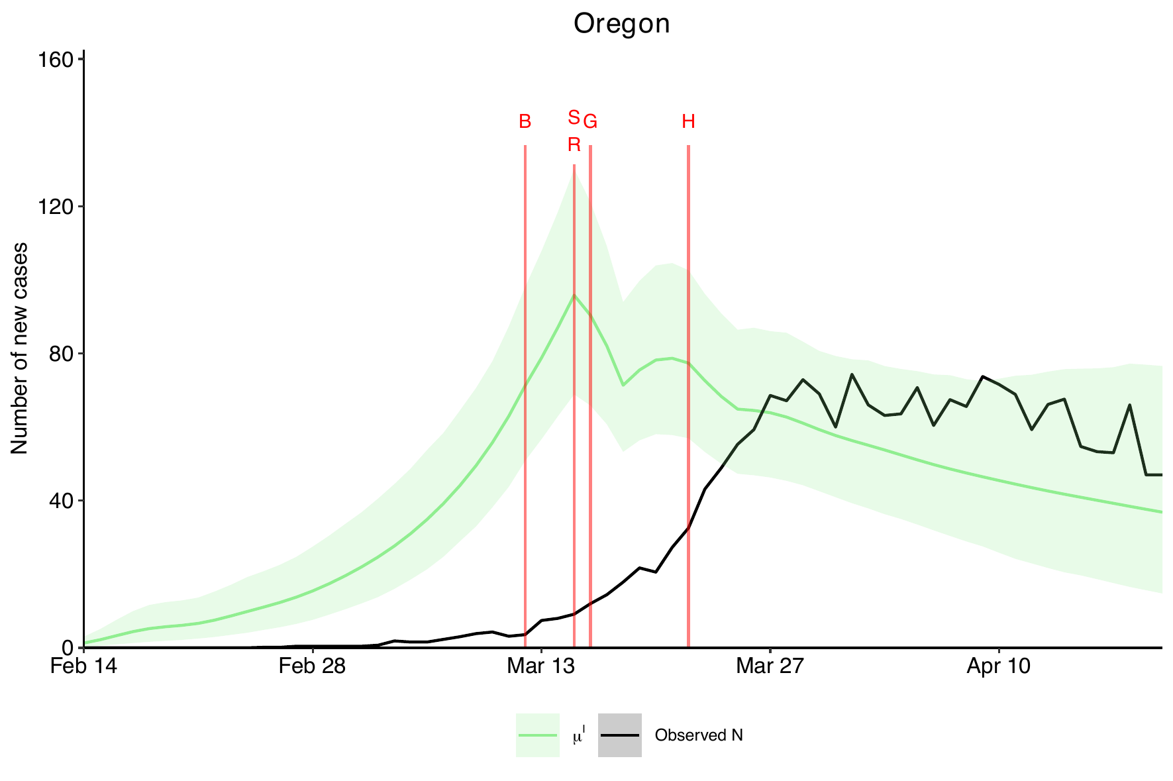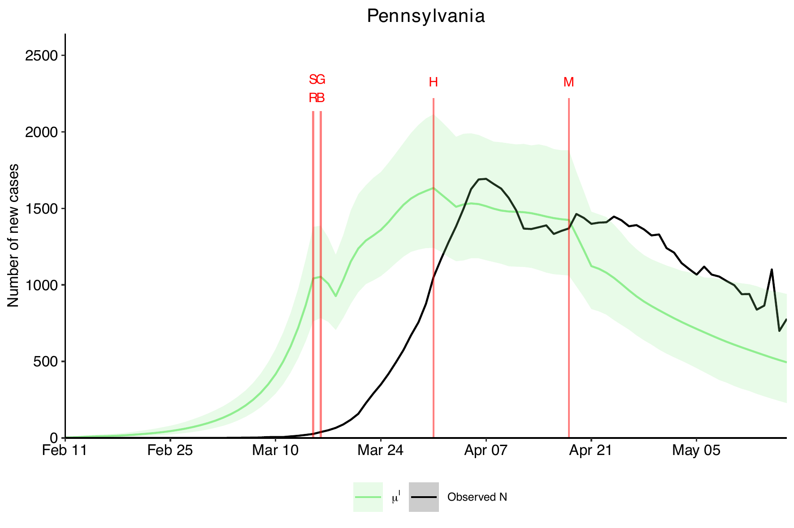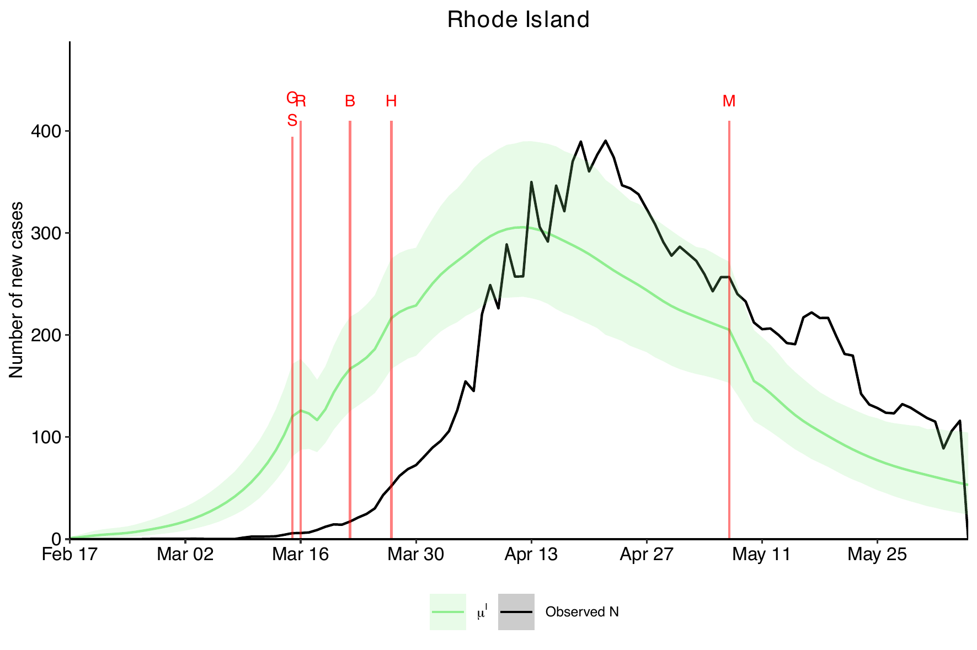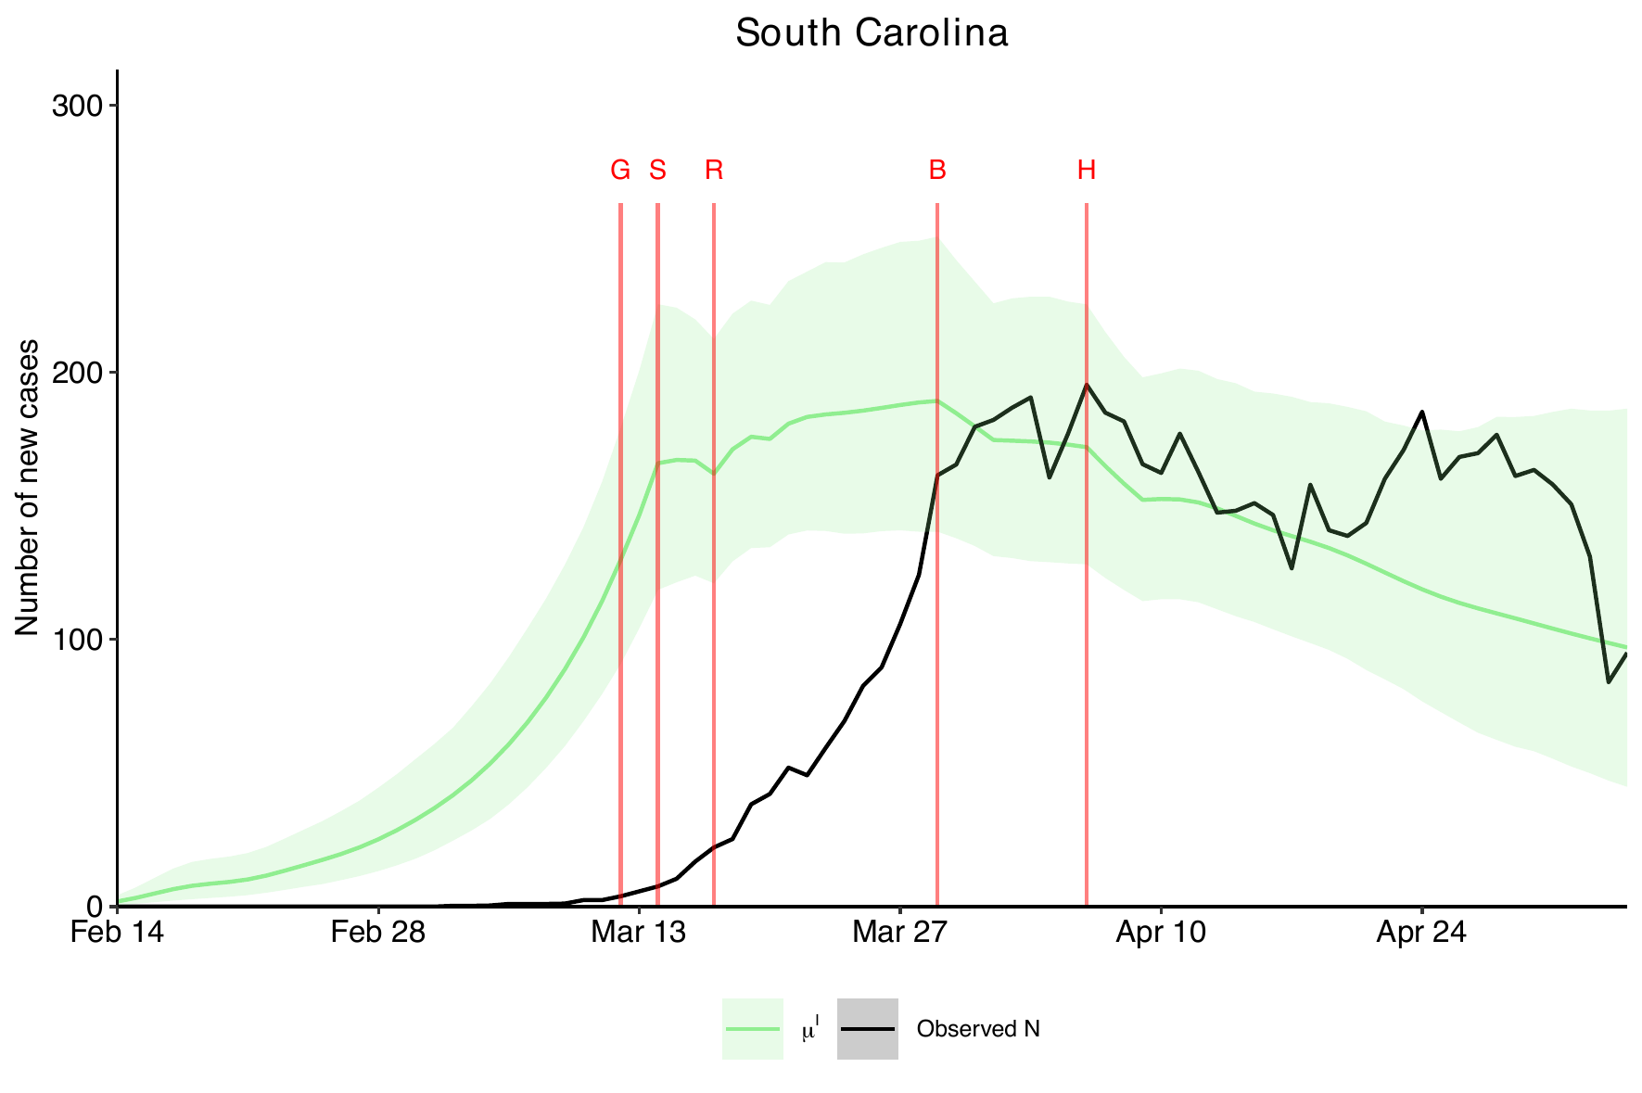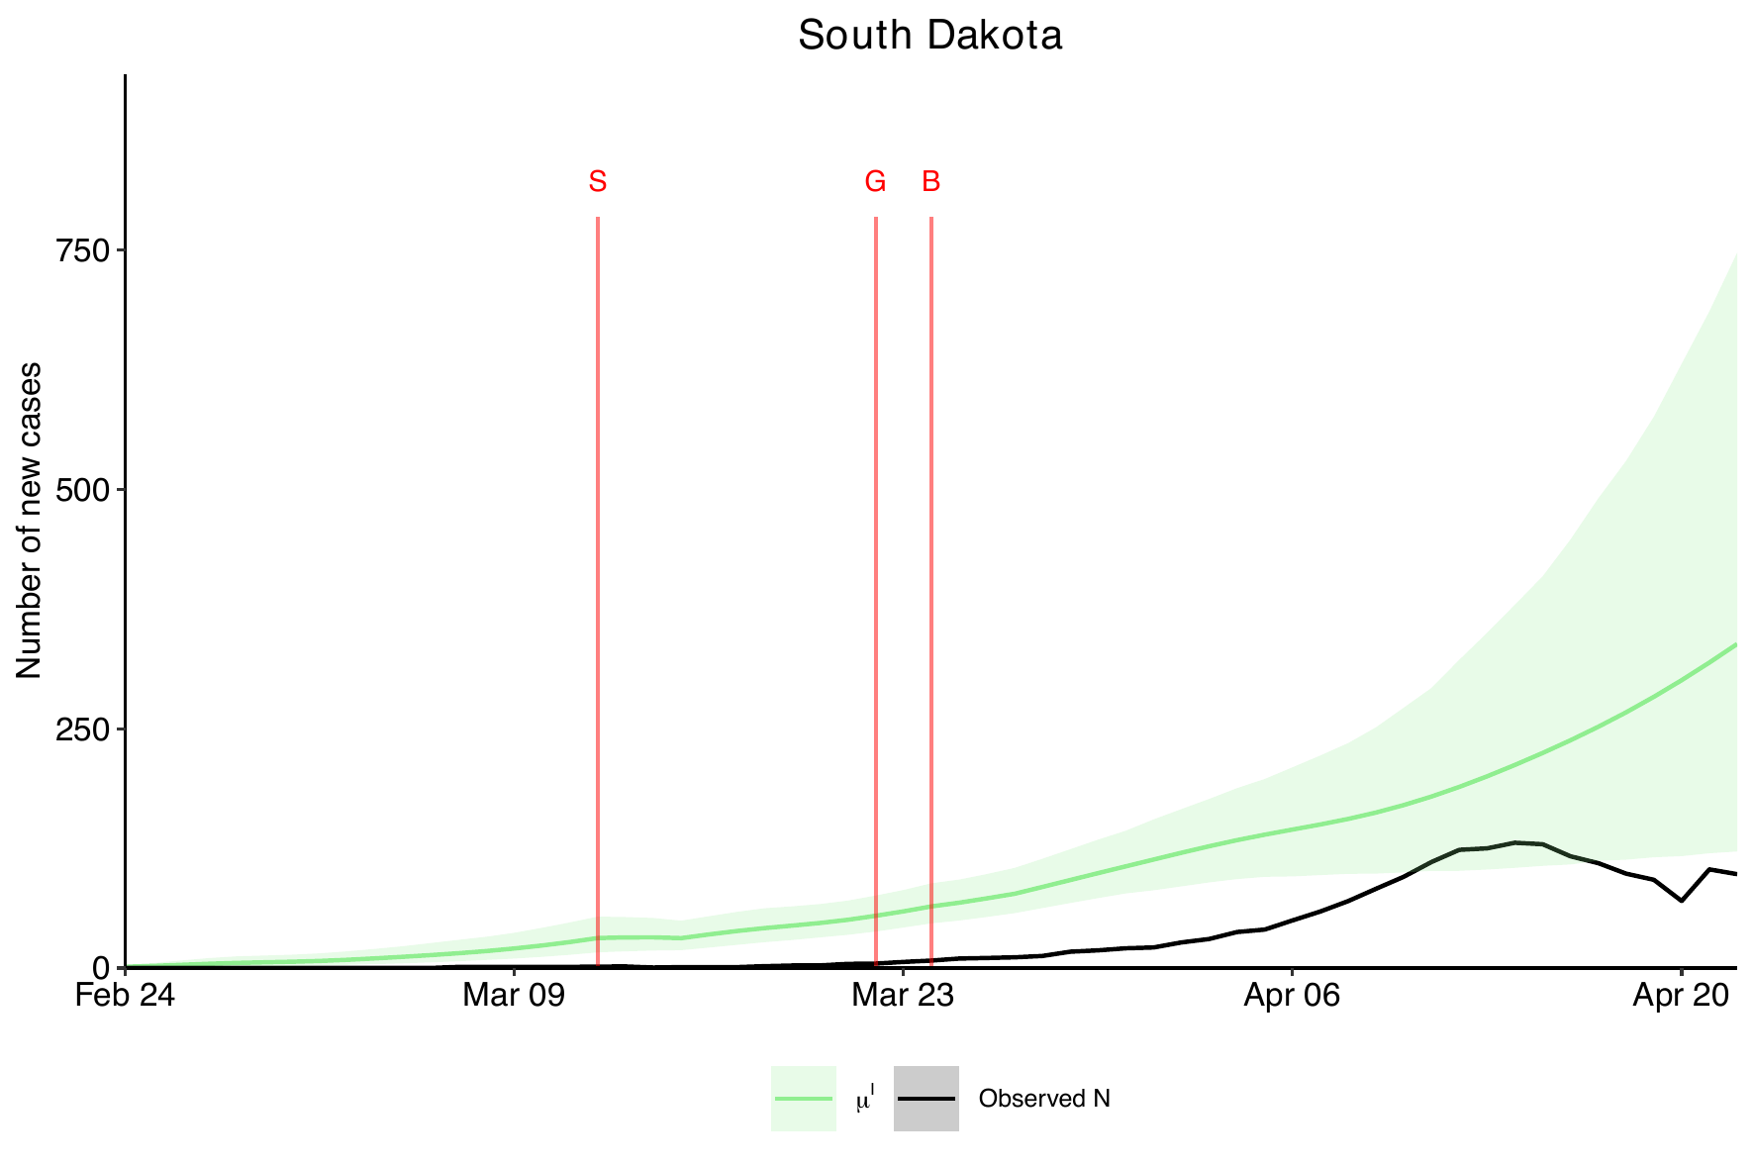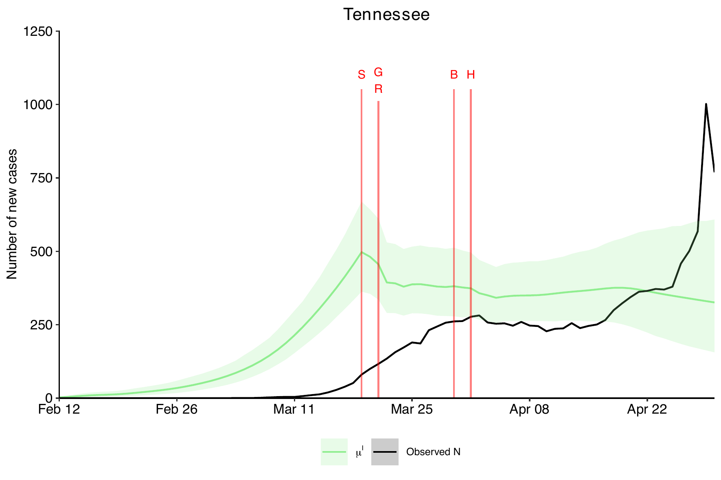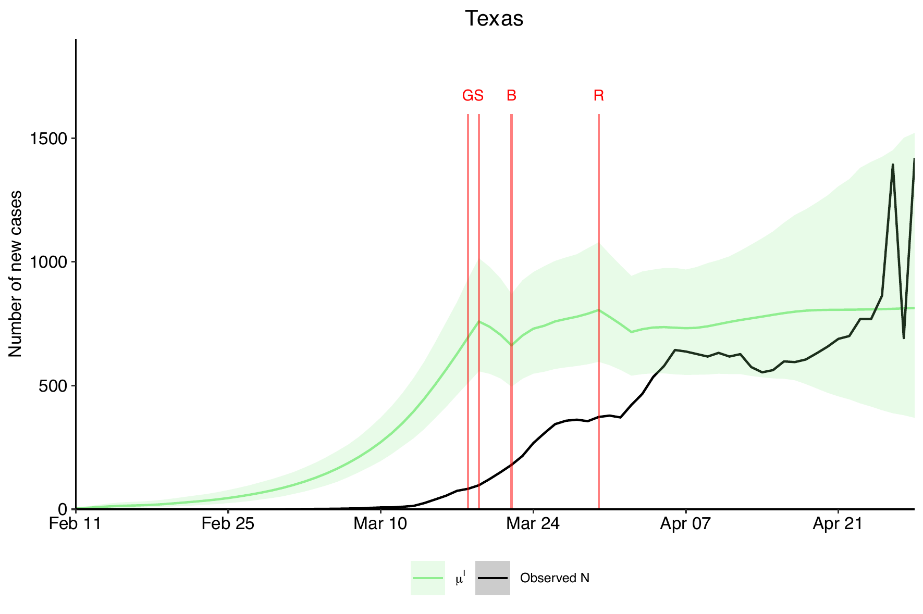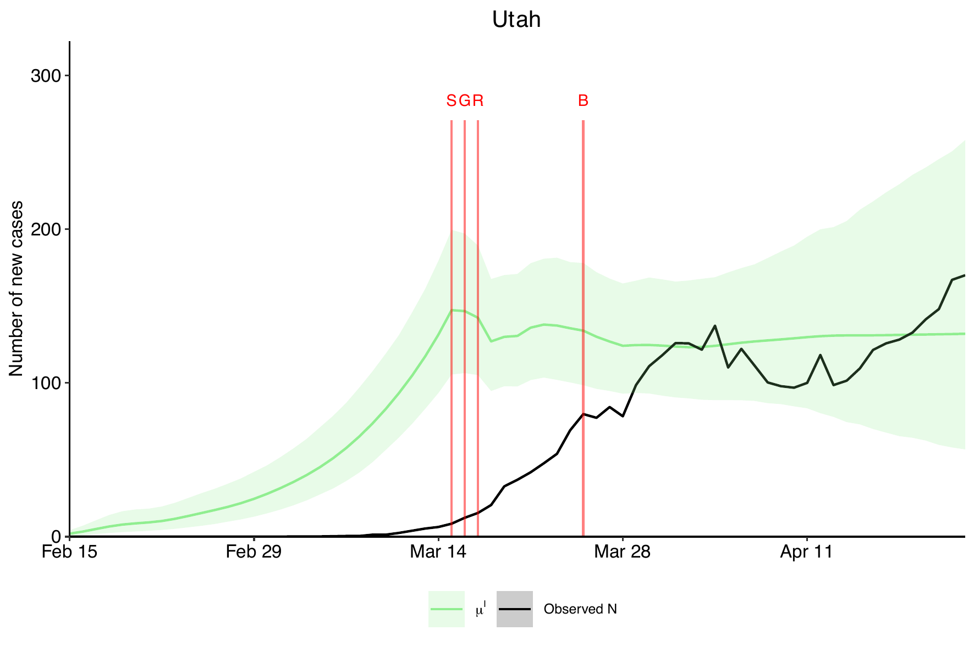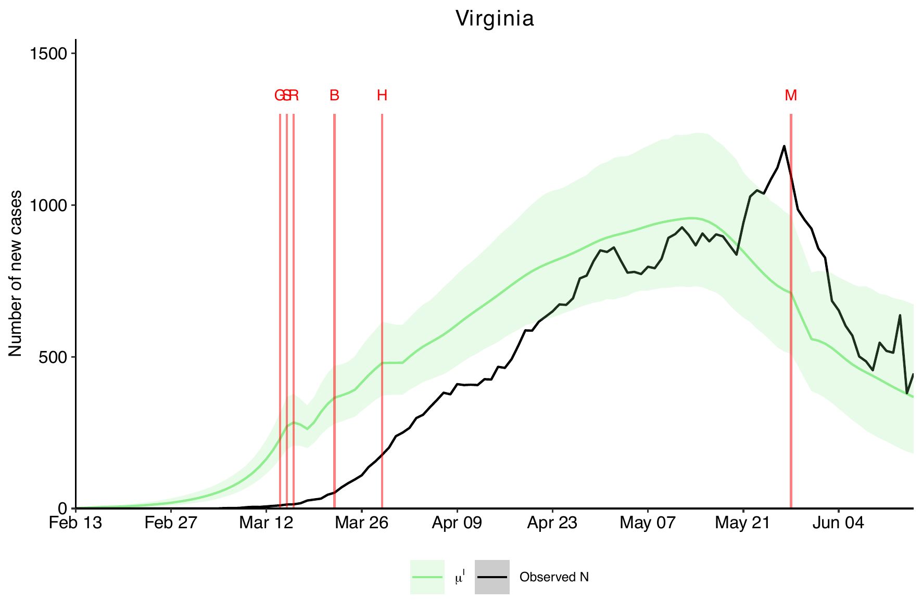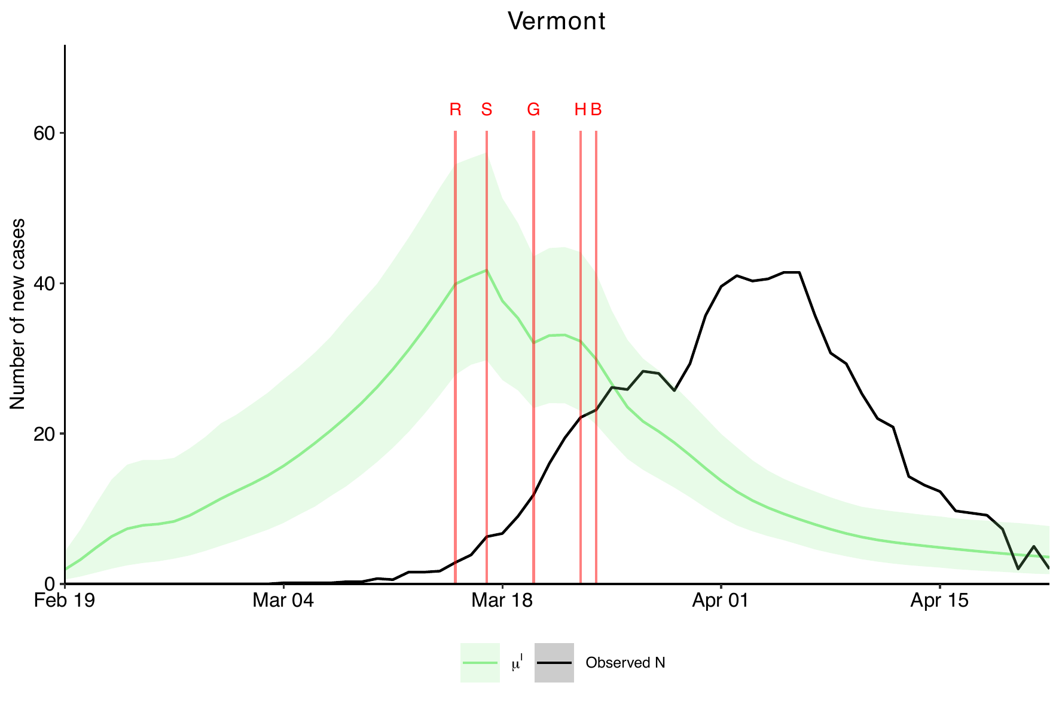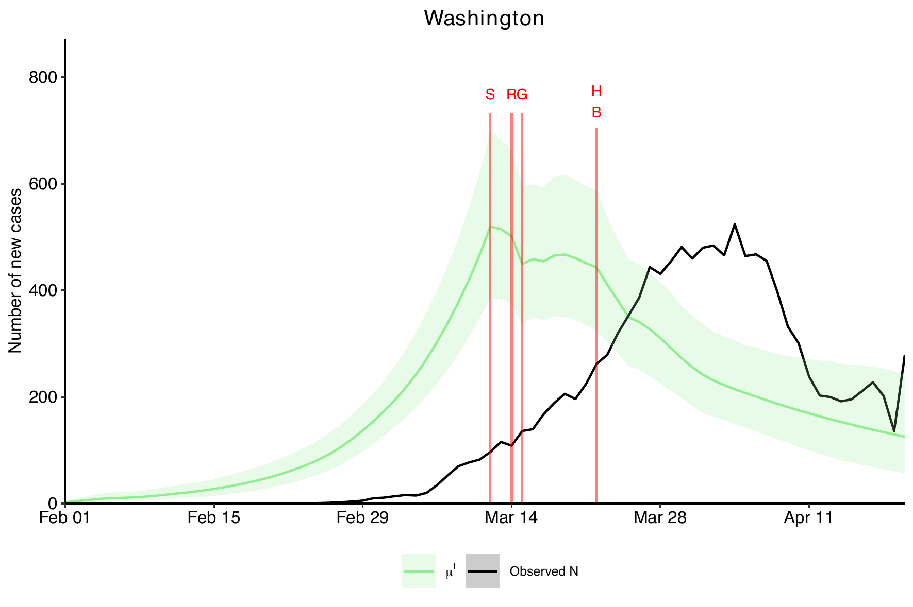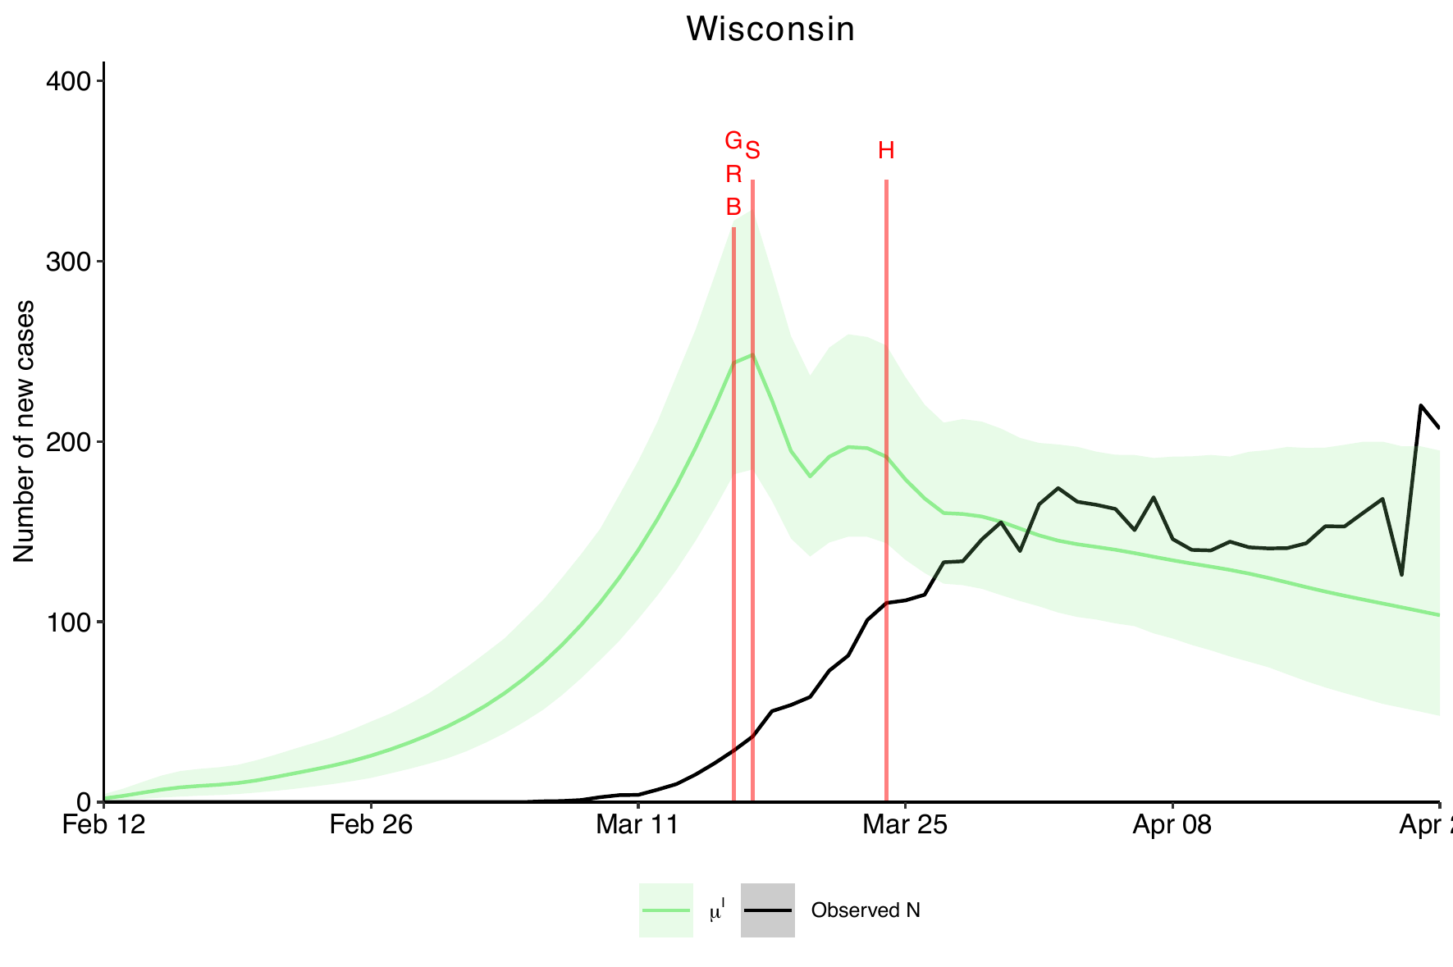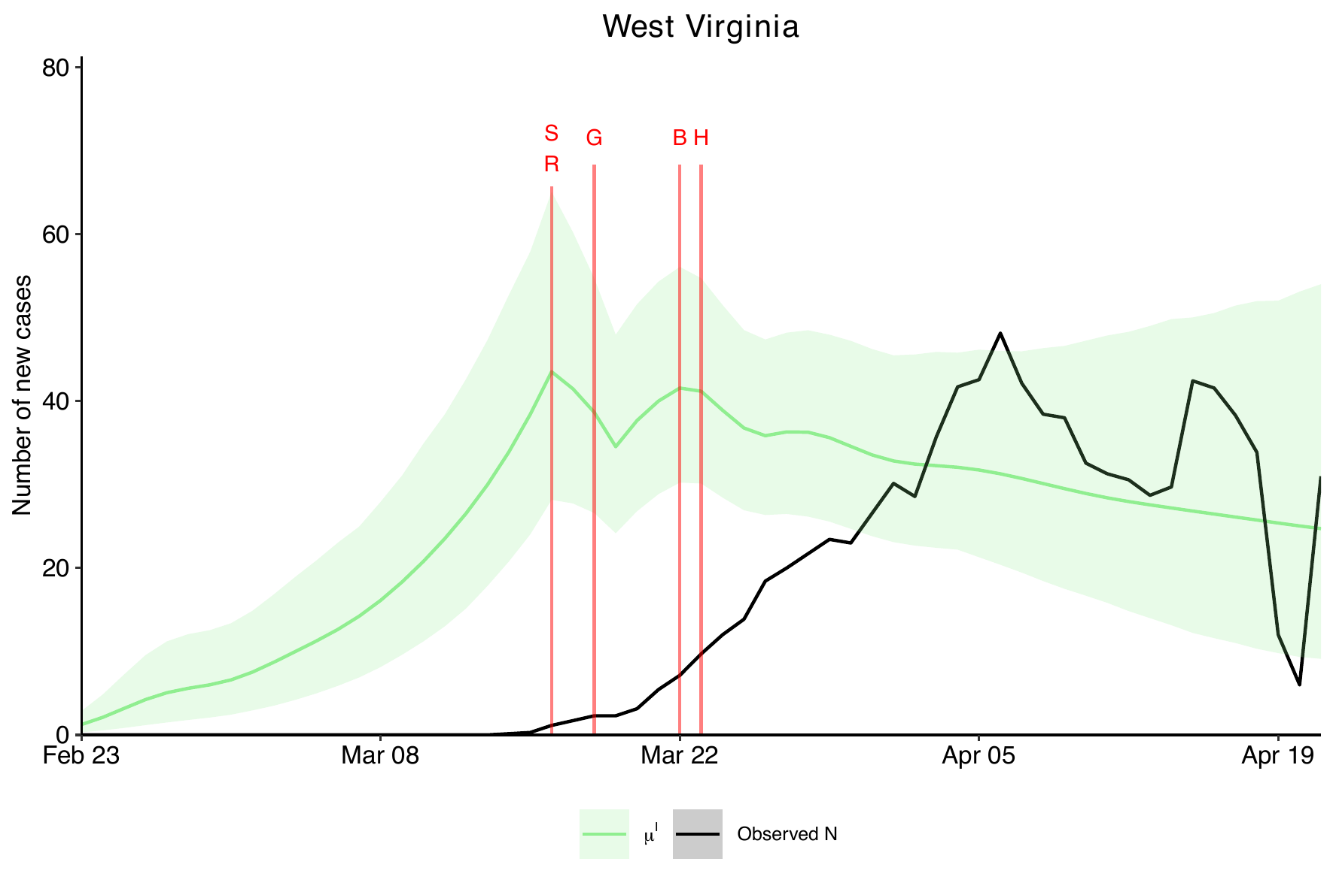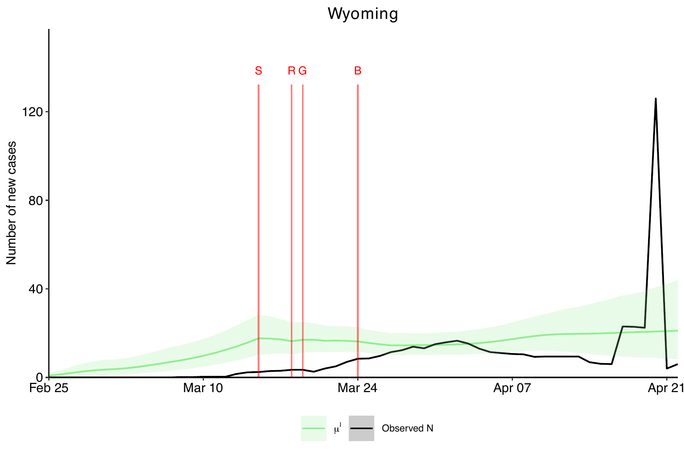

- Figure 1: US map of face mandate policy during the study period.
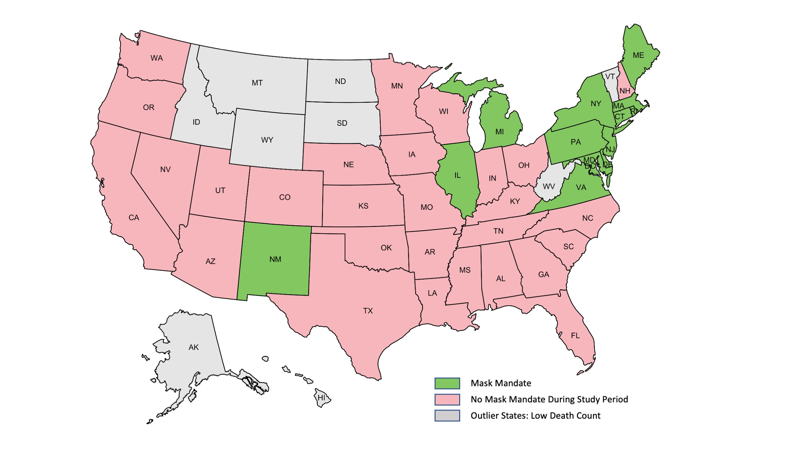
States highlighted in green initiated facemask mandate policy during the study period (February 1 to June 15, 2020) and states highlighted in pink did not introduce facemask mandate policy. States in grey had very low death count (<100), indicating COVID-19 was not prevalent in these states and thus excluded from the analyses.

- Figure 2: Frequency of imposing at least $m$ NPIs with Positive Effects (in yellow) and greater than 10% (in green) using Analysis 3.

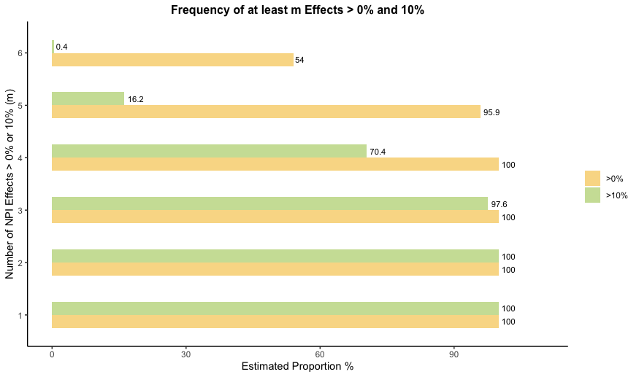
References

- Azimi S.S., et al. Estimation of the Basic Reproduction Number of the COVID-19 Epidemic in Iran. Med J Islam Repub Iran. 34: 95 (2020). doi: 10.34171/mjiri.34.95
- Banholzer N, van Weenen E, Lison A, Cenedese A, Seeliger A, Kratzwald B, et al. (2021) Estimating the effects of non-pharmaceutical interventions on the number of new infections with COVID-19 during the first epidemic wave. PLoS ONE 16(6): e0252827. https://doi.org/10.1371/journal.pone.0252827
- Bo et al. Effectiveness of Non-Pharmaceutical Interventions on COVID-19 Transmission in 190 Countries from 23 January to 13 April 2020. Int H Infect Dis. 102: 247-253 (2021) https://doi.org/10.1016/j.ijid.2020.10.066
- Chernozhukov, V., Kasahara, H. & Schrimpf, P. Causal impact of masks, policies, behavior on early covid-19 pandemic in the U.S. J. Econom. 220, 23–62 (2021).
- Dreher N., et al. Policy Interventions, Social Distancing, and SARS-CoV-2 Transmission in the United States: A Retrospective State-Level Analysis. Am J Med Sci. 2021. 361: 575-584. https://doi.org/10.1016/j.amjms.2021.01.007
- Ebrahim, S. et al. Reduction of COVID-19 Incidence and Nonpharmacologic Interventions: Analysis Using a US County–Level Policy Data Set (Preprint). Jmir preprint. 24614 (2020) doi:10.2196/preprints.24614.
- Esra R., et al. Evaluating the Impact of Non-Pharmaceutical Interventions for SARS-CoV-2 on a Global Scale. MedRxiv, 2020. doi: https://doi.org/10.1101/2020.07.30.20164939
- Flaxman, S., Mishra, S., Gandy, A. et al. Estimating the effects of non-pharmaceutical interventions on COVID-19 in Europe. Nature 584, 257–261 (2020). https://doi.org/10.1038/s41586-020-2405-7
- Ivorra, B., Ferrández, M., Vela-Pérez, M., & Ramos, A. Mathematical modeling of the spread of the coronavirus disease 2019 (COVID-19) taking into account the undetected infections. The case of China. Commun Nonlinear Sci Numer Simul. Vol. 88, 105303 (2020). doi:10.1016/j.cnsns.2020.105303
- Jalali, A. M. et al. Delayed Interventions, Low Compliance, and Health Disparities Amplified the Early Spread of COVID-19. Medrixiv (2020). doi:10.1101/2020.07.31.20165654.
- Leffler C.T., et al. Association of Country-wide Coronavirus Mortality with Demographics, Testing, Lockdowns, and Public Wearing of Masks. Am J Trop Med Hyg. 2020. 103: 2400-2411. https://doi.org/10.4269/ajtmh.20-1015
- Li Y., et al. The Impact of Policy Measures on Human Mobility, COVID-19 Cases, and Mortality in the US: A Spatiotemporal Perspective. Int J Environ Res Public Health. 2021; 18: 996. https://doi.org/10.3390/ijerph18030996
- Mishra, S., Scott, J.A., Laydon, D.J. et al. Comparing the responses of the UK, Sweden and Denmark to COVID-19 using counterfactual modelling. Sci Rep 11, 16342 (2021). https://doi.org/10.1038/s41598-021-95699-9
- Olney, A. M., Smith, J., Sen, S., Thomas, F. & Unwin, H. J. T. Estimating the Effect of Social Distancing Interventions on COVID-19 in the United States. Am. J. Epidemiol. 190, 1504–1509 (2021).
- Pozo-Martin F., et al. The Impact of Non-Pharmaceutical Interventions on COVID-19 Epidemic Growth in the OECD Member States. Eur J Epidemiol. 2021. https://doi.org/10.1007/s10654-021-00766-0
- Sharma M., et al. Understanding the Effectiveness of Government Interventions Against the Resurgence of COVID-19 in Europe. Nature Communications, 12 : 5820. (2021) doi: 10.1038/s41467-021-26013-4
- White, L. & Pagano, M. A likelihood-based method for real-time estimation of the serial interval and reproductive number of an epidemic. Stat Med. Vol. 27 (16), 2999-3016 (2008). doi:10.1002/sim.3136
- Zhang X. & Warner M.E. Covid-19 Policy Differences Across US States: Shutdowns, Reopening, and Mask Mandates. Int J Environ Res Public Health. 17: 9520 (2020). https://doi.org/10.3390/ijerph17249520

