Supplementary Information
High strength and low hysteresis hydrogel based sensing control IoT system for both visible self-monitoring and remote monitoring of massage pressure

Min Chen¹, Chengwei Wu¹, Wei Zhang¹*

¹State Key Laboratory of Structural Analysis, Optimization and CAE Software for Industrial Equipment, Department of Engineering Mechanics, Dalian University of Technology (DUT), Dalian 116024, China

* Correspondence should be addressed to Prof. Zhang (E-mail: wei.zhang@dlut.edu.cn).

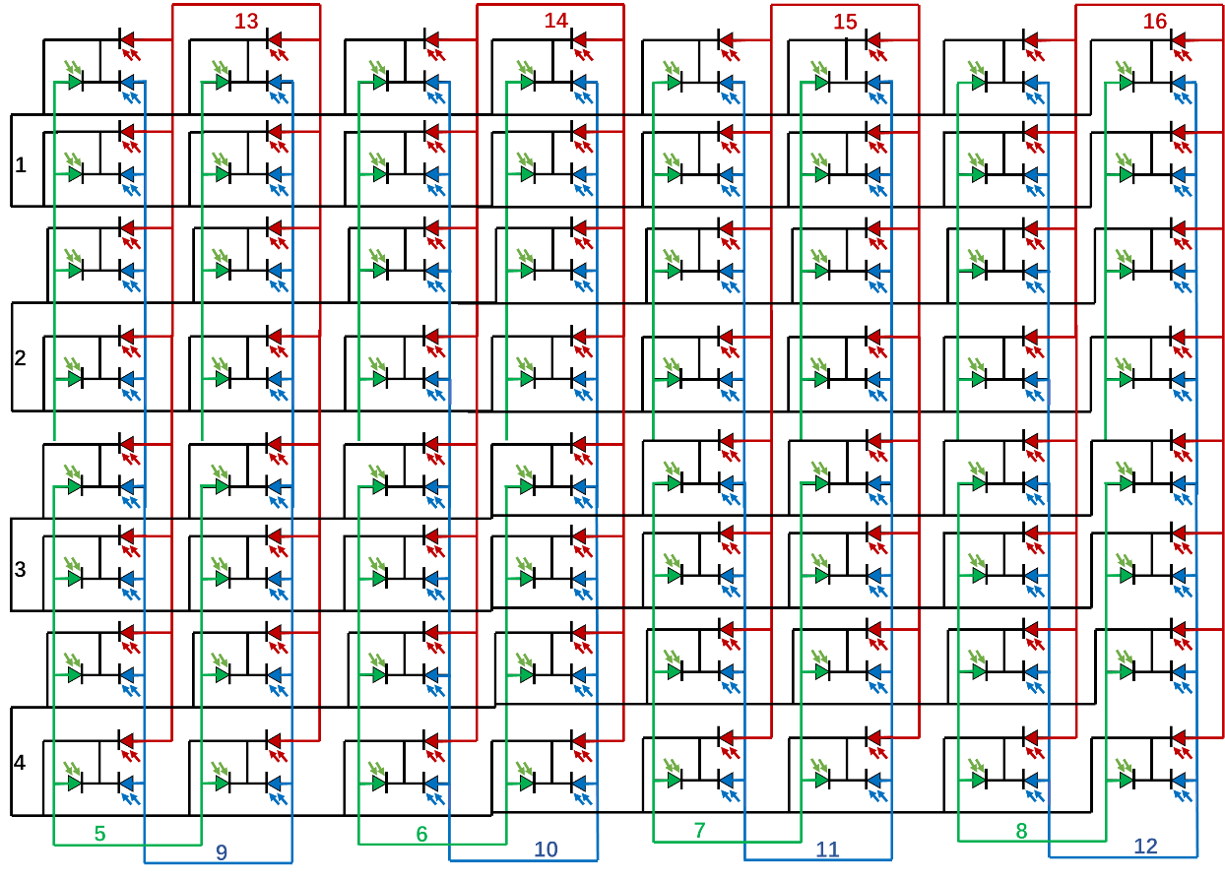
Fig. S1. Overall schematic of connection of LEDs arrays

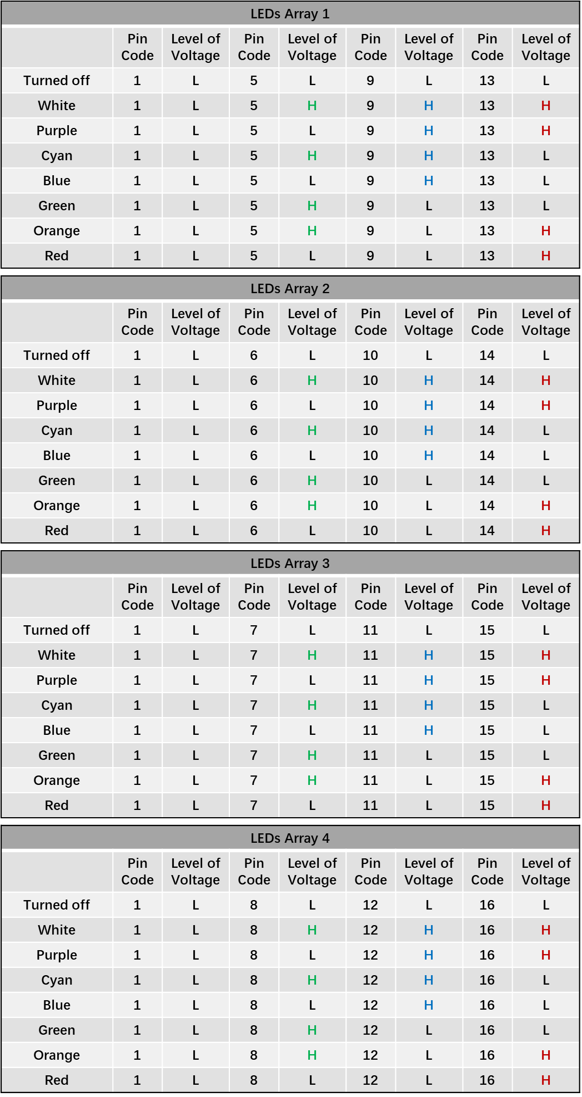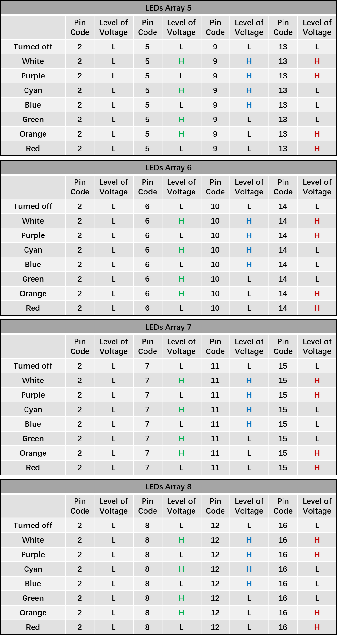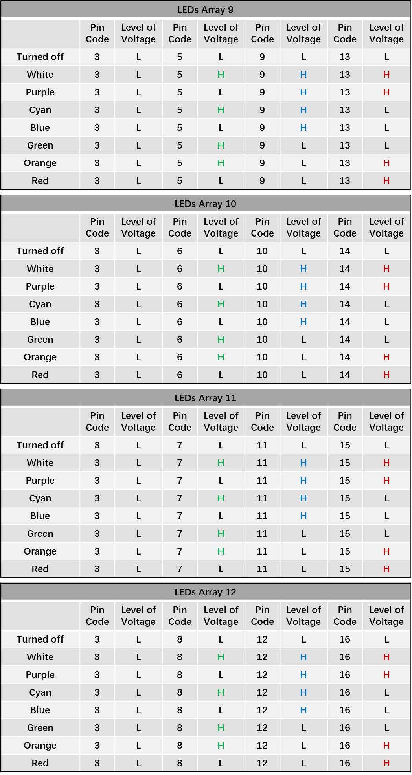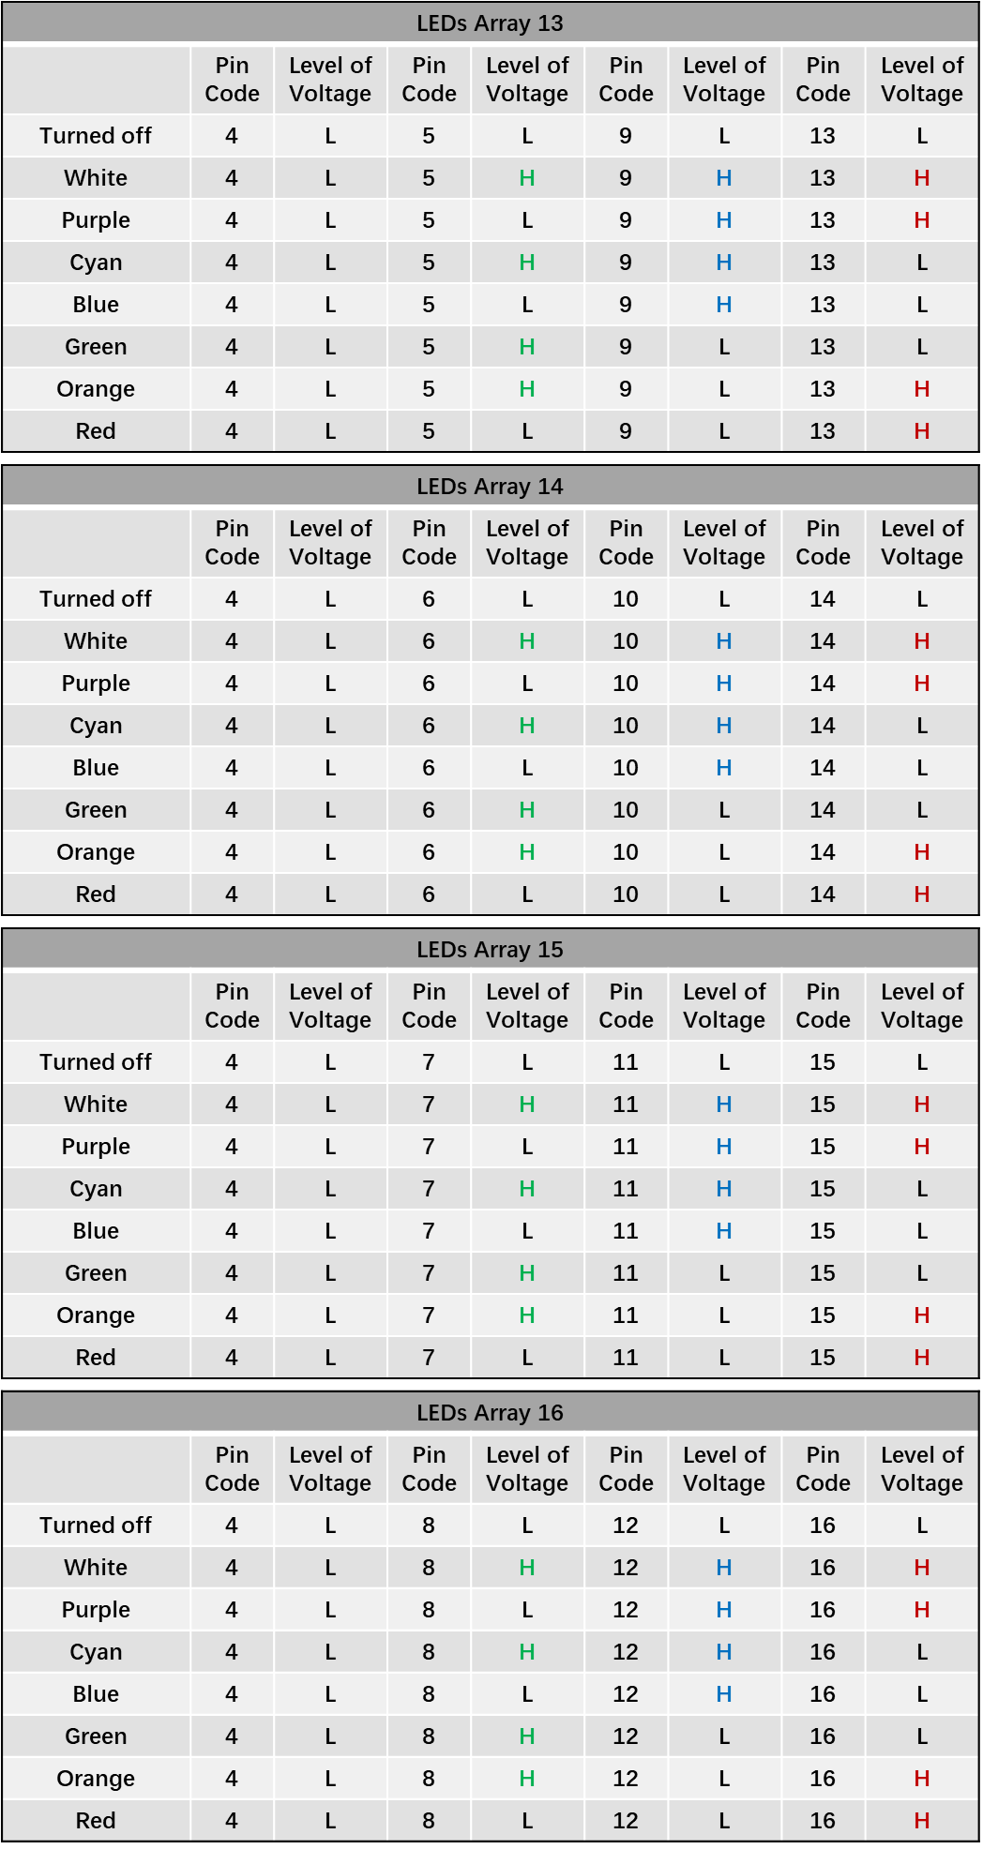
Fig. S2. Level of voltage of digital output pins to control different color states of the LEDs arrays.

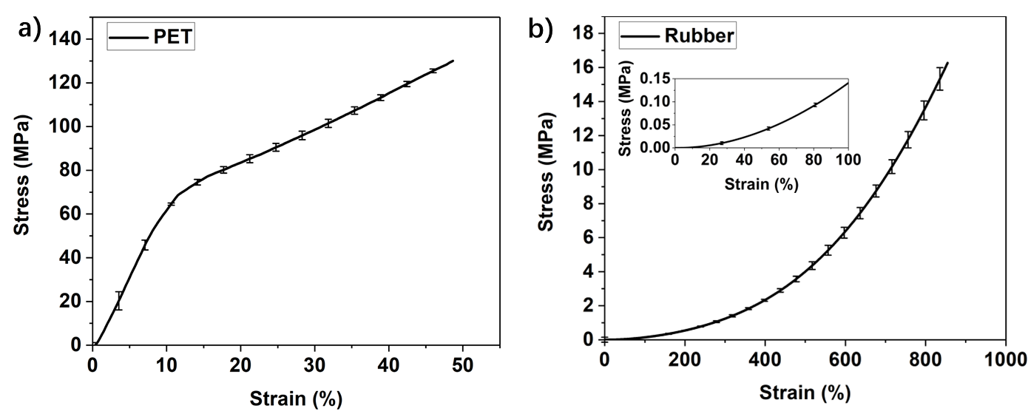
Fig. S3. a) the stress-strain curve of PET. b) the stress-strain curve of the rubber, the inset: the stress-strain curve between strain of 0 and 100% of the rubber.

