Supplementary Material

Supplementary Figures

Supplementary Figures
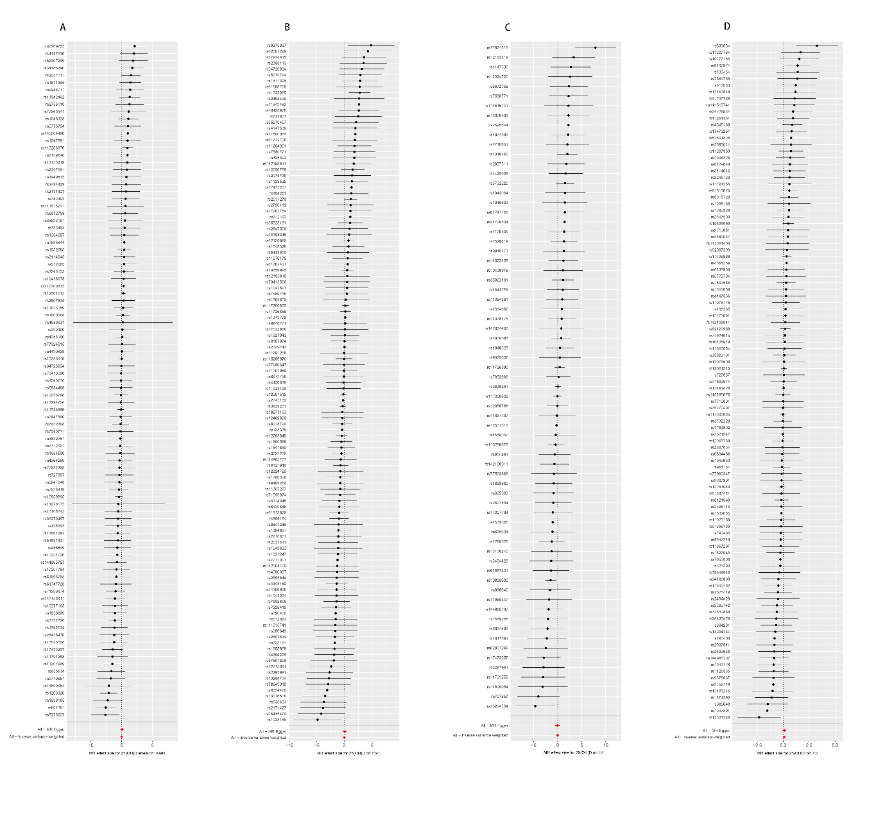
Supplementary Figure 1. MR effect size for 25(OH)D on sex hormones(A AMH, B FSH, C LH, and D E2).
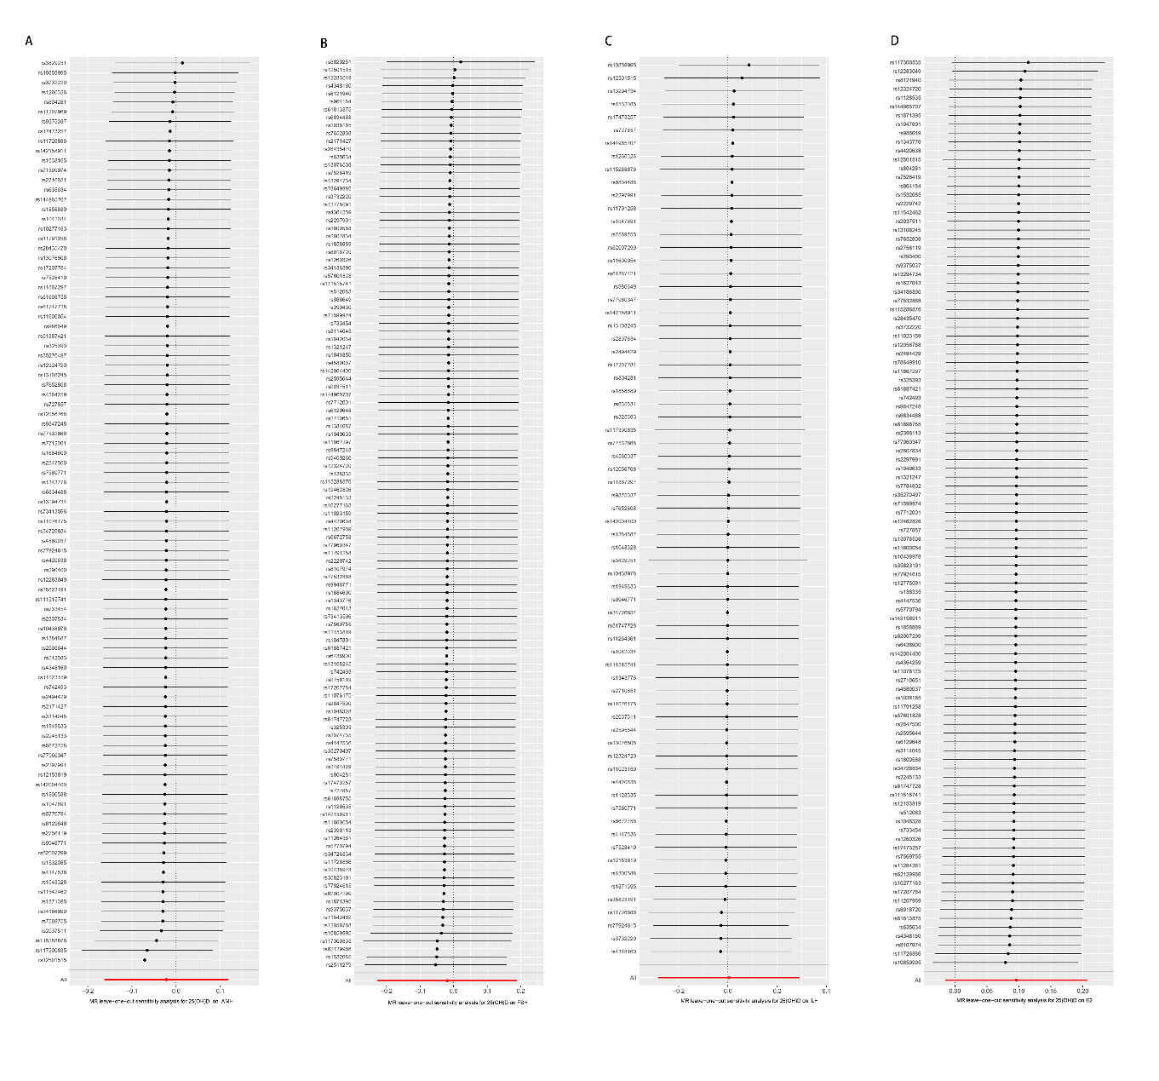
Supplementary Figure 2. The leave-one-out sensitivity analysis of associations between genetically predicted A AMH, B FSH, C LH, and D E2and 25(OH)D.

