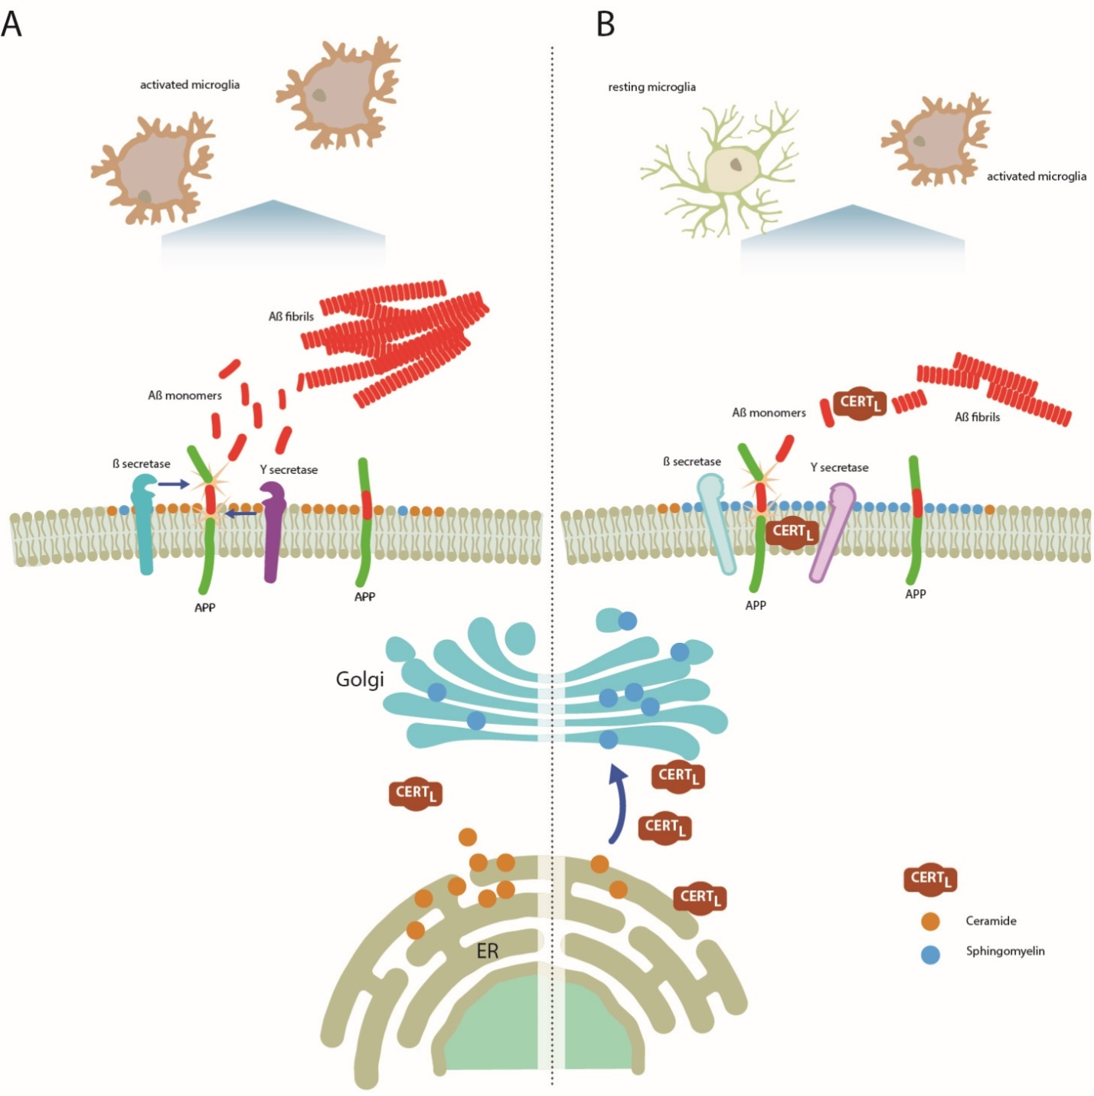
Schematic model of CERT_{L} action in AD. A) CERT_{L}concentration is decreased in AD neuronal cells. Consequently, the transport of Cer to the Golgi is impaired and Cer accumulates in the cell. Cer elevation stabilizes and favors the secretases activity. The amyloidogenic APP processing is favored and Aβ is produced. The neighboring microglia changes the resting status to activate. B) By overexpressing CERT_{L}the physiological transfer of Cer from the ER to the Golgi is restored favoring SM synthesis, which is intensified. The reduction of Cer levels in neuronal cells diminished secretases activity, reducing Aβ biogenesis. The interaction between CERT_{L} and APP may be important in stabilizing APP in the membrane and in protecting APP from secretase activity. Furthermore, CERT_{L} affects Aβ fibrilization by organizing Aβ into less neurotoxic aggregates that may be cleared from the brain more easily and reduces the number of activated microglia.

Supplementary methods
Lipidomics in CERT_{L} transfected HEK 293 cells
Transfection of CERT_{L} in HEK 293 cells. Wilde type HEK293 were cultured in DMEM supplemented with fetal bovine serum (FBS), Pen/Strep, and L-glutamine. Cells were seeded in 25 cm2 flasks and maintained in complete DMEM for 24 hours prior to the transfection. Cells were transfected with 4 µg pcDNA3.1-CERT_{L} (NM_005713.3) by lipofectamine 2000 (ThermoFisher -11668019) following the manufacturer’s instructions. Cells transfected with 4 µg of empty pcDNA3.1 were used as a control. After 72 hours, cells were washed three times with PBS, trypsinized, and centrifuged at 2000 x g for 5 min. Pellet was stored at -80 before the lipid analysis.
LipidomicsCell pellets containing 10 µg of DNA were homogenized in 700 μl of water and were mixed with 800 μl 1 N HCl:CH₃OH 1:8 (v/v), 900 μl CHCl₃ and 200 μg/ml of the antioxidant 2,6-di-tert-butyl-4-methylphenol (BHT; Sigma Aldrich). 3 μl of SPLASH® LIPIDOMIX® Mass Spec Standard (#330707, Avanti Polar Lipids) was spiked into the extract mix. The organic fraction was evaporated using a Savant Speedvac spd111v (Thermo Fisher Scientific) at room temperature, and the remaining lipid pellet was stored at - 20°C under argon.
Mass spectrometry.Just before mass spectrometry analysis, lipid pellets were reconstituted in 100% ethanol. Lipid species were analyzed by liquid chromatography electrospray ionization tandem mass spectrometry (LC-ESI/MS/MS) on a Nexera X2 UHPLC system (Shimadzu) coupled with hybrid triple quadrupole/linear ion trap mass spectrometer (6500+ QTRAP system; AB SCIEX). Chromatographic separation was performed on a XBridge amide column (150 mm × 4.6 mm, 3.5 μm; Waters) maintained at 35°C using mobile phase A [1 mM ammonium acetate in water-acetonitrile 5:95 (v/v)] and mobile phase B [1 mM ammonium acetate in water-acetonitrile 50:50 (v/v)] in the following gradient: (0-6 min: 0% B 6% B; 6-10 min: 6% B 25% B; 10-11 min: 25% B 98% B; 11-13 min: 98% B 100% B; 13-19 min: 100% B; 19-24 min: 0% B) at a flow rate of 0.7 mL/min which was increased to 1.5 mL/min from 13 minutes onwards. SM and CER, were measured in positive ion mode with a precursor scan of 184.1 and 264.4, respectively. Lipid quantification was performed by scheduled multiple reactions monitoring (MRM), the transitions being based on the neutral losses or the typical product ions as described above. The instrument parameters were as follows: Curtain Gas = 35 psi; Collision Gas = 8 a.u. (medium); IonSpray Voltage = 5500 V and −4,500 V; Temperature = 550°C; Ion Source Gas 1 = 50 psi; Ion Source Gas 2 = 60 psi; Declustering Potential = 60 V and −80 V; Entrance Potential = 10 V and −10 V; Collision Cell Exit Potential = 15 V and −15 V.The following fatty acyl moieties were taken into account for the lipidomic analysis: 14:0, 14:1, 16:0, 16:1, 16:2, 18:0, 18:1, 18:2, 18:3, 20:0, 20:1, 20:2, 20:3, 20:4, 20:5, 22:0, 22:1, 22:2, 22:4, 22:5 and 22:6
Data Analysis. Peak integration was performed with the MultiQuantTM software version 3.0.3. Lipid species signals were corrected for isotopic contributions (calculated with Python Molmass 2019.1.1) and were normalized to internal standard signals. Unpaired T-test p-values and FDR corrected p-values (using the Benjamini/Hochberg procedure) were calculated in Python StatsModels version 0.10.1.
Far Western blot
For far, Western experiments, human recombinant CERT_{L}(hCERT_{L}, 1875bp NP_005704.1) (80ng), produced as previously described (28), and Aβ peptide 1-42 (80ng) (Anaspec) were analyzed by SDSPAGE under reducing conditions. A 17kDa Lama antibody fragment (H6) with myc and hist6 tags (a kind gift of Dr A.J. Groot), was used as a negative control (80ng). Proteins were transferred to nitrocellulose membranes renatured in Tris-buffered saline (TBS) in the presence of Tween20 (0.05%) and probed for 1 hour at 37°C with 30µg/mL of CERT_{L} or Aβ peptide in the same buffer. Bound complexes were detected using polyclonal rabbit anti-CERTs (epitope 1-50 of human CERTs, Bethyl Laboratories), mouse anti-Aβ mAb 6E10 (Covance) and mouse mAb anti-human c-Myc (clone 9E10, Invitrogen). Finally, incubation with secondary goat anti-rabbit IRdye 800 and donkey anti-mouse IRdye 680 (Rockland Immunochemicals) was followed as described above.
Neuronal primary cell culture.
Rat hippocampal neuronal cultures were prepared as reported elsewhere(87). In brief, embryos from pregnant Wistar rats (Charles River) were removed on embryonic day 18. After removing the meninges, the hippocampi were insolated under the lupa preserved in the hibernate medium. Subsequently, they were incubated with trypsin for 20 minutesat 37ºC. Hippocampus were then transferred to a tube with DMEM complete medium. With a sterile glass pipette, the cells were disbanded doing up and down until the tissue was disaggregated/disintegrated and homogeneous. Cells were plated at ~80,000 cell/ 35mm Ø plate containing coverslips and incubated in Neurobasal medium (supplemented with B27) (Thermo Fisher Scientific) for 2-3 weeks. The medium was partially exchanged 24 hours after and then once a week.
Immunoassay for CERTs detection.
CERTs were quantified by enzyme-linked immunoassay or Western blot. In brief, microplates were coated with 100 μL of polyclonal rabbit 01 (2,46 mg/mL) diluted 1:1000 using coating buffer (50 mM carbonate pH 9.6), sealed with a plastic sticker and incubated for 1 h at 37ºC. To build up the standard curveserial dilutions of recombinant CERTs, produced as previously explained (28),were diluted in 10% BSA, 0.02% Tween-20 in PBS. Biotinylated polyclonal rabbit anti-CERTs02, was used as a detection antibody diluted 1:500 in 1% BSA and 0.02% Tween-20 in PBS and incubated for 1 h at 37 ºC. Blocking, washes, and absorbance were performed as described in method sections immunoassays. Cortex sample were lysed in composed by 0.1% SDS, 0.1% Triton X-100, 1% glycerol, 1 mM EDTA, 1 mM EGTA, PhosSTOP and protein inhibitors (Roche). 40µg of protein extracted separated in SDS-PAGE electrophoresis and blotted onto nitrocellulose membrane. The membrane was probed with anti-GAPDH antibody (10R-G109A, Fitzgerald) as internal control and anti CERTs (epitope 300-350 of human CERTs, Bethyl Laboratories). After incubation with donkey anti-mouse, IRdye680, and anti-rabbit IRdye800 (Rockland Immunochemicals) diluted 1:10,000 in Odyssey blocking buffer, the membrane was scanned and analyzed with Odyssey imager Li-Cor. The intensities were measured with Odyssey imager Li-Cor.
  - CERTs inhibitor administration
HPA-12 was prepared in control solution PEG400/PBS 1:4 (V/V). Before re-suspension vehicle wassterilized by filtration and pH was adjusted to 7.4. PEG400/PBS was warmed up to 37°C and vortexed tocompletely dissolve the compound. HPA-12 was administered subcutaneously (SC) for 4-weeks at the dose 4 µg / g animals every 48 hours.The volume injected per animal was of 0.15 mL with insulin syringes.HPA-12 was tested on8-14 months old mice. The AD transgenic (E4FAD and E3FAD) mice were purchased from Dr. Mary Jo LaDu (University of Illinois at Chicago) and bred in house as described elsewhere (88).The mice were housed socially on a 12-hour day-night cycle and had ad libitum access to food and water. All experiments were approved by the Animal Welfare Committee of Maastricht University and followed the laws, rules, and guidelines of the Netherlands.

Cytokines analysis
Cytokines were measured in total protein homogenate extracted from the cortex in lysis buffer containing 0.1% SDS, 0.1% Triton X-100, 1% glycerol, 1 mM EDTA, 1 mM EGTA, phosphatase and protease inhibitors. Samples were diluted to 0.1mg / mL total protein and cytokines (IFN-γ, IL-1β, TNF-α, IL-6, IL-4, IL-10, and IL-33) were measured on Meso Scale Discovery V-PLEX custom mice (K152A0H-1) and read on a Meso Scale Discovery SECTOR 600 (Meso Scale Discovery).

Supplementary figures

Supplementary figure 1. Immunostaining of CERT_{L}in the brain and analysis of CERT_{L} Aβ interaction by far Western blot.A-B) Far-Western blot analysis of CERT_{L}and IgG (negative control) interaction with Aβ₁₋₄₂ peptide and a 17 kDa Lama antibody fragment (H6) (negative control).
Supplementary figure 2.CERTs concentration in WT compared to 5xFAD and evidence of CERT_{L}transduction in vitro and in vivo.A) AAVs transduction on neuronal primary cell culture. Neonatal rat neuronal cells were isolated from the cortex of pups at embryonic day 18. After 2-3 weeksin Neurobasal medium were incubated with AAVs particles at the dose of 100 multiplicity of infection (MOI) for 6 days. CERT_{L} was visualized in red and nuclei in blue. B) A timeline describing the experimental design to assess transduction efficiency in vivo. C) AAVs transduction in WT animals 1, 2, 6- and 12-weeks post-injection by immunofluorescence. CERT_{s}were visualized in redand nuclei in blue (scale bar 50 μm). D) Immunofluorescencestaining on brain sections showing injections site(CERT_{L}in redand nuclei in blue). Scale bars 200 and 50 μm. M1:motor sensory cortex 1; M2:motor sensory cortex 2; LV: lateral ventricle; I,II,III, IV, and Vcortical layers. E)AAVs were tested for brain transduction in WT animals 1, 2, 6- and 12-weeks post-injection by qPCR. Bars represent the mean ± S.E.M 3/per group(ANOVA; *p< 0.05).

Supplementary figure 3. Sphingolipid changes in the hippocampus region of AAV-control or AAV-CERTL treated WT and 5xFAD mice.Sphingolipids levels were measured in the hippocampus by HPLC-MS/MS. Ceramides were classified based on acyl chain number of carbons (Cer d18:1/16:0, Cer d18:1/18:0, Cer d18:1/18:1, Cer d18:1/20:0, Cer d18:1/22:0 and Cer d18:1/24:1). as well as sphingomyelin (SM d18:1/16:0, SM d18:1/18:0, SM d18:1/18:1, SM d18:1/20:0, SM d18:1/22:0 and SM d18:1/24:1). Ceramides levels were expressed as pg / mg tissue, while sphingomyelins were expressed as pmol/mg tissue. Bars represent the mean ± S.E.M per group(Two-way ANOVA, LSD, significant effects, *p< 0.05; **p<0.01; ***p<0.001).

Supplementary figure 4. Sphingolipid changes in plasmaof AAV-control or AAV-CERTL treated WT and 5xFAD mice. Plasma was collected 1 week before AAV injection (time1), 2 (time 2), and 6 (time 3) weeks after injection, and when the experiment was ended (time 4). Sphingolipids levels were measured at each time point by HPLC-MS/MS. Ceramides were classified based on acyl chain number of carbons (Cer d18:1/16:0, Cer d18:1/18:0, Cer d18:1/18:1, Cer d18:1/20:0, Cer d18:1/22:0 and Cer d18:1/24:1). Ceramides concentration is expressed in µ Molarity. Bars represent the mean ± S.E.M per group(Two-way ANOVA, Bonferroni correction, significant effects, WT AAV-control vs 5xFAD AAV-CERT_{L} §p<0.05; 5xFAD AAV-control vs 5xFAD AAV-CERT_{L} *p<0.05).

Supplementary figure 5.Western blot analysis of APP fragments to study APP processing. TBS cortex homogenate wasanalyzed by Western blot FL-APP, CTFβ, and Aβ bands were detected with 6E10 antibody at the band corresponding to respectively of 100,15, and 6-4kDa.

Supplementary figure 6. Cytokines and apoptotic markers Bcl-2 and Caspase 3 were unaffected by AAV-CERT_{L} treatment.A) Cytokines measurements in brain homogenate with multiplex system IFN-γ, IL-1β, TNF-α, IL-6, IL-33, IL-4, and IL-10 (5-10 number of animals per group).B) Analysis of gene expression of apoptotic markers Bcl-2 and Caspase-3 (4-5 number of animals per group, two-way ANOVA, Bonferroni correction).

 | Cortex |  |  |  |  | Hippocampus |  |  |  |  | Cerebellum
 | WT (N=11) |  | 5xFAD (N=12) |  |  | WT (N=11) |  | 5xFAD (N=12) |  |  | WT (N=11) |  | 5xFAD (N=12)
Sphingolipid species | Mean | STDEV | Mean | STDEV | p-value | Mean | STDEV | Mean | STDEV | p-value | Mean | STDEV | Mean | STDEV | p-value
SPH | 0.3 | 0.2 | 0.3 | 0.1 | 0.9475 | 0.2 | 0.1 | 0.3 | 0.1 | 0.2347 | 0.4 | 0.1 | 0.3 | 0.1 | 0.1823
SPA | 0.5 | 0.2 | 0.5 | 0.2 | 0.5042 | 0.3 | 0.1 | 0.5 | 0.2 | ↑0.0216* | 0.4 | 0.2 | 0.4 | 0.1 | 0.9206
S1P | 2.8 | 1.6 | 3.0 | 1.6 | 0.8084 | 2.0 | 0.8 | 3.0 | 1.8 | ↑0.0038* | 3.2 | 1.5 | 3.6 | 2.3 | ↑0.0123*
Cer d18:1/14:0 | 0.1 | 0.1 | 0.1 | 0.0 | 0.8960 | 0.0 | 0.0 | 0.0 | 0.0 | 0.4043 | 0.0 | 0.0 | 0.0 | 0.0 | 0.5884
Cer d18:1/16:0 | 0.8 | 0.3 | 1.1 | 0.3 | ↑0.0080* | 0.6 | 0.3 | 0.8 | 0.2 | ↑0.0400* | 0.5 | 0.3 | 0.6 | 0.2 | 0.6812
Cer d18:1/18:1 | 0.2 | 0.1 | 0.2 | 0.1 | 0.0531 | 0.1 | 0.1 | 0.2 | 0.1 | ↑0.0050* | 0.1 | 0.0 | 0.1 | 0.0 | 0.9309
Cer d18:1/18:0 | 40.1 | 14.0 | 43.9 | 10.5 | 0.4833 | 36.8 | 10.8 | 43.7 | 15.8 | 0.0959 | 14.6 | 4.7 | 14.3 | 3.9 | 0.8843
Cer d18:1/20:0 | 1.4 | 0.4 | 1.7 | 0.4 | 0.1361 | 1.0 | 0.3 | 1.4 | 0.3 | ↑0.0041* | 0.8 | 0.2 | 0.9 | 0.2 | 0.6595
Cer d18:1/22:0 | 0.6 | 0.2 | 0.7 | 0.2 | 0.1888 | 0.4 | 0.2 | 0.6 | 0.2 | ↑0.0222* | 0.6 | 0.2 | 0.6 | 0.2 | 0.9508
Cer d18:1/24:1 | 50.5 | 25.0 | 55.9 | 20.6 | 0.5752 | 31.3 | 11.1 | 32.1 | 9.6 | 0.7817 | 101.7 | 57.9 | 90.7 | 36.9 | 0.5888
Cer d18:1/24:0 | 0.4 | 0.2 | 0.5 | 0.2 | 0.5214 | 0.2 | 0.1 | 0.4 | 0.2 | 0.0666 | 0.5 | 0.2 | 0.5 | 0.2 | 0.9824
Total SM | 2592.1 | 1221.9 | 2895.1 | 888.2 | 0.2631 | 4041.1 | 1926.9 | 5050.3 | 3730.6 | 0.4308 | - | - | - | - | -

Supplementary Table 1 Sphingolipid levels on cortex, hippocampus, and cerebellum of WT and 5xFAD treated with AAV-control
(student′s t‐test*p<0.05)
↑ 5xFAD mean significantly bigger than WT animals

