Supplementary materials

Causality of Genetically Determined Monounsaturated Fatty Acids on Risk of Cardiovascular Disease: A Mendelian Randomization Study
Authors:
- Danial Habibi; Ph.D., Department of Biostatistics and Epidemiology, School of Health, and Student Research Committee, School of Health, Isfahan University of Medical Sciences, Isfahan, Iran. Email: dhabibi67@gmail.com
- Mahdi Akbarzadeh; Ph.D., Cellular and Molecular Endocrine Research Center, Research Institute for Endocrine Sciences, Shahid Beheshti University of Medical Sciences, Tehran, Iran. Email: akbarzadeh.ms@gmail.com
- Farshad Teymoori, Ph.D., Nutrition and Endocrine Research Center, Research Institute for Endocrine Sciences, Shahid Beheshti, Tehran, Iran. Email: teymoori.f68@gmail.com
- Sahand Tehrani Fateh; MD, School of Medicine, Tehran University of Medical Sciences, Tehran, Iran. Email: Sahh.tf@gmail.com
- Sajedeh Masjoudi, MSc., Cellular and Molecular Endocrine Research Center, Research Institute for Endocrine Sciences, Shahid Beheshti University of Medical Sciences, Tehran, Iran. Email: smasjoodi07@gmail.com
- Amir Hossein Saeidian, Ph.D., Center for Applied Genomics, The Children’s Hospital of Philadelphia, Abramson Research Building, Suite 1016I, 3615 Civic Center Boulevard, Philadelphia, PA, 19104-4318, USA, E-mail: saeidiana@chop.edu
- Farhad Hosseinpanah, MD, Obesity Research Center, Research Institute for Endocrine Sciences, Shahid Beheshti University of Medical Sciences, Tehran, Iran. Email: fhospanah@endocrine.ac.ir
- Noushin Mosavi; Ph.D., Department of Metabolism, digestion and reproduction, Imperial College London, Email: noushin.masoudi16@gmail.com
- Hakon Hakonarson, MD, PhD, Center for Applied Genomics, The Children’s Hospital of Philadelphia, Abramson Research Building, Suite 1016I, 3615 Civic Center Boulevard, Philadelphia, PA, 19104-4318, USA, Department of Pediatrics, University of Pennsylvania Perelman School of Medicine, Philadelphia, PA, USA, Division of Human Genetics, The Children’s Hospital of Philadelphia, Philadelphia, PA, USA, E-mail: hakonarson@chop.edu
- Fereidoun Azizi; MD, Endocrine Research Center, Research Institute for Endocrine Sciences, Shahid Beheshti University of Medical Sciences, Tehran, Iran. Email: azizi@endocrine.ac.ir
- Alireza Soleymani T, MSc., International Artificial Intelligence Department, School of Management, National Yunlin University of Science and Technology, Douliu, Taiwan. Email: M11163022@yuntech.edu.tw
- Mehdi Hedayati; Ph.D., Cellular and Molecular Endocrine Research Center, Research Institute for Endocrine Sciences, Shahid Beheshti University of Medical Sciences, Tehran, Iran. Email: hedayati47@gmail.com
- Maryam Sadat Daneshpour*; Ph.D., Cellular and Molecular Endocrine Research Center, Research Institute for Endocrine Sciences, Shahid Beheshti University of Medical Sciences, Tehran, Iran. Email: daneshpour@sbmu.ac.ir
- Marjan Mansourian*; (Ph.D.), Epidemiology and Biostatistics Department, School of Health, Isfahan University of Medical Sciences, Isfahan, Iran; Email: jmansourian@gmail.com

Corresponding authors:
Marjan Mansourian (Ph.D.),
Department of Automatic Control, Biomedical Engineering Research Center, Universitat Politècnica de Catalunya, BarcelonaTech (UPC), Building H, Floor 4, Av. Diagonal 647, 08028 Barcelona, Spain, Email: marjan.mansourian@upc.edu, Child Growth and Development Research Center, Research Institute for Primordial Prevention of Non-Communicable Disease, Isfahan University of Medical Sciences, Isfahan, Iran. Tel: +98-9131133949, Fax: +983137927658 Email: j_mansourian@hlth.mui.ac.ir
Maryam Sadat Daneshpour (Ph.D.), Associate Professor. Cellular and Molecular Endocrine Research Center, Research Institute for Endocrine Sciences, Shahid Beheshti University of Medical Sciences. Email: daneshpour@sbmu.ac.ir; P.O. Box: 19395- 4763, 1985717413, Tel: +98 (21) 22432500, Fax: +98 (21) 22402463.
* These authors contributed equally: Marjan Mansourian and Maryam Sadat Daneshpour.
These authors contributed equally: Danial Habibi and Mahdi Akbarzadeh.

Contents
Figure S1. Diagram of Mendelian randomization framework . 3
Figure S2. Display relationship of the undefined causal variables to CVD disease………………………………4
Figure S3. Scatter plot showing the genotype summary level data points and the fitted MR-Egger model…………………………………………………………………………………………………………………………………………….... 5
Figure S4. The investigating of outliers based on MR-PRESSO, RadialMR, and Cook's distance ………...7
Figure S5. Comparison of the causal estimates from the various Mendelian randomization methods and scatter plot of the potential effects of MUFA-association SNPs on cardiovascular diseases………………16
Figure S6. Leave-one-out plot to assess if a single variant is driving the association between MUFA and cardiovascular diseases……………………………………………………………………………………………………………………..22
Figure S7. Funnel plot of causal association between MUFA and cardiovascular diseases…………………24
Figure S8. Forest plot of variant specific inverse variance estimates for causal association between MUFA and cardiovascular diseases………………………………………………………………………………………………………………26
Figure S9. Densities of the IV estimates using different values of the phi parameter………………………. 28

Figure S1. Diagram of Mendelian randomization framework in the current paper.
MR utilizes genetic variation as an instrumental variable (IV) to investigate the causal association between exposure and outcome in non-experimental data. To utilize a genetic variant to be a valid instrumental variable, several main assumptions should be satisfied. The IVs (SNPs) are strongly associated with exposure (s) and should be clear quantifiably. (ii) The SNPs are not linked with any confounder of the exposure-outcome association. (iii) The SNPs do not affect the outcome, except possibly through their association with the exposure (s).

SNPs related to Monounsaturated Fatty Acids
Confounders
Monounsaturated Fatty Acids
Angina, atherosclerotic, ischemic heart disease, myocardial infarction, and high blood pressure
Association
Association only by exposure
Causal
No Association
Mendelian Randomization design

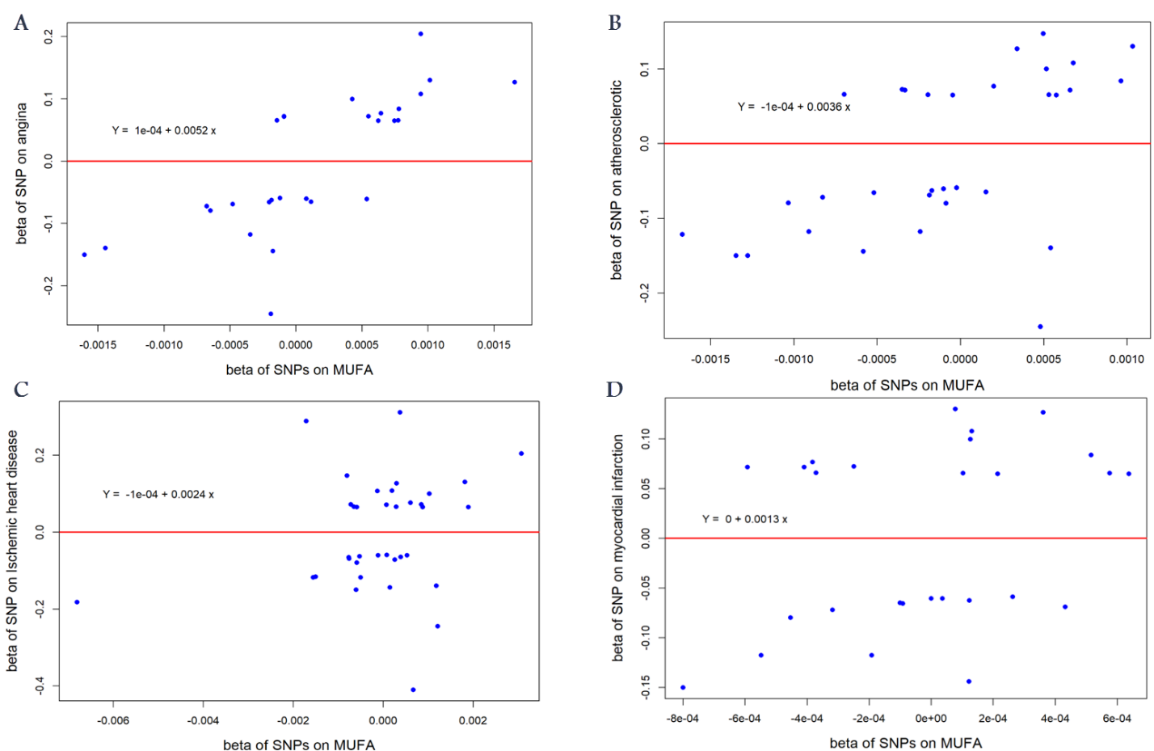
Figure S2. Display relationship of the undefined causal variables to CVD disease.

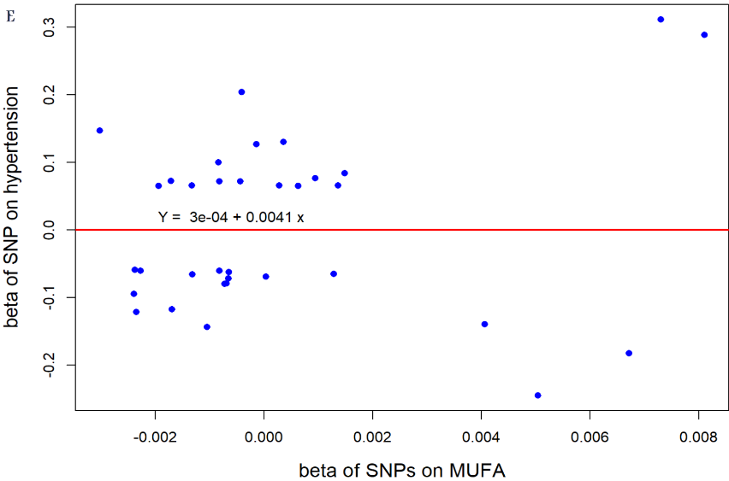

A: Angina~MUFA; B: Atherosclerotic~MUFA; C: Ischemic heart disease~MUFA; D: Myocardial infarction ~MUFA; E: Hypertension ~MUFA.

Figure S3. Scatter plot showing the genotype summary level data points and the fitted MR-Egger model.

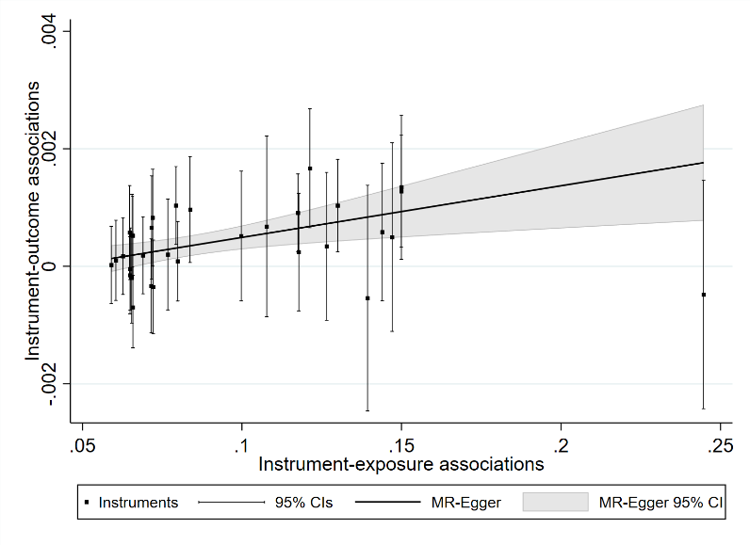
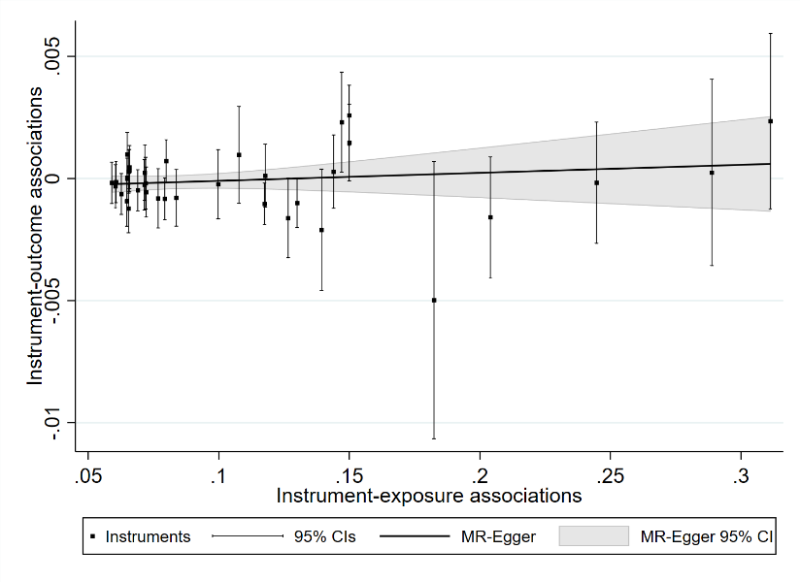
A) Angina B) Atherosclerotic

C) Ischemic heart disease D) Myocardial infarction
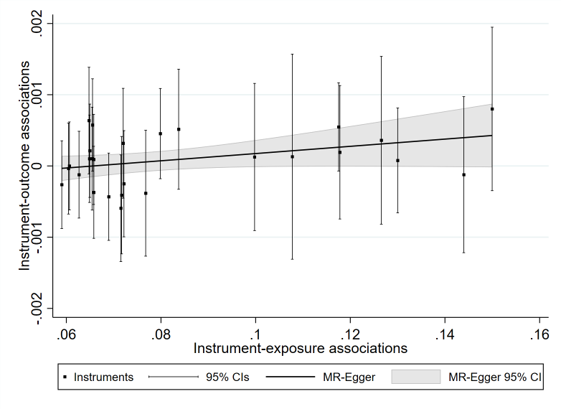
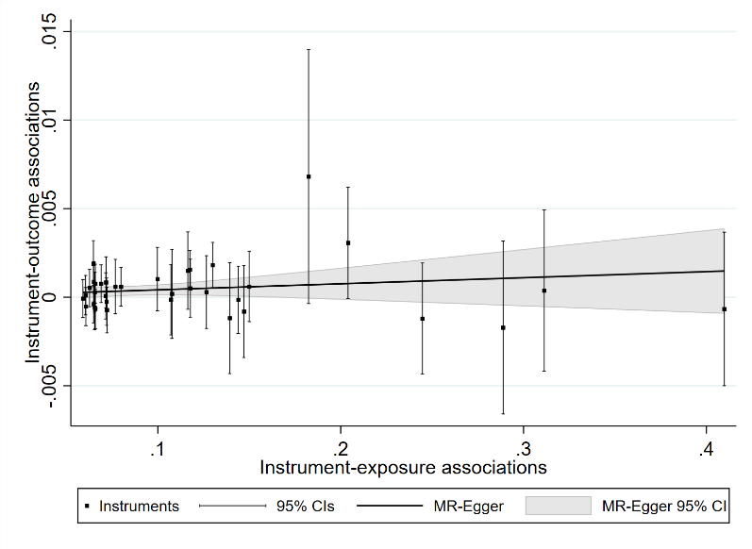

E) Hypertension

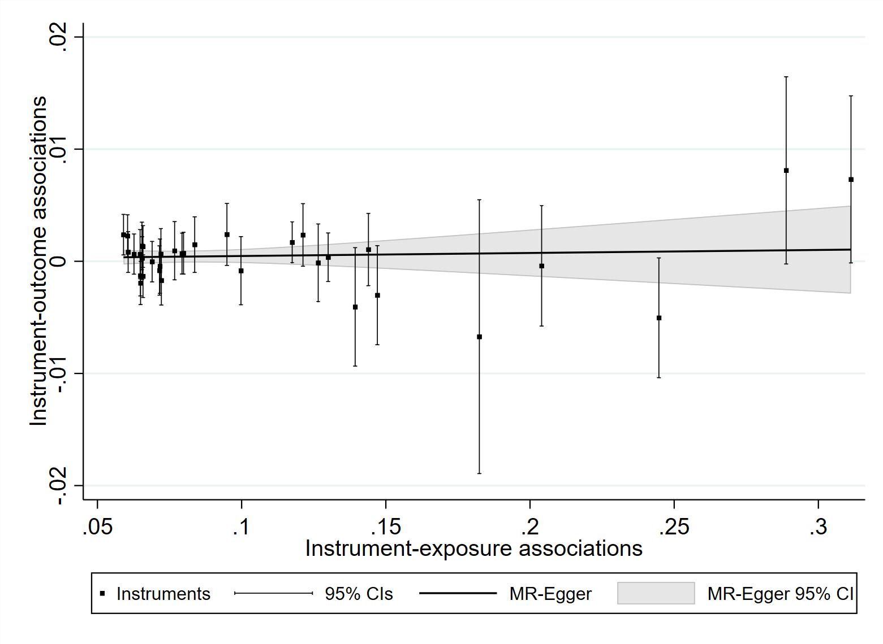

Figure S4. The investigating of outliers based on MR-PRESSO, RadialMR, and Cook's distance.
To identify outliers SNPs, we used several methods, including MR-PRESSO, RadialMR, and Cook's distance.
- Angina
The following figure reveals the results of them. As seen, Cook's distance was outperformed by others. As a result, we used Cook's distance to detect the potential outlier and influential point.

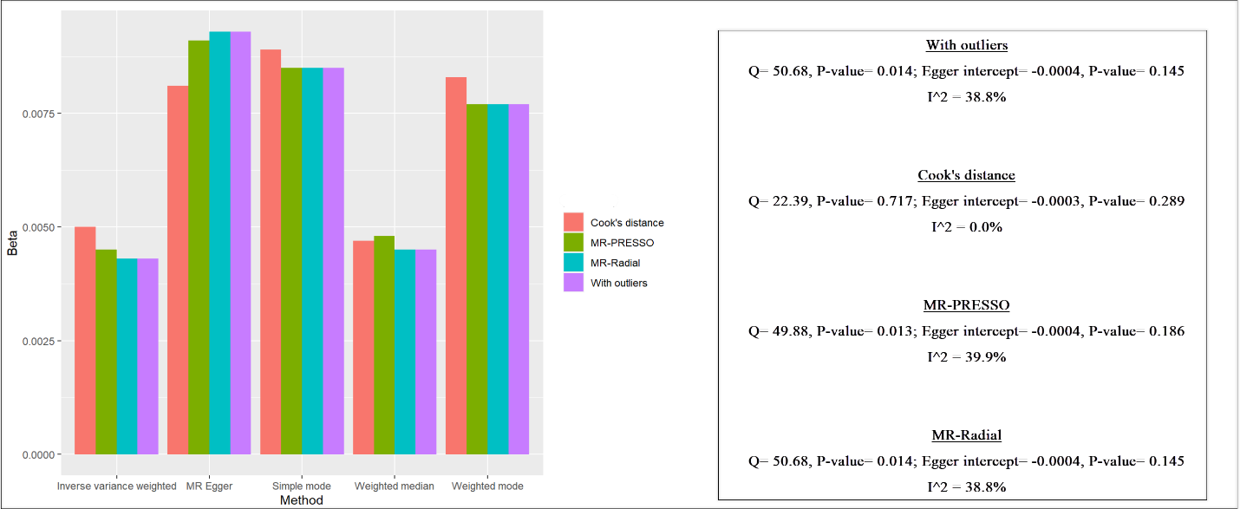
When data was with the outlier and influential points, we observed that heterogeneity existed [Q=50.68, P-value= 0.014; I2=38.8%; Egger intercept= -0.0004, P-value=0.145]. After applying MR-PRESSO, RadialMR, and Cook's distance, we found that these approaches could reduce the heterogeneity [Q=49.88, P-value=0.013; I2=39.9%; Egger intercept=-0.0004, P-value=0.186], [Q=50.68, P-value=0.014; I2=38.8%; Egger intercept=-0.0004, P-value=0.145], and [Q=22.39, P-value=0.717; I2=0.0%; Egger intercept=-0.0003, P-value=0.289], respectively.
In these methods, Cook's distance outperformed others and dispelled the heterogeneity. The following figure displays the identifying steps and results of Cook's distance. We detected four SNPs (rs10152355, rs591592, rs77548999, and rs1860356), which could affect the results.
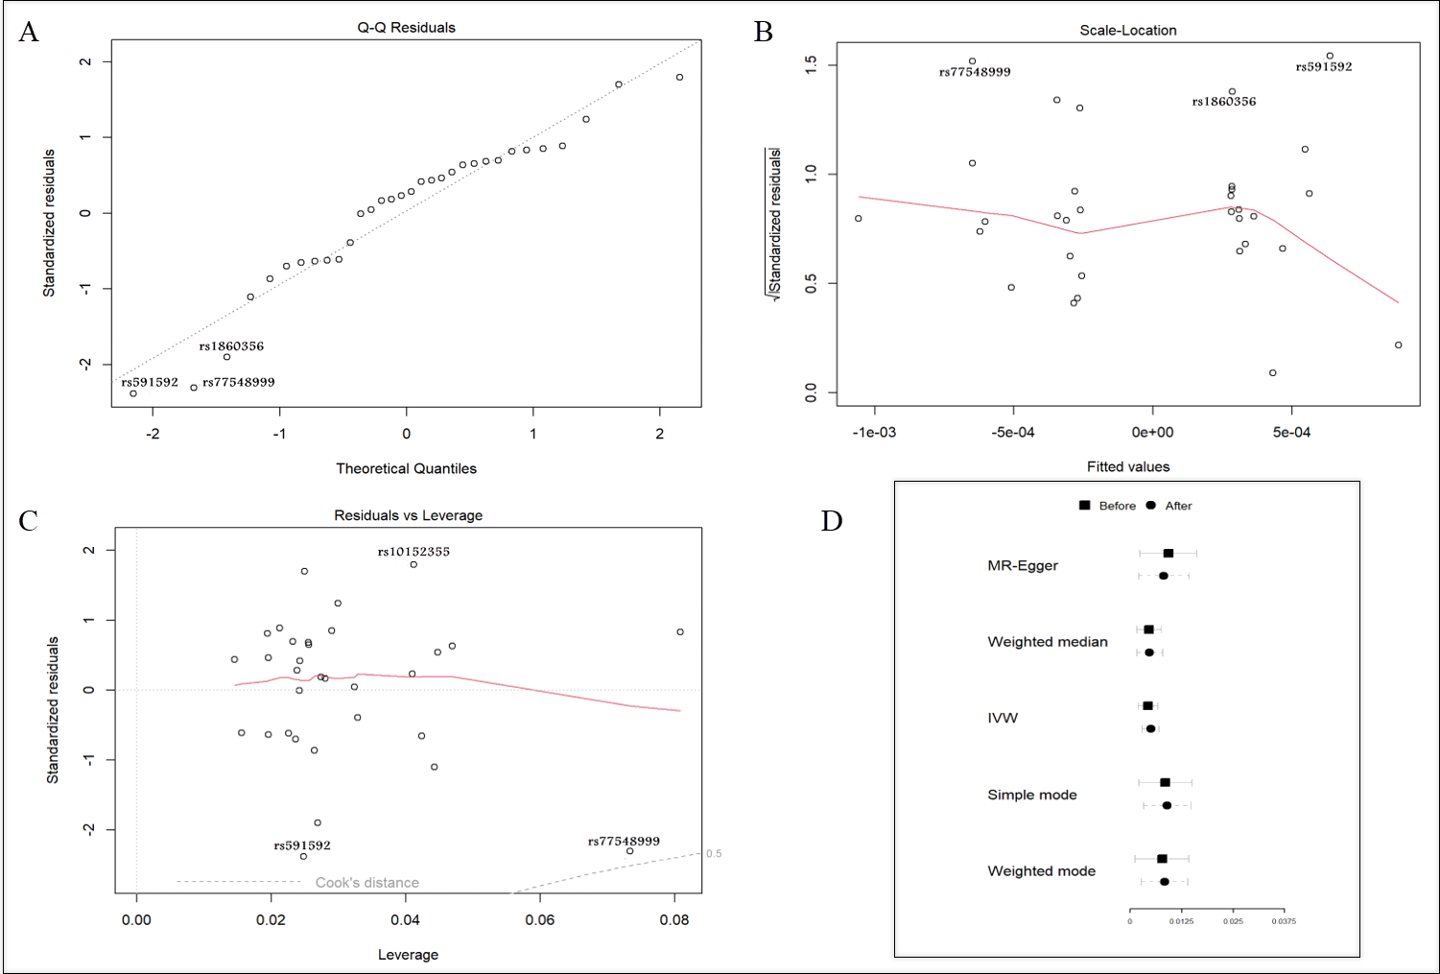
A: q-q plot; B: standardized residual; C: Cook's distance; D: the result (based on beta) of the before and after cook's distance; IVW: Inverse variance weighted
Figure A shows the q-q plot to detect the outlier, and we identified three SNPs (rs591592, rs77548999, and rs1860356). Figure B displays standardized residual, and we again found the same SNPs (rs591592, rs77548999, and rs1860356), which were previously observed in the q-q plot. Figure C demonstrates the Cook's distance, and we here realized three SNPs (rs10152355, rs591592, and rs77548999), which potential influential point could affect the results. Figure D exhibited the result (based on beta) of the before and after cook's distance.

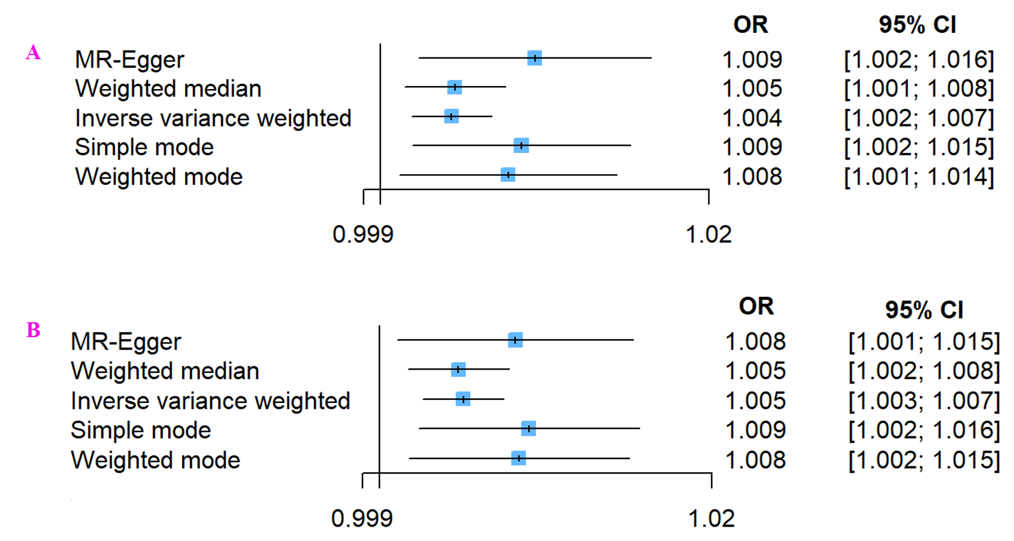
A: Main analysis (with potential outliers, influential points); B: After used Cook's distance (remove outliers); IVW: Inverse variance weighted; OR: odds ratio; CI: confidence interval.

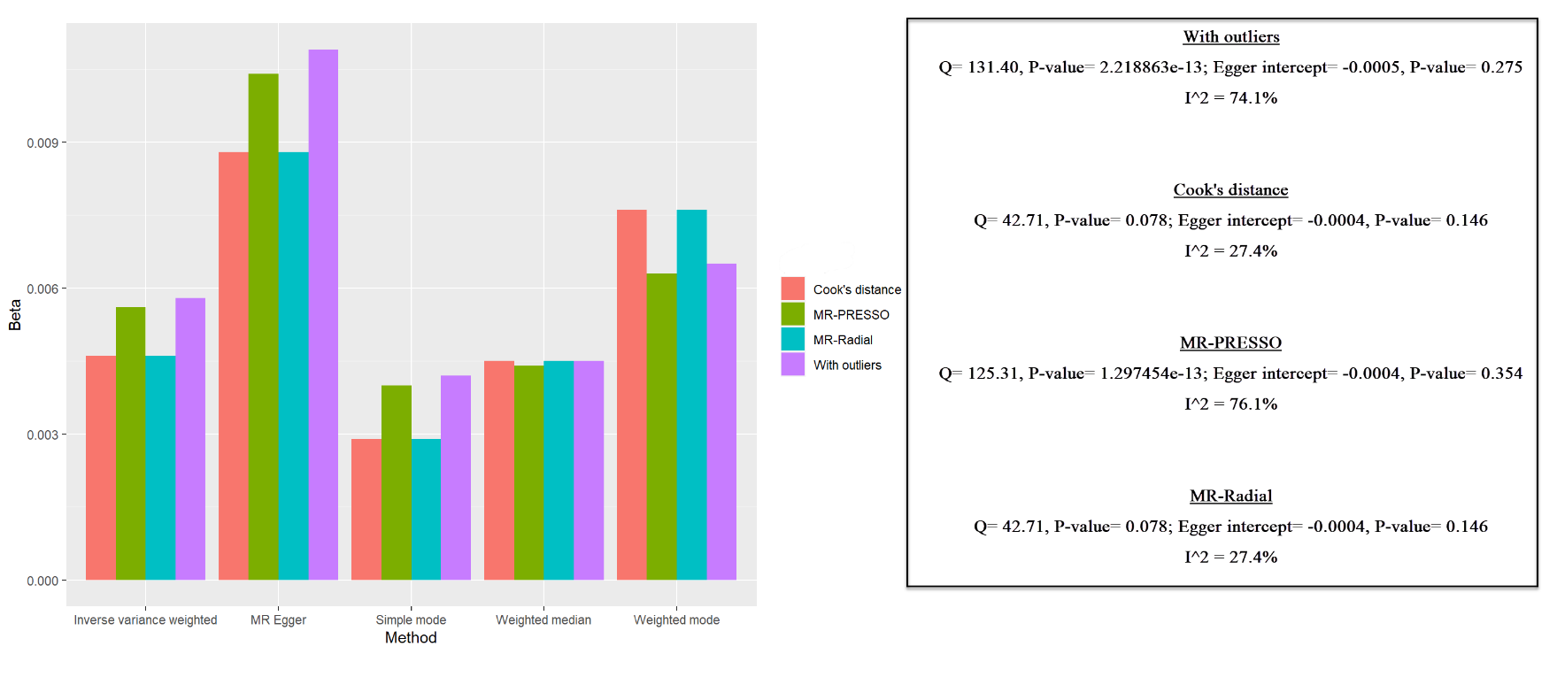
- Atherosclerotic
When data was with the outlier and influential points, we observed that heterogeneity existed [Q=131.40, P-value= 2.218863e-13; I2=74.1%; Egger intercept= -0.0005, P-value=0.275]. After applying MR-PRESSO, RadialMR, and Cook's distance, we found that these approaches could reduce the heterogeneity [Q=125.31, P-value=1.297454e-13; I²=76.1%; Egger intercept=-0.0004, P-value=0.354], [Q=42.71, P-value=0.078, I²=27.4%; Egger intercept=-0.0004, P-value=0.146], and [Q=42.71, P-value=0.078, I2=27.4%; Egger intercept=-0.0004, P-value=0.146], respectively.
In these methods, RadialMR and Cook's distance outperformed other than MR-PRESSO and dispelled the heterogeneity. The following figure displays the identifying steps and results of RadialMR.
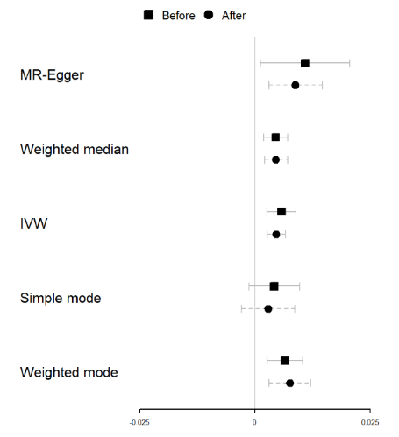
We detected three SNPs (rs2642636, rs429358, and rs56289821), which could affect the results, as shown following figure.

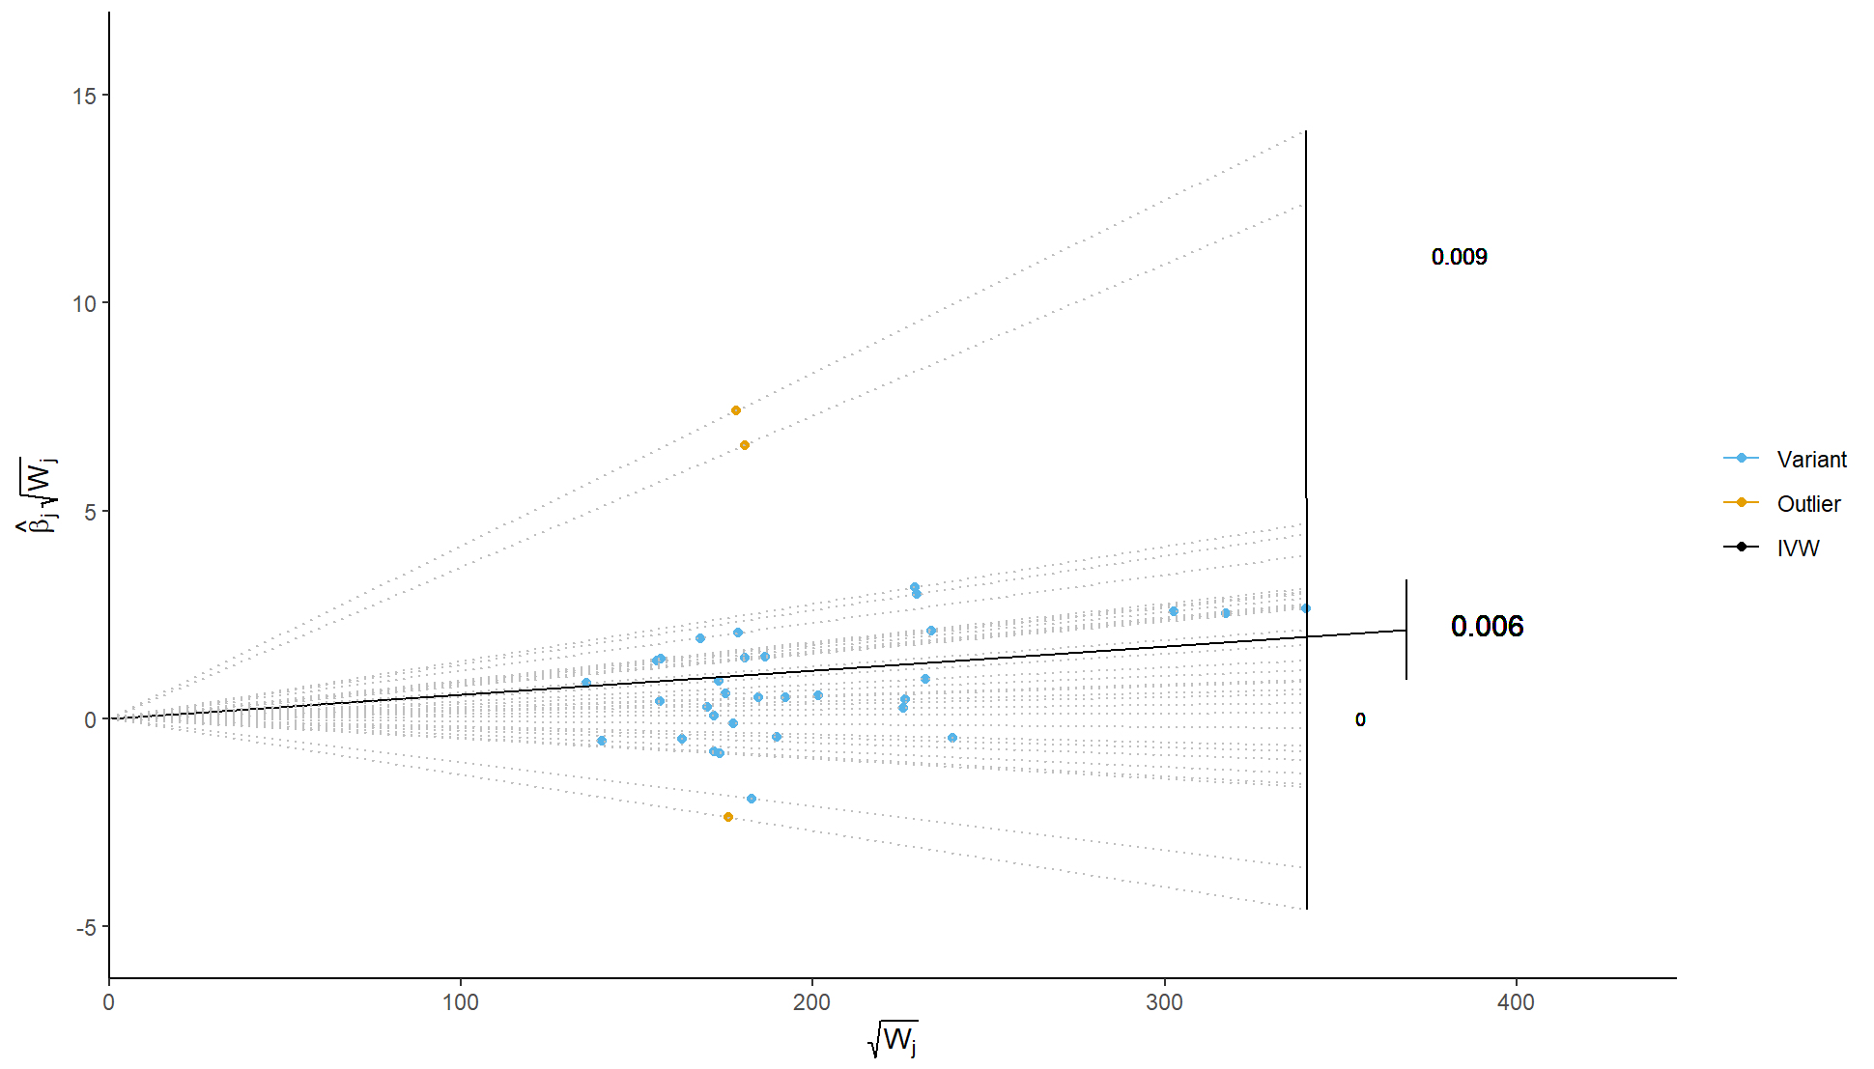
The following figure showed main analysis (with potential outliers, influential points) and after used RadialMR.
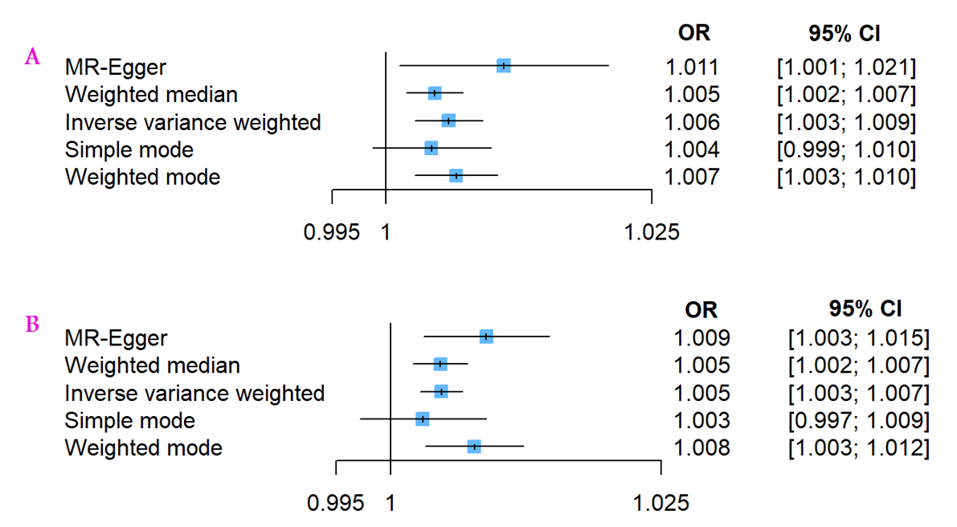
A: Main analysis (with potential outliers, influential points); B: After used RadialMR (remove outliers); IVW: Inverse variance weighted; OR: odds ratio; CI: confidence interval.

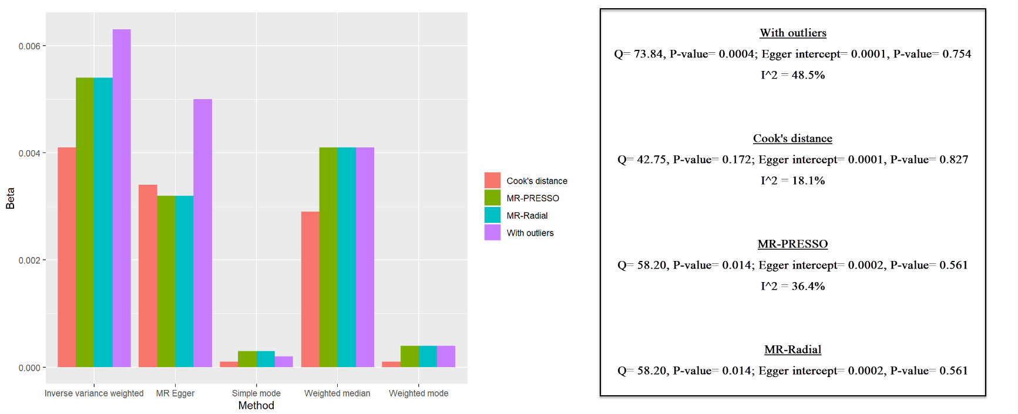
- Ischemic heart disease

When data was with the outlier and influential points, we observed that heterogeneity existed [Q=73.84, P-value= 0.0004; I²=48.5%; Egger intercept= 0.0001, P-value=0.754]. After applying MR-PRESSO, RadialMR, and Cook's distance, we found that these approaches could reduce the heterogeneity [Q=58.20, P-value=0.014; I²=36.4%; Egger intercept=0.0002, P-value=0.561], [Q=58.20, P-value=0.014; I²=36.4%; Egger intercept=0.0002, P-value=0.561], and [Q=42.75, P-value=0.178, I²=18.1%; Egger intercept=0.0001, P-value=0.827], respectively.
In these methods, Cook's distance outperformed others and dispelled the heterogeneity. The following figure displays the identifying steps and results of RadialMR. We detected three SNPs (rs12185072, rs174418, and rs115849089), which could affect the results.
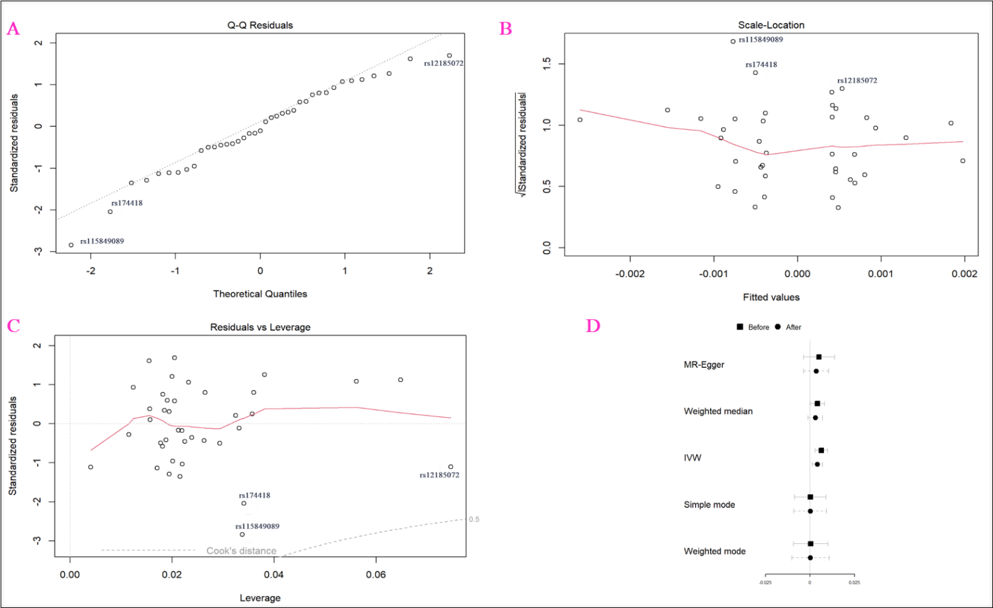
A: q-q plot; B: standardized residual; C: Cook's distance; D: the result (based on beta) of the before and after cook's distance; IVW: Inverse variance weighted
Figure A shows the q-q plot to detect the outlier, and we identified three SNPs (rs591592, rs77548999, and rs1860356). Figure B displays standardized residual, and we again found the same SNPs (rs591592, rs77548999, and rs1860356), which were previously observed in the q-q plot. Figure C demonstrates the Cook's distance, and we here realized three SNPs (rs10152355, rs591592, and rs77548999), which potential influential point could affect the results. Figure D exhibited the result (based on beta) of the before and after cook's distance.
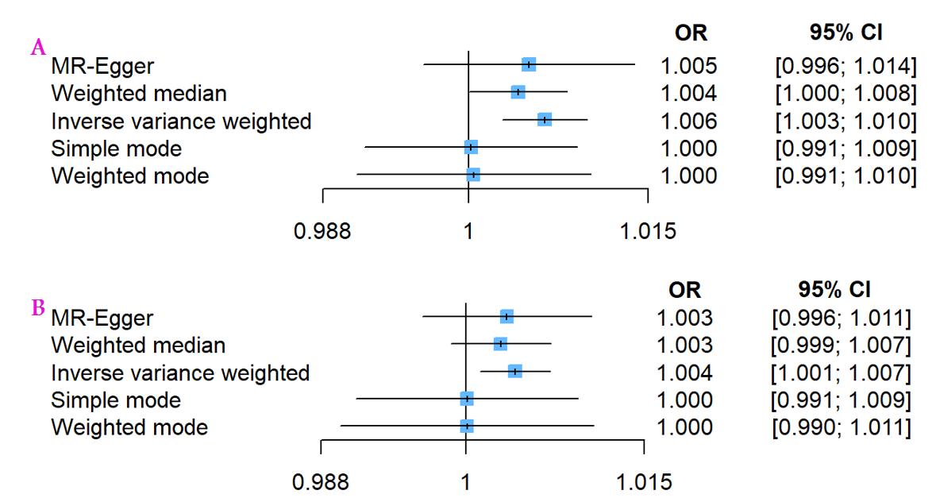
A: Main analysis (with potential outliers, influential points); B: After used Cook's distance (remove outliers); IVW: Inverse variance weighted; OR: odds ratio; CI: confidence interval.

- Heart attack
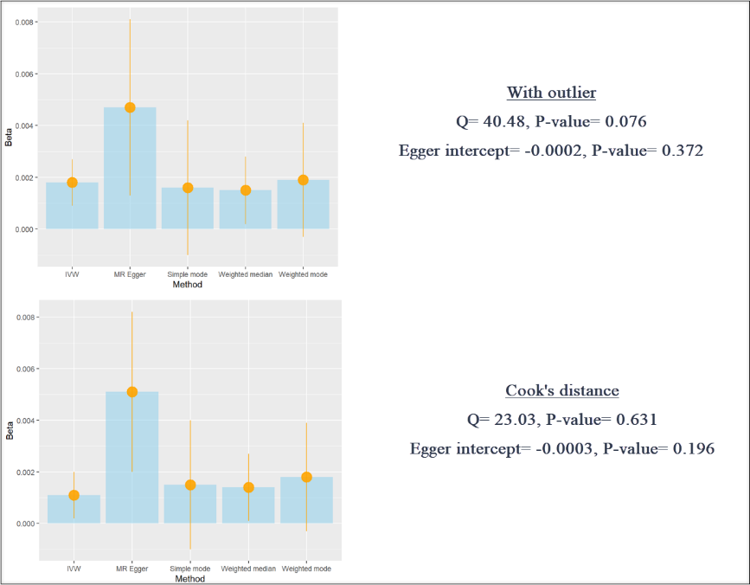
MR-PRESSO and RadialMR did not identify any potential hotspots, but Cook's distance could identify three SNPs (rs61999891, rs174418, and rs115849089) that affected the results. The below figure shows the results before and after Cook's distance.

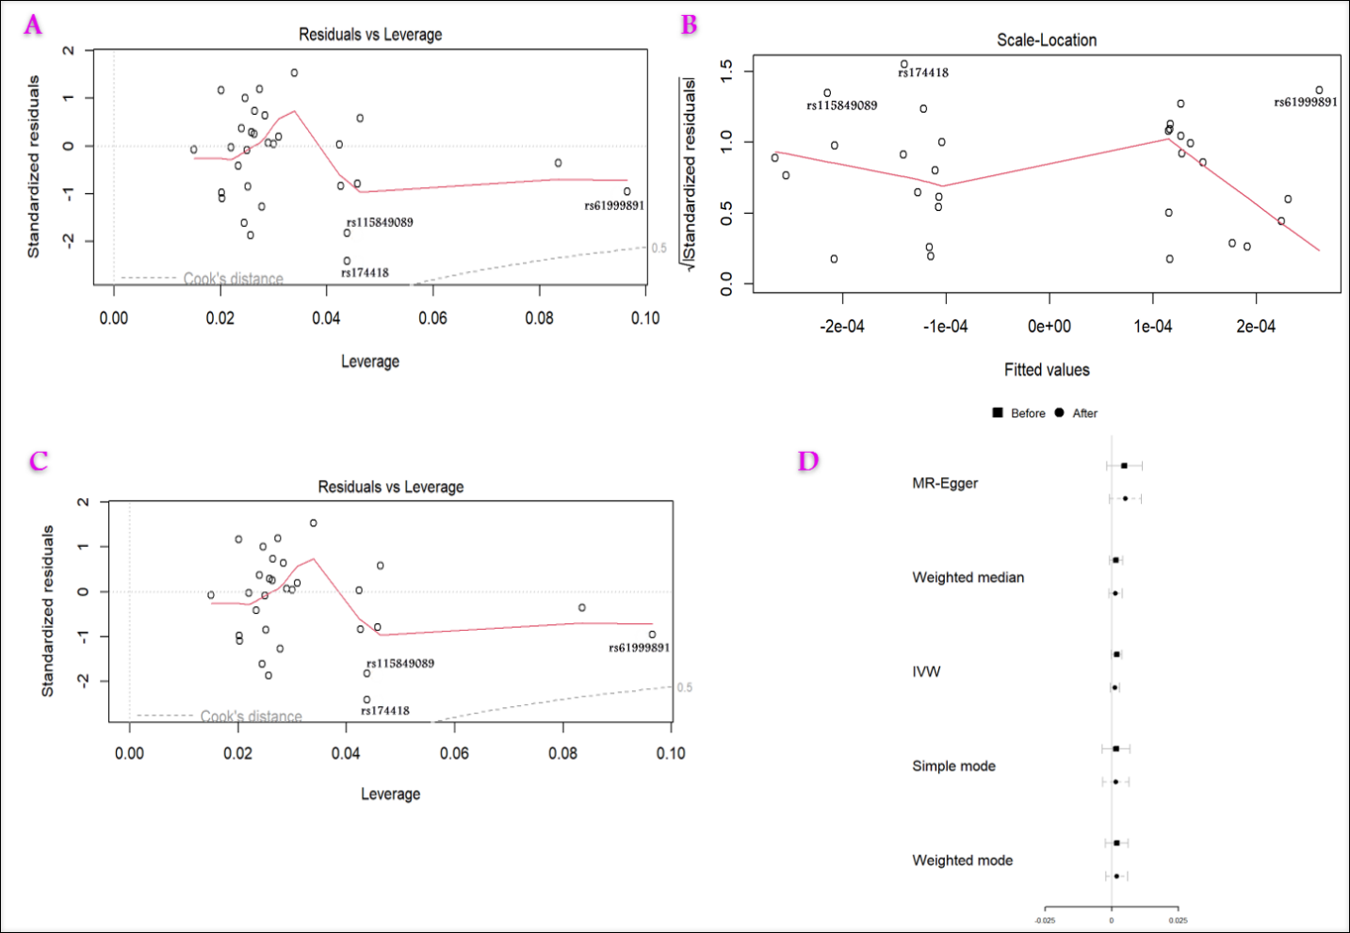
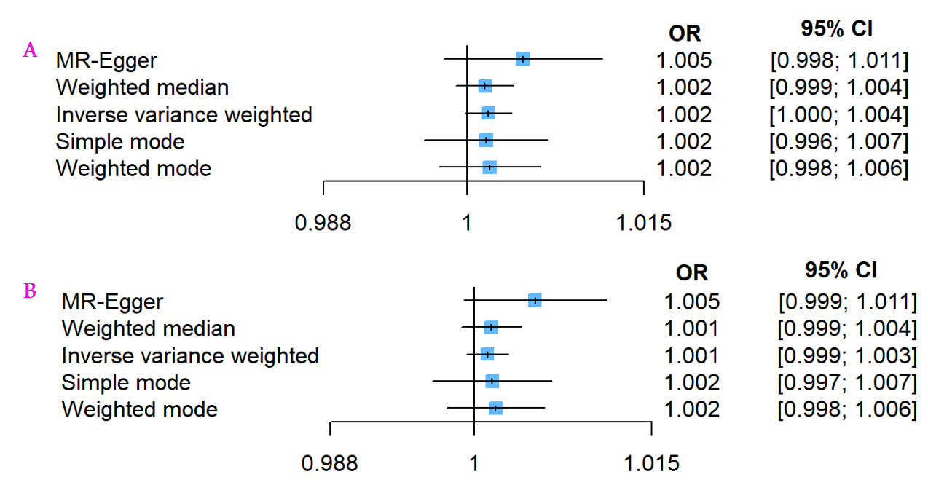
A: Main analysis (with potential outliers, influential points); B: After used Cook's distance (remove outliers); IVW: Inverse variance weighted; OR: odds ratio; CI: confidence interval.

- High Blood Pressure

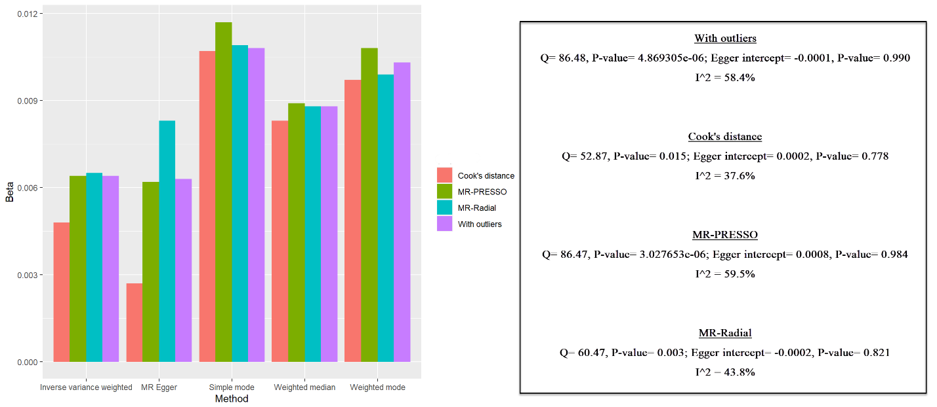
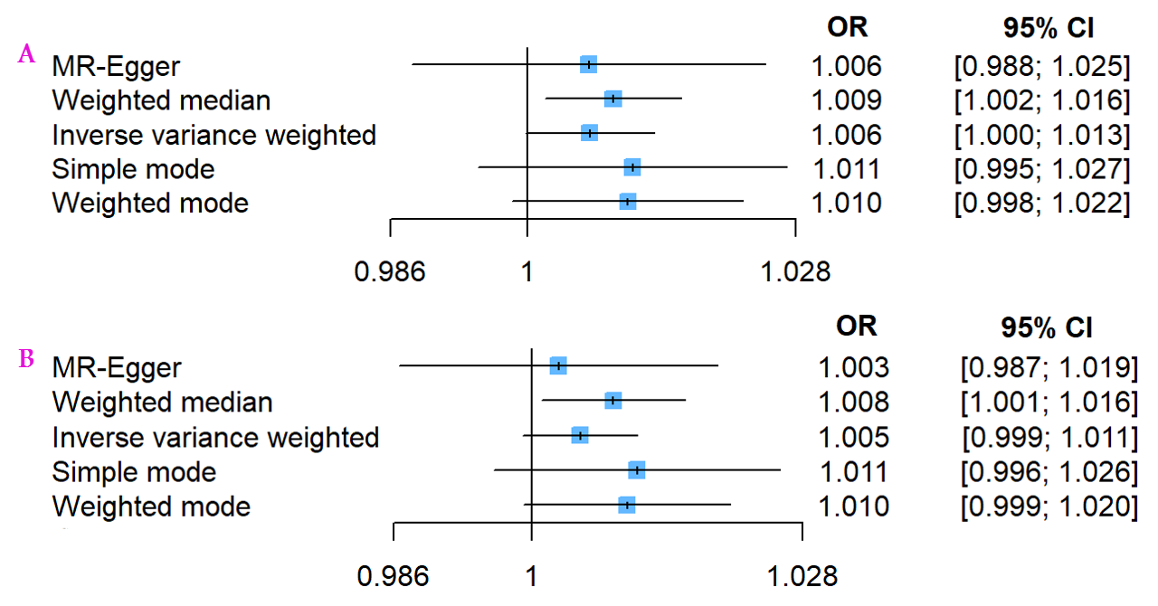
A: Main analysis (with potential outliers, influential points); B: After used Cook's distance (remove outliers); IVW: Inverse variance weighted; OR: odds ratio; CI: confidence interval.

Figure S5: Comparison of the causal estimates from the various Mendelian randomization methods and scatter plot of the potential effects of MUFA-association SNPs on cardiovascular diseases
The following figures show the several Mendelian randomization methods, including Simple median, Weighted median, Penalized weighted median, Inverse variance weighted, Penalized Inverse variance weighted, Robust inverse variance weighted, Penalized robust inverse variance weighted, MR-Egger, Penalized MR-Egger, Robust MR-Egger, Penalized robust MR-Egger, Maximum likelihood estimate, and Mode-based method.

A) Angina

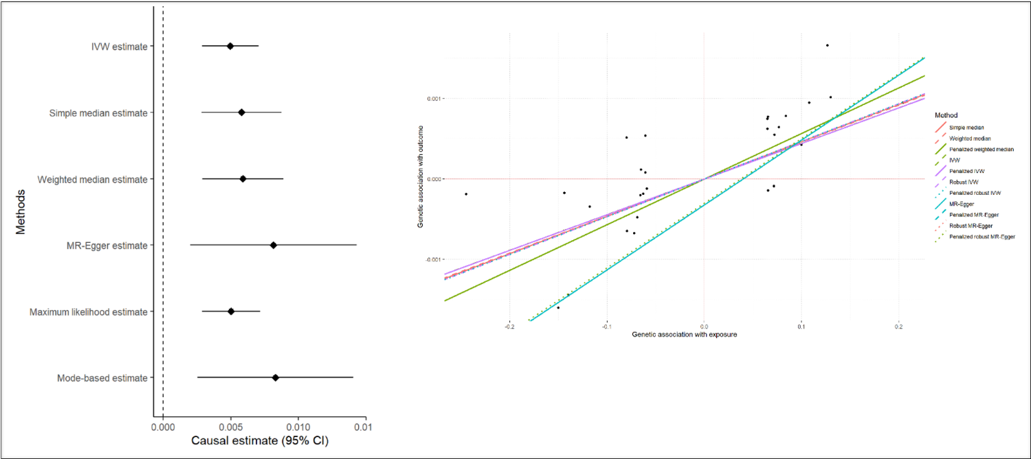
Left plot shows point estimate (beta) and its 95% confidence interval. Right plot exhibits positive causality about MUFA on angina.

The following figure displays a scatter plot, which shows a genetic association. X-axis lies with the genetic association of exposure (MUFA), and the y-axis is the genetic association of outcome (angina). The linear line corresponds to the Inverse variance weighted method. As seen, slop is positive.

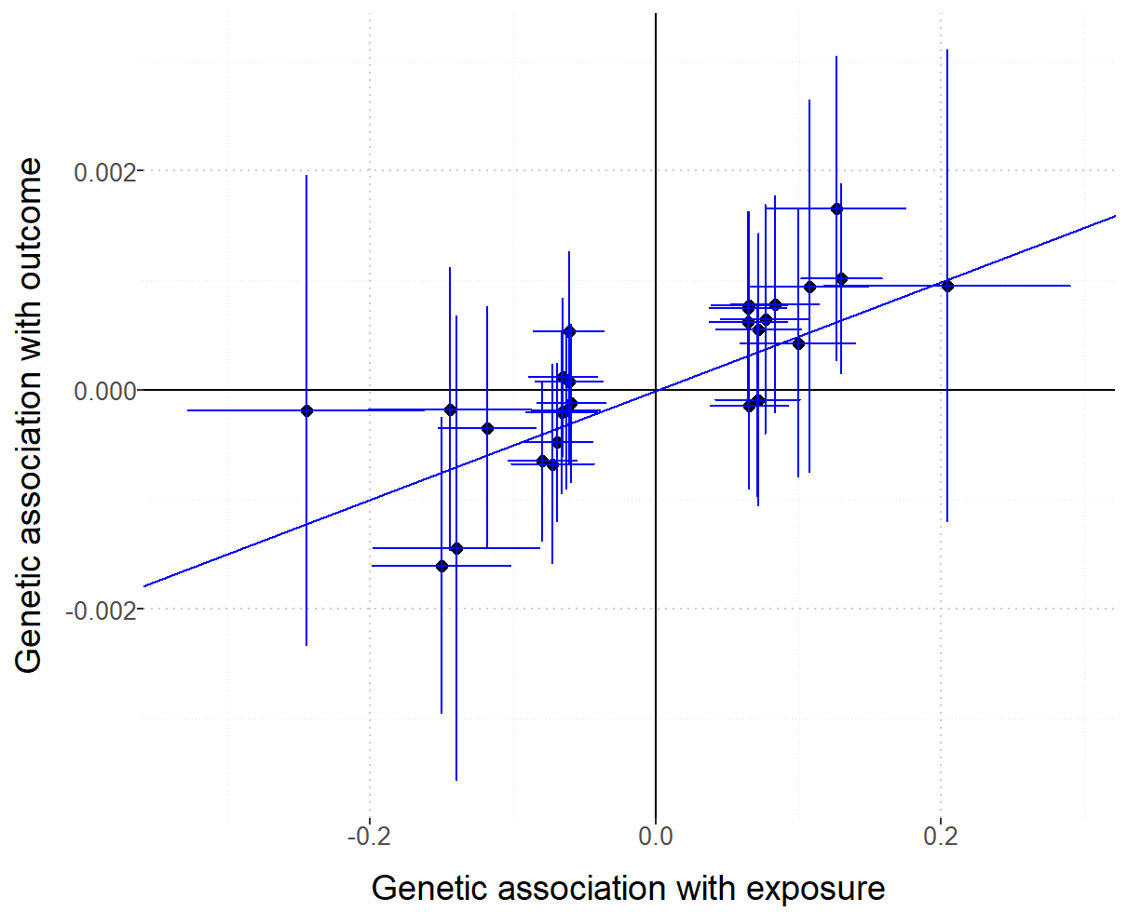

B) Atherosclerotic
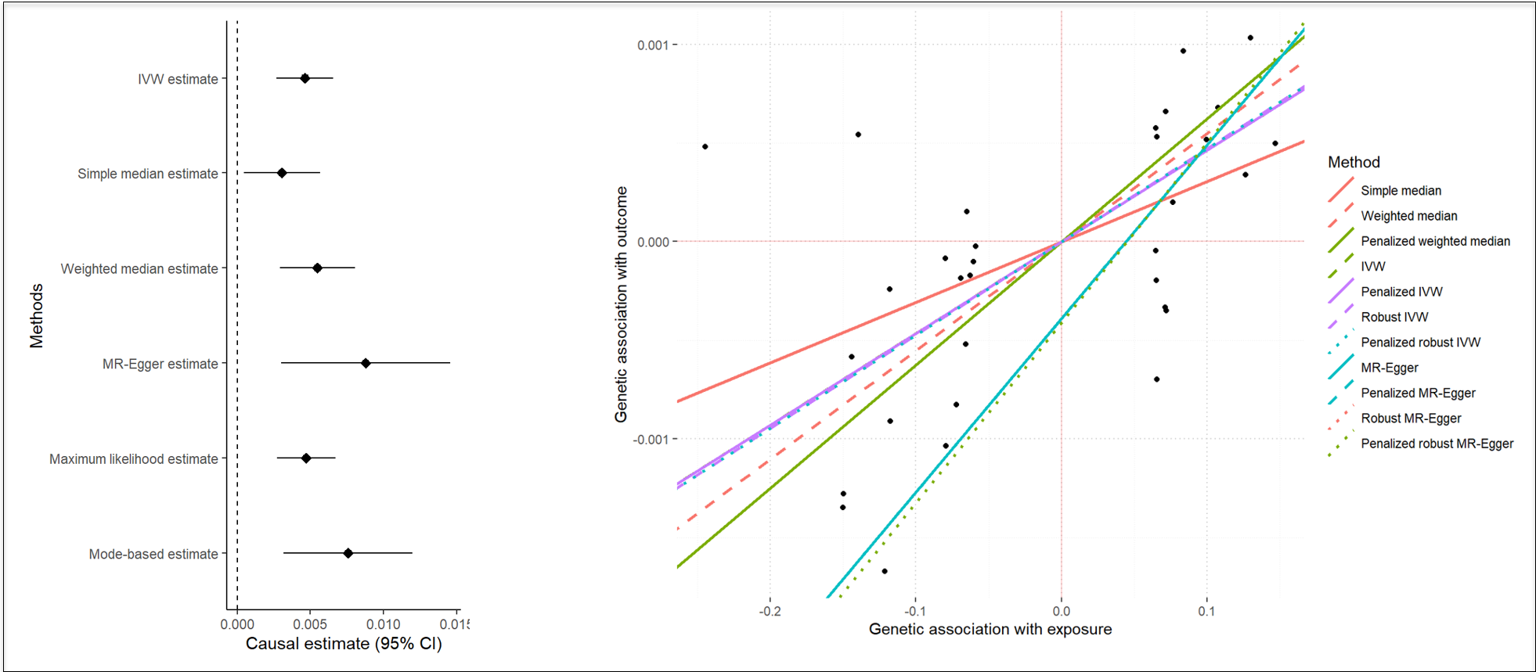
Left plot shows point estimate (beta) and its 95% confidence interval. Right plot exhibits positive causality about MUFA on atherosclerotic.

The following figure displays a scatter plot, which shows a genetic association. X-axis lies with the genetic association of exposure (MUFA), and the y-axis is the genetic association of outcome (atherosclerotic). The linear line corresponds to the Inverse variance weighted method. As seen, slop is positive.
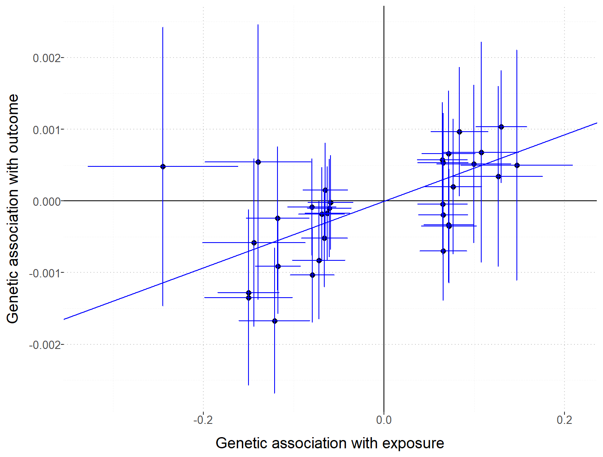

C) Ischemic heart disease

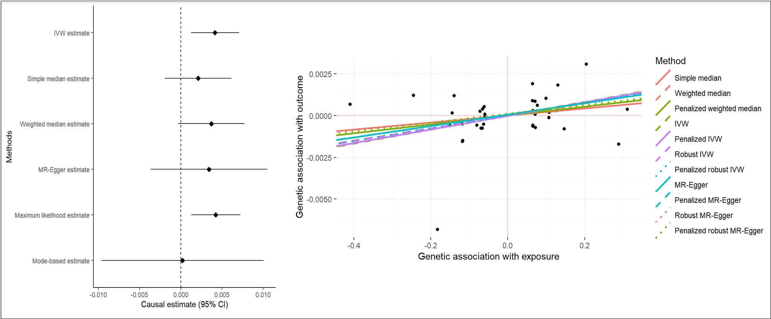
Left plot shows point estimate (beta) and its 95% confidence interval. Right plot exhibits positive causality about MUFA on ischemic heart disease.

The following figure displays a scatter plot, which shows a genetic association. X-axis lies with the genetic association of exposure (MUFA), and the y-axis is the genetic association of outcome (ischemic heart disease). The linear line corresponds to the Inverse variance weighted method. As seen, slop is positive.

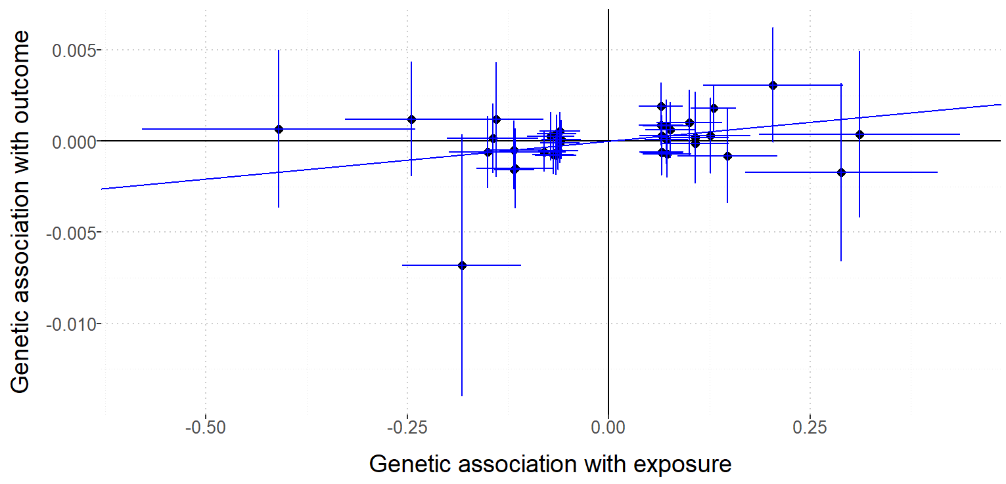

D) Heart attack

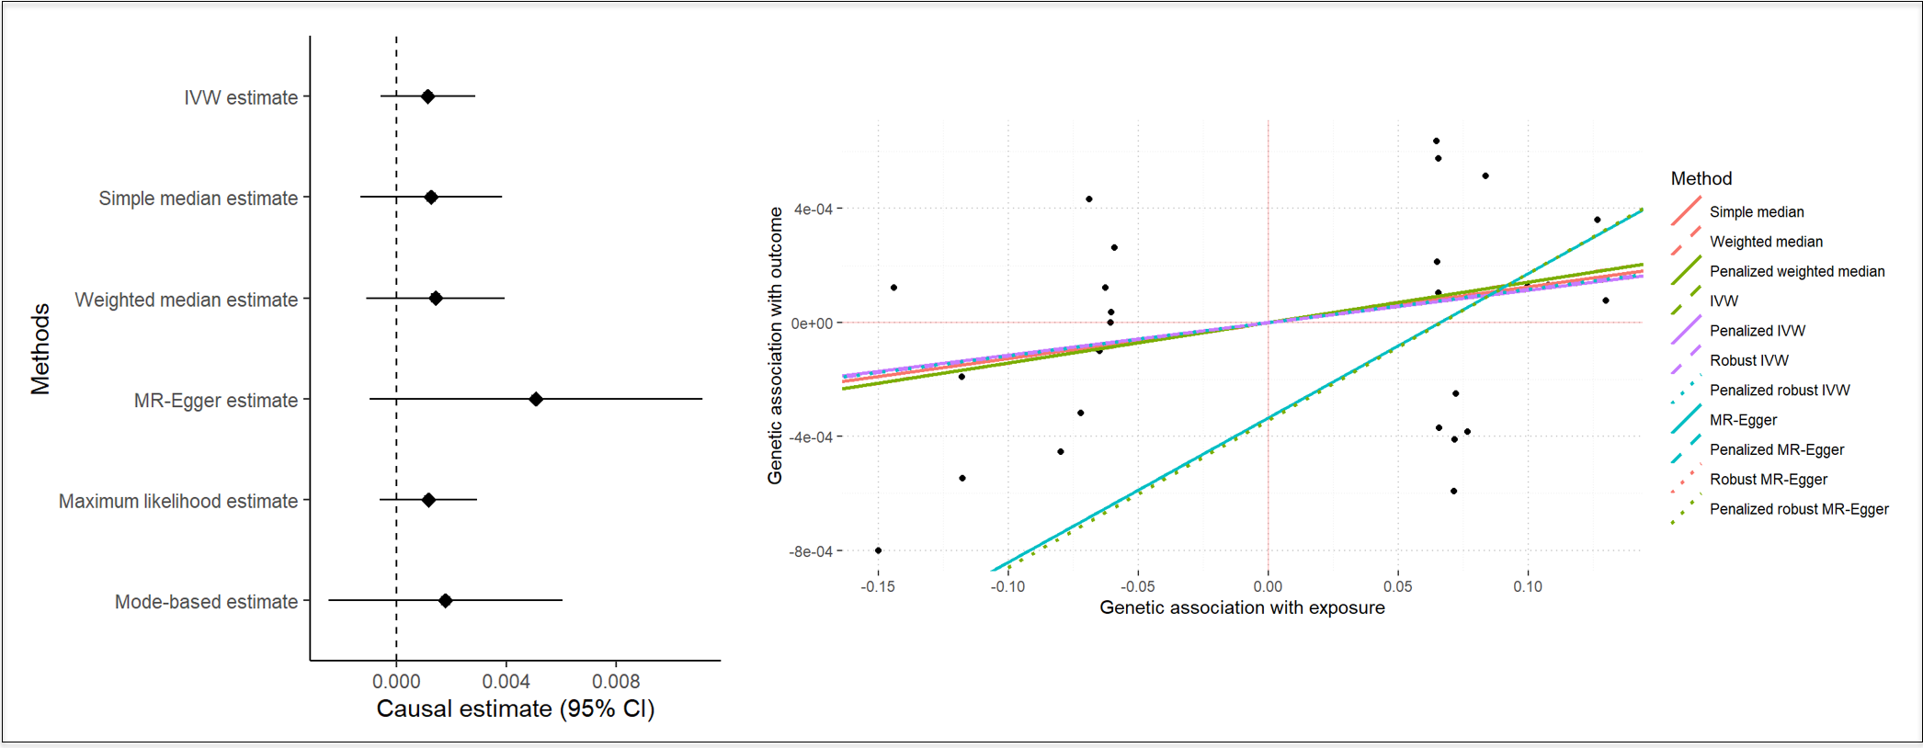
Left plot shows point estimate (beta) and its 95% confidence interval. Right plot exhibits positive causality about MUFA on ischemic heart disease.
The following figure displays a scatter plot, which shows a genetic association. X-axis lies with the genetic association of exposure (MUFA), and the y-axis is the genetic association of outcome (ischemic heart disease). The linear line corresponds to the Inverse variance weighted method. As seen, slop is positive.

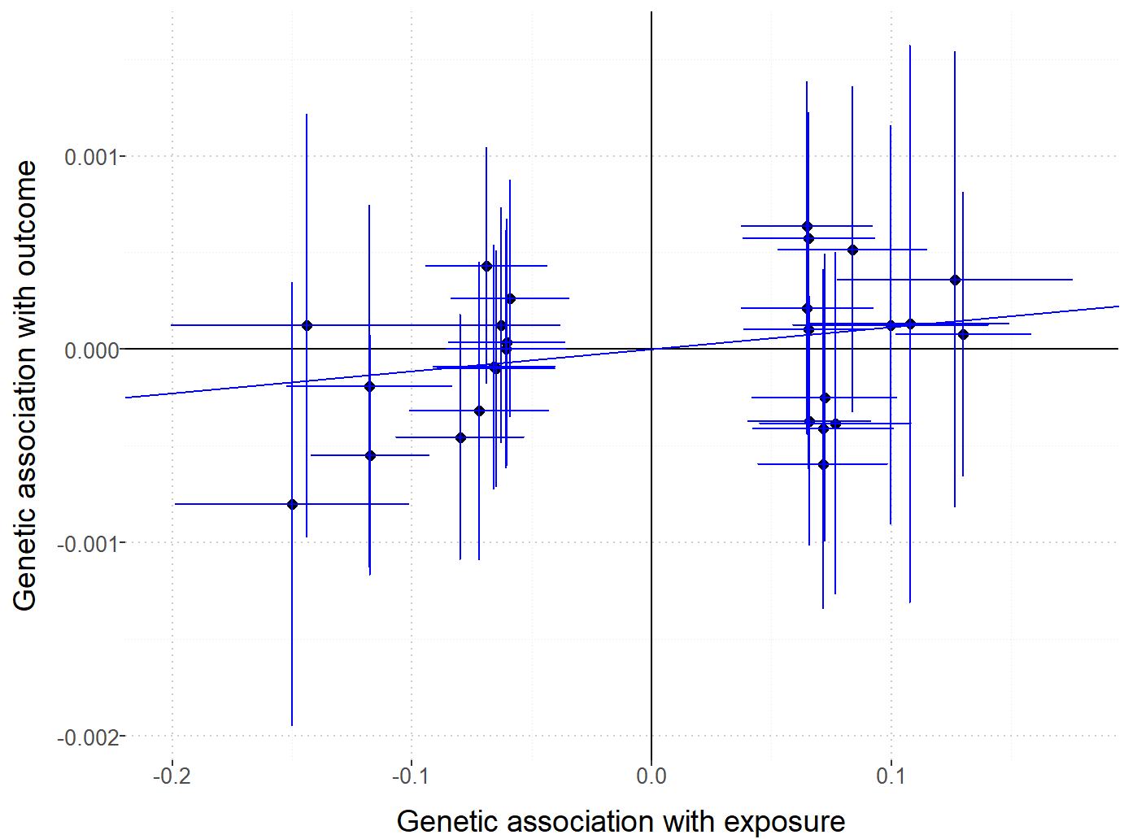

E) High Blood Pressure
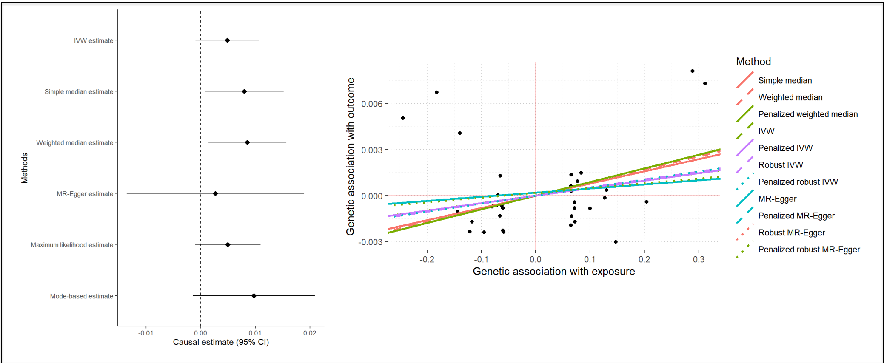
Left plot shows point estimate (beta) and its 95% confidence interval. Right plot exhibits positive causality about MUFA on ischemic heart disease.
The following figure displays a scatter plot, which shows a genetic association. X-axis lies with the genetic association of exposure (MUFA), and the y-axis is the genetic association of outcome (ischemic heart disease). The linear line corresponds to the Inverse variance weighted method. As seen, slop is positive.

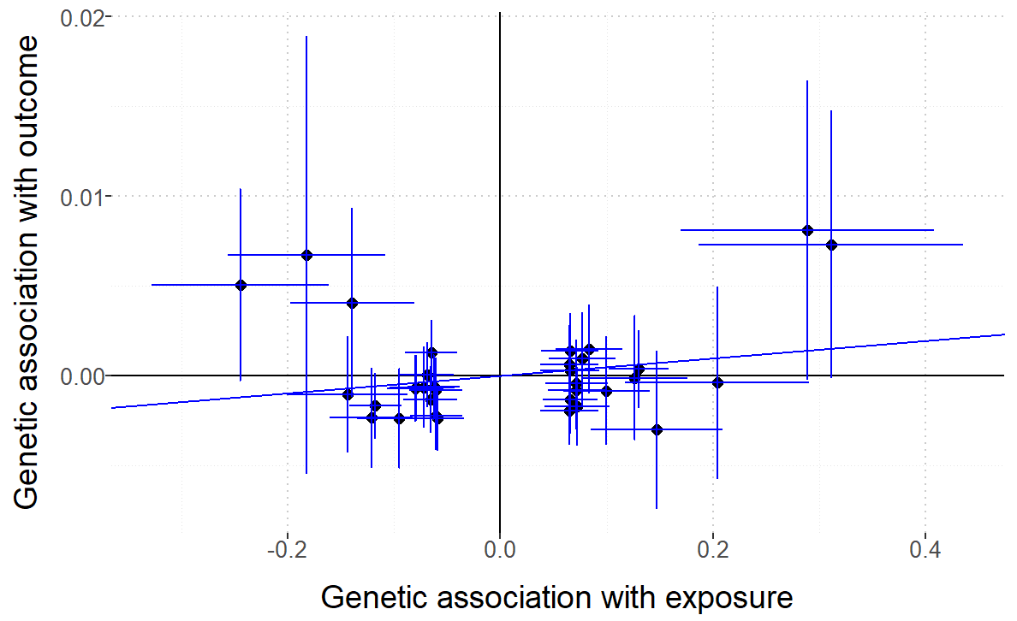

Figure S6: Leave-one-out plot to assess if a single variant is driving the association between MUFA and cardiovascular diseases.
- Angina B) Atherosclerotic
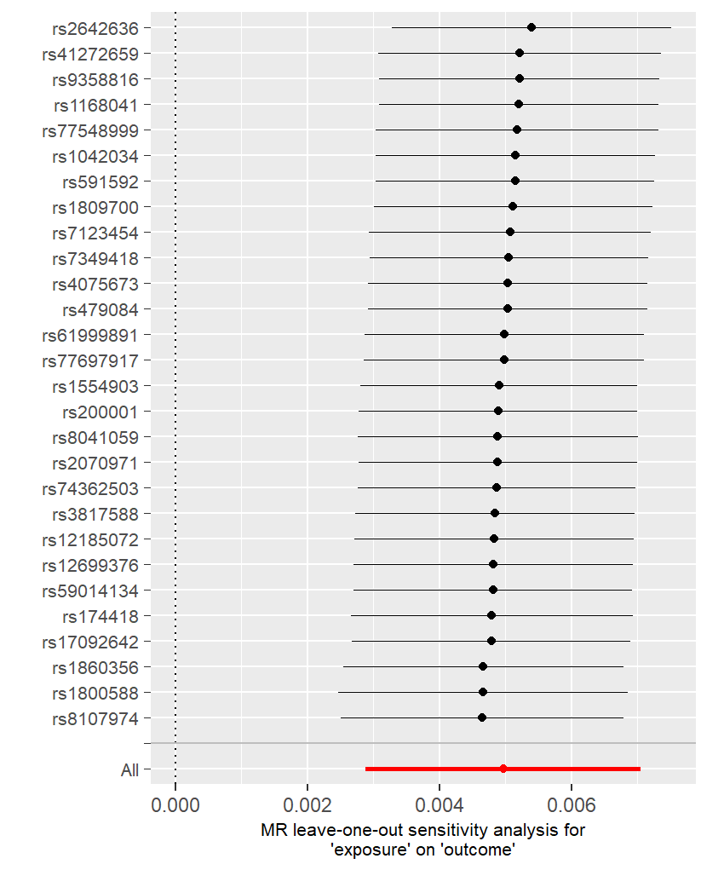

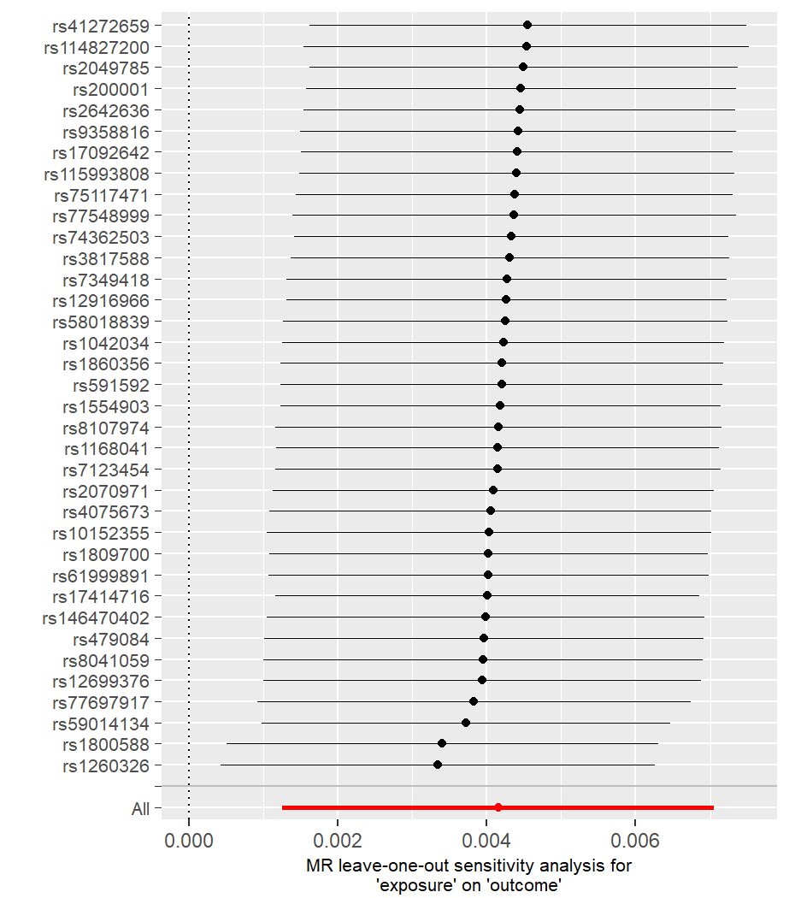
C) Ischemic heart disease D) Heart attack
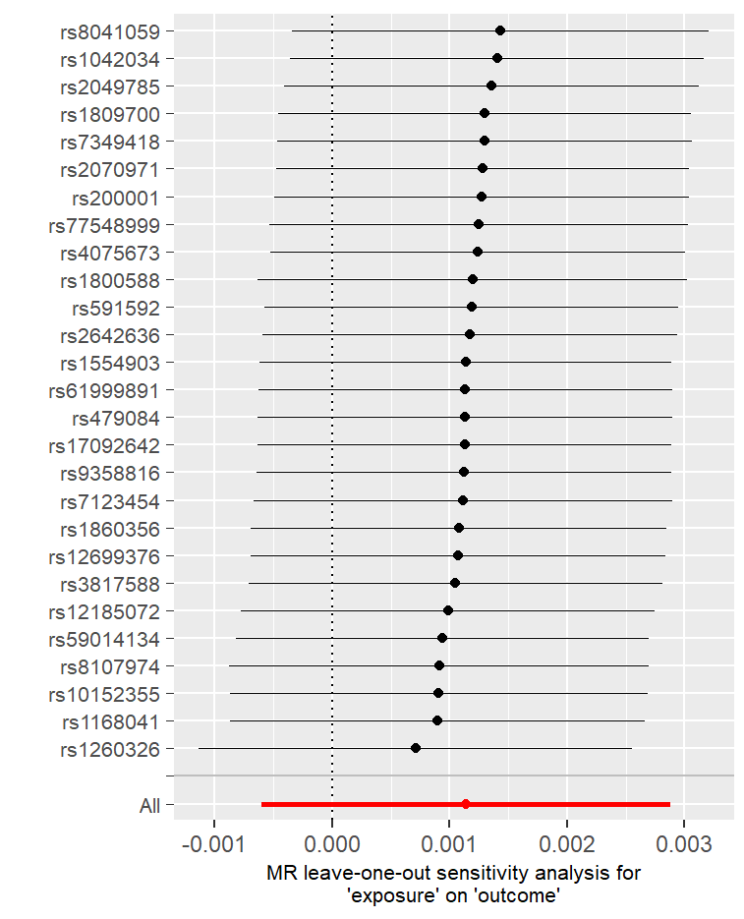

E) High Blood Pressure
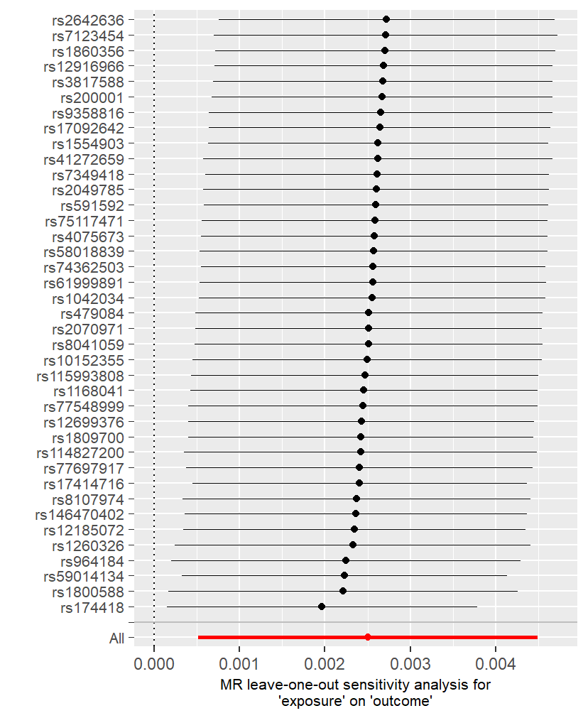

Figure S7. Funnel plot of causal association between MUFA and cardiovascular diseases
A) Angina B) Atherosclerotic
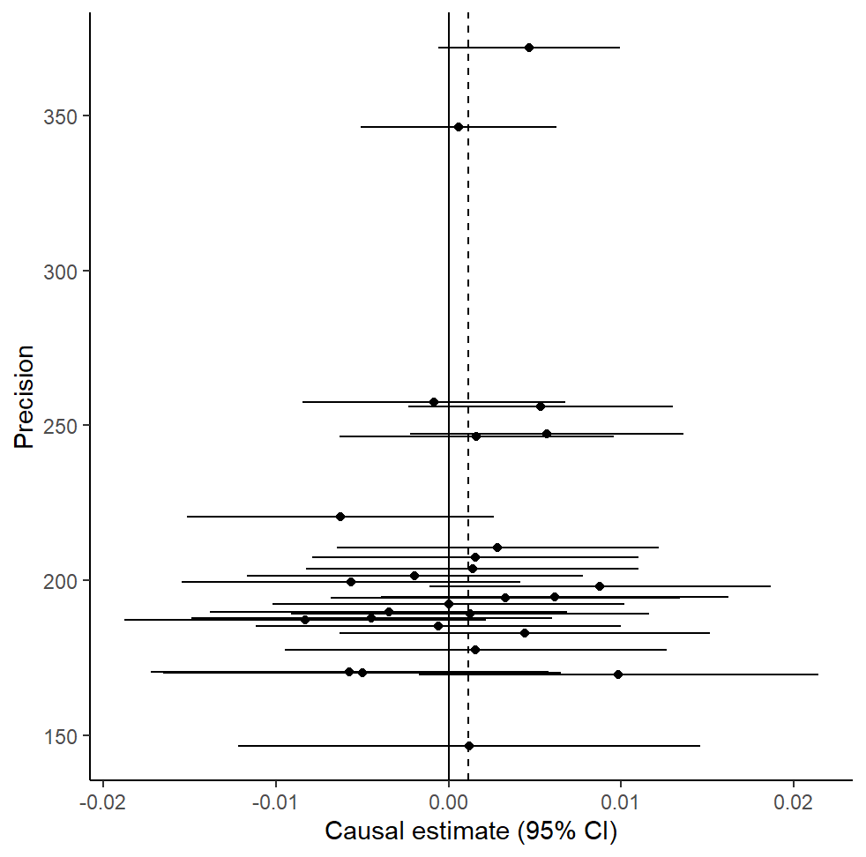
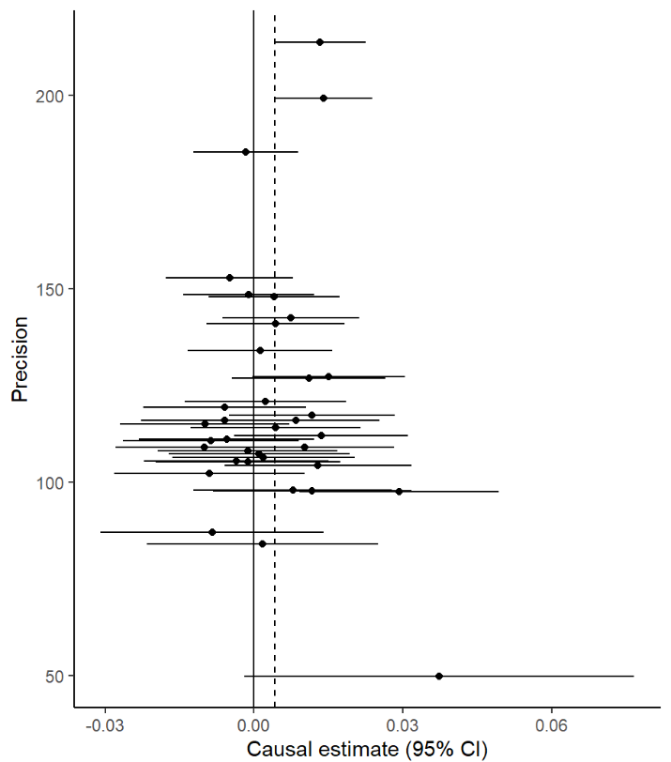
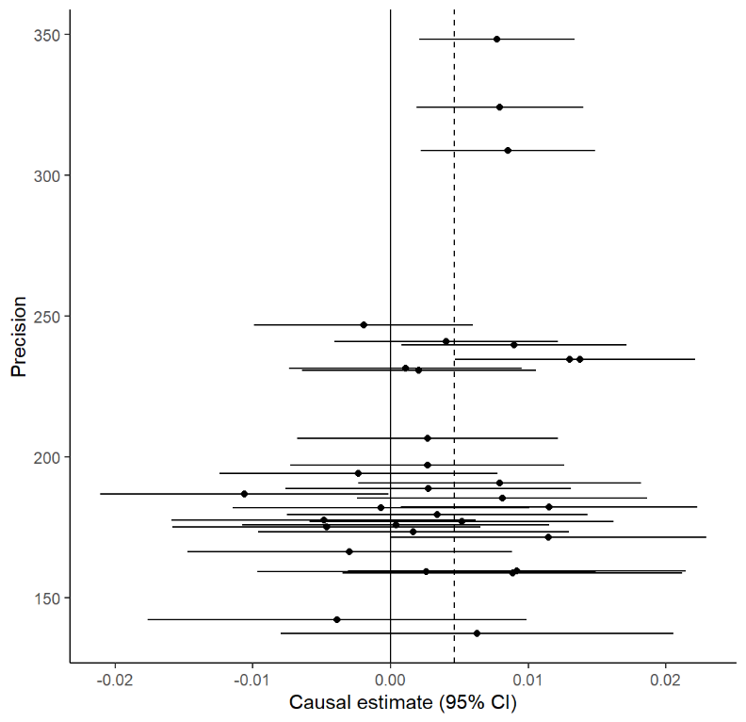
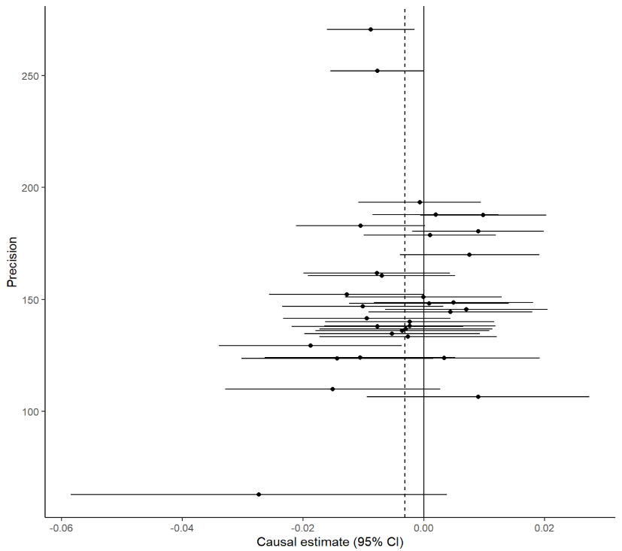
C) Ischemic heart disease D) Heart attack

E) High Blood Pressure

Figure S8: Forest plot of variant specific inverse variance estimates for causal association between MUFA and cardiovascular diseases

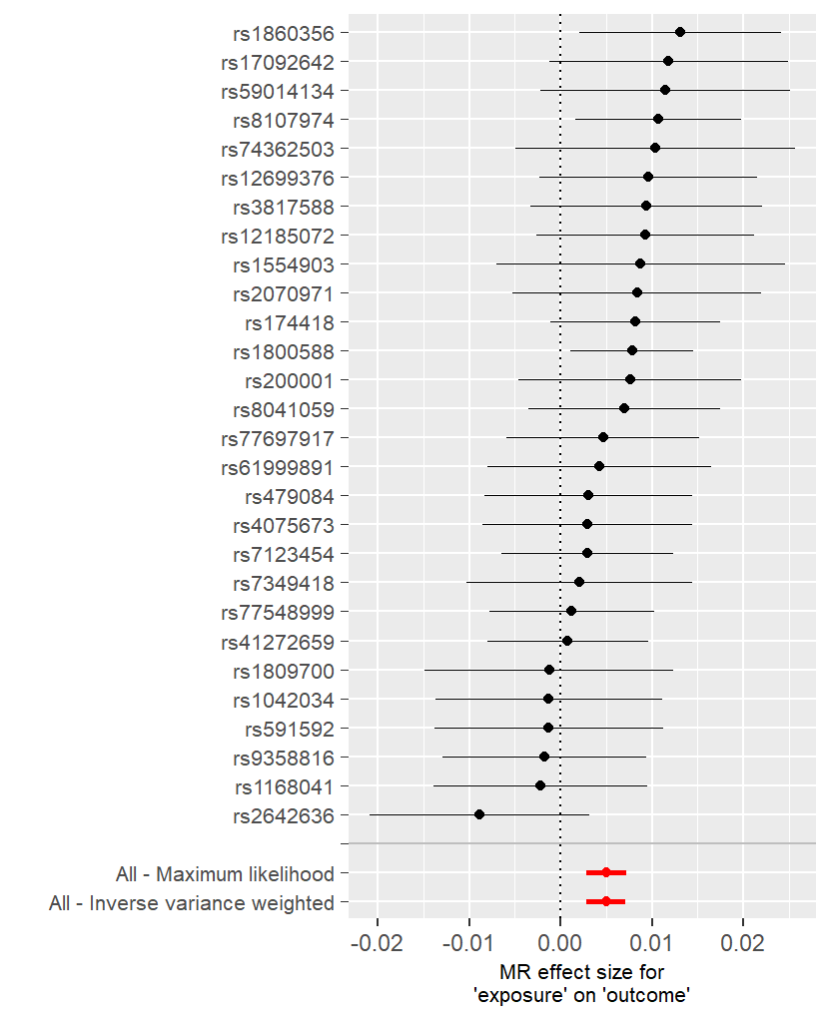
- Angina B) Atherosclerotic
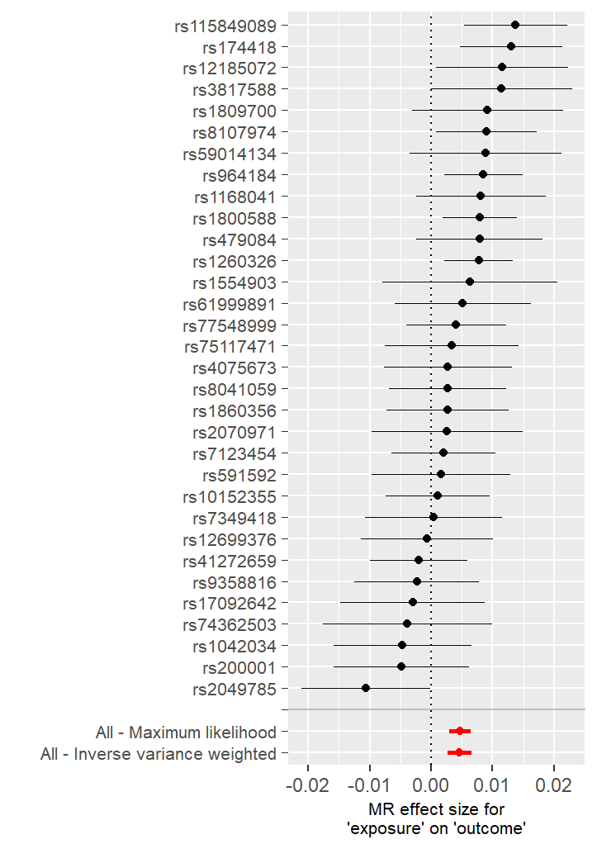

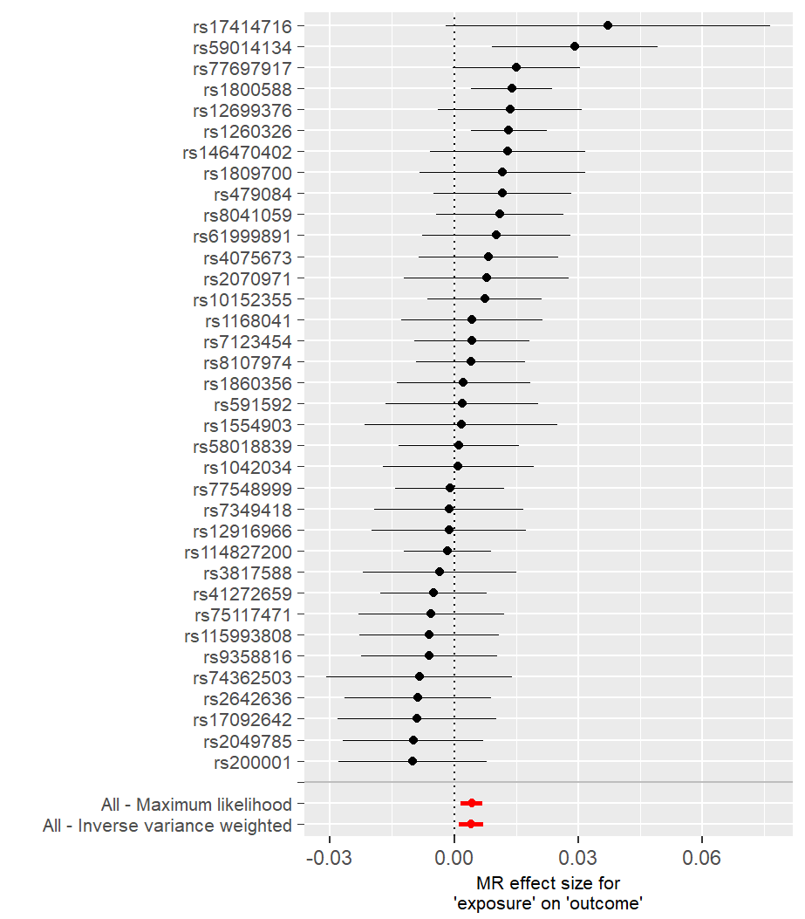
C) Ischemic heart disease D) Heart attack
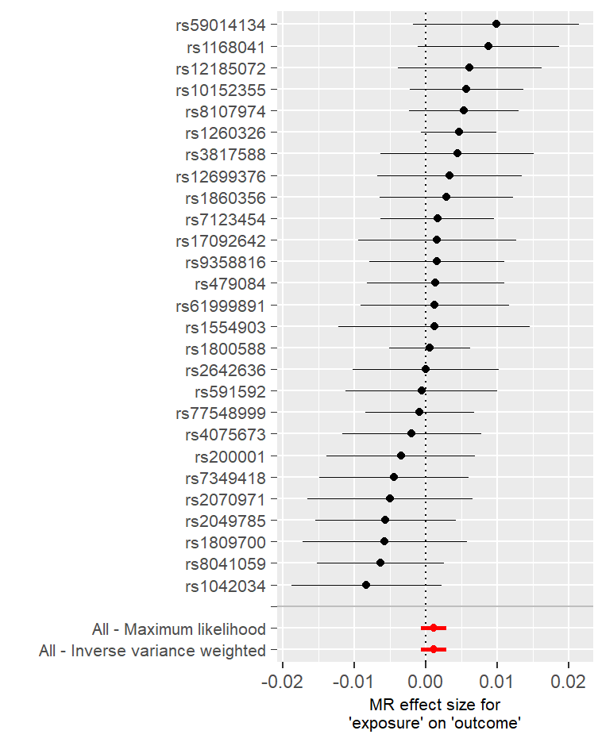

E) High Blood Pressure

Figure S9. Densities of the IV estimates using different values of the phi parameter.

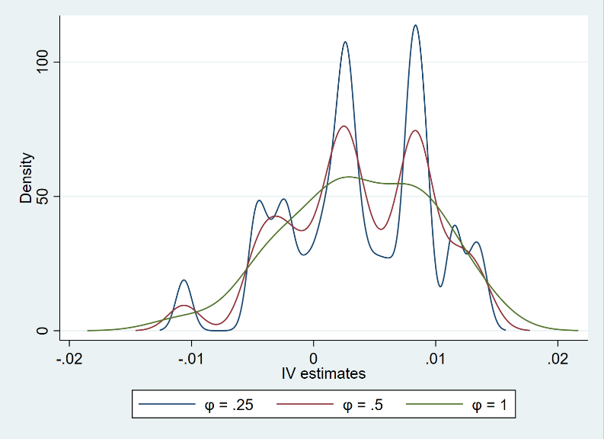
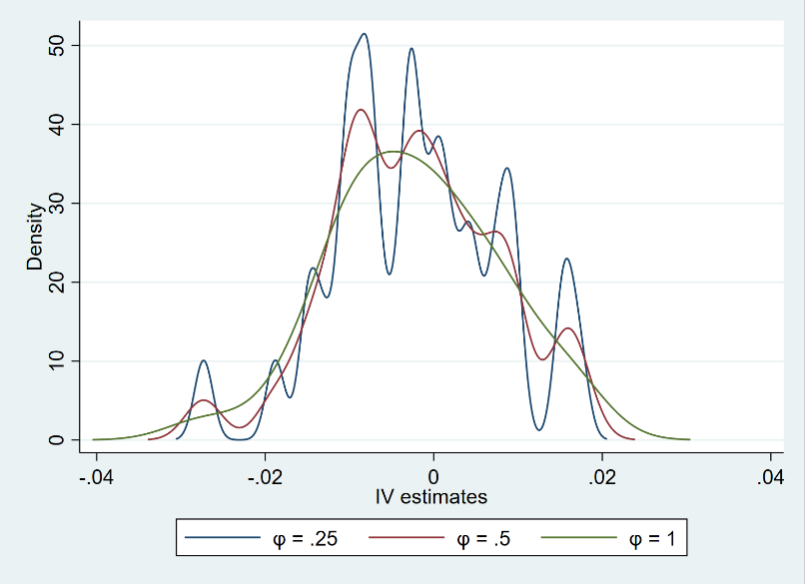
A) Angina B) Atherosclerotic

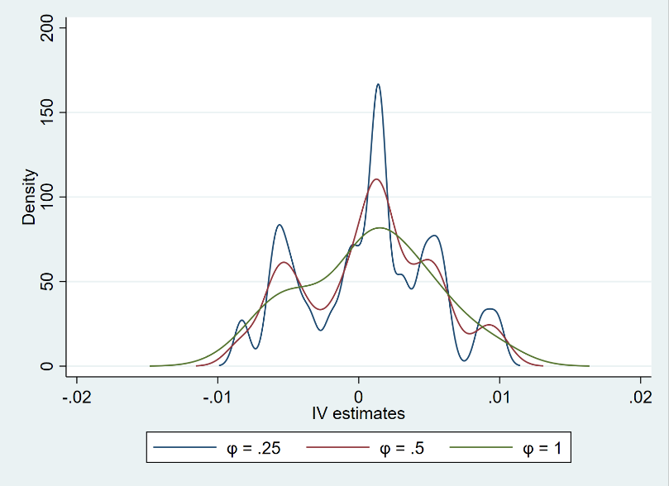
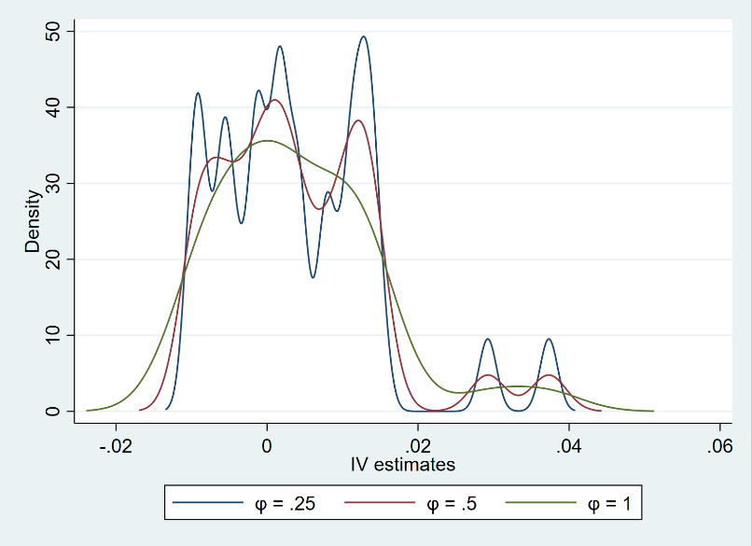
C) Ischemic heart disease D) Myocardial infarction

E) Hypertension

