Fig. S1 Leaf damage image

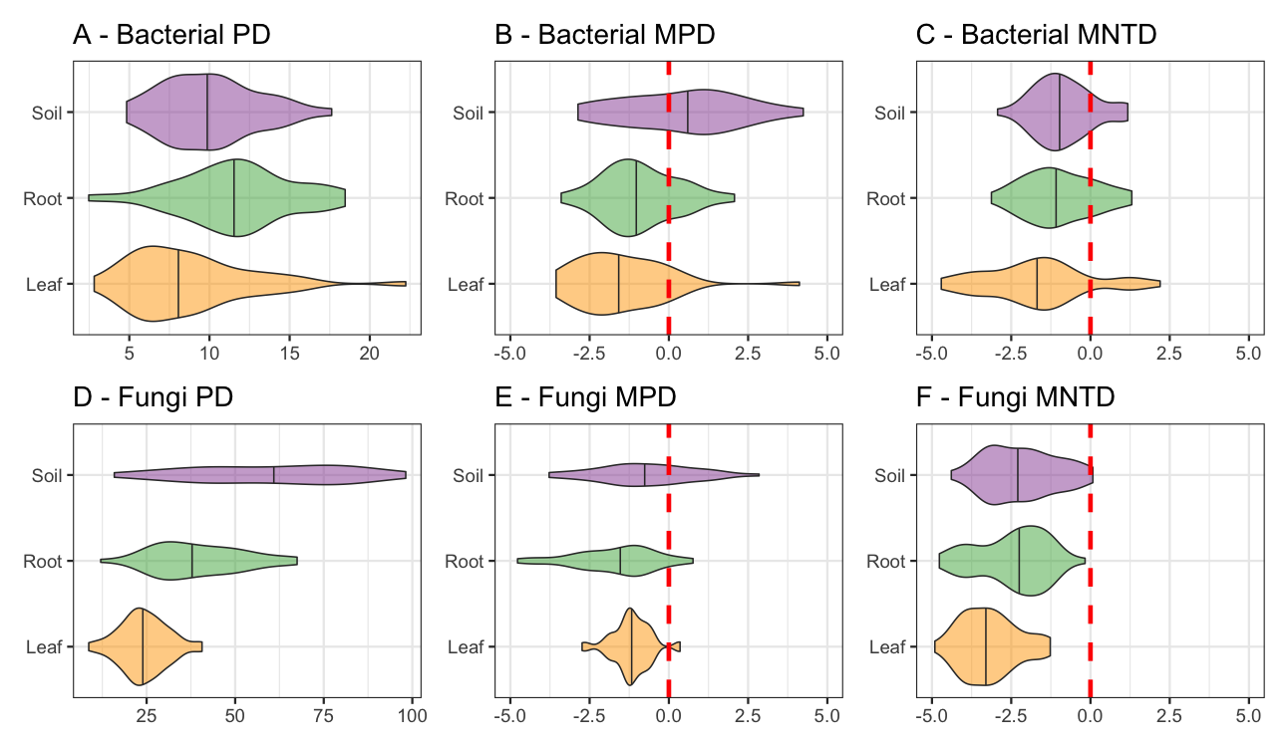

Fig. S2 Faith’s phylogenetic distance (PD), mean pairwise distances (standardised effect size; MPD) and Mean nearest taxon distance (standardised effect size; MNTD) were calculated. Higher PD values represent more evolutionary diverse communities occupying the sample tyle. Meanwhile MPD and MNTD measure whether phylogenetic diversity is lower or higher than expected (from a null model), with negative values suggesting environmental filtering regulates communities, while postive values suggest competition between microbes regulates the communities. MPD is more sensitive to tree-wide patterns, and MNTD is more senstive to differences at the tips of trees.

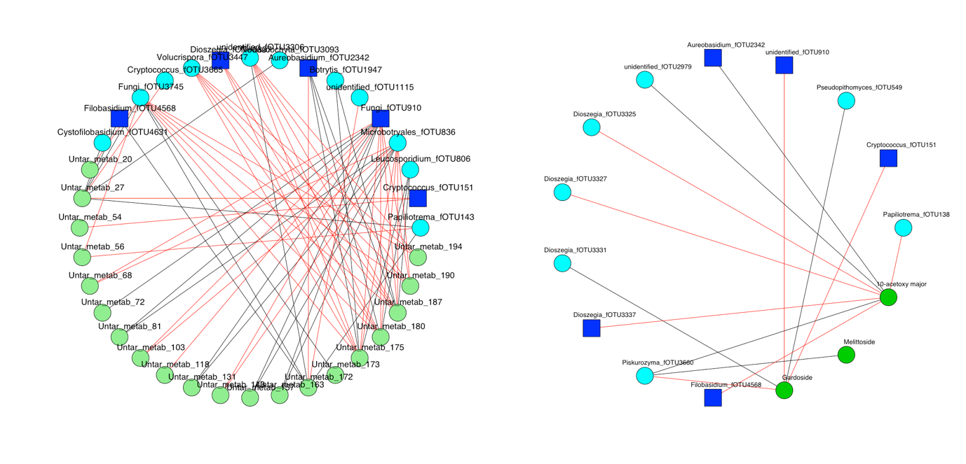
Fig. S3 Regularised Canonical Correlation Analysis (rCCA) was performed to correlate individual untargeted (light green) and targeted anti-herbivory/microbial metabolites (green nodes) and to leaf fungi (blue nodes; fungi in both networks in dark blue squares). Positive correlations represented by black lines, red lines represent negative.

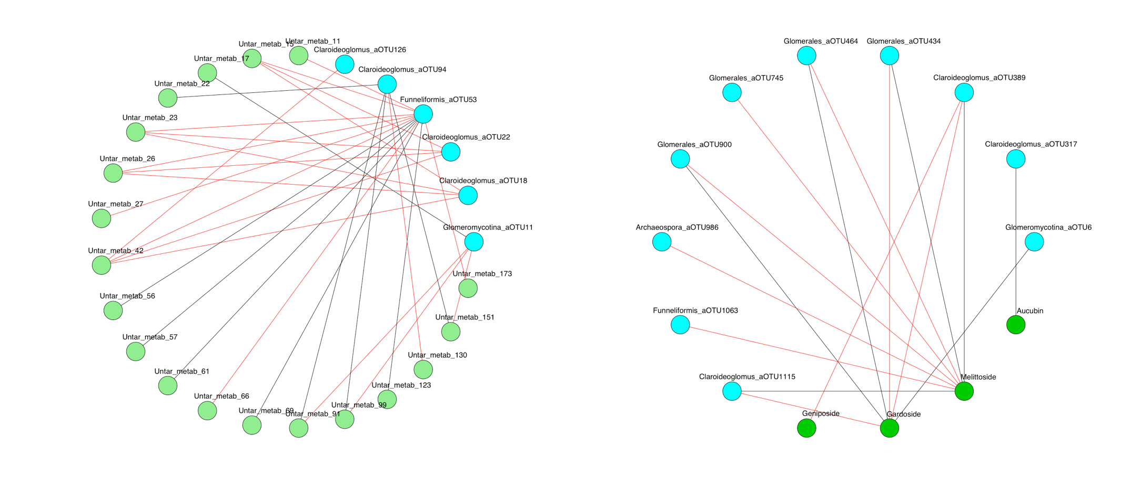
Fig. S4 Regularised Canonical Correlation Analysis (rCCA) was performed to correlate individual untargeted (light green) and targeted anti-herbivory/microbial metabolites (green nodes) and to glomeromycota in the roots (blue nodes). Positive correlations represented by black lines, red lines represent negative.

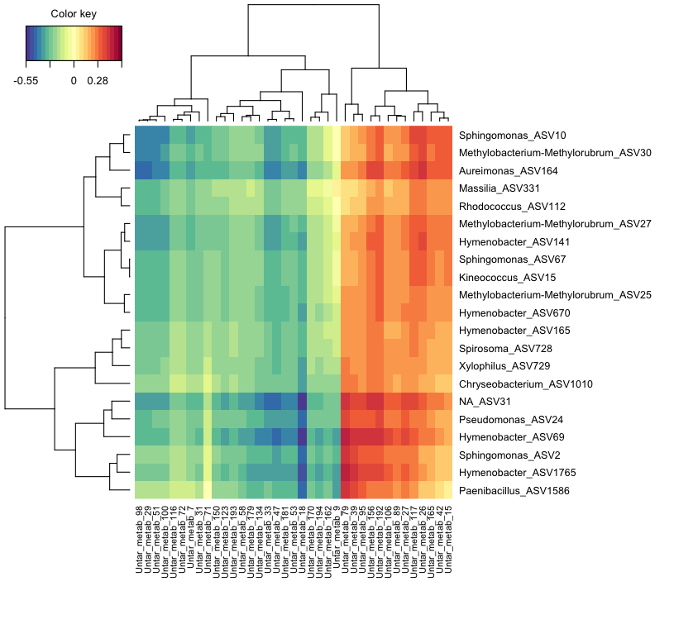
Fig. S5 The microbes and metabolites that correlated with one or more of the other were extracted. Hierarchical clustering was then performed on each of the metabolome and the leaf bacterial communities. Unlike the leaf fungi and root glomeromycota, all bacteria seemingly interacted similarly with the host, rather than forming co-varying blocks.

