Supporting Information
Improving Quality of Analysis by Suppression of Unwanted Signals Through Band-Selective Excitation in NMR Spectroscopy for Metabolomics Studies.
Upendra Singh,¹ Ruba Al-Nemi,¹ Fatimah Alahmari,² Abdul-Hamid Emwas*,³ Mariusz Jaremko*⁴

¹Division of Biological and Environmental Sciences and Engineering (BESE), King Abdullah University of Science and Technology (KAUST), Thuwal, Makkah, 23955-6900, Saudi Arabia
²Department of nanomedicine research, Institute for Research & Medical Consultations (IRMC), Imam Abdulrahman Bin Faisal University, P.O. Box 1982, 31441 Dammam, Saudi Arabia.
³Core Lab of NMR, King Abdullah University of Science and Technology (KAUST), Thuwal, Makkah, 23955-6900, Saudi Arabia
⁴Smart-Health Initiative (SHI) and Red Sea Research Center (RSRC), Division of Biological and Environmental Sciences and Engineering (BESE), King Abdullah University of Science and Technology (KAUST), Thuwal, Makkah, 23955-6900, Saudi Arabia

Corresponding Authors
Abdul-Hamid Emwas
Email: abdelhamid.emwas@kaust.edu.sa
Mariusz Jaremko
Email: mariusz.jaremko@kaust.edu.sa

Table of Contents:

Experimental Section
Table S1. Experimental data for honey, Figs 2-3 and Figs S1-S8.
Table S2. Experimental data for dates-flesh, Figs 4 and Figs S9-S17.
Table S3. Experimental data for a standard stock solution of glucose and nine amino acids, Fig 5 and Figs S18-S21.
Table S4. Experimental data for fetal bovine serum, Figs S22-S30.
Figure S1. 2D ¹H-¹H TOCSY and 2D ¹H-¹H TOCSY-SSMS spectra of the honey sample.
Figure S2. Overlapped spectra of 2D ¹H-¹H TOCSY and of 2D ¹H-¹H TOCSY-SSMS spectra for the honey sample.
Figure S3. Projected 1D ¹H overlapped spectra of 2D TOCSY and 2D TOCSY-SSMS for the honey sample.
Figure S4. Projected 1D ¹H toggled spectra of 2D TOCSY and 2D TOCSY-SSMS for the honey sample with expanded sections.
Figure S5. 2D J-RES and 2D J-RES-SSMS spectra for honey sample.
Figure S6. Projected 1D ¹H overlapped spectra of 2D J-RES and 2D J-RES -SSMS for the honey sample.
Figure S7. Projected 1D ¹H toggled spectra of 2D J-RES and 2D J-RES-SSMS for the honey sample with expanded sections.
Figure S8. The expanded sections of projected 1D ¹H spectra of 2D ¹H-¹³C HSQC and 2D ¹H-¹³C HSQC-SSMS experiments.
Figure S9. The toggled spectra of 1D ¹H presat and ¹H presat-SSMS NMR for the dates-flesh sample.
Figure S10. 2D ¹H-¹H TOCSY and 2D ¹H-¹H TOCSY-SSMS spectra for dates-flesh sample.
Figure S11. Projected 1D ¹H overlapped spectra of 2D TOCSY and 2D TOCSY-SSMS for the dates-flesh sample.
Figure S12. Projected 1D ¹H toggled spectra of 2D TOCSY and 2D TOCSY-SSMS for the dates-flesh sample with expanded sections.
Figure S13. 2D J-RES and 2D J-RES-SSMS spectra for the dates-flesh sample.
Figure S14. Projected 1D ¹H overlapped spectra of 2D J-RES and 2D J-RES -SSMS for the dates-flesh sample.
Figure S15. Projected 1D ¹H toggled spectra of 2D J-RES and 2D J-RES-SSMS for the dates-flesh sample with expanded sections.
Figure S16. 2D ¹H-¹³C HSQC and 2D ¹H-¹³C HSQC-SSMS spectra for dates-flesh sample.
Figure S17. Projected 1D ¹H of 2D ¹H-¹³C HSQC and 2D ¹H-¹³C HSQC-SSMS spectra for dates-flesh sample.
Figure S18. 2D J-RES and 2D J-RES-SSMS spectra of the mixture of amino acids and glucose sample.
Figure S19. Projected 1D ¹H toggled spectra of 2D J-RES-SSMS and 2D J-RES for the mixture of amino acids and glucose.
Figure S20. 2D ¹H-¹H TOCSY and 2D ¹H-¹H TOCSY-SSMS spectra for the mixture of amino acids and glucose sample.
Figure S21. Projected 1D ¹H toggled spectra of 2D TOCSY-SSMS and 2D TOCSY for the mixture of amino acids and glucose sample.
Figure S22. 1D ¹H presat-SUN, 1D ¹H presat-SSMS, and 1D ¹H presat for the fetal bovine serum sample.
Figure S23. Toggled spectra of 1D ¹H presat-SUN, 1D ¹H presat-SSMS, and 1D ¹H presat for the fetal bovine serum sample, with expanded sections.
Figure S24. 2D J-RES and 2D J-RES-SSMS spectra for the fetal bovine serum sample.
Figure S25. Projected 1D ¹H overlapped spectra of 2D J-RES and 2D J-RES -SSMS for the fetal bovine serum sample.
Figure S26. Projected 1D ¹H toggled spectra of 2D J-RES and 2D J-RES-SSMS for the fetal bovine serum sample, with expanded sections.
Figure S27. 2D ¹H-¹H TOCSY, 2D ¹H-¹H TOCSY-SSMS, and 2D ¹H-¹H TOCSY-SUN spectra for the fetal bovine serum sample.
Figure S28. Projected 1D ¹H toggled spectra of 2D TOCSY-SUN, 2D TOCSY-SSMS, and 2D TOCSY for the sample of the fetal bovine serum.
Figure S29. 2D ¹H-¹³C HSQC and 2D ¹H-¹³C HSQC-SSMS spectra for the fetal bovine serum sample.
Figure S30. Projected 1D ¹H of 2D ¹H-¹³C HSQC and 2D ¹H-¹³C HSQC-SSMS spectra for the fetal bovine serum sample.
Table S5. Estimated signal-to-noise ratio (SNR) of suppression and enhancement in the current methods compared to their conventional methods.
1. Figure S31. Pulse Sequences of 1D and 2D NMR Experiments
2. Pulse Sequence (Bruker format)

NMR acquisition parameters for measurements
Table S1. Experimental data for honey sample, Figs 2-3 and Figs S1-S8.
Experiment  Name | Acq  (s) | D1  (s) | SW  (ppm) | Data  points | NS | FID  Res.  (Hz) | Zero  Filling | LB  Hz | Δ  ms | WDW | Expt  Time
¹H presat | 2.0 | 2.0 | 20.15 | 64516 | 128 | 0.5 | 131K | 0.3 | -  20 | EM | 8 m,  51 s
¹H presat-SSMS |  |  |  |  |  |  |  |  |  | EM | 8 m,  53 s
J-RES | 0.481  0.875 | 1.5  - | 10.24  0.08 | 7894  56 | 20  - | 2.07  1.14 | 16K  128 | 0.3  0.3 | -  20 | SINE  SINE | 46 m,  9 s
J-RES-SSMS |  |  |  |  |  |  |  |  |  |  | 47 m, 11 s
TOCSY | 0.199  0.031 | 1.5  - | 10.24  10.24 | 3278  512 | 8  - | 5.00  32.01 | 8192  1024 | 1.0  0.3 | -  -  20 | QSINE  QSINE | 2 h, 4 m, 21 s
TOCSY-SSMS |  |  |  |  |  |  |  |  |  |  | 2 h, 8 m, 5 s
HSQC | 0.190  .0038 | 1.5  - | 10.24  165.0 | 3114  1.24 | 26  - | 5.26  259 | 8192  2048 | 1.3  0.3 | -  -  20 | QSINE  QSINE | 12 h, 37 m, 59 s
HSQC-SSMS |  |  |  |  |  |  |  |  |  |  | 13 h, 2 m, 10 s

Table S2. Experimental data for the dates-flesh sample, Fig 4 and Figs S9-S17.
Experiment  Name | Acq  (s) | D₁  (s) | SW  (ppm) | Data  points | NS | FID  Res.  (Hz) | Zero  Filling | LB  (Hz) | Δ  ms | WDW | Expt  Time
¹H presat | 2.0 | 2.0 | 20.15 | 64516 | 32 | 0.5 | 131K | 0.3 | -  20 | EM | 2 m,  25 s
¹H presat-SSMS |  |  |  |  |  |  |  |  |  |  | 2 m,  27 s
J-RES | 0.481  0.875 | 1.5  - | 10.24  0.08 | 7894  56 | 20  - | 2.07  1.14 | 1638  4128 | 0.3  0.3 | -  20 | SINE  SINE | 46 m,  9 s
J-RES-SSMS |  |  |  |  |  |  |  |  |  |  | 47 m, 11 s
TOCSY | 0.124  0.031 | 1.5  - | 10.24  10.24 | 2048  512 | 8  - | 8.00  32.01 | 4096  1024 | 1.0  0.3 | -  20 | QSINE  QSINE | 1 h, 59 m, 12 s
TOCSY-SSMS |  |  |  |  |  |  |  |  |  |  | 2 h, 2 m, 56 s
HSQC | 0.190  0.012 | 1.5  - | 10.24  165.0 | 3114  800 | 26  - | 5.26  83.0 | 8192  2048 | 1.0  0.3 | -  20 | QSINE  QSINE | 9 h, 51 m, 42 s
HSQC-SSMS |  |  |  |  |  |  |  |  |  |  | 10 h, 10 m, 36 s

Table S3. Experimental data of amino acid mixture sample, Fig 5 and Figs S18-S21.
Experiment  Name | Acq  (s) | D1  (s) | SW  (ppm) | Data  points | NS | FID  Res.  (Hz) | Zero  Filling | LB  Hz | Δ  ms | WDW | Expt  time
¹H presat | 2.0 | 2 | 20.15 | 64516 | 32 | 0.5 | 131K | 0.3 | -  20 | EM | 2 m,  25 s
¹H presat-SSMS |  |  |  |  |  |  |  |  |  |  | 2 m,  27 s
J-RES | 0.481  0.875 | 1.5  - | 10.24  0.08 | 7894  56 | 16  - | 2.07  1.14 | 16384  128 | 0.3  0.3 | -  20 | SINE  SINE | 37 m,  1 s
J-RES-SSMS |  |  |  |  |  |  |  |  |  |  | 37 m, 51 s
TOCSY | 0.124  0.031 | 1.5  - | 10.24  10.24 | 2048  512 | 8  - | 8.00  32.01 | 4096  1024 | 1.0  0.3 | -  20 | QSINE  QSINE | 1 h, 59 m, 12 s
TOCSY-SSMS |  |  |  |  |  |  |  |  |  |  | 2 h, 2 m, 56 s
HSQC | 0.190  0.012 | 1.5  - | 10.24  165.0 | 3114  800 | 8  - | 5.26  83.0 | 8192  2048 | 1.0  0.3 | -  20 | QSINE  QSINE | 3 h, 2 m, 24 s
HSQC-SSMS |  |  |  |  |  |  |  |  |  |  | 3 h, 14 m, 25 s

Table S4. Experimental data for fetal bovine serum sample, Figs S22-S30.
Experiment  Name | Acq  (s) | D1  (s) | SW  (ppm) | Data  points | NS | FID  Res.  (Hz) | Zero  Filling | LB  Hz | Δ  ms | WDW | Expt  time
¹H presat | 2.0 | 2 | 20.15 | 64516 | 128 | 0.5 | 131K | 0.3 | -  20 | EM | 8 m,  51 s
¹H presat-SSMS |  |  |  |  |  |  |  |  |  |  | 8 m,  53 s
J-RES | 0.481  0.875 | 1.5  - | 10.24  0.08 | 7894  56 | 40  - | 2.07  1.14 | 16384  128 | 0.3  0.3 | -  20 | SINE  SINE | 1h, 31m,  46 s
J-RES-SSMS |  |  |  |  |  |  |  |  |  |  | 1h, 33 m, 49 s
TOCSY | 0.199  0.015 | 1.5  - | 10.24  10.24 | 3278  256 | 24  - | 5.00  64.03 | 8192  512 | 1.0  0.3 | -  20 | QSINE  QSINE | 3 h, 5 m, 29 s
TOCSY-SSMS |  |  |  |  |  |  |  |  |  |  | 3 h, 11 m, 4 s
HSQC | 0.190  0.012 | 1.5  - | 10.24  165.0 | 3114  800 | 30  - | 5.26  83.0 | 8192  2048 | 1.0  0.3 | -  20 | QSINE  QSINE | 11 h, 22 m, 39 s
HSQC-SSMS |  |  |  |  |  |  |  |  |  |  | 11 h, 44 m, 28 s

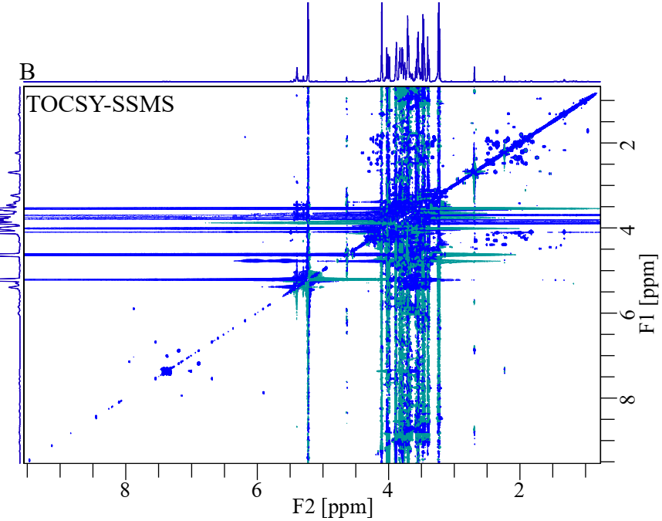
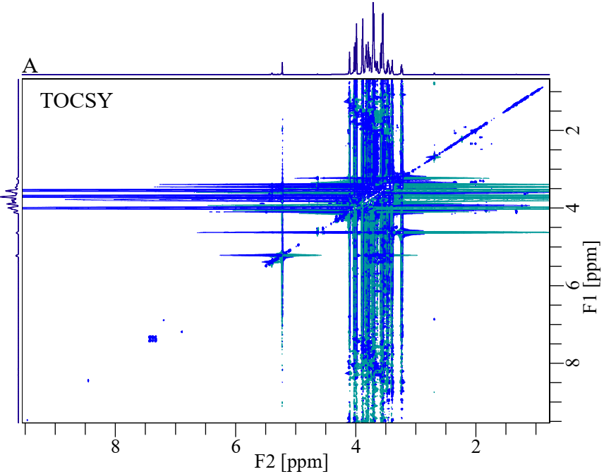

Figure S1. (A) 2D ¹H-¹H TOCSY and (B) 2D ¹H-¹H TOCSY-SSMS spectra for honey sample. Both spectra are at the same contour levels showing the significant suppression of sugar signals and increased visibility of other signals in TOCSY-SSMS compared to that of TOCSY.

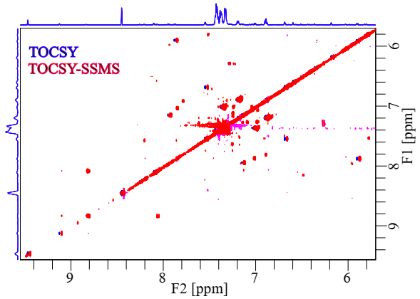

Figure S2. Overlapped spectra with the shift of 0.014 ppm along F₂-dimension in the shaded regions (A) of 2D ¹H-¹H TOCSY (blue) and (B) of 2D ¹H-¹H TOCSY-SSMS (red) spectra for the honey sample which shows great enhancement in the visibility and number of signals in TOCSY-SSMS compared to TOCSY.

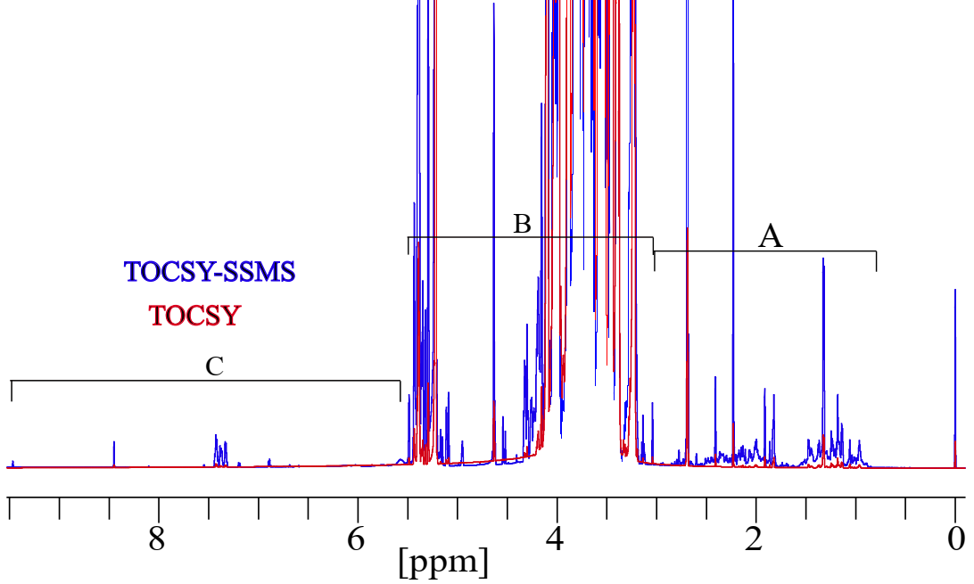
Figure S3. Projected 1D ¹H overlapped spectra of 2D TOCSY (red) and 2D TOCSY-SSMS (blue) for the honey sample show significant enhancement of the sensitivity of the spectrum in TOCSY-SSMS compared to that of TOCSY.

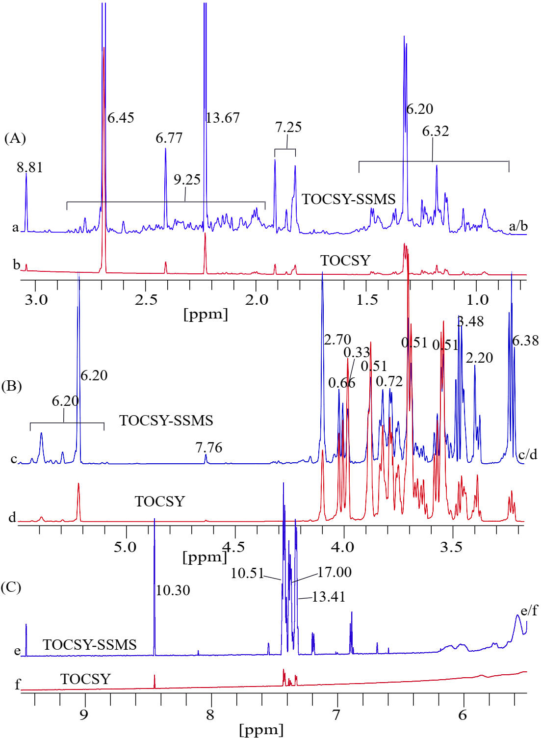

Figure S4. Projected 1D ¹H toggled spectra of 2D TOCSY (red) and 2D TOCSY-SSMS (blue) for the honey sample were expanded in the sections from 0.78 to 3.05 ppm in 4A, 3.18 to 5.49 ppm in 4B, and 5.50 to 9.45 ppm in 4C showing significant enhancement of the sensitivity of the spectrum in TOCSY-SSMS compared to that of TOCSY.
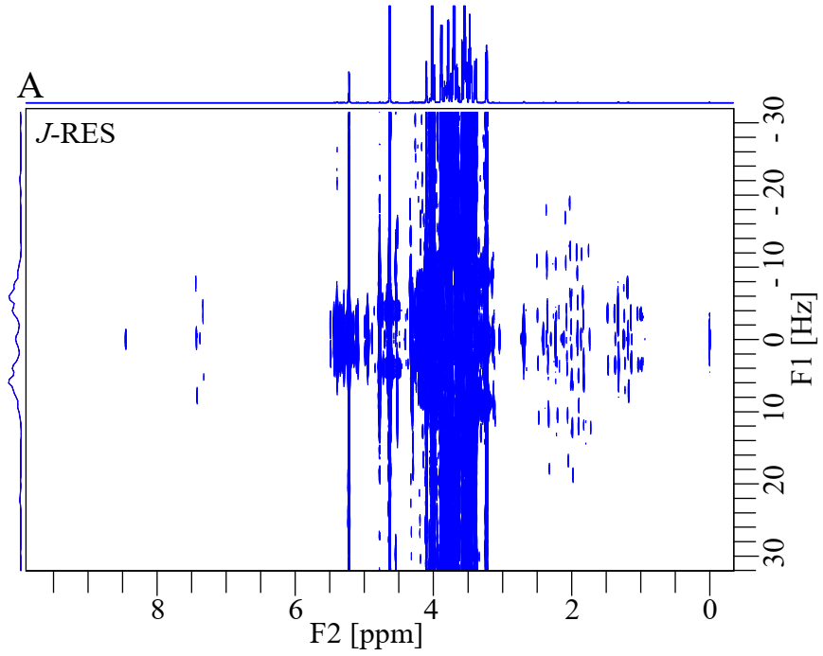
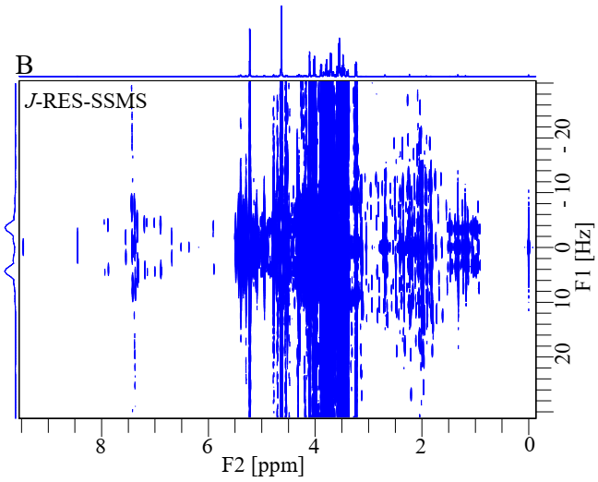

Figure S5. (A) 2D J-RES and (B) 2D J-RES-SSMS spectra for the honey sample. Both spectra are at the same contour levels, showing significant suppression of sugar moieties as well as increased visibility of the rest of the signals in J-RES-SSMS compared to J-RES.

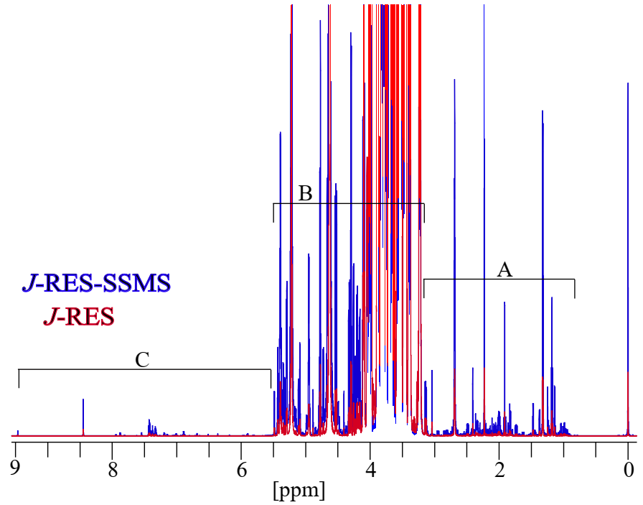Figure S6. Projected 1D ¹H overlapped spectra of 2D J-RES (red) and 2D J-RES -SSMS (blue) for the honey sample showing significant suppression of sugar signals and enhancement of the sensitivity of other signals in the spectrum J-RES-SSMS compared to that of J-RES.

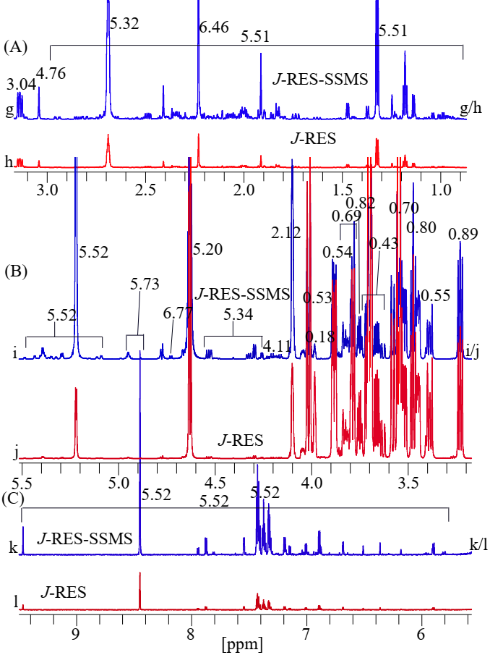
Figure S7. Projected 1D ¹H toggled spectra of 2D J-RES (red) and 2D J-RES-SSMS (blue) for the honey sample were expanded in the sections from 0.85 to 3.15 ppm in 7A, 3.17 to 5.51 ppm in 7B, and 5.60 to 9.45 ppm in 7C, showing significant suppression of sugar signals and greatly enhancement of sensitivities of other signals in the spectrum of J-RES-SSMS compared to J-RES.

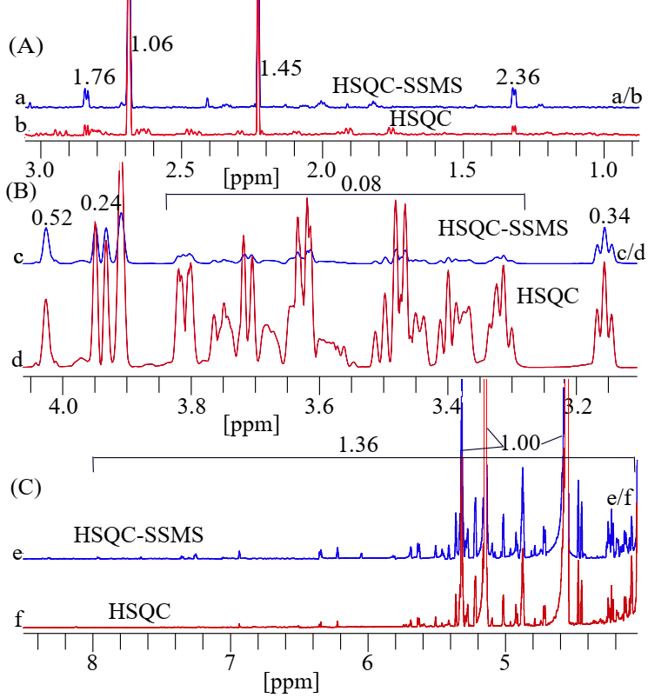 Figure S8. The expanded sections of projected 1D ¹H spectra of 2D ¹H-¹³C HSQC (red, d, f) and 2D ¹H-¹³C HSQC-SSMS (blue, c, e) experiments are shown in the regions from 0.92 to 3.02 ppm, 3.15 to 4.05 ppm, and 4.02 to 8.45 ppm in 13A, 13B, and 13C, respectively, for the honey sample. The significant suppression of sugar signals and enhancement of the sensitivity of other signals was obtained in HSQC-SSMS compared to HSQC.

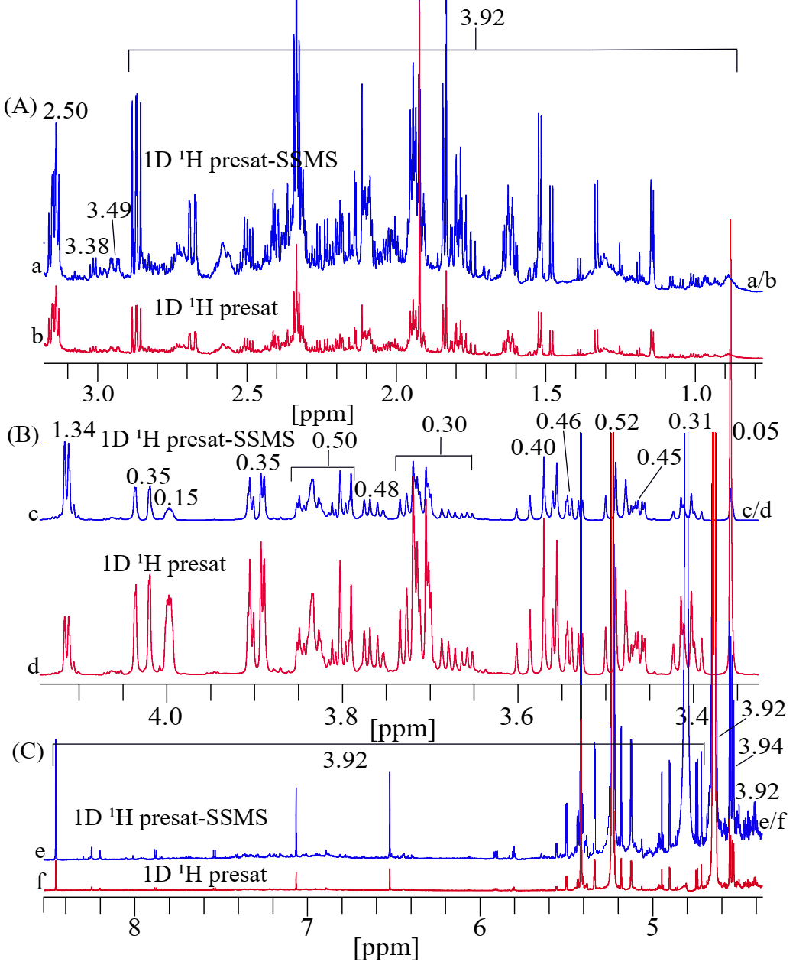
Figure S9. The toggled spectra of 1D ¹H presat and ¹H presat-SSMS NMR for dates-flesh sample are illustrated in (b, d, f) in red and (a, c, e) in blue assigned with measured values of SNR. The spectra of Figure 5D have sections (A, B, C) that were expanded into three sections as A, B, and C in Figure S9. The suppression of sugar moieties cause enhancement of the sensitivity of the remaining signals by more than three times in the spectrum of ¹H presat-SSMS (blue) compared to the conventional ¹H presat spectrum (red).

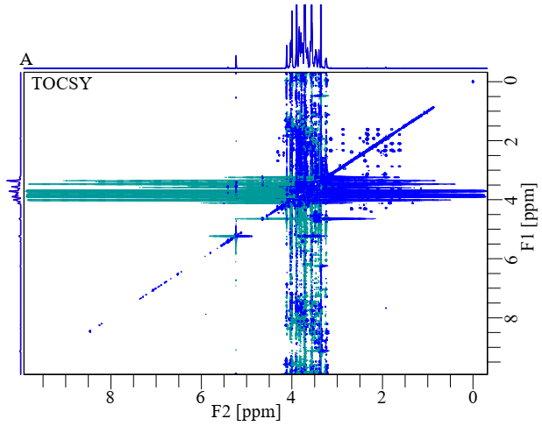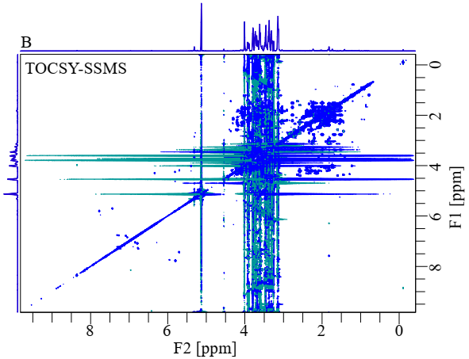
Figure S10. (A) 2D ¹H-¹H TOCSY and (B) 2D ¹H-¹H TOCSY-SSMS spectra of dates-flesh sample. Both spectra are at the same contour levels, showing the increased number and visibility of signals in the methyl, methylene, and their derivatives regions, as well as aromatic regions, and significant suppression of sugar moieties in TOCSY-SSMS compared to TOCSY.

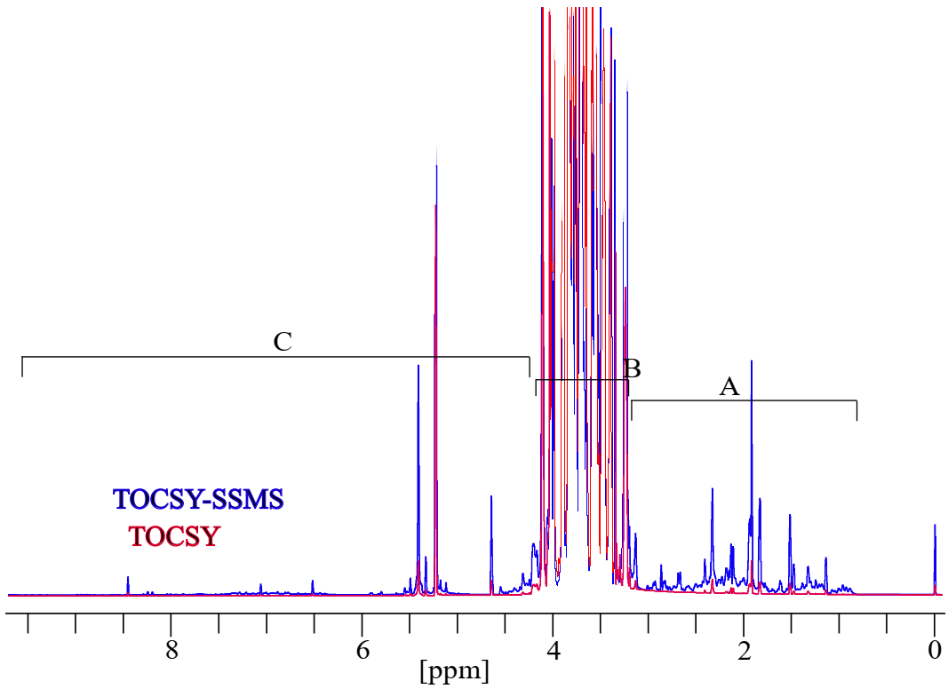
Figure S11. Projected 1D ¹H overlapped spectra of 2D TOCSY (red) and 2D TOCSY-SSMS (blue) of the dates-flesh sample, showing significant enhancement of spectral sensitivity in TOCSY-SSMS compared to TOCSY.

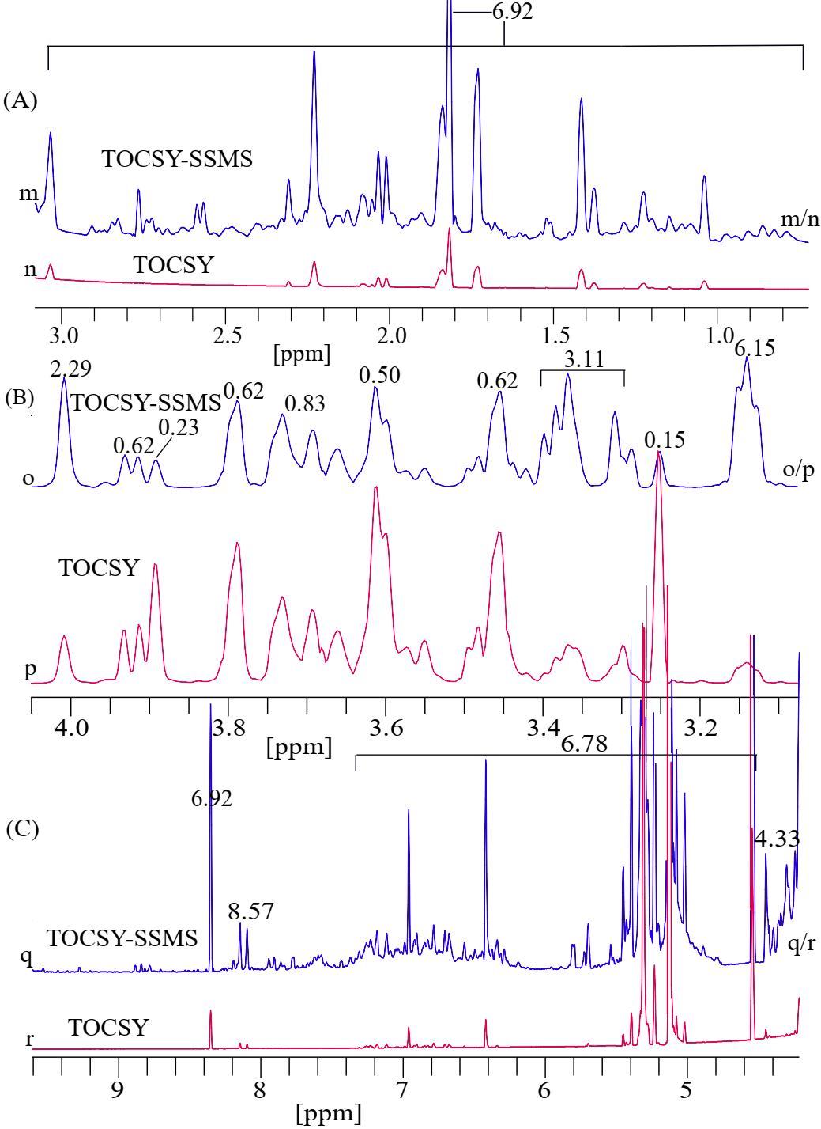
Figure S12. Projected 1D ¹H toggled spectra of 2D TOCSY (red) and 2D TOCSY-SSMS (blue) of the dates-flesh sample were expanded in the sections from 0.75 to 3.09 ppm in 12A, 3.10 to 4.05 ppm in 12B, and 5.50 to 9.60 ppm in 12C, showing significant suppression of sugar signals and greatly enhancement of sensitivities of other signals in the spectrum of TOCSY-SSMS compared to that of TOCSY.
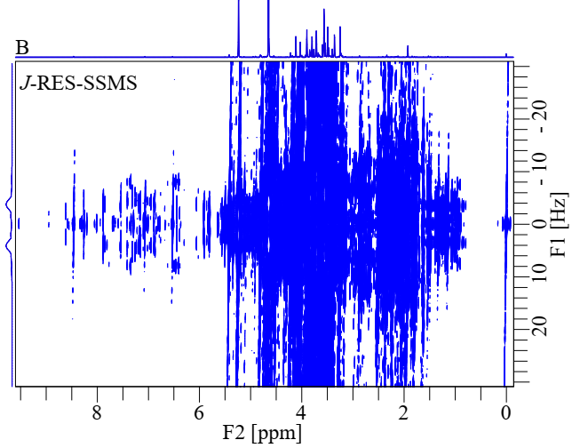
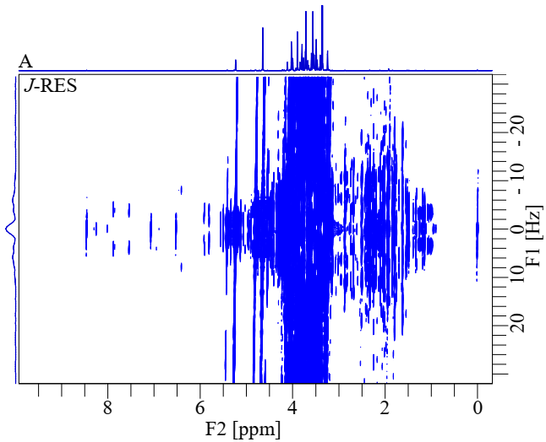

Figure S13. (A) 2D J-RES and (B) 2D J-RES-SSMS spectra of the dates-flesh sample. Both spectra are at the same contour levels, showing significant suppression of sugar moieties as well as increased visibility of the remaining signals in J-RES-SSMS compared to J-RES.

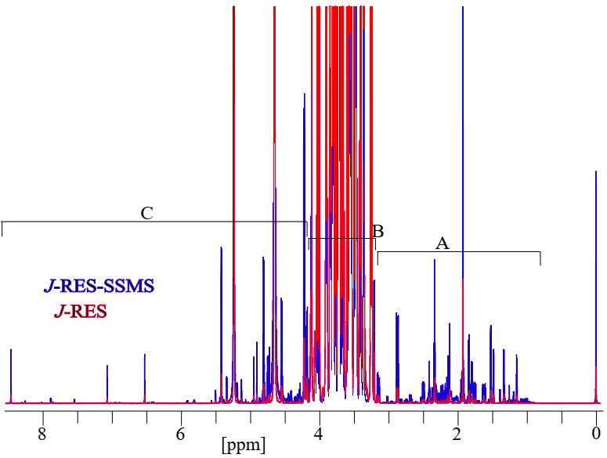Figure S14. Projected 1D ¹H overlapped spectra of 2D J-RES (red) and 2D J-RES -SSMS (blue) for the dates-flesh sample, showing significant enhancement of spectral sensitivity in J-RES-SSMS compared to J-RES.

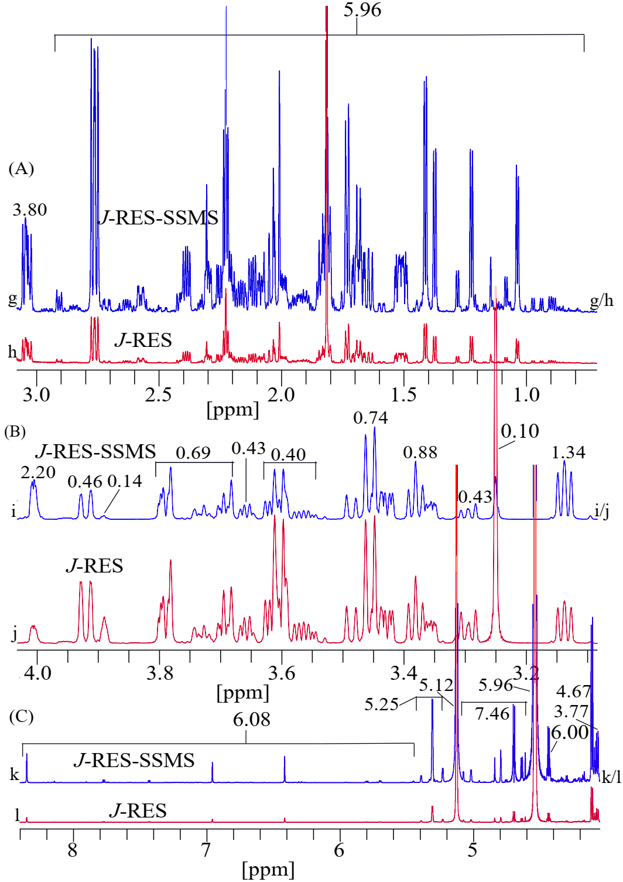
Figure S15. Projected 1D ¹H toggled spectra of 2D J-RES (red) and 2D J-RES-SSMS (blue) for the dates-flesh sample were expanded in the sections from 0.75 to 3.09 ppm in 15A, 3.10 to 4.09 ppm in 15B, and 4.12 to 8.40 ppm in 15C, showing significant suppression of sugar signals and greatly enhancement of sensitivities of other signals in the spectrum of J-RES-SSMS compared to that of J-RES.

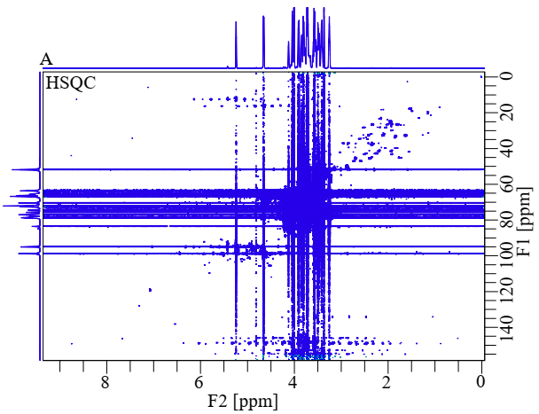
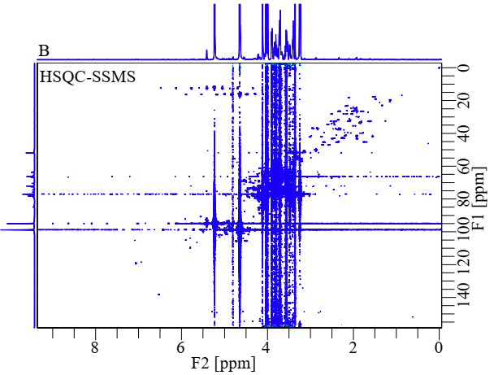
Figure S16. (A) 2D ¹H-¹³C HSQC and (B) 2D ¹H-¹³C HSQC-SSMS spectra for dates-flesh sample. The significant suppression of sugar signals and enhancement of the visibility of the remaining signals was obtained in HSQC-SSMS compared to HSQC.

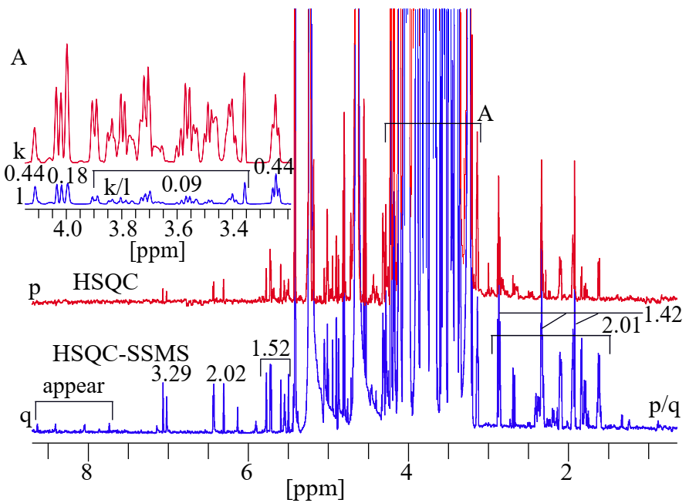
Figure S17. Projected 1D ¹H of (p) 2D ¹H-¹³C HSQC (red) and (q) 2D ¹H-¹³C HSQC-SSMS (blue) spectra of dates-flesh sample. The expanded section of the sugar region is shown in 17A. The significant suppression of sugar signals and enhancement of sensitivity for the remaining other signals were obtained in HSQC-SSMS compared to HSQC.

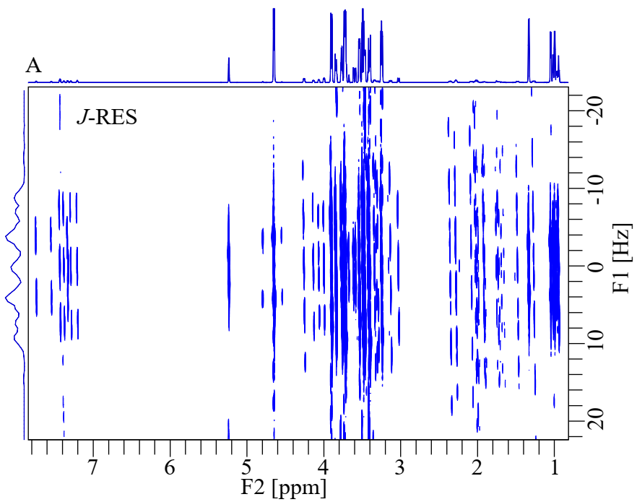
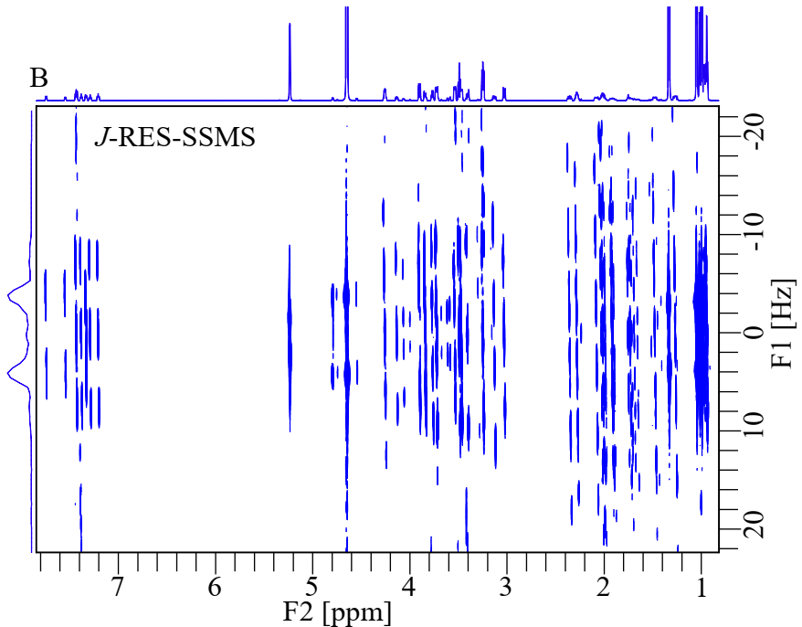

Figure S18. (A) 2D J-RES and (B) 2D J-RES-SSMS spectra for the sample mixture of glucose and amino acids. Both spectra are at the same contour levels, showing significant suppression of sugar signals and increased visibility of the remaining signals in J-RES-SSMS compared to J-RES.

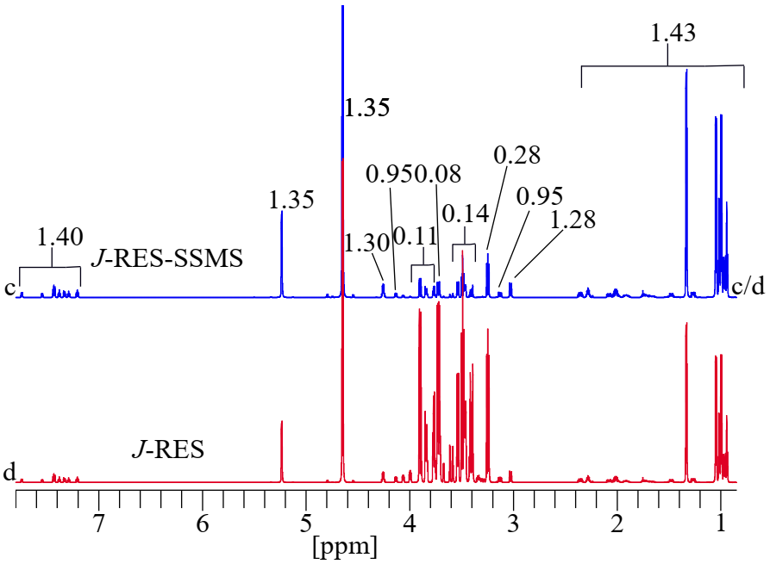
Figure S19. Projected 1D ¹H toggled spectra of 2D J-RES-SSMS (c) and 2D J-RES (d) for the sample mixture of glucose and amino acids, showing significant enhancement in the sensitivity of the spectrum in J-RES-SSMS compared to J-RES.

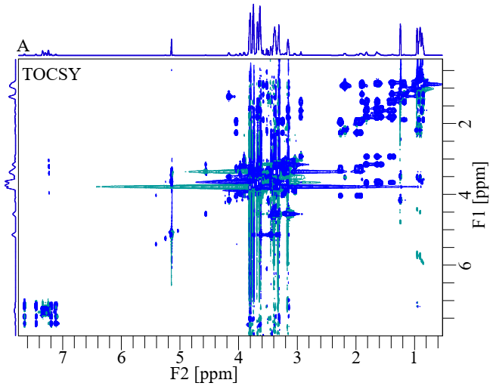
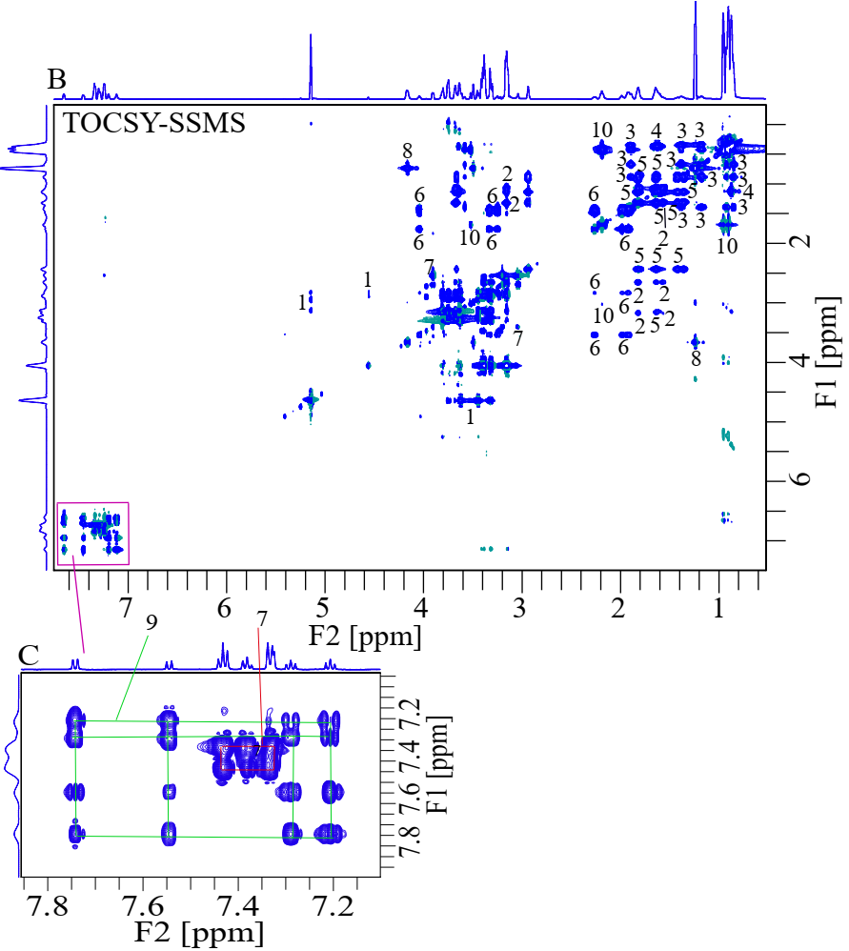

Figure S20. (A) 2D ¹H-¹H TOCSY, (B) 2D ¹H-¹H TOCSY-SSMS, and (C) expanded pink box of spectra for the sample mixture of (1) glucose and amino acid are (2) arginine, (3) isoleucine, (4) leucine, (5) lysine, (6) proline, (7) phenylalanine, (8) threonine, (9) tryptophan, and (10) valine. Both spectra are at the same contour levels, showing significant suppression of the glucose signals as well as the increased visibility of amino acid signals in TOCSY-SSMS compared to TOCSY.

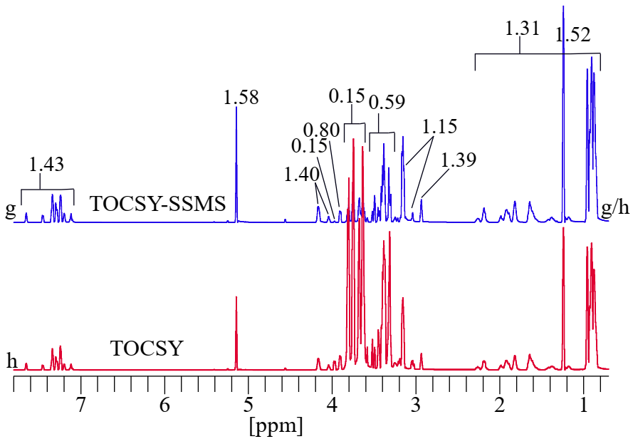
Figure S21. Projected 1D ¹H toggled spectra of 2D TOCSY-SSMS (g) and 2D TOCSY (h) in the sample mixture of glucose and amino acids, showing significant suppression of glucose signals and significant enhancement in the sensitivity of the amino acid signals in TOCSY-SSMS compared to TOCSY.

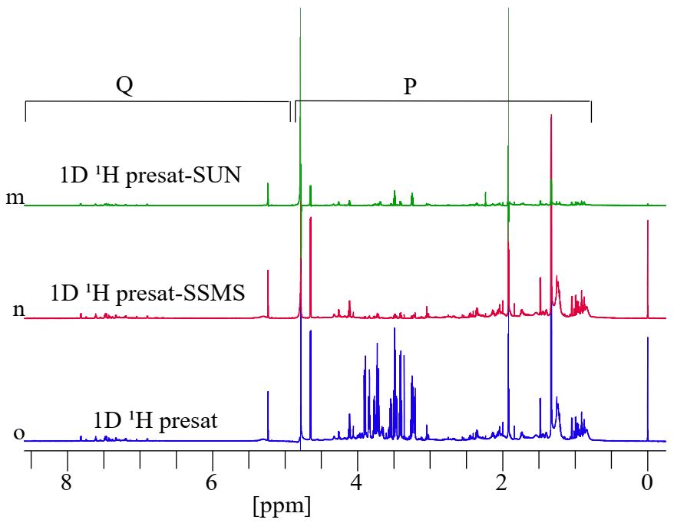
Figure S22. 1D ¹H presat-SUN (m), 1D ¹H presat-SSMS (n), and 1D ¹H presat (o) for the fetal bovine serum sample. Efficient suppression of sugar but without and with great reduction in the sensitivity for the signals of amino acids was observed in ¹H presat-SSMS and ¹H presat-SUN, respectively compared to ¹H presat.

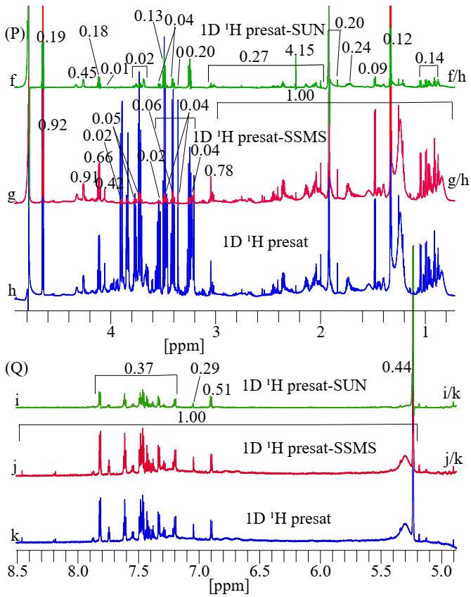
Figure S23. Toggled spectra of 1D ¹H presat-SUN (f, i, green), 1D ¹H presat-SSMS (g, j, red), and 1D ¹H presat (h, k, blue) for the fetal bovine serum sample, shown in the expanded region of the sections from 0.75 to 4.90 ppm in 23P, 4.90 to 8.50 ppm in 23Q, showing significant suppression of the sugar signals and without enhancement in the sensitivities for the rest of the signals in the spectrum of the ¹H presat-SSMS, and also showing significant reduction in sensitivity of the spectrum of ¹H presat-SUN compared to that of ¹H presat.

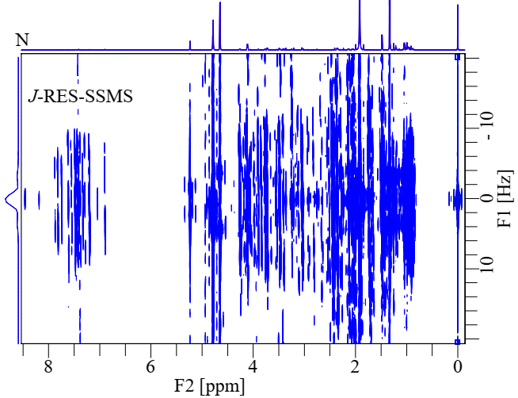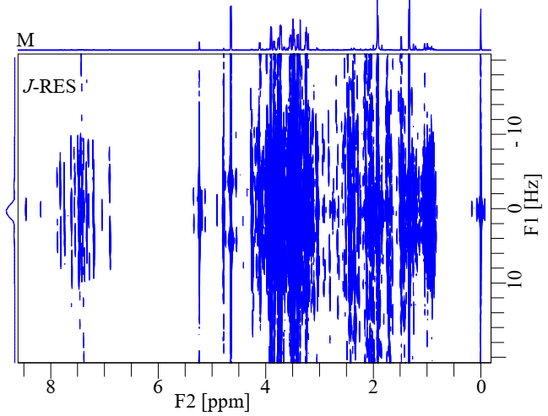

Figure S24. (M) 2D J-RES and (N) 2D J-RES-SSMS spectra for the fetal bovine serum sample. Both spectra are at the same contour levels, showing significant suppression of sugar signals as well as great enhancement in the visibility of the remaining signals in J-RES -SSMS compared to J-RES.

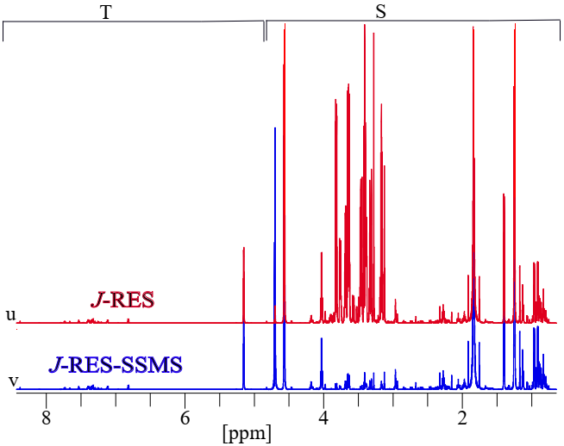
Figure S25. Projected 1D ¹H overlapped spectra of (u) 2D J-RES (red) and (v) 2D J-RES -SSMS (blue) for the fetal bovine serum sample, showing significant suppression of the sugar signals in the spectrum of J-RES -SSMS compared to that of J-RES.

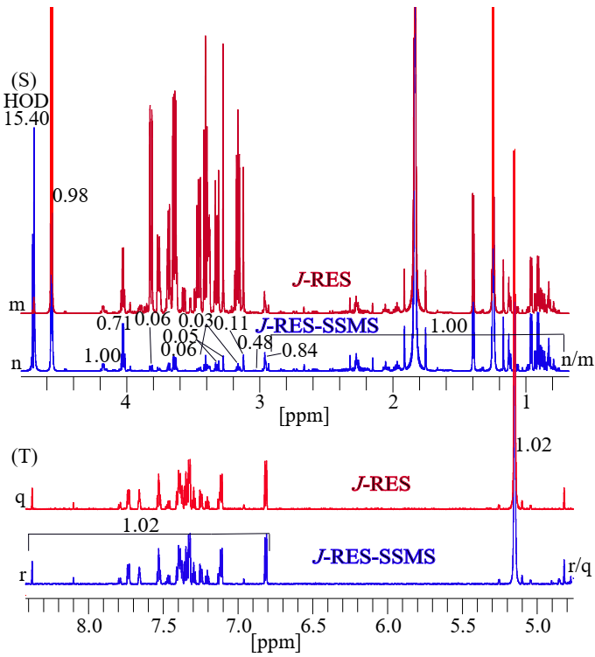
Figure S26. Projected 1D ¹H toggled spectra of 2D J-RES (m, q, red) and 2D J-RES-SSMS (n, r, blue) for the fetal bovine serum sample which are expanded in the sections from 0.72 to 4.68 ppm in 26S, and from 5.78 to 8.40 ppm in 26T, showing the significant suppression of the sugar signals and no enhancement in sensitivity in the higher magnetic field region but 2% enhancement of the sensitivity in the lower magnetic field region in the spectrum of J-RES-SSMS compared to that of J-RES.
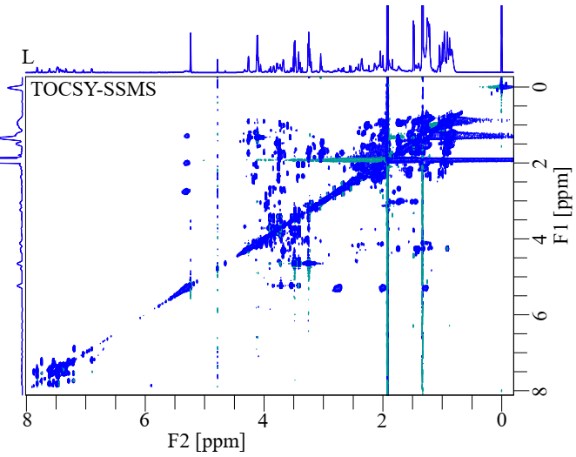
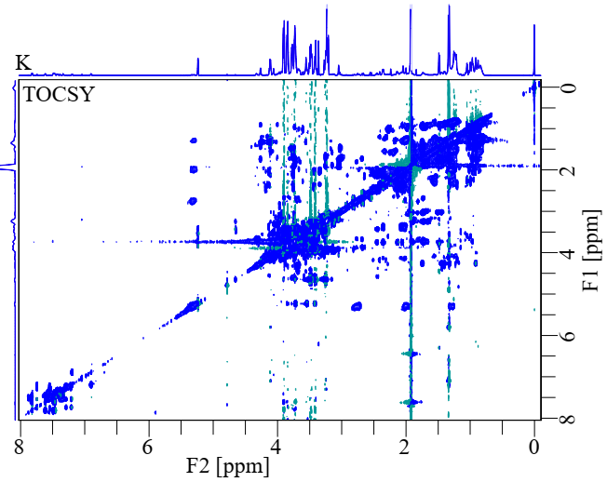

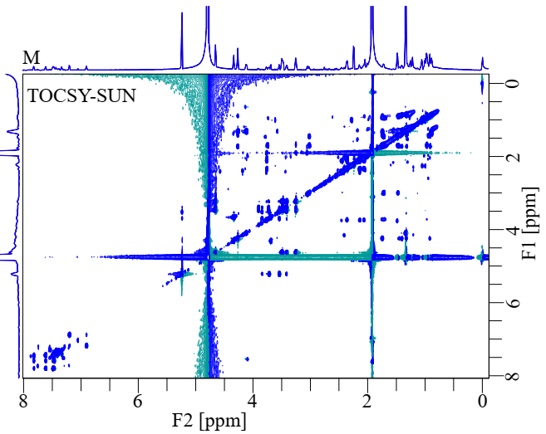
Figure S27. (K) 2D ¹H-¹H TOCSY, (L) 2D ¹H-¹H TOCSY-SSMS, and (M) 2D ¹H-¹H TOCSY-SUN spectra for the fetal bovine serum sample. All spectra are at the same contour levels, showing significant suppression of the sugar signals without increasing and with decreasing visibility of the remaining other signals in the spectrum of TOCSY-SSMS and TOCSY-SUN, respectively compared to that of TOCSY.

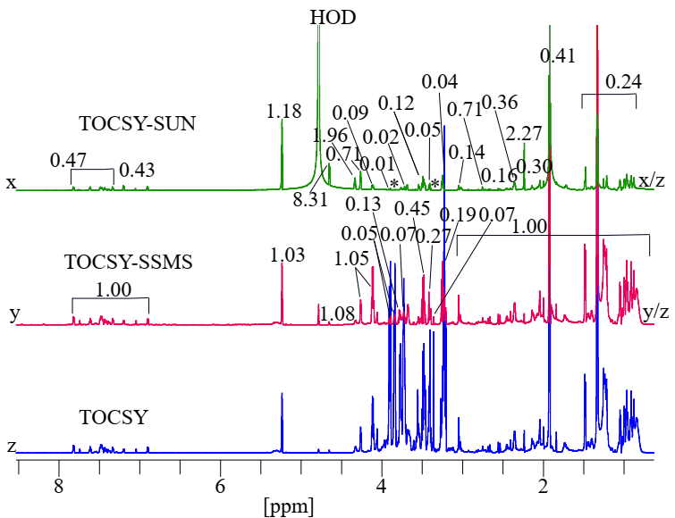
Figure S28. Projected 1D ¹H toggled spectra of 2D TOCSY-SUN (x), 2D TOCSY-SSMS (y), and 2D TOCSY (z) for the fetal bovine serum sample, showing great suppression of sugar signals and no enhancement in the sensitivities of rest of the signals in the spectrum of the TOCSY-SSMS, while showing great reduction in the sensitivity in the spectrum of TOCSY-SUN compared to that of TOCSY.

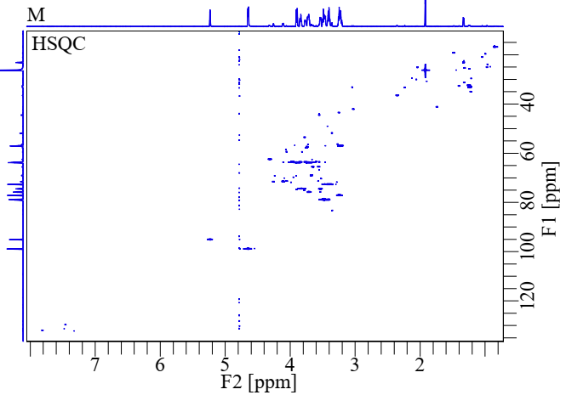
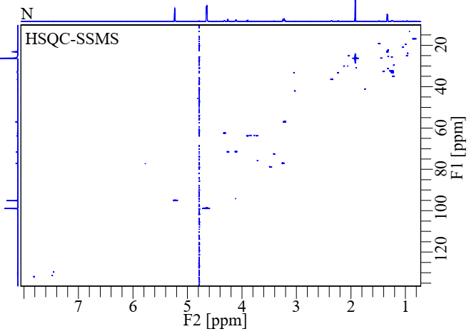
Figure S29. (M) 2D ¹H-¹³C HSQC and (N) 2D ¹H-¹³C HSQC-SSMS spectra of the fetal bovine serum sample. The significant suppression of sugar signals without enhancement in the visibility of the remaining other signals was obtained in HSQC-SSMS compared to HSQC.

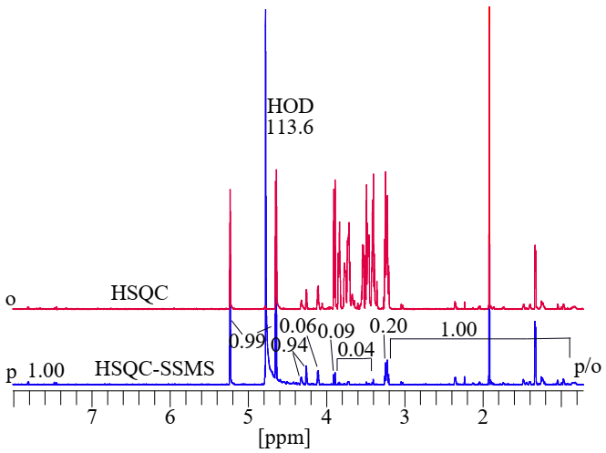
Figure S30. Projected 1D ¹H of (o) 2D ¹H-¹³C HSQC (red) and (p) 2D ¹H-¹³C HSQC-SSMS (blue) spectra of the fetal bovine serum sample. The significant suppression of sugar signals without enhancement in the sensitivity of the remaining other signals was obtained in HSQC-SSMS compared to HSQC.

Experiments | Honey |  | Dates-Flesh |  | Standard stock solution |  | Fetal Bovine Serum (FBS)
Experiments | Supp.  (SNR) | Enh.  (SNR) | Supp.  (SNR) | Enh.  (SNR) | Supp.  (SNR) | Enh.  (SNR) | Supp.  (SNR) | Enh.  (SNR)
¹H presat-SSMS | 0.40 | 3.50 | 0.36 | 3.92 | 0.22 | 1.50 | 0.07 | 1.00
J-RES-SSMS | 0.60 | 5.50 | 0.47 | 6.00 | 0.41 | 1.40 | 0.07 | 1.00
TOCSY-SSMS | 0.50 | 6.50 | 0.44 | 6.92 | 0.42 | 1.40 | 0.17 | 1.00
HSQC-SSMS | 0.16 | 1.40 | 0.13 | 2.00 | 0.13 | 1.50 | 0.06 | 1.00
¹H-SUN | - | - | - | - | - | - | 0.08 | 0.20
TOCSY-SUN | - | - | - | - | - | - | 0.06 | 0.30
Table S5. Estimated signal-to-noise ratio (SNR) of suppression and enhancement in the current methods compared to their conventional methods.

SNR of all conventional Methods have been normalized for comparison with current methods.

- Pulse Sequences of 1D and 2D NMR experiments
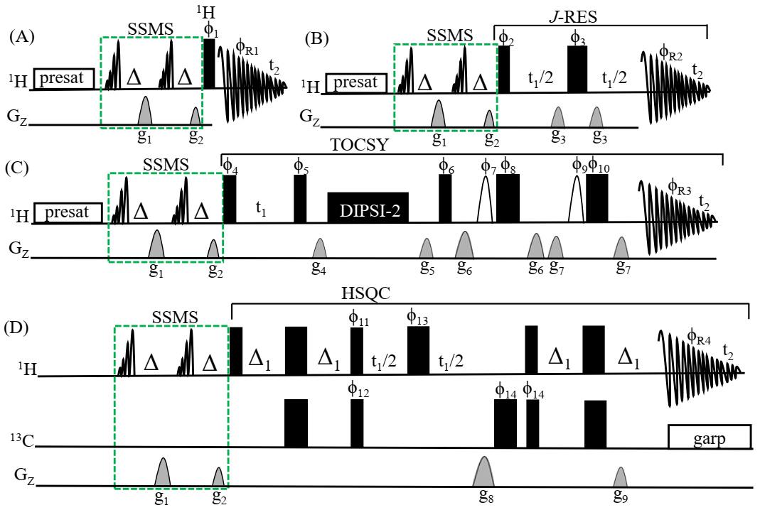

Figure S31. Pulse sequences of (A) 1D ¹H-presat with SSMS for band-selective suppression, (B) 2D J-RES with SSMS for band-selective suppression, (C) 2D TOCSY with SSMS for band-selective suppression, (D) 2D HSQC with SSMS for band-selective suppression. SSMS box has two 90° band-selective pulses of EBurp1 (750 Hz, 6 ms), narrow and wild filled black rectangles are 90° and 180° hard pulses, respectively and open half-sine shapes are selective pulses of Gauss1. Gradient pulses of all experiments are g₁=47%, g₂=27%, g₃=10%, g₄=1%, g₅=3%, g₆=31%, g₇=11%, g₈=80%, and g₉= 20.1%. Pulses are applied along the x-axis, unless indicated otherwise, and phases of pulses and receivers are
φ₁= x, -x, -x, x, y, -y, -y, y, and φ_{R1}= x, -x, -x, x, y, -y, -y, y.
φ₂=x₄, y₄, (-x)₄, (-y)₄, φ₃=x, -x, y, -y, y, -y, -x, x, y, -y, -x, x, -x, x, -y, y, and φ_{R2}=x, x, -x, -x, y, y, -y, -y.
φ₄=x, -x, φ₅=x₄, (-x)₄, φ₆= x₈, (-x)₈, φ₇=x₂, (-x)₂, φ₈=(-x)_{2,} (-y)₂, φ₉= x₄, y₄.
φ₁₀=(-x)_{2,} (-y)_{2,} and φ_{R3}=x, -x, -x, x, x, -x, -x, x, -x, x, x, -x, -x, x, x, -x.
φ₁₁=y, φ₁₂=x, -x, φ₁₃= x₂, (-x)₂, φ₁₄= x₄, (-x)₄, and φ_{R3}=x, -x, x, -x, -x, x, -x, x.

- Pulse Sequence (Bruker format)
Simple way for starting-up

- Select and copy the pulse program from this document and past it to text file, save it as “¹H-presat-SSMS” and named as folder_(Y,Y) in Bruker\Topspin\exp\stan\nmr\lists\pp\user.
- For SSMS pulses, calibrate selective pulse of EBurp1 with bandwidth of 750 Hz and around 6 ms.
- Fix the selective pulse frequency offset of these band-selective pulses.
- For the combined 1D ¹H-presat and 2D (J-RES, TOCSY, and HSQC) NMR experiments, follow their standard acquisition parameters given in the library of Bruker\Topspin\exp\ stan\nmr\lists\pp.

1D ¹H-presat-SSMS with band-selective suppression

;¹H-presat-SSMS
;avance-version (12/01/11)
;1D sequence with f1 presaturation
;$CLASS=HighRes
;$DIM=1D
;$TYPE=
;$SUBTYPE=
;$COMMENT=
#include <Avance.incl>
#include <Grad.incl>
#include <Delay.incl>
"d12=20u"
;"TAU=50m"
"acqt0=-p1*2/3.1416"

1 ze
2 30m
d12 pl9:f1
d1 cw:f1 ph29
4u do:f1
20u UNBLKGRAD
4u pl0:f1
p11:sp1:f1 ph2:r
d20
p16:gp1
d16
p11:sp1:f1 ph2:r
d20
p16:gp2
d16
d12 pl1:f1
p1 ph1
4u BLKGRAD
go=2 ph31
30m mc #0 to 2 F0(zd)
exit
ph2=0
ph1=0 2 2 0 1 3 3 1
ph29=0
ph31=0 2 2 0 1 3 3 1
;pl1 : f1 channel - power level for pulse (default)
;pl9 : f1 channel - power level for presaturation
;p1 : f1 channel - 90 degree high power pulse
;d1 : relaxation delay; 1-5 * T1
;d12: delay for power switching [20 usec]
;ns: 1 * n, total number of scans: NS * TD0
;$Id: zgpr,v 1.11 2012/01/31 17:49:32 ber Exp $

2D J-RES-SSMS with band-selective suppression

;J-RES-SSMS
;avance-version (12/01/11)
;homonuclear J-resolved 2D correlation
;with presaturation during relaxation delay
;using gradients
;$CLASS=HighRes
;$DIM=2D
;$TYPE=
;$SUBTYPE=
;$COMMENT=
#include <Avance.incl>
#include <Grad.incl>
"p2=p1*2"
"d11=30m"
"d12=20u"
"in0=inf1/2"
"d0=3u"
1 ze
2 d11
3 d12 pl9:f1
d1 cw:f1 ph29
4u do:f1
;d12 pl1:f1
50u UNBLKGRAD
4u pl0:f1
p11:sp1:f1 ph3:r
d20
p16:gp3
d16
p11:sp1:f1 ph3:r
d20
p16:gp4
d16
d12 pl1:f1
p1 ph1
4u
d0
p16:gp1
d16
p2 ph2
4u
p16:gp2
d16
d0 BLKGRAD
go=2 ph31
d11 mc #0 to 2 F1QF(caldel(d0, +in0))
exit
ph1=0 0 0 0 1 1 1 1 2 2 2 2 3 3 3 3
ph2=0 2 1 3 1 3 2 0 1 3 2 0 2 0 3 1
ph3=0
ph29=0
ph31=0 0 2 2 1 1 3 3
;pl1 : f1 channel - power level for pulse (default)
;pl9 : f1 channel - power level for presaturation
;p1 : f1 channel - 90 degree high power pulse
;p2 : f1 channel - 180 degree high power pulse
;p16: homospoil/gradient pulse [1 msec]
;d0 : incremented delay (2D) [3 usec]
;d1 : relaxation delay; 1-5 * T1
;d11: delay for disk I/O [30msec]
;d12: delay for power switching [20 usec]
;d16: delay for homospoil/gradient recovery
;inf1: 1/w, w = max. width of multiplet
;in0: 1/(2 * w), w = max. width of multiplet
;nd0: 2
;ns: 4 * n
;ds: 16
;td1: number of experiments
;FnMODE: QF
;use gradient ratio: gp 1 : gp 2
; 10 : 10
;for z-only gradients:
;gpz1: 10%
;gpz2: 10%
;use gradient files:
;gpnam1: SMSQ10.100
;gpnam2: SMSQ10.100
;$Id: jresgpprqf,v 1.4 2012/01/31 17:49:26 ber Exp $

2D TOCSY-SSMS with band-selective suppression

; TOCSY-SSMS
;avance-version (19/02/08)
;homonuclear Hartman-Hahn transfer using DIPSI2 sequence
; for mixing
;phase sensitive
;water suppression using excitation sculpting with gradients
;(use parameterset DIPSI2ESGPPH)
;A.J. Shaka, C.J. Lee & A. Pines, J. Magn. Reson. 77, 274 (1988)
;T.-L. Hwang & A.J. Shaka, J. Magn. Reson.,
; Series A 112 275-279 (1995)
;$CLASS=HighRes
;$DIM=2D
;$TYPE=
;$SUBTYPE=
;$COMMENT=
prosol relations=<triple>
#include <Avance.incl>
#include <Delay.incl>
#include <Grad.incl>
"p2=p1*2"
"d11=30m"
"d12=20u"
"d13=4u"

"in0=inf1"
"d0=in0*0.5-p1*4/3.1416"
"TAU=de+p1*2/3.1416+4u"
"FACTOR1=(d9/(p6*115.112))/2"
"l1=FACTOR1*2"
"acqt0=0"
baseopt_echo
1 ze
2 d11
3 d12 pl32:f1
d1 cw:f1 ph29
d13 do:f1
20u UNBLKGRAD
4u pl0:f1
p13:sp3:f1 ph8:r
d20
p16:gp5
d16
p13:sp3:f1 ph8:r
d20
p16:gp6
d16
d12 pl1:f1
p1 ph1
d0
p1 ph2
;50u UNBLKGRAD
p16:gp1
d16 pl10:f1

;begin DIPSI2
4 p6*3.556 ph23
p6*4.556 ph25
p6*3.222 ph23
p6*3.167 ph25
p6*0.333 ph23
p6*2.722 ph25
p6*4.167 ph23
p6*2.944 ph25
p6*4.111 ph23
p6*3.556 ph25
p6*4.556 ph23
p6*3.222 ph25
p6*3.167 ph23
p6*0.333 ph25
p6*2.722 ph23
p6*4.167 ph25
p6*2.944 ph23
p6*4.111 ph25
p6*3.556 ph25
p6*4.556 ph23
p6*3.222 ph25
p6*3.167 ph23
p6*0.333 ph25
p6*2.722 ph23
p6*4.167 ph25
p6*2.944 ph23
p6*4.111 ph25
p6*3.556 ph23
p6*4.556 ph25
p6*3.222 ph23
p6*3.167 ph25
p6*0.333 ph23
p6*2.722 ph25
p6*4.167 ph23
p6*2.944 ph25
p6*4.111 ph23
lo to 4 times l1 ;end DIPSI
4u
p16:gp2
d16 pl1:f1
p1 ph3
p16:gp3
d16 pl0:f1
(p12:sp1 ph4:r):f1
4u
d12 pl1:f1
p2 ph5
4u
p16:gp3
d16
TAU
p16:gp4
d16 pl0:f1
(p12:sp1 ph6:r):f1
4u
d12 pl1:f1
p2 ph7
4u
p16:gp4
d16
4u BLKGRAD
go=2 ph31
d11 mc #0 to 2 F1PH(calph(ph1, +90) & calph(ph29, +90), caldel(d0, +in0))
exit
ph1=0 2
ph2=0 0 0 0 2 2 2 2
ph3=0 0 0 0 0 0 0 0 2 2 2 2 2 2 2 2
ph4=0 0 1 1
ph5=2 2 3 3
ph6=0 0 0 0 1 1 1 1
ph7=2 2 2 2 3 3 3 3
ph8=0
ph23=3
ph25=1
ph29=0
ph31=0 2 2 0 0 2 2 0 2 0 0 2 2 0 0 2
;pl0 : 0W
;pl1 : f1 channel - power level for pulse (default)
;pl10: f1 channel - power level for TOCSY-spinlock
;pl32: f1 channel - power level for low power presaturation
;sp1 : f1 channel - shaped pulse 180 degree
;p1 : f1 channel - 90 degree high power pulse
;p2 : f1 channel - 180 degree high power pulse
;p6 : f1 channel - 90 degree low power pulse
;p12: f1 channel - 180 degree shaped pulse (Squa100.1000) [2 msec]
;p16: homospoil/gradient pulse
;d0 : incremented delay (2D)
;d1 : relaxation delay; 1-5 * T1
;d9 : TOCSY mixing time
;d11: delay for disk I/O [30 msec]
;d12: delay for power switching [20 usec]
;d13: short delay [4 usec]
;d16: delay for homospoil/gradient recovery
;l1: loop for DIPSI cycle: ((p6*115.112) * l1) = mixing time
;inf1: 1/SW = 2 * DW
;in0: 1/(1 * SW) = 2 * DW
;nd0: 1
;ns: 8 * n
;ds: 16
;td1: number of experiments
;FnMODE: States-TPPI, TPPI, States or QSEQ
;use gradient ratio: gp 1 : gp 2 : gp 3 : gp 4
; 1 : 3 : 31 : 11
;for z-only gradients:
;gpz1: 1%
;gpz2: 3%
;gpz3: 31%
;gpz4: 11%
;use gradient files:
;gpnam1: SMSQ10.100
;gpnam2: SMSQ10.100
;gpnam3: SMSQ10.100
;gpnam4: SMSQ10.100

;set pl32 to 0W when presaturation is not required
; use pl1 + 75 to 80dB to reduce radiation damping
;Processing
;PHC0(F1): 90
;PHC1(F1): -180
;FCOR(F1): 1
;$Id: dipsi2esgpph,v 1.15 2019/02/11 14:04:14 ber Exp $

2D HSQC-SSMS with band-selective suppression

;HSQC-SSMS
;avance-version (12/01/11)
;HSQC
;2D H-1/X correlation via double inept transfer
;phase sensitive using Echo/Antiecho-TPPI gradient selection
;with decoupling during acquisition
;using trim pulses in inept transfer
;$CLASS=HighRes
;$DIM=2D
;$TYPE=
;$SUBTYPE=
;$COMMENT=
#include <Avance.incl>
#include <Grad.incl>
#include <Delay.incl>
"p2=p1*2"
"p4=p3*2"
"d4=1s/(cnst2*4)"
"d11=30m"
# ifdef LABEL_CN
"p22=p21*2"
# else
# endif /*LABEL_CN*/
"d0=3u"
"in0=inf1/2"
"DELTA1=d4-p16-de+p1*2/PI-8u"
# ifdef LABEL_CN
"DELTA=p16+d16+larger(p2,p22)+d0*2"
# else
"DELTA=p16+d16+p2+d0*2"
# endif /*LABEL_CN*/
1 ze
d11 pl12:f2
2 d1 do:f2
20u UNBLKGRAD
4u pl0:f1
3 p13:sp3:f1 ph1:r
d20
p16:gp3
d16
p13:sp3:f1 ph1:r
d20
p16:gp4
d16
20u pl1:f1
(p1 ph1)
d4 pl2:f2
(center (p2 ph1) (p4 ph6):f2 )
d4 UNBLKGRAD
p28 ph1
4u
(p1 ph2) (p3 ph3):f2
d0
# ifdef LABEL_CN
(center (p2 ph5) (p22 ph1):f3 )
# else
(p2 ph5)
# endif /*LABEL_CN*/
d0
p16:gp1*EA
d16
(p4 ph4):f2
DELTA
(ralign (p1 ph1) (p3 ph4):f2 )
d4
(center (p2 ph1) (p4 ph1):f2 )
4u
p16:gp2
DELTA1 pl12:f2
4u BLKGRAD
go=2 ph31 cpd2:f2
d1 do:f2 mc #0 to 2
F1EA(calgrad(EA), caldel(d0, +in0) & calph(ph3, +180) & calph(ph6, +180) & calph(ph31, +180))
exit
ph1=0
ph2=1
ph3=0 2
ph4=0 0 0 0 2 2 2 2
ph5=0 0 2 2
ph6=0
ph31=0 2 0 2 2 0 2 0
;pl1 : f1 channel - power level for pulse (default)
;pl2 : f2 channel - power level for pulse (default)
;pl3 : f3 channel - power level for pulse (default)
;pl12: f2 channel - power level for CPD/BB decoupling
;p1 : f1 channel - 90 degree high power pulse
;p2 : f1 channel - 180 degree high power pulse
;p3 : f2 channel - 90 degree high power pulse
;p4 : f2 channel - 180 degree high power pulse
;p16: homospoil/gradient pulse
;p22: f3 channel - 180 degree high power pulse
;p28: f1 channel - trim pulse
;d0 : incremented delay (2D) [3 usec]
;d1 : relaxation delay; 1-5 * T1
;d4 : 1/(4J)XH
;d11: delay for disk I/O [30 msec]
;d16: delay for homospoil/gradient recovery
;cnst2: = J(XH)
;inf1: 1/SW(X) = 2 * DW(X)
;in0: 1/(2 * SW(X)) = DW(X)
;nd0: 2
;ns: 1 * n
;ds: >= 16
;td1: number of experiments
;FnMODE: echo-antiecho
;cpd2: decoupling according to sequence defined by cpdprg2
;pcpd2: f2 channel - 90 degree pulse for decoupling sequence
;use gradient ratio: gp 1 : gp 2
; 80 : 20.1 for C-13
;80 : 8.1 for N-15
;for z-only gradients:
;gpz1: 80%
;gpz2: 20.1% for C-13, 8.1% for N-15
;use gradient files:
;gpnam1: SMSQ10.100
;gpnam2: SMSQ10.100
;preprocessor-flags-start
;LABEL_CN: for C-13 and N-15 labeled samples start experiment with
;option -DLABEL_CN (eda: ZGOPTNS)
;preprocessor-flags-end
;$Id: hsqcetgp,v 1.7 2012/01/31 17:49:26 ber Exp $

