Supplementary Material

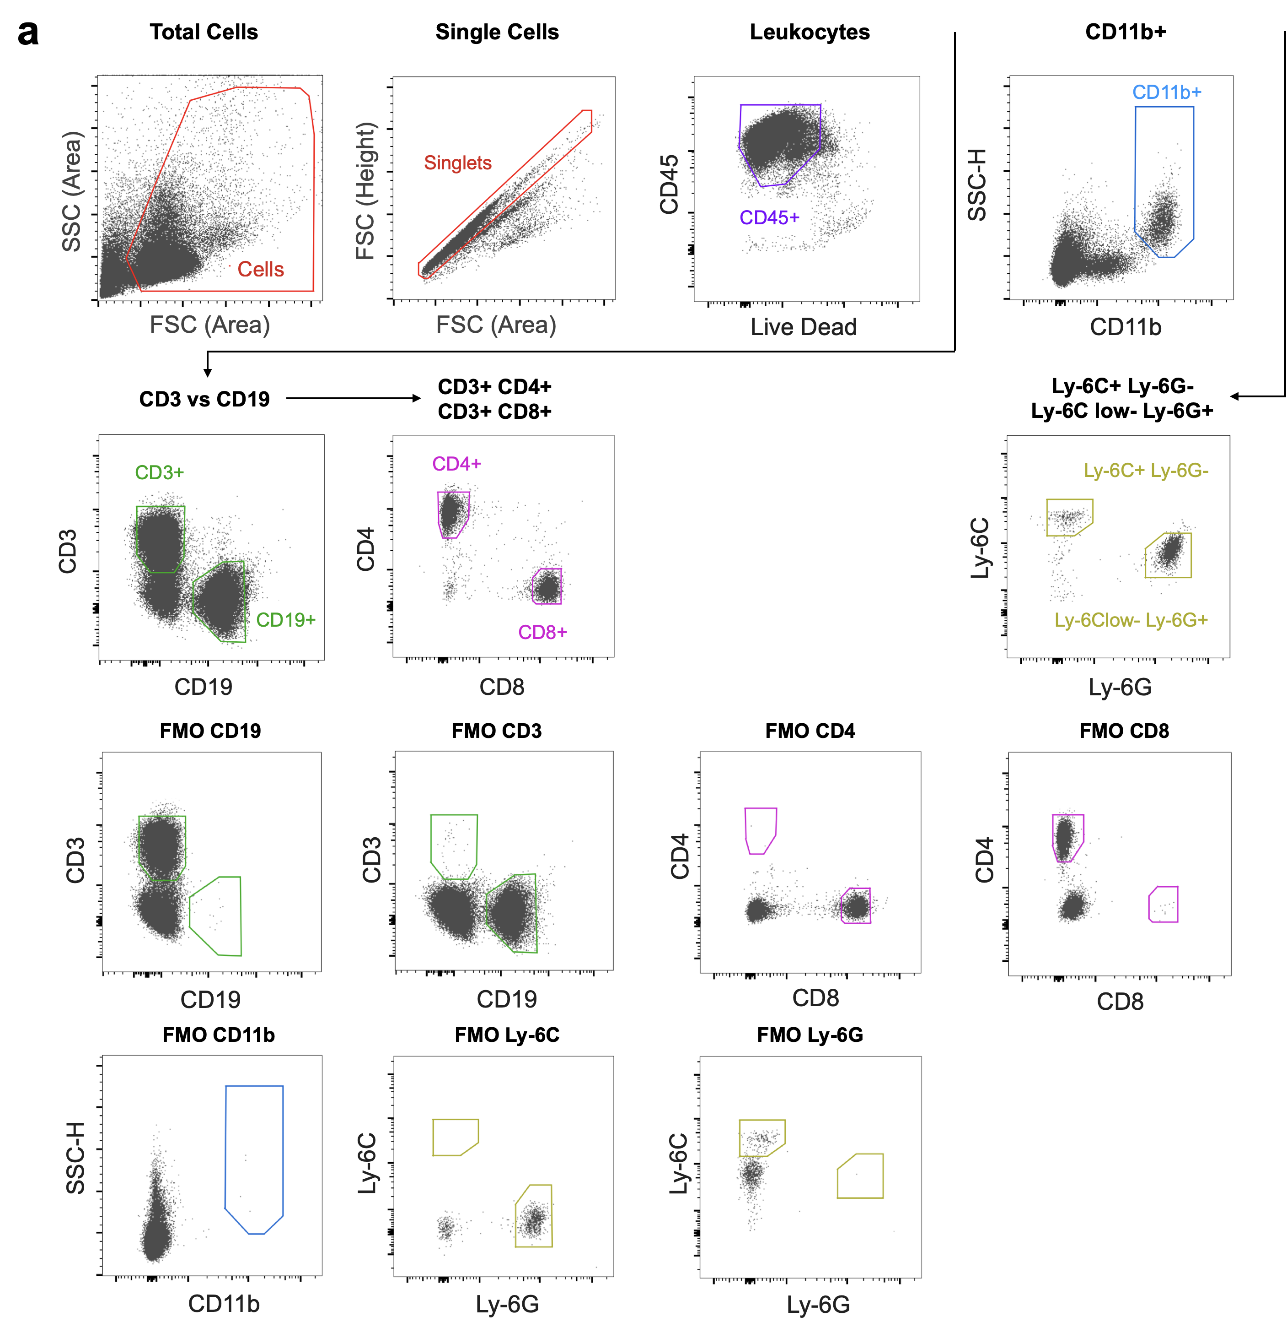
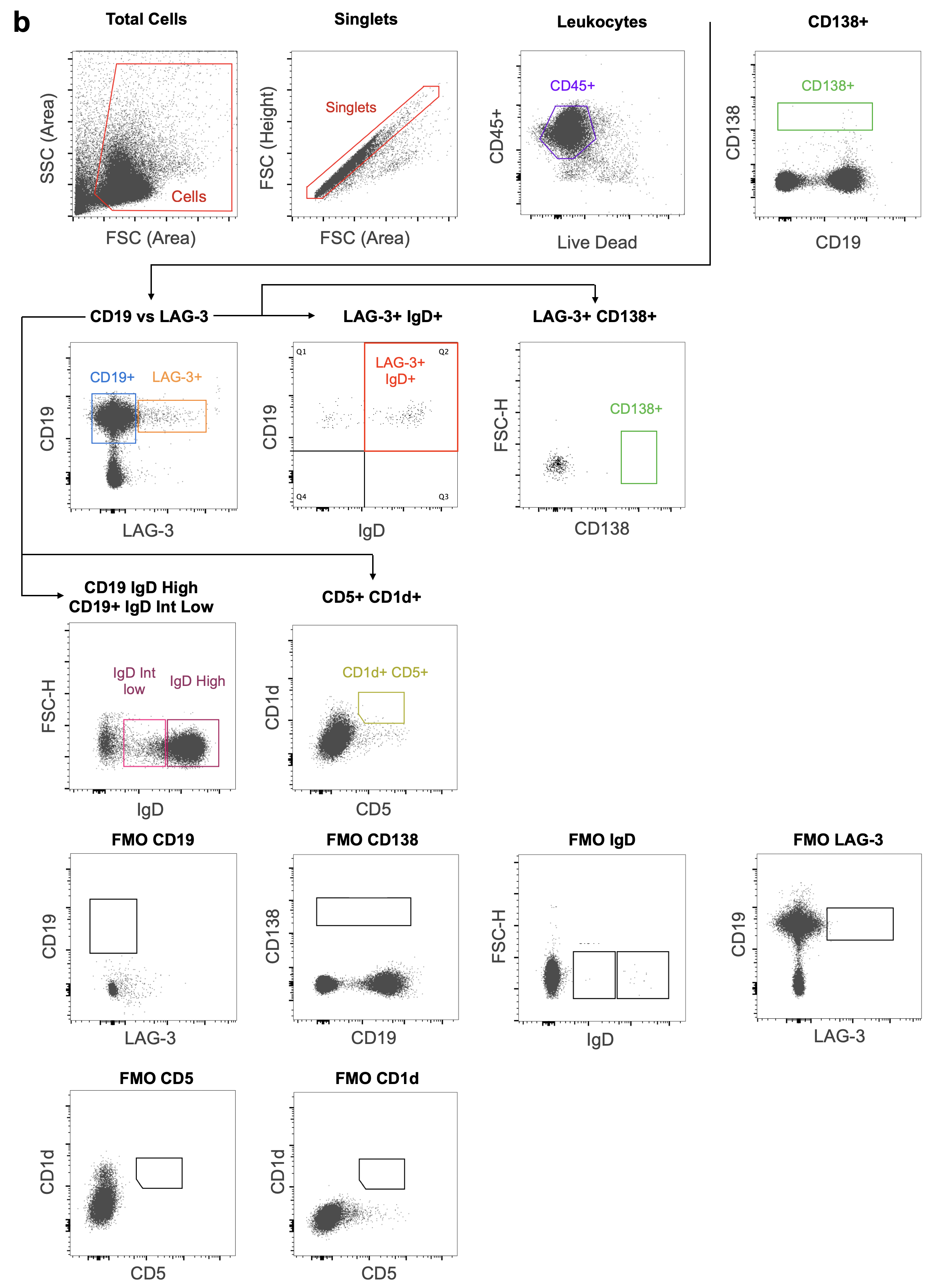

Figure S1. Gating strategies for the assessment of myeloid and lymphoid cells. Total cells were gated by plotting forward scatter area (FSC-A) versus side scatter area (SSC-A). Single cells were selected by plotting forward scatter area (FSC-A) versus forward scatter height. Live cells were selected by gating unstained cells for the viability dye. Total leukocytes in the samples were selected by gating CD45+ cells. (a) Lymphoid cell populations were gated by plotting CD19 versus CD3, and myeloid cells were gated by plotting side scatter height (SSC-H) versus CD11b. Each population of interest were gated as follows: B Cell (CD45+ CD19+); TCD4 Cells (CD45+ CD3+ CD4+); TCD8 Cells (CD45+ CD3+ CD8+); Polymorphonuclear myeloid cells (CD11b+ Ly-6G+ Ly-6C-); Mononuclear myeloid cells (CD11b+ Ly-6G- Ly-6C+). (b) Each population of interest were gated as follows: B Cell (CD45+ CD19+); Plasma cells (CD45+ CD138+); B10 B cell (CD45+ CD19+ CD5+ CD1d+), Naive B Cell (CD45+ CD19+ IgD High), Early-activated B cells (CD45+ CD19+ IgD Int Low); B Cell LAG-3+ subsets (CD45+ CD19+ LAG-3+): IgD Int Low, IgD High, CD138+.

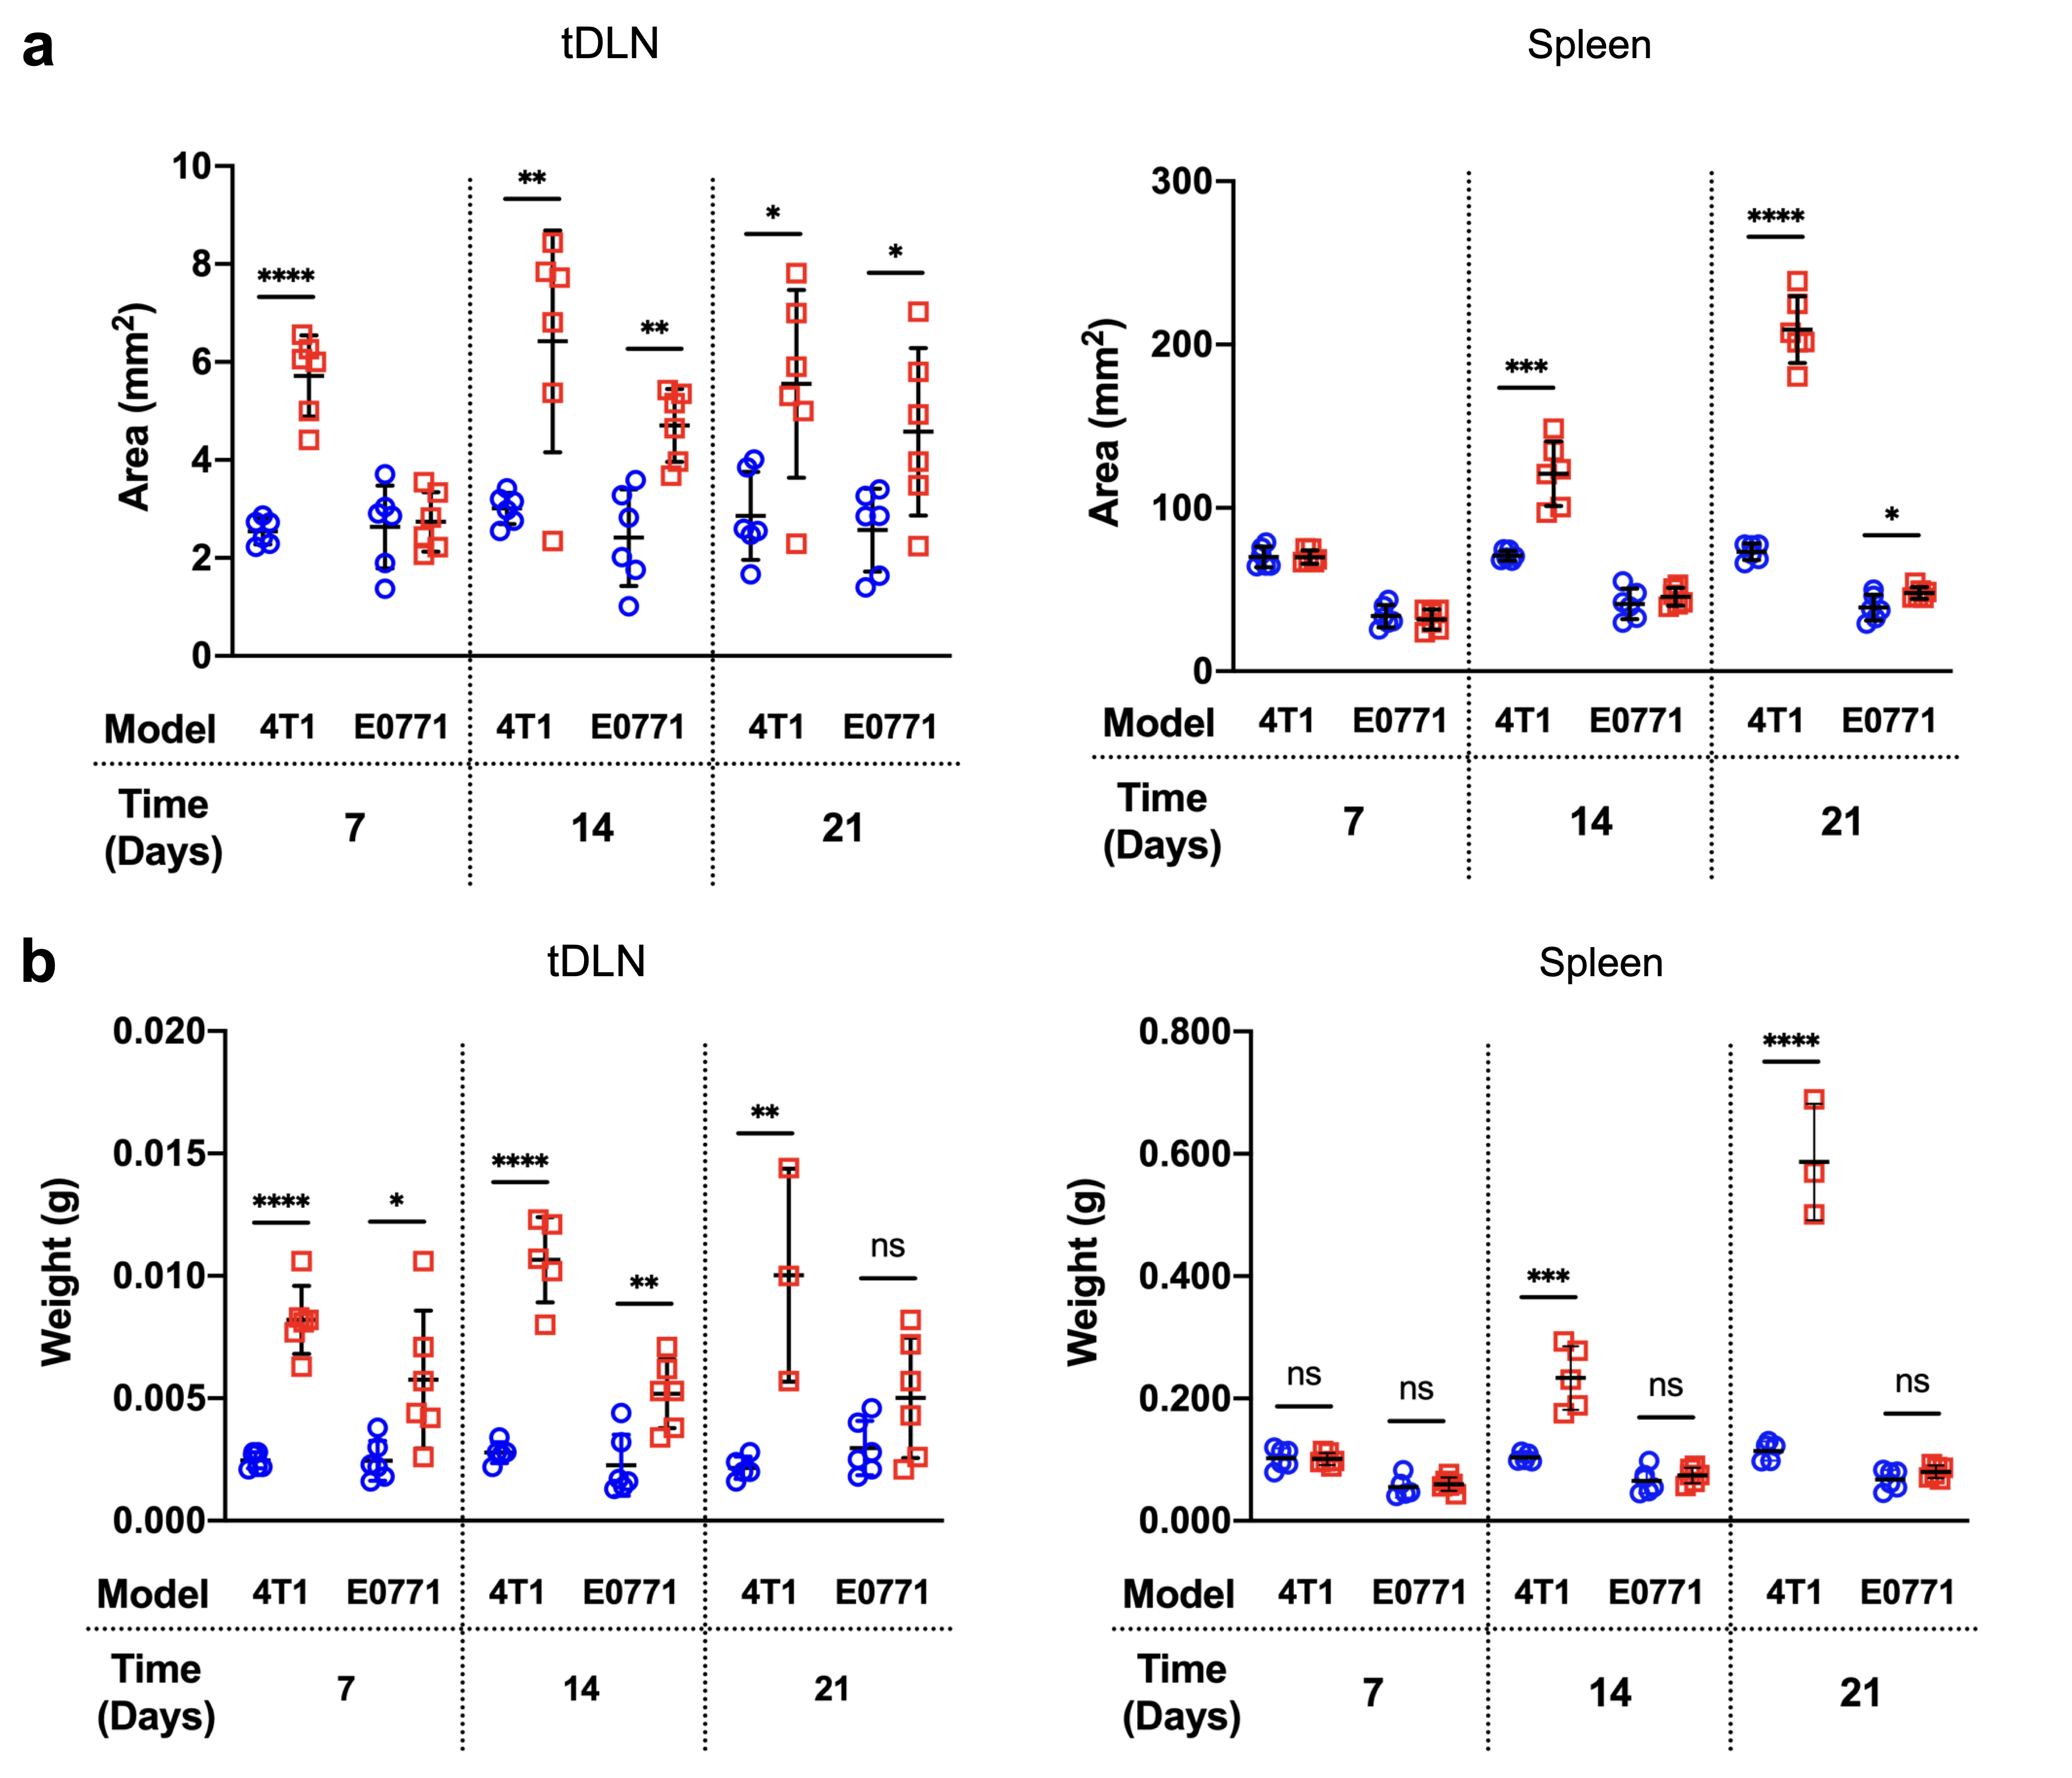
Figure S2. Area and weight of spleen and tDLNs. Area of the tDLNs (right) and the spleen (right) in mice from control (blue) and 4T1/E0771 tumor-bearing mice after 7, 14 and 21 days of tumoral challenge (a). Weight of the tDLNs (right) and the spleen (right) in mice from control (blue) and 4T1/E0771 tumor-bearing mice after 7, 14 and 21 days of tumoral challenge (b). p<0.05, ** p<0.01, *** p<0.001, **** p<0.0001.
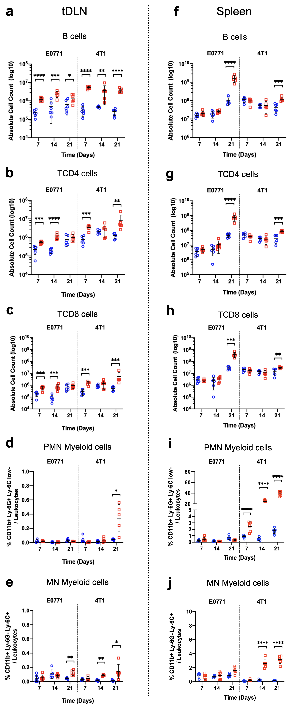

Figure S3. Absolute cell count for lymphoid and myeloid cells in the tDLN and spleen. Cell count for B cells (a, f), TCD4 cells (b, g), TCD8 cells (c, h), PMN myeloid cells (d, i), and MN myeloid cells (e, j) in the tDLNs and the spleen from control (blue) and 4T1/E0771 tumor-bearing mice (red) 7, 14 and 21 days after the initial inoculation, respectively. p<0.05, ** p<0.01, *** p<0.001, **** p<0.0001.

