Supplementary Appendix
Supplementary Methods
Figure S1. The diagnosis efficiency of conventional PMD biomarkers in the PMD cohorts.
Figure S2. The consensus k-values analysis of PMD subtyping.
Figure S3. The diagnostic performance of HBB, N-acetylasparagine, and gamma-glutamylserine in the validation cohort.
Figure S4. In-depth analysis of clinical manifestation subtypes and multi-omics data in the PMD cohort.
Table S1. Detailed medical records of all individuals recruited. (See Sheet Supplementary Table 1)
Table S2. Whole blood transcriptomics profile data. (See Sheet Supplementary Table 2)
Table S3. Untargeted plasma metabolomic profile data. (See Sheet Supplementary Table 3)
Table S4. Untargeted plasma proteomic profile data. (See Sheet Supplementary Table 4)
Table S5. The detailed information on PMD molecular subtyping. (See Sheet Supplementary Table 5)

Supplementary Methods
Patient and samples
PMD patients and matched healthy controls were recruited by the Department of Pediatrics, Peking University First Hospital, and the Second Affiliated Hospital of Wenzhou Medical University. 2-2.5 mL blood from patients and healthy controls who had fasted for more than 12 h for transcripts analysis were collected by PAXgene Blood RNA Tube (BD Biosciences). After blood collection, tubes were stored at -120 ℃ for analysis. Plasma was isolated from blood drawn from patients and healthy controls who had fasted for more than 12 h. By immediately centrifuging at 2000 × g for 10 min at room temperature, the upper plasma was aspirated and transferred in new tubes, snap-frozen in liquid nitrogen, and stored at -80 ℃ for further analysis.
The samples from patients are from a clinical trial that our team initiated and registered in the Chinese Clinical Trial Registry with an ID of 2017-217. And the samples from healthy controls are recruited by the Second Affiliated Hospital of Wenzhou Medical University and registered in the Chinese Clinical Trial Registry with an ID of 2021-K-54-02. Our study was approved by the Ethics Committee of Beijing Children’s Hospital Medical University and above hospitals.

Whole blood transcription analysis
RNA extraction
The total RNA was obtained by TRIzol Reagent (Thermo Fisher Scientific) according to a previously described protocol. Samples were added to the proper TRIzol reagent. The mixture was shaken and incubated at room temperature for 5 min to dissolve fully, centrifuged at 12000 × g for 5 min. And then transfer the aqueous phase containing the RNA to a new tube. Chloroform was added into samples according to the ratio of TRIzol: chloroform=5:1 and incubated at room temperature for 2-3 min to allow natural phase separation. After centrifugation at 12000 × g for 10 min at 4 ℃, RNA was mainly concentrated in the aqueous phase. Transfer the supernatant into a new tube and add an equal volume of chloroform, and swirl softly. Then vortex and incubate at room temperature for 2-3 min to allow natural phase separation at 4 ℃ and 12000 × g. Transfer the upper aqueous phase into a new tube. An equal volume of isopropanol was added, mixed, and placed at room temperature for 10 min. Centrifugation at 12000 × g for 15 min at 4 ℃ and discard the supernatant. The RNA precipitate was added 1 mL of 75% ethanol, centrifuged at 7500 × g for 5 min at 4 ℃, and then the supernatant was discarded twice. Then centrifugation at 7500 × g at 4 ℃ for 1 min, and carefully discard excess liquid. And the RNA was dissolved with an appropriate amount of DEPC-treated water.

RNA amplification
The purification of RNA was generalized by Ambion GLOBINclear Kit (Thermo Fisher Scientific). Beads were captured carefully, and the supernatant was discarded with caution. RNA treated with Capture Oligo Mix and Hybridization Buffer and nuclease-free water was hybridized at 50 ℃ for 15 min. The beads were added to each sample and incubated for 30 min at 50 ℃. Then beads were captured to collect the supernatant containing the RNA. Samples were added RNA binding buffer and Bead Resuspension Mix, then RNA binding beads were captured and washed in RNA Wash Solution. The RNA was incubated at 58 ℃ for 5 min after adding Elution Buffer. Magnetically capture the RNA binding beads and transfer the GLOBINclear RNA to a new tube for the next steps.
Whole blood transcription analysis
Gene expression profiles from whole blood samples were generated using Agilent 2100 bioanalyzer. The expression data for each dataset were preprocessed and independently clustered. To minimize confounding, expression residuals were generated by regressing transcript expression levels on age, sex, measured or predicted blood cell count and differential cell proportions, and genetic principal components. In addition, we adjusted for a relatedness matrix and technical covariates, including year of blood collection, batch, and RNA concentration.

Untargeted plasma metabolome analysis
Untargeted UPLC–MS/MS analysis
Untargeted metabolomic analysis was conducted by Calibra Lab at DIAN Diagnostics (Hangzhou, Zhejiang, China) on their CalOmics metabolomics platform. Samples were extracted using methanol (Sigma-Aldrich) in a ratio of 1:4. The mixtures were shaken for 3 min and precipitated by centrifugation at 4000 × g, 10 min at 20 ℃. The mixtures were shaken vigorously for 2 min. Proteins were denatured and precipitated by centrifugation. The supernatants contained metabolites of diverse chemical natures. Four aliquots of 100 μL supernatant were transferred to sample plates and dried under blowing nitrogen, then re-dissolved in reconstitution solutions for sample injection into UPLC-MS/MS systems. To ensure the quantity and reliability of metabolite detection, four methods were performed with untargeted metabolomics analysis. The instruments for the four UPLC-MS/MS methods are ACQUITY 2D UPLC (Waters, Milford) plus Q Exactive (QE) hybrid Quadrupole-Orbitrap mass spectrometer (Thermo Fisher Scientific). The mass spectrometer was operated at 35,000 mass resolution with a scan range was 70-1000 m/z. In the first UPLC-MS/MS method, QE was operated in positive electron spray ionization (ESI) mode, and the UPLC column was C18 reverse-phase (UPLC BEH C18, 2.1x100 mm, 1.7 um; Waters); the mobile solutions used in the gradient elution were water and methanol containing 0.05% perfluorooctanoic acid (PFPA) and 0.1% formic acid (FA). In the second UPLC-MS/MS method, QE was operated in negative ESI mode, and the UPLC column was C18 reverse-phase (UPLC BEH C18, 2.1x100 mm, 1.7 um; Waters), the mobile solutions used in the gradient elution were water and methanol containing 6.5 mM ammonium bicarbonate at pH 8. The third UPLC-MS/MS method had the QE operated in ESI positive mode, and the UPLC column was C18 reverse-phase (UPLC BEH C18, 2.1x100 mm, 1.7 um; Waters), the mobile solutions were water and methanol/acetonitrile/water contain 0.05% PFPA and 0.01% FA. In the fourth method, QE was operated in negative ESI mode, the UPLC column was HILIC (UPLC BEH Amide, 2.1x150 mm, 1.7 um; Waters), and the mobile solutions were water and acetonitrile with 10 mM ammonium formate.
Compound identification and quantification
After pre-processing of raw data and data quality control inspection, ion peaks were extracted using proprietary in-house IT hardware and software. Metabolites were identified by searching an in-house library generated from pure standards commercially purchased or obtained from other sources. Identification of metabolites in samples requires strict matching of three criteria between experimental data and library entry: narrow window retention index (RI), accurate mass with variation less than 10 ppm, and MS/MS spectra with high forward and reverse searching scores. The peak area for each metabolite was calculated using the area under the curve.
Data normalization
Before statistical analysis, raw peak areas were normalized to adjust for system fluctuation among different run days. The normalized peak areas were then log-transformed (log2) to reduce data distribution skewness and be in an approximately normal distribution (Gaussian distribution). Missing values in the peak area matrix were imputed by using the minimal detection value of a metabolite among all samples.
All statistical analyses were performed with R language (R version 3.4.1: http://www.cran.com; Rstudio version 1.4.1717 https://www.rstudio.com; mixOmics version 6.10.9 http://mixomics.org/; randomForest version 4.6-14 https://www.rdocumentation.org/packages/randomForest/versions/4.6-14). Significantly changed metabolites between case and control groups were found by parametric (student’s t test, ANOVA) or non-parametric (Wilcox’s rank test, Kruskal-Wallis) statistical methods. Multivariate analysis approaches, including principal component analysis (PCA), partial least square discriminate analysis (PLS-DA), and random forest (RF), were also conducted. When there are only two sample groups, orthogonal partial least square discriminant analysis (OPLS-DA) would be used instead of PLS-DA.

Untargeted Plasma proteome analysis
Sample depletion, protein digestion and TMT labeling
Take out the samples from -80 ℃ refrigerator in advance and thaw. The samples were separated using a gradient from 5% to 35% acetonitrile (ACN) in 10 mM ammonia (pH=10.0) at a flow rate of 1 mL/min. Peptides were separated into 120 fractions, which were consolidated into 30 fractions. The fractions were subsequently dried and re-dissolved in 2% ACN/0.1% FA. The re-dissolved peptides were analyzed by LC-MS/MS with the same LC system coupled to a Q Exactive HF-X hybrid Quadrupole-Orbitrap (Thermo Fisher Scientific) in data-dependent acquisition (DDA) mode. For each acquisition, peptides were loaded onto a pre-column (3 mm, 100 Å, 20 mm*75 mm) at a flow rate of 6 mL/min for 4 min and then analyzed using a 35 min LC gradient (from 5% to 28% buffer B) at a flow rate of 300 nL/min (analytical column, 1.9 mm, 120 Å, 150 mm*75 mm ). Buffer A was 2% ACN, 98% H2O containing 0.1% FA, and buffer B was 98% ACN in water containing 0.1% FA. Every reagent was of MS grade. The m/z range of MS1 was 350-1,800 with the resolution at 60,000 (at 200 m/z), AGC target of 3e6, and maximum ion injection time (max IT) of 50 ms. For sample collection, peptides entered the precolumn at A flow rate of 6μL/min (3 µm, 100 Å, 20 mm*75 µm), "The analytical column was then entered at A flow rate of 300nL/min (1.9 µm, 120 Å, 150 mm*75 µm) and analyzed using a 60-min effective liquid chromatography gradient (7% to 30% mobile phase B). The MS scanning parameters were as follows: Cycle time was set to 1 second. The primary scanning range was 375-1,800 m/z, the resolution was 60,000 (at 200 m/z), the normalized AGC target was set to 300%, the maximum ion implantation time (max IT) was 50ms, and ions with signal intensity lower than 2e4 were not collected. The secondary resolution was 30,000, the normalized AGC target was set to 200%, and the maximum ion implantation time was 86ms. turbo-TMT was turned on, the isolation window was set to 0.7m/z for parent ion selection, and the first mass of the scan was set to 110 m/z.
Protein quantification
Untargeted proteomic analysis was conducted by Tiannan Guo’s Lab in Westlake University (Hangzhou, Zhejiang, China). The peptides were prepared as previously described with TMT labeled, further, the peptides were analyzed by LC-MS/MS with the same LC system coupled to a Q Exactive HF-X hybrid Quadrupole-Orbitrap (Thermo Fisher Scientific) in data-dependent acquisition (DDA) mode.
The quality of proteomic data was ensured at multiple levels. We included water samples ( or buffer solution) as blanks to avoid carry-over. The same samples were arranged between every two batches as between-group controls. Each batch contained a pooled sample, a mixture of all peptide samples, which served as a control sample, and was used to calibrate data from different batches and to assess the accuracy of quantification.

Differential expressed genes, metabolites, proteins identification and pathway analysis
For transcriptomic data, clean data were obtained for downstream analysis. Reads were mapped to human reference genome (GRCh38) using HISAT2 with default parameters, and featureCounts was used to count the reads numbers mapped to each gene. The DESeq2 package in R software was used to normalize the gene count and determine differential expressed genes (DEGs) (with the criterion of adjusted P value ≤0.05). The clusterProfiler R package was used to perform Kyoto Encyclopedia of Genes and Genomes (KEGG) pathway enrichment analyses using DEGs. Metabolomics statistical analysis was performed using statTarget R package, differential expressed metabolites (DEMs) were considered statistically significant at adjusted P < 0.05. Metabolite set enrichment analysis (MSEA) based on KEGG database was performed on MetaboAnalyst 5.0 website (https://www.metaboanalyst.ca/MetaboAnalyst/home.xhtml). Differential expressed proteins (DEPs) were calculated using two-sided unpaired t-test with Welch's correction (P < 0.05). Protein-protein interactions prediction and pathway analysis were determined with STRING database (https://string-db.org/). Prior to differential expression analysis among transcriptomic, metabolic and proteomic data, ropls R package was used for partial least-squares discrimination analysis (PLS-DA). Heatmaps were performed using pheatmap R package.

Consensus clustering
DEPs and DEMs were coclustered using the ConsensusClusterPlus R package to identify subtypes within PMD samples. In order to ensure stability of the results, the number of clusters between K=2–10 was evaluated for the cluster identification.

Feature selection and machine learning models construction
All of the DEGs, DEMs and DEPs previously identified were put into as candidate diagnosis biomarkers. To minimize the number of markers for future clinical testing, we used three algorithms, containing Boruta, RFE and RandomForest to select important features to distinguish the PMD and Ctrl samples. The intersection of the important features selected by three algorithms is used as the final biomarkers set. In order to explore the diagnostic value of the biomarker set, we create a random forest classification model using scikit-learn in Python with the sklearn RandomForestClassifier, the discovery cohort was randomly split into a training (80%) and a test set (20%), GridSearchCV was used to find the best set of parameters, and ROC (Receiver Operating Characteristic) curves was used to evaluate the performance of diagnostic efficiency in test set.

Plasma biomarker analyses
The plasma samples were thawed on ice and diluted with 1x Assay Diluent 2-fold prior to testing. The established biomarkers were analyzed with Human GDF-15 ELISA Kit (Thermo Fisher Scientific) and Human FGF-21 ELISA Kit (Thermo Fisher Scientific) according to the manufacturer’s instructions.
For human GDF-15 analyses, diluted samples were added to wells and incubated for 2.5 h at room temperature with light shaking. The plate was then removed from the solution and thoroughly cleaned with 1X Wash Buffer 3 times. Each well was added 100 μL of prepared biotin conjugate for 1 h at room temperature with shaking. Repeat the washing steps 3 times. Then 100 μL of prepared Streptavidin-HRP solution was added for 45 mins at room temperature with gentle shaking. Repeat the washing steps again. Then 100 μL of TMB Substrate was added to the plate, which was shaken for 30 mins at room temperature in the dark. For fluorescence detection, 50 μL of Stop Solution was then added to each well. The plate absorbances were measured using a SpectraMax iD3 Multi-Mode Microplate Reader (Molecular Devices)
For human FGF-21 analyses, diluted samples were added to wells and incubated for 2.5 h at room temperature with gentle shaking. Then the plate was discarded from the solution and washed 3 times with 1X Wash Buffer. Each well was added 100 μL of prepared biotin conjugate and the plate was incubated for 1 h at room temperature. Repeat the washing steps for 3 times and add 100 μL of prepared Streptavidin-HRP solution to each well for 45 mins at room temperature with shaking. Repeat the washing steps 3 times again. Then the plate was added 100 μL of TMB Substrate for 30 mins at room temperature in the dark with shaking. Finally, 50 μL of Stop Solution was added to each well for fluorescence detection. The plate absorbances were measured using a SpectraMax iD3 Multi-Mode Microplate Reader.

Statistics
All quantitative experiments were performed with three or more independent replicates, and all quantitative data are presented as mean ± SEM. For comparison of biomarker validated in the validation cohort, an independent Student’s t test or paired Student’s t test was performed using SPSS 21.0. Graphs were generated using Prism 8.0 (GraphPad Software).

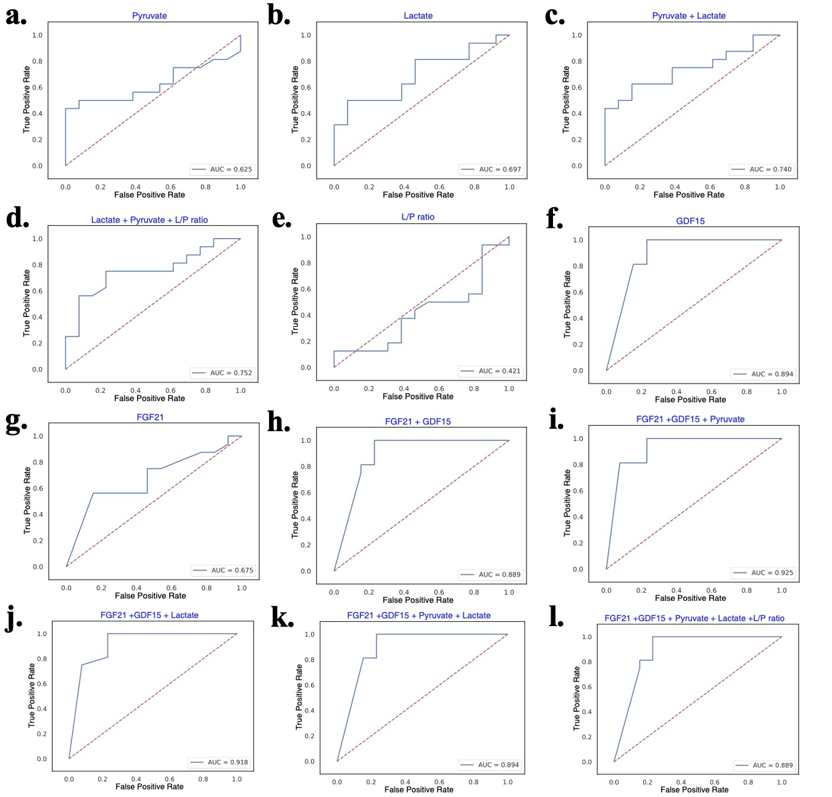
Figure S1. The diagnosis efficiency of conventional PMD biomarkers in the PMD cohorts. (A) The diagnosis efficiency of pyruvate. (B) The diagnosis efficiency of lactate. (C) The diagnosis efficiency of pyruvate and lactate. (D) The diagnosis efficiency of lactate/pyruvate (L/P) ratio. (E) The diagnosis efficiency of lactate, pyruvate, and L/P ratio. F. The diagnosis efficiency of GDF15. (G) The diagnosis efficiency of FGF21. (H) The diagnosis efficiency of FGF21 and GDF15. (I) The diagnosis efficiency of FGF21 and GDF15 combined with pyruvate. (J) The diagnosis efficiency of FGF21 and GDF15 combined with lactate. (K) The diagnosis efficiency of FGF21 and GDF15 combined with lactate and pyruvate. (L) The diagnosis efficiency of FGF21 and GDF15 combined with lactate, pyruvate, and L/P ratio.

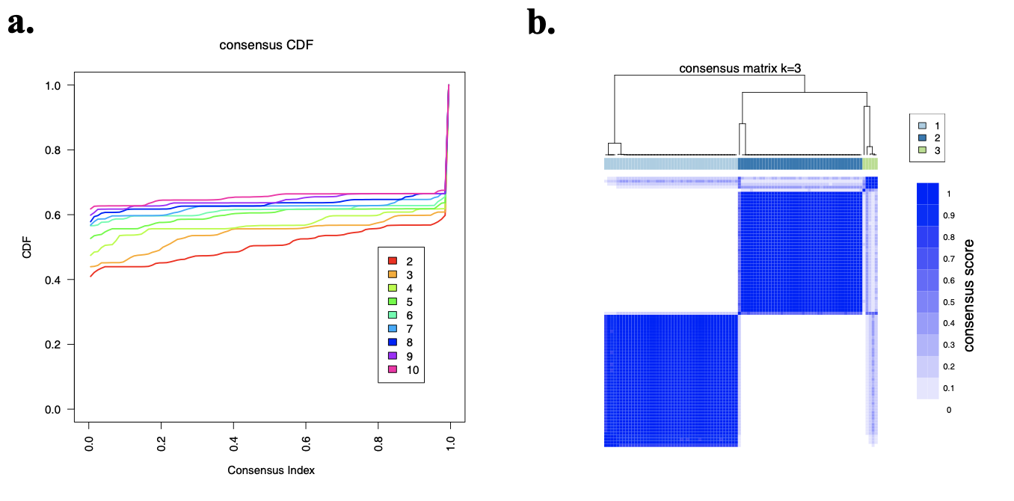
Figure S2. The consensus k-values analysis of PMD subtyping. (A) The consensus CDF of pediatric PMD patients based on multi-omics. (B) The consensus matrix k value of pediatric PMD patients is based on multi-omics.

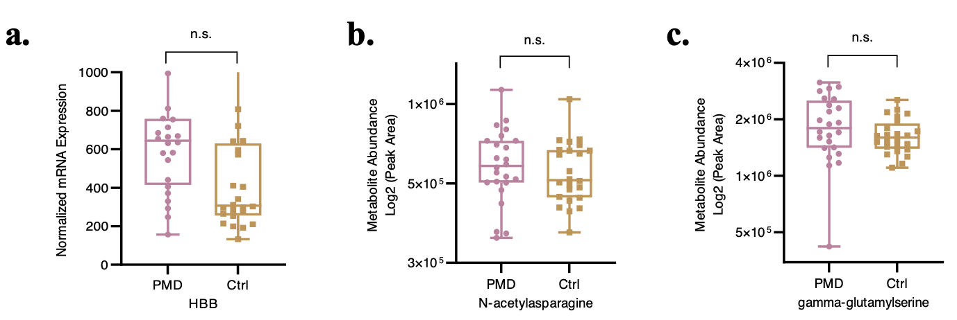
Figure S3. The diagnostic performance of HBB, N-acetylasparagine, and gamma-glutamylserine in the validation cohort.

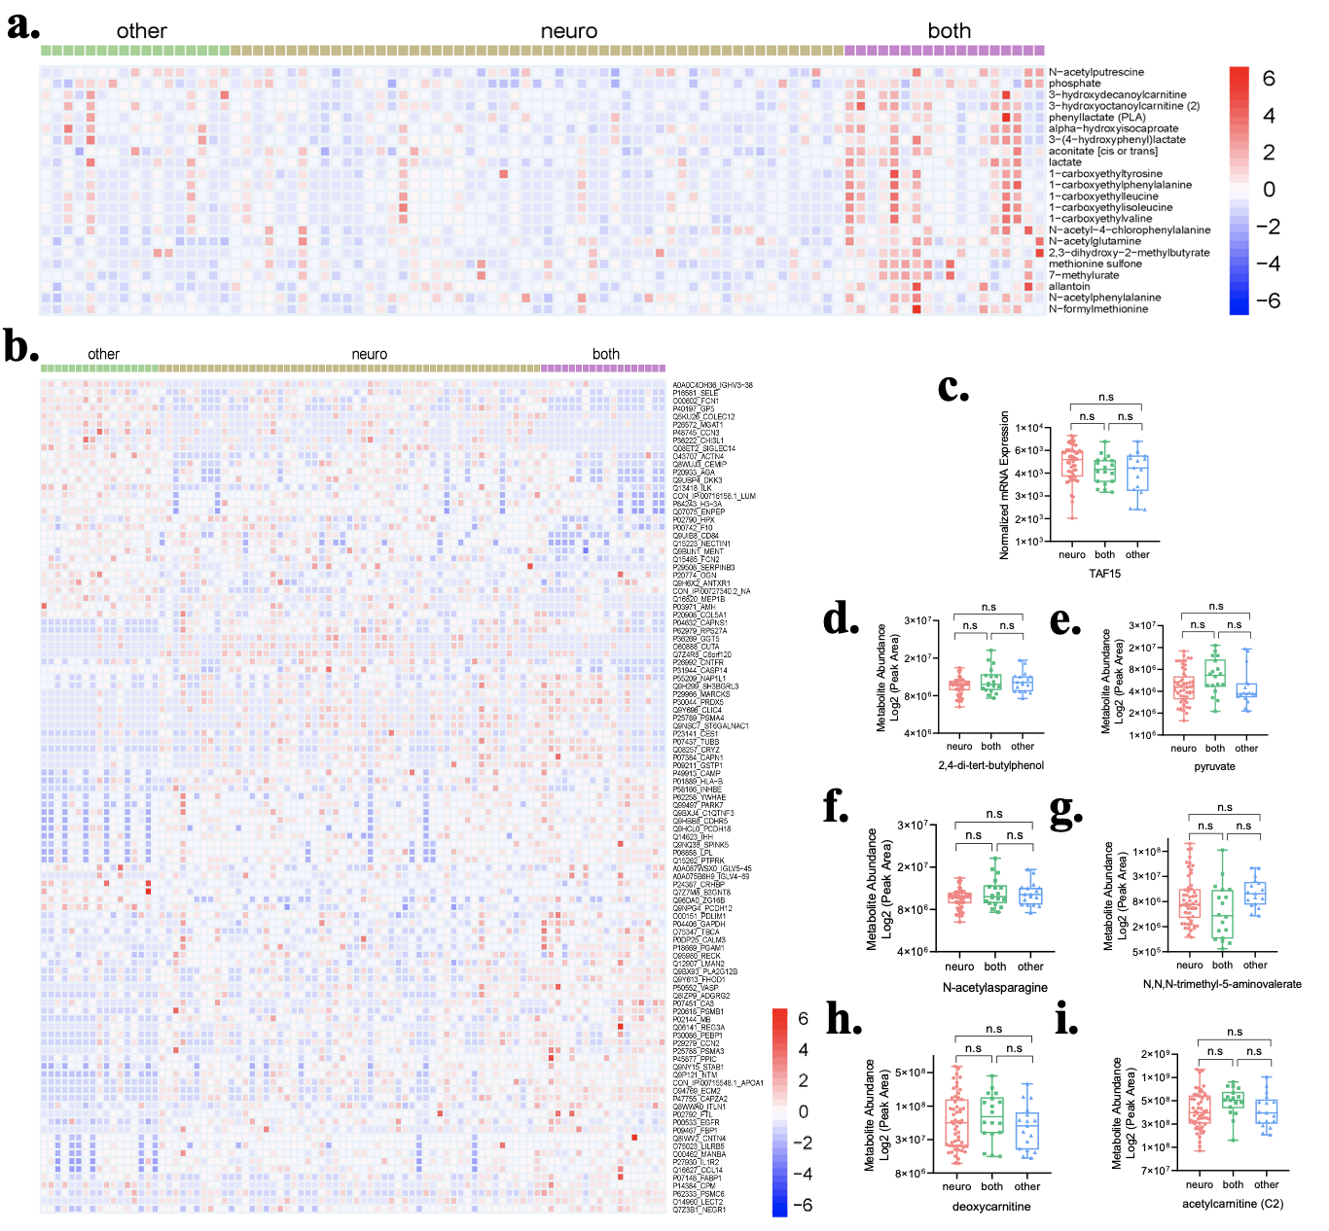
Figure S4. In-depth analysis of clinical manifestation subtypes and multi-omics data in the PMD cohort. “neuro” annotated for the patients suffers for only neurologic symptoms, “both” for the patients suffered for both neurologic and cardiac symptoms, and “other” for the patients of the rest, the detailed criteria for each system can be attached in the Table 1. (A-B) The heatmap of proteins and metabolites changed significantly between 3 subgroups of PMD. (C-I) The normalized mRNA expression level of TAF15, abundance of 2,4-di-tert-butylphenol, pyruvate, N-acetylasparagine, N,N,N-trimethyl-5-aminovalerate and deoxycarnitine in plasma between 3 subgroups of PMD.
HBB, abundance of Q13418_ILK, lactate, 2,3-dihydroxy-e-methylbutyrate, 2-hydroxyadipate, gamma-glutamylserine in plasma between 3 subgroups of PMD.

Table S1. Detailed medical records of all individuals recruited. (See Sheet Supplementary Table 1)
Table S2. Whole blood transcriptomics profile data. (See Sheet Supplementary Table 2)
Table S3. Untargeted plasma metabolomic profile data. (See Sheet Supplementary Table 3)
Table S4. Untargeted plasma proteomic profile data. (See Sheet Supplementary Table 4)
Table S5. The detailed information on PMD molecular subtyping. (See Sheet Supplementary Table 5)

