Unveiling the Inhibitory Potential of Gingerol Substructures against SARS-CoV-2 RBD: An Integrated Ensemble Learning and In Silico Screening Approach
Sherin D. R.^{a,}*, Linda S. R.^{b} and Akhila A.^{a,}
ªSchool of Digital Sciences, Kerala University of Digital Sciences, Innovation and Technology, Thiruvananthapuram, Kerala
^{b}Government Medical College, Asaripallam, Kanyakumari, Tamilnadu
sherin.dr@duk.ac.in*

Supplementary Information

Correlation heatmap for the features generated from RDKit

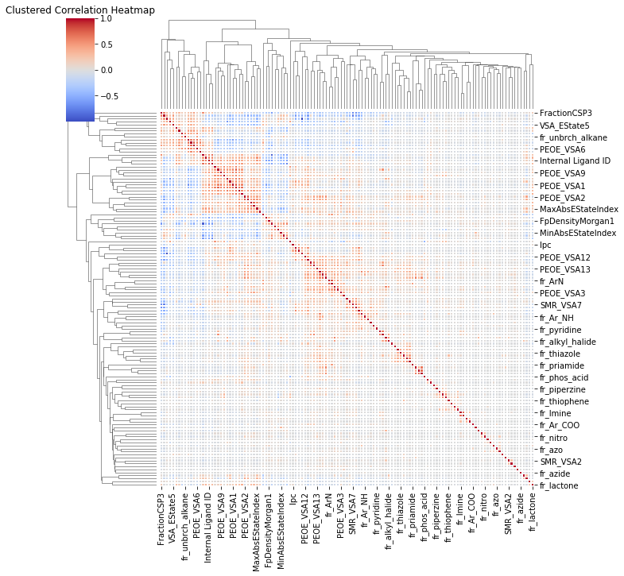

5-fold cross validation curves for RF model

