Supplementary Information for

Robust multiferroic in interfacial modulation synthesized wafer-scale one-unit-cell of chromium sulfide
Luying Song^{1,#}, Ying Zhao^{2,#}, Bingqian Xu³, Ruofan Du¹, Hui Li¹, Wang Feng¹, Junbo Yang¹, Xiaohui Li¹, Zijia Liu³, Xia Wen¹, Yanan Peng¹, Yuzhu Wang¹, Hang Sun¹, Ling Huang¹, Yulin Jiang¹, Yao Cai⁴, Xue Jiang², Jianping Shi^{1,}*, Jun He^{3,}*

¹The Institute for Advanced Studies, Wuhan University, Wuhan, China.
²Key Laboratory of Materials Modification by Laser, Ion and Electron Beams (Ministry of Education), Dalian University of Technology, Dalian, China.
³Key Laboratory of Artiﬁcial Micro- and Nano-Structures of Ministry of Education, School of Physics and Technology, Wuhan University, Wuhan, China.
⁴The Institute of Technological Sciences, Wuhan University, Wuhan, China
*Address correspondences: jianpingshi@whu.edu.cn, He-jun@whu.edu.cn
#These authors contributed equally to this work.

Supplementary Fig. 1 | XRD rocking curve of c-plane sapphire. The miscut angles towards A and M axis are measured to be 0° and 0.2°, respectively.

Supplementary Fig. 2 | Schematic diagram of CVD synthesis of 1-inch 2D one-unit-cell of non-layered Cr₂S₃ with unidirectional orientation on c-plane sapphire. The temperatures of S and Cr powders are set to be 170 °C and 980 °C, respectively. The KI particles are used to reduce the evaporating temperature of Cr powders.

Supplementary Fig. 3 | OM images of as-grown Cr₂S₃ nanosheets captured from different areas of 1-inch c-plane sapphire. The unidirectional alignment feature of one-unit-cell of Cr₂S₃ is further confirmed.

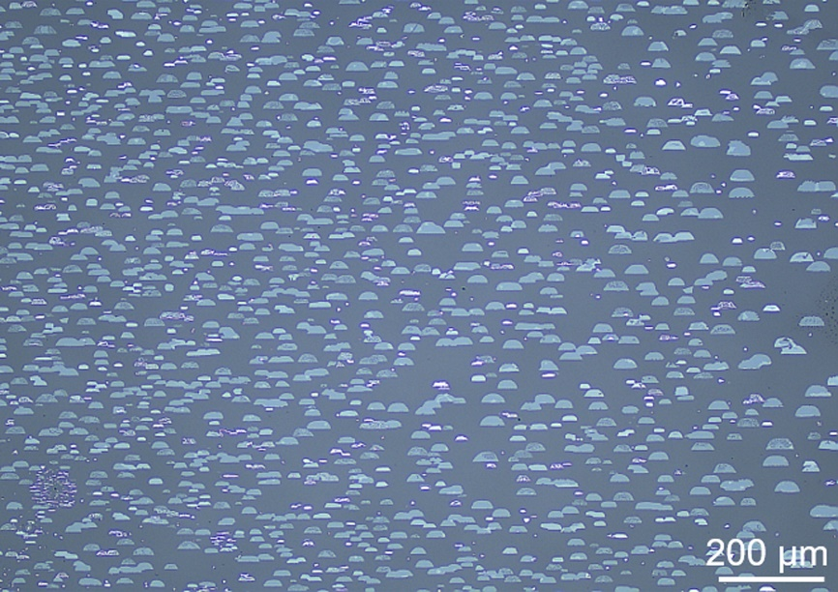
Supplementary Fig. 4 | Large-area OM image of as-grown one-unit-cell of Cr₂S₃ nanosheets with unidirectional alignment on 1-inch c-plane sapphire.

Supplementary Fig. 5 | OM images of as-grown one-unit-cell of Cr₂S₃ nanosheets on c-plane sapphire with the carrier gas flow direction vertical (a) and parallel (b) to the step edge direction of sapphire, respectively. The carrier gas flow direction reveals negligible influence on the domain orientation of Cr₂S₃.

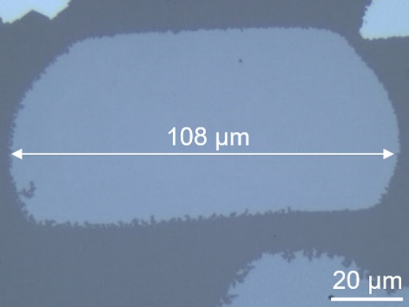
Supplementary Fig. 6 | OM image of an as-grown one-unit-cell of Cr₂S₃ nanosheet on c-plane sapphire with the domain size of 108 μm.

Supplementary Fig. 7 | OM images of as-grown Cr₂S₃ nanosheets on diverse substrates including (a) Au foil, (b) mica, and (c) HOPG. The small domain sized triangular or irregular Cr₂S₃ nanosheets with random orientations are evolved, indicating the advantage of sapphire for the growth of unidirectionally aligned one-unit-cell thick Cr₂S₃.

Supplementary Fig. 8 | XPS spectrum of Al₂S₃ powders. The characteristic peak at 164.0 eV is also observed for the as-grown Cr₂S₃ on c-plane sapphire (Fig. 1f), indicating the formation of Al-S bonds and the strong interfacial interaction between Cr₂S₃ and sapphire substrate.

Supplementary Fig. 9 | Raman spectra of Al₂S₃ powders (a), one-unit-cell of Cr₂S₃ (b) and 370.0 nm Cr₂S₃ (c) on c-plane sapphire. The nearly identical characteristic peaks in (a) and (b) indicates the formation of Al-S bonds (indicated by the black arrows). For the 370.0 nm Cr₂S₃, these peaks are not observed due to the detection depth limit of Raman spectroscopy.

Supplementary Fig. 10 | The semiconducting determination of CVD-synthesized one-unit-cell of Cr₂S₃. a, Temperature-dependent output characteristic curves of a Cr₂S₃ back-gated FET. b, Plot of the resistance as a function of temperature.

Supplementary Fig. 11 | Water contact angle measurements on two distinct sapphire surfaces. a, Contact angles of distilled water droplet on the sapphire surface after annealing at 980 °C with the presence of Cr powders. b, Contact angles of distilled water droplet on the sapphire surface after annealing at 980 °C without the presence of Cr powders.

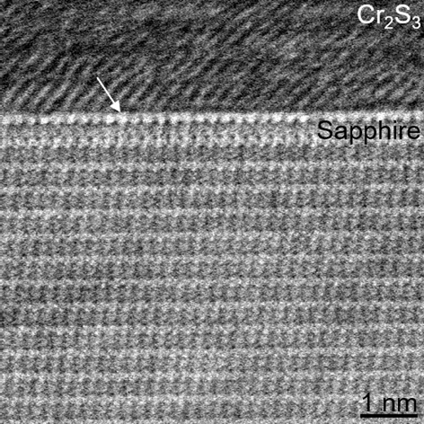
Supplementary Fig. 12 | Atomic-resolution cross-sectional STEM image of as-grown Cr₂S₃ on c-plane sapphire. The Al-terminated structure of sapphire surface is observed, as indicated by the white arrow.

Supplementary Fig. 13 | Atomic structure models of Cr₂S₃ with different rotation angles on Al-terminated sapphire surface. θ is defined as the angle between [110] direction of Cr₂S₃ and [11–20] direction of c-plane sapphire.

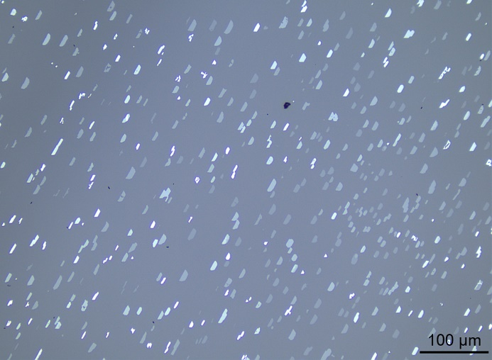
Supplementary Fig. 14 | Large-area OM image of as-grown 2D Cr₂Se₃ nanosheets with unidirectional alignment on c-plane sapphire, showing the universality of this interface modulated growth strategy.

Supplementary Fig. 15 | The single-crystal determination of an isolated Cr₂S₃ nanosheet. a, Low-magnification TEM image of a transferred Cr₂S₃ nanosheet. b, SAED patterns captured from different areas of the Cr₂S₃ nanosheet. The close angles within a deviation of 0.4° in the SAED patterns prove that the obtained Cr₂S₃ is single crystal.

Supplementary Fig. 16 | The element distribution determination of Cr₂S₃. a, Low-magnification STEM image of a transferred Cr₂S₃ nanosheet. b,c, Corresponding EDS mapping images of Cr and S, showing the uniform element distributions.

Supplementary Fig. 17 | The determination of unidirectionally aligned Cr₂S₃ nanosheets. A series of SAED patterns captured from different nanosheets show nearly the identical orientations, indicating the unidirectional alignment of Cr₂S₃.

Supplementary Fig. 18 | The defective stitching of Cr₂S₃ nanosheets with random orientations. a,b, Polarized SHG spectra and mapping image measured on two merged Cr₂S₃ domains with random orientations. Inset: OM image of such two merged domains. c,d, OM and SEM images of two merged Cr₂S₃ domains with random orientations before and after Ar/O₂ etching.

Supplementary Fig. 19 | SHG characterizations of as-grown Cr₂S₃ nanosheets with different thicknesses, showing the non-centrosymmetric structure.

Supplementary Fig. 20 | Schematic diagram of PFM measurement. The Cr₂S₃ nanosheet is transferred onto Au/Si substrate for the further PFM characterization.

Supplementary Fig. 21 | PPC-assisted etching-free transfer of 2D Cr₂S₃. a, Schematic diagram of the etching-free transfer process. b, OM image of transferred Cr₂S₃ nanosheets onto SiO₂/Si substrates.

Supplementary Fig. 22 | PFM characterizations of Cr₂S₃ nanosheets with different thicknesses. a,e,i,m, AFM images and height profiles of Cr₂S₃ nanosheets with the thicknesses of 2.9, 5.6, 7.6 and 9.8 nm, respectively. b,f,j,n, Corresponding PFM phase images. c,g,k,o, Corresponding PFM amplitude images. d,h,l,p, PFM phase and amplitude hysteresis loops of Cr₂S₃ nanosheets with the thicknesses of 2.9, 5.6, 7.6 and 9.8 nm, respectively.

Supplementary Fig. 23 | PFM characterizations of a Cr₂S₃ nanosheet with the thickness of 73.9 nm. a, AFM image and height profile of a Cr₂S₃ nanosheet with the thickness of 73.9 nm. b,c, Corresponding PFM phase and amplitude hysteresis loops.

Supplementary Fig. 24 | Macroscopic polarization hysteresis loops of a freshly synthesized and one month aged Cr₂S₃ nanosheet with the thickness of 13.0 nm. The negligible variation of remanent polarization indicates the robust room-temperature ferroelectricity.

Supplementary Fig. 25 | Transfer characteristic curves of a Cr₂S₃ vertical FET at different sweep rates and drain-source voltages. The counterclockwise hysteresis loops of transfer characteristic curves at different sweep rates and drain-source voltages are observed, and the large hysteresis window (40 V) further verifies the ferroelectric polarization in Cr₂S₃. Besides, the relatively high current on/off ratio (18) indicates the potential applications of Cr₂S₃ in memory devices.

Supplementary Fig. 26 | DFT calculated the remanent polarization of one-unit-cell thick (a) and bulk (b) Cr₂S₃.

Supplementary Fig. 27 | Robust ferromagnetism in CVD-synthesized Cr₂S₃ nanosheets with different thicknesses. a,c, Anomalous Hall effects of as-grown Cr₂S₃ nanosheets with the thicknesses of 2.4 and 3.1 nm, respectively. b,d, MRs of as-grown Cr₂S₃ nanosheets with the thicknesses of 2.4 and 3.1 nm, respectively.

Supplementary Fig. 28 | Phase diagram regarding the Curie temperature of 2D Cr₂S₃ with the thickness.

Supplementary Fig. 29 | Environmental stability determination of CVD-synthesized 2D Cr₂S₃. a, AFM image of a seven months aged Cr₂S₃ nanosheet. b, Low-magnification TEM image of a seven months aged Cr₂S₃ nanosheet. c,d, Corresponding SAED pattern and atomic-resolution STEM image, showing its robust environmental stability.

Supplementary Fig. 30 | Magnetoelectric coupling in 2D Cr₂S₃. a, AFM image and height profile of a Cr₂S₃ nanosheet with the thickness of 2.7 nm. b, MFM phase image of a Cr₂S₃ nanosheet, after applying the voltage of +1 V. c−f, MFM phase images of the Cr₂S₃ nanosheet, after applying the voltages of ±5 and ±7 V, respectively.

