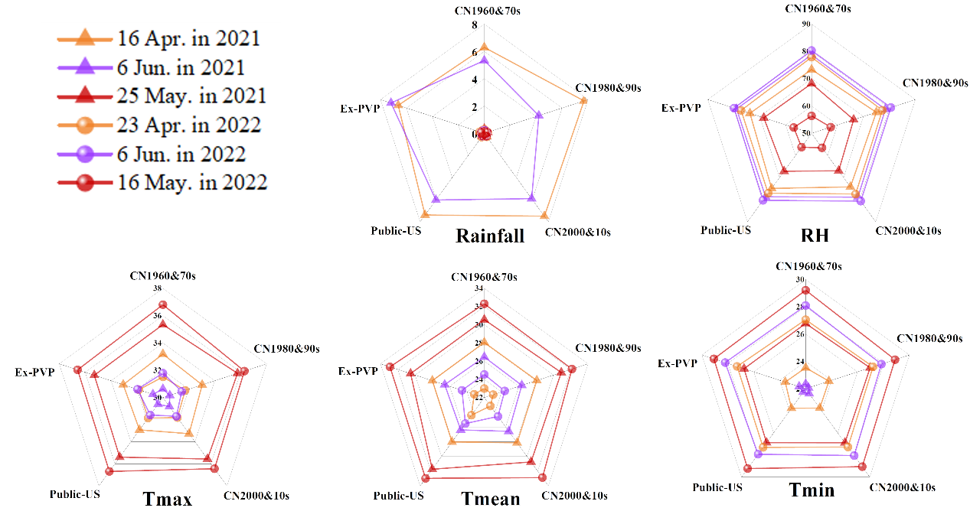
Extended Data Fig. 1 | Meteorological conditions during flowering of maize inbred lines from China and the United States. Maximum daily temperature (Tmax), mean daily temperature (Tmean), minimum daily temperature (Tmin), mean daily relative air humidity (RH) and mean daily rainfall during 15 days bracket silking were averaged, respectively, at different sowing dates in 2021-2022.

Extended Data Fig. 2 | Maize inbred lines of different breeding eras used in this study.

Extended Data Fig. 3 | Correlations of flowering events of tassel and ear with pollen shedding duration, anthesis-silking interval, and anthesis-silking overlap duration. Flowering events includes the time of tasseling, shedding, end of shedding and silking in different growth environments that were achieved by adjusting sowing dates at two locations (Wuqiao Experimental Station, W and Baishiyi Experimental Station, B), including April 16, May 25, June 6 in 2021 and April 23, June 6 in 2022.
. *, **, and *** indicate significance at P<0.05, 0.01, and 0.001, respectively.

Extended Data Fig. 4 | Correlations of kernel number per ear (KN/ear) and seed set with daily maximum temperature (Tmax), mean temperature (Tmean), minimum temperature (Tmin), relative air humidity (RH), and rainfall during the 15 days bracketing the silking stage.

Extended Data Fig. 5 | Correlations of Tmax against tassel and ear characteristics around flowering stage. Tmax: daily maximum temperature; PV: pollen viability; PSD: pollen shedding duration; SOA: spikelet opening angle; ESN: emerged silk number per ear; ASI: anthesis silking interval duration; ASO: anthesis silking overlap duration. Values (-0.3 to 0.1) represent the correlation coefficient. To accurately detect the relationships between Tmax, tassel, and ear traits, Tmax in different periods were averaged and then used for the correlation analysis with the corresponding parameters. Tmax in the 7 days before the sampling stage (around blooming stage) was used for the correlations with PV and SOA. Tmax during the 7 days before the end of shedding stage was used for the correlations with ESN, PSD, and ASO. Tmax in the 7 days before the silking stage was used for the correlation with ASI. * and ** indicate significance at P<0.05 and 0.01, respectively.
Extended Data Fig. 6 | The effects of tassel and ear characteristics on kernel number per ear and seed set. Correlations of tassel characteristics (spikelet/tassel, spikelet opening angle, pollen viability, pollen shedding duration) and ear characteristics (kernel row/ear, floret/ear row, floret/ear, emerged silk number per ear, anthesis-silking interval and anthesis-silking interval overlap duration) with kernel number per ear and seed set. Red represents positive correlation and blue represents negative correlation. *, **, and *** indicate significance at P<0.05, 0.01, and 0.001, respectively.

Extended Data Fig. 7 | Seed set of maize inbred lines that have large tassel (spikelet number per tassel ≥700; large) and small tassel (<700; small) under different growth environments that were achieved by adjusting sowing dates at two locations (Wuqiao Experimental Station, W and Baishiyi Experimental Station, B), including April 16, May 25, June 6 in 2021 and April 23, June 6 in 2022.

