Global Pathways for Universal Electricity Access in 2030

Appendices

Further results
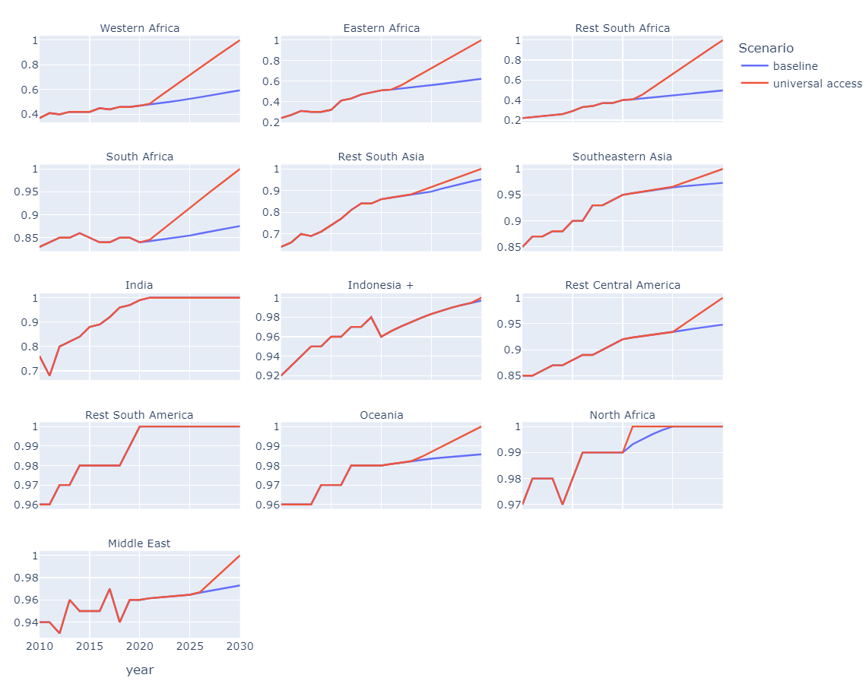
Figure A1 Electrification rate projections under the SSP2 baseline scenario (blue) and for achieving universal access by 2030 (red)

TableA1 Data results obtained under all scenarios analysed for 2030 for the Sub Sahara Africa region
Scenario | Description | Residential electricity demand (TWh) | Share of low carbon technologies in the electricity mix (%) | CO2 emissions from residential electricity use (Mt) | Average electricity prices ($/MWh) | Annual discounted investment required until 2030 (Billion US$/year)
SSP2-BL | Baseline leading to a 65% electrification rate | 98 | 48 | 42 | 87 | 21
SSP2-UA | Universal Access (UA) with baseline demand | 144 | 49 | 52 | 159 | 33
SSP2-2C-UA | UA with climate mitigation | 144 | 62 | 31 | 177 | 38
SSP2-UA-DLS | UA and ensures decent living standard levels (DLS) | 569 | 47 | 149 | 140 | 86
SSP2-2C-UA-DLS | UA with climate mitigation and ensures DLS | 569 | 61 | 88 | 169 | 102

Table A2 The annual regional investment for electrification until 2030 for the scenarios analysed
 | Regional annual investment required until 2030 (Billion $/year)
region | SSP2-BL | SSP2-UA | SSP2-2C-UA | SSP2-UA-DLS | SSP2-2C-UA-DLS
Western Africa | 12.3 | 19.2 | 21.5 | 47.0 | 58.9
Eastern Africa | 3.2 | 5.6 | 8.5 | 23.5 | 25.3
Rest South Africa | 3.1 | 5.3 | 5.6 | 12.7 | 14.4
Middle East | 8.3 | 10.1 | 16.4 | 11.0 | 16.5
Southeastern Asia | 7.2 | 8.7 | 8.9 | 10.2 | 10.8
Rest Central America | 2.8 | 4.0 | 4.3 | 4.4 | 4.9
Indonesia + | 8.2 | 9.1 | 13.0 | 11.6 | 19.3
Rest South Asia | 10.9 | 11.7 | 11.3 | 24.5 | 25.5
Oceania | 0.1 | 0.6 | 0.9 | 0.6 | 0.9
India | 33.4 | 33.8 | 34.9 | 47.1 | 48.2
South Africa | 2.1 | 2.5 | 2.6 | 2.7 | 2.9
Rest South America | 2.3 | 2.6 | 2.9 | 2.9 | 3.1

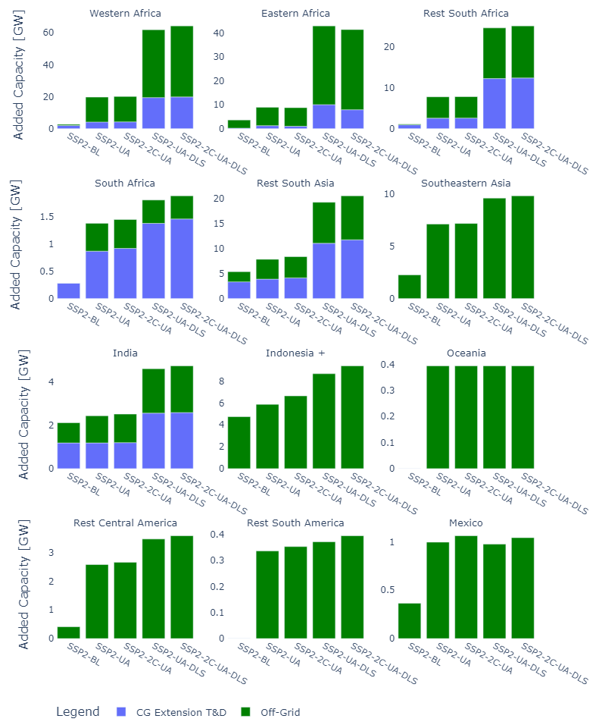
Figure A2 Estimated Increased installed capacity required for electrification under the different scenarios between 2021 to 2030 for the new central grid (blue) and off-grid connections (green).

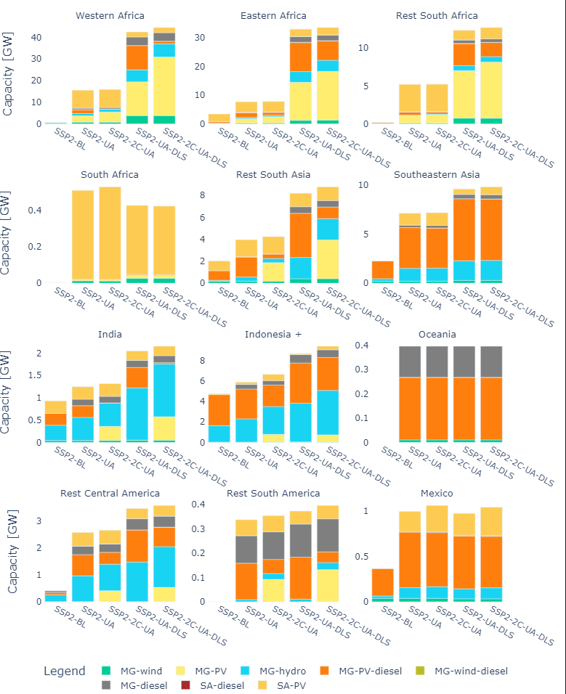
Figure A3 Estimated Increased installed capacity required for electrification under the different scenarios between 2021 to 2030 for the new off-grid installed technologies.

General assumptions
The transmission and distribution capacity for central grid connections or mini-grids were calculated using a threshold on the average household demand per region. Regions with low household demand (700kWh/year) are assumed to use electricity for four hours daily. While for regions with average household demand exceeding this threshold, the peak demand was implemented using a residential load curve obtained from Zapata et al., [1]
Other techno-eonomic assumptions are listed below, and the remaining assumptions were left as described in Dagnechew et al., [2]
Description | Value
Discount rate for net present value | 10%
CO2 emissions of diesel generators | 2.68 kgCO₂/liter
Diesel consumption in generators | 0.266 liters/kWh
Diesel generator stand -alone life-time [3] | 10 years
Diesel cost: world-bank country data for retail price [4] and trended with IMAGE scenario results.
Technical lifetime of solar wind and diesel mini-grids [3] | 25 years
Storage kwh per system kilowatt for solar systems | 4 hours
Storage kwh per system kilowatt for wind systems | 2 hours
Battery lifetime [5] | 10 years

Figure A4 Carbon tax implemented for mitigation scenarios for selected regions

References
[1] Zapata Castillo V, Boer HS de, Muñoz RM, Gernaat DEHJ, Benders R, van Vuuren D. Future global electricity demand load curves. Energy 2022;258:124741. https://doi.org/10.1016/J.ENERGY.2022.124741.
[2] Dagnachew AG, Lucas PL, Hof AF, Gernaat DEHJ, de Boer HS, van Vuuren DP. The role of decentralised systems in providing universal electricity access in Sub-Saharan Africa – A model-based approach. Energy 2017;139:184–95. https://doi.org/10.1016/J.ENERGY.2017.07.144.
[3] Taliotis C, Shivakumar A, Ramos E, Howells M, Mentis D, Sridharan V, et al. An indicative analysis of investment opportunities in the African electricity supply sector — Using TEMBA (The Electricity Model Base for Africa). Energy Sustain Dev 2016;31:50–66. https://doi.org/10.1016/J.ESD.2015.12.001.
[4] World Bank. Pump price for diesel fuel n.d. https://doi.org/https://data.worldbank.org/indicator/EP.PMP.DESL.CD.
[5] Peña Balderrama JG, Balderrama Subieta S, Lombardi F, Stevanato N, Sahlberg A, Howells M, et al. Incorporating high-resolution demand and techno-economic optimisation to evaluate micro-grids into the Open Source Spatial Electrification Tool (OnSSET). Energy Sustain Dev 2020;56:98–118. https://doi.org/10.1016/J.ESD.2020.02.009.

