supporting information
HPAM-Biomass Phenol-Formaldehyde Resin Dispersion System: Evaluation of Stability
Dan Zhao^{a,*}, Weili Yangª , Guanglite Shenª , Huixia Feng^{a,b}

ªSchool of petrochemical engineering, Lanzhou University of Technology, Lanzhou, 730050, Gansu, China
^{b}State Key Laboratory of Advanced Processing and Recycling of Nonferrous Metals, Lanzhou University of Technology, Lanzhou, 730050, Gansu, China
*Corresponding author
- E-mail:zhaodan765@163.com

Contents
Contents 2
1. Infrared Spectrum Analysis of PFR 3
Fig.S1 FT-IR spectrum of PFR 3
Table S1. Characteristic groups corresponding to infrared absorption peak of PFR 4
2. HPLC-MS spectrometry analysis of high relative molecular mass components of PFR 4
Fig.S2 Total ion current chromatogram of PFR 4
Fig.S3 Mass spectrum and molecular structure of the products in retention time being 34min~37min 5
Fig.S4 Molecular structure of the products in retention time being 34min~37min 6
3. DLVO Interaction Energy 6
Table S2. The related parameters of PFR 9

1. Infrared Spectrum Analysis of PFR
Fig.S1 is the infrared spectrum of PFR prepared by phased alkali addition.Table S1 Absorption band I is the standard absorption peak corresponding to the characteristic group, and absorption band II is the characteristic group corresponding to the infrared absorption peak of PFR. The characteristic groups of PFR can be determined by comparing with absorption bands I and II. From the analysis of infrared absorption peaks in Table S1, it can be seen that the corresponding characteristic groups belong to groups on PFR molecules.
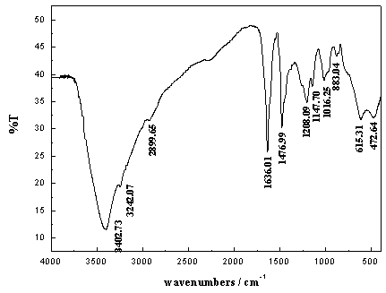
Absorption band I( cm⁻¹ ) | Absorption Band II ( cm⁻¹ ) | Group
3600~3300 | 3402.73 | Hydrogen bond association absorption peak of hydroxyl O-H on benzene ring
1650~1450 | 1636.01 | Absorption peak of stretching vibration of C=C on benzene ring
1250~1000 | 1208.09 | Stretching vibration absorption peak of phenol C-O
3000~2800 | 2899.65 | Asymmetric stretching vibration absorption peak of aliphatic -CH₂-
1250~1000 | 1016.25 | C-O stretching vibration of hydroxymethyl
1500~1400 | 1476.99 | Absorption peaks of methylene bridge -CH₂- linked by ortho-para position
900~840 | 883.04 | The out of plane bending vibration absorption peak of 1,2,3,4,5 position substituted -CH- on benzene ring
Fig.S1 FT-IR spectrum of PFR
Table S1. Characteristic groups corresponding to infrared absorption peak of PFR
1053cm⁻¹ is the absorption peak of dibenzyl ether, there is no absorption peak, indicating that there is no ether bond in PFR.
2. HPLC-MS spectrometry analysis of high relative molecular mass components of PFR
PFR solution was diluted 1000 times with deionized water, and its relative molecular mass and structure were analyzed by HPLC-MS. Since the phenol-formaldehyde group in the PFR molecule is easy to remove a proton to form negative ions, the negative ion detection method used in the mass spectrometry analysis is adopted.
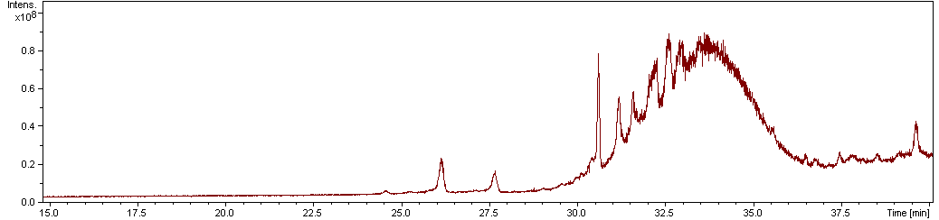
Fig.S2 Total ion current chromatogram of PFR
It can be seen from the total ion flow diagram in Fig.S2 that PFR with low molecular weight can be effectively separated, and the chromatographic peaks of PFR with high molecular weight overlap. The PFR synthesized under the experimental conditions is a mixture of various components with different structures.The ion total flow Fig.S2 shows that when the retention time is greater than 34 minutes, the chromatographic peaks overlap, and the PFR is not effectively separated. For the mass spectrometry analysis of the retention time in 34-37 minutes, the PFR is mainly a mixture of three components.As shown in Fig.S3, from m/z 377.2,619.2 and 725.3, the relative molecular mass of each ion fragment varies by 136 from small to large. The molecular structure of PFR is shown in Fig.S4.
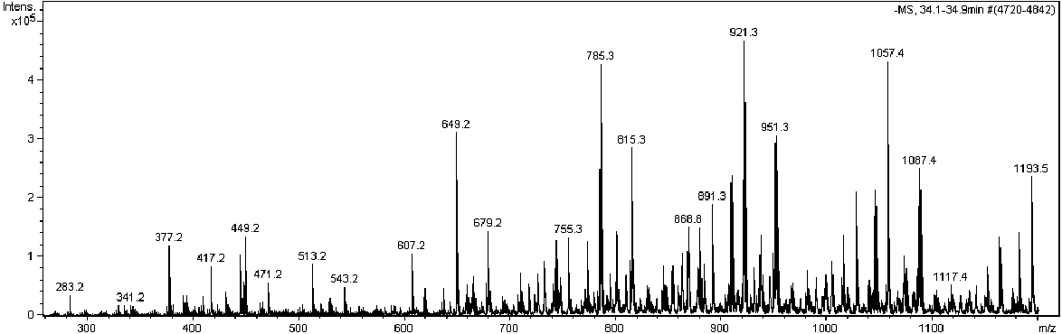
A
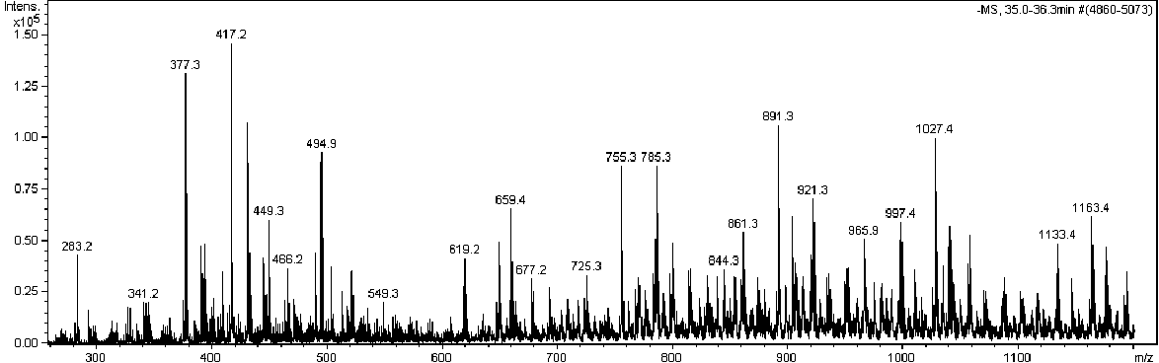
B
Fig.S3 Mass spectrum and molecular structure of the products in retention time being 34min~37min
Fig.S4 Molecular structure of the products in retention time being 34min~37min
It can be seen that the low-solubility PFR is a mixture and its degree of polymerization is between 3 to 9. One to two hydroxymethyls are connected to each phenol-formaldehyde ring. Methylene is connected to the phenol ring in the ortho- and para-positions, and the relative molecular mass is between 400 to 1200. The molecular structure is shown in Fig.S4.
- DLVO Interaction Energy
There are two kinds of interaction forces between colloidal particles : electrostatic repulsion and van der Waals force.In DLVO theory, the total potential energy U_{DLVO} between colloidal particles is the linear superposition of $U_{A}$ van der Waals force potential energy and $U_{R}$ electrostatic repulsion potential energy.
Van der Waals force potential energy between particles can be expressed as equation :¹
$U_{A}=−\frac{AR}{12h}$ (S1)
R is the radius of the particle, m; h is the distance between particles, m ; A is the Hamaker constant of phenolic resin colloidal solution, J.
In phenolic resin colloid solution, metal cations Na⁺ adsorbed on the surface of the colloid, forming a double layer.With the increase of H⁺ concentration in the solution, the oxygen anion on the phenolic resin was protonated, which reduced the surface potential of the colloid.For two colloidal particles with the same surface potential, the electrostatic repulsion potential energy of the double layer can be expressed as equation :¹
$U_{R}=\frac{64πRcN_{A}k_{B}Tγ^{2}}{κ^{2}}e^{−κh}$ (S2)
where c is electrolyte solution concentration, mol/m³ ; N_{A} is the avogadro constant,6.02×10²³ mol⁻¹; k_{B} is Boltzmann constant, 1.38×10⁻²³J/K; T is the absolute temperature(283.15K), K ; $γ$is the particle surface potential parameter ;$κ$ is the Debye parameter, m⁻¹. In the PFR dispersion system, the concentration of electrolyte solution was only considered NaCl added in the preparation of PFR. Therefore $κ^{−1}$ is 1.26×10⁻⁸ nm in the PFR dispersion system.
According to Gouy-Chapman potential distribution equation, surface potential parameter$γ$can be expressed as:¹
$γ=\frac{exp(\frac{zeφ_{0}}{2k_{B}T})−1}{exp(\frac{zeφ_{0}}{2k_{B}T})+1}$ (S3)
According to Poisson - Boltzmann equation, The electric double layer thickness $κ^{−1}$ can be expressed as:²
$κ^{−1}=\sqrt{\frac{εε_{0}k_{B}T}{N_{A}e^{2}\sum{c_{i}z_{i}^{2}}}}$ (S4)
Where z is ion valence; e is the electron charge, 1.6×10⁻¹⁹C;φ₀ is surface potential(zeta potentials were used to approximate surface potentials in the calculation), V; $ε$ is the relative dielectric constant of water,87.73×10^{-0.002(T-273.15)}F/m; $ε_{0}$ is the dielectric constant of vacuum,8.854×10⁻¹² F/m; N_{A} is the Avogadro constant,6.02×10²³mol⁻¹; c_{i} is the concentration of i ion at φ potential ,mol/m³; z_{i} is ion valence.
In many studies, when the separation distance between particles in water is 0 ~ 2 nm, the change of potential energy between particles is obviously deviated from the DLVO theory.It is speculated that the additional repulsion potential caused by the formation of hydrated ions by antiions and colloid surface groups or hydrated layers formed by strong hydrophilic groups on the colloid surface.Although the origin of hydration force is still under debate, there is overwhelming evidence that it exists.Since the 1970s, it is generally believed that the effective hydration potential decreases exponentially from the surface, so the following general forms can be adopted :^{2, 3}
$U_{h}=F_{0}πRλexp(−\frac{h}{λ})$ (S5)
Where F₀ is the hydration force constant, N/m², λ is the characteristic decay length, m.
The extended eDLVO theory considers the influence of the hydration potential (U_{h}) based on the DLVO theory, and the specific expression of the total potential energy (U_{T}) between particles is expressed as follows :^{2, 3}
U_{T=}$U_{h}+U_{R}{+U}_{A}$ (S6)
Hamaker constant is the parameter that affects van der waals force. According to DLVO Theory, The height of barrier is the main factor that determines whether colloids precipitate or not. When the charged colloid reaches the critical flocculation point, The barrier between colloids is 0.The formula is expressed as:⁴
$\left\{\begin{aligned}U_{DLVO}=\frac{64πRC_{CFC}N_{A}k_{B}Tγ^{2}}{{κ^{2}}_{CFC}}e^{−κ_{CFC}h_{,CFC}}−\frac{A}{12}\frac{R}{h_{CFC}}=0 （S7−1） \\ \frac{dU_{DLVO}}{dU_{0}}=−\frac{64πRC_{CFC}N_{A}k_{B}Tγ^{2}}{{κ^{2}}_{CFC}}κ_{CFC}e^{−κ_{CFC}h_{CFC}}+\frac{A}{12}\frac{R}{{h_{CFC}}^{2}}=0 （S7−2）\end{aligned}\right.$ (S7)
Solving for Eq.(S12),the relation between $h_{CFC}$and $κ_{CFC}$ can be deduced as follows:
${κ_{CFC}h}_{CFC}=1$ (S8)
Substituting Eq.(S12) into Eq.(S12-1) leads to.
$A=\frac{768{πN}_{A}C_{CFC}k_{B}Tγ^{2}}{{κ_{CFC}}^{3}exp(1)}$ (S9)
Where $C_{CFC}$is the electrolyte solution concentration at the flocculation point,mol/m³;$κ_{CFC}$is the Debye parameter of flocculation point,m⁻¹;$h_{CFC}$is separation distance, m.
Table S2. The related parameters of PFR
Type | Value | Reference
$$F_{0}$$ | 1.15×10⁶ N/m² | Jia et al.,2006
λ | 6×10⁻¹⁰ m | Jia et al.,2006
$$A$$ | 2.98×10⁻²¹J | calculated by Eq. (S9)

References
1. Ishikawa, Y.; Katoh, Y.; Ohshima, H., Colloidal stability of aqueous polymeric dispersions: Effect of pH and salt concentration. Colloids and Surfaces B-Biointerfaces 2005, 42 (1), 53-58.
2. van der Linden, M.; Conchúir, B. O.; Spigone, E.; Niranjan, A.; Zaccone, A.; Cicuta, P., Microscopic Origin of the Hofmeister Effect in Gelation Kinetics of Colloidal Silica. The Journal of Physical Chemistry Letters 2015, 6 (15), 2881-2887.
3. Jia, Z.; Gauer, C.; Wu, H.; Morbidelli, M.; Chittofrati, A.; Apostolo, M., A generalized model for the stability of polymer colloids. Journal of Colloid and Interface Science 2006, 302 (1), 187-202.
4. Xu, Z.; Sun, Y.; Niu, Z.; Xu, Y.; Wei, X.; Chen, X.; Pan, D.; Wu, W., Kinetic determination of sedimentation for GMZ bentonite colloids in aqueous solution: Effect of pH, temperature and electrolyte concentration. Applied Clay Science 2020, 184.

