Extrusion-based Additive Manufacturing of Three-dimensional MoSe₂-nanosheet-coated TiO₂ Hetero-structures for Photocatalytic CO₂ Reduction

Heungseok Oh, Hazina Charles, Taehyeob Im, Haritham Khan, and Caroline Sunyong Lee*
Department of Materials and Chemical Engineering, Haiyang University, Ansan 15588, Republic of Korea
*Corresponding author
Caroline Sunyong Lee
sunyonglee@hanyang.ac.kr

Supplementary information
The aim was to determine the most suitable powder content for feedstock production by mixing TiO₂ raw powder with a binder. The morphology of the raw powder is shown in Figure S1a. The binder was progressively added to the raw powder, starting at 20 vol% and increasing in 2 vol% increments, while measuring the mixing torque. Mixing continued for approximately 15 minutes at each powder content, as the graph showing torque vs. time is provided in Figure S1c. Mixing torque exhibited a rapid increase upon powder addition, eventually stabilizing at a constant torque level, indicating saturation over time. This observation confirms the uniform mixing of the feedstock. Subsequently, the graph in Figure S1d illustrates the average mixing torque plotted against powder content. In Zone 1 (20 - 36 vol.%), which featured low powder content, the increase in mixing torque with powder content was minimal. Zone 2 (38 - 44 vol.%) displayed a linear rise in mixing torque with powder content, representing the region where the optimal balance between powder and binder was achieved. In Zone 3 (46 vol.% -), mixing torque rapidly increased, accompanied by a significant rise in the standard deviation of mixing torque, indicating insufficient binder content. The critical solid loading of TiO₂ feedstock was found to be 44 vol.%, while the optimal solid loading suitable for extrusion, approximately 3~5 vol.% lower, was determined to be 40 vol.%, exhibiting favorable flow properties [1].
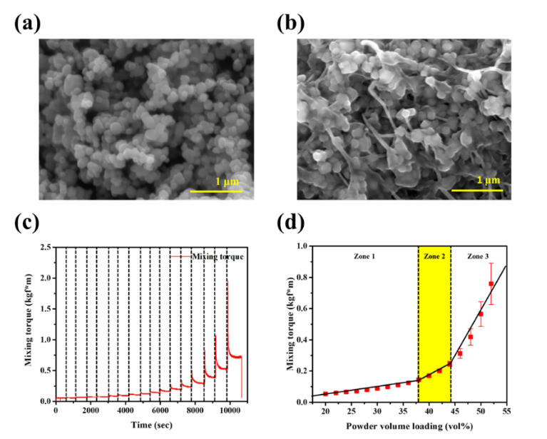
Fig. S1 SEM images of (a) TiO₂ powder, (b) TiO₂ feedstock, (c) mixing torque-time graph, and (d) mixing torque-powder volume loading graph.
The dimensions of the TiO₂ 3D structure were designed to be 60·30·2 mm³. The top surface area of the structure, measuring 60*30 mm², was determined with considerations for the size of the CO₂ photoreduction reactor and the Xe lamp. To optimize the height, the efficiency of CO₂ photoreduction was compared at different heights for TC25. When the height was 1 mm, gas yields of H₂, CO, and CH₄ were observed to be 0.11, 0, and 0.02 μmol, respectively. At its height of 2 mm, there was an increase in the gas yields of H₂, CO, and CH₄ to 0.37, 0.13, and 0.09 μmol, respectively, attributed to the increased amount of photocatalyst. Surprisingly, when the height was further increased to 10 mm, the gas yields decreased to 0.20, 0, and 0.01 μmol for H₂, CO, and CH₄, respectively. It was expected that increasing the height would result in higher gas yields, but the opposite trend was observed. According to Vaildyanathan et al., as the thickness of the photocatalyst film increases, the surface area also increases. However, the 3D structure receives the same photon flux, while the penetration and desorption of the required CO₂ become more difficult, making the photoreduction reaction less favorable [2]. Therefore, it was confirmed that a height of 2 mm provided the highest efficiency.
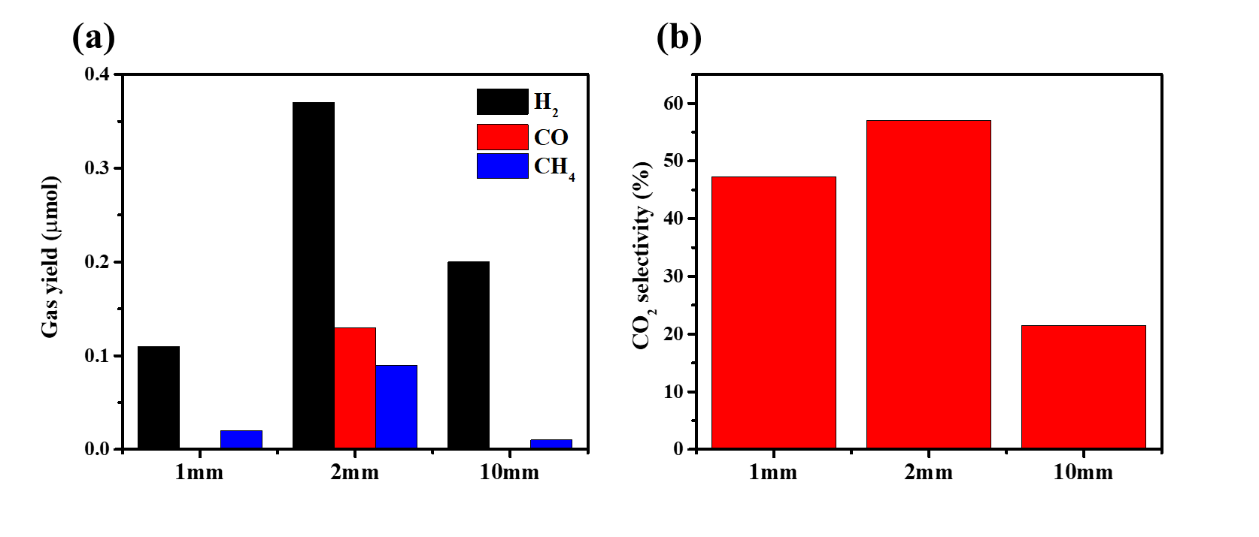
Fig. S2 (a) gas yield according to varying heights of TiO₂ 3D structure and (b) CO₂ selectivity according to corresponding heights of TiO₂ 3D structure
To investigate the electrical properties with varying infill percentages, sheet resistance was measured. Initially, for the pure TiO₂ 3D structure without MoSe₂ coating, the sheet resistance was measured to be 1.50·10⁷ Ω/□. However, with MoSe₂ coating, the sheet resistance decreased to approximately 10³ Ω/□, indicating that MoSe₂ was successfully grown on the surface. This reduction in sheet resistance signifies the effective coating of MoSe₂ on the surface. TC100c exhibited the lowest Mo and Se content among all samples, likely due to the limited amount of Mo and Se precursors relative to the amount of photocatalyst, resulting in poor coating. Moreover, the highest sheet resistance of 1.99·10³ Ω/□ was obtained. As the infill percentage decreased, the Mo and Se content increased, accompanied by a decrease in sheet resistance. In conclusion, TC25c displayed the lowest sheet resistance, suggesting that it efficiently enhances charge transfer at the surface, expecting potentially the highest photocatalytic efficiency among samples.

Table S1 Sheet resistance and weight fraction of Ti, Mo, and Se depending on infill percent.
Sample name | Sheet resistance  (Ω/□) | Weight fraction (%)
Sample name | Sheet resistance  (Ω/□) | Ti | Mo | Se
TS25 | 1.50x10⁷ | 100 | 0 | 0
TC25c | 0.25x10³ | 81.32 | 6.04 | 12.63
TC50c | 1.02x10³ | 85.39 | 3.64 | 10.98
TC75c | 1.42x10³ | 86.09 | 3.26 | 10.65
TC100c | 1.99x10³ | 87.19 | 3.15 | 9.66

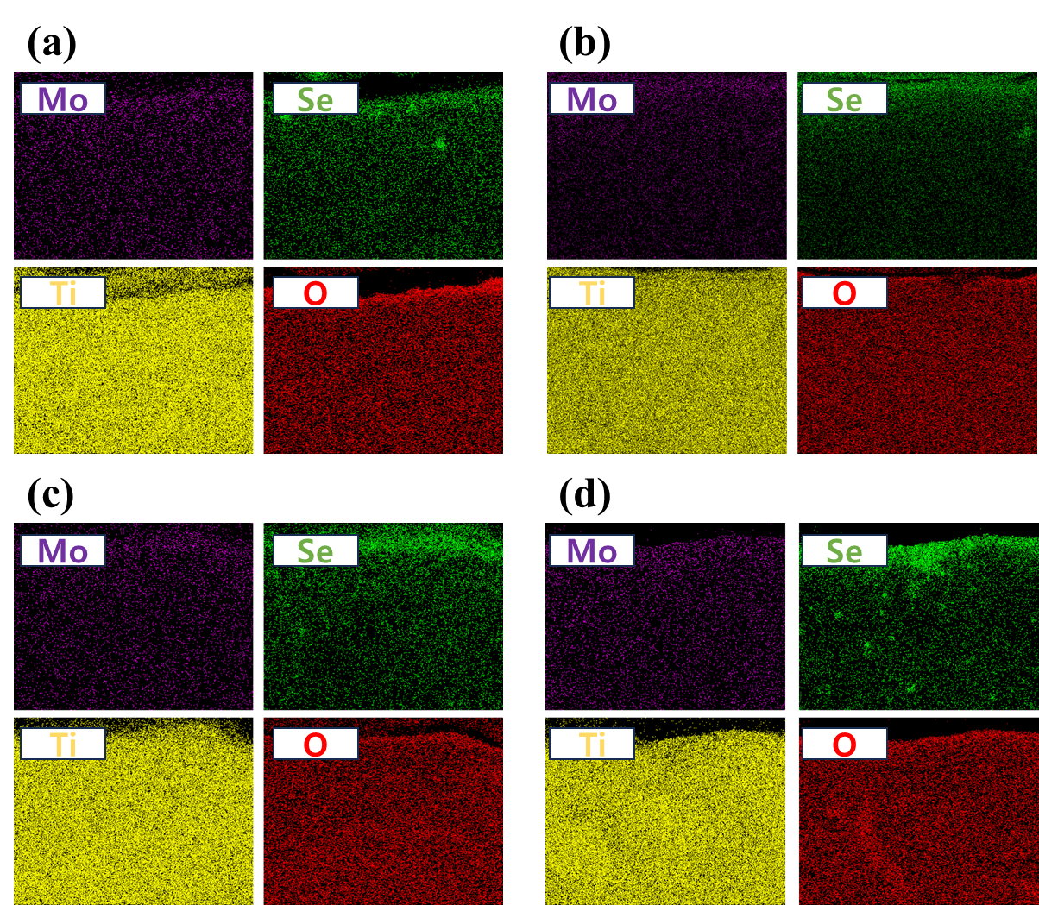
Fig. S3 EDX mapping images of (a) TS25c, (b) TS50c (c) TS75c, and (d) TS100c.
The amount of gas produced was measured using Gas Chromatography. Fig. 10a depicts the gas yield of each infill structure. TC25 produced 0.37, 0.13, and 0.09 μmol of H₂, CO, and CH₄, respectively. TC50 produced 0.14, 0.03, and 0.03 μmol, respectively, TC75 produced 0.12, 0.01, and 0.02 μmol, and TC100 produced 0.11, 0, and 0.01 μmol, respectively. After the hydrothermal growth of the TiO₂–MoSe₂ heterostructure, the gas production was evaluated. TC25c produced 0.19, 0.29, and 0.14 μmol of H₂, CO, and CH₄, respectively. TC50c yielded 0.49, 0.30, and 0.19 μmol of H₂, CO, and CH₄, respectively. TC75c produced 0.15, 0.02, and 0.04 μmol of H₂, CO, and CH₄, respectively. TC100c generated 0.07, 0.001, and 0.003 μmol of H₂, CO, and CH₄, respectively.
Fig. S4 H₂, CO, and CH₄ yield of TiO₂ 3D structures with/without MoSe₂ coating.

Reference
[1] H. Oh, T. Im, J. Pyo, J.-s. Lee and C. S. Lee (2023) Study of solid loading of feedstock using trimodal iron powders for extrusion based additive manufacturing. Scientific Reports 13:4819. https://doi.org/10.1038/s41598-023-32095-5
[2] V. Subramanian, P. V. Kamat and E. E. Wolf (2003) Mass-transfer and kinetic studies during the photocatalytic degradation of an azo dye on optically transparent electrode thin film. Industrial & engineering chemistry research 42:2131-2138. https://doi.org/10.1021/ie020636u

