Supplementary Material
Exposure to multiple heavy metals is associated with hypertension: A cross-sectional study in China
Ruoyu Gou ^{1,2, †}, Qiumei Liu^{3, †}, Ruiying Li^{1,2, †}, Jian Qin³, Tingyu Luo^{1,2}, Weiyi Pang^{1,2}, Kailian He^{1,2}, Song Xiao^{1,2}, Xiaoting Mo³, Yanfei Wei³, Tingjun Li^{1,2}, Jie Xiao^{1,2}, You Li^{1,2, *} and Zhiyong Zhang^{1,2, *}
¹ Department of Environmental Health and Occupational Medicine, School of Public Health, Guilin Medical University, Zhiyuan Road No.1, Guilin, 541199, Guangxi province, PR China
² Guangxi Key Laboratory of Environmental Exposomics and Entire Lifecycle Health, Guilin Medical University, Guilin, PR China
³ Department of Environmental and Occupational Health, School of Public Health, Guangxi Medical University, Shuangyong Road No.22, Nanning, 530021, Guangxi province, PR China
† These authors contributed equally to this work.
* Corresponding author:
rpazz@163.com (Z.Y.Z);
liyou121300@163.com（Y.L）;

Supplementary Figures and Tables

Supplementary Figures

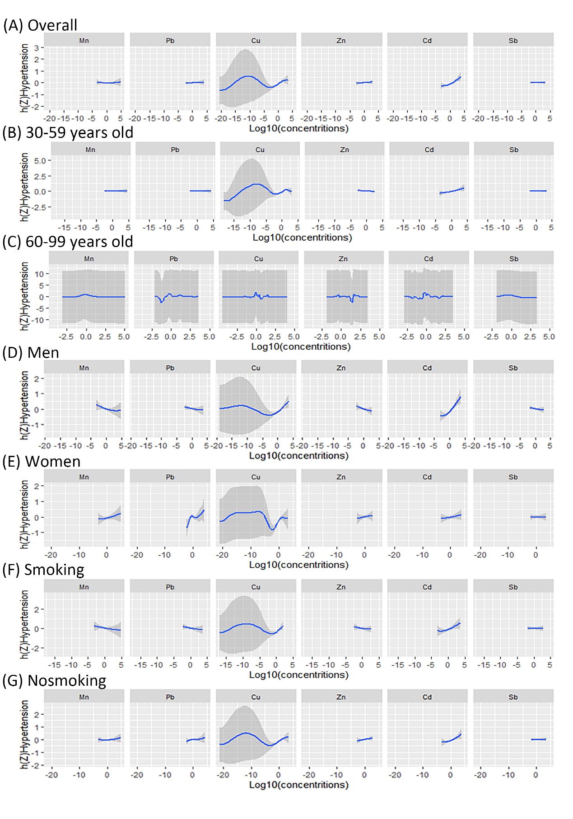
Figure.2. Univariate exposure-response functions and 95% confidence intervals (shaded areas) for manganese, lead, copper, zinc, cadmium, and antimony, with median for other elements. (A) Overall participants; (D) Participants aged 30-59 years; (E) Participants aged ≥60 years; (B) the male; (C) women; (F) Smokers; (G) Non-smokers. H(Z) can be interpreted as a relationship between a chemical and a potential continuous outcome. In adjusting sex (male/female) and/or age (30 to 59/60 or higher), race (Han/Yao/Other), degree of culture (6 years old or less / > 6 years old), and/or smoking(yes/no), alcohol (yes/no), body mass index (< 23/23-27.49/27.5 or higher Kg /m2), agricultural physical activity (yes/no), hyperglycemia (yes/no) and hyperlipidemia (yes/no) were analyzed by Bayesian kernel regression.
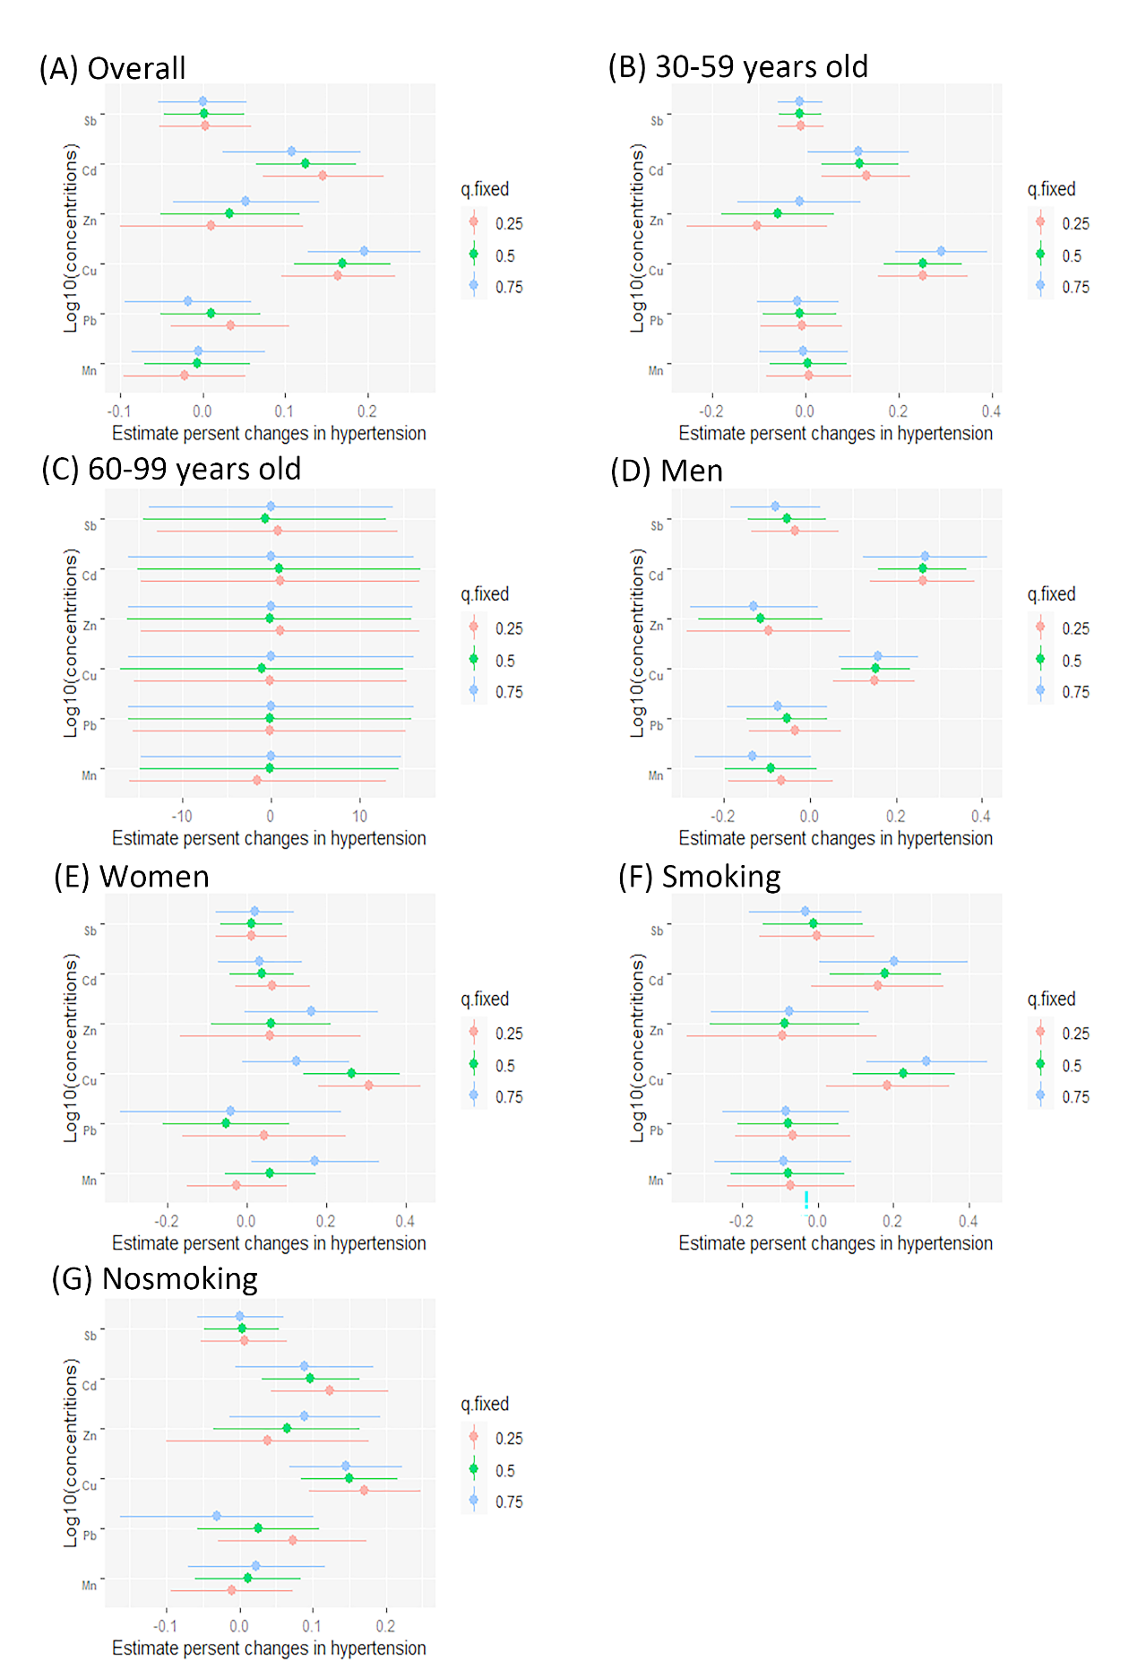
Figure. 3. Effect of single exposure of a single metal on hypertension using a Bayesian core machine regression model (estimate and 95% confidence interval). (A) Overall participants; (D) Participants aged 30-59 years; (E) Participants aged 60 years or older; (B) the male; (C) women; (F) Smokers; (G) Non-smokers. According to gender (male/female), and/or age (30 to 59/60 or higher), race (Han/Yao/Other), degree of culture (6 years old or less / > 6 years old) and/or smoking (yes/no), alcohol(yes/no), body mass index (< 23/23-27.49/27.5 or higher Kg /m2), agricultural physical activity (yes/no), hyperglycemia (yes/no), and hyperlipidemia (yes/no).
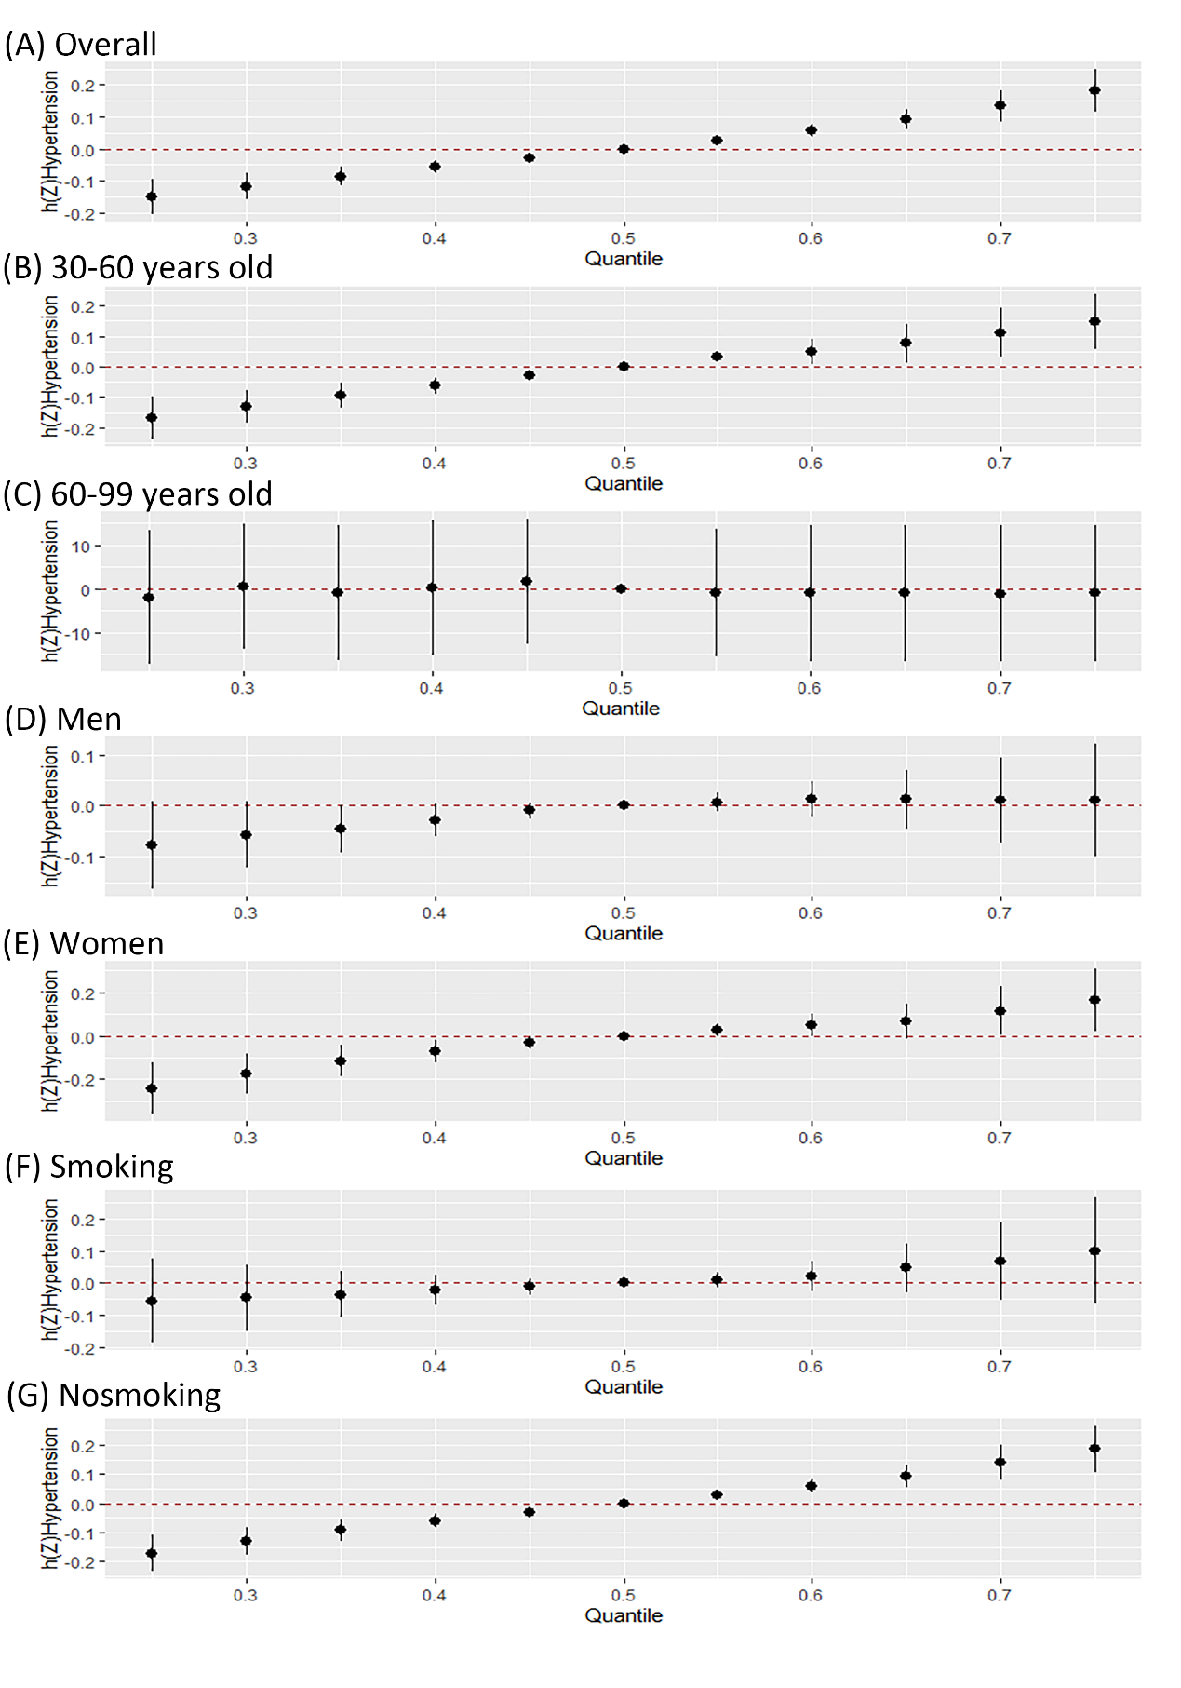
Figure. 4. Overall correlation between 95% confidence intervals of manganese, lead, copper, zinc, cadmium and antimony mixtures. (A) All participants; (D) Participants aged 30-59 years; (E) Participants aged 60 years or older; (B) the male; (C) women; (F) Smokers; (G) Non-smokers. H(Z) can be interpreted as the relationship between the chemical and the potential continuous outcome, estimated values marked at the top of the graph. In adjusting sex (male/female) and/or age (30 to 59/60 or higher), race (Han/Yao/Other), degree of culture (6 years old or less / > 6 years old), and/or smoking (yes/no), alcohol (yes/no), body mass index (< 23/23-27.49/27.5 or higher Kg /m2), agricultural physical activity (yes/no), hyperglycemia (yes/no) and hyperlipidemia (yes/no) were analyzed by Bayesian kernel regression.
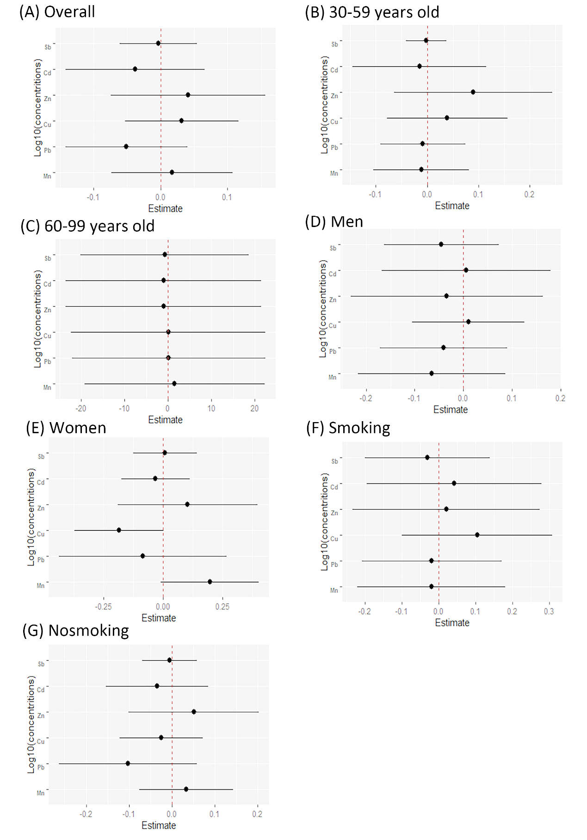
Figure. 5. Health risks from a single exposure when all other exposures were fixed at the 75th percentile were compared with health risks when all other exposures were fixed at the 25th percentile. (A) All participants; (D) Participants aged 30-59 years; (E) Participants aged 60 years or older; (B) the male; (C) women; (F) Smokers; (G) Non-smokers. In adjusting sex (male/female) and/or age (30 to 59/60 or higher), race (Han/Yao/Other), degree of culture (6 years old or less / > 6 years old), and/or smoking (yes/no), alcohol (yes/no), body mass index (< 23/23-27.49/27.5 or higher Kg /m2), agricultural physical activity (yes/no), hyperglycemia (yes/no) and hyperlipidemia (yes/no) were analyzed by Bayesian kernel regression.

Supplementary Figures
Table.5. BKMR model posterior inclusion probability
Variable | Mn | Pb | Cu | Zn | Cd | Sb
Total | - | - | 0.99 | - | 1 | -
30-59 | - | - | 0.99 | - | 0.69 | -
60-99 | 0.97 | 0.99 | 1 | 1 | 1 | 0.94
men | 0.64 | - | 0.94 | 0.72 | 1 | -
women | 0.80 | 0.92 | 0.99 | 0.76 | - | -
Smoking | - | - | 0.89 | - | 0.71 | -
Nonsmoking | - | - | 0.99 | - | 0.97 | -
Do not show values with too low posterior inclusion probability (PIP<0.5).

