Table 3. Effects of isolated fungal compounds on NIH-3T3 fibroblast migration*, **
Time point | Wound closure rates (%)
Time point | Control | Cerevisterol (1) | Aloesol (2)
Day 0 | 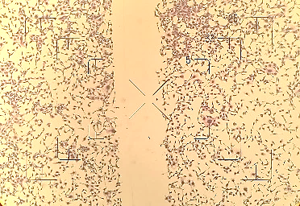 | 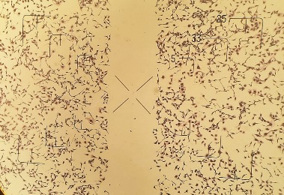 | 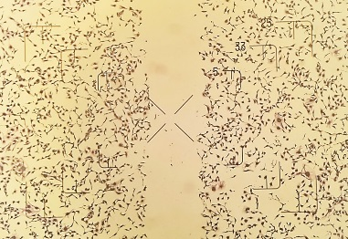
Day 0 | 0.03±0.01 | 0.01±0.01 | 0.02±0.01
Day 0 |  | p>0.05 | p>0.05
Day 2  (48 h) | 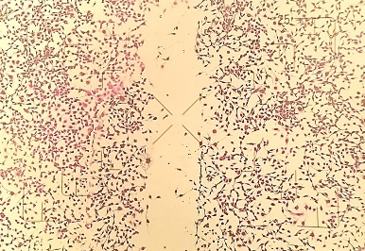 | 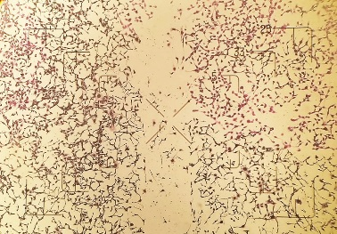 | 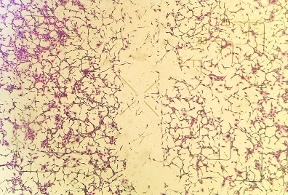
Day 2  (48 h) | 12.37±2.15 | 19.50±3.23 | 20.41±3.59
Day 2  (48 h) |  | p<0.05 | p<0.05
Day 4  (72 h) | 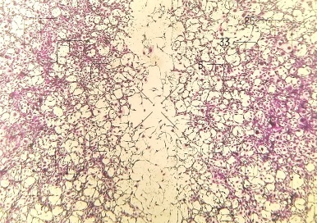 | 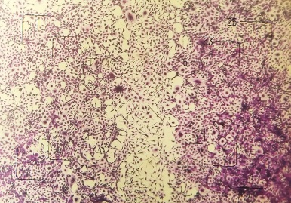 | 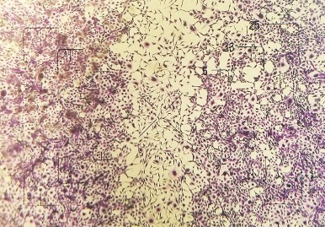
Day 4  (72 h) | 51.80±3.45 | 76.62±4.04 | 71.66±3.37
Day 4  (72 h) |  | p<0.05 | p<0.05
*Staining of fibroblasts was conducted by sulforhodamine B (SRB) (Orellana and Kasinski 2016).
** Representative images were taken by light microscopy at 10x magnification.

