Supporting Information
Polydopamine/redox graphene oxide/Fe³⁺ composite fabrics with excellent photothermal properties for continuous desalination
Yan Ding,ª Qi Yuan,ª Ming-Guo Ma^{a,b,∗} Da-Qi Cao^{c}
ªMOE Engineering Research Center of Forestry Biomass Materials and Bioenergy, Research Center of Biomass Clean Utilization, Beijing Key Laboratory of Lignocellulosic Chemistry, College of Materials Science and Technology, Beijing Forestry University, Beijing 100083, PR China;
^{b}State Silica-based Materials Laboratory of Anhui Province, Bengbu 233000, PR China;
^{c}Sino-Dutch R&D Centre for Future Wastewater Treatment Technologies/Key Laboratory of Urban Stormwater System and Water Environment, Beijing University of Civil Engineering and Architecture, Beijing 100044, PR China.

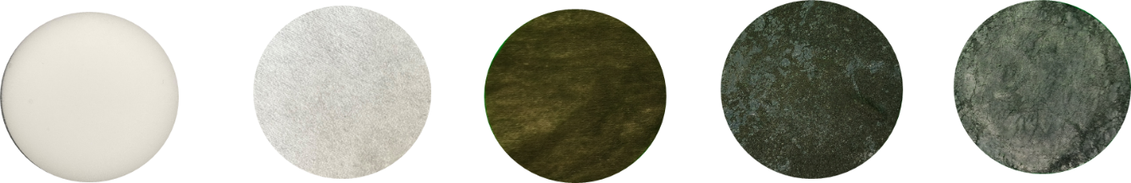
Figure S1 Melamine Sponge, CT, CT-PDA, CT-PDA/GO-Fe3+ and CT-PDA/rGO-Fe3+ (from left to right).
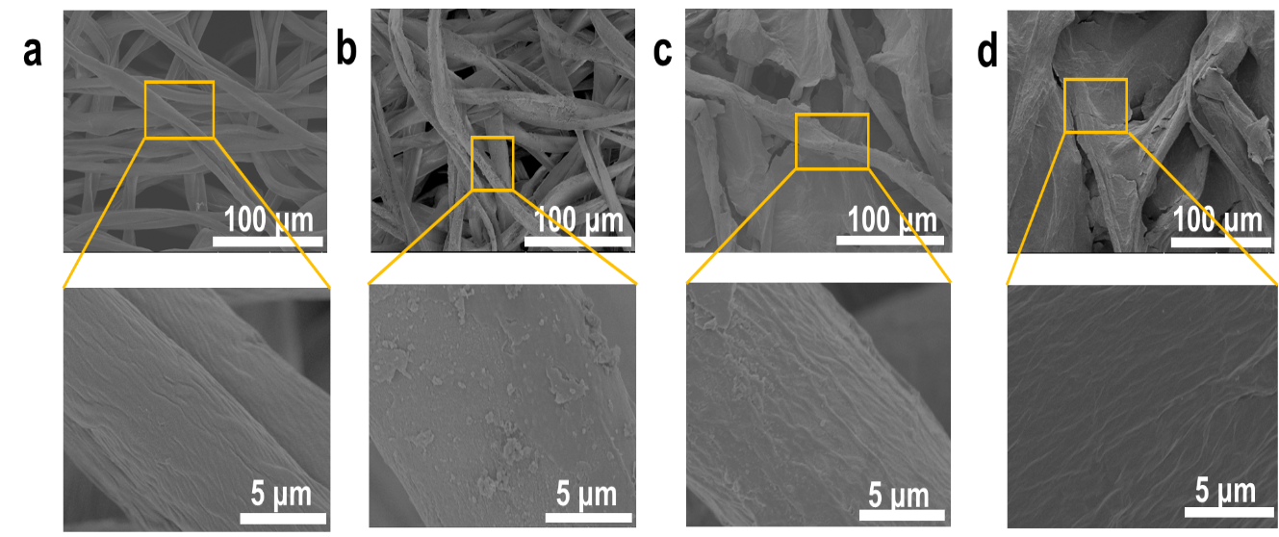
Figure S2. SEM images of (a) CT, (b) CT-PDA, (c) CT-PDA/GO, and (d) CT-PDA/rGO composite fabric.

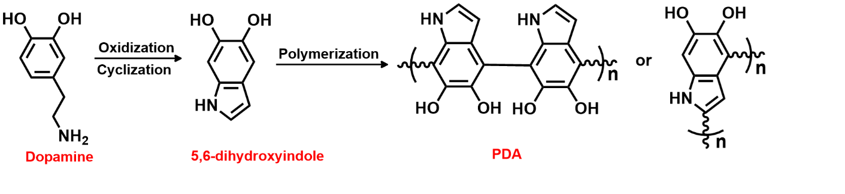
Figure S3. Reaction mechanism of self-polymerization of DA.

∗Corresponding author. Tel.: +0086-10-62337250. E-mail address: mg_ma@bjfu.edu.cn (M.-G. Ma).

