Supplementary Materials

Supplementary Table S1: Index of textural features

Supplementary Figure S1: Flowchart of the analysis steps

Supplementary Figure S2: Clustering dendrogram of samples based on their Euclidean distance by weighted gene co-expression network analysis.

Supplementary Figure S3: Analysis of network topology for various soft-thresholding powers by weighted gene co-expression network analysis

Supplementary Figure S4: Distribution and box plot of SUV max extracted from the internal and external cohorts before and after harmonization.
- A: Distribution of SUV max extracted from all T stage patient before ComBat
- B: Distribution of SUV max extracted from all T stage patient after ComBat
- C: Box polot of SUV max extracted from all T stage patient before ComBat
- D: Box polot of SUV max extracted from all T stage patient after ComBat
- E: Distribution of SUV max extracted from T2 stage or higher patient before ComBat
- F: Distribution of SUV max extracted from T2 stage or higher after ComBat
- G: Box polot of SUV max extracted from T2 stage or higher before ComBat
- H: Box polot of SUV max extracted from T2 stage or higher after ComBat

Supplementary Table S1: Index of textural features

Features | Parameters | Image features
1st order | Conventional indices | Minimum standard uptake value (SUVmin)
1st order | Conventional indices | Mean standard uptake value (SUVmean)
1st order | Conventional indices | Standard deviation (SUVstd)
1st order | Conventional indices | Maximum standard uptake value (SUVmax)
1st order | Conventional indices | SUVpeak (0.5ml and 0.1ml)
1st order | Conventional indices | SUV quartiles (SUVQ1, SUVQ2, and SUVQ3)
1st order | Conventional indices | Total lesion glycolysis (TLG)
1st order | Shape | Volume of mL
1st order | Shape | Volume of voxel
1st order | Shape | Sphericity
1st order | Shape | Compacity
1st order | Histogram | Skewness
1st order | Histogram | Kurtosis
1st order | Histogram | Entropy (log₁₀, log₂)
1st order | Histogram | Energy
2nd order | Gray-level co-occurrence matrix  (GLCM) | Homogeneity
2nd order | Gray-level co-occurrence matrix  (GLCM) | Energy
2nd order | Gray-level co-occurrence matrix  (GLCM) | Contrast
2nd order | Gray-level co-occurrence matrix  (GLCM) | Correlation
2nd order | Gray-level co-occurrence matrix  (GLCM) | Entropy (log₁₀, log₂)
2nd order | Gray-level co-occurrence matrix  (GLCM) | Dissimilarity
2nd order | Neighborhood gray-level different matrix (NGLDM) | Coarseness
2nd order | Neighborhood gray-level different matrix (NGLDM) | Contrast
2nd order | Neighborhood gray-level different matrix (NGLDM) | Busyness
2nd order | Gray-level run length matrix  (GLRLM) | SRE, LRE
2nd order | Gray-level run length matrix  (GLRLM) | LGRE, HGRE
2nd order | Gray-level run length matrix  (GLRLM) | SRLGE, SRHGE
2nd order | Gray-level run length matrix  (GLRLM) | LRLGE, LRHGE
2nd order | Gray-level run length matrix  (GLRLM) | GLNU, RLNU
2nd order | Gray-level run length matrix  (GLRLM) | RP
2nd order | Gray-level zone length matrix  (GLZLM) | SZE, LZE
2nd order | Gray-level zone length matrix  (GLZLM) | LGZE, HGZE
2nd order | Gray-level zone length matrix  (GLZLM) | SZLGE, SZHGE
2nd order | Gray-level zone length matrix  (GLZLM) | LZLGE, LZHGE
2nd order | Gray-level zone length matrix  (GLZLM) | GLNU, ZLNU
2nd order | Gray-level zone length matrix  (GLZLM) | ZP

Supplementary Figure S1: Flowchart of the analysis steps

STEP 1: Gene analysis
Internal cohort
Enrichment analysis (KEGG and GO term)
Finding metastasis involved function
Hub gene selection by DEG and univariate analysis
WGCNA
DEG analysis
STEP 2: Image feature selection
Harmonization
Correlation of image texture features and hub genes
AUC calculation
1st order and 2nd order separation
STEP 3: Internal and external validation
Internal cohort: 66 patients
T2a or higher stage: 47 patients
External cohort: 102 patients
T2a or higher stage: 32 patients

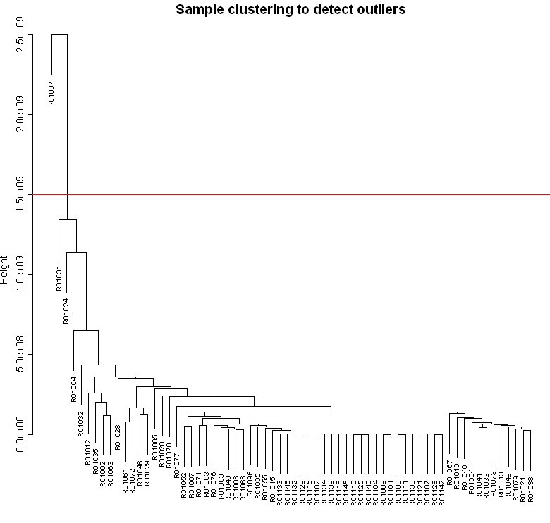
Supplementary Figure S2: Clustering dendrogram of samples based on their Euclidean distance by weighted gene co-expression network analysis.

Supplementary Figure S3: Analysis of network topology for various soft-thresholding powers by weighted gene co-expression network analysis.
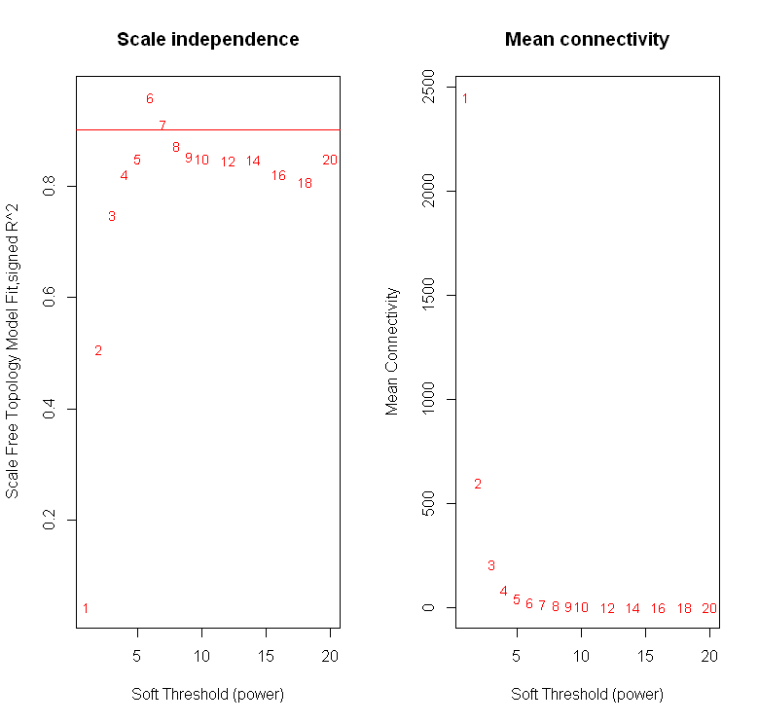

Supplementary Figure S4: Distribution and box plot of SUV max extracted from the internal and external cohorts before and after harmonization.
- A: Distribution of SUV max extracted from all T stage patient before ComBat
- B: Distribution of SUV max extracted from all T stage patient after ComBat
- C: Box polot of SUV max extracted from all T stage patient before ComBat
- D: Box polot of SUV max extracted from all T stage patient after ComBat
- E: Distribution of SUV max extracted from T2 stage or higher patient before ComBat
- F: Distribution of SUV max extracted from T2 stage or higher after ComBat
- G: Box polot of SUV max extracted from T2 stage or higher before ComBat
- H: Box polot of SUV max extracted from T2 stage or higher after ComBat