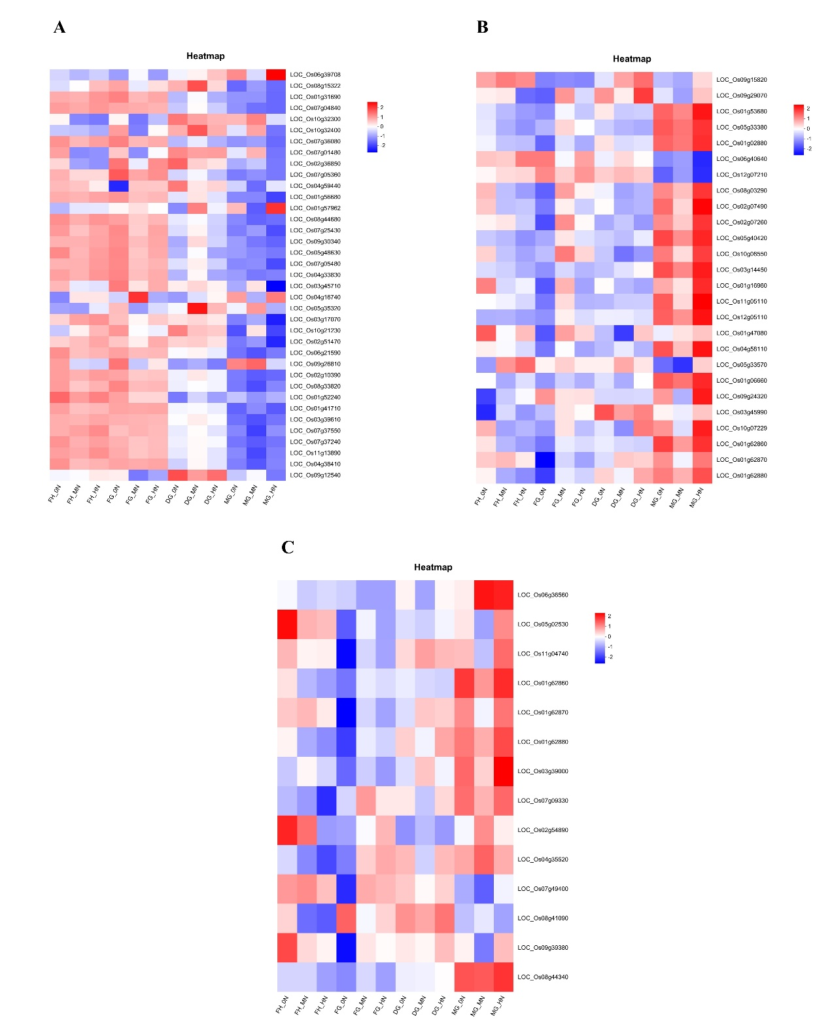
Fig. S4 Key enzymes expressed in our study have colored shaded rectangles and genes link to these enzymes as well as their expression are presented in the heatmap. A. DEGs in photosynthesis pathway. B. DEGs in glycolysis/gluconeogenesis pathway. C. DEGs in ascorbate and aldarate metabolism pathway.

