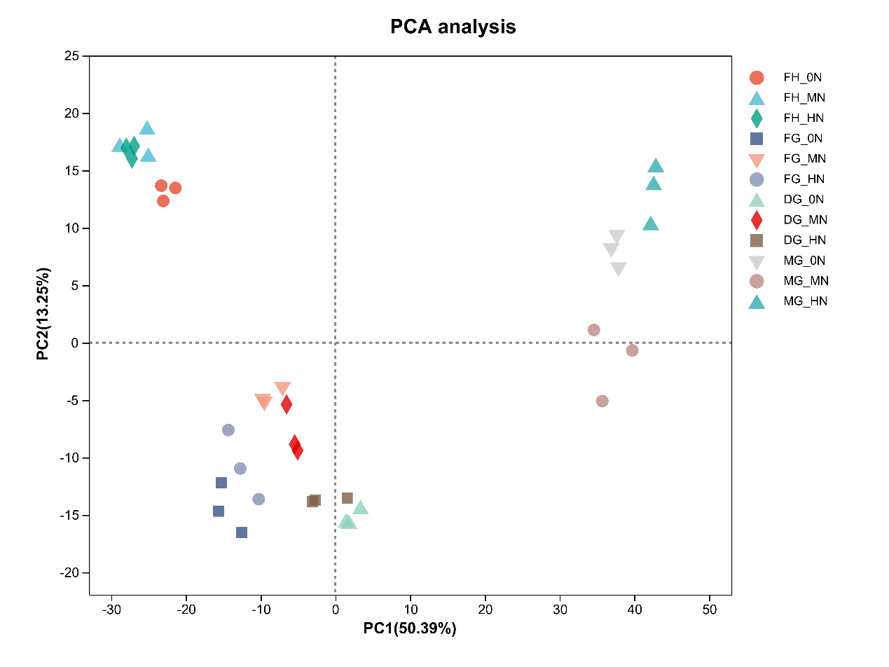
Fig. S2 PCA of RNA-seq data of nitrogen application rates at four stages. The horizontal axis represents the contribution of Principal Component 1 (PC1) to discriminate the samples in the two-dimensional plot, and the vertical axis represents the contribution of Principal Component 2 (PC2) to discriminate the samples in the two-dimensional plot. The closer the distance of each sample point indicates the higher similarity between the samples.

