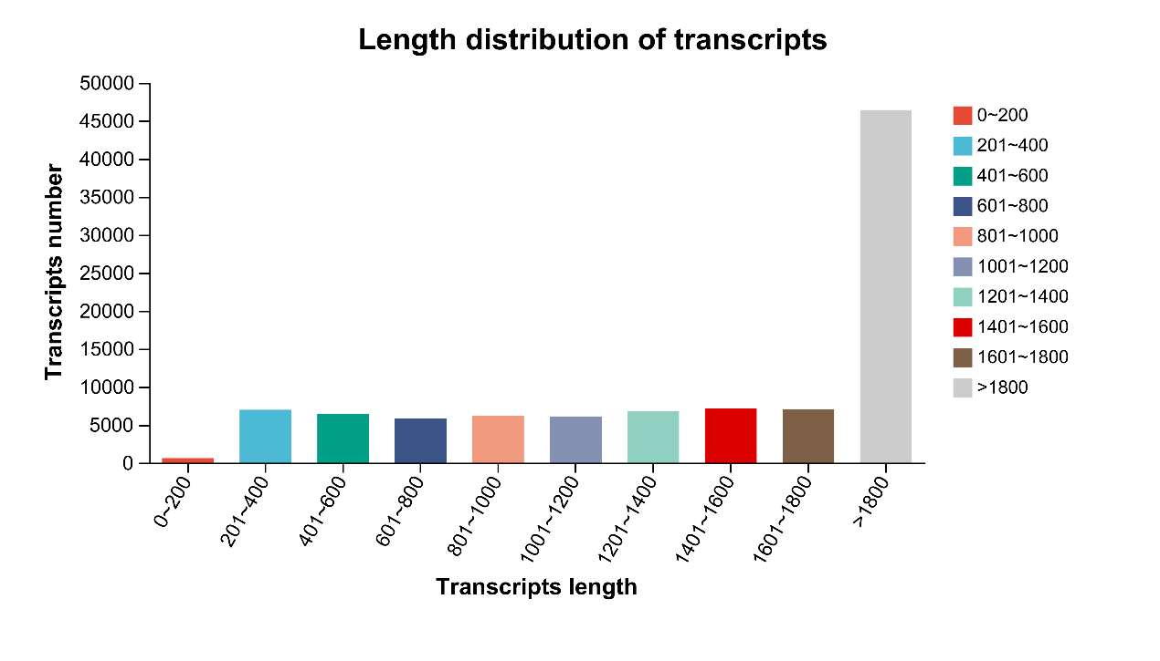
Fig. S1 Distribution of different transcript lengths. The horizontal coordinate is the range of transcript lengths; the vertical coordinate is the number of transcripts within that range of transcript lengths.

